DEVELOPMENT OF A WEB-BASED POINT OF SALE APPLICATION USING THE LARAVEL FRAMEWORK

Rika Apriani¹, Reni Haerani ², Praditya Adi Nugroho ³, Imam Farisi
¹ Informatics Management Study Program, Bina Insany University
² Information Systems Study Program, Bina Insany University
³ Electrical Engineering Department, Polytechnic PGRI Banten
⁴ Informatics Engineering Study Program, Bina Insany University
email: renihaerani@binainsani.ac.id

Abstract: The development of information technology encourages businesses to take over digital systems in business operations, even in the sales process. The Point of Sales (POS) system is the leading solution for recording transactions, managing stock, and creating sales reports efficiently. This study aims to develop a POS application based on a website and make it easier for administrators to manage sales transactions, making them faster and more efficient. This system is made with a structured Agile method, requirements, design, development, testing, deployment, and implementation, and the framework used is the Laravel framework. The test results show that the system is on track and that the efficiency of the transaction and reporting process can be increased. A web-based basis allows users to manage their business more easily in real time because this application is flexible and can be used on various devices.
Keywords: Point of Sales; Laravel; Agile Model;Websites

Abstrak: Pengembangan teknologi informasi mendorong bisnis untuk mengambil alih sistem digital dalam operasi bisnis, bahkan dalam proses penjualan. Sistem Point of Sales (POS) adalah solusi utama untuk merekam transaksi, mengelola stok dan membuat laporan penjualan secara efisien. Tujuan dari penelitian ini adalah untuk mengembangan aplikasi POS berdasarkan situs web dan memudahkan administrator dalam mengelola transaksi penjualan, membuatnya lebih cepat dan lebih efisien. Sistem ini dibuat dengan metode Agile yang terstruktur, requirement, design, development, testing, deployment, dan implementation serta kerangka kerja yang digunakan yaitu framework Laravel. Hasil pengujian menunjukkan bahwa sistem berada di jalur dan bahwa efisiensi proses transaksi dan pelaporan dapat meningkat. Dengan berbasis web memungkinkan pengguna untuk lebih mudah mengelola bisnisnya secara real time, karena aplikasi ini fleksibel melalui berbagai perangkat.

Kata kunci: Point of Sales; Laravel; Model Agile; Website

INTRODUCTION
With the rapid development of information technology, many corporate sectors aim to encourage digital systems to improve operational efficiency and effectiveness. With the rapid development of information technology, many corporate sector goals promote using digital systems to improve operational efficiency and effectiveness. The system that is often used in business activities, especially in the sales department, is Point of Sales (POS). Point of Sale (POS) is an information system that makes transactions easier, such as using cash registers for purchase and sales transactions. [1][2]. Point of Sales is a system that can help sellers process consumer payments or transactions [3]. Another definition of Point of Sale is a system that enables sales transaction processes to be carried out in companies, including shops, hotels, restaurants, supermarkets, and retail outlets [4]. POS systems play a vital role in the fast and accurate presentation of transaction records, product management, and sales reports.
Retail companies often face obstacles to manual transaction management, including recording errors, late reporting, and difficulties monitoring stock. MSMEs are economic activities widely carried out, especially by Indonesians, as a source of income [5]. Therefore, a solution that is flexible, efficient, and practically accessible is needed in the form of POS reports.
In the digital era like today, several companies and MSMEs have different advantages, thus switching to web-based POS systems. These systems allow businesses and MSMEs to manage sales and make the transaction process faster so that the quality of service is more efficient.
Using website-based technology offers advantages in terms of devices and locations without relying on local installations. The Laravel Framework was chosen as the development platform because of its architecture, excellent security, and comprehensive community support. Laravel also offers the latest features to speed up developing and maintaining web applications from various cyber-attacks. [6]. Laravel is used to build application frameworks, manage routing, handle user requests, and interact with MySQL databases [7].
This study aims to use the Laravel framework to develop a website-based point of Sale that helps companies manage transactions and stock more effectively and efficiently. This is in line with previous studies conducted previously, including research studies conducted. [8].

METHOD

- Data Collection Method
To get very accurate, relevant, and valid data, collect data by:
a). Observation
Data collection through direct observation and recording of research objects or stakeholders involved in this research.
b). Documentation
Collecting and searching for documents that are directly related to the research topic and all related to the research.
c). Interview
This method is carried out directly with respondents; information will be obtained through sources to get the required information.
- System Development Method
One of the developments used to build websites is the Laravel framework. This model provides software developers with a systematic and sequential approach [9]. The Laravel Framework model includes many process activities and software design implementations to meet the needs.
- Research Methods
Research stages are a series of steps that help researchers systematically plan, implement, and analyze research. They provide a valuable framework for managing the research process effectively [10].
This research phase is also an ongoing and iterative process. This study uses a system development method with an Agile approach to develop a web-based system. The Agile approach was chosen because it is flexible in responding to changes in user needs during the development process. [11]. The Agile model phase is shown in Figure 1

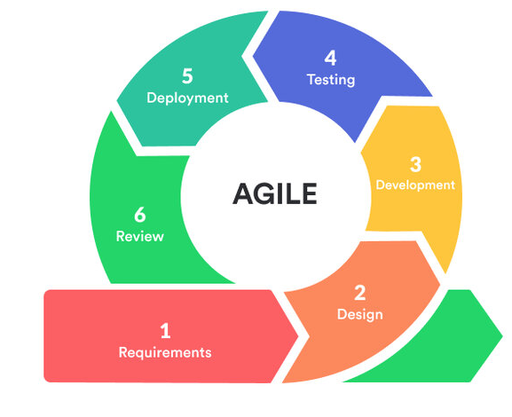
Figure 1. Research Stages Using Agile Model

Using Agile methods in research on website modeling in a website-based saving system can allow researchers to respond flexibly to changes in needs and requirements that may arise during the research process. The research phases are listed below using the Agile method:

- Needs Identification
Conducted by interviewing and observing schools (administrators, teachers, and students) to collect system needs.
- Sprint Planning
Developers address the product deficit, which persists for about one month. The sprint duration does not change between product development processes. The goal of the sprint is to complete the sprint deficit tasks.
- Design and System
The Design Team Interface and System Flow used design tools such as UML (Unified Modelling Language) and developed the main functions of savings transactions, balance reporting, and user account management.
- Testing Every Sprint (Testing)
After each sprint, system tests, including functional and validation, are run to ensure the system meets user requirements.
- Evaluation and Feedback
Each sprint result is evaluated with users, and input is captured in the next sprint to ensure that the system continues to be refined.
- Implementation and Documentation
Once the system is declared stable and meets the requirements, it is fully implemented in the school environment with user training and technical documentation.

This continuous process focuses on teamwork, accountability, and adaptation to change. Agile methods allow researchers to create web-based system models that meet responsiveness and user requirements, business needs, and users.

- System Testing Methods
System testing methods are the process of studying and analyzing problems being studied to solve problems related to existing developments [12]. The system testing method used is the Black Box Testing method, which uses instructors and control modules to ensure complete coverage and maximum error detection [13]. The result of this research is a form of Point of Sales based on a website that uses the development of the Laravel framework programming language to promote users when making all transactions. This program is based on PHP with the concept of MVC (Model View Controller ), applications, activities, sequences, use case diagrams, input and output designs, and others from the proposed system.

RESULT AND DISCUSSION

- Login Page
The login page allows the administrator to fill in the login form with the username and password created to enter the system and manage data and transactions. The login indicator is shown in Figure 2.
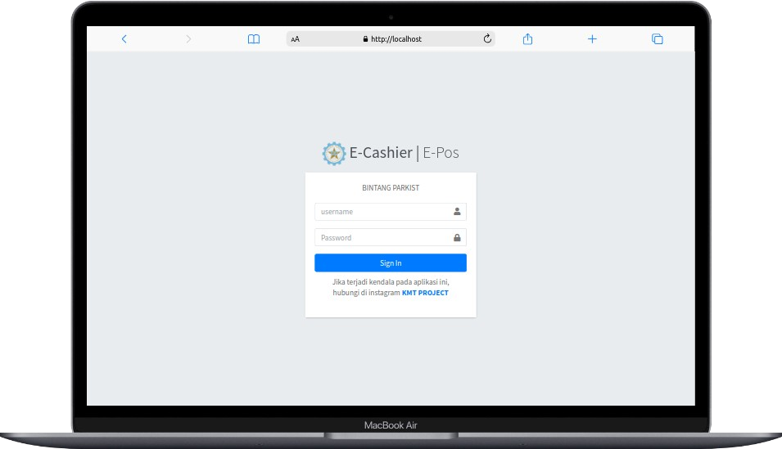
Figure 2. Login Page

- Dashboard Page
The Dashboard page is located on the main page of this system. Used to view information from the dashboard. This can be seen in Figure 3.
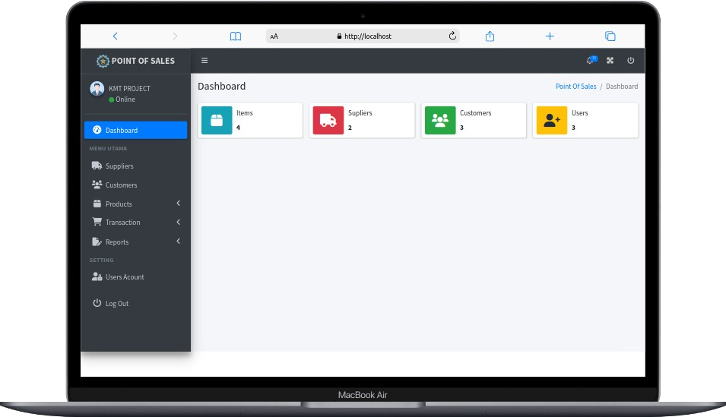

Figure 3. Dashboard Page

- Suppliers Data Page
On the shipping page, suppliers are used for data management. Administrators can manage data on this page. The supplier data menu display is in Figure 4.

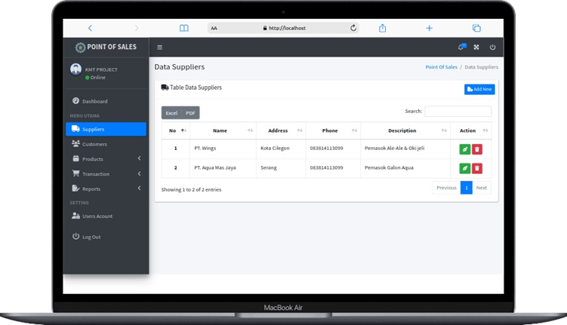

Figure 4. Suppliers Data Page

- Customer Data Page
On this page, the administrator manages customers (add and delete additional data, customer data. The customer data display is shown in Figure 5.

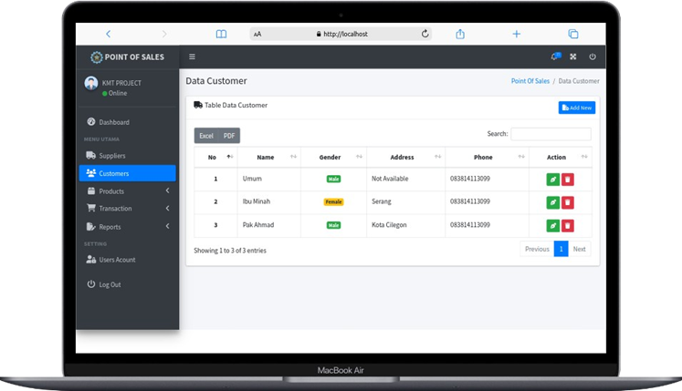

Figure 5. Customer Data Page

- Sales Page
This page will enter the sales transaction data for product selection. The administrator then enters the final edition of the financial and transactional data storage process. The sales page display is shown in Figure 6.

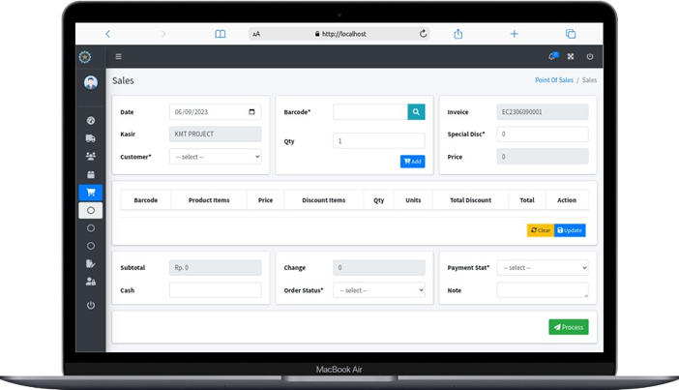
Figure 6. Sales Page

- Stock in and Out Page
The administrator can manage data on this page (delete changes and data). The display of the stock in and out page storage can be seen in Figure 7.

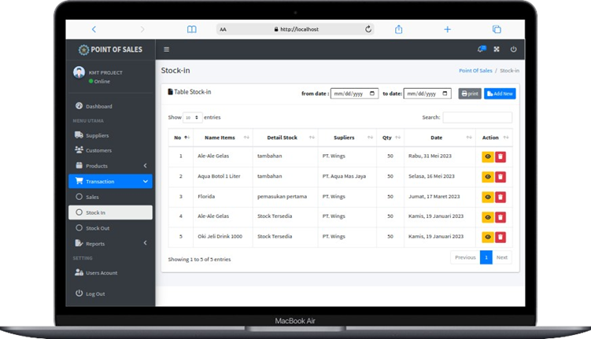

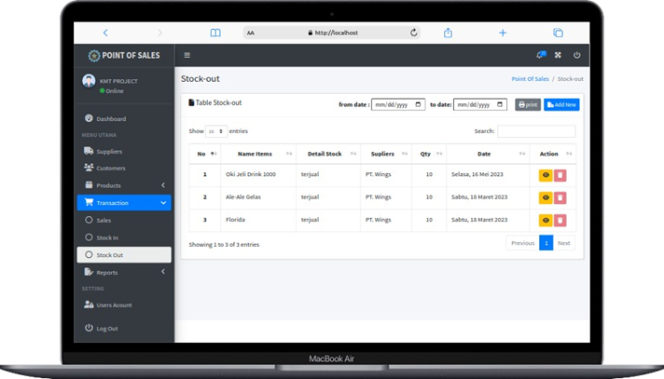

Figure 7. Stock In and Out Page

- Sales Report Page
Used to view sales reports based on day, month, and year. It is also used to see which transactions will be executed automatically when a sale is successful. The sales report page display can be seen in Figure 8.

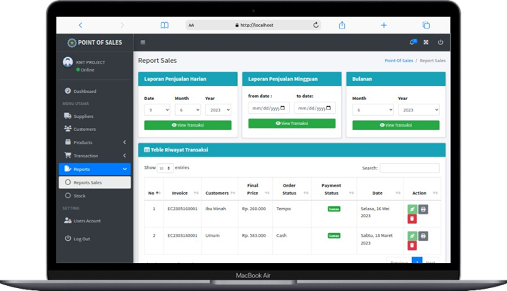

Figure 8. Sales Report Page

- User Data Page
The administrator uses this page to manage patches and deletion data. The user data page display can be seen in Figure 9.

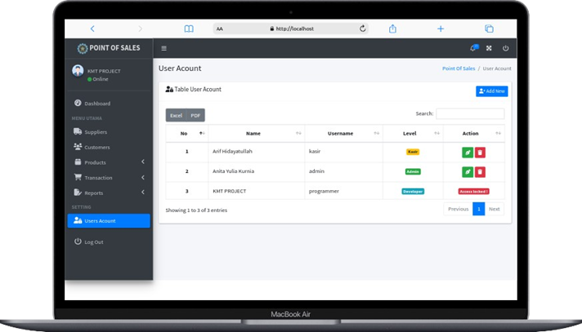

Figure 9. User Data Page

- Invoice Page
The invoice page is a page that can be accessed by the administrator and can help view, create, or manage billing data. The invoice page display is shown in Figure 10.

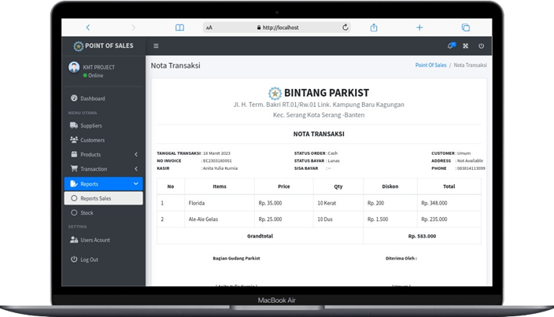
Figure 10. Invoice Page

CONCLUSION

A website-based Point of Sales (POS) application using the Laravel framework has been successfully developed to support a more efficient, accurate, and integrated sales transaction process. Using Laravel’s characteristics makes system development more structured, safer, and easier to wait for. The POS application created includes key features such as product management, categories, stock, sales transactions, reports, user management, and the provision of automatic invoice inquiries for each transaction. Web-based implementation requires access from various devices without special installation, providing greater flexibility in use. Overall, using Laravel has proven effective in demonstrating the application development process, maintaining system security, providing a removable user interface, and providing user-friendly acceleration. In addition, it is recommended that the cost of implementing and maintaining the system be analyzed to meet the company’s capabilities and needs. It is also important to include end users, such as owners and employees, in all post-development systems to ensure that the resulting system fully meets the needs and workflows of users.

BIBLIOGRAPHY
[1] M. Siddik and S. Samsir, “Rancang Bangun Sistem Informasi Pos (Point of Sale) Untuk Kasir Menggunakan Konsep Bahasa Pemrograman Orientasi Objek,” JOISIE (Journal Inf. Syst. Informatics Eng., vol. 4, no. 1, p. 43, 2020, doi: 10.35145/joisie.v4i1.607.
[2] R. Maulana, S. April, and J. Barat, “PERANCANGAN SISTEM INFORMASI POINT OF SALE BERBASIS WEBSITE PADA TOKO ABEL DENGAN METODE WATERFALL Design of Website-Based Point of Sale Information System at Abel Store with Waterfall Method,” 2023.
[3] P. U. Boba, “Perancangan Sistem Point Of Sales Multi Payment Berbasis Web Menggunakan Framework Laravel,” no. September, pp. 357–369, 2023.
[4] S. Suprianto, M. Fadlan, and D. Prayogi, “Perancangan Aplikasi Point of Sale Berbasis Web Pada Toko Project Salfa Tarakan,” Sebatik, vol. 25, no. 2, pp. 624–631, 2021, doi: 10.46984/sebatik.v25i2.1519.
[5] C. Yolanda, “Peran Usaha Mikro, Kecil Dan Menengah (UMKM) Dalam Pengembangan Ekonomi Indonesia,” J. Manaj. Dan Bisnis, vol. 2, no. 3, pp. 170–186, 2024, doi: 10.36490/jmdb.v2i3.1147.
[6] B. Wicaksono et al., “Rancang bangun aplikasi pengaduan sarana dan prasarana berbasis web pada smk idn jonggol,” vol. 9, no. 3, pp. 4361–4370, 2025.
[7] R. Y. Endra, Y. Aprilinda, Y. Y. Dharmawan, and W. Ramadhan, “Analisis Perbandingan Bahasa Pemrograman PHP Laravel dengan PHP Native pada Pengembangan Website,” Expert J. Manaj. Sist. Inf. dan Teknol., vol. 11, no. 1, p. 48, 2021, doi: 10.36448/expert.v11i1.2012.
[8] A. Septian Nugraha, ) ; Sapri, ) ; Arius, S. Kurniawansyah, A. S. J. Komitek, and ) Doi, “Building an Online-Based Point of Sale Application at the Anton Store Membangun Aplikasi Point of Sale Berbasis Online di Toko Anton,” J. Kom., vol. 1, no. 2, pp. 307–311, 2021, [Online]. Available: https://doi.org/10.53697/jkomitek.v1i2.287.
[9] R. Mulyadi, S. B. Rahardjo, and A. T. Sasongko, “Sistem Aplikasi Absensi Guru Menggunakan QrCode Berbasis Android Pada Smp Negeri 1 KarangBahagia Kabupaten Bekasi,” J. Ris. Sist. Inf. Dan Tek. Inform., vol. 8, no. 2, pp. 469–479, 2023.
[10] H. Alhakami, A. Baz, W. Alhakami, A. K. Pandey, A. Agrawal, and R. A. Khan, “A Usability Management Framework for Securing Healthcare Information System,” Comput. Syst. Sci. Eng., vol. 42, no. 3, pp. 1015–1030, 2022, doi: 10.32604/csse.2022.021564.
[11] J. Heimicke, K. Dühr, M. Krüger, G. L. Ng, and A. Albers, “A framework for generating agile methods for product development,” Procedia CIRP, vol. 100, no. March, pp. 786–791, 2021, doi: 10.1016/j.procir.2021.05.043.
[12] I. P. Sari, A. Azzahrah, I. F. Qathrunada, N. Lubis, and T. Anggraini, “Perancangan Sistem Absensi Pegawai Kantoran Secara Online pada Website Berbasis HTML dan CSS,” Blend Sains J. Tek., vol. 1, no. 1, pp. 8–15, 2022, doi: 10.56211/blendsains.v1i1.66.
[13] A. R. F. Najoan and N. Setiyawati, “Pembangunan Sistem Informasi Administrasi Desa Berbasis Web Dengan Menggunakan Framework Laravel,” J. Pendidik. Teknol. Inf., vol. 6, no. 2, pp. 212–221, 2023, doi: 10.37792/jukanti.v6i2.984.

