**OPTIMIZATION OF DECISION SUPPORT SYSTEM (DSS) CUSTOMER SERVICE OF TELECOMMUNICATION COMPANIES**

**WITH MOORA METHOD**

**Dely Indah Sari, I Made Sondra Wijaya, Mohd Rizki, Karlina**

Bisnis Digital, Manajemen Rekayasa Institut Teknologi Batam

*deli@iteba.ac.id,* *made@iteba.ac.id*

**Abstract:** Good service and customer service functions are needed by the Consumer Service Unit in handling various complaints from customers so that they are handled immediately to get satisfaction and maintain customer interest. To facilitate decision making on what form of action should be taken, the Decision Support System here plays a very important role. Decision Support System (DSS) is part of a knowledge management system that is used to assist or support decision making in an organization or company. DSS will process data into important information to assist in decision making on specific and semi-structured problems. The method used in this case is the MOORA method, because the MOORA method has a good level of selectivity in determining an alternative.

**Keywords:** customer service, decision support system, MOORA

**Abstrak:** Pelayanan yang baik dan fungsi customer servive diperlukan oleh Unit Consumer Service dalam menangani berbagai macam keluhan dari pelanggan agar segera ditangani untuk mendapatkan kepuasan serta mempertahankan minat pelanggan. Untuk mempermudah dalam pengambilan keputusan bentuk tindakan apa yang sebaiknya diambil maka Decision Support System disini sangat berperan penting. Decision Support System (DSS) merupakan bagian dari sistem manajemen pengetahuan yang digunakan untuk membantu atau mendukung pengambilan keputusan dalam suatu organisasi atau perusahaan. DSS akan mengolah data menjadi sebuah informasi penting untuk membantu dalam pengambilan keputusan pada masalah spesifik dan juga semi-terstruktur. Metode yang dipakai dalam kasus ini yaitu metode MOORA, karena metode MOORA memiliki tingkat selektifitas yang baik dalam menentukan suatu alternatif.

**Kata kunci:** customer service, decision support system, MOORA

**INTRODUCTION**

Maintaining customer loyalty in the telecommunications industry means handling customer complaints quickly and accurately. By providing customer data, complaint history, and recommendations for the best solution, decision support systems (DSS) improve process efficiency. With DSS, customer service can easily find patterns of problems that often occur and immediately provide the right solution without having to do a long manual search. In addition, DSS offers historical data-based solutions to help automate the complaint resolution process [1]. In telecommunications companies, DSS can directly suggest problem solutions to customers[2].

Not only will it speed up problem resolution, but it will also reduce the workload of customer service, allowing them to serve more customers in less time. In addition, an integrated system can integrate various communication methods, such as chatbots, email, social media, and telephone, to monitor and manage all complaints. With this method, communication companies can ensure that every customer complaint gets the right attention, reduce the possibility of complaints going unanswered, and monitor how customer service agents handle complaints so that companies can find areas where services need to be improved[3].

Telecommunication companies can increase customer satisfaction, reduce churn rates, and enhance their reputation as responsive and reliable service providers [4].

The purpose of this study is to improve the quality of customer service of telecommunications companies so that customers can receive accurate and precise information. With more responsive and efficient services, it is expected that the level of customer satisfaction will increase. Because customer satisfaction is one of the indicators of company performance, companies can evaluate aspects of service that need to be improved if customers feel dissatisfied or disadvantaged. If this happens, it can endanger the reputation and survival of the company. Therefore, this study concentrates on how companies can use DSS technology to identify problems faster, provide better solutions to complaints, and proactively take action to improve customer experience.

In this study, the following problems are formulated the first what is the role of DSS in improving the efficiency and effectiveness of customer service in telecommunications companies. Second how DSS can help in processing customer data to provide faster and more accurate solutions to customer complaints and third challenges faced when implementing DSS in telecommunications companies.

A decision support system (DSS) is a component of a knowledge management system that functions significantly to assist an organization or company in the decision-making process. DSS can be described as a computer system that can transform data into information needed for a relatively structured decision-making process [5]. DSS assists the decision-making process by helping solve problems and communicate about structured and unstructured problems[6].

Decision Systems have objectives related to basic principles that include the structure of problems that are difficult to distinguish between structured and unstructured problems, so that computer decision support is needed to be applied to the unstructured parts of the problem so that effective decisions can be made [7].

DSS explains the type that provides the least support is the manager taking the information element, where the manager in the implementation of the Decision Support System (DSS) in telecommunications companies, the information elements used are very diverse and have an important role in supporting more accurate and efficient decision making. One of the main elements is customer data, which includes customer profiles, service usage history, complaints that have been submitted, and satisfaction levels based on surveys and reviews. In addition, DSS also relies on network operational data[8] such as network status, service usage traffic, and network capacity monitoring, which helps companies optimize service performance and resolve disruptions more quickly [9].

In addition to technical aspects, customer financial data will be a crucial element in DSS including customer payment history, revenue analysis and customer churn prediction to identify potential customers who will stop using the service. Telecommunication companies need to consider competitor and market data such as competitor price and service analysis, communication market trends and marketing effectiveness to maintain competitiveness [10].

Moora is one of the methods in the Decision Support System or DSS which is used to solve multi-criteria problems in decision making[11]. This method has a good level of selectivity in determining an alternative. The approach taken by MOORA is defined as a simultaneous process to optimize two or more conflicting constraints on several constraints [12]. MOORA works by normalizing each criterion in a decision and then optimizing the values ​​obtained to obtain the best alternative [13].

identify attributes and evaluate them. All identified attributes are formed into a decision matrix. Then the ratio system is developed into a comparison alternative, where the attributes are compared as denominators. The attributes themselves are representatives for all these alternatives, Determine the value of the decision matrix

$$X_{ij} =\left[\begin{aligned}\begin{aligned}X_{11} X_{1i} X_{\begin{aligned}1n \\ \end{aligned}} \\ X_{j1} X_{ji} X_{\begin{aligned}jn \\ \end{aligned}}\end{aligned} \\ { X}_{m1} X_{m1} X_{mn}\end{aligned}\right]……….(1)$$

Determining the normalization of the matrix. Concluded by Breaures, for the denominator, the best choice is the square root of the sum of the squares and each alternative per attribute.

$$X_{ij}^{*}= \frac{x_{ij}}{\sqrt{\left[Σ_{j=1}^{m} x_{ij}^{2}\right]}}……….(2)$$

Determining the attribute optimization For Multi-Objective optimization, the normalized performance is added in the case of maximization (for profitable attributes) and subtracted in the case of minimization (for non-profitable attributes)

$$Y_{1}=\sum_{j-1}^{x}{W_{j} X_{ij}^{*}- \sum_{j=g+1}^{n}{W_{j}X_{ij}^{*}……(3)}}$$

The value of 𝑌𝑖 depends on the maximum and minimum totals in the decision matrix, positive or negative bias. The ranking of the 𝑌𝑖 values ​​can be used as the decision result.

**METODE**

Data collection was done using a questionnaire. In addition to interviews, data collection was also done using a questionnaire. A questionnaire is a series of formal questions used to obtain information from respondents. In this form of question, respondents are asked to answer questions in the form of a scale to measure the respondent's attitude towards the questions in the questionnaire. Likert Scale 1-5 is used in this study which is divided into: 1: Strongly Agree, 2: Agree, 3: Neutral, 4: Disagree, 5: Strongly Disagree

The questionnaire was filled out by respondents, this study used questionnaire distribution conducted on some telecommunication users with as many as 64 respondents so that it is easier for researchers to get appropriate respondents. In addition to primary data, this study also uses secondary data obtained from journals, books, articles from print media, and the internet.

**RESULT**

The objects in this research are: The criteria in this research are Product Quality, Cost, Service Quality, Majority of Users. The alternative in this study uses the user age range, namely:

**Tabel 1. Alternatif**

|  |  |  |
| --- | --- | --- |
| No | Alternatif | Kode |
| 1 | < 25 year | A01 |
| 2 | 25-35 year | A02 |
| 3 | 36-45 year | A03 |
| 4 | > 45 year | A04 |

**Table 2 Input criteria value**

|  |  |  |  |
| --- | --- | --- | --- |
| No | Criteria name | Weight Value | Criteria |
| 1 | Product quality | A01 | Benefit |
| 2 | Affordable prices | A02 | Cost |
| 3 | Majority of Users | A03 | Benefit |
| 4 | Service Quality | A04 | Benefit |

Information:

Cost = Min

Benefit = Max

**Table 3 Responden to criteria**

|  |  |  |  |  |
| --- | --- | --- | --- | --- |
| Alternatif | C1 | C2 | C3 | C4 |
| A01 | 2,7 | 2,86 | 2,5 | 2,89 |
| A02 | 1,95 | 2,33 | 1,86 | 2,3 |
| A03 | 1,92 | 2,56 | 1,93 | 2,31 |
| A04 | 2,075 | 1,96 | 2 | 2,29 |
| Optimum | Max | Min | Max | Max |

**Table 4** **Decision matrix**

|  |  |  |  |  |
| --- | --- | --- | --- | --- |
| Alternatif | C1 | C2 | C3 | C4 |
| A01 | 2,7 | 2,86 | 2,5 | 2,89 |
| A02 | 1,95 | 2,33 | 1,86 | 2,3 |
| A03 | 1,92 | 2,56 | 1,93 | 2,31 |
| A04 | 2,075 | 1,96 | 2 | 2,29 |

|  |  |  |  |  |
| --- | --- | --- | --- | --- |
|  | 2,7 | 2,86 | 2,5 | 2,89 |
|  | 1,95 | 2,33 | 1,86 | 2,3 |
| Xij = | 1,92 | 2,56 | 1,93 | 2,31 |
|  | 2,075 | 1,96 | 2 | 2,29 |

**Table 5 Normalisasi Matriks**

|  |  |  |  |
| --- | --- | --- | --- |
| Product Quality (C1) | | Affordable Price (C2) | |
| XA01 | 0,618049254 | XA01 | 0,58375006 |
| XA02 | 0,446368906 | XA02 | 0,475572601 |
| XA03 | 0,439501692 | XA03 | 0,522517536 |
| XA04 | 0,474982297 | XA04 | 0,400052488 |

**Table 6 Normalisasi Matriks**

|  |  |  |  |
| --- | --- | --- | --- |
| Majority User (C3) | | Service Quality (C4) | |
| XA01 | 0,598735846 | XA01 | 0,587205552 |
| XA02 | 0,44545947 | XA02 | 0,467326218 |
| XA03 | 0,462224073 | XA03 | 0,469358071 |
| XA04 | 0,478988677 | XA04 | 0,465294365 |

Product quality normalization 1:

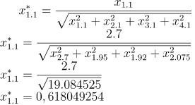

Product quality normalization 2:

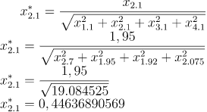

Product quality normalization 3:



Product quality normalization 4:

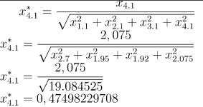

Price Normalization 1:

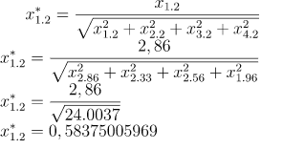

Price Normalization 2:

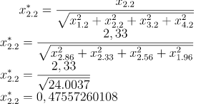

Price Normalization 3:

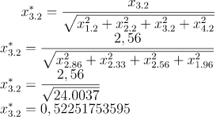

Price Normalization 4:

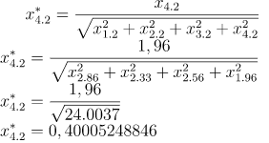

Use Normalization 1:

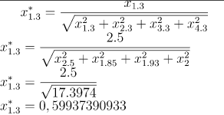

Use Normalization 2:

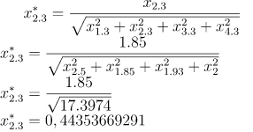

Use Normalization 3:

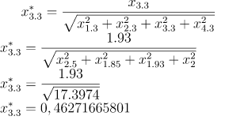

Use Normalization 4:

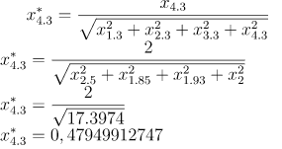

Service Normalization 1:

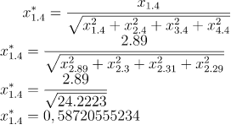

Service Normalization 2:

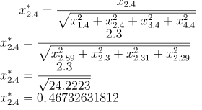

Service Normalization 3:

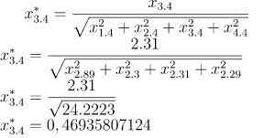

Service Normalization 4:

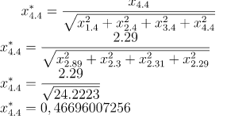

**Tabel 7 Matrix Ternomalisasi**

|  |  |  |  |
| --- | --- | --- | --- |
| Matrix Ternomalisasi | | | |
| 0,618049 | 0,58375 | 0,598736 | 0,587206 |
| 0,446369 | 0,475573 | 0,445459 | 0,467326 |
| 0,439502 | 0,522518 | 0,462224 | 0,469358 |
| 0,474982 | 0,400052 | 0,478989 | 0,465294 |
| C1 | C2 | C3 | C4 |

**Table 8 Result**

|  |  |  |  |  |
| --- | --- | --- | --- | --- |
| Hasil | | | | |
| A01 | 0,123609851 | 0,087562509 | 0,089810377 | 0,293602776 |
| A02 | 0,089273781 | 0,07133589 | 0,06681892 | 0,233663109 |
| A03 | 0,087900338 | 0,07837763 | 0,069333611 | 0,234679036 |
| A04 | 0,094996459 | 0,060007873 | 0,071848302 | 0,232647183 |
| Optimum | Max | Min | Max | Max |

**Table 9 Rank**

|  |  |  |  |  |
| --- | --- | --- | --- | --- |
| Alf | Max | Min | Yi | Ranking |
| A01 | 0,507023004 | 0,087562509 | 0,419460495 | 1 |
| A02 | 0,389755811 | 0,071335890 | 0,318419921 | 3 |
| A03 | 0,391912985 | 0,078377630 | 0,313535355 | 4 |
| A04 | 0,399491943 | 0,060007873 | 0,339484070 | 2 |

**CONCLUSION**

Based on the data processing and analysis that has been carried out, the following conclusions can be drawn from this research:

* The criteria used in this study are Product Quality, Price, Service Quality, and many users, as well as including alternative age ranges.
* This questionnaire was taken from 64 respondents, but the data was analyzed using 10 samples from each alternative age.
* From the calculation results, it was found that the age range <25 years was ranked first as users who felt satisfied with Product Quality, Price, Service Quality, and the most telecommunications users and the second rank was the age range 25-35 years, the third rank was the age range 36-45 years, the fourth rank was the age range >45 years.

**ACKNOWLEGMENTS**

Thank for LPPM ITEBA with a letter of assignment for funding research Optimization of Decision Support System (DSS) Customer Service of Telecommunication Companies with Moora Method.

**BIBLIOGRAPHY**

[1] E. Turban, R. Sharda, and D. Delen, ‘Decision support and business intelligence systems (required)’, *Google Scholar*. 2010.

[2] A. H. Azhar and R. A. Destari, ‘Optimasi Decision Support System (DSS) Pemilihan Paket Layanan Internet Prabayar Dengan Metode ANP’, *J-SAKTI (Jurnal Sains Komput. dan Inform.*, vol. 3, no. 2, 2019, doi: 10.30645/j-sakti.v3i2.139.

[3] D. J. Power, *Decision Support Systems: Concepts and Resources for Managers*, vol. 20, no. 4. 2002.

[4] N. H. Fitri and A. S. Purnomo, ‘Sistem Penunjang Keputusan Pemilihan Paket IndiHome Calon Pelanggan Menggunakan Metode Weighted Product’, *INFORMAL Informatics J.*, vol. 5, no. 3, 2020, doi: 10.19184/isj.v5i3.19463.

[5] M. Syafrizal, ‘Sistem Pendukung Keputusan (Decision Support System)’, *J. Dasi*, vol. 11, no. 3, 2010.

[6] S. Saliman, ‘Mengenal DEcision Support System (DSS)’, *EFISIENSI - Kaji. ILMU Adm.*, vol. 10, no. 1, 2015, doi: 10.21831/efisiensi.v10i1.3971.

[7] D. I. Sari, W. L. Harahap, and Y. T. Yoss, ‘TRANSFORMATION DIGITAL IN LOGISTIC COMPANY STRATEGY MANAGEMENT AFTER PANDEMIC COVID 19’, *JURTEKSI (Jurnal Teknol. dan Sist. Informasi)*, vol. 9, no. 3, 2023, doi: 10.33330/jurteksi.v9i3.2427.

[8] D. I. Sari, ‘Implementasi Manajemen Proyek CPM pada Pembangunan Infrastruktur IT Optical Distribution Point’, *JURTEKSI (Jurnal Teknol. dan Sist. Informasi)*, vol. 7, no. 3, pp. 267–276, 2021.

[9] D. Stodolsky, ‘Steven L. Alter: Decision support systems: Current practice and continuing challenges. Reading, Massachusetts: Addison-Wesley Publishing Co., 1980, 316 pp.’, *Behav. Sci.*, vol. 27, no. 1, 1982, doi: 10.1002/bs.3830270109.

[10] Muhammad Faizal, Mochammad Rizki Romdoni, and Gunawan Pratama, ‘Sistem Pendukung Keputusan Teknisi Terbaik PT.Telkom Indonesia Tanjungpinang Menggunakan Metode TOPSIS’, *J. Bangkit Indones.*, vol. 7, no. 2, 2018, doi: 10.52771/bangkitindonesia.v8i1.163.

[11] W. K. M. Brauers and E. K. Zavadskas, ‘The MOORA method and its application to privatization in a transition economy’, *Control Cybern.*, vol. 35, no. 2, 2006.

[12] Y. D. Lestari, M. Eka, and R. Saragih, ‘Sistem Pendukung Keputusan Penentuan IT Support Perusahan Telekomunikasi Terbaik Menggunakan Metode Moora’, *Algoritm. J. Ilmu Komput. dan Inform.*, 2021.

[13] R. Aulina, P. PujiSariRamadhan, and ..., ‘Sistem Pendukung Keputusan Dalam Menentukan Customer Loyal Pada PT. Telkom Tanjung Balai Menggunakan Metode MOORA (Multi Objective Optimazation On …’, *J. Cyber …*, 2022.