ANALYSIS OF LMS EFFECTIVENESS IN INDONESIAN HIGHER
EDUCATION USING THE DELONE AND MCLEAN APPROACH – PLS-SEM

Marvello Yang^{1*}, Melyanto², Fry Melda Saragih ³, Filbert Ivander ⁴
¹Kewirausahaan, Institut Teknologi dan Bisnis Sabda Setia
^{2,4}Sistem & Teknologi Informasi, Institut Teknologi dan Bisnis Sabda Setia
³Bisnis Digital. Institut Teknologi dan Bisnis Sabda Setia
email: melyanto@itbss.ac.id

Abstract: Information Technology has impacted various sectors, including education. Many universities in Indonesia have adopted Learning Management Systems (LMS) as a means for online learning or e-learning. LMS is designed to facilitate both lecturers and students in accessing academic activities online. This analysis is important to assess the extent of success in the use of LMS by universities in Indonesia, so that the investments allocated to LMS can provide optimal results. This study will apply the Delone & McLean IS Success Model (D&M IS Success Model) and Partial Least Square Structural Equation Modeling (PLS-SEM) by evaluating the relationships between various variables, such as system quality, information quality, service quality, user satisfaction, and benefits, using PLS-SEM as the data analysis technique. The D&M model is one of the models widely used by researchers to evaluate the success of information system implementation in various institutions. The results of this study indicate a positive relationship between system quality, information quality, and service quality with user satisfaction, as well as a positive relationship between user satisfaction and benefits. Furthermore, satisfaction plays a significant mediating role in this study. These findings can serve as a reference for universities to pay attention to aspects of system quality, information quality, and service quality in LMS to improve user satisfaction and create a positive perception of benefits. Therefore, this research has significant results for contributing to the academic world, particularly higher education in Indonesia, as well as the development of knowledge in management information systems.
Keywords: Delone and Mclean, Information System Success, LMS, SEM-PLS.

Abstrak: Abstrak— Teknologi Informasi telah menyentuh berbagai sektor, termasuk bidang pendidikan. Banyak perguruan tinggi di Indonesia telah mengadopsi sistem manajemen pembelajaran atau Learning Management System (LMS) sebagai sarana pembelajaran online atau e-learning. LMS dirancang untuk mempermudah dosen dan mahasiswa dalam mengakses kegiatan perkuliahan secara daring. Analisis ini penting untuk menilai sejauh mana keberhasilan penggunaan LMS oleh perguruan tinggi di Indonesia, sehingga investasi yang dialokasikan untuk LMS dapat memberikan hasil yang optimal.
Penelitian ini akan menerapkan metode Delone & McLean IS Success Model (D&M IS Success Model) dan Partial Least Square Structural Equation Modeling (PLS-SEM) dengan mengevaluasi hubungan antara berbagai variabel, seperti kualitas sistem, informasi, layanan, kepuasan pengguna, dan net benefit, menggunakan PLS-SEM sebagai teknik analisis data. Model D&M merupakan salah satu model yang telah banyak digunakan oleh para peneliti untuk mengevaluasi keberhasilan implementasi sistem informasi di berbagai institusi. Hasil penelitian ini menunjukkan adanya hubungan positif antara kualitas sistem, informasi, dan layanan dengan kepuasan pengguna, serta hubungan positif antara kepuasan pengguna dan net benefit atau manfaat bersih. Selain itu, kepuasan memiliki peran mediasi yang signifikan dalam penelitian ini. Temuan ini dapat menjadi acuan bagi perguruan tinggi untuk memperhatikan aspek-aspek kualitas sistem, informasi, dan layanan pada LMS guna meningkatkan kepuasan pengguna dan menciptakan persepsi manfaat yang positif. Oleh karena itu, peneliti ini memiliki hasil yang penting bagi kontribusi dunia akademis khususnya Perguruan Tinggi di Indonesia dan juga perkembangan ilmu pengetahuan pada system informasi menejemen.

Kata kunci: Delone and Mclean, Kesuksesan Sistem Informasi, LMS, SEM-PLS

INTRODUCTION

The utilization of technology, particularly information technology, has been rapidly advancing in the modern era. Various sectors, including business, government, healthcare, and education, have adopted information systems. This development is expected to continue in the future. Information systems can assist individuals or organizations in decision-making . One of the applications of information technology in the education sector is the implementation of Learning Management Systems (LMS) in higher education. LMS is expected to facilitate lecturers and students in conducting academic activities more efficiently, whether in online or offline learning environments.
Academic activities supported by information systems are generally more efficient compared to conventional methods that still rely on paper-based processes. Information systems offer advantages in data integration, from data input to processing. Data recording becomes easier to manage and more secure as it is stored on servers, unlike manual methods or non-integrated applications, which often result in unsystematic data management. This research goal is to analyze the success of LMS by utilizing the Delone & McLean IS Success Model (D&M IS Success Model) and Partial Least Squares Structural Equation Modeling (PLS-SEM).

Learning Management System (LMS)
LMS (Learning Management System) is a learning system developed to create, distribute, and manage the delivery of learning materials in education [2]. LMS provides several features that can be utilized, such as planning and creating syllabi, managing learning materials, organizing lecture activities, handling grading, recording attendance, displaying transcripts, facilitating discussions, and creating quizzes or exams. All these features can be accessed online anytime and anywhere.

Information System Analysis
A comprehensive analysis is necessary to assess the measurable benefits of LMS utilization in academic activities within higher education, ensuring that technology implementation is well-targeted. The ineffective implementation of information systems can lead to suboptimal investments. Therefore, evaluating information systems is crucial to ensuring their success. Evaluation can involve continuous feedback, allowing information systems to be continuously improved and developed sustainably [3].

Delone and Mclean IS Success Model
The D&M IS Success Model utilizes several variables, such as information quality, system quality, service quality, and user satisfaction, as indicators for assessing the benefits of an information system [4], [5]. The Delone & McLean method comprises several key variables:
System Quality refers to the characteristics that determine how effectively an information system functions, including ease of use, flexibility, reliability, and speed. System quality is highly dependent on the software and hardware used. The better the quality of these components, the more optimal the application's or website's performance will be for users.
Information Quality pertains to the characteristics of the system's output, such as managerial reports or interface displays on applications and websites. Key aspects of information quality include relevance, ease of understanding, data accuracy, clear summarization, completeness, timeliness, and usability. Users expect information that is easy to read and comprehend, whether in text, image, audio, or video format. Moreover, the accuracy of information significantly influences user experience, as outdated information can lead to serious communication errors. Therefore, high-quality information contributes to user satisfaction [6].
Service Quality represents the level of support provided to ensure the effective use of the information system. This service can be offered by the information systems department responsible for system operations and maintenance.
System Use assesses how frequently and extensively users utilize the information system, including usage intensity, purpose, and habits.
User Satisfaction measures the degree of satisfaction users experience while using the information system.
Net Benefits describe the overall contribution of the information system to individuals, organizations, businesses, industries, and the economy of a country. These benefits include improvements in decision-making processes, productivity, sales growth, cost efficiency, profitability, and positive impacts on economic growth.

Partial Least Square Structural Equation Modeling (SEM PLS)
The PLS-SEM method consists of two stages: evaluating the relationship between indicators and latent constructs through validity and reliability testing and examining the relationships between constructs using hypothesis testing. Validity and reliability tests aim to assess the extent to which measurement instruments—specifically indicators and variables—accurately represent the constructs being measured.
The measurement model assesses validity by evaluating the indicators used as instruments. An indicator is considered valid if it has a loading factor greater than 0.7 and an Average Variance Extracted (AVE) value above 0.5 [7]. A loading factor exceeding 0.7 indicates a strong relationship between an indicator and its latent variable, while AVE score greater than 0.5 suggests that the data collection instrument possesses good discriminant validity [8].
Reliability refers to the consistency of a condition, method, and research results. Reliability testing is necessary to assess the extent to which each variable remains consistent, both in the current study and in future research [9]. The purpose of reliability testing is to ensure the stability and consistency of indicators within the measurement tool used. A variable's reliability can be determined by its Cronbach’s alpha and composite reliability values, both of which must exceed 0.7 to be considered reliable [10]. The PLS-SEM method is used to evaluate model feasibility, ensuring that it can be classified as a good-fit model [11].

Prior Research
Previous studies have shown that information system implementations often encounter failures. Only about 32% of implementations are successful, while the highest failure rate occurs in the public sector, reaching 84% ([12]. Ineffective implementation of information systems can lead to unprofitable IT investments. Therefore, analyzing information systems is crucial to ensuring their success. Understanding the factors that determine the success of an information system within an organization can help mitigate potential failures.
Various methods have been used to evaluate the success of information systems, such as the Delone and McLean IS Success Model, Technology Acceptance Model (TAM), Unified Theory of Acceptance and Use of Technology (UTAUT), and other approaches. The D&M IS Success Model is considered a systematic and comprehensive approach for analyzing information system success [13]. Several studies have demonstrated a positive relationship between user satisfaction and net benefits in various information systems. System quality, information quality, and service quality have also been found to influence user satisfaction by up to 91% [14].
Research on another information systems has justified that system quality, information quality, and service quality positively impact user satisfaction [15]. A study on the SAMSAT website found that user satisfaction affects net benefits [16]. Research on the Nampah application confirmed the relationship between system and information quality with user satisfaction, as well as its impact on net benefits ([17]. Factors such as system quality, information quality, and service quality were also found to influence user satisfaction in the information system at IAIN Batanghari [18]. A study on the Integrated Management Information System (SIMPADU) at IAIN Madura also found a positive relationship between system quality, information quality, and service quality with net benefits [19].
A study utilizing the PLS-SEM method on the LMS at Hasanuddin University revealed that good system and information quality play a crucial role in enhancing user satisfaction and the individual impact of the system [20]. This study complements previous research by validating the variables in the Delone & McLean model related to information system success, particularly in educational institutions that have recently implemented an LMS. Additionally, this study provides a new perspective on selecting appropriate indicators to measure variables in assessing information system success, based on findings from previous research

METHOD
The study on analyzing the success of LMS implementation in Indonesian higher education institutions using the D&M IS Success Model will be conducted through several stages, as illustrated in the following steps:
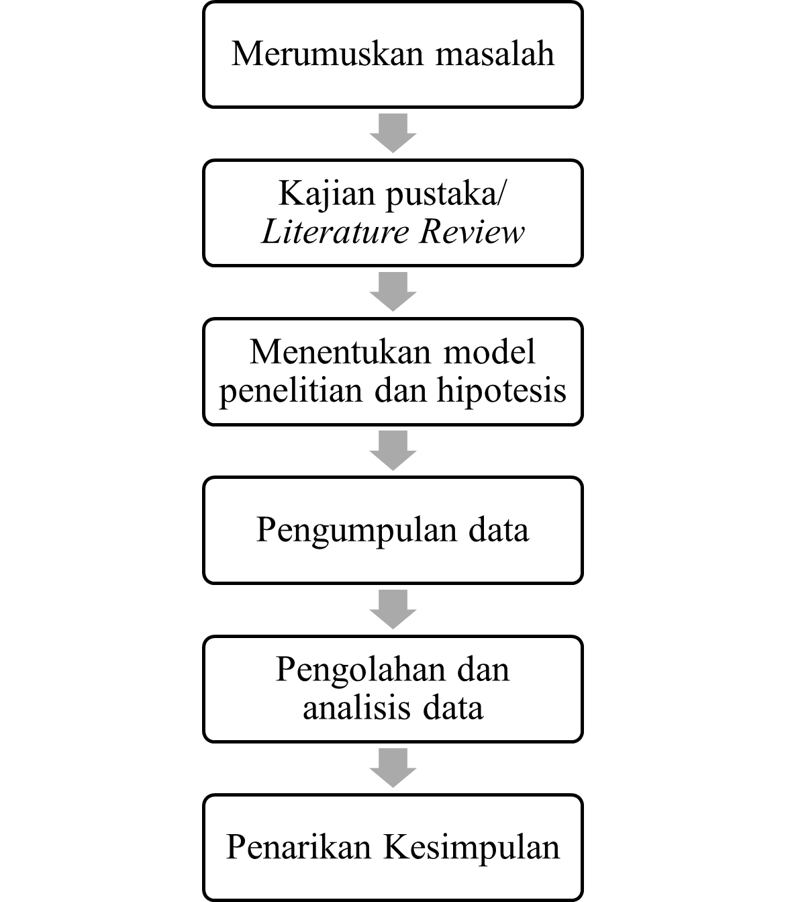
Image 1. Research Flow
First step is, Formulating the main research problem, which involves identifying the factors influencing LMS success in Indonesian higher education institutions using the Delone & McLean IS Success Model and PLS-SEM. Then conduct a literature review, referring to books and previous relevant research studies.
Third one is, establishing hypotheses and designing a research model to determine the key success factors based on the D&M IS Success Model. Collecting data by distributing online questionnaires to respondents, specifically university rectors or vice-rectors. Analyzing the data using the PLS-SEM method with the SmartPLS 4 application. This process consists of two stages: validity and reliability testing, followed by structural model analysis to test the hypotheses. Drawing conclusions from the data analysis results to address the formulated research problem.

Research Model
This research model has been modified by removing the intention to use/use variable since LMS is a mandatory system for lecturers and students. This modification aligns with the study by Kristy M [21], which stated that the use/intention to use variable is not relevant for systems that are compulsory. The following picture below is the proposed research model and hypotheses based on the D&M IS Success Model:
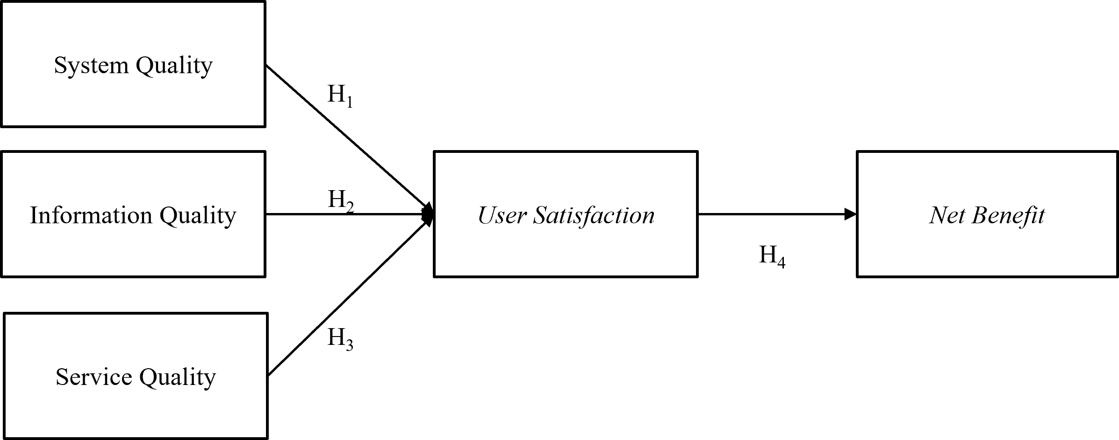
Image 2. Proposed Model
Proposed model could be elaborate as H1: Information Quality (IQ) positively affects User Satisfaction (US), H2: System Quality (SQ) positively affects User Satisfaction (US), H3: Service Quality (SQ) positively affects User Satisfaction (US), H4 User Satisfaction (US) positively affects Net Benefit (NB).
Data Collection
The respondents in this study are representatives from higher education institutions in Indonesia, represented by the rector or vice rector. The respondents were asked to complete a questionnaire, which served as the instrument for data collection. The questionnaire was administered online using Google Forms. It consists of 19 indicators, divided into several questions as follows:

Table 1. Quesstioniare Items
Variable | Number of items
System quality | 4 items
Information quality | 4 items
Service quality | 5 items
User satisfaction | 3 items
Net Benefit | 3 items
TOTAL | 19 items
The measurement scale for variables in this study utilizes a Likert scale. The Likert scale was chosen to measure individual or group attitudes, opinions, and perceptions toward a phenomenon [22]. Each question is rated on a scale from one to five, with the following explanations:
Table 2. Likert Scale
Response categories | Value
Strongly agree | 5
Agree | 4
Undecided | 3
Disagree | 2
Strongly disagree | 1
Each variable has several indicators that serve as measurement tools for the variable. The indicators for each variable are presented on the table below:
Table 3. Variable Indicators
Variable | Indicators | Item Code
System quality  (SQ) | The LMS is easily accessible to lecturers and students. | SQ1
System quality  (SQ) | The LMS interface is easy to understand for lecturers and students when accessed via PC or smartphone. | SQ2
System quality  (SQ) | The LMS has user-friendly menu navigation for lecturers and students. | SQ3
System quality  (SQ) | The LMS responds quickly when accessed by lecturers and students. | SQ4
Information quality  (IQ) | The LMS provides comprehensive information. | IQ1
Information quality  (IQ) | The LMS provides accurate information. | IQ2
Information quality  (IQ) | The information presented in the LMS is easy to read and understand. | IQ3
Information quality  (IQ) | The LMS provides the latest/up-to-date information. | IQ4
Service quality  (SERVQ) | The IT officer responds promptly to LMS errors. | SERVQ1
Service quality  (SERVQ) | The IT officer can resolve LMS issues quickly. | SERVQ 2
Service quality  (SERVQ) | The IT officer can provide appropriate solutions for users. | SERVQ 3
Service quality  (SERVQ) | Clear LMS usage guidance is provided by the IT officer. | SERVQ 4
Service quality  (SERVQ) | The IT officer provides written documentation on LMS usage. | SERVQ 5
User satisfaction  (US) | The university is satisfied with the LMS technology that supports the learning process. | US1
User satisfaction  (US) | The university is satisfied with the course-related information provided by the LMS. | US2
User satisfaction  (US) | The university is satisfied with the services provided by the IT officer regarding the LMS. | US3
Net Benefit  (NB) | The LMS helps save time and costs for accessing academic information. | NB1
Net Benefit  (NB) | The university obtains transparent information from the LMS. | NB2
Net Benefit  (NB) | The university finds the LMS highly beneficial. | NB3
The collected data was then analyzed using the PLS-SEM method. PLS-SEM was chosen for this study based on several considerations which are PLS-SEM can explain relationships between variables, making it suitable for the D&M IS Success Model, which involves multiple variables to assess information system success. PLS-SEM is well-suited for the D&M IS Success Model, which consists of five latent variables with a high level of indicator complexity. The data obtained may not follow a normal distribution, which is common for Likert scale-based data. PLS-SEM is an appropriate choice because it does not require the assumption of multivariate normality. PLS-SEM can be applied to small sample sizes while still providing stable results as long as the required criteria are met. PLS-SEM can analyze data with both formative and reflective constructs.
Validity and Reliability
SEM is a method to assess the measurement model, which includes evaluating construct reliability, indicator reliability, convergent validity, and discriminant validity of the defined constructs. Construct reliability is determined by using composite reliability (CR) and Cronbach’s alpha (CA). The criterion is that the CR value must above 0.7 to indicate adequate construct reliability [23]. The result of measurement model results shown in the following Table 4. In table 4, it’s shown that that the CR values obtained in this study are greater than 0.70, confirming sufficient construct reliability.
Next, indicator reliability is assessed through CA, where the CA value must be higher than 0.60. As a result, the CA values for all factors in this study are acceptable. Convergent validity of the constructs is determined using the average variance extracted (AVE), which must exceed 0.50 [24]. Since the results indicate that all constructs have substantial AVE values, the convergent validity of the constructs in this study has been verified. The CA, CR, and AVE values are presented in Table 4.

Table 4. Validity and Reliability Test
Variables | Mean | SD | CA | Dgrho | CR | AVE | VIF
SQ | 3,32 | 0,82 | 0,932 | 0,881 | 0,870 | 0,504 | 3,730
IQ | 3,55 | 1,200 | 0,915 | 0,933 | 0,977 | 0,827 | 3,362
SERVQ | 3,53 | 1,020 | 0,765 | 0,774 | 0,902 | 0,770 | 4.21`
US | 3,46 | 0,170 | 0,770 | 0,833 | 0,901 | 0,755 | 4.55`
NB | 3,57 | 0,977 | 0,822 | 0,892 | 0,920 | 0,771 | -
Note: SD: Standar Deviation; CA: Cronbach’s Alpha; CR: Composite Reliability; AVE: Average Variance Extracted; VIF: Variance Inflation Factor

The assessment of the measurement model includes evaluating the discriminant validity of the constructs based on three methods: the Fornell-Larcker criterion and the Heterotrait-Monotrait (HTMT) ratio [9]. The Fornell-Larcker criterion is used to assess discriminant validity by comparing the square root of the AVE extracted from each construct with the correlations between constructs.
Discriminant validity of the constructs was further assessed using the HTMT approach, which relies on a multitrait-multimethod matrix. Table V displays the outcomes of both the Fornell-Larcker criterion and HTMT analysis, while the cross-loading values are reported separately. As a report by Kline [25], discriminant validity is considered sufficient when values exceed 0.85. In this study, the findings support the presence of discriminant validity, as each construct shows higher loading values compared to other constructs. Additionally, the Fornell-Larcker criterion analysis demonstrated strong inter-construct relationships, reinforcing the robustness of the measurement model.

Table 5. Measurement Model Assessment
 | SQ | IQ | SERVQ | US | NB
Fornell-Larcker Criterion
SQ | 0,900
IQ | 0,455 | 0,887
SERVQ | 0,592 | 0,732 | 0,922
US | 0,524 | 0,802 | 0,876 | 0,954
NB | 0,543 | 0,663 | 0,779 | 0,745 | 0,945
Heterotrait-Monotrait Ratio (HTMT)
SQ | -
IQ | 0,563 | -
SERVQ | 0,780 | 0,881 | -
US | 0,511 | 0,867 | 0,843 | -
NB | 0,626 | 0,832 | 0,871 | 0,77 | -
Note: SQ: System Quality; IQ; Information Quality; SERVQ: Service quality; US: User satisfaction; NB: Net Benefit

RESULT AND DISCUSSION

Based on Table 6, the study respondents indicate that 77.1% of higher education institutions (HEIs) have implemented LMS to enhance institutional effectiveness. Additionally, 14.1% of HEIs in residences and rural areas have adopted LMS, while 8.8% of HEIs in coastal regions have also implemented it. Furthermore, 40.6% of HEIs have been using LMS for a duration of 1–5 years, 35.3% for less than one year, and 24.1% for more than five years. In terms of institutional type, 55.9% of LMS users are private HEIs, while 44.1% are public HEIs. The highest concentration of LMS users is in Java (32.3%), followed by Kalimantan (24.7%), Sumatra (15.9%), Bali (11.8%), Sulawesi (8.2%), and Papua (7.1%).

Table 6. Respondent Profile
 | N | % |  | N | %
Operating area |  |  | The Period of Employment of LMS
Rural | 24 | 14,1 | <1 Year | 60 | 35,3
Urban | 131 | 77,1 | 1-5 Years | 69 | 40,6
Coast | 15 | 8,8 | > 5Years | 41 | 24,1
Total | 170 | 100 | Total | 170 | 100
Provinces |  |  | Institution/Uni/Higher Edu
Sumatera | 27 | 15,9 | Private | 95 | 55,9
Kalimantan | 42 | 24,7 | Public | 75 | 44,1
Java | 55 | 32,3
Sulawesi | 14 | 8,2
Papua | 12 | 7,1
Bali | 20 | 11,8
Total | 170 | 100 | Total | 170 | 100

The hypothesis testing results in Table 7 also indicate significant relationships between the examined variables. Hypothesis 1 shows a relationship between KS → KP with a significant value of α = 0.000, confirming that Hypothesis 1 is accepted. Hypothesis 2 shows a relationship between KI → KP with a significant value of α = 0.012, confirming that Hypothesis 2 is accepted. Hypothesis 3 shows a relationship between KL → KP with a significance value of α = 0.000, confirming that Hypothesis 3 is accepted. Hypothesis 4 shows a relationship between KP → NB with a significant value of α = 0.000, confirming that Hypothesis 4 is accepted.

Table 7. Hypothesis Result
Hypothesis |  | Beta | t | p | Decision
Factors users' satisfaction
H1 | SQ->US | 0,250 | 5,078 | 0,000 | Accepted
H2 | IQ -> US | 0,084 | 1,552 | 0,012 | Accepted
H3 | SERVQ -> US | 0,251 | 4,068 | 0,000 | Accepted
Factor affecting Benefit
H4 | US -> NB | 0,842 | 13,035 | 0,000 | Accepted
Mediating effect
H5a | SQ -> US -> NB | 0,4 | 2,645 | 0,024 | Accepted
H5b | IQ-> US-> NB | 0,264 | 4, 720 | 0,001 | Accepted
H5c | SERVQ -> US -> NB | 0,285 | 5,671 | 0,000 | Accepted

This study aims to test causal relationships through mediation analysis using SEM-PLS, examining the relationships between System Quality, Information Quality, Service Quality, User Satisfaction, and the Net Benefit of LMS for users in higher education institutions in Indonesia. The findings indicate that System Quality significantly influences User Satisfaction (H₁ accepted). This aligns with the study by Sumarningsih [14], which states that System Quality, Information Quality, and Service Quality impact User Satisfaction because they facilitate users' tasks. The results also show that Information Quality significantly influences User Satisfaction (H₂ accepted). This finding supports the study by Melgis [18], which suggests that users gain knowledge and ease in utilizing the system effectively.
Additionally, Service Quality significantly influences User Satisfaction (H₃ accepted). This outcome aligns with the conclusions drawn in Pereira's study [26], which highlights that high-quality service within a system contributes to sustained user satisfaction. Moreover, User Satisfaction has a significant impact on Net Benefit for users (H₄ accepted). This aligns with the research by Sumarningsih [14], which emphasizes the critical role of satisfaction in determining the benefits an institution gains from the system. Furthermore, this study confirms that User Satisfaction mediates the relationship between System Quality, Information Quality, and Service Quality on the Net Benefit received by HEIs through the LMS (H₅ accepted), with significant results. This finding supports the study by Diana [17], which asserts that when users experience satisfaction with a well-designed and informative system, they can derive substantial benefits in terms of financial savings, time efficiency, and work effectiveness.
CONCLUSION
This study analyze the effectiveness of LMS with variable of: information quality, system quality, and service quality on the satisfaction and net benefits of higher education institutions in Indonesia by using PLS-SEM as data analytic technique. The findings conclude that system quality, information quality, and service quality, have a significant influence on user satisfaction. Furthermore, user satisfaction has a positive and significant impact on the benefits experienced by higher education institutions in Indonesia. In other words, satisfaction plays a mediating role in this study. This research provides valuable insights for higher education institutions to keep maintaining the quality of systems, information, and services of LMS to ensure the best academic services. Higher education institutions should pay attention to enhance their LMS to support teaching and learning process. With this digital transformation, academic activities are expected to run more efficiently and improve users’ productivity.
However, this study has limitations in terms of the sample size and the scope of respondents. Therefore, including respondents from other sectors could provide broader insights into future research. Additionally, this study suggests incorporating theoretical approaches such as UTAUT and the Diffusion of Innovation theory to better explain LMS adoption and related phenomena. Longitudinal data analysis is also recommended to obtain more comprehensive and robust results.
ACKNOWLEDGEMENT
We sincerely thank all individuals who have contributed to the success of this research. Our sincere appreciation goes to the higher education institutions in Indonesia that participated in this study by providing valuable insights and responses. We are also grateful to our colleagues and academic advisors for their constructive feedback and support throughout the research process until completion.
BIBLIOGRAPHY
[1] J. Pereira, J. Varajão, and N. Takagi, “Evaluation of Information Systems Project Success–Insights from Practitioners,” Information Systems Management, vol. 39, no. 2, pp. 138–155, 2022, doi: 10.1080/10580530.2021.1887982.
[2] N. K. J. Marhum, Pengembangan Learning Management System (LMS) SiCeria (Siswa Cerdas Indonesia). Penerbit NEM, 2022. [Online]. Available: https://books.google.co.id/books?id=rXCAEAAAQBAJ
[3] J. Sligo, R. Gauld, V. Roberts, and L. Villa, “A literature review for large-scale health information system project planning, implementation and evaluation,” Int J Med Inform, vol. 97, pp. 86–97, 2017, doi: https://doi.org/10.1016/j.ijmedinf.2016.09.007.
[4] K. Çelik and A. Ayaz, “Validation of the Delone and McLean information systems success model: a study on student information system,” Educ Inf Technol (Dordr), vol. 27, no. 4, pp. 4709–4727, May 2022, doi: 10.1007/s10639-021-10798-4.
[5] W. H. Delone and E. R. McLean, “The DeLone and McLean Model of Information Systems Success: A Ten-Year Update,” Journal of Management Information Systems, vol. 19, no. 4, pp. 9–30, Apr. 2003, doi: 10.1080/07421222.2003.11045748.
[6] N. P. D. Pratiwi, D. Ariyanto, I. N. W. A. Putra, and N. P. S. H. Mimba, “Penilaian Kesuksesan Penerapan Xero Accounting Software Dengan Model UTAUT dan Delone & McLean,” E-Jurnal Akuntansi, vol. 32, no. 2, p. 3764, Feb. 2022, doi: 10.24843/eja.2022.v32.i02.p13.
[7] A. M. Musyaffi, H. Khairunnisa, and D. K. Respati, KONSEP DASAR STRUCTURAL EQUATION MODEL- PARTIAL LEAST SQUARE (SEM-PLS) MENGGUNAKAN SMARTPLS. Pascal Books, 2022. [Online]. Available: https://books.google.co.id/books?id=KXpjEAAAQBAJ
[8] P. U. Gio, PARTIAL LEAST SQUARES STRUCTURAL EQUATION MODELING (PLS-SEM) DENGAN SOFTWARE SMARTPLS. Uwais Inspirasi Indonesia, 2022. [Online]. Available: https://books.google.co.id/books?id=TPGiEAAAQBAJ
[9] J. F. Hair, M. C. Howard, and C. Nitzl, “Assessing measurement model quality in PLS-SEM using confirmatory composite analysis,” J Bus Res, vol. 109, pp. 101–110, Mar. 2020, doi: 10.1016/j.jbusres.2019.11.069.
[10] A. Sulistyawati, A. Santoso, Rosyati, Indarto, and A. Nugroho, “Determinants Of Accounting Fraud Trends With Un Ethical Behavior As Mediation,” Jurnal Akuntansi, vol. 27, pp. 99–117, Jan. 2023, doi: 10.24912/ja.v27i1.1234.
[11] S. Sukri and W. Rahmalina, “FAKTOR YANG MEMPENGARUHI PROMOSI DAN INFORMASI WISATA PULAU CINTA,” Rabit : Jurnal Teknologi dan Sistem Informasi Univrab, vol. 4, no. 1, pp. 40–48, Jan. 2019, doi: 10.36341/rabit.v4i1.557.
[12] M. M. Altuwaijri and M. S. Khorsheed, “InnoDiff: A project-based model for successful IT innovation diffusion,” International Journal of Project Management, vol. 30, no. 1, pp. 37–47, 2012, doi: https://doi.org/10.1016/j.ijproman.2011.04.007.
[13] H. Sabeh, H. Husin, D. Kee, A. Baharudin, and R. Abdullah, “A Systematic Review of the DeLone and McLean Model of Information Systems Success in an E-Learning Context (2010–2020),” IEEE Access, vol. PP, p. 1, May 2021, doi: 10.1109/ACCESS.2021.3084815.
[14] E. Y. Sumarningsih, C. Hudaya, and K. Hermanto, “Mengukur Kesuksesan Penggunaan SIAKAD Menggunakan Model DeLone & McLean di Universitas Teknologi Sumbawa,” Jurnal Ilmu Sosial dan Pendidikan (JISIP), vol. 6, no. 4, pp. 2598–9944, 2022, doi: 10.36312/jisip.v6i4.3661/http.
[15] F. S. Rahayu, R. Apriliyanto, P. W. Putro, A. J. Yogyakarta, J. Babarsari, and J. 55281, “Analisis Kesuksesan Sistem Informasi Kemahasiswaan (SIKMA) dengan Pendekatan Model DeLone dan McLean,” 2018.
[16] M. Rosario B, M. Istoningtyas, and F. Febrianti, “ANALISIS KUALITAS WEBSITE SAMSAT JAMBI MENGGUNAKAN METODE DELONE AND MCLEAN,” Rabit : Jurnal Teknologi dan Sistem Informasi Univrab, vol. 6, no. 2, pp. 138–144, Jul. 2021, doi: 10.36341/rabit.v6i2.1743.
[17] R. Diana, I. V. Paputungan, and A. Luthfi, “Integration of TAM and DeLone and McLean Models to Evaluate the Quality of NAMPAH Applications,” Jurnal Teknologi Dan Sistem Informasi Bisnis, vol. 6, no. 4, pp. 723–731, Oct. 2024, doi: 10.47233/jteksis.v6i4.1583.
[18] S. A. Melgis, R. Aryani, D. Lestari, and M. N. A. Abdulnazar, “Analyzing the Quality of Academic Information Systems on System Success,” INTENSIF: Jurnal Ilmiah Penelitian dan Penerapan Teknologi Sistem Informasi, vol. 8, no. 1, pp. 140–161, Feb. 2024, doi: 10.29407/intensif.v8i1.21512.
[19] C. A. Permatasari, T. L. M. Suryanto, and A. Wulansari, “Analisis Kesuksesan Sistem Informasi Manajemen Terpadu Perguruan Tinggi Menggunakan Model DeLone and McLean,” Jurnal Ilmiah Teknik Informatika dan Sistem Informasi , vol. 11, no. 2, 2022.
[20] A. Rachmat, B. Hamzah, and M. Niswar, “Evaluation of Academic Information System Using Delone and Mclean Success Model: A Case Study of Academic Information System Hasanuddin University,” 2022.
[21] M. A. Kristy, P. I. Santosa, and R. Ferdiana, “A Model for Understanding Mandatory System Implementation: A Literature Review,” JATISI (Jurnal Teknik Informatika dan Sistem Informasi), 2022.
[22] P. D. Sugiyono, “Metode Penelitian Pendidikan (Kuantitatif, Kualitatif, Kombinasi, R&d dan Penelitian Pendidikan),” Metode Penelitian Pendidikan, vol. 67, 2019.
[23] L. Fong and R. Law, “Hair, J. F. Jr., Hult, G. T. M., Ringle, C. M., Sarstedt, M. (2014). A Primer on Partial Least Squares Structural Equation Modeling (PLS-SEM). Sage Publications. ISBN: 978-1-4522-1744-4. 307 pp.,” European Journal of Tourism Research, vol. 6, pp. 211–213, Oct. 2013, doi: 10.54055/ejtr.v6i2.134.
[24] J. F. Hair, G. T. M. Hult, C. M. Ringle, M. Sarstedt, N. P. Danks, and S. Ray, Partial Least Squares Structural Equation Modeling (PLS-SEM) Using R. in Classroom Companion: Business. Cham: Springer International Publishing, 2021. doi: 10.1007/978-3-030-80519-7.
[25] E. Kline et al., “Convergent and discriminant validity of attenuated psychosis screening tools,” Schizophr Res, vol. 134, no. 1, pp. 49–53, 2012, doi: https://doi.org/10.1016/j.schres.2011.10.001.
[26] J. Pereira, J. Varajão, and N. Takagi, “Evaluation of Information Systems Project Success – Insights from Practitioners,” Information Systems Management, vol. 39, no. 2, pp. 138–155, Apr. 2022, doi: 10.1080/10580530.2021.1887982.

