EXPLANATION OF FEATURE EXTRACTION IN
FACE RECOGNITION USING VIOLA JONES ALGORITHM

Retno Devita^{1*}, Eva Rianti², Muhammad Habib Yuhandri³, Ondra Eka Putra⁴
¹Computer Systems, Universitas Putra Indonesia YPTK Padang
^{2,3,4} Information Systems, Universitas Putra Indonesia YPTK Padang
email: retno_devita@upiyptk.ac.id

Abstract: Face recognition has become a common thing used in the field of surveillance and security in computer technology and image devices. This study aims to identify the usefulness of a person's face on 3 test images. This study examines the methods of cropping techniques, image enhancement through intensity measurement, and histogram analysis to improve the contrast and distribution of image intensity. In addition, the Viola-Jones algorithm is used to detect key facial features such as eyes, nose, and mouth. The results of the analysis are then applied in the feature evaluation stage, where usually between facial features are applied to measure the ratio of facial proportions. Furthermore, the comparison of proportional ratios of several images was analyzed using bar graphs and line graphs to evaluate the trend and stability of facial proportions. The results showed the best ratio stability with a smaller variation of the on-off ratio of image 2 which is 0.4762 pixels to 0.4983 pixels. Image 2 is the most ideal for face measurement systems based on geometric ratios because it provides more consistent and visible results.
Keywords: cropping, enhancement, face recognition, ratio, Viola-Jones

INTRODUCTION

As computers and imaging equipment have advanced, facial recognition has become commonplace for convenience and surveillance purposes[1],[2]. Face recognition is in great demand for Face Identification[3]. The use of facial recognition technology is becoming more and more significant in the fields of crime investigation, border control surveillance, video surveillance, access control, and human-computer interaction[4],[5]. In computerized image pattern processing, face image processing has emerged as one of the computer vision domains. One of the most essential biometrics that contains crucial data for determining a person's traits is their face[6]. The face is the most crucial feature for identifying each person. It acts as each person's identity[7]. There are two steps in the process of verifying face data. In the first step, face detection is done rapidly unless the item is positioned far enough away. The second stage begins with the recognition of individual faces. The entire procedure is then repeated, which aids in the creation of a facial recognition model that is regarded as one of the best in biometric technology. The Eigenface and Fisherface methods are facial pattern recognition techniques. In essence, the eigenface approach reduces the face dimensional space of facial traits by using Principal Component Analysis, or PCA[8].
A computer program called facial recognition may recognize, track, detect, or validate human faces in photos or videos taken with a digital camera. Even while face detection and recognition technology has advanced significantly for security, identity, and attendance purposes, issues still exist that prevent it from reaching or surpassing human-level accuracy. These issues include differences in how the human face appears, including different lighting, noise in the face image, scale, posture, and more. In order to improve the LBP code and raise the overall accuracy of the face recognition system, this study introduces a novel approach that combines Local Binary Pattern (LBP) algorithms with sophisticated image processing techniques like contrast adjustment, bilateral filters, histogram equalization, and image blending[9].
Human identity and verification depend on ethnic identification for demographic data, which has been researched for soft biometric analysis. Identification by ethnicity techniques using color-based features largely fail to accurately determine ethnic class because of to color-based features' poor qualities. The suggested model goes through multiple stages, including feature selection, classification, and skin color feature extraction. In the feature extraction process, Dynamic Skin Color detection is adapted to extract skin color information from candidate faces. Multi-colored features are formed from descriptive statistical models. Feature selection techniques are applied to reduce the dimensions of the feature space. Lastly, a number of classification techniques were used to test the proposed ethnic identification. The Random Forest approach produced better results in multi-color data than individual color space models, with an accuracy of 0.888[10].
The Viola-Jones method is one of the most widely used face detectors in numerous real-world applications with heterogeneous computing architectures. Viola Jones becomes a real-time and powerful face detector. In the paper, a method of selecting trainsets based on histograms was generated from AdaBoost. The training procedure was then compared with the basic training presented[11].
Face detection utilizing Viola Jones method in this study was used to examine the performance of the algorithm in detecting faces from diverse photographs from the internet. The methods used are Haar-Like features for facial feature extraction, Integral Image to speed up feature calculations, AdaBoost Learning to select the most relevant facial features and Cascade Classifier to improve Face detection efficiency. The data tested as many as 15 random images from the internet with the number of faces varies. The results obtained in detecting faces with an average accuracy of 89.86% [12].
In this study, the impact of the Gaussian Blur filter on the accuracy of face detection using the Viola-Jones technique. This study determines how much the blur effect affects the object detection process. In addition, it also finds the minimum Peak Signal-to-Noise Ratio (PSNR) value that can still be used to detect objects. Converting color images to grayscale, adding gaussian blur effects, and converting images to video format are all data processing techniques used. The method for Face detection process using viola Jones with Haar-Like features, PSNR, and K-Means clustering algorithm. The outcomes of this investigation showed that the Viola-Jones method was unable to find faces with a blur rate of 68%. A PSNR value of at least 17.84 dB is still appropriate. during The procedure of detecting, but if the value is below 16.6 dB, the object cannot be detected at all [13].
Facial mask identification systems utilizing fuzzy logic and the Viola-Jones approach will be used in a variety of environments, such as public transportation, educational institutions, and shopping centers. Research on face and feature using the Viola-Jones method for detection method with Haar cascade to detect the face, eyes, and mouth as well as fuzzy logic to improve detection accuracy. The results showed that the combination of Viola-Jones method and fuzzy logic is more accurate in detecting faces and masks [14].
Improved image processing efficiency taken through PGC (Phase Gradient Correlation) and stereo vision techniques by using innovative Viola-Jones (VJ) algorithms, and comparing them with Local Binary Pattern Histogram (LBPH) algorithms. The Data used 20 face image samples taken at various times for testing of the automatic face detection and recognition system. The algorithms used are the innovative Viola-Jones algorithm for Face Detection and the Local Binary Pattern Histogram (LBPH) algorithm for Face Recognition. The results obtained by the innovative Viola-Jones algorithm show an increase in efficiency in face detection compared to previous methods. The LBPH algorithm gives competitive results in face recognition, in accordance with other studies showing high accuracy under certain conditions [15].
Early warning system to detect driver fatigue using innovative image processing techniques and Histogram of Oriented Gradients (HOG), as well as evaluate the quality of the driver by comparing the Viola-Jones algorithm and HOG in detecting the frequency of blinking eyes. Using samples varied up to 100 times to ascertain the Viola-Jones machine learning system's forecast accuracy in blink frequency detection. The method used is Viola-Jones to predict driver sleepiness behavior through Blink frequency detection and hog (Histogram of Oriented Gradients) as a comparison in evaluating the quality of Blink frequency detection. The result was that Viola-Jones achieved a percentage of Blink frequency detection of 86.14%, while HOG reached 75.84% [16].
The use of MATLAB features in a more accurate, secure, and adaptive facial authentication system is built to handle a variety of facial recognition challenges. The face detection approach with Viola-Jones and Deep Learning, developed using the MATLAB application designer, makes it easy for users to register faces and authenticate. The use of metrics for accuracy, precision, recall, and processing time to guarantee that the system is working correctly. Compared to traditional approaches, the results of the combination of Viola-Jones and deep learning increase the resilience of the system to environmental variations [17]. Face detection is done in this study is to determine the ratio between objects in an image to help face recognition using Viola jones algorithm.

METHOD

The methodology used in this study discusses utilizing the Viola Jones algorithm to recognize a person's face. The process used in this study is cropping, enhancement, histogram, viola jones algorithm, feature extraction and determination of facial proportion ratio.

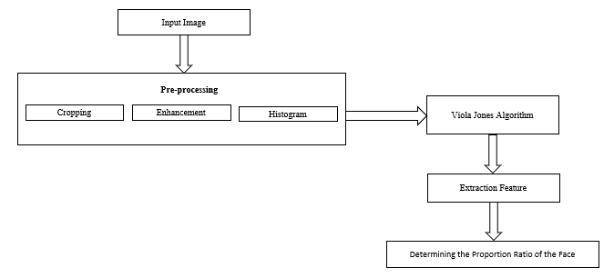
Figure 1. Research Methodology

A. Input Image
Input image is an image taken from the image that is on the internet as many as 30 images, but the image presented in this process as many as 3 input images with 4 objects in the image. The process of image capture can occur if there is a transformation of analog images into digital images [18].

Table 1. Input image
No | Input image | Description
1 |  | Image 1
2 |  | Image 2
3 |  | Image 3

B. Pre-Processing
At the pre-processing stage will be done cropping, enhancement and histogram of the face image. The cropping stage aims to cut the image that will be used in the process and discard the image that is not used[19]. The image will be cut into rectangular shapes. The formula used is:
x’ = x – x. L ………………………. (1)
for x = x. L to x. R
y’ = y – y. T ……………………..... (2)
for y = y. T to y. B
(x. L, y. T) and (x. R, y. B) are the coordinates of the image's lower right and upper left corner points that need to be cropped. Image size becomes:
w’ = x. R – x. L …………………... (3)
h’ = y. B –YT ………………….…. (4)
The image from cropping has different pixel size, while in the feature extraction stage, the image used must have the same pixel size. Enhancement stage aims to improve image quality by manipulating image parameters. The image repair operation to be performed in this stage is noise filtering [20], [21]. A histogram is a graphic representation of the frequency distribution of an image's pixel intensity values. The vertical axis shows the frequency or quantity of pixels, and the horizontal axis shows the pixel intensity value[22].
C. Viola Jones Algorithm
Images are categorized using the Viola-Jones face detection process using basic feature values[23],[24],[25]. There are numerous justifications for using features rather than pixels directly. In this Viola jones algorithm, the process will determine the object and detect the displayed object, specifically the mouth, nose, right and left eyes, and face[26].
F(Xi)=sign(∑t=1(ati*fti(xi)+s))) …..(5)
The Viola-Jones algorithm employs a medium, and the integral image is employed to streamline the process of determining the value of features. An integral image is one where each pixel's value is equal to the sum of the values of the pixels in the upper left to bottom right[27].
D. Feature Extraction
At this stage, The procedure of feature extraction will be executed from the face by determining the distance(pixels) between object points. Analyzing the obtained form's characteristics will be the next step. Feature extraction looks for important feature regions in a picture based on its inherent properties and intended use[28]. Such territories are characterized by their size, shape, texture, intensity, statistical characteristics, and other characteristics, and can be specified in a local or global context. Counting the number of dots or pixels found in each check which are conducted in different directions is how features are extracted. tracing checks on the digital image's Cartesian coordinates, namely vertical, horizontal, right diagonal, and left diagonal[29].
E. Ratio of Facial Proportions
At this stage, the ratio of facial proportions will be determined by comparing the distance of other facial features to the main reference distance[30]. In this process, facial recognition will be performed to distinguish individuals based on specific facial features with the right eye-the left eye as the main reference.
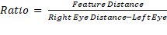……(6)

RESULT AND DISCUSSION

Input image obtained from the internet is done preprocessing process is the process of cropping, image enhancement and histogram. At the cropping stage, the image will be cut according to what is needed in processing. The next stage is the removal of noise from the image resulting from the cropping process.
This stage is used to get better results. The image enhancement technique used is an intensity-adjustable point operation. By linearly transferring the intensity values on the original histogram into intensity values on the new histogram, intensity adjustment raises the image's contrast value. The preprocessing process's outcomes are displayed in Table 2.

Table 2. Pre-processing Results
No | Input image | Cropping | Histogram after cropping | Image Enhancement | Histogram Image Enhancement
1 |  |  | 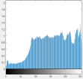 |  | 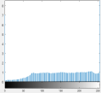
2 |  |  | 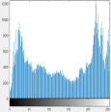 |  | 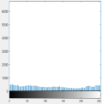
3 |  |  | 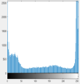 |  | 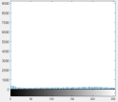

Based on Table 2 above presents the results of preprocessing, namely cropping, histogram analysis, and image enhancement. The origin image is the initial image before going through processing. The first stage is cropping, in which certain parts of the image are cut to highlight more relevant areas, such as the face or the main object, so that unnecessary parts of the background can be removed. After that, histogram analysis is performed on the cropped image, which shows the distribution of color intensity in the image.
From this histogram, it can be judged which image lighting needs to be improved. Next, the image enhancement stage is carried out, which aims to use contrast enhancement methods to raise the image's quality to make the details clearer. After the enhancement process, the histogram of the enhanced image shows a change in the intensity distribution, which is usually more even than before. This indicates that the exposure and contrast of the image have been improved. By going through this preprocessing, the image becomes more optimal for further analysis, such as in facial recognition systems.
The next stage will be facial recognition process using viola jones algorithm. The objects detected with viola jones ' algorithm are the face, right eye, left eye, nose and mouth. The results of the Viola jones algorithm process are presented in Table 3.

Table 3. Viola Jones Algorithm Results
No |  | Input image |  | Face |  | Right Eye |  | Left Eye |  | Nose |  | Mouth
1 |  |  |  |  |  |  |  |  |  |  | 
2 |  |  | 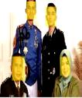 |  |  |  |  |  |  |  | 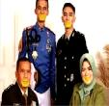
3 |  |  | 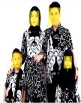 |  |  |  |  |  |  |  | 

Based on Table 3 above shown objects detected by viola jones algorithm, the tested image can detect the face, right eye, left eye, nose and mouth. The result of viola jones algorithm process can be used for feature extraction process in face recognition. At this stage there are four faces in one image to be determined the distance between the pixels of the right eye-left eye, right eye-nose, left eye-nose, right eye-mouth, left eye-mouth and nose-mouth of each face. Feature extraction results from the selected image can detect every face in the image well. The results of the feature extraction process are presented in Table 4.

Table 4. Feature Extraction Results
No |  | Input image |  | Detection |  | Feature Extraction Results
1 |  |  | 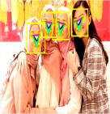 |  | 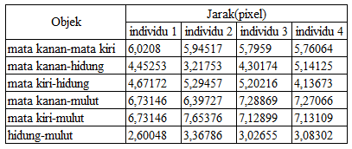
2 |  |  | 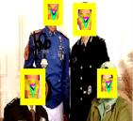 |  | 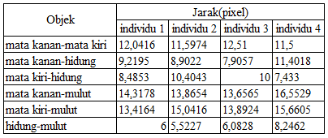
3 |  |  | 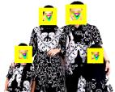 |  | 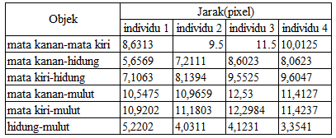

Based on Table 4 above presented the results of feature extraction for all objects in the three images tested. Detection results with feature extraction used for the last stage in this study is the determination of the ratio of facial proportions in determining the uniqueness of the face under study. The results of the face ratios of the 3 tested images can be seen in Table 5.

Table 5. Ratio Results
Image | Object | Individual 1 | Individual 2 | Individual 3 | Individual 4
Image 1 | Right eye-nose | 0.7395 | 0.5412 | 0.7422 | 0.8929
Image 1 | Left eye-nose | 0.7761 | 0.8904 | 0.8975 | 0.7183
Image 1 | Right eye-mouth | 11.179 | 10.760 | 12.582 | 12.625
Image 1 | Left eye-mouth | 11.179 | 12.877 | 12.299 | 12.373
Image 1 | Nose-mouth | 0.432 | 0.5665 | 0.5221 | 0.5353
Image 2 | Right eye-nose | 0.7657 | 0.7678 | 0.6322 | 0.9915
Image 2 | Left eye-nose | 0.7048 | 0.8968 | 0.8298 | 0.6463
Image 2 | Right eye-mouth | 11.895 | 11.955 | 10.918 | 14.394
Image 2 | Left eye-mouth | 11.142 | 12.968 | 11.107 | 13.627
Image 2 | Nose-mouth | 0.4983 | 0.4762 | 0.4863 | 0.7171
Image 3 | Right eye-nose | 0.6557 | 0.7591 | 0.7489 | 0.8055
Image 3 | Left eye-nose | 0.8235 | 0.8568 | 0.8307 | 0.9592
Image 3 | Right eye-mouth | 12.218 | 11.543 | 10.896 | 11.400
Image 3 | Left eye-mouth | 12.654 | 11.769 | 10.694 | 11.411
Image 3 | Nose-mouth | 0.6051 | 0.4243 | 0.3585 | 0.3351

Based on Table 5 above image 1 shows a fairly wide variation in the ratio, especially in the ratio between the eye-nose and nose-mouth. The ratio of right eye-mouth and left eye-mouth is relatively consistent, being in the range of 11,179 to 12,873. In contrast, the nose-mouth ratio showed a more significant variation, which was between 0.432 to 0.5353. Image 2 shows a more consistent right-eye-mouth and left-eye-mouth ratio than Image 1, with a range of 11,142 to 13,627. For the nose-mouth ratio, the variation is smaller than in image 1, ranging from 0.4762 to 0.4983, which indicates a lower distortion in the ratio of facial proportions. Image 3 has a wider range of right-eye-mouth and left-eye-mouth ratios, ranging from 10,896 to 12,654. Meanwhile, the nose-mouth ratio showed higher variation compared to image 2, with values between 0.3351 to 0.6051, which may indicate instability in the capture of facial features.
The ratio of the 3 images above can be presented in the form of bar charts and line charts. The Bar chart aims to present the results of the distribution of the ratio of facial proportions of individuals in image 1, image 2, and image 3, while the line chart is used to see the trend of changes in the ratio between individuals in various images.

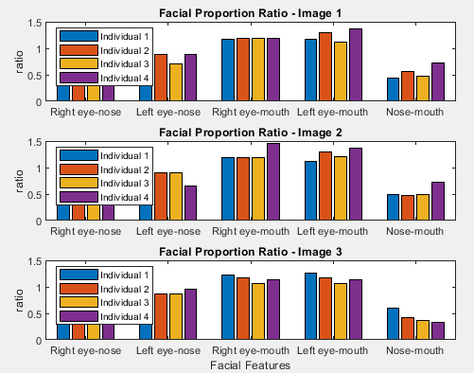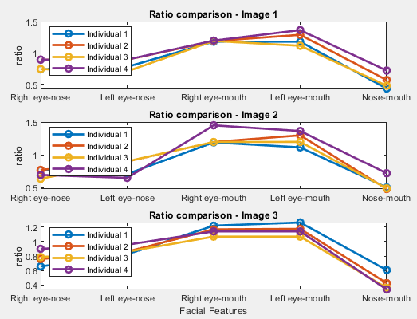

Figure 2. Bar Chart dan Line Chart

Based on Figure 2 above the bar chart shows the distribution of facial proportion ratios for each individual in image 1, image 2, and image 3. This allows a direct comparison between individuals based on the measured facial features. Meanwhile, line charts are used to observe the trend of changing ratios among individuals in various images, so as to identify individuals with similar facial proportions based on the formed line patterns.

CONCLUSION

Based on the above results, Image 2 is the best for face recognition because the consistency ratio is better than Image 1 and image 3. The variation in the ratio is smaller, especially in the nose-mouth ratio, which shows less distortion. The proportion value range is more stable, which makes it more reliable for face recognition systems. So, Image 2 gives the best results in terms of stability and consistency of the face ratio, making it more ideal for use in geometry ratio-based face recognition systems.

BIBLIOGRAPHY

[1] X. Dong, S. Kim, Z. Jin, J. Y. Hwang, S. Cho, dan A. B. J. Teoh, “Open-set face identification with index-of-max hashing by learning,” Pattern Recognition, vol. 103, hal. 107277, 2020, doi: 10.1016/j.patcog.2020.107277.
[2] A. I. Awad, A. Babu, E. Barka, dan K. Shuaib, “AI-powered biometrics for Internet of Things security: A review and future vision,” Journal of Information Security and Applications, vol. 82, no. May, hal. 103748, 2024, doi: 10.1016/j.jisa.2024.103748.
[3] S. Saleem, J. Shiney, B. Priestly Shan, dan V. Kumar Mishra, “Face recognition using facial features,” Materials Today: Proceedings, vol. 80, no. iii, hal. 3857–3862, 2023, doi: 10.1016/j.matpr.2021.07.402.
[4] I. Vukovic, P. Cisar, K. Kuk, M. Bandjur, dan B. Popovic, “Influence of image enhancement techniques on effectiveness of unconstrained face detection and identification,” Elektronika ir Elektrotechnika, vol. 27, no. 5, hal. 49–58, 2021, doi: 10.5755/j02.eie.29081.
[5] S. Komputer, A. Wijaya, B. S. Yudha, Y. Apridiansyah, N. David, dan M. Veronika, “Integrasi Metode Viola-Jones dan Algoritma Pelabelan untuk Akurasi Deteksi Objek Manusia,” vol. 19, no. 2, hal. 227–239, 2024.
[6] V. Wati, K. Kusrini, H. Al Fatta, dan N. Kapoor, “Security of facial biometric authentication for attendance system,” Multimedia Tools and Applications, vol. 80, no. 15, hal. 23625–23646, 2021, doi: 10.1007/s11042-020-10246-4.
[7] H. L. Gururaj, B. C. Soundarya, S. Priya, J. Shreyas, dan F. Flammini, “A Comprehensive Review of Face Recognition Techniques, Trends, and Challenges,” IEEE Access, vol. 12, no. June, hal. 107903–107926, 2024, doi: 10.1109/ACCESS.2024.3424933.
[8] G. Singh dan A. K. Goel, “Face Detection and Recognition System using Digital Image Processing,” no. Icimia, hal. 348–352, 2020.
[9] S. M. Bah dan F. Ming, “An improved face recognition algorithm and its application in attendance management system,” Array, vol. 5, no. February 2019, hal. 100014, 2020, doi: 10.1016/j.array.2019.100014.
[10] M. Z. Osman, M. A. Maarof, M. F. Rohani, N. N. A. Sjarif, dan N. S. A. Zulkifli, “A multi-color based features from facial images for automatic ethnicity identification model,” Indonesian Journal of Electrical Engineering and Computer Science, vol. 18, no. 3, hal. 1383–1390, 2020, doi: 10.11591/ijeecs.v18.i3.pp1383-1390.
[11] P. Tavallali, M. Yazdi, dan M. R. Khosravi, “A Systematic Training Procedure for Viola-Jones Face Detector in Heterogeneous Computing Architecture,” Journal of Grid Computing, vol. 18, no. 4, hal. 847–862, 2020, doi: 10.1007/s10723-020-09517-z.
[12] M. Akbar, H. Hikmatiar, dan U. M. Maumere, “Graphical User Interface ( GUI ) For Face Detection Using Viola-Jones,” vol. 4, no. 01, hal. 1–9, 2025, doi: 10.56741/bst.v4i01.768.
[13] K. Jambe, V. Jones, dan D. Obyek, “Gaussian Blur Filter Effect Analysis on Facial Detection Accuracy Using Viola Jones Method,” no. x, hal. 1–12, 1978, doi: 10.22146/ijccs.xxxx.
[14] S. Balovsyak, O. Derevyanchuk, V. Kovalchuk, H. Kravchenko, dan M. Kozhoka, “Face Mask Recognition by the Viola-Jones Method Using Fuzzy Logic,” International Journal of Image, Graphics and Signal Processing, vol. 16, no. 3, hal. 39–51, 2024, doi: 10.5815/ijigsp.2024.03.04.
[15] S. Pokhrel, “No TitleΕΛΕΝΗ,” Αγαη, vol. 15, no. 1, hal. 37–48, 2024, doi: 10.1109/IITCEE59897.2024.10468022.Abstract.
[16] K. B. Naidu, A. S. Vickram, dan S. Udhayakumar, “An early warning system of fatigue detection of drivers using novel image processing and HOG for evaluation of the driver quality using Viola-Jones over hog algorithm,” AIP Conference Proceedings, vol. 2853, no. 1, hal. 2024, 2024, doi: 10.1063/5.0198486.
[17] L. Sudha, R. Vadhani, K. B. Aruna, V. Sureka, dan V. Sasikala, “Cutting-edge Facial Authentication System in Matlab (CFAS-M),” 2024 International Conference on Communication, Computing and Internet of Things, IC3IoT 2024 - Proceedings, no. April, hal. 17–18, 2024, doi: 10.1109/IC3IoT60841.2024.10550320.
[18] W. Bismi, D. Riana, dan A. S. Hewiz, “Disease Identification on Fig Leaf Images Using Deep Learning Method,” International Journal of Advanced Science Computing and Engineering, vol. 6, no. 2, hal. 57–63, 2024, doi: 10.62527/ijasce.6.2.203.
[19] J. Kim dan H. Park, “Adaptive Latent Diffusion Model for 3D Medical Image to Image Translation: Multi-modal Magnetic Resonance Imaging Study,” Proceedings - 2024 IEEE Winter Conference on Applications of Computer Vision, WACV 2024, hal. 7589–7598, 2024, doi: 10.1109/WACV57701.2024.00743.
[20] N. R. D. Cahyo dan M. M. I. Al-Ghiffary, “An Image Processing Study: Image Enhancement, Image Segmentation, and Image Classification using Milkfish Freshness Images,” IJECAR) International Journal of Engineering Computing Advanced Research, vol. 1, no. 1, hal. 11–22, 2024.
[21] U. S. Muhammadiyah, “Optimizing Rice Plant Disease Classification Using Data Augmentation with GANs on Convolutional Neural Networks,” vol. 9, no. 1, hal. 97–114, 2025.
[22] P. N. Kumar, V. Yadav, P. Ghuge, A. Varpe, dan S. Rathod, “Detailed Study of Histogram Compution Algorithm in Image Processing,” vol. 13, no. 2231, hal. 1071–1078, 2024.
[23] V. F. D. Algorithms, “African Journal of Advanced Pure and Applied Sciences ( AJAPAS ) Estimating the Number of People in Digital Still Images Based on Viola-Jones Face Detection Algorithms,” vol. 3, no. 2, hal. 146–154, 2024.
[24] S. A. H. Shaikh, “Human Face Detection and Facial Expression Identification,” no. Iccmc, hal. 956–962, 2018.
[25] G. Ramkumar dan E. Logashanmugam, “Hybrid framework for detection of human face based on haar-like feature,” vol. 7, no. 3, hal. 1786–1790, 2018, doi: 10.14419/ijet.v7i3.16227.
[26] V. Jones dan U. Trisakti, “BETWEEN OBJECTS AND FACIAL RECOGNITION USING THE TINY-YOLOV4 METHOD , CONVOLUTIONAL NEURAL,” vol. 4, no. 10, hal. 9771–9790, 2024.
[27] Y. Deng, X. Liu, K. Yang, dan Z. Li, “Flexible thin parts multi-target positioning method of multi-level feature fusion,” IET Image Processing, vol. 18, no. 11, hal. 2996–3012, 2024, doi: 10.1049/ipr2.13151.
[28] J. Xu, “Image data visualization and communication system based on sensor network simulation and visual feature extraction,” Measurement: Sensors, vol. 33, no. June, hal. 101223, 2024, doi: 10.1016/j.measen.2024.101223.
[29] C. E. Widodo dan K. Adi, “Face geometry as a biometric-based identification system,” Journal of Physics: Conference Series, vol. 1524, no. 1, 2020, doi: 10.1088/1742-6596/1524/1/012008.
[30] R. Magdalena, E. Susatio, F. T. Elektro, dan U. Telkom, “Pengaruh Golden Ratio Pada Proporsi Wajah Terhadap Persepsi Estetika Wajah the Role of Golden Ratio on Face Proportion,” e-Proceeding of Engineering, vol. Vol. 2, no. 2 (Agustus), hal. 3047–3053, 2015.

