Design of Electronic Supply Chain Management as a Solution to Optimize Shoe Stock Supply Chain in Gasti Jaya Store

Sindi Fatika Sari Siregar^{1*}, Muhammad Ardiansyah Sembiring ², Ricki Ananda³
^{1,2} Information Systems, Royal University
³ Computer Systems, Royal University
email: sindisiregar6451@gmail.com

Abstract: In the retail industry, effective supply chain management is essential to ensure stock availability aligns with market demand. Gasti Jaya Store, a growing shoe retailer, faces challenges in optimizing inventory management, often leading to stock surpluses or shortages. These issues can impact operational efficiency and customer satisfaction.
To address this problem, this study proposes the implementation of Electronic Supply Chain Management (E-SCM) as a solution to optimize supply chain management. E-SCM enables the integration of technology-based systems for real-time stock monitoring, procurement, and distribution. Using a case study method and a qualitative approach, this research evaluates the effectiveness of E-SCM in enhancing operational efficiency, reducing excess stock, and accelerating the distribution process at Gasti Jaya Store.
The findings indicate that E-SCM implementation improves data transparency, speeds up decision-making, and enhances customer satisfaction. Additionally, the system helps reduce operational costs by optimizing inventory management and minimizing the risk of stock imbalances. In conclusion, the adoption of E-SCM can serve as an effective strategy for mid-sized retail businesses to improve their competitiveness and supply chain efficiency.
Keywords: E-SCM; Inventory Stock; Operational Efficiency; Supply Chain

Abstrak: Abstrak: Dalam industri ritel, manajemen rantai pasok yang efektif sangat diperlukan untuk memastikan ketersediaan stok sesuai dengan permintaan pasar. Toko Gasti Jaya sebagai salah satu toko sepatu yang berkembang menghadapi tantangan dalam mengelola persediaan secara optimal, yang sering kali menyebabkan kelebihan atau kekurangan stok. Permasalahan ini dapat berdampak pada efisiensi operasional dan kepuasan pelanggan. Untuk mengatasi masalah tersebut, penelitian ini mengusulkan penerapan Electronic Supply Chain Management (E-SCM) sebagai solusi dalam mengoptimalkan manajemen rantai pasok. E-SCM memungkinkan integrasi sistem berbasis teknologi dalam proses pemantauan stok, pengadaan barang, hingga distribusi secara real-time. Dengan metode studi kasus dan pendekatan kualitatif, penelitian ini mengevaluasi efektivitas E-SCM dalam meningkatkan efisiensi operasional, mengurangi kelebihan stok, serta mempercepat proses distribusi di Toko Gasti Jaya. Hasil penelitian menunjukkan bahwa implementasi E-SCM mampu meningkatkan transparansi data, mempercepat pengambilan keputusan, dan meningkatkan kepuasan pelanggan. Selain itu, sistem ini membantu mengurangi biaya operasional dengan mengoptimalkan manajemen persediaan dan meminimalkan risiko ketidakseimbangan stok. Kesimpulannya, penerapan E-SCM dapat menjadi strategi yang efektif bagi bisnis ritel skala menengah untuk meningkatkan daya saing dan efisiensi rantai pasok mereka.

Kata Kunci: E-SCM; Efisiensi Operasional; Persediaan Stok; Rantai Pasok.

INTRODUCTION

Fashion is often used as a means for individuals to express themselves and connect with specific times, events, or occasions. The term "fashion" typically incorporates four key components: style, change, acceptance, and taste [1]. One of the most popular fashion products is footwear. Shoes serve as an essential accessory to enhance one's appearance, and over time, they have become a crucial aspect of personal style. As the industry evolves, footwear companies continuously innovate in terms of design and color [2]
Gasti Jaya Store, as a growing shoe retailer, faces challenges in managing inventory effectively. One of the primary challenges is the unpredictable fluctuations in market demand. With a diverse range of shoes, including sports, formal, and casual footwear, Gasti Jaya Store often struggles to maintain optimal stock levels that align with consumer needs. A shortage of specific products can lead to customer loss, while excess inventory increases storage costs and poses a risk of financial losses due to unsold products [3].
In the retail industry, efficient supply chain management plays a critical role in business sustainability [4]. A common challenge is the imbalance between demand and supply, which can result in stock shortages or surpluses. Therefore, a system that optimizes the supply chain through technological advancements is necessary.
Electronic Supply Chain Management (E-SCM) presents a promising solution for enhancing supply chain efficiency by leveraging information technology [5]. With E-SCM, stock monitoring, procurement, and distribution processes can be automated and conducted in real-time [6]. This study aims to analyze the implementation of E-SCM at Gasti Jaya Store to improve inventory management efficiency.
Previous studies have shown that E-SCM implementation has been widely applied across various industries to enhance operational efficiency and supply chain data transparency. For instance, research by Santoso et al. (2021) revealed that E-SCM systems improve inventory accuracy and accelerate product distribution in the manufacturing sector. Additionally, a study by Rahmawati & Prasetyo (2022) found that integrating technology into retail supply chains can reduce excess stock risks by up to 30%. Meanwhile, research by Nugroho (2023) highlighted that the adoption of E-SCM in retail businesses still faces challenges related to implementation costs and system integration.
Based on previous studies, several research gaps need to be addressed. First, prior research has primarily focused on the manufacturing sector and large-scale retail, while studies on E-SCM implementation in mid-sized retail businesses, particularly shoe stores, remain limited. Second, most studies emphasize technical aspects without exploring the impact of E-SCM on customer satisfaction and business decision-making. Therefore, this study aims to bridge these gaps by examining E-SCM implementation in shoe store inventory management and analyzing its effects on supply chain efficiency and customer satisfaction.

METHOD

This study employs a qualitative approach using a case study method at Gasti Jaya Store. Data is collected through interviews with the store owner, operational observations, and analysis of relevant documents. The obtained results are analyzed descriptively to understand the benefits of E-SCM implementation in inventory management.
The research framework is illustrated in Image 1.

Problem Identification
Data Collection
System Analysis
System Design
Implementation

Image 1. Research stages

The research process consists of the following stages:
- Problem Identification: Conducting observations and interviews with the store owner to understand inventory management issues.
- Data Collection: Gathering data on transaction volumes, stock levels, and inventory management methods used before E-SCM implementation.
- System Analysis: Evaluating the existing supply chain management system at Gasti Jaya Store, including its strengths and weaknesses.
- System Design: Developing an E-SCM model to optimize the supply chain.
- Implementation: Testing the E-SCM application on a small scale to assess its effectiveness.
- Evaluation and Result Analysis: Comparing data before and after implementation to determine improvements in inventory management efficiency.

RESULT AND DISCUSSION

Use Case Diagram
The Use Case Diagram is an essential part of system design, illustrating the interaction between users and the system itself. This diagram highlights the various actors involved, such as the Admin and Supplier. By presenting this use case diagram, readers can better understand how the system is designed to meet user needs and enhance business process efficiency.
Image 2. Supplier Actor Usecase
Diagram

This Usecase diagram illustrates how suppliers interact with the system in the procurement process.

Activity Diagram
The Activity Diagram illustrates the flow of activities within the developed software, showing how each process starts and ends, as well as possible decision points. Below is the Activity Diagram for the design of the web-based Supply Chain Management application for shoe inventory management at Gasti Jaya Store.

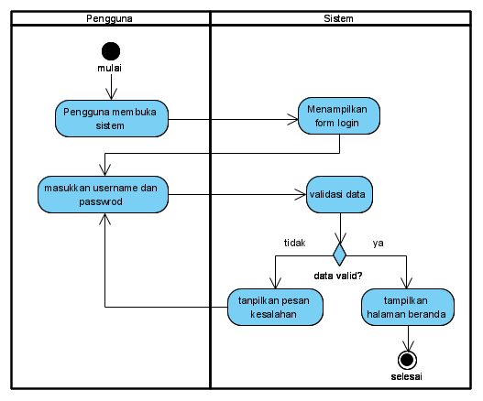
Image 3. Activity Diagram Login

This diagram shows how the system ensures that only users with valid credentials can access the home page, increasing system security as well as providing feedback in case of login errors.

Image 4. Activity Diagram Admin
Manage Offer Data

This activity diagram illustrates the process flow when the Building Admin manages supplier data in the system. This process is divided into two swimlanes, namely Building Admin and System, which show the interaction between users and the system. This diagram shows how the system facilitates the Building Admin in adding, editing, and deleting supplier data, so that the supplier data management process can be carried out more efficiently and structured.

Image 5. Activity Diagram Supplier Manages Goods Offers

This activity diagram illustrates the process flow when a supplier manages product offers in the system. The process is divided into two swimlanes, namely Supplier and System, which show the interaction between the user and the system.

System Implementation
The implementation phase details the results of the analysis and design discussed in the previous chapters. In this stage, the designed system is deployed and optimized for operational use, ensuring it meets the intended requirements effectively.

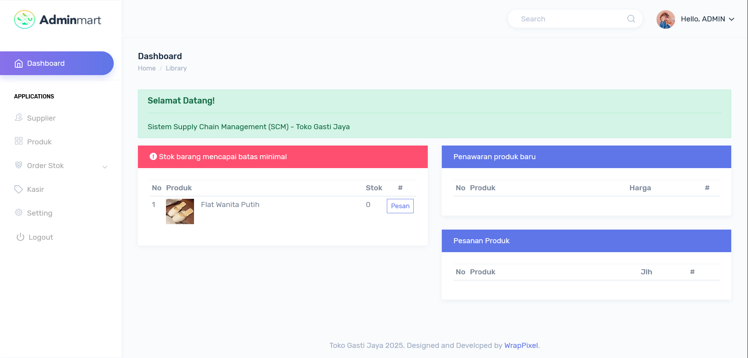
Image 6. Admin Home Page View

On the main page interface, the Admin can manage various functions, including supplier data, inventory data, new product offers, order management, incoming goods data, and password updates. On this page interface, the Admin can manage product data, including editing, deleting, and printing.

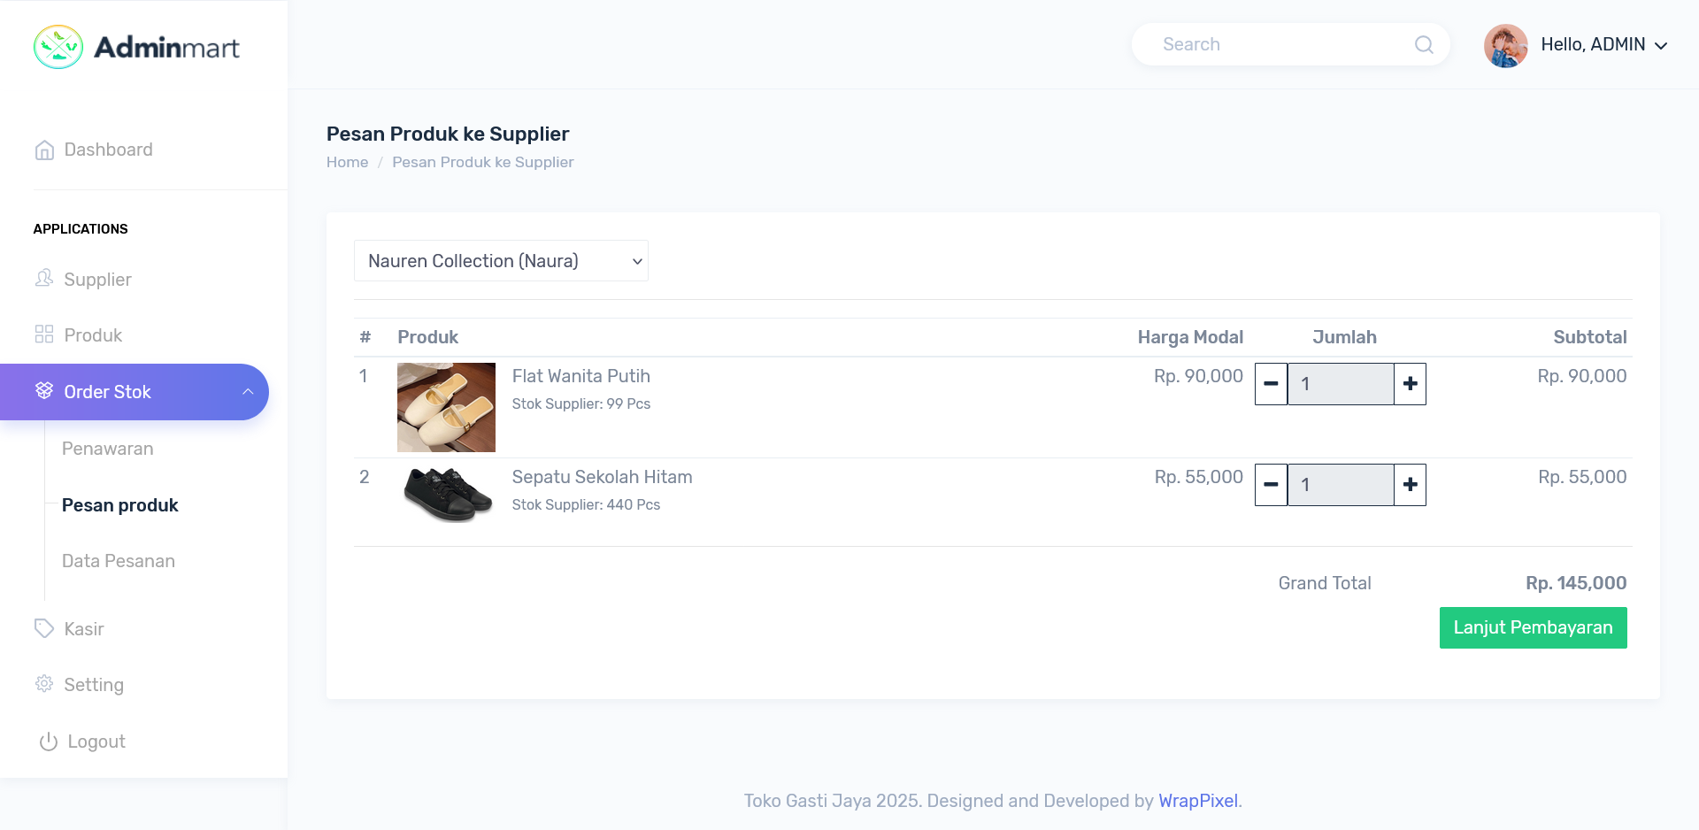
Image 7. Admin Page View Processing Product Data

Image display 4 of the order page is the Admin page for placing orders with suppliers.

Image 8. Admin Page View Make Order

The order page display is the Admin page for placing orders with suppliers.

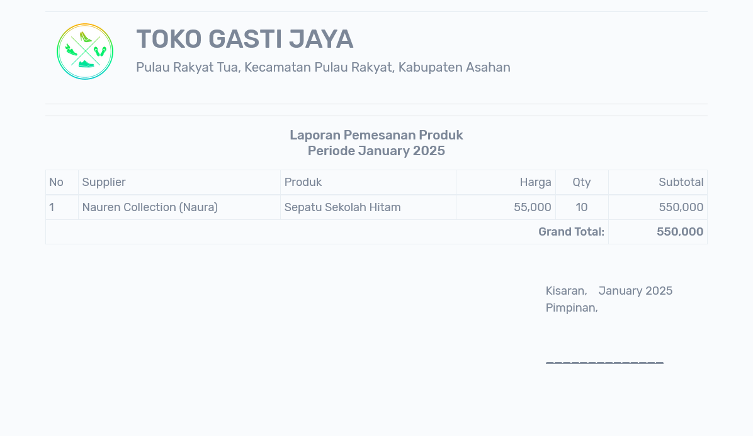
Image 9. Product Order Data Report View

The product order data report display is a page that displays incoming goods data from suppliers for later printing.

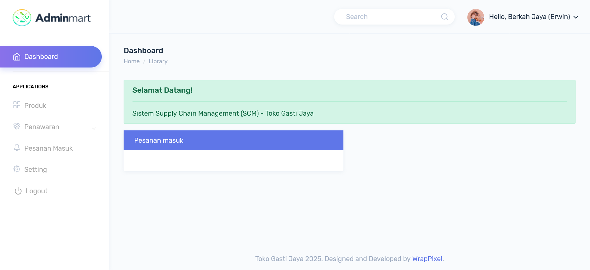
Image 10. Supplier Home Page View

On this main page display, Suppliers process orders, view order data, and provide offers for new goods.

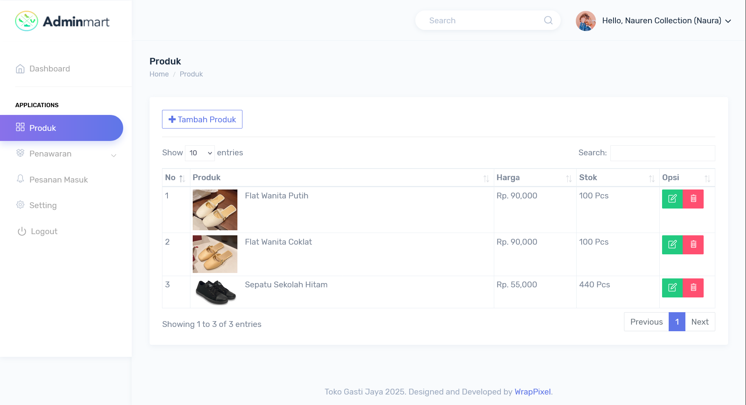
Image 11. Supplier Page View Processing Product Data

On this page display, Suppliers can process product data such as editing, deleting and printing.

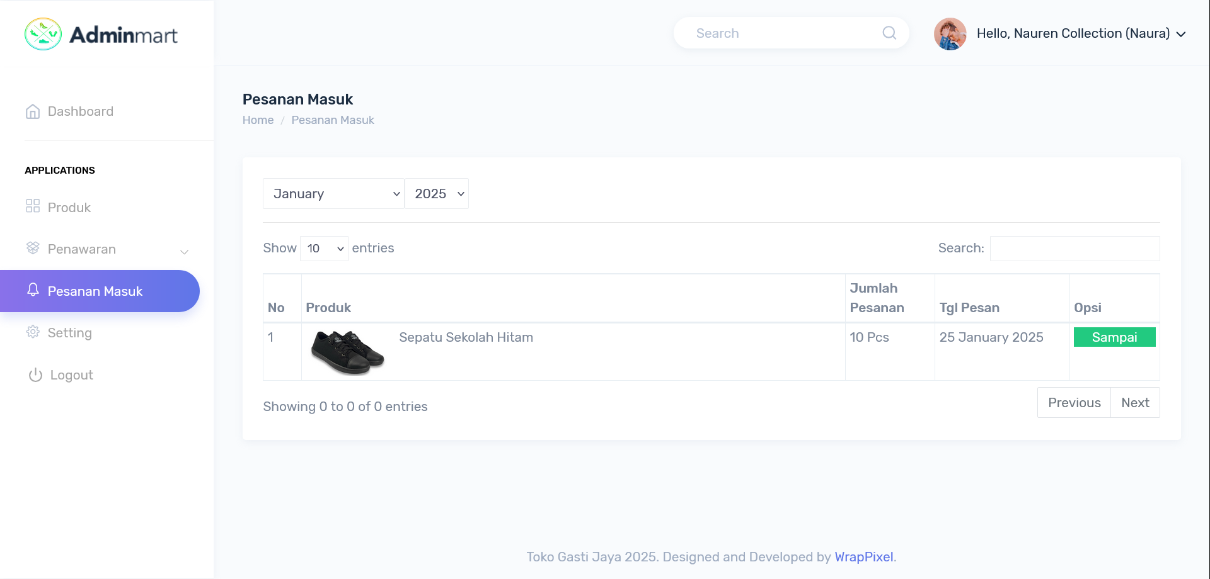
Image 12. Supplier Page View Processing Orders
On this main page display, Suppliers can process orders for goods from the Gasti Jaya warehouse.

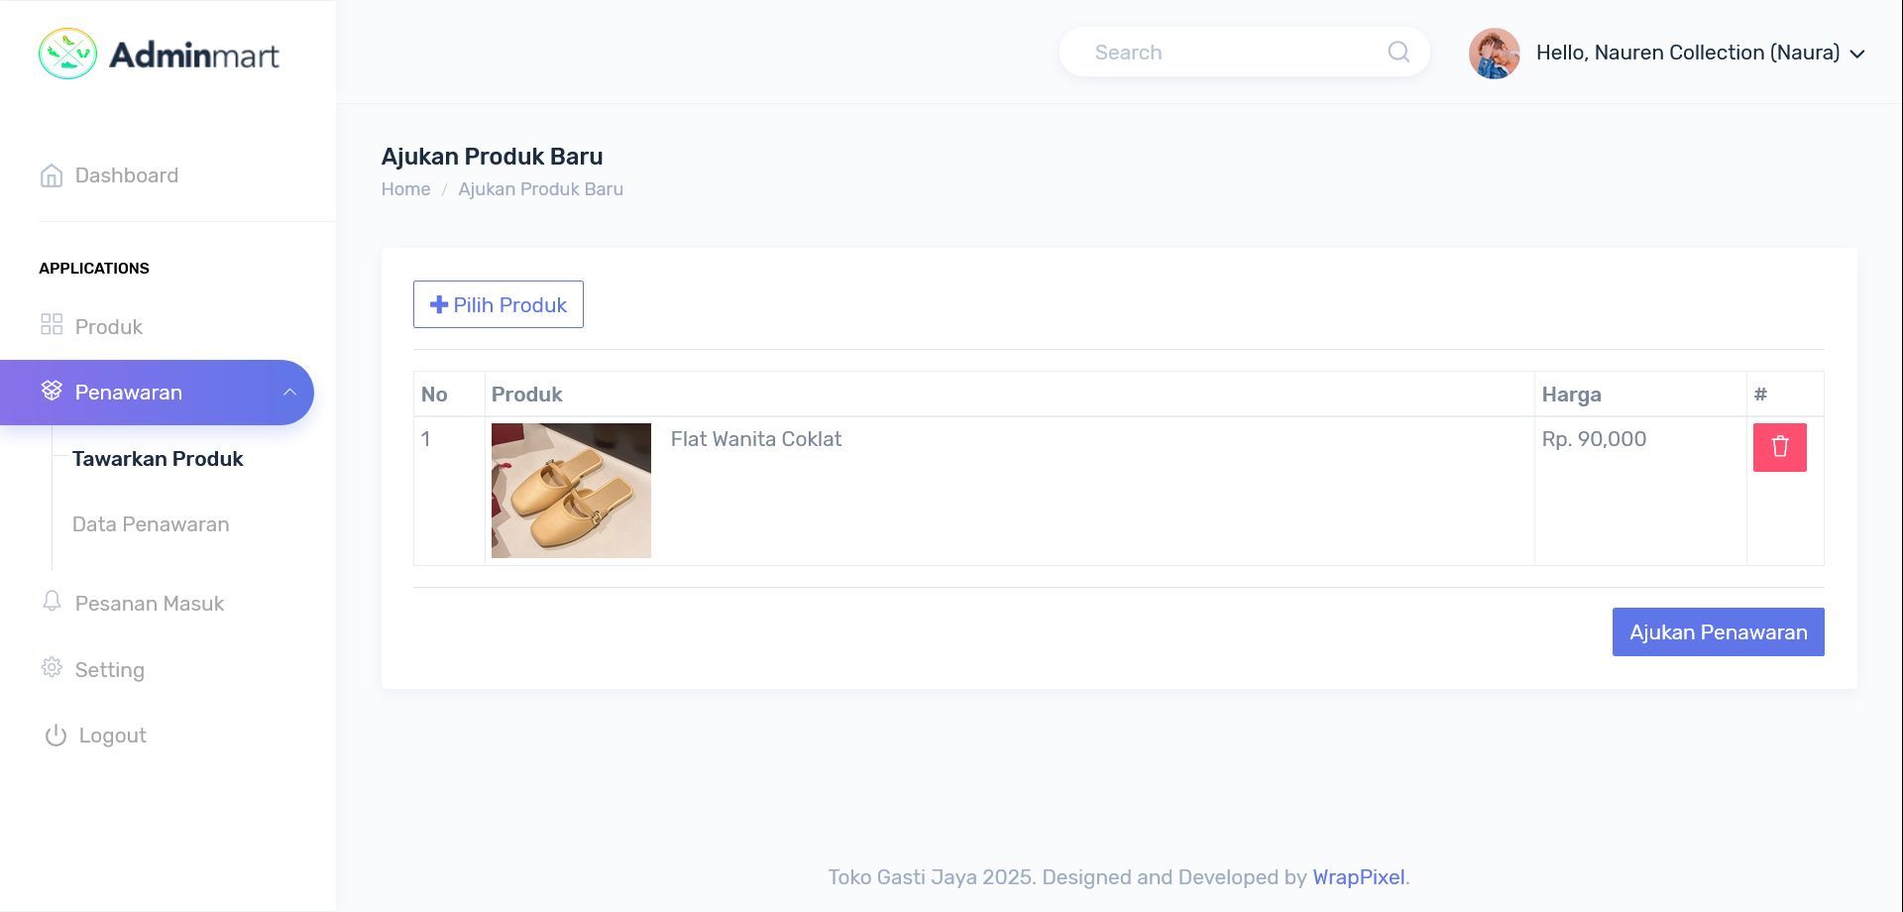
Image 13. Supplier Page View Input New Item Offer

On this page display, the Supplier inputs a new product offer to be offered to the Gasti Jaya Admin.

CONCLUSION

The implementation of E-SCM at Gasti Jaya Store has proven to be effective in enhancing supply chain efficiency and inventory management. This system enables real-time stock monitoring, improves data accuracy, and accelerates the distribution process. Therefore, it is recommended that other retail stores consider adopting E-SCM to enhance competitiveness and customer satisfaction.

BIBLIOGRAPHY

[1] G. E. Putri, “FAKTOR-FAKTOR MEMPENGARUHI KEPUTUSAN PEMBELIAN PRODUK FASHION SECARA ONLINE MELALUI E-COMMERCE,” J. Univ. Negeri Yogyakarta, vol. 16, no. 1, pp. 1–8, 2021.
[2] S. N. Rakhmah and I. Rizki, “SISTEM INFORMASI PELAYANAN JASA LAUNDRY SEPATU PADA QUEEN SHOES CLEANING,” J. Kaji. Ilm., vol. 22, no. 1, pp. 21–34, 2022, doi: 10.31599/jki.v22i1.782.
[3] N. L. Sari, H. Saputra, and H. D. Ellyany Sinaga, “Implementasi Supply Chain Management Berbasis Web Untuk Pengelolaan Stok Dan Distribusi Spare Part Handphone Pada Erwin Ponsel,” J-Com (Journal Comput., vol. 1, no. 2, pp. 103–108, 2021, doi: 10.33330/j-com.v2i1.1207.
[4] Paramita Citra Indah Mulia, Muhamad Farid, and Evy Nurmiati, “Perancangan Electronic Supply Chain Management (E-SCM) pada PT. Indofood CBP Sukses Makmur TBK,” INSOLOGI J. Sains dan Teknol., vol. 1, no. 3, pp. 218–231, 2022, doi: 10.55123/insologi.v1i3.407.
[5] T. Qurohman and L. Noviani, “IMPLEMENTASI SISTEM MANAJEMEN INVENTARIS BERBASIS TEKNOLOGI INFORMASI UNTUK OPTIMALISASI RANTAI PASOK DI INDUSTRI RITEL,” J. Manaj. Retail, vol. 4, no. 2, pp. 55–66, 2024, [Online]. Available: https://ejournal.lppm-unbaja.ac.id/index.php/jumareta/article/view/3836
[6] R. M. Afifi, E. K. Putra, and T. H. Pudjiantoro, “Sistem Electronic Supply Chain Management Menggunakan Metode Just in Time di PT Cemara Agung Mandiri,” J. Media Inform. Budidarma, vol. 4, no. 4, pp. 970–978, 2020, doi: 10.30865/mib.v4i4.2338.

