IoT-ENABLED SMART FIELD LIGHT AUTOMATION
WITH MONITORING
FOR FUTSAL

Haris Izwan Nasution^{1*}, Adi Prijuna Lubis², Ruri Ashari Dalimunthe³
^{1,2}Sistem Komputer, Universitas Royal Kisaran
email: harisnasution74bae@gmail.com

Abstract: Smart automation systems have become an innovative solution in facility management, particularly in lighting systems. This study develops a futsal court lighting control system based on the Internet of Things (IoT) using a Light Dependent Resistor (LDR) sensor and an ESP32 microcontroller with combination of Ultrasonic sensor. The system is designed to automatically adjust lighting based on ambient light intensity, enhancing energy efficiency and ease of use for court managers. Sensors data is transmitted to the Kodular application for remote monitoring and control. Testing results show that the system effectively controls lighting based on natural light changes with fast response. The implementation of this system is expected to improve the operational efficiency of futsal courts and provide a more modern technology-based solution.
Keywords: automation; IoT; LDR sensor; ultrasonic sensor; ESP 32; light controlling

Abstrak: Sistem otomatisasi pintar telah menjadi solusi inovatif dalam pengelolaan fasilitas lapangan, terutama dalam sistem pencahayaan. Penelitian ini mengembangkan sistem pengontrolan pencahayaan lapangan futsal berbasis Internet of Things (IoT) menggunakan sensor Light Dependent Resistor (LDR) dan mikrokontroler ESP32. Sistem ini dirancang untuk menyesuaikan pencahayaan secara otomatis berdasarkan intensitas cahaya di sekitar lapangan, sehingga meningkatkan efisiensi energi dan kemudahan penggunaan bagi pengelola lapangan. Data dari sensor dikirimkan ke aplikasi Kodular untuk pemantauan dan kontrol jarak jauh. Hasil pengujian menunjukkan bahwa sistem dapat secara efektif mengontrol pencahayaan berdasarkan perubahan cahaya alami dengan respons yang cepat. Implementasi sistem ini diharapkan dapat meningkatkan efisiensi operasional lapangan futsal dan memberikan solusi berbasis teknologi yang lebih modern.

Kata kunci: otomatisasi; IoT; sensor LDR; sensor ultrasonik; ESP 32; pengendalian cahaya

INTRODUCTION

Smart Futsal is one of the many futsal courts favored by futsal enthusiasts, located on Jl. Murai, Gambir Baru Subdistrict, Kisaran Timur City District, Asahan Regency. It has adequate facilities but lacks proper facility management, particularly in lighting, which often leaves the court dark at night. As a result, futsal players have to search for the caretaker to turn on the lights before starting a game or match..
To design this system, several studies have been referenced. For example, a study by Khairul and colleagues found that the Smart Field Control (SFC) system at the Kembar Jaya futsal court could lower room temperature and control electricity usage more efficiently while also sending SMS notifications to the futsal court owner regarding the duration of use per day via an SMS modem. Based on their analysis, the system could reduce temperature if it reached 30°C or above and notify the owner via SMS. Additionally, energy consumption was better structured, as lights would turn off automatically when the court was not in use or after rental periods ended [1].
Futsal is a ball game played by two teams, each consisting of five players, aiming to score goals by controlling the ball with their feet. Each team is allowed substitutes. Unlike other indoor soccer games, futsal courts are marked with lines instead of nets or boards. The game is officiated by two referees who monitor the match. However, issues such as disallowed goals despite the ball crossing the goal line can arise. Passive Infrared Receiver (PIR) sensors detect object movement by emitting infrared light and sensing its reflection. This module is pre-assembled, making it easy to use. The sensor can detect movement within a 5-7 meter range. To address this issue, this research develops a goal detection system to assist referees in making decisions, thereby reducing controversial goals in futsal matches [2].
Maestro Futsal Kemayoran is a futsal rental business with a high demand for court bookings, averaging around six reservations per day. However, the booking system is still manual, requiring customers to visit the location or call to check availability [3].

Futsal court management services have become increasingly popular, especially in Malang. For instance, Champions Futsal can secure up to 400 rental hours per month. However, customers face challenges due to lengthy booking procedures and additional services such as product purchases and report submissions. Data integration is also problematic, potentially leading to data loss, which affects management decisions. Therefore, this research develops a web-based management system to streamline futsal court operations [4].
The quality of futsal courts is another crucial factor, as many owners fail to provide complete facilities [5].
A study on futsal goalkeepers in Cirebon and nationally licensed referees produced a sensor tool to detect violations of goalkeepers crossing the goal line during penalty kicks [6].
This research aims to develop a goal sensor tool to assist in matches and training sessions [7].
Based on these identified issues, this study proposes a web-based futsal court rental management system using the Waterfall development model and black-box testing for system validation [8].

METHOD

The research methodology includes data collection from various aspects, data analysis, process analysis, configuration analysis for each device, and system design based on these analyses.

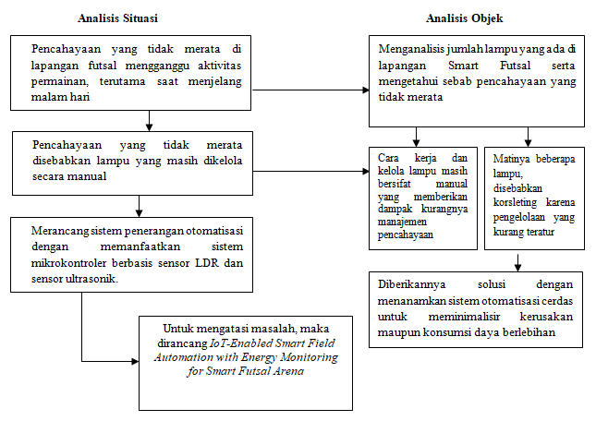
Image 1. Reseach Process Analysis

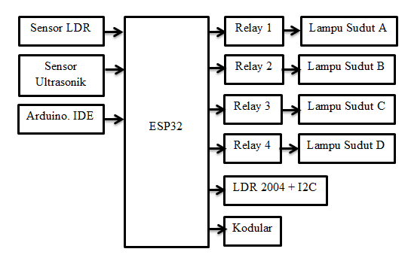
Image 2. System Design Flow

After the design phase, the system was implemented based on the available analysis and integrated into the final tool.

RESULTS AND DISCUSSION

Testing was conducted directly using hardware modules to enable automatic lighting control for futsal courts. Several testing stages were performed to obtain accurate data. The results are presented in Table 1

Table 1. Test Result
Conditions | Sensor |  | Description
Conditions | LDR | Ultrasonik | Description
Entering nighttime without people on the court | Aktive | Passive | The system enters ON mode and is ready to detect objects.
Entering nighttime with people on the court | Aktive | Aktive | All lights turn on for the court.
Entering daytime with or without people on the court | Passive | Passive | All lights remain off, indicate entering daytime, and the system is inactive.

And test result documentations
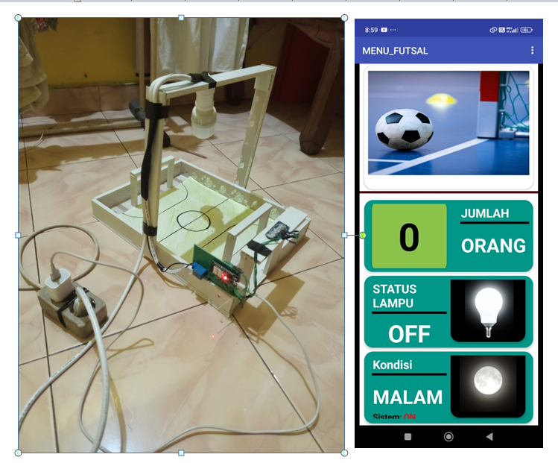
Image 3. Test Condition 1

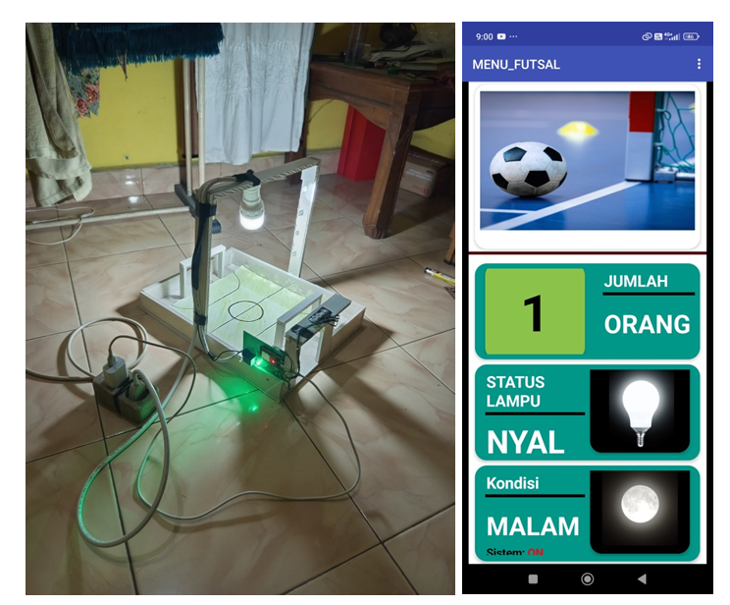
Image 4. Test Condition 2

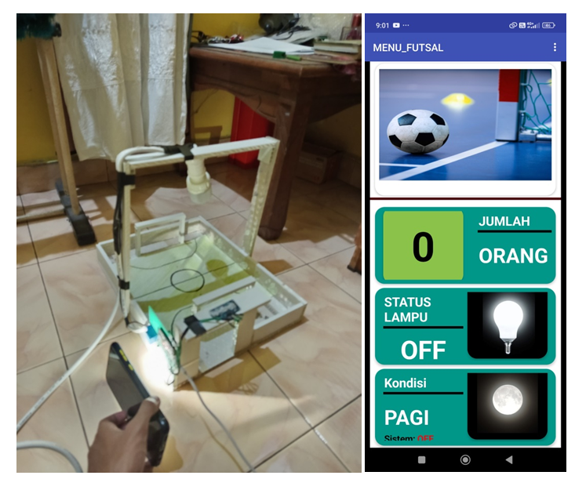
Image 5. Test Condition 3

CONCLUSION

Based on the implementation and findings, this research concludes that an automated lighting system is essential for enhancing the efficiency and effectiveness of futsal court lighting. By replacing manual operation with automation, lighting management performance improves significantly. The integration of IoT technology enables real-time system monitoring, resulting in a more efficient and responsive system.

ACKNOWLEDGMENTS

The author expresses deep gratitude to family and relatives for their continuous support, both physically and emotionally. Special thanks to supervising lecturers Mr. Adi Prijuna Lubis and Mr. Ruri Ashari Dalimunthe for their guidance in realizing this journal.

BIBLIOGRAPHY

[1] Muyasir and Rahmat Musfikar, “Perancangan Aplikasi Media Pembelajaran Dasar Desain Grafis Berbasis Android Menggunakan Web Kodular,” JINTECH : Journal of Information Technology. UIN Ar-Raniry Banda Aceh, vol. 3, no. 1, 2022.
[2] Faisal Lutfi and Mochamad Sanwasih, “Perancangan Alat Pendeteksi Garis Gawang Lapangan Futsal Dengan Sensor Passive Infrared Receiver (PIR) Berbasis Arduino (Studi Kasus Lapangan Futsal Komplek Polri Pengadegan),” Jurnal Maklumatika, Universitas Islam Attahiriyah, vol. 7, no. 1, 2020.
[3] Wahidin, Verdi Yasin, and Rachmawaty Haroen, "Perancangan Sistem Infomasi Pengelolaan Lapangan Futsal Berbasis Web Dengan Metode Rapid Application String Matching Di Maestro Futsal Kemayoran Jakarta," Journal of Information System, Informatics and Computing. Sekolah Tinggi Manajemen Informatika dan Komputer (STMIK Jayakarta), vol.5 no.1, 2021
[4] Hafidz Aulia Setijadi, Achmad Arwan, and Komang Candra Brata, “Pengembangan Sistem Manajemen Lapangan Futsal Berbasis Web (Studi Kasus: Champions Futsal Malang),” Jurnal Pengembangan Teknologi Informasi dan Ilmu Komputer, Universitas Brawijaya, vol. 5, no. 5, 2021.
[5] Gede Deffa Ade Darsana, I Made Satyawan, and I Ketut Semarayasa, "Manajemen Pengelolaan Lapangan Futsal di Kota Singaraja pada Masa Pandemi," Jurnal Ilmu Keolahragaan Undiksha. Universitas Pendidikan Ganesha, vol. 10, no. 3, 2022
[6] Yudi Permana, Soegiyanto Soegiyanto , Donny Wira Yudha Kusuma, “Development of Sensor Aids for Goalkeeping Violations Over the Goal Line on First Point Penalty Kicks on Futsal,” Journal of Physical Education and Sports, Universitas Negeri Semarang, vol. 10, no. 4, 2021.
[7] David Susilo Budi, and Amir Supriadi, “Pengembangan Sensor Gol Pada Gawang Futsal Menggunakan Deteksi Pola Tahun 2020,” JPJ (Jurnal Pendidikan Jasmani), Universitas Negeri Medan, vol. 2, no. 2, 2021.
[8] Dwi Azaliza, Kristianus Jago Tute, and Melky Radja, “Rancang Bangun Sistem Informasi Manajemen Penyewaan Lapangan Futsal Berbasis Web (Studi kasus Lapangan futsal Tanjung Ende),” Jurnal Sistem Informasi dan Teknik Komputer, Universitas Flores, vol. 9, no. 2, 2024.

