**FORECASTING POPULATION GROWTH IN TANJUNG TIRAM USING LEAST SQUARE METHOD**

**Rainah1*, Nofriadi2, Ahamad Muhazir3**

1,2,3 Sistem Informasi, Universitas Royal

*email*: *rainahalfa09@gmail.com*

**Abstract:** Population growth is caused by three components, namely birth (fertility), death (mortality) and migration. These three components greatly influence the population growth process that occurs. It is very important to detail the development of population growth in a sub-district, so that the development of that sub-district can be improved. Forecasting is an important tool in effective and efficient planning. An important step after the forecast is carried out is to verify the forecast in such a way that it reflects past data and the causal system underlying the growth. As long as the forecasting representation is reliable, the forecasting results can continue to be used. The aim of this research is to apply the Least Square method to predict population growth in Tanjung Tiram District in the next few years based on three components, namely births (fertility), deaths (mortality) and migration. The results of this research can predict population growth using the Least Square Method in 2024 with a birth rate of 936, arrivals of 104 and movements of 142 with an error value below 5%.

**Keywords:** forecasting; population growth; tanjung tiram; trending moments;

**Abstrak:** Pertumbuhan penduduk diakibatkan oleh tiga komponen yaitu kelahiran (*fertilitas*), kematian (*mortalitas*) dan migrasi. Tiga komponen tersebut sangat mempengaruhi proses pertumbuhan penduduk yang terjadi. Perkembangan pertumbuhan penduduk padasatu kecamatan sangat penting untuk dirincikan, agar perkembangan kecamatan tersebut dapat ditingkatkan. Peramalan merupakan alat bantu yang penting dalam perencanaan yang efektif dan efisien. Langkah penting setelah peramalan dilakukan adalah verifikasi peramalan sedemikian rupa sehingga mencerminkan data masa lalu dan sistem penyebab yang mendasari pertumbuhan tersebut. Sepanjang representasi peramalan tersebut dapat dipercaya, hasil peramalan dapat terus digunakan. Tujuan penelitian ini yaitu menerapkan metode *Least Square* untuk memprediksi jumlah pertumbuhan penduduk di Kecamatan Tanjung Tiram dalam beberapa tahun kedepan berdasarkan tiga komponen yaitu kelahiran (*fertilitas*), kematian (*mortalitas*) dan migrasi. Hasil dari penelitian ini dapat memprediksi jumlah pertumbuhan penduduk menggunakan Metode *Least Square* pada tahun 2024 dengan angka kelahiran 936, kedatangan 104 dan perpindahan 142 dengan nilai error dibawah 5%.

**Kata kunci:** peramalan; pertumbuhan penduduk; tanjung tiram; trend moment;

**INTRODUCTION**

Information technology plays a very important role in today's world development, because it is widely used in government agencies and individuals who involve a lot of information in decision making. Every agency is required to always be professional in running its organization, so that it can improve the quality of community services. Computer technology allows a government agency to process data quickly and accurately so that it can produce reliable information and can increase work efficiency and the capabilities of government agencies [1].

Tanjung Tiram District is the 3rd largest district in Batu Bara Regency. The administrative area in the Tanjung Tiram District government consists of 9 villages with an area of ​​157.19 Km2 [2], [3]. Based on data from Tanjung Tiram District, in-migration that occurred in Tanjung Tiram District experienced an increase in 2020, namely 11,391,000 people and a growth rate of 2.16%, so it can be concluded that population growth in Tanjung District Oysters often increase [4].High population growth can actually have positive impacts, including being an important element in efforts to increase production and develop economic activities with abundant labor availability [5]. High population growth, especially in Indonesia, can not only have a positive impact, but will also have a negative impact in various fields which will of course influence each other.

The negative impact of this high population growth will arise if the population growth that occurs is not balanced with adequate facilities and infrastructure to support the survival of the population concerned in order to obtain a prosperous and prosperous life and livelihood. Population growth is caused by three components, namely: birth (fertility), death (mortality) and migration [6]. These three components greatly influence the population growth process that occurs. The development of population growth in a sub-district has a very important role to detail [7].

Based on what was implemented in Tanjung Tiram District, the population density calculation process was still carried out manually by collecting information from the Central Statistics Agency (BPS) at the end of each year and collecting data from each village and sub-district took a lot of time. This results in the slow performance of sub-district employees in calculating population growth in Tanjung Tiram sub-district. Seeing how important information about population numbers is, a population growth forecasting application is needed, which will make it easier to calculate the increase in population growth each year. So that the sub-district can prepare assistance in the form of direct assistance such as Cash Social Assistance (BST), Social Safety Net Assistance (JPS), Non-Cash Basic Food Assistance and Direct Cash Assistance (BLT) or construction and development in all villages under the sub-district.

In terms of providing facilities and infrastructure to offset the negative impacts of population growth, the government is required to carry out various breakthrough activities and capabilities to predict the rate of population growth. Because the ability to predict population growth will make it easier for the government to distribute budget portions to support the policies taken to minimize problems arising from the rate of population growth. Predictions are usually applied to predict sales, money exchange rates, river water flows, etc. To make it easier to make predictions, there are many choices of tools that can be used, one of which is using an algorithm. An algorithm is a method in statistics that is used to predict something with a forecasting algorithm[8].

Forecasting is an important tool in effective and efficient planning. An important step after the forecast is carried out is to verify the forecast in such a way that it reflects past data and the causal system underlying the growth [9]. As long as the forecasting representation can be trusted, the forecasting results can continue to be used. The Least Square method has been widely used in several case studies, including the results of the optimal LSSVM model for forecasting Covid-19 cases in Indonesia from 1 February 2021-28 February 2022, namely the M14 and V24 models [10]. As a fixed calculation to determine the sales target for Honda brand motorbikes, with an average MAPE value of 5.3% or an accuracy value of 94.7% [11]. Forecasting the types of staple ingredients for broiler chickens using the Least Square Method, the forecasting value is IDR. 31,329, with a MAD error value of 1.09% of the actual data value, namely Rp. 31,000,00 [12].

In this case, a solution is needed in the form of a forecasting system that is able to predict future population growth, which will later become a reference in the process of preparing social assistance or funds from the government. Therefore, the Least Square method is used to forecast population growth, especially when the data shows seasonal trends and patterns. By implementing this method in the information system, it is hoped that forecasting can be done with a minimum level of error and close to the actual value, so that the Tanjung Tiram District Head Office can estimate the aid or social funds that will be distributed to its residents and avoid losses.

**METHOD**

The calculation algorithm uses the Least Square method to predict population growth in Tanjung Tiram District. The Population Growth data from 2019 to 2023 is as in table 1, while the Population Growth Forecasting Error value is in table 2.

Table 1. Population Data

|  |  |  |  |  |
| --- | --- | --- | --- | --- |
| No | Year | Birth | Arrival | Displacement |
| 1 | 2019 | 829 | 196 | 113 |
| 2 | 2020 | 833 | 128 | 124 |
| 3 | 2021 | 857 | 133 | 142 |
| 4 | 2022 | 889 | 147 | 131 |
| 5 | 2023 | 907 | 132 | 129 |

Table 2. Forecasting Error Value

|  |  |  |  |
| --- | --- | --- | --- |
| No | Forecasting Error Value | | |
| Population Growth | Forecasting Results | Error Result |
| 1 | Birth | 936 | 0,01% |
| 2 | Arrival | 104 | 0,12% |
| 3 | Displacement | 142 | 0,04% |

From the results of this research, it is possible to predict population growth using the Least Square Method in 2024 with a birth rate of 936, arrivals of 104 and movements of 142 with an error value below 5%.

The calculation algorithm uses the Least Square method to predict population growth in Tanjung Tiram District with the formula below:

$$Y=a+bx……………………(1)$$

Information:

Y = periodic data (*time series* data).

X = time variables (day, week, month, year).

a and b = constant number.

To get the Y value, you must first find the values ​​of the constants a and b using the following formula:

$$a=\frac{Σy}{n}…………………\left(2\right)$$

(*n* is a lot of data)

$$b=\frac{Σxy}{Σx }…………………\left(3\right)$$

To carry out calculations on the data, a certain value is needed for the time variable (X) as the weight. In general, what is given a value of 0 is the time variable which is located in the middle of 1. To carry out calculations on the data, a certain value is needed for the time variable (X) as the weight. In general, what is given the value 0 is the time variable which is located in the middle of 1. For odd data, the distance between two times is given a value of one unit.

Above 0 is marked + and below it is marked – (For example: 0, 1, 2 , 3... and . . . , -3, -2, -1, 0). 2. For even data, the distance between two times is given a value of two units. Above 0 there is a + sign, below it is a – sign (0, 1, 3, 5, ... and ... -5, -3, -1, 0). The accuracy of a forecast can be measured by several measures, among others [13]:

Mean Squere Error (MSE) The average of the squared differences between the estimated value and the actual value:

$$MSE= \frac{Σ| x_{t}-F|^{2}}{n}……………(4)$$

*Mean Absolute Deviation* (MAD)

$MAD =Σ$ $\left(\frac{Actual-Forecast}{n}\right)……..(5)$

*Mean Absolute Percentage Error (MAPE)*

$MAPE=$ $\left(\frac{100\%}{n}\right)\sum_{t-1}^{n}{| \frac{x_{t}-f_{t}}{x_{t}}}$

The Least Square method is a forecasting method that is usually used to predict sales forecasting. This method is a method in the form of periodic series or time series data, where past sales data is needed to forecast future sales so that the results can be determined. The Least Square method is also one of the most widely used methods for determining data trend equations because this method produces what is mathematically described as the line of best fit. [14]. This method is applied to previous sales data to predict future sales results [15]. Metode *Least Square* terbagi menjadi dua kasus, yaitu kasus data genap dan kasus data ganjil [16]. The Least Square method can be used to predict drug sales using drug sales data in the previous period [17]. The Least Square model is based on historical data on coal export sales to the Philippines. Complete and detailed data on sales volumes, prices and relevant environmental factors are analyzed to identify demand trends and patterns [18]. The Least Square method is a method in the form of periodic series or time series data, which requires past sales data to forecast future sales so that the results can be determined. [19]. With the Least Square system, it will be easier for dealers because they can prepare more appropriate stock so that sales can increase and reduce the buildup of dealer stock. The test was carried out with 5 different motorbike brands which produced the lowest MAPE values. Based on test results, the AEROX motorbike brand has a MAPE value of 0.03% [20].

**RESULTS AND DISCUSSION**

The problem analysis is intended to determine the problems that occur at the Tanjung Tiram Subdistrict Office so that the needs that need to be provided for system and software development can be met. Following are the problems that occurred. do not yet know population growth in the coming period. There is no system yet available that can calculate population growth for the coming period and assist sub-districts in preparing assistance in the form of direct assistance or development. Implementation of population growth forecasting at the Tanjung Tiram Subdistrict Office using the Least Square method is carried out using the PHP programming language and the database used is MySQL.

**Main Menu Use**

If you have successfully logged in, the main menu page for the population growth system at the Tanjung District Head Office will appear.

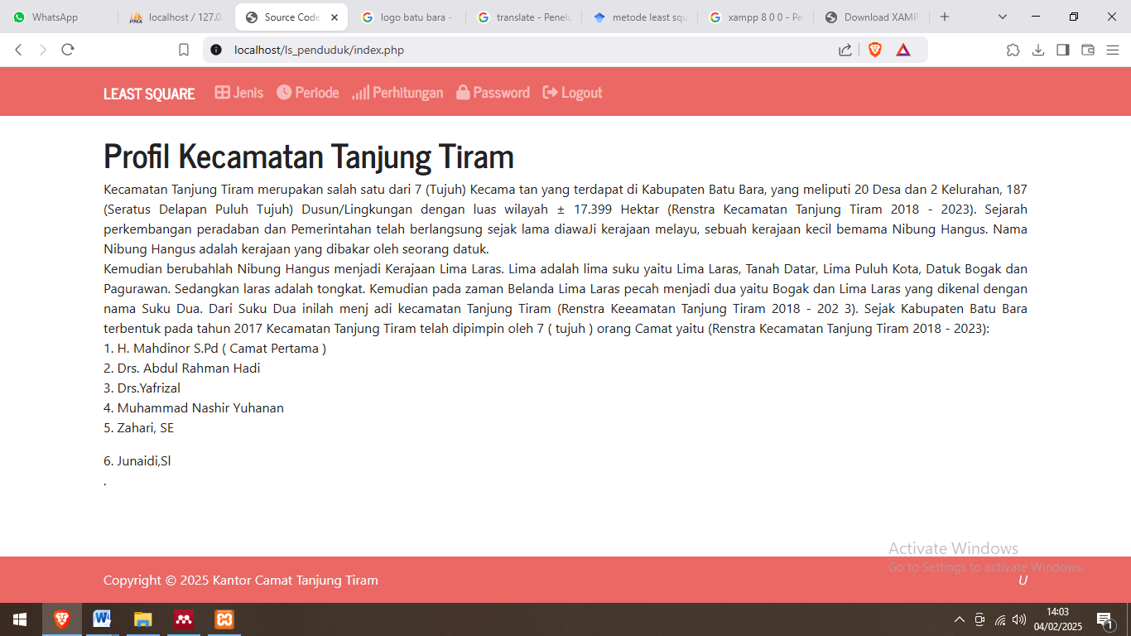

Figure 1. Main Menu Page

**Input Data on Types of Population Growth**

The following displays the form for types of population growth in the population growth forecasting system in Tanjung Tiram District.

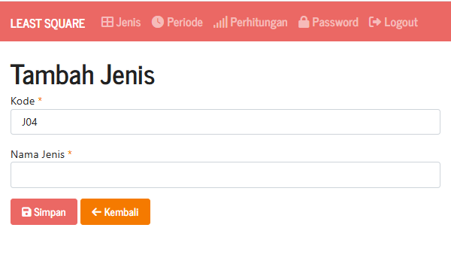

Figure 1. Page Input Data on Types of Population Growth

**Forecasting Results Report**

The following are the results of the population growth data forecast report at the Tanjung Tiram District Head Office using the Least Square Method*.*

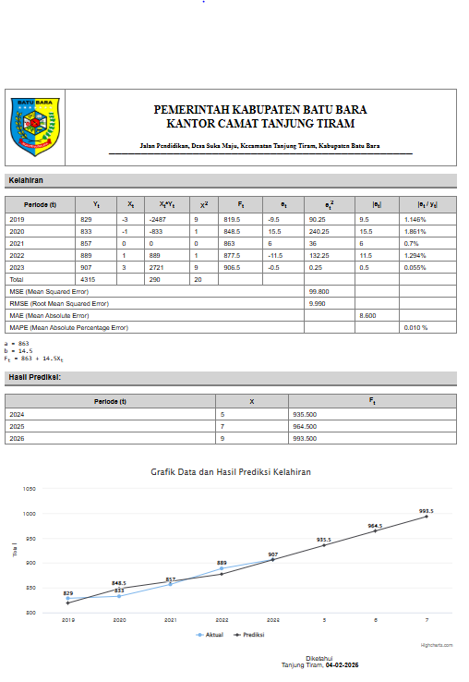

Figure 3. Forecasting Results Report

**CONCLUSION**

The conclusion of this research is that a system built using the PHP programming language and MySQL database can predict population growth in the Tanjung Tiram area using the Least Square method in the following year. The implementation of population growth forecasting at the Tanjung Tiram Subdistrict Office using the Least Square method provides results of forecasting population growth for birth types in 2024 of 936, migration types in 2024 of 142, and arrival types in 2022 of 104 with an error rate below 5%.

**BIBLIOGRAPHY**

[1] A. D. P. Rusman and U. Suwardoyo, *Penerapan Sistem Informasi Berbasis IT Pengolahan Data Rekam Medis untuk Peningkatan Pelayanan di Rumah Sakit*. Penerbit Nem, 2022.

[2] C. Nurita, V. F. H. Nst, R. Novita, and D. Lubis, “Sosialisasi Pencegahan Tindak Asusila Anak Dibawah Umur Di Desa Bandar Rahmat Kecamatan Tanjung Tiram Kabupaten Batubara,” *J. PKM Hablum Minannas*, vol. 1, no. 2, pp. 42–46, 2022.

[3] A. Armawati, “Pengaruh Kepemimpinan, Analisis Jabatan Dan Fasilitas Kerja Terhadap Kinerja Pegawai Pada Kantor Camat Tanjung Tiram Kabupaten Batu Bara,” *Maneggio J. Ilm. Magister Manaj.*, vol. 6, no. 2, pp. 112–122, 2023.

[4] Fi. Zulfarina, H. M. Munthe, and B. Hafi, “Pernikahan Dini Dan Kerentanan Rumah Tangga (Studi Kasus Di Desa Ujung Kubu Kecamatan Tanjung Tiram Kabupaten Batu Bara),” *G-Couns J. Bimbing. dan Konseling*, vol. 8, no. 1, pp. 67–88, 2023.

[5] L. P. Sinambela, *Manajemen Sumber Daya Manusia: Membangun tim kerja yang solid untuk meningkatkan kinerja*. Bumi Aksara, 2021.

[6] H. Wijoyo, D. Sunarsi, Y. Cahyono, and A. Ariyanto, “Pengantar Bisnis,” *Insa. Cendekia Mandiri*, vol. 1, 2021.

[7] A. T. Putri, N. M. Lubis, S. H. B. Hasibuan, S. R. Lingga, S. Surianti, and V. S. Sabillah, “Pemahaman Dan Pemecahan Isu Masalah Kesehatan Terkini,” 2022.

[8] D. Purnamasari, E. R. Arumi, and A. Primadewi, “Implementasi Metode Single Moving Average Untuk Prediksi Stok Produsen,” *JURIKOM (Jurnal Ris. Komputer)*, vol. 9, no. 5, p. 1495, 2022, doi: 10.30865/jurikom.v9i5.4946.

[9] F. K. Zega, T. H. S. Hulu, S. Zebua, and E. Zebua, “Analisis Peramalan (Forecasting) Penjualan Tahu dengan Metode Single Moving Average untuk Mengoptimalkan Produksi pada Pabrik Tahu Nias,” *Innov. J. Soc. Sci. Res.*, vol. 4, no. 1, pp. 2931–2942, 2024.

[10] Y. S. Dewi, J. Matematika, and U. Jember, “Penerapan model least square support vector machine (lssvm) untuk peramalan kasus covid-19 di indonesia,” vol. 12, pp. 304–313, 2023, doi: 10.14710/j.gauss.12.2.304-313.

[11] N. Maulida, “Proyeksi Peningkatan Penjualan Motor Merk Honda Dengan Metode Least Square,” vol. 2, no. 2, 2024.

[12] U. B. Darma, “Implementasi metode least square pada sistem forecasting harga bahan pokok di unit pasar tradisional kota palembang,” vol. 8, no. 1, pp. 291–301, 2023.

[13] W. Apriliah, I. Kurniawan, M. Baydhowi, and T. Haryati, “Prediksi kemungkinan diabetes pada tahap awal menggunakan algoritma klasifikasi Random Forest,” *Sistemasi*, vol. 10, no. 1, pp. 163–171, 2021.

[14] C. Nggadas, Y. P. K. Kelen, and K. J. T. Seran, “Jurnal Manajemen dan Teknologi Informasi ( JMTI ) IMPLEMENTASI METODE LEAST SQUARE DALAM,” vol. 13, no. 2, pp. 74–85, 2023.

[15] B. G. A. Shidiq, M. T. Furqon, and L. Muflikhah, “Prediksi Harga Beras menggunakan Metode Least Square,” *J. Pengemb. Teknol. Inf. dan Ilmu Komput.*, vol. 6, no. 3, pp. 1149–1154, 2022.

[16] R. Dewantara and J. Giovanni, “Analisis Peramalan Item Penjualan dalam Optimalisasi Stok Menggunakan Metode Least Square,” *J. Krisnadana*, vol. 3, no. 1, pp. 59–66, 2023.

[17] E. Arnorce, H. Herdi, and K. P. Sanga, “Analisis Forecasting Penjualan Obat Dengan Menggunakan Metode Least Square ( Studi Kasus Pada Klinik King Medika Pelibaler ),” vol. 1, no. 5, 2023.

[18] E. Sulaeman, “Peramalan Permintaan Metode Least Square Terhadap Penjualan Ekspor Batu Bara Pada Negara Filipina Untuk Tahun 2022-2025,” vol. 3, pp. 616–622, 2025.

[19] E. Sinaga, “Penerapan Metode Least Squares Method Dalam Estimasi Penjualan Produk Elektronik,” vol. 2, no. 2, pp. 44–48, 2023, doi: 10.47065/comforch.v2i2.380.

[20] A. Gaum, A. Putri, S. Lestanti, and M. T. Chulkamdi, “SISTEM FORECASTING PENJUALAN SEPEDA MOTOR DENGAN MENERAPKAN METODE LEAST SQUARE,” vol. 7, no. 2, pp. 1185–1190, 2023.