**STATEMENT OF ORIGINALITY**

I, the undersigned :

Name : Cahya Mutiara Al Azhar

Affiliation : Universitas Dian Nuswantoro

Title of Manuscript : PREDICTING OF BREAST CANCER RISK USING MACHINE LEARNING WITH FEATURE SELECTION THROUGH XGBOOST

Hereby declare that the manuscript I am submitting for publication is my original work. The manuscript :

1. Has not been published in any form or language in any journal, proceedings, or other publication platform.
2. Is not currently under consideration for publication by any other publisher or journal.

I affirm that the all of this manuscript complies with ethical standards in academic writing and research. Should any evidence of a breach of originality arise, I accept full responsibility for any consequences that may follow.

Semarang, Indonesia 02 January 25

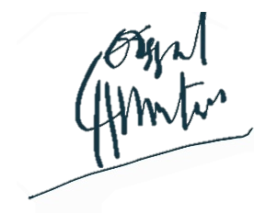

Cahya Mutiara Al Azhar