LANDSLIDE RISK IN JAYAPURA REGENCY USING PARAMETER WEIGHTING METHOD FOR DISASTER MITIGATION

Kristia Yuliawan
Informatic Study, STMIK Pesat Nabire, Nabire, Indoensia
email : christianpesat@gmail.com

Abstract: This study investigates the landslide risk in Jayapura Regency, a region characterized by diverse topography, including lowlands, mountains, and coastal areas, which makes it highly susceptible to landslides. The research identifies key natural factors contributing to landslide risk, such as steep slopes, heavy rainfall, and loose volcanic rocks, especially in the Cyclops Mountains. The significant landslide and flood event in March 2019 in Sentani highlighted the severe impact of these natural hazards, causing extensive loss of life, property damage, and displacement. Additionally, human activities like deforestation, land encroachment, and quarry mining exacerbate the risk. By utilizing Geographic Information Systems (GIS) for mapping and risk assessment, the study offers a comprehensive analysis of landslide vulnerability in the region, providing valuable insights for disaster mitigation planning. The research employs a weighting method in GIS mapping, assigning scores to various parameters, including topography, land use, soil type, rainfall, and geological factors, to create a detailed landslide vulnerability map. The findings reveal that 30.38% of Jayapura Regency is at high risk of landslides, 53.26% at medium risk, and 16.34% at low risk. The BNPB Inarisk method further refines this risk distribution, indicating 4.47% at low risk, 77.95% at medium risk, and 17.75% at high risk. This integrative approach to assessing landslide risk underscores the necessity for informed land use planning, sustainable infrastructure development, and community preparedness to mitigate the impacts of landslides and enhance the region's resilience to natural disasters.

Keywords: Landslide; Jayapura Regency; Parameter Weighting Method; Inarisk BNPB methods; Disaster Mitigation.

Abstrak: Penelitian ini menyelidiki risiko longsor di Kabupaten Jayapura, wilayah yang ditandai dengan topografi yang beragam, termasuk dataran rendah, pegunungan, dan daerah pesisir, yang membuatnya sangat rentan terhadap tanah longsor. Penelitian ini mengidentifikasi faktor alam yang berkontribusi terhadap risiko tanah longsor, seperti lereng curam, curah hujan lebat, dan batuan vulkanik yang longgar, terutama di Pegunungan Cyclops. Peristiwa tanah longsor dan banjir yang signifikan pada Maret 2019 di Sentani menyoroti dampak parah dari bencana alam ini, yang menyebabkan hilangnya nyawa yang luas, kerusakan properti, dan pengungsian. Selain itu, aktivitas manusia seperti deforestasi, perambahan lahan, dan penambangan tambang memperburuk risikonya. Dengan memanfaatkan Sistem Informasi Geografis (GIS) untuk pemetaan dan penilaian risiko, studi ini menawarkan analisis komprehensif tentang kerentanan tanah longsor di wilayah tersebut, memberikan wawasan berharga untuk perencanaan mitigasi bencana. Penelitian ini menggunakan metode pembobotan dalam pemetaan GIS, menetapkan skor untuk berbagai parameter, termasuk topografi, penggunaan lahan, jenis tanah, curah hujan, dan faktor geologis, untuk membuat peta kerentanan tanah longsor yang terperinci. Temuan tersebut mengungkapkan bahwa 30,38% wilayah Kabupaten Jayapura berisiko tinggi mengalami longsor, 53,26% berisiko sedang, dan 16,34% berisiko rendah. Metode BNPB Inarisk lebih menyempurnakan distribusi risiko ini, menunjukkan 4,47% pada risiko rendah, 77,95% pada risiko sedang, dan 17,75% pada risiko tinggi. Pendekatan integratif untuk menilai risiko tanah longsor ini menggarisbawahi perlunya perencanaan penggunaan lahan yang tepat, pembangunan infrastruktur berkelanjutan, dan kesiapan masyarakat untuk mengurangi dampak tanah longsor dan meningkatkan ketahanan kawasan terhadap bencana alam.

Kata kunci: Tanah longsor; Kabupaten Jayapura; Metode Pembobotan Parameter; Metode BNPB Inarisk; Mitigasi Bencana.

INTRODUCTION

Studying landslide risk is beneficial because it helps understand the factors that cause landslides and their relationships to each other. Some of the causes of landslides are steep slopes, very thick and loose types of volcanic rocks that form very thick soils, inappropriate land use patterns, poor drainage systems that can increase pressure on slopes, extreme rainfall, and development that does not pay attention to the environment(1). Other consequences of landslides can lead to the death of people, and damage to infrastructure, buildings, and agriculture(2). Landslides can also cause deforestation, soil erosion, and destruction of natural habitats, all of which can have lasting environmental impacts(3). Research related to landslides can provide benefits in providing information on land use planning and infrastructure development to minimize the risk of landslides(4) About factors affecting landslide risk that can be directed to reduce the potential risk of landslide disasters.
The diverse topography of Jayapura Regency, which includes lowlands, mountains, and coastal areas, is almost the same as many regions in Indonesia. Most of the area of Jayapura Regency is mountainous, including part of the Cyclops Mountains. Its steep slopes and distinct contours increase the chances of landslides, especially during heavy rainfall. One of the most severe landslides and floods occurred in March 2019 in Jayapura Regency, especially in Sentani. Heavy rains caused landslides and overflowed rivers, causing flash floods. Dozens of people died, hundreds were left homeless, and thousands were affected by this disaster. Infrastructure such as houses, bridges, and roads suffered severe damage. Head of BNPB Data and Information Center Sutopo Purwo Nugroho stated that the encroachment of 43,030 people in the Cyclops Nature Reserve since 2003, the use of mixed dry land covering an area of 2,415 ha of Water Storage Area (DTA), the cutting of trees for land clearing, housing, and timber needs, as well as the presence of quarry mines were the causes of this landslide and flood(5).
Landslide disaster mitigation planning can be used to minimize threats and vulnerabilities and optimize capacity. One way to do this is to map landslide-prone areas using the Geographic Information System (GIS) to determine appropriate mitigation strategies based on the condition of the area(6). Mapping using Geographic Information Systems (GIS) is essential for determining disaster mitigation strategies for various natural disasters, such as landslides, droughts, and floods. GIS enables the integration and analysis of a wide range of spatial data, such as topography, land use, soil type, and rainfall patterns, to identify areas vulnerable to such disasters and assess their vulnerability. (7). Some of the factors taken into account in GIS analysis to determine landslide topography and soil type include rainfall, slope, soil type, land use or cover, geology, and groundwater conditions(8).
One of the landslide mapping techniques in GIS is to provide weighting and assessment to map landslide vulnerability. This technique assigns weight to several parameters and assigns a score to each parameter based on its contribution to landslide vulnerability. Then, these parameters are overlaid to generate a landslide vulnerability map(9). Slope slope, soil type, rainfall, land use, and geological factors are some of the parameters used in landslide vulnerability mapping. One of the advantages of the weighting method in mapping landslide vulnerability is that it is so simple and easy to use, that many people can use it(10).
In landslide vulnerability mapping, weighting methods are used to limit each parameter. The process of weighting can be subjective and vary depending on the field of study and research objectives. In this study, the determination of parameters was based on the opinion of experts, who assessed each parameter based on their knowledge of the studied region hit by landslides and factors contributing to landslides. This study focuses on the risk of landslides because landslides are one of the most frequent natural disasters in Jayapura Regency and there are other reasons why they occur the development of modern technology, such as Geographic Information Systems, allows researchers to study landslides more efficiently and effectively(11).

METHOD
2.1 Geology and morphology of the region
In landslide vulnerability mapping, the parameter weighting method involves collecting and analyzing data from various factors that affect landslide disasters. Data for landslide parameters are obtained from InaRISK BNPB, such as geographical data, risk parameters, historical data, and others. InaRISK BNPB is a system developed by Indonesia's National Disaster Management Agency (BNPB) to manage and analyze information related to disaster risk. The location of Jayapura Regency is 129°00'16"-141°01'47" East Longitude, 2°23'10" North Latitude, and 9°15'00" South Latitude.
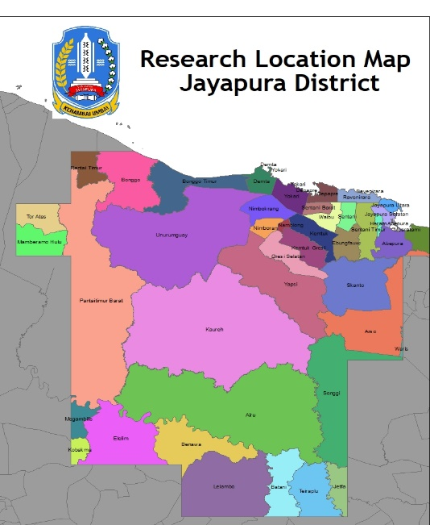
Figure 1. Jayapura Regency Administration Map as a Research Location

2.2 Research Design
Rainfall, geological conditions, soil type, and slope slope are some of the natural factors that can cause landslides, other factors come from human intervention such as land cover(12). The Center for Volcanology and Geological Hazard Mitigation (PVMBG) or similar institutions analyze various geological, topographical, hydrological, and geotechnical factors to compile and determine landslide vulnerability zones. The creation of a map of the vulnerability zone of ground movement must be based on accurate data, as the flow can be seen in Figure 2.

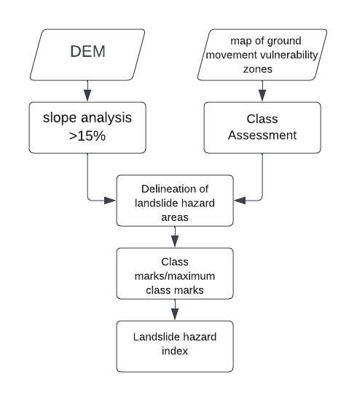

Figure 2. The process flow of making maps based on vulnerability zone maps Land movement (Source: BNPB, 2016)

Table 1. BNPB Inarisk Parameter Data (Source: BNPB, 2016)
Number | Data | Parameter |  | Class | Class Value | Score | Weight
1 | DEM | 1 | Slope | 15 – 30% | 1 | 0.250 | 0.3
 |  |  |  | 30 – 50 % | 2 | 0.500 | 0.3
 |  |  |  | 50 – 70% | 3 | 0.750 | 0.3
 |  |  |  | > 70 % | 4 | 1.000 | 0.3
1 | DEM | 2 | Aspect | Flat | 0 | 0.000 | 0.05
 |  |  |  | North | 1 | 0.125 | 0.05
 |  |  |  | Northwest | 2 | 0.250 | 0.05
 |  |  |  | West | 3 | 0.375 | 0.05
 |  |  |  | Northeast | 4 | 0.500 | 0.05
 |  |  |  | Southwest | 5 | 0.625 | 0.05
 |  |  |  | East | 6 | 0.750 | 0.05
 |  |  |  | Southeast | 7 | 0.875 | 0.05
 |  |  |  | South | 8 | 1.000 | 0.05
1 | DEM | 3 | Length/Shape of Slope | < 200 m | 1 | 0.250 | 0.05
 |  |  |  | 200 - 500 m | 2 | 0.500 | 0.05
 |  |  |  | 500 – 1000 m | 3 | 0.750 | 0.05
 |  |  |  | > 1000 m | 4 | 1.000 | 0.05
2 | Geology | 1 | Rock Type | Alluvial Rock | 1 | 0.333 | 0.2
 |  |  |  | Sedimentary Rock | 2 | 0.667 | 0.2
 |  |  |  | Volcanic Rock | 3 | 1.000 | 0.2
2 | Geology | 2 | Distance from the active fault/fault | > 400 m | 1 | 0.200 | 0.05
 |  |  |  | 300 – 400 m | 2 | 0.400 | 0.05
 |  |  |  | 200 – 300 m | 3 | 0.600 | 0.05
 |  |  |  | 100 – 200 m | 4 | 0.800 | 0.05
 |  |  |  | 0 - 100 m | 5 | 1.000 | 0.05
3 | Land | 1 | Soil Type | Sandy | 1 | 0.333 | 0.1
 |  |  |  | Clayey – Sandy | 2 | 0.667 | 0.1
 |  |  |  | Clay | 3 | 1.000 | 0.1
3 | Land | 2 | Solum | < 30 m | 1 | 0.250 | 0.05
 |  |  |  | 30 – 60 m | 2 | 0.500 | 0.05
 |  |  |  | 60 – 90 m | 3 | 0.750 | 0.05
 |  |  |  | > 90 m | 4 | 1.000 | 0.05
4 | Hydrology | 1 | Annual Rainfall | < 2000 m | 1 | 0.333 | 0.2
 |  |  |  | 2000 – 3000 m | 2 | 0.667 | 0.2
 |  |  |  | > 3000 m | 3 | 1.000 | 0.2

Table 2. Classification of Land Movement Vulnerability Zones and Risk Index Calculation (Source: BNPB, 2016)
Ground Movement Vulnerability zone | Class value | Risk Index
Very Low | 1 | Class Value / Maximum Class Value
Low | 2 | Class Value / Maximum Class Value
Currently | 3 | Class Value / Maximum Class Value
High | 4 | Class Value / Maximum Class Value
Very High |  | Class Value / Maximum Class Value

RESULT AND DISCUSSION

The distribution of landslide risk can be identified and assessed based on several parameters that can affect the potential for landslides. The weighting of these parameters can be done through a risk analysis approach. Some parameters that are generally taken into account in landslide risk weighting such as Slope Slope, Rainfall, Soil Type, Land Use, and Geological Factors.

  - Soil Type
High-Volume Change Clay Soil (HVCCS) is a very common type of soil in the United States and has the potential to cause landslides, especially the expansive type. These landslides can cause a variety of infrastructure problems, including landslides on highway embankments (13). Because of their high porosity and permeability, sandy soils can cause landslides, water-saturated sandy soils making them less stable and prone to landslides than other soil types(14).
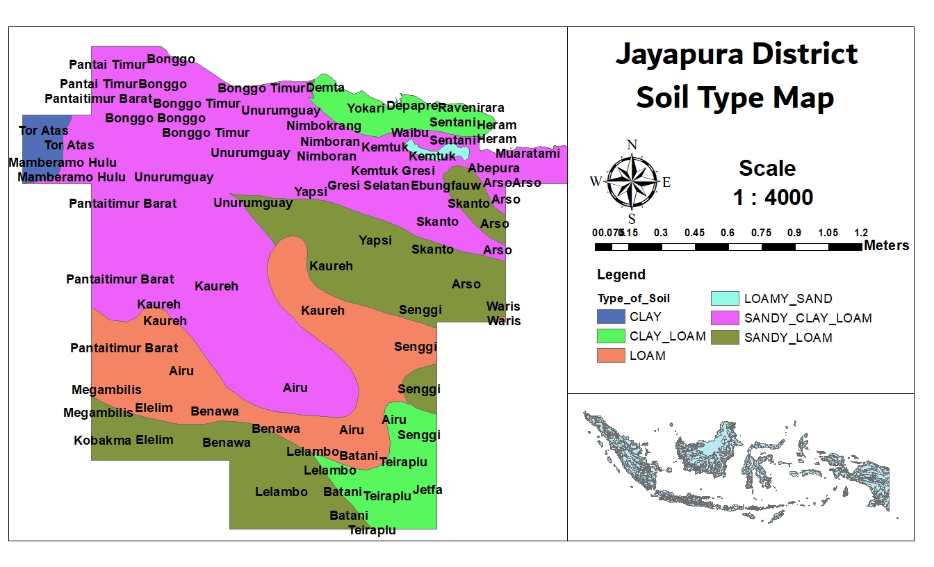
Figure 3. Soil Type Map
The type of soil in Jayapura Regency based on the soil type map issued by FAO (Food and Agriculture Organization) shows that Jayapura Regency consists of several types of soil, namely clay, clay, loamy sandy, sandy clay (sandy clay), and sandy loam.

Tabel 2. Jenis Tanah di Kabupaten Jayapura
No | Type  Of Soil | Shape Area | Persentase  (%) | Classification
1 | Clay | 0.78778 | 1.61 | Not Prone
2 | Clay Loam | 3.518552 | 8.70 | Little
3 | Loam | 4.884181 | 17.58 | Somewhat prone
4 | Loamy Sand | 0.60684 | 0.39 | Keep
5 | Sandy Loam | 6.547394 | 22.81 | Prone
6 | Sandy Clay Loam | 8.580703 | 48.90 | Very Prone
Based on Table 2, it was found that the type of sandy clay soil 48.90% showed that this type of soil was very prone to landslides.

  - Slope
Landslides can be caused by the angle of inclination or the slope of the slope. Landslides occur when the angle of inclination exceeds a critical point, causing instability and downward movement of soil and rocks. Some factors that can cause landslides include the historical slope time of the slope surface, displacement, and slope surface slope angle (15). The angle of inclination, the amount of water present, and the type of soil are factors that can cause slopes to experience landslides, research shows that slopes with an angle of more than 30 degrees are more susceptible to landslides(16). To predict and reduce landslide risk, it is important to understand how slope angle, displacement, and slope angle relate to each other.
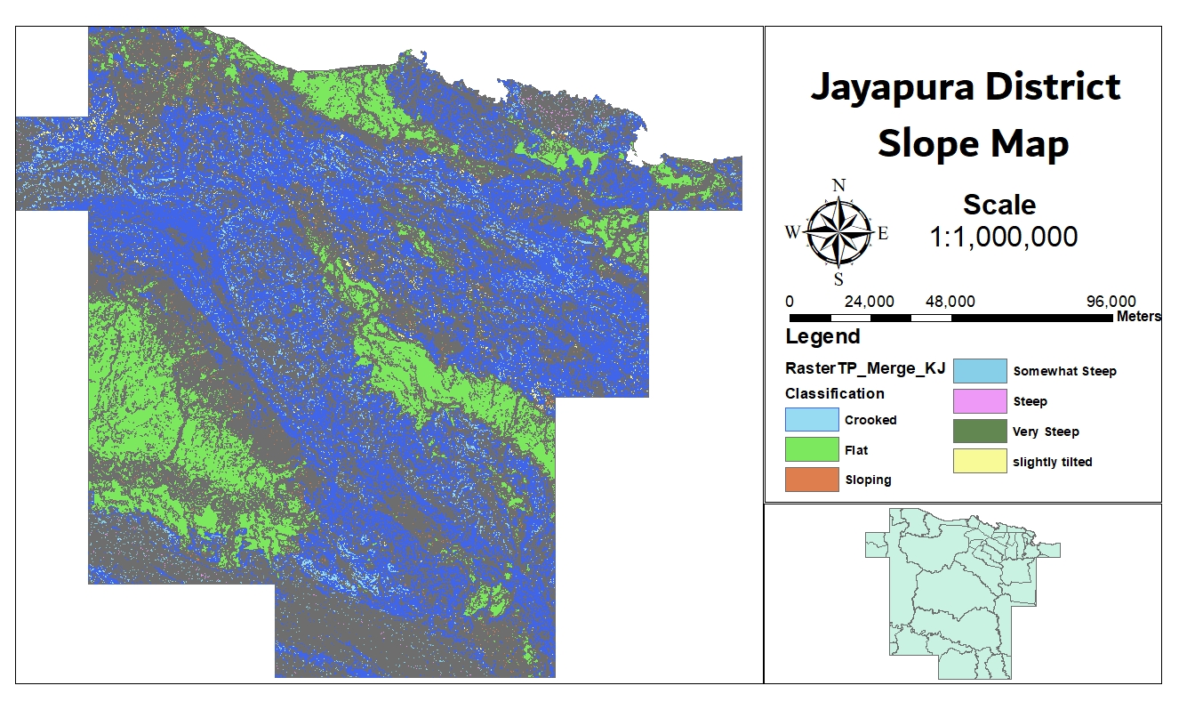
Figure 4. Slope Map
In 1989, Sintamala Arsyad proposed classifying slope slopes based on slope levels. The classification of the slope level is as follows:

Table 3. Classification of slope classes based on Sintamalaya Arsyad, 1989
Class | Slope (value in percent) | Classification
A | 0 – 3 | Flat
B | 3 – 8 | Sloping
C | 8 – 15 | Slightly tilted
D | 15 – 30 | Crooked
E | 30 – 45 | Somewhat steep
F | 45 – 65 | Steep
G | > 65 | Very Steep

Based on the results obtained, it shows that in Jayapura Regency has slopes with slope angles between 15-30 degrees with a crooked classification that has a percentage of 21.70% so this slope angle is very prone to landslides.

Table 4. Slope in Jayapura Regency
Class | Shape Area | Classification | Percentage(%)
A | 0.539441 | Flat | 24.17862
B | 0.439429 | Sloping | 19.69592
C | 0.485399 | Slightly tilted | 21.75637
D | 0.572351 | Crooked | 25.6537
E | 0.156566 | Somewhat steep | 7.017542
F | 0.036912 | Steep | 1.654456
G | 0.000968 | Very Steep | 0.043387

  - Rainfall
Landslides caused by rainfall are the main cause of landslides, especially in mountainous areas. Landslides caused by rainfall can endanger the lives and property of people living in hilly areas (17). The soil can expand due to high rainfall, especially in areas with large soils, such as red-layer weathered soil; This expansion is due to the hydration of soil particles and the influence of particle orientation (18). If there is a lot of rain, the pore pressure of the soil increases, which can cause landslides in areas with weak rock structures or unstable slopes(19). Although heavy rainfall can cause landslides, it is not the only cause. Soil composition, slope stability, and deforestation are other factors that can cause landslides besides rainfall.
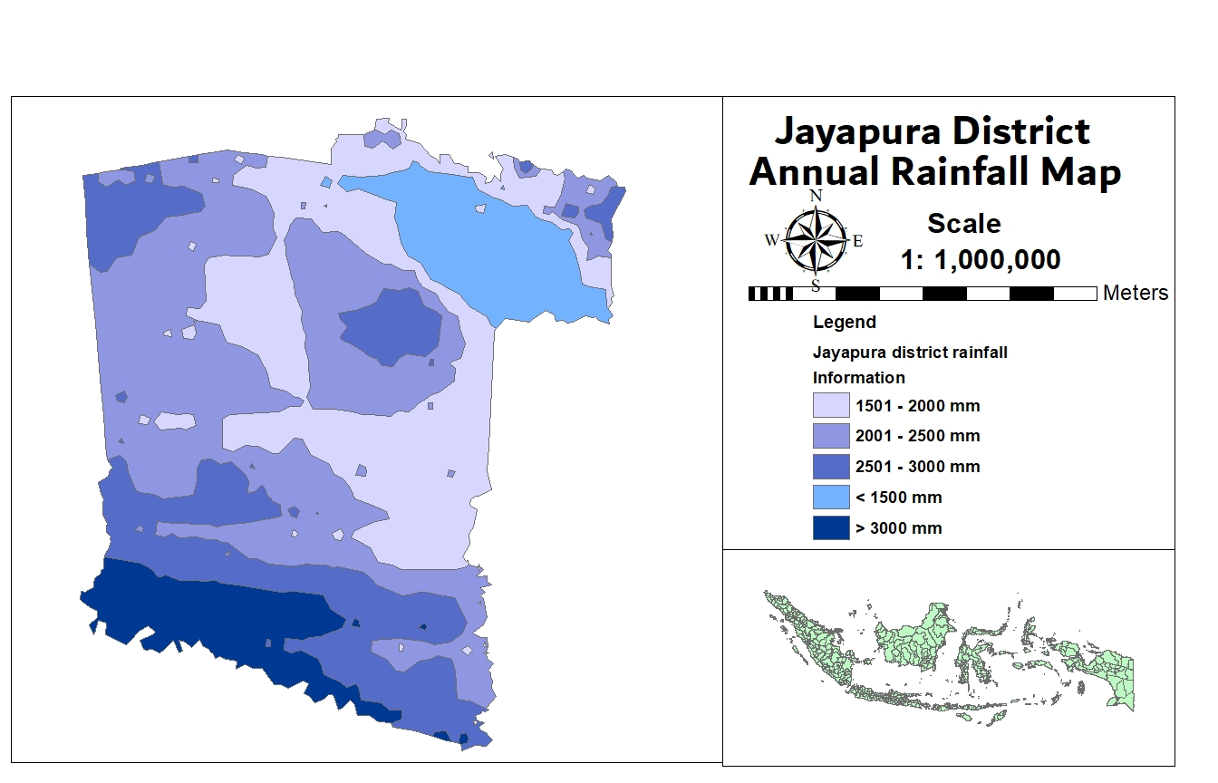
Figure 5. Annual Rainfall Map

The scoring of high rainfall classes influences landslides as follows:

Table 5. Rainfall class classification based on Primayuda, Aris 2006
Score | Category (mm) | Classification
1 | > 3000 | Wet
2 | 2501 – 3000 | Wet
3 | 2001 – 2500 | Moist
4 | 1501 – 2000 | Dry
5 | < 1500 | Very dry

Based on the results obtained, it shows that Jayapura Regency has a yearly rainfall of 25.88% with a wet classification with an area of 4853051685 and 9.42% with a very wet classification with an area of 1768024608 so with this high rainfall with a large area causing Jayapura Regency to be very prone to landslides.

Table 6. Rainfall in Jayapura Regency
Score | Shape Area | Classification | Percentage(%)
1 | 1768024608 | Wet | 9.429587
2 | 4853051685 | Wet | 25.88328
3 | 6739455486 | Moist | 35.94423
4 | 3759353124 | Dry | 20.05014
5 | 1629872649 | Very dry | 8.692767

  - Geological Factor
The geological condition of the Jayapura Regency consists of 25 types of rocks but 4 types of rocks dominate, Alluvium rock types by 18.9% and Unk formation rock types by 17.05%, namely Aurimi Formation rock types by 11.59% and Makats Formation rock types by 10.49%. Alluvium rock is a loose type of soil or sediment that is not consolidated (not cemented into solid rock) and is more susceptible to erosion and movement(20).
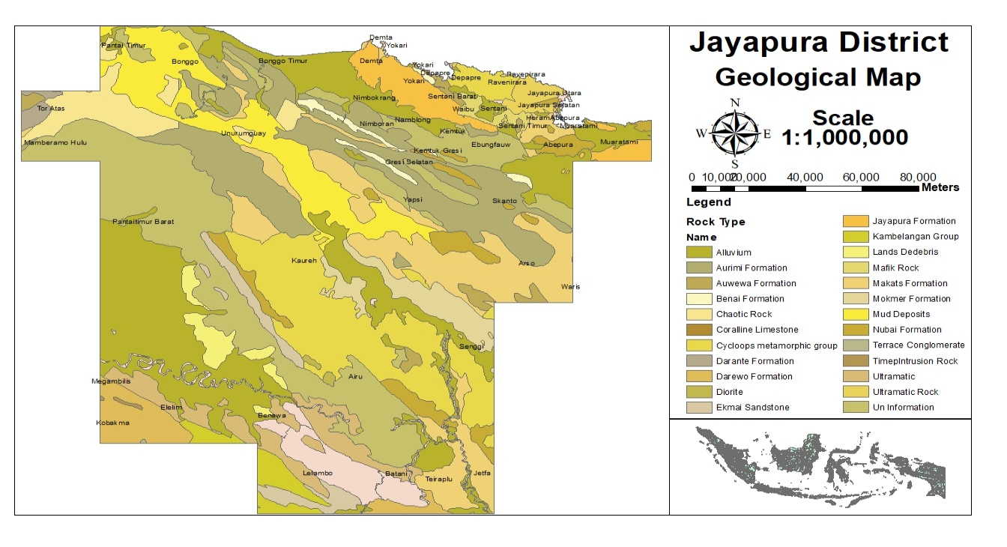
Figure 6. Geologic Map
  - Land Use
Human actions, such as land conversion and improper land management, have been identified as major contributing factors to landslides(21). Uncontrolled forest clearing, for example, can lead to loss of vegetation cover, increase the risk of landslides, and decrease soil stability and surface runoff. This suggests that improper land transformation can be a major cause of landslides(22), In addition, unplanned development due to urbanization and increased development activity can lead to improper and rushed land use, which can increase the risk of landslides(23).
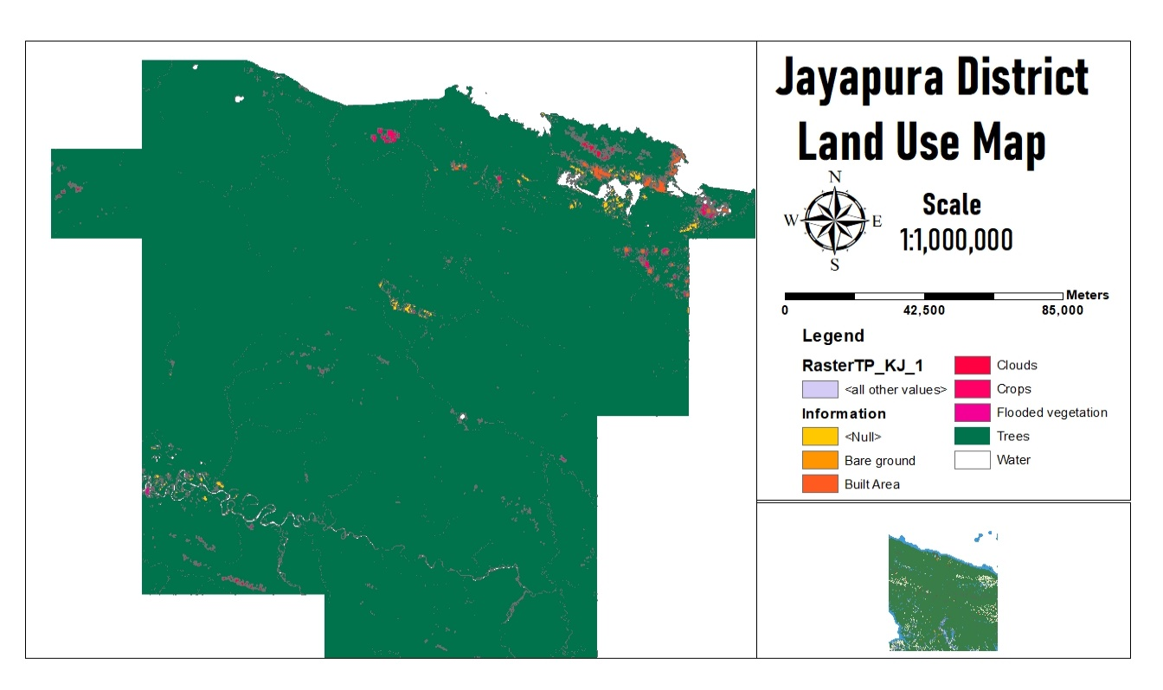
Figure 7. Land Use Map
The results of processing land use data show that in Jayapura Regency the forest domination is 97.30%. Forests have an important role in preventing landslides and maintaining soil stability because massive deforestation can reduce soil resistance to erosion and landslides. In addition to forests, land use in Jayapura Regency is as follows:

Table 7. Land Cover in Jayapura Regency
Class | Information | Shape Area | Percentage(%)
1 | Water | 392,687,984 | 1.440156554
2 | Trees | 26,533,179,236 | 97.30863562
4 | Flooded vegetation | 16,003,053 | 0.058690113
5 | Crops | 104,195,990 | 0.382131728
7 | Built Area | 150,313,064 | 0.551262968
8 | Bare ground | 12,607,282 | 0.046236353

The calculation of landslide risk is based on a combination of rainfall parameters, soil type, slope, geological factors, and land cover involving integrative analysis of these factors. After scoring each parameter to produce a forecast of the landslide risk area in Jayapura Regency can be shown as follows:
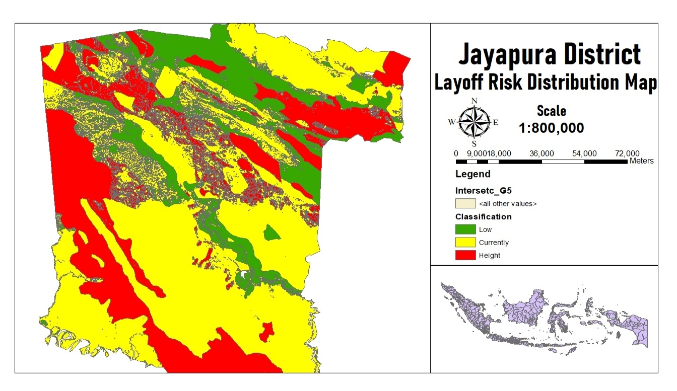
Figure 8. Longsor Risk Spread Map with Parameter Bombing
Based on landslide risk analysis, it shows that the Jayapura Regency area has 16.34% low-risk areas, 53.26% medium-risk areas, and 30.38% high-risk landslides.
  - Distribution of Risk Areas Based on the BNPB Inarisk Method
The BNPB Inarisk method is a risk assessment and mapping technique used to analyze and predict the distribution of areas prone to landslides. This method involves collecting relevant data, using spatial modeling and mapping techniques, assessing risk levels, and validating the results(24).
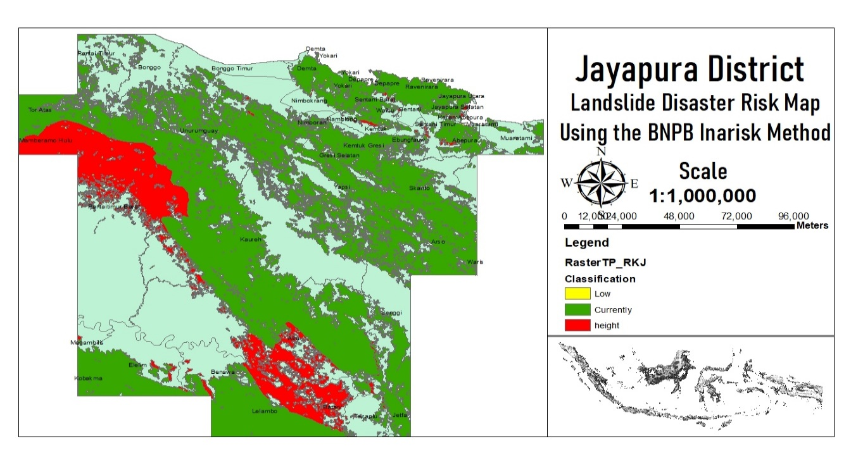
Figure 8. Landslide Risk Map based on BNPB's Inarisk method
Based on the results of landslide risk analysis using the Inarisk method, BNPB showed that the Jayapura Regency area has a low risk of 4.47%, a medium risk of 77.95%, and 17.75% of the high risk of the area of Jayapura Regency.

Table 8. Landslide Risk Level in Jayapura Regency with BNPB Inarisk Method
Level of Risk | Shape Area | Percentage(%)
Low | 749,970,771.85 | 4,47%
Currently | 13,065,316,326.81 | 77,95%
Height | 2,944,846,628.20 | 17,75%

CONCLUSION
The study on landslide risk in Jayapura Regency reveals the intricate interplay of natural and human-induced factors contributing to the region's susceptibility to landslides. Key natural factors include steep slopes, heavy rainfall, and the presence of loose volcanic rocks, which are prevalent in the Cyclops Mountains. The significant landslide and flood event in March 2019, which caused substantial loss of life, property damage, and displacement, underscores the critical need for effective disaster management. Human activities such as deforestation, land encroachment, and quarry mining further exacerbate the risk. By analyzing these factors through Geographic Information Systems (GIS), the study provides a comprehensive understanding of landslide vulnerability, facilitating the development of targeted mitigation strategies. The research highlights the importance of integrative approaches in assessing landslide risk, combining spatial data on topography, land use, soil type, rainfall, and geology. The weighting method used in GIS mapping assigns scores to these parameters to create a landslide vulnerability map, demonstrating that 30.38% of Jayapura Regency is at high risk of landslides, 53.26% at medium risk, and 16.34% at low risk. Additionally, the BNPB Inarisk method indicates a slightly different risk distribution with 4.47% at low risk, 77.95% at medium risk, and 17.75% at high risk. This comprehensive risk assessment underscores the necessity for informed land use planning, infrastructure development, and community preparedness to mitigate the impacts of landslides and enhance the region's resilience to such natural disasters.

BIBLIOGRAPHY

- Naryanto, H. S., Prawiradisastra, F., Ardiyanto, R., & Hidayat, W. (2020). Analisis Pasca Bencana Tanah Longsor 1 Januari 2020 Dan Evaluasi Penataan Kawasan Di Kecamatan Sukajaya, Kabupaten Bogor. Jurnal Geografi Gea, 20(2), 197-213.
- Sumantra, S. B., & Raghunath, P. (2016). Causes of Landslides in Darjeeling Himalayas during June-July, 2015. J. Geogr. Nat. Disasters, 6, 1-5.
- Ramanathan, K., & Vasudevan, N. (2021, April). Anthropogenic causes of landslides and their implications for monitoring. In EGU General Assembly Conference Abstracts (pp. EGU21-6933).
- Aminatun, S., & Muntafi, Y. Settlement Arrangement based on Landslide Risk Analysis in Girirejo, Bantul, Yogyakarta. In Social, Humanities, and Educational Studies (SHES): Conference Series (Vol. 3, No. 1).
- Hardiago, D., & Syafrinaldi, R. F. (2021). Bencana Alam Banjir Dan Tanah Lonsor Di Kabupaten Sentani Jayapura Dalam Prespektif Green Criminology. UIR Law Review, 5(1), 59-75.
- Susetyaningsih, A., & Nurhakim, A. I. (2022, November). Analysis of Landslide Prone Areas as the Basis for Landslide Disaster Mitigation in Bungbulang District of Garut Regency. In IOP Conference Series: Earth and Environmental Science (Vol. 1104, No. 1, p. 012033). IOP Publishing.
- Patriadi, A., Sutra, N., Sugiharto, T. H., & Pamungkas, H. W. (2023). Penerapan Sistem Informasi Geografis (SIG) Dalam Mengidentifikasi Potensi Kelongsoran. Lamahu: Jurnal Pengabdian Masyarakat Terintegrasi, 2(2), 116-122.
- Nasution, A. F. R., Azizah, D. N., Khairani, A., & Akbar, R. (2022). Vulnerability Analysis of Landslide Disaster in Nagari Sungai Pinang, Sungai Nyalo and Mandeh, XI Tarusan Sub-District, Pesisir Selatan. EPICENTRUM, 1(02).
- Es-Smairi, A., El Moutchou, B., El Ouazani Touhami, A., Namous, M., & Mir, R. A. (2022). Landslide susceptibility mapping using GIS-based bivariate models in the Rif chain (northernmost Morocco). Geocarto International, 37(27), 15347-15377.
- Trisnawati, D., Hidayatillah, A. S., Robbany, A. Z., & Pellokila, Y. A. L. (2022, September). Comparative Study of Determination of Landslide Susceptibility Based on Weighting Methods and Analytical Hierarchy Processes in Pringapus, East Ungaran. In IOP Conference Series: Earth and Environmental Science (Vol. 1039, No. 1, p. 012024). IOP Publishing.
- Patriadi, A., Sutra, N., Sugiharto, T. H., & Pamungkas, H. W. (2023). Penerapan Sistem Informasi Geografis (SIG) Dalam Mengidentifikasi Potensi Kelongsoran. Lamahu: Jurnal Pengabdian Masyarakat Terintegrasi, 2(2), 116-122.
- Nasution, A. F. R., Azizah, D. N., Khairani, A., & Akbar, R. (2022). Vulnerability Analysis of Landslide Disaster in Nagari Sungai Pinang, Sungai Nyalo and Mandeh, XI Tarusan Sub-District, Pesisir Selatan. EPICENTRUM, 1(02).
- Davar, S., Nobahar, M., Khan, M. S., & Amini, F. (2022). The development of PSO-ANN and BOA-ANN models for predicting matric suction in expansive clay soil. Mathematics, 10(16), 2825.
- Ariyanto, S. V., & Joni, I. (2019). Zone landslide analysis using geophysical method and analysis of soil type for disaster mitigation in Waru Pamekasan. Indonesian Journal of Applied Physics, 9(02), 68-75.
- Xie, J., Uchimura, T., Wang, G., Shen, Q., Maqsood, Z., Xie, C., ... & Qiao, S. (2020). A new prediction method for the occurrence of landslides based on the time history of tilting of the slope surface. Landslides, 17, 301-312.
- Çellek, S. (2020). Effect of the slope angle and its classification on landslide. Natural Hazards and Earth System Sciences Discussions, 2020, 1-23.
- Ma, S., Shao, X., & Xu, C. (2022). Characterizing the distribution pattern and a physically based susceptibility assessment of shallow landslides triggered by the 2019 heavy rainfall event in Longchuan County, Guangdong Province, China. Remote Sensing, 14(17), 4257.
- Zhou, C., Cui, G., Yin, H., Yu, L., Xu, G., Liu, Z., & Zhang, L. (2021). Study of soil expansion characteristics in rainfall-induced red-bed shallow landslides: Microscopic and macroscopic perspectives. Plos One, 16(1), e0246214.
- Bai, H. L., Feng, W. K., Li, S. Q., Ye, L. Z., Wu, Z. T., Hu, R., ... & Deng, P. C. (2022). Flow-slide characteristics and failure mechanism of shallow landslides in granite residual soil under heavy rainfall. Journal of Mountain Science, 19(6), 1541-1557.
- Hagos, A. A. (2013). Remote sensing and GIS-based mapping on landslide phenomena and landslide susceptibility evaluation of Debresina Area (Ethiopia) and Rio San Girolamo basin (Sardinia).
- Angra Muda, S., & Priyana, Y. (2018). Analisis Potensi Longsor Lahan Di Kecamatan Jatiyoso Kabupaten Karanganyar Provinsi Jawa Tengah (Doctoral dissertation, Universitas Muhammadiyah Surakarta).
- Montgomery, D. R., Schmidt, K. M., Greenberg, H. M., & Dietrich, W. E. (2000). Forest clearing and regional landsliding. Geology, 28(4), 311-314.
- Kanungo, D. P., Singh, R., & Dash, R. K. (2020). Field observations and lessons learnt from the 2018 landslide disasters in Idukki District, Kerala, India. Current Science, 119(11), 1797-1806.
- Fauzia, H., Cahyaningsih, E., Hariyanto, H. N., & Nugraha, S. B. (2021). Distribution of flood risk area in Bodri watershed of Kendal regency. Sriwijaya Journal of Environment, 6(2), 59-69.

