**APPLICATION OF THE DEATH METHOD IN RECIPIENTS OF THE INDONESIA SMART PROGRAM (PIP) IN STATE PRIMARY SCHOOLS 014673 MEKAR SARI VILLAGE**

**Sapriyanti1*, Risnawati2, Endra Saputra3**

1,2,3Program Studi Sistem Informasi, Universitas Royal

*sapriyanti0611@gmail.com*

**Abstract:** Many children drop out or stop going to school due to economic constraints, especially personal costs such as not being able to buy school supplies, education assistance donations, and so on. Therefore, the government took the initiative to help by issuing the Smart Indonesia Program (PIP) with the aim of helping students' personal costs in pursuing education. As the Smart Indonesia Program progressed, many parents complained that the selection of students who received PIP assistance was not on target and did not comply with the provisions. Then the data collection on students receiving Smart Indonesia Program (PIP) assistance at State Elementary School 014673 Mekar Sari Village is also not optimal, namely they still use books and then input them into Microsoft Excel. So a Decision Support System is needed that is used at the State Elementary School 015673 Mekar Sari Village to determine which potential recipients of Smart Indonesia Program assistance are worthy and deserving of assistance. For this reason, the author uses the Multi-Attribute Utility Theory (MAUT) method to find students who deserve PIP benefits in the determination process.

***Keywords:*** *MAUT method; Recipient of PIP, PHP and MySQL assistance.*

**Abstrak:** Banyaknya anak yang putus atau berhenti sekolah dikarenakan kendala ekonomi terutama pada biaya pribadi seperti tidak mampu membeli perlengkapan sekolah, uang Sumbangan Pembinaan Pendidikan, dan lain sebagainya. Maka dari itu pemerintah berinisiatif membantu dengan mengeluarkan Program Indonesia Pintar (PIP) dengan tujuan untuk membantu biaya pribadi siswa dalam menempuh pendidikan. Seiring berjalannya Program Indonesia Pintar banyak kalangan orang tua siswa mengeluh dikarenakan dalam pemilihan siswa penerima bantuan PIP tidak tepat sasaran dan tidak sesuai dengan ketentuan. Lalu pendataan siswa penerima bantuan Program Indonesia Pintar (PIP) di Sekolah Dasar Negeri 014673 Desa Mekar Sari juga belum optimal yaitu masih menggunakan buku lalu di *input* ke *Microsoft Excel*. Maka dibutuhkan sebuah Sistem Pendukung Keputusan yang digunakan pada Sekolah Dasar Negeri 015673 Desa Mekar Sari untuk penentuan calon penerima bantuan Program Indonesia Pintar yang layak dan pantas menerima bantuan. Untuk itu penulis menggunakan metode *Multi-Attribute Utility Theory (MAUT)* untuk mencari siswa yang layak mendapat manfaat PIP dalam proses penentuannya.

**Kata kunci:** metode MAUT; Penerima Bantuan PIP, PHP dan MySQL.

**INTRODUCTION**

Education is one of the things that guarantees life in the future. However, economic constraints often force parents to stop sending their children to school. Therefore, the Ministry of Education and Culture (Kemendikbud) and the Ministry of Religion (Kemenag) took the initiative to provide assistance for the Smart Indonesia Program (PIP). The Smart Indonesia Program (PIP) is a government initiative that provides financial assistance to students aged between 6 and 21 years. This aid is provided to low-income students to reduce strain on parents and keep them in school.

State Elementary School 014673 Mekar Sari Village is a State Elementary School which was established on December 31 2002 and is located in Mekar Sari Village, Kec. Buntu Pane District. Asahan Provincial North Sumatra. In carrying out its activities, the State Elementary School 014673 Mekar Sari Village is under the auspices of the UPTD of the Buntu Pane District Education Service with a total of 302 students from Class I to Class VI with 25 potential recipients of the Smart Indonesia Program (PIP). The data on potential recipients of the Smart Indonesia Program (PIP) assistance are:

Table 1. Data on Prospective PIP Recipients SDN 014673 Mekar Sari Village

|  |  |  |  |
| --- | --- | --- | --- |
| No | NISN | Name Siswa | Class |
| 1 | 3144974 | Zayuka | 1 |
| 2 | 3154560 | Rasya Fachiny | 1 |
| 3 | 3162807 | Ramadhan | 1 |
| 4 | 3157359 | Abid Alfakhri | 1 |
| 5 | 3151984 | Mhd Irfan | 1 |
| 6 | 3179525 | Ardiansya | 1 |
| 7 | 3150688 | Dinda Riana | 1 |
| 8 | 3167087 | Kenzi Wijaya | 1 |
| 9 | 3165058 | Anugrah Senja | 2 |
| 10 | 3144974 | Vanesa | 2 |
| Dst | Dst | Dst | Dst |
| 25 | 3155121 | Indah Laura | 3 |

*Source: SDN 014673 Mekar Sari Village, (2024)*

The background to this research is that many children drop out or stop going to school due to economic constraints, especially personal costs such as not being able to buy school supplies, money from Educational Development Contributions, and so on. Therefore, the government took the initiative to help by issuing the Smart Indonesia Program (PIP) with the aim of helping students with their personal costs in pursuing education. As the Smart Indonesia Program progressed, many parents complained that the selection of students who received PIP assistance was not on target and did not comply with the provisions. Then data collection on students receiving Smart Indonesia Program (PIP) assistance at State Elementary School 014673 Mekar Sari Village is also not optimal, namely they still use books and then input them into Microsoft Excel.

To solve the problems in the research above, a Decision Support System is needed which is used to determine which potential recipients of Smart Indonesia Program assistance are worthy and worthy of receiving assistance. For this reason, the author uses the Multi-Attribute Utility Theory (MAUT) method to find students who deserve PIP benefits. Processing or modifying data using unstructured solving models or rules combined with computer capabilities in interactive services to create a DSS. The technique for making this application is the Multi Attribute Utility Theory (MAUT) technique. This method will later be created for recipients of the Smart Indonesia Program (PIP) assistance at State Elementary School 014673 Mekar Sari Village. The application of SPK has been widely used to solve problems, as was done in research, namely from the results of previous research, the author wanted to help employees in determining recommendations for prospective heads of community health centers using a Decision Support System using the MAUT method to make it easier for employees to determine the best decisions at the Lama Village Community Health Center. Sei Lepan [1].

Future research applying the Multi Attribute Utility Theory (MAUT) method can help pharmacists in making decisions on controlling the inventory of medicines and medical devices very well. So this research is very appropriate in controlling the supply of medicines and medical devices in pharmacies [2].

Future research applying the MAUT method is expected to be able to determine the criteria for employees who are worthy of deactivation, because the MAUT method will carry out a ranking process based on attributes with different weights so that the results are more optimal, then a ranking process will be carried out which will determine the optimal alternative [3]. Providing an assessment of a lecturer's performance, and a consideration of the best alternative from the various existing options. By processing the value of the assessment results using the MAUT method, the final result with the highest ranking will be obtained [4]. To select the best employees using the website-based MAUT method with the CodeIgniter framework and MySQL database and this research was conducted using the RUP methodology [5]. It has been proven that employee performance assessments can help the South Pesisir Population and Civil Registration Service [6]. The calculation results from the MAUT method obtained a result of 0.6731 with alternative A7 in the name of Bintang Simanjuntak as the best alternative that deserves to be accepted as Broadcasting [7]. The decision support system developed can be an effective and efficient tool in helping sellers make the right decisions in selecting used cars to sell to consumers [8]. With the existence of a decision support system using the MAUT method, it can make it easier to determine the recipients of elderly assistance to the people who are entitled to receive it [9]. Based on calculations carried out using the MAUT method, it was found that the MSI Cyborg Katana (B13VGK) laptop is the first ranked gaming laptop with a utility value of 0.7035[10].

A solution is needed in this case in the form of a decision support system in determining recipients of Smart Indonesia Program (PIP) assistance and making it easier for Smart Indonesia Program (PIP) Assistance Recipients at State Elementary School 014673 Mekar Sari Village using the Multi-Attribute Utility Theory (MAUT) model.

**METHOD**

The calculation method uses the MAUT method in determining the Smart Indonesia Program (PIP) at State Elementary School 014673 Mekar Sari Village using the smallest value (Min) and the largest value (Max) in table 1.

Table 1. Find Min and Max Values

|  |  |  |  |  |  |
| --- | --- | --- | --- | --- | --- |
| Alternative/Criteria | C1 | C2 | C3 | C4 | C5 |
| Zayuka | 3 | 3 | 2 | 3 | 1 |
| Rasya Fachiny | 2 | 3 | 4 | 3 | 1 |
| Ramadhan | 2 | 2 | 4 | 1 | 1 |
| Abid Alfakhri | 3 | 2 | 2 | 3 | 1 |
| Mhd Irfan | 1 | 2 | 5 | 3 | 1 |
| Ardiansya | 3 | 3 | 4 | 1 | 1 |
| Dinda Riana | 2 | 3 | 5 | 3 | 1 |
| Kenzi Wijaya | 3 | 5 | 5 | 2 | 1 |
| Anugrah Senja | 3 | 4 | 3 | 3 | 1 |
| Vanesa | 1 | 2 | 2 | 2 | 1 |
| - | - | - | - | - | - |
| Indah Laura | 2 | 5 | 2 | 3 | 1 |
| Max | 3 | 5 | 5 | 3 | 3 |
| Min | 1 | 1 | 1 | 1 | 1 |

Calculating the normalized matrix utility value for each alternative according to its attributes can be seen in table 2.

Table 2. Matrix Normalization Utility Value Results

|  |  |  |  |  |  |
| --- | --- | --- | --- | --- | --- |
| Alternative | C1 | C2 | C3 | C4 | C5 |
| Zayuka | 1,0 | 0,5 | 0,3 | 1,0 | 0,0 |
| Rasya Fachiny | 0,5 | 0,5 | 0,8 | 1,0 | 0,0 |
| Ramadhan | 0,5 | 0,3 | 0,8 | 0,0 | 0,0 |
| Abid Alfakhri | 1,0 | 0,3 | 0,3 | 1,0 | 0,0 |
| Mhd Irfan | 0,0 | 0,3 | 1,0 | 1,0 | 0,0 |
| Ardiansya | 1,0 | 0,5 | 0,8 | 0,0 | 0,0 |
| Dinda Riana | 0,5 | 0,5 | 1,0 | 1,0 | 0,0 |
| Kenzi Wijaya | 1,0 | 1,0 | 1,0 | 0,5 | 0,0 |
| Anugrah Senja | 1,0 | 0,8 | 0,5 | 1,0 | 0,0 |
| Vanesa | 0,0 | 0,3 | 0,3 | 0,5 | 0,0 |
| - | - | - | - | - | - |
| Indah Laura | 0,5 | 1,0 | 0,3 | 1,0 | 0,0 |

Multiply the criteria weight by the utility value to determine the ranking value for each alternative. This is the weight that determines the value of how important the element is with the weight values ​​used can be seen in table 3.

Table 3. Nilai Bobot

|  |  |  |
| --- | --- | --- |
| Nama Kriteria | Nilai Bobot | |
| Penghasilan Orang Tua | 5 | 0.278 |
| Jumlah Tanggungan | 3 | 0.167 |
| Kehadiran | 4 | 0.222 |
| Nilai Rapot | 3 | 0.167 |
| Kelengkapan Berkas | 3 | 0.167 |
| Total | 15 | 1.000 |

The results of multiplying the weight values ​​with the criteria values ​​per alternative can be seen in table 4.

Table 4. Multiplication Results of Each Alternative

|  |  |  |  |  |  |
| --- | --- | --- | --- | --- | --- |
| Alternatif/Nilai Bobot | C1 | C2 | C3 | C4 | C5 |
| 0,28 | 0,17 | 0,22 | 0,17 | 1,17 |
| Zayuka | 0,28 | 0,08 | 0,06 | 0,17 | 0,00 |
| Rasya Fachiny | 0,14 | 0,08 | 0,17 | 0,17 | 0,00 |
| Ramadhan | 0,14 | 0,04 | 0,17 | 0,00 | 0,00 |
| Abid Alfakhri | 0,28 | 0,04 | 0,06 | 0,17 | 0,00 |
| Mhd Irfan | 0,00 | 0,04 | 0,22 | 0,17 | 0,00 |
| Ardiansya | 0,28 | 0,08 | 0,17 | 0,00 | 0,00 |
| Dinda Riana | 0,14 | 0,08 | 0,22 | 0,17 | 0,00 |
| Kenzi Wijaya | 0,28 | 0,17 | 0,22 | 0,08 | 0,00 |
| Anugrah Senja | 0,28 | 0,13 | 0,11 | 0,17 | 0,00 |
| Vanesa | 0,00 | 0,04 | 0,06 | 0,08 | 0,00 |
| - | - | - | - | - | - |
| Indah Laura | 0,14 | 0,17 | 0,06 | 0,17 | 0,00 |

The results of adding up the weight values ​​with the values ​​per criteria for each alternative can be seen in the table 5.

Table 5. Hasil Pekalian dari Setiap Altenatif

|  |  |  |
| --- | --- | --- |
| Nama Siswa | Total | Rank |
| Zayuka Alfaroh | 0,58 | 11 |
| Rasya Fachiny | 0,56 | 12 |
| Yoga Ramadhan | 0,35 | 22 |
| Abid Alfakhri | 0,54 | 14 |
| Mhd Irfan | 0,43 | 21 |
| Ardiansya | 0,53 | 18 |
| Dinda Riana | 0,61 | 10 |
| Kenzi Wijaya | 0,75 | 4 |
| Anugrah Senja | 0,68 | 7 |
| Vanesa Daviera | 0,18 | 24 |
| - | - | - |
| Indah Laura | 0,53 | 16 |

Based on the global priority values ​​from table 5, the highest value obtained as a Smart Indonesia Program (PIP) Assistance Recipient is alternative A14, namely Kesya Fitri Azzahra with a value of 0.90 in 1st place, Salsabila Ayu Hanifa with a value of 0.80 in 2nd place, Reza Arfana with a value 0.78 which refers to each criterion held by State Elementary School 014673 Mekar Sari Village.

The quantitative method uses various mathematical models that rely on historical data or associative variables to determine recipients of the Smart Indonesia Program (PIP) assistance at State Elementary School 014673 Mekar Sari Village. The framework stages carried out are as follows:

The framework stages carried out are in Figure 1.

Identify the Problem

System Analysis

Data Collection

Literature study or library study

System Design

System Implementation and Results

**Figure 1. Research Framework**

**Identify the Problem**

Problem identification is the first step in research. identify problems by explaining what problems were found. Problems identified in this research. Recipients of the Smart Indonesia Program (PIP) assistance are not yet optimal and not on target. Data collection on students receiving Smart Indonesia Program (PIP) assistance in schools is not yet optimal, namely they still use books and then input them into Microsoft Excel.

**Literature study or library study**

After identifying the problem, the carried out a literature study by searching for theoretical foundations obtained from various sources to complete the concepts and theories, so that they have a good and appropriate scientific basis.

**Data Collection**

The data collection stage was carried out after literature study and problem identification. Data collection is a technique or method used by to collect data. Data collection is carried out in order to obtain the information needed to achieve research objectives. Meanwhile, data collection instruments are tools used to collect data. Because it is a tool, the data collection instruments can be interviews and observations. The data taken is data on the amount of meat needed for broiler chickens by taking data from the previous period.

**System Analysis**

After data collection was carried out, a system analysis was created which aimed to determine the decision support system in determining recipients of the Smart Indonesia Program (PIP) assistance. Analysis of the existing system needs to be carried out before analyzing problems, system weaknesses and system needs.

**System Design**

This stage was carried out after the carried out a system analysis and identified the obstacles and problems that occurred. System design an activity of designing and processing an information system from the results of system analysis so that it can meet the needs of users.

**System Implementation and Results**

After the system trial is carried out, the next stage is the system implementation stage, where this stage is the system implementation stage which will later help in reducing and eliminating existing.

Multi Attribute Utility Theory (MAUT) is a scheme in which the final evaluation, v(x), of an object x is defined as the weight added to a value relevant to its dimension value. The expression usually used to call it is utility value. Multi-Attribute Utility Theory is used to convert several interests into numerical values ​​on a scale of 0-1 with 0 representing the worst option and 1 the best. This allows direct comparison of various measures [11].

In summary, the steps in the MAUT method are to determine the relative weight for each criterion, where the total weight is 1.

$$\sum_{ i =1}^{n}{Wi=1……………(1)}$$

Information:

Wi= Criteria Weight

List all alternatives

Calculate the matrix normalized utility value for each alternative according to its attributes:

$$U\left(x\right)= \frac{x- {xi}^{-}}{{xi}^{+}-{xi}^{-}}……………(2)$$

Information:

U (x) = Normalization of alternative weights

xi- = Minimum criteria value (worst weight)

xi+ = Maximum criteria value (best weight)

x = Alternative weights

Multiply the criteria weight by the utility value to determine the ranking value for each alternative:

$${V(x)}^{}=\sum_{i =1}^{n}{Wi.Vi \left(x\right)………………(3)}$$

Where v(x) is the evaluation value of an object i and wi is the weight that determines the value of how important the i element is compared to other elements. Meanwhile, n is the number of elements in normalizing alternative weights.

So to calculate the relative weight for each criterion, use the weight normalization function as follows [12] :

$wi= \frac{w^{'}i^{}}{\sum{w^{i}i}}$…………….(4)

The Multi Attribute Utility Theory (MAUT) method is a scheme in which the final evaluation, v(x), of an object x is defined as the weight added to a value that is relevant to its dimension value. The expression usually used to call it is utility value. Multi-Attribute Utility Theory is used to convert several interests into numerical values ​​on a scale of 0-1 with 0 representing the worst option and 1 the best. This allows direct comparison of various measures [13], as weights that add up to a value relevant to their dimension values. The expression usually used to call it is utility value [14], this method is quantitative comparisons that apply in various fields by combining

different expenses and profits [15]. This method is used to determine value the weight of each criterion, which is then carried out the process of sorting the final scores from highest to lowest (ranking) to determine recommendations best alternative to worst alternative [16]. This MAUT method will be used to process the existing criteria determined previously, and these criteria will be processed into a recommendation [17].

**RESULT AND DISCUSSION**

**Main Menu Use**

This main menu form contains menus and sub menus found in the admin system that have been previously designed, users can choose menus provided by the system that has been created:

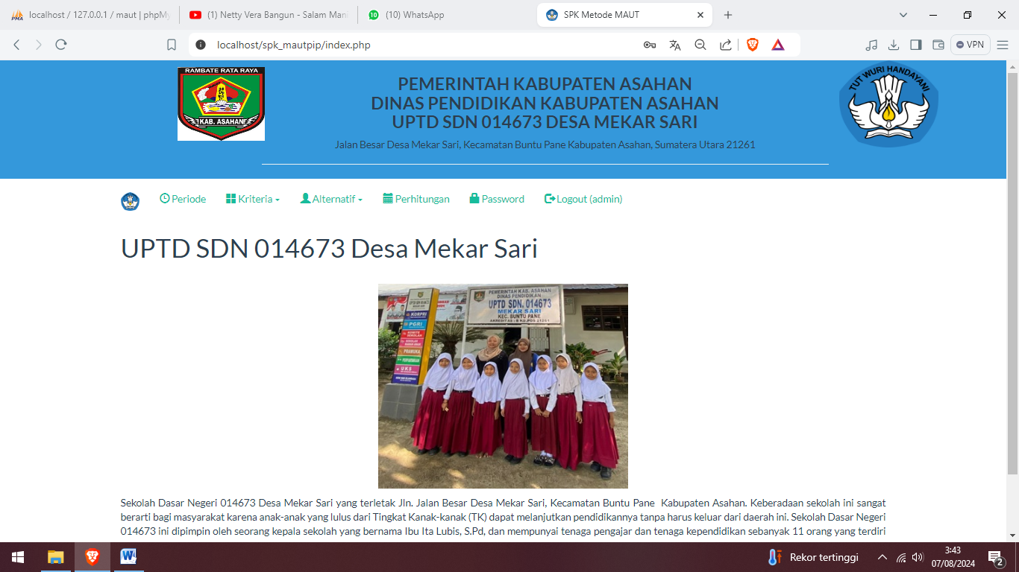

Figure 2. Home page display

**Smart Indonesia Program (PIP) Assistance Recipient Input Form**

The alternative data input form is inputting, editing, canceling and deleting alternative data.

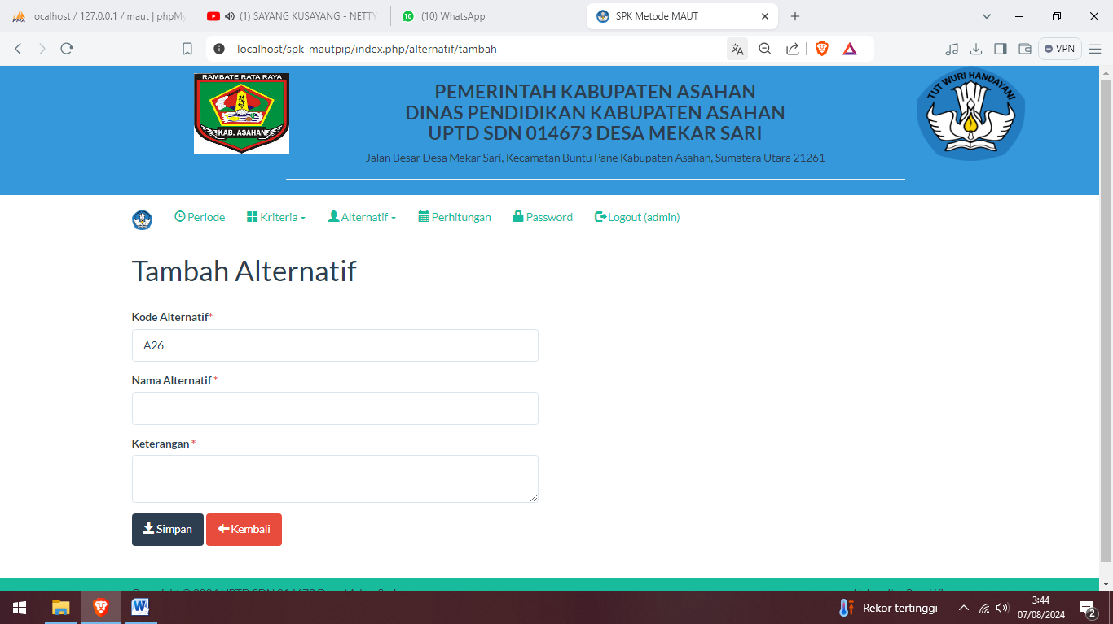

Figure 3. Smart Indonesia Program (PIP) Assistance Recipient Input Form

**MAUT Method Calculation Result Form**

The Multi Attribute Utility Theory (MAUT) Method calculation results form is a display of the results of the criteria and alternative values:

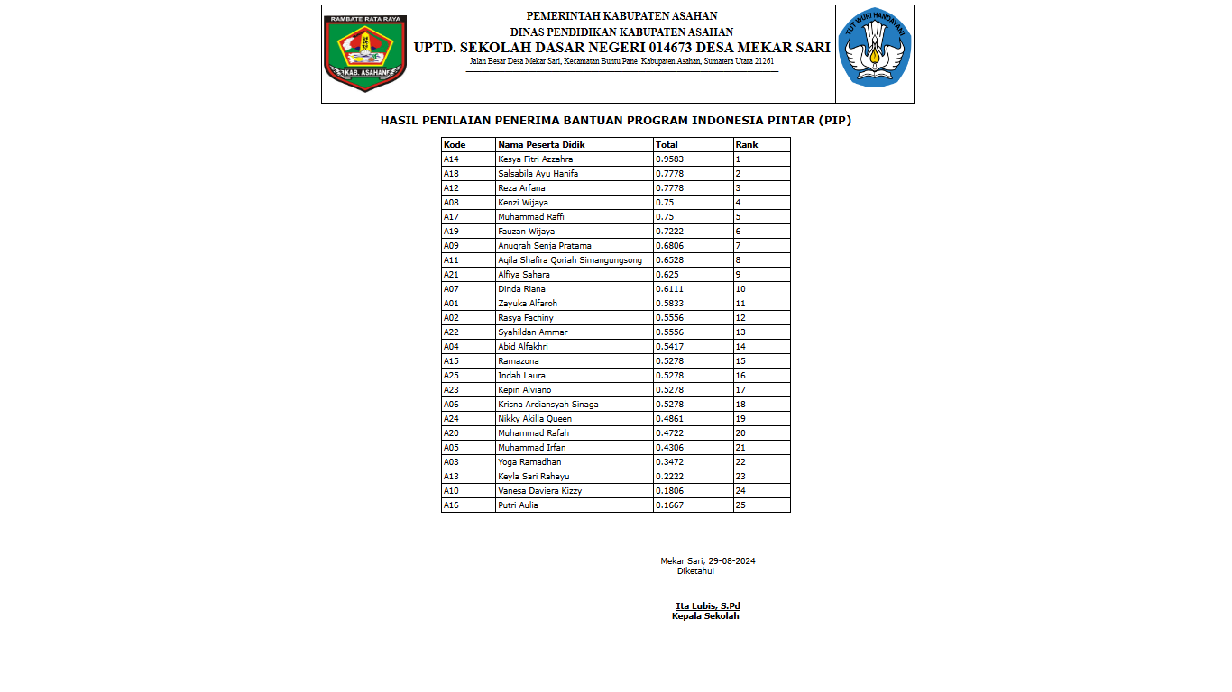

Figure 4. MAUT Method Calculation Result Form

**CONCLUSION**

The decision support system for recipients of the Smart Indonesia Program (PIP) assistance experienced by the school and State Elementary School 014673 Mekar Sari Village uses the MAUT method. The decision support system application for determining Smart Indonesia Program (PIP) Assistance Recipients at State Elementary School 014673 Mekar Sari Village was created to obtain more objective results. The results of calculations using alternative data obtained are that the highest value weight determines the recipient of the Smart Indonesia Program (PIP) assistance, namely Kesya Fitri Azzahra with a value of 0.9583, the second alternative is Salsabila Ayu Hanifa with a value of 0.7778 and the alternative is Reza Arfana with a value of 0.7778.

**ACKNOWLEGMENTS**

I would like to express my gratitude to LPPM Universitas Royal for providing the opportunity to publish this article in the new journal. Additionally, I extend my thanks to the lecturer who has motivated and guided me in the development of this thesis as a valuable source of research

**BIBLIOGRAPHY**

[1] J. Nasution and M. Syahrizal, “Puskesmas Mengunakan Metode Multi Attribute Utility Theory ( Maut ) ( Studi Kasus : Puskesmas Desa Lama Sei Lepan ),” vol. 3, pp. 176–182, 2019, doi: 10.30865/komik.v3i1.1586.

[2] J. Informasi and R. Puspita, “Metode MAUT Dalam Keputusan Pengendalian Persediaan Obat dan Alat Kesehatan,” vol. 4, no. 3, pp. 5–9, 2022, doi: 10.37034/infeb.v4i3.148.

[3] J. Media and I. Budidarma, “Penerapan Metode MAUT Dalam Pemilihan Karyawan yang di Non-Aktifkan di Masa Pandemi,” vol. 6, no. April, pp. 969–978, 2022, doi: 10.30865/mib.v6i2.3909.

[4] D. Aldo, “Sistem Pendukung Keputusan Penilaian Kinerja Dosen Dengan Menggunakan Metode MAUT,” *Jursima*, vol. 7, no. 2, p. 76, 2019, doi: 10.47024/js.v7i2.180.

[5] A. Pratama, D. P. Kesuma, P. Studi, S. Informasi, and U. M. Data, “PEnerapan Sistem Pendukung Keputusan Dengan,” pp. 510–518, 2023.

[6] F. El Khair, S. Defit, and Y. Yuhandri, “Sistem Keputusan dengan Metode Multi Attribute Utility Theory dalam Penilaian Kinerja Pegawai,” *J. Inf. dan Teknol.*, vol. 3, pp. 215–220, 2021, doi: 10.37034/jidt.v3i4.155.

[7] K. Suhada, A. Sadikin, I. K. Dewi, and F. Nugroho, “Penerapan Metode MAUT pada Pemilihan Broadcasting Terbaik,” vol. 7, no. April, pp. 641–649, 2023, doi: 10.30865/mib.v7i2.5937.

[8] R. W. Dari, S. Sapriadi, N. A. Rahmi, P. Ayu, and W. Purnama, “Jurnal KomtekInfo Metode Multi Attribute Utility Theory ( MAUT ) untuk Sistem Pendukung Keputusan Pemilihan Mobil Bekas,” vol. 10, no. 2, 2023, doi: 10.35134/komtekinfo.v10i2.378.

[9] J. Jureksi, U. Menentukan Penerima Bantuan Lansia Berbasis Web, N. Lutfiyani, R. Sri Hayati, K. Kunci, and S. Pendukung Keputusan, “Penerapan Metode Multy Attribute Utility Theory(Maut),” *Januari*, vol. 2, no. 1, pp. 337–350, 2024.

[10] W. Ardiantito, S. Ramadhani, and S. Jesika, “Implementasi Metode Multi-Attribute Utility Theory (MAUT) dalam Pemilihan Laptop Gaming Implementation of Multi-Attribute Utility Theory (MAUT) Method in Gaming Laptop Selection,” *J. Bumigora Inf. Technol.*, vol. 6, no. 1, pp. 73–84, 2023, doi: 10.30812/bite/v6i1.4083.

[11] M. H. Botutihe, Z. Biki, S. Informasi, U. Pohuwato, T. Informatika, and U. I. Gorontalo, “Metode Maut Untuk Sistem Pendukung Keputusan Seleksi Awal Penerima Bantuan Beasiswa Program Indonesia Pintar Program Indonesia pintar adalah pemberian bantuan tunai pendidikan untuk anak usia sekolah dari keluarga yang mendapat Kartu penelitian ini adalah.”

[12] “Bahan Sempro 3 (2).” .

[13] I. T. Silitonga, M. Syahril, and A. Calam, “Penerapan Metode MAUT Untuk Menentukan Kader Partai Terbaik,” *J. Sist. Inf. Triguna Dharma (JURSI TGD)*, vol. 1, no. 4, p. 332, 2022, doi: 10.53513/jursi.v1i4.5393.

[14] O. N. Silalahi, N. Y. L. Gaol, and J. Halim, “Sistem Pendukung Keputusan Menentukan Kualitas Pupuk Menggunakan Metode Maut,” *J. Sist. Inf. Triguna Dharma (JURSI TGD)*, vol. 2, no. 3, p. 394, 2023, doi: 10.53513/jursi.v2i3.6260.

[15] W. H. B. Lumbanbatu, J. Sitorus, and M. Mesran, “Penerapan Metode Maut Dengan Pembobotan Roc Dalam Penentuan Calon Mahasiswa Penerima Kip, vol. 7, no. 1, pp. 60–67, 2022, doi: 10.32767/jusim.v7i1.1617.

[16] M. M. Boangmanalu, M. Mesran, and B. Purba, “Implementasi Metode MAUT Dalam Seleksi Calon Marketing Retail dengan menerapkan pembobotan ROC,” *J. Ilm. Media Sisfo*, vol. 16, no. 2, pp. 81–91, 2022, doi: 10.33998/mediasisfo.2022.16.2.1264.

[17] K. J. Hondro, “Implementasi metode MAUT pada proses rekrutmen tenaga kerja honorer (studi kasus: dinas perkebunan SUMUT),” *JIKTEKS J. Ilmu Komput. dan Teknol. Inf.*, vol. 1, no. 1, pp. 36–48, 2022.