IMPLEMENTASI E-CRM DALAM MENINGKATKAN PENJUALAN MINYAK VIRGIN COCONUT OIL (VCO) PADA INDUSTRI MAZZURI BATU BARA

Siti Fadillah Khairani^{1*}, Herman Saputra ², Rohminati ³
^{1,2,3}Program Studi Sistem Informasi, Universitas Royal
email: sitifadilakharani@gmail.com

Abstract: The services provided by the Mazzuri Batu Bara Industry are still not effective, so the Mazzuri Batu Bara Industry has not received maximum customers. Industry owners here are required to look for more new customers than before and keep old customers by providing the latest information and maintaining good communication. Then, after the development of the Virgin Coconut Oil (VCO) oil industry, the level of industrial competition will definitely become stronger so that entrepreneurs must think of new strategies to improve the quality of E-CRM and retain their consumers. Therefore, a system is needed that supports the product marketing process to customers using the Customer Relationship Management (CRM) method, via internet technology. This application will help the Mazzuri Batu Bara Industry in promoting products, maintaining good relationships with customers, getting new customers, increasing customer loyalty, providing services and making it easier for customers to access the products offered. Apart from that, it will make it easier for the Mazzuri Batu Bara Industry to sell products that suit customer needs and desires. Customer Relationship Management (CRM) is a strategy for maintaining good relationships with customers, both new and old customers. Companies must also know how to win the hearts of customers by prioritizing customer satisfaction, such as providing all the latest information about VCO oil and providing the best service to customers.

Keywords: increasing vco oil sales; e-crm; mazzuri coal industry.

Abstrak: Dalam pelayanan yang dilakukan Industri Mazzuri Batu Bara juga masih belum belum efektif sehingga Industri Mazzuri Batu Bara belum mendapatkan pelanggan secara maksimal. Pemilik industri disini dituntut untuk mencari pelanggan baru dengan lebih banyak dari sebelumnya dan menjaga pelanggan lama dengan cara memberikan informasi terbaru serta menjaga komunikasi yang baik. Kemudian, setelah berkembangnya industri minyak Virgin Coconut Oil (VCO) sudah pasti tingkat persaingan industri menjadi lebih kuat sehingga pengusaha harus memikirkan strategi baru untuk meningkatkan kualitas E-CRM dan mempertahankan konsumennya. Oleh karena itu dibutuhkan sebuah sistem yang mendukung proses pemasaran produk kepada pelanggan menggunakan metode Customer Relationship Management (CRM), melalui teknologi internet. Aplikasi tersebut akan membantu Industri Mazzuri Batu Bara dalam mempromosikan produk, menjaga hubungan baik dengan pelanggan, mendapat pelanggan baru, meningkatkan loyalitas pelanggan, memberikan pelayanan, dan kemudahan kepada pelanggan dalam mengakses produk yang ditawarkan. Selain itu, akan memudahkan Industri Mazzuri Batu Bara dalam menjual produk yang sesuai dengan kebutuhan dan keinginan pelanggan. Customer Relationship Management (CRM) adalah suatu strategi untuk menjaga hubungan yang baik kepada pelanggannya, baik itu pelanggan baru maupun pelanggan lama. Perusahaan juga harus mengetahui cara untuk mendapatkan hati pelanggan dengan cara mengutamakan kepuasan pelanggan, seperti memberitahu semua informasi terbaru tentang minyak VCO maupun dengan cara pelayanan terbaik untuk pelanggan.

Kata kunci: meningkatkan penjualan minyak vco; e-crm; industri mazzuri batu bara.

INTRODUCTION

Web and internet-based technology has now become an important necessity in life activities. Every day it continues to develop, the development that is being talked about and discussed now is technology that leads to information systems and web-based applications. With the implementation of web-based technology, communication between users, admins and developers is wider because the standby time of information systems and web-based applications is very high, some even up to 24 hours per day in one week, namely the web uses advanced servers [1].
Industri Mazzuri Batu Bara is one of the UDs that sells several types of products, namely coconut oils and where the shop has attractive prices. Industri Mazzuri Batu Bara does not yet have a strategy to get new customers to find out information about the products at Industri Mazzuri Batu Bara, customers must ask other customers who have purchased at Industri Mazzuri Batu Bara, Tinggi Raja District, meanwhile to maintain UD's regular customers. Nazwan Tinggi Raja District provides discount prices to customers who frequently visit or shop at Industri Mazzuri Batu Bara.
Currently the sales and ordering process is still done manually and customers come directly to Industri Mazzuri Batu Bara, Tinggi Raja District, then there is no customer data storage so it is less effective and efficient in managing customers. As for Industri Mazzuri Batu Bara sales data table 1.
Table 1. Industri Mazzuri Batu Bara in 2023
No | Month | Data Sale
No | Month | 250ml (Soul) | 500 ml (Soul)
1 | Oktober | 32 | 110
2 | November | 38 | 120
3 | Desember | 33 | 97
4 | Januari | 34 | 91
5 | Februari | 40 | 98
6 | Maret | 42 | 101
7 | April | 53 | 104
Source : Industri Mazzuri Batu Bara, (2024)
Therefore, Industri Mazzuri Batu Bara really needs a special strategy regarding the right customers and marketing electronic products using E-CRM with applications to make it easier for customers to find out the information available at Industri Mazzuri Batu Bara and displays features such as discounts, promos, ratings, live chat and coins to satisfy customers so that customers buy products in the shop repeatedly and customers feel loyal to Industri Mazzuri Batu Bara with CRM can help Industri Mazzuri Batu Bara in customer loyalty, so entrepreneurs must think of new strategies to improve sales quality and retain customers.
Customer Relationship Management (CRM) is an approach that views that customers are the core of their business and the success of a company depends on how they manage their relationships effectively. Customer Relationship Management (CRM), which aims to increase long-term company profitability growth. Relationships with customers (customer relations), where this includes activities such as providing information to customers or customers, explaining procedures, procedures, times for holding events [2].
Previous research with the title "Implementation of E-CRM in Retaining Customers at Key Distro Kisaran Stores", the results of this research aim to apply the concept of Customer Relationship Management (CRM) to Key Distro Stores in order to create loyalty and improve relationships with customers . The results of this research activity are in the form of implementing CRM in the form of a Web-based application so that later the sales transaction and product delivery process becomes easier and more effective [3].
Further research with the title "Customer Service Transformation: Implementation of E-CRM in the Website-Based Indonesian Tea Business", the results of this research are expected to provide practical guidance for the Indonesian Tea business and other companies in facing intense business competition. In addition, this research also provides insight into how website-based CRM technology can improve business performance and overall customer satisfaction [4].
Further research with the title "Information System for Implementing E-CRM to Improve the Quality of Customer Service at Family Box Pekanbaru", the results of this research will provide the company with detailed information about customers. This information is in the form of customer personal data, criticism, suggestions and whatever the customer needs, so that the company can provide responses, services and changes that are in accordance with what the customer wants [5].
The next research is "Customer Relationship Management Strategy To Retain Customers In Wholesale Muslim Website Based", the results of research conducted on Muslim wholesale stores can help increase customer loyalty, maintain good relationships with customers. Furthermore, it will make it easier for Muslim wholesale stores to sell fashion products that suit customer desires [6].
The next research is "Web-Based CRM Design at UD. Arises Fortune, the results of this research apply Customer Relationship Management can improve service to customers at UD. Generates sustenance by providing information about products, account registration, product orders, media comments and product ratings, chat, coupon vouchers, discounts, and product catalogs as product promotion media [7].
The next research is entitled "Implementation Of E - CRM Up - Selling And Cross - Selling Strategy At Mitra Se-jahtera Store" The goal achieved at this stage is the operability of the system design results that have been created. With this CRM design and UpSelling and Cross-Selling strategies, you can increase sales to meet customer needs. This system was created to make it easier for Mitra Sejahtera Stores to sell products, process data computerizedly and improve service to customers [8].
The next research is entitled "Application Of CRM Methods For Sales Systems Shoes And Sandal Products At Koaki Store".. The goal to be achieved in this research is to make it easier for Koaki Shop to provide online promotions to get new customers. [9].
The next research is entitled "Application of Customer Relationship Management (CRM) in a Web-Based Cosmetic Sales Information System". The result is a web-based CRM system application that can manage customer data, product promotions, product sales, data and customer service management which is used to store customer questions [10].
In connection with this, a special strategy is needed for this information system, which is expected to be used by shops to improve product sales services. Therefore, the author intends to conduct research in the form of a thesis with the title "Application of E-CRM to Increase Consumer Interest in Industri Mazzuri Batu Bara, Tinggi Raja District".

METHOD
The framework is the stages or flow carried out in solving problems that will be carried out in designing E-CRM for Industri Mazzuri Batu Bara using the PHP and MySQL programming languages. The framework stages carried out are in Figure 1.
:
Problem Identification
System Design

System Analysis
Data Collection
Testing
System Evaluation
System Implementation

Figure 1. Research Framework
Based on the research framework above, each stage is described as follows:
- Problem Identification
At this stage the researcher identifies what problems occur in the Industri Mazzuri Batu Bara.
- Data Collection
At the data collection stage, the data obtained are obtained through observation, interviews and literature studies.
- System Analysis
At this stage an analysis of the running system is carried out. Thus, it is hoped that researchers can find problems that occur in the system so that it makes it easier for Industri Mazzuri Batu Bara to serve customers.
- System Design
System design is a stage of the planned sales system. In designing a system that will be designed in accordance with the objectives of the Industri Mazzuri Batu Bara so that it can overcome existing problems.
- System Creation
In the creation of this system is the stage that converts the results of previous analysis and design into a programming language that is understood by the computer.
- System Trials
System Trials are carried out after the system design process has been completed. This is to find out whether the system that has been created is as expected.
- System Implementation
In this stage, it will be discussed how users will use the system and explained about the flow of using the application so that users can optimize the system that has been created again.
The process in this research is focused on the application for selling clothes, shirts, trousers, school uniforms and shoes at Industri Mazzuri Batu Bara. This system is made website-based by implementing E-CRM and strategy. This system is useful for improve service to customers and maintain good relations between company. This system will be created according to customer requirements attract and retain Industri Mazzuri Batu Bara customer. In this research method there is a method carried out to find a solution to the problem what happened at Industri Mazzuri Batu Bara. That The research method used for this research is qualitative methods. Qualitative methods are methods which emphasizes more on aspects deep understanding of a problem. The type of research used is tends to be descriptive research analyze. Descriptive research is research This is done by collecting data in the form in the form of written words, spoken words and images. This research takes objects research at Industri Mazzuri Batu Bara.

RESULT AND DISCUSSION

Home Page
The home page is the initial page found after users enter the Industri Mazzuri Batu Bara website, here is the home page display:
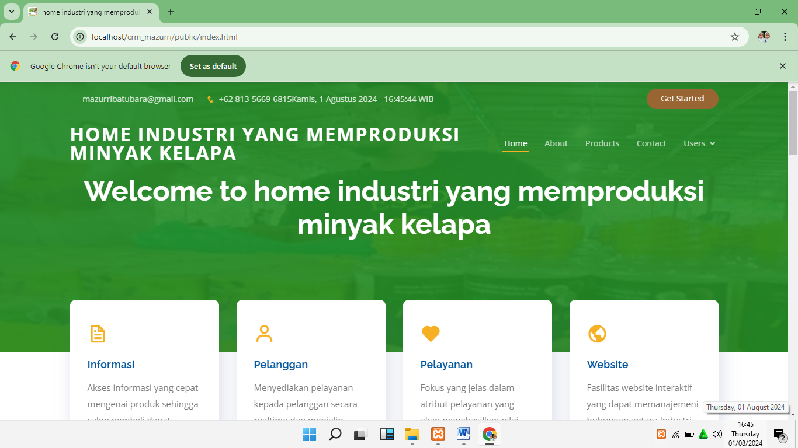
Figure 1. Home page display

All Products Page
The all products page is a page that contains a list of products on the Industri Mazzuri Batu Bara Website. The following is a page view of all products.
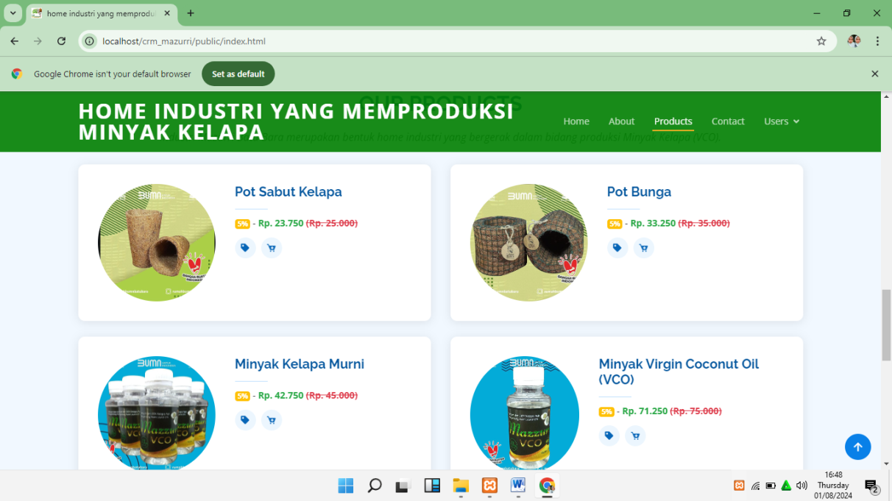
Figure 2. All Products Page Display

Shopping Cart Page
The shopping cart page is a page that contains a list of products to be purchased. The following displays the shopping cart page:
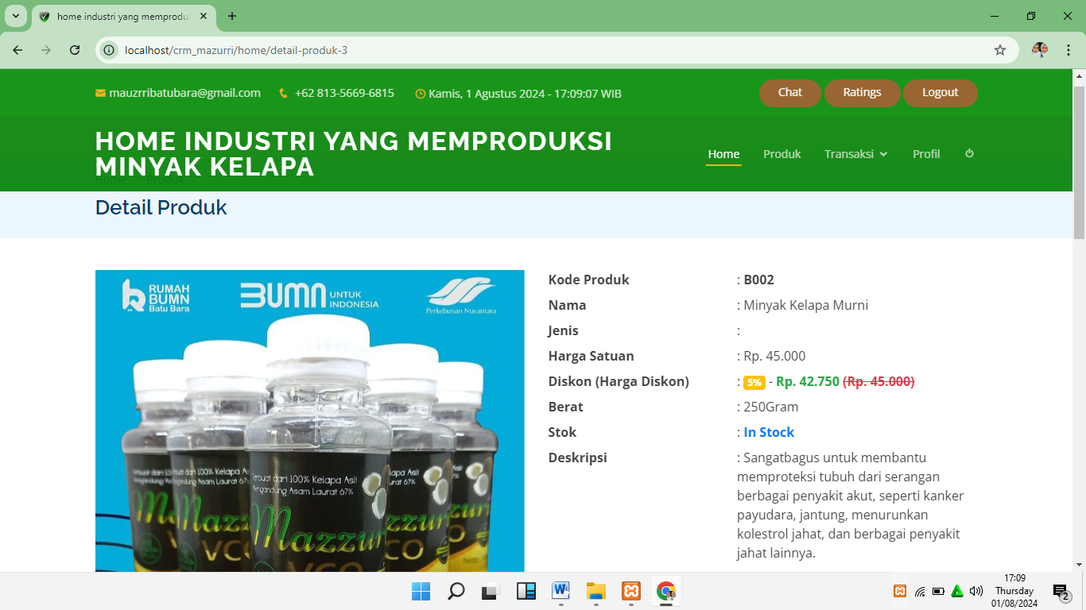
Figure 3. Shopping Cart Page View

Shopping Cart Page
The shopping cart page is a page that contains a list of products to be purchased. Here's what the shopping cart page looks like:
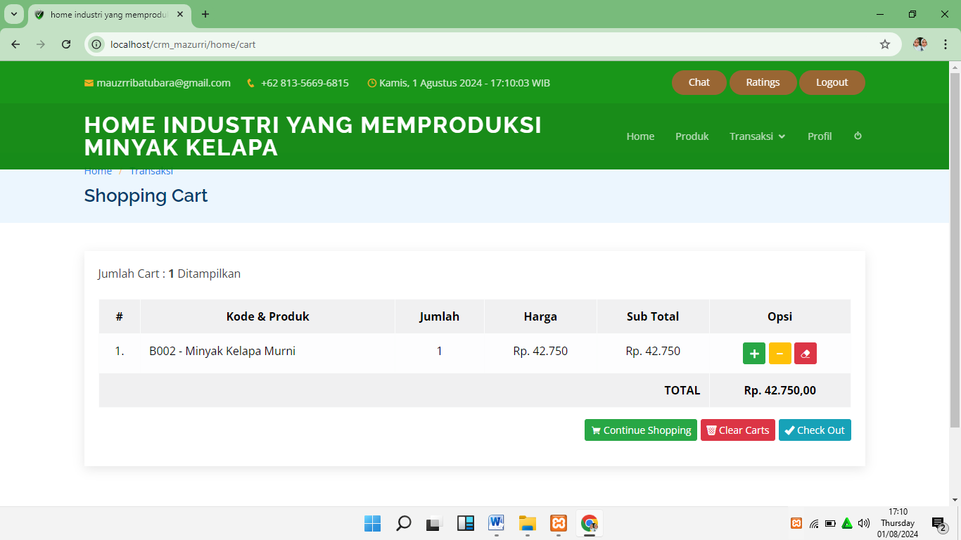
Figure 4. Shopping Cart Page View

Checkout Page
When the buyer has finished shopping, he will go to the checkout page to complete all shipping data, following the checkout page display:
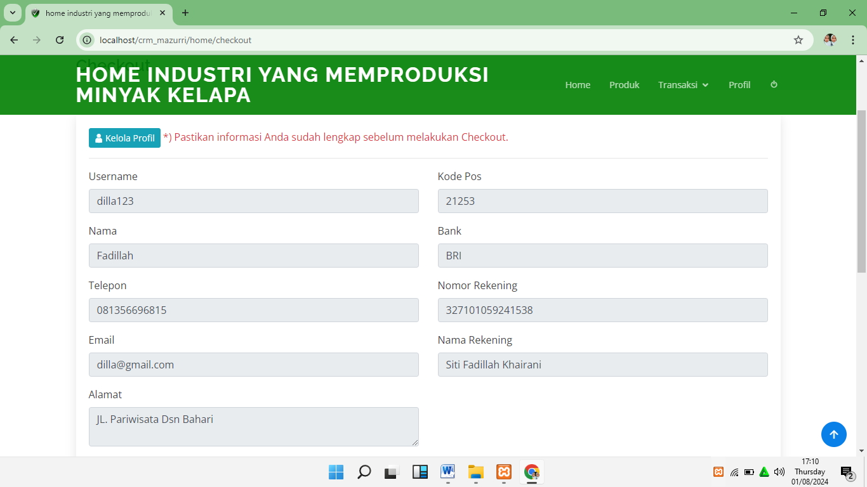
Figure 5. Checkout page display

Customer Order Data Report Page to Owner
The customer order data report will appear when all customers check out, it will go to the order data page and will be processed by the owner, the following is what the customer order data page looks like to the owner:
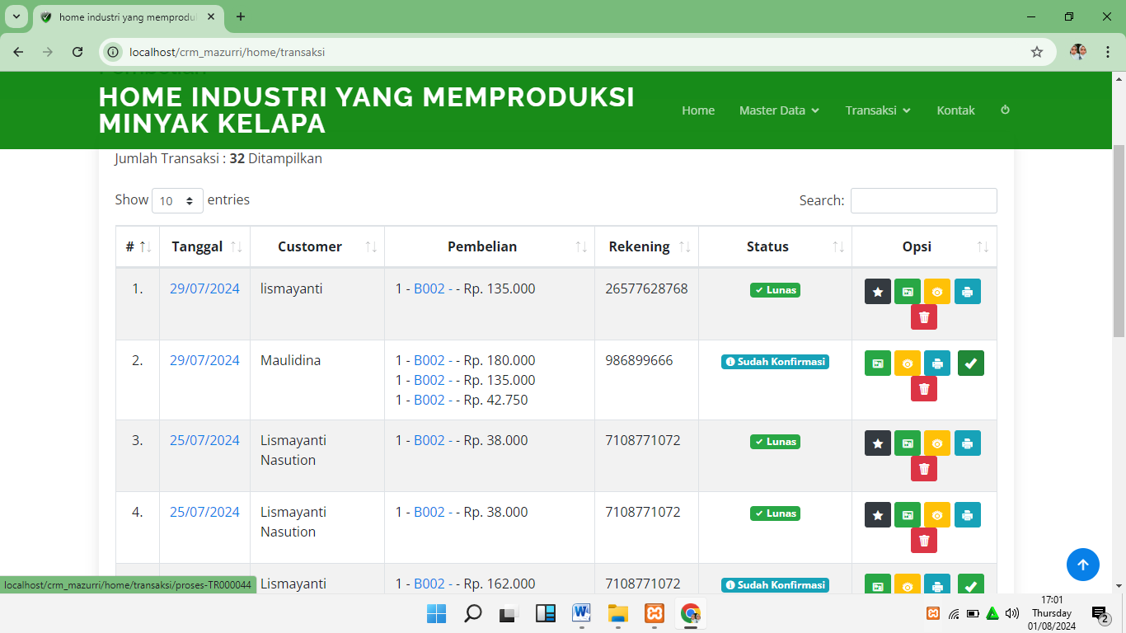
Figure 6. Owner's Customer Order Data Page Display

Sales Transaction Report Page to Owner
The sales transaction report will appear when all customers pay and will be processed by the owner, following the sales transaction report page display to the owner:
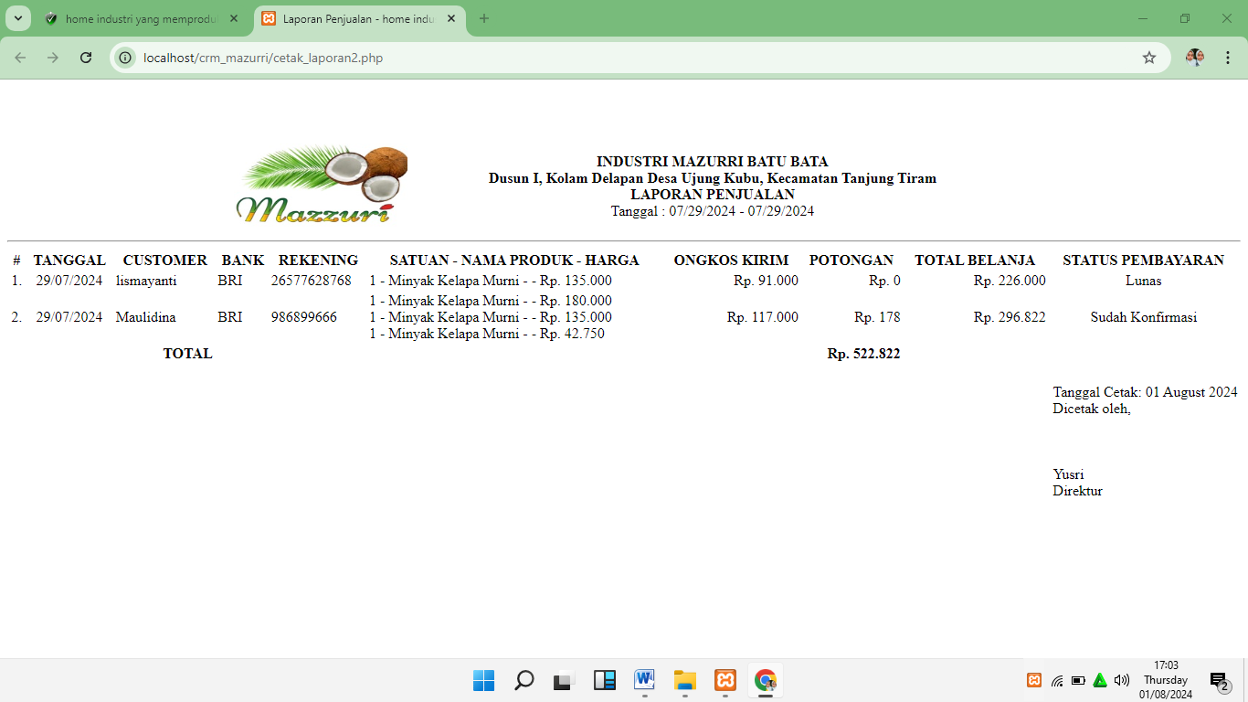
Figure 7. Owner Transaction Report Page Display

CONCLUSION

With E-CRM design, This can make it easier for trading business owners to do so record sales report data computerized and expand the media promote your business to customers with it It is hoped that sales will increase at the meeting customer needs. So that's an old customer and new customers are not easy switch to another trading business.
With discounts, cashback and other sales, Industri Mazzuri Batu Bara makes customers interested in shopping, and by providing good service, you can establish relationships with customers better for the future loyal customers to Usahan Dagang. With website at Industri Mazzuri Batu Bara can help customers find information on Trading Business, and make it easier customers to place orders and transactions remotely.
This website will also be successful make it easier for Industri Mazzuri Batu Bara in managing it sales data every month, and can find out stock of goods available at websites that previously only could known manually, and can provide convenience in managing all data and transaction.

ACKNOWLEGMENTS

I would like to express my gratitude to LPPM Universitas Roayal for providing the opportunity to publish this article in the new journal. Additionally, I extend my thanks to the lecturer who has motivated and guided me in the development of this thesis as a valuable source of research

BIBLIOGRAPHY
[1] A. S. Faqih and A. D. Wahyudi, “Rancang Bangun Sistem Informasi Penjualan Berbasis Web (Studi Kasus : Matchmaker),” J. Teknol. dan Sist. Inf., vol. 3, no. 2, pp. 1–8, 2022.
[2] J. P. Wildyaksanjani and D. Sugiana, “Strategi Customer Relationship Management (CRM) PT Angkasa Pura II (Persero),” J. Kaji. Komun., vol. 6, no. 1, p. 10, 2018, doi: 10.24198/jkk.v6i1.8754.
[3] Mutia Hannisyah Putri Lubis, Havid Syafwan, and Pristiyanilicia Putri, “Implementasi E-CRM dalam Mempertahankan Pelanggan Pada Toko Key Distro Kisaran,” J. Ilm. Multidisiplin Nusant., vol. 1, no. 2, pp. 51–57, 2023, doi: 10.59435/jimnu.v1i2.108.
[4] P. T. Prasetyaningrum, A. R. Wicaksono, and H. Nurrofiq, “Transformasi Pelayanan Pelanggan: Implementasi E-Crm Pada Bisnis Teh Nusantara Berbasis Website,” Technol. J. Ilm., vol. 14, no. 4, p. 368, 2023, doi: 10.31602/tji.v14i4.12157.
[5] S. A. Handayani and E. Asril, “Sistem Informasi Penerapan E-Crm Untuk Meningkatkan Kualitas Layanan Pelanggan Di Family Box Pekanbaru,” J-Com (Journal Comput., vol. 3, no. 1, pp. 36–41, 2023, doi: 10.33330/j-com.v3i1.2171.
[6] D. Anisah, N. Irawati, I. A. Lubis, S. Informasi, and S. Komputer, “Customer relationship management strategy to retain customers in wholesale muslim website based,” vol. VIII, no. 3, 2022.
[7] P. Ud and T. Rezeki, “1 , 2* , 3 1,” vol. 3, no. 1, pp. 35–42, 2023.
[8] S. Informasi, “IMPLEMENTATION OF E - CRM UP - SELLING AND CROSS - SELLING STRATEGY AT MITRA SEJAHTERA STORE Nur Adlina 1* , Afrisawati 1 , Indra Ramadona Harahap 1 1,” vol. IX, no. 2, pp. 303–310, 2023.
[9] J. Teknologi et al., “APPLICATION OF CRM METHODS FOR SALES SYSTEMS SHOES AND,” vol. VIII, no. 3, pp. 279–284, 2022.
[10] N. Ayu et al., “Penerapan Customer Relationship Management ( CRM ) Dalam Sistem Informasi Penjualan Kosmetik Berbasis Web,” vol. 3, no. 4, pp. 480–488, 2022, doi: 10.47065/bits.v3i4.1440.

