Implementasi Aplikasi Electronic Customer Relationship Management Berbasis Web Di Symple Store

Aqli Fatona^{1*}, Havid Syafwan², Akmal³
^{1,2,3}Information System, Sekolah Tinggi Manajemen Informatika dan Komputer Royal
email: *aqlifathonah@gmail.com

Abstract: In the development of the business world, information technology is very helpful and needed. The Internet is one of the information technologies that is developing rapidly such as helping in promotions, speeding up performance, reducing costs, increasing sales and also as a means of two-way communication between stores and customers. Electronic Customer Relationship Management (E-CRM) is a business strategy where a process is built to maintain relationships with consumers to create a good atmosphere for employees and consumers, thus sales success will be maximized. Symple Store is a business engaged in the manufacture and sale of apparel retail, and t-shirt screen printing which was founded in 2021 by Lukma Nulhakim. This business is located at Jl. Cokroaminoto Kisaran. This business sells various items such as t-shirts, apparel, and screen printing services, with a web-based E-CRM application using PHP and MySQL programming languages as a database. Can strengthen and improve the relationship between customers and the Symple Store.
Keywords: Implementation, E-CRM, Symple Store

Abstrak: Dalam perkembangan dunia bisnis, teknologi informasi sangat membantu dan dibutuhkan. Internet adalah salah satu teknologi informasi yang berkembang dengan pesat seperti membantu dalam promosi, mempercepat kinerja, mengurangi biaya, meningkatkan penjualan dan juga sebagai sarana komunikasi dua arah antara toko dengan para pelanggan. Electronic Customer Relationship Management (E-CRM) merupakan sebuah strategi bisnis dimana terjadi sebuah proses yang dibangun untuk mempertahankan hubungan dengan konsumen guna menciptakan suasana yang baik bagi karyawan maupun bagi konsumen, dengan demikian kesuksesan penjualan pun akan lebih maksimal. Symple Store merupakan sebuah usaha yang bergerak dibidang pembuatan dan penjualan retail pakaian jadi, dan sablon kaos yang didirikan pada tahun 2021 oleh Lukma Nulhakim. Usaha ini beralamat di Jl. Cokroaminoto Kisaran. Usaha ini menjual berbagai barang seperti kaos, pakaian jadi, dan jasa sablon.dengan aplikasi E – CRM berbasis web dengan menggunakan bahasa program PHP dan MySQL sebagai database. Dapat memperkuat dan meningkatkan hubungan antara pelanggan dengan Symple Store.

Kata kunci: Implementasi, E-CRM, Symple Store

INTRODUCTION

In the development of the business world, information technology is very helpful and needed. The internet is one of the information technologies that is developing rapidly such as helping in promotions, speeding up performance, reducing costs, increasing sales and also as a means of two-way communication between stores and customers.
Along with the company's mission to increase customer satisfaction with good management. One of the concepts that can be adopted to respond to this is to implement a Customer Relationship Management that can connect companies and customers directly (online) called Electronic Customer Relationship Management [1].
Electronic Customer Relationship Management (E-CRM) is a business strategy where there is a process that is built to maintain relationships with consumers to create a good atmosphere for employees and consumers, thus sales success will be maximized [2]. There are countless reasons why implementing an E-CRM is so important for companies. Through the use of E-CRM, companies can get benefits for sales, marketing, service and other company activities [3].
E-CRM can also make it easier for customers to get the necessary information from the company [4]. This is a means to maintain the company's relationship with customers in order to realize customer loyalty, by designing a new system, customers and the company will be able to cooperate well with marketing transactions [5]. E-CRM is an approach in business that manages the relationship between stores and customers in terms of communication and marketing. This concept has been known and widely applied to improve service in stores [6]. The main goal is the long-term development and improvement of the store's profits, being able to retain customers and provide added value for customers [7].
Symple store is a business engaged in the manufacture and sale of apparel retail, and t-shirt screen printing which was founded in 2021 by Lukma Nulhakim. This business is located at Jl. Cokroaminoto Kisaran. This business sells various goods such as t-shirts, apparel, and screen printing services. The many types and models of products sold, while there is no system that oversees the place of buying and selling and ordering, makes it a little difficult for Symple stores to handle each order of their products. The promotion is only carried out through social media that displays photos of the product and there is no further information about the product.
The purpose of this research is to know the system that is currently running in the Symple store so that it can design applications using the web-based E-CRM concept using PHP and MySQL programming languages as a database and after the system is created, it can strengthen and improve the relationship between the Symple store and customers.

METHOD

E-CRM is an adaptation of CRM to the e-commerce environment and builds and maintains customer relationships by using a network based on a business strategy that requires the development of a set of integrated software applications to process [8] [9]. E-CRM is a method of managing the relationship between the company and customers in order to increase the loyalty of the consumption of products or services offered by the company by utilizing electronic media [10].

Research Stages:
- Problem Identification
Problem identification is the process of determining what is the core part of the problem of a research. Here the author finds several problems, including that Symple store products are only marketed in stores, which leads to limited target markets and unsatisfactory sales, the current marketing method only relies on offline sales, which requires a lot of time and effort and is prone to delivery errors, and there is no effective promotion system to introduce Symple store products to a wider market
- Collecting Data
Data collection is carried out to obtain the information needed. The author collects data in various ways, including conducting interviews, observations, and literature studies. The interview was conducted by interviewing the owner and employees of the Symple store.
- Data Analysis
After collecting data, the author analyzed the data and found a solution to the existing problem, namely by building an E-CRM system that can help promotion, sales, and customer service at the Symple store.
- Design System
From the results of problem identification and data analysis, the author then designs the system to be built, including designing databases, user interfaces, inputs, outputs and other process activities on the Symple store.
- System Testing
At this stage, it is an activity in testing the system that has been built whether it is in accordance with the needs of the system or in accordance with the expected results. A system test is carried out to find out whether the system runs according to the design or not.
- System Imlementation
The implementation of the system is to ensure whether the implementation of Customer Relationship Management that has been made in the Kisaran Symple store is in accordance with the implementation of the system. The implementation of the system is carried out to complete the design in the document, namely the system design that has been approved, tested, installed, started and used a new or improved system.

RESULTS AND DISCUSSION

This is a display of the implementation of an application program that has been integrated using a web based E-CRM:

Main Page
It is the initial view of the program for visitors who will see the product.
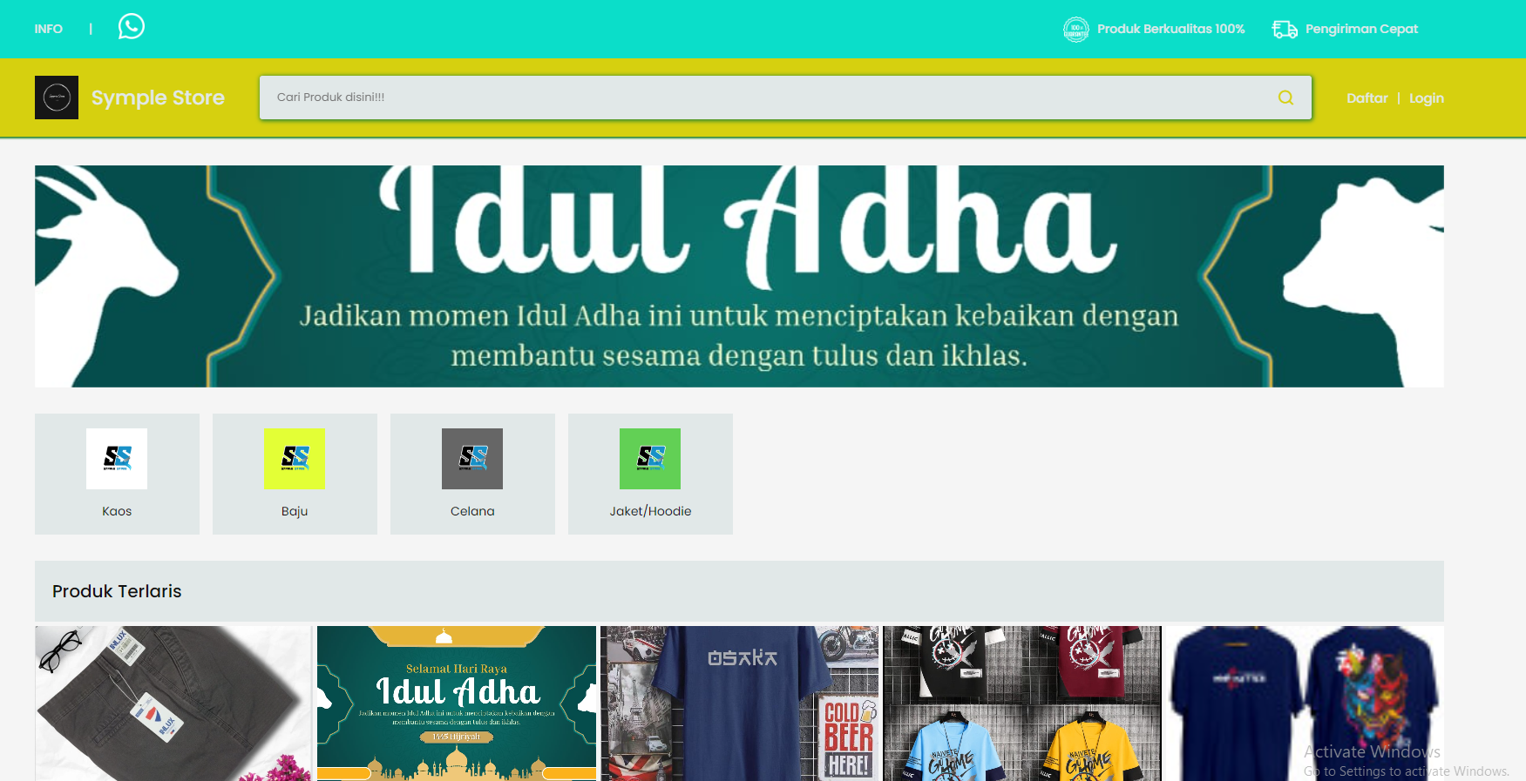
Figure 1. Main Page

Login Page
Is the page used to log in to the system E-CRM.
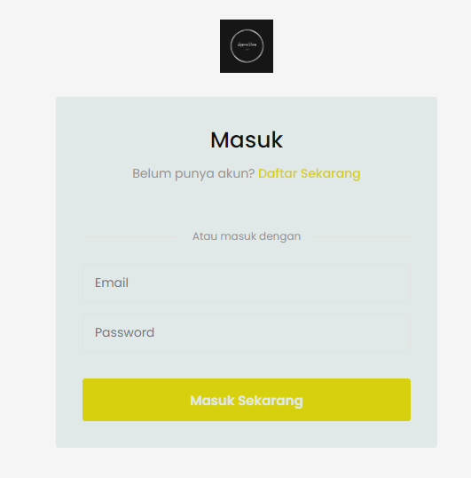
Figure 2. Login Page

Register Page
It is a page to register new customers who do not have an account yet.

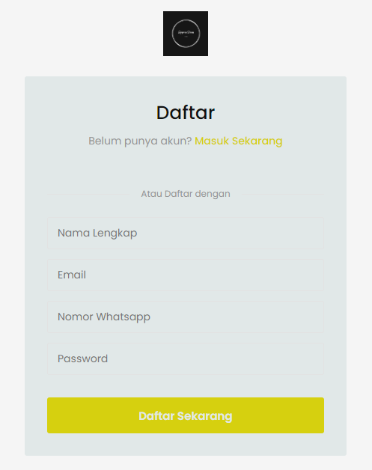
Figure 3. Register Page

Product Page
This is a page to display products that are sold on the Simply Store
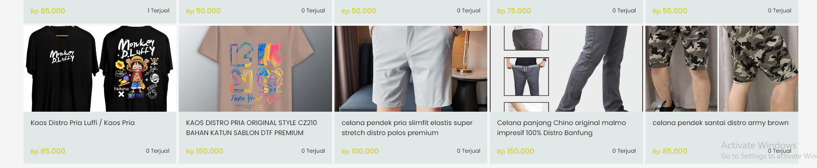
Figure 4. Product Page

Chart Page
It is a page to accommodate groceries that will be paid.
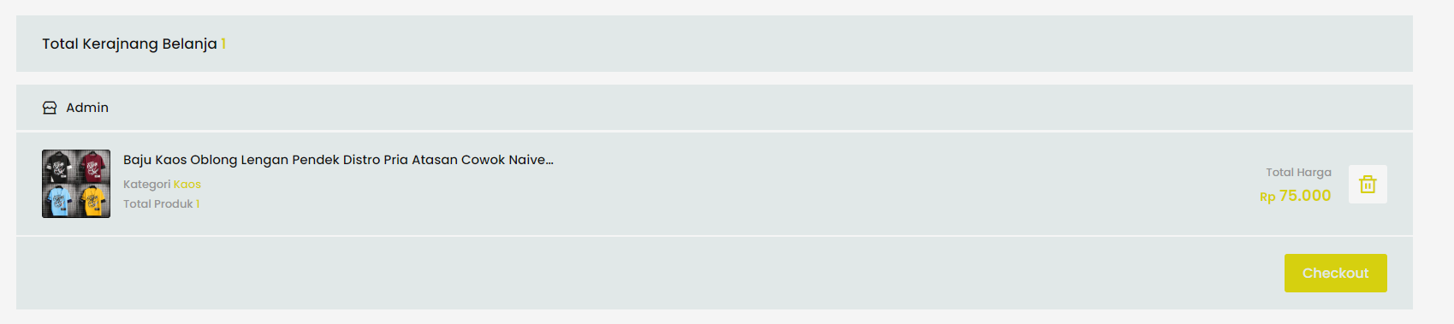
Figure 5. Chart Page

Checkout Page
It is the payment page of the products that enter the cart to be paid.
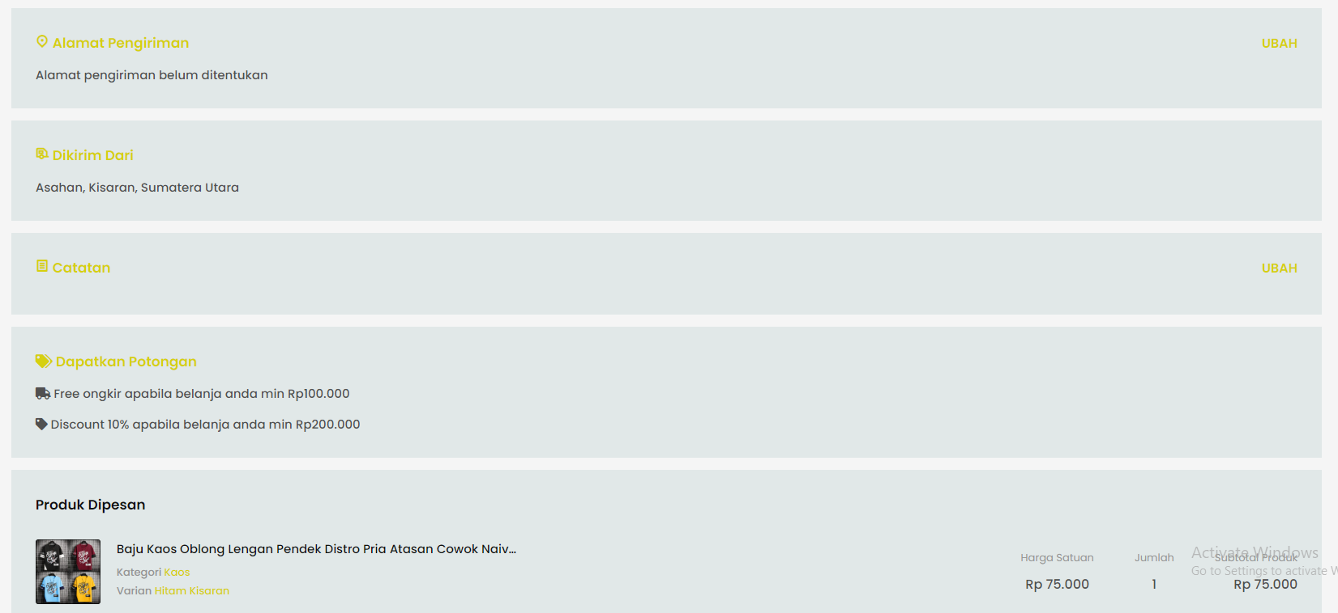
Figure 6. Checkout Page

Dashboard Admin Page
Will display the admin dashboard page to display revenue recap, transaction recap, and customer recap.
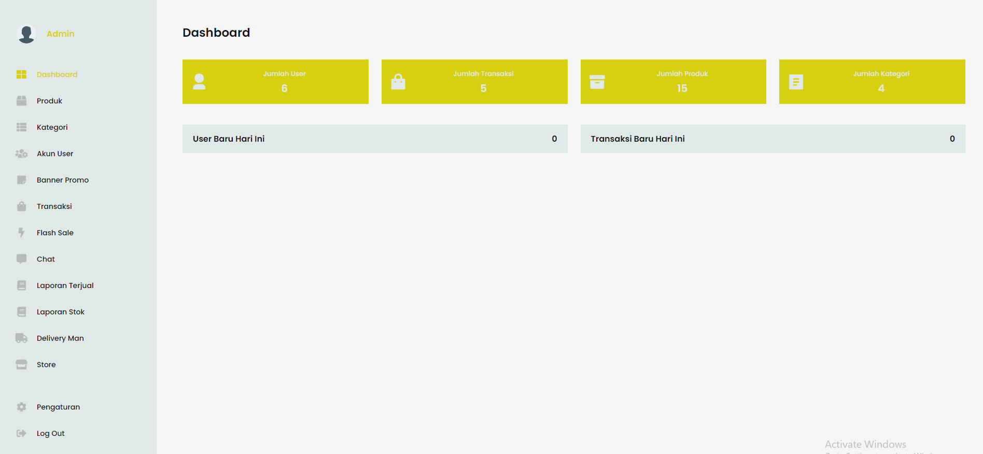
Figure 7. Dashboard Admin Page

Chatting Page
This page is used by customers to contact the admin to ask about product information.
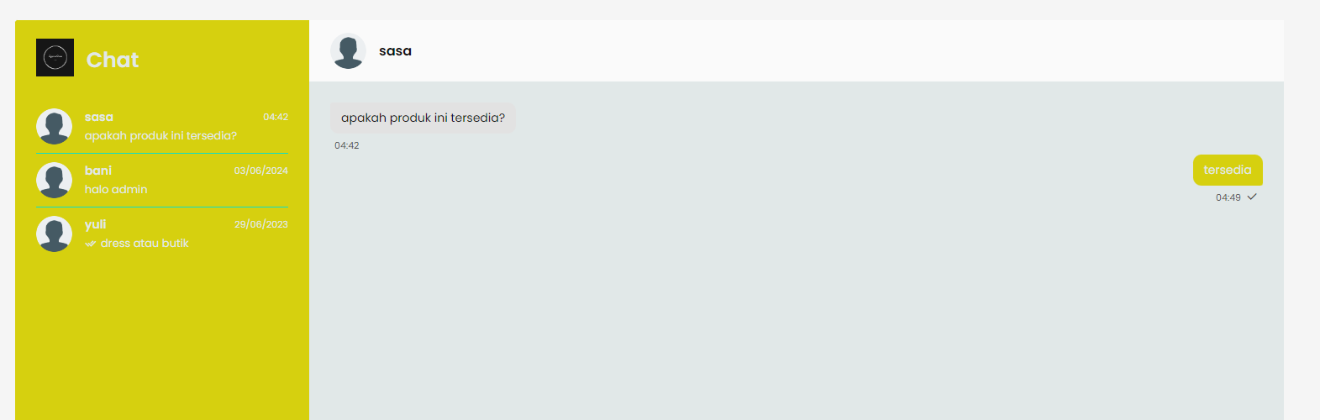
Figure 8. Checkout Page

CONCLUSION

The conclusion of the implementation of the E-CRM-based system in the Simply Store is that by integrating E-CRM in the functions in the store can improve service to customers, both new and old customers, the application of the E-CRM method of selling Symple Store fash-ion products can be seen in several features such as discounts, sending direct messages, viewing comments from customers who have ordered products and the feature of tracking product shipments and maintaining existing customers and attract new customers, and improve customer service so that customers remain loyal and will not move to other stores.

DAFTAR PUSTAKA

[1] L. Melia Sari, E. Melisa, D. Agnes Fitria, and T. Sutabri, “Analisis Penerapan Strategi Customer Relationship Marketing Blibli,” J. Ris. dan Inov. Manaj., vol. 2, no. 1, pp. 33–39, 2024, [Online]. Available: https://doi.org/10.59581/jrim-widyakarya.v2i1.2359
[2] M. A. Murtadlo, T. H. Pudjiantoro, and I. S. Rama, “Pembangunan Customer Relationship Management (Crm) Pada Cv. Berkah Logam Kota Tegal,” Pros. SNST 10, pp. 76–81, 2019.
[3] D. Pertiwi, Y. Siagian, and A. K. Syahputra, “E-Crm for Sales of Fashion Products At Jannah Simpang Four Boutique,” J. Tek. Inform., vol. 3, no. 4, pp. 929–937, 2022, doi: 10.20884/1.jutif.2022.3.4.474.
[4] N. A. A. Anggara, J. Hutahaean, and M. Iqbal, “Penerapan Customer Relationship Management (CRM) Dalam Sistem Informasi Penjualan Kosmetik Berbasis Web,” Build. Informatics, Technol. Sci., vol. 3, no. 4, pp. 480–488, 2022, doi: 10.47065/bits.v3i4.1440.
[5] D. P. Ramadhani, H. Syafwan, and C. Latiffani, “Penerapan Metode E – CRM Pada Toko Wati Collection,” JATISI (Jurnal Tek. Inform. dan Sist. Informasi), vol. 9, no. 4, pp. 3503–3518, 2022, doi: 10.35957/jatisi.v9i4.2839.
[6] P. R. Siregar, N. Irawati, and I. R. Harahap, “E - CRM Penjualan Keripik Kemuning Pada Usaha Kecil Menengah (UKM),” J-Com (Journal Comput., vol. 2, no. 3, pp. 195–204, 2022, doi: 10.33330/j-com.v2i3.1937.
[7] S. Fabriani and S. Juanita, “Implementasi Electronic Relationship Management ( E- Crm ) Pada Beauty Karlina Salon Untuk Meningkatkan,” Idealis, vol. 3, no. 1, pp. 381–385, 2020.
[8] A. Hidayat, A. Yani, Rusidi, and Saadulloh, “Membangun Website Sma Pgri Gunung Raya Ranau Menggunakan Php Dan Mysql,” JTIM J. Tek. Inform. Mahakarya, vol. 2, no. 2, pp. 41–52, 2019.
[9] L. A. Anggraeni, “Tantangan Kompetisi dan Risiko Monopoli dalam Transformasi Digital E-Commerce dengan Studi Kasus Aplikasi TikTok di Indonesia,” Sains J. Manaj. dan Bisnis, vol. 16, no. 1, p. 87, 2024, doi: 10.35448/jmb.v16i1.23398.
[10] L. Musa’ad and Y. Yuliazmi, “Perancangan Sistem Electronic Customer Relationship Management (E-Crm) Berbasis Web Studi Kasus: Mika Tour Indonesia,” J. IDEALIS, vol. 2, no. 6, pp. 280–286, 2019, [Online]. Available: https://jom.fti.budiluhur.ac.id/index.php/IDEALIS/article/view/1692

