**Digital Transformation on Public Service: Perceived Control and Perceived Quality as Determinants to Spatial Information System Adoption Using Extended TAM Model AND IS Success Model**

**Heni Anjani 1*, Dedi I. Inan2, Ratna Juita3, Marlinda Sanglise4**

1,2,3,4 Informatics Engineering, Engineering Faculty, Universitas Papua

**\***henianjani2019021@gmail.com

**Abstract:** The Laporkitong website functions as an online reporting application aimed at documenting instances of spatial planning violations in the West Papua Province. This study aims to investigate the influence of Perceived Quality, Perceived Control, and Perceived Ease of Use factors as determinants of the residents' willingness to use the Laporkitong application, employing the Technology Acceptance Model (TAM) and DeLone and McLean IS Success (IS D&M) theories. As many as 160 valid respondents are gathered based purposive sampling technique and evaluated using Partial Least Square Structural Equation Modeling (PLS-SEM). The results inform that all seven hypotheses are accepted with the R-square of the intention to use is 0.273 indicationg 27.3% variance of the model can determine the outcome. Further discussion and conclusion regarding the implication of theoretical and practical contribution are also discussed.

**Keywords**: laporkitong; *perceived control; perceived ease of use; perceived quality; technology acceptance model*

**Abstrak:** *Website* Laporkitong berfungsi sebagai aplikasi pelaporan *online* yang bertujuan untuk mendokumentasikan pelanggaran perencanaan tata ruang di Provinsi Papua Barat. Penelitian ini bertujuan untuk menyelidiki pengaruh faktor Kualitas yang Dirasakan, Kendali yang Dirasakan, dan Kemudahan Penggunaan yang Dirasakan sebagai penentu keinginan penduduk untuk menggunakan aplikasi Laporkitong, dengan menggunakan Model Penerimaan Teknologi (TAM) dan teori Kesuksesan Sistem Informasi (IS D&M) DeLone dan McLean. Sebanyak 160 responden valid dikumpulkan berdasarkan teknik *purposive sampling* dan dievaluasi menggunakan *Partial Least Square Structural Equation Modeling* (PLS-SEM). Hasilnya menunjukkan bahwa semua tujuh hipotesis diterima dengan R-square niat untuk menggunakan adalah 0,273, menunjukkan bahwa 27,3% variasi model dapat menentukan hasilnya. Diskusi lebih lanjut dan kesimpulan mengenai implikasi kontribusi teoritis dan praktis juga dibahas.

**Kata Kunci:** laporkitong; *perceived control; perceived ease of use; perceived quality; technology acceptance model*

**INTRODUCTION**

The Laporkitong application has been deployed by the Regional Development Planning, Research, & Development Agency (BAPPEDA), a public service agency situated in Manokwari, West Papua (<https://kitorang.papuabaratprov.go.id/>). Laporkitong is an online reporting application designed to report indications of spatial planning violations in West Papua Province [1]. This research case study focuses on the Laporkitong application in its website version.

The web application Laporkitong, plays a significant supporting the Sustainable Development Goals (SDGs) [2]. This application enables citizens to report various violations of spatial plans, permit discrepancies, and closures of access to public property areas, which are crucial steps in ensuring fair and sustainable resource management [3].

By leveraging digital technology, Laporkitong enhances transparency and accountability, as well as facilitates public participation in the oversight and enforcement processes related to land use and natural resource management. This is aligned with the SDGs, particularly Purpose 11 on sustainable cities and communities, and Purpose 16 on peace, justice, and strong institutions. Thus, Laporkitong serves not only as a reporting tool but also as an instrument for community empowerment and strengthening of good governance [2].

Referring to [4], the population growth in Manokwari is continuing to increase, and migration is on the rise, resulting in communities being compelled to construct housing that does not comply with regional spatial planning standards, thus leading to the growth of slum settlements and various physical issues including high building density. In response to these conditions, the Laporkitong website application serves as an appropriate solution as it can help mitigate the issues present in West Papua Province.

However, there are still challenges in its usage, such as the lack of public awareness of the Laporkitong website application, which has only been operational since 2022, and inadequate network support [5]. These constraints have resulted in less-than-optimal performance of the Laporkitong website application. Moreoever, there has been no specific research conducted regarding the adoption of the Laporkitong website application up to this point.

The goal of this research is to investigate influence of perceived quality, perceived control, and perceived ease of use factors as determinants of the intention of residents of West Papua Province to use the Laporkitong application. The Technology Acceptance Model (TAM) and Information System Success Model of DeLone and McLean (D&M) [6], are utilized as the theoretical lens in this study. Both theoretical lenses have been recognized by various scholars as the most represenative theory underpining the investegitation of the intention to use a new information technology. Thus, both are imployed in this study.

**METHOD**

Method employed in this research utilizes a quantitative study. Quantitative method utilizes precise numerical data obtained from the field as a tool for analysis [1]. Researchers distributed online questionnaires to the entire population residing in West Papua Province over a period of three months. The study population includes all users of the Laporkitong website application in Manokwari, West Papua. Data collection involved distributing questionnaires via Google Forms. The questionnaire included respondent identification, instructions, and statements representing each indicator of the variables: light quality, system quality, service quality, computer self-efficacy, internet self-efficacy, perceived ease of use, and satisfaction.

Based on the framework diagram, it can be elucidated that perceived quality (customers' opinions regarding a product's quality) correlates with user satisfaction in utilizing information systems [7]. Perceived Quality is represented as Information Quality, System Quality, and Service Quality. Hence, this study hypothesizes that:

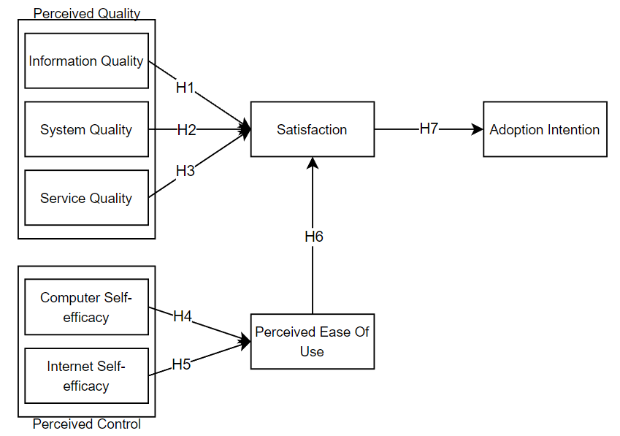

Figure 1. Reserach Model

H1: Information Quality significantly influences Satisfaction with the Laporkitong website application.

H2: System Quality significantly influences Satisfaction with the Laporkitong website application.

H3: Service Quality significantly influences Satisfaction with the Laporkitong website application.

According to Ajzen (1991) in [8], Perceived Control is an individual's perspective on the difficulty or ease of realizing a certain behavior. Perceived Control is presented as Computer Self-efficacy and Internet Self-efficacy. Hence, this study hypothesizes that:

H4: Computer Self-Efficacy significantly influences Perceived Ease of Use of the Laporkitong website application.

H5: The Laporkitong website application's perceived ease of use is highly influenced by internet self-efficacy.

Perceived Ease of Use refers to how much a person thinks using a technology will be easy and won't need a lot of labor. People will use an information system if they think it's user-friendly. On the other

hand, people won't use the information system if they think it's difficult to use. [9]. Hence, this study hypothesizes that:

H6: Perceived Ease of Use significantly influences Satisfaction with Laporkitong website application.

Satisfaction is defined as "an affective state that is an emotional response to a product or service experience" [8]. Hence, this study hypothesizes that:

H7: Satisfaction significantly influences Adoption Intention of the Laporkitong website application.

**RESULT AND DISCUSSION**

The data collection process was successfully conducted for 7 months, from July 2023 to January 2024. The researcher obtained 160 valid responses. The measurement model describes the relationship between indicators and hidden variables. Three criteria are employed in this study to evaluate the outer model: composite reliability, discriminant validity, and convergent validity [1]. As cited in [3], the loading factor value must be above 0.7 to be considered valid.

Convergent validity testing can be conducted by examining the loading factor values (outer loading) and the Average Variance Extracted (AVE).

For each construct, the goodness of fit of the model should be shown by a number larger than 0.50 [5]. Testing for reliability Two methodologies are employed in its execution: Cronbach's alpha (CA) and composite reliability (CR). If CA and CR have values above 0.70, then the construct is considered reliable [5].

Table 1. Loading Factor Test Result

|  |  |  |  |  |  |  |  |  |
| --- | --- | --- | --- | --- | --- | --- | --- | --- |
|  | AI | CSE | INFQ | ISE | PEOU | S | SERVQ | SYSQ |
| AI1 | 0.837 |  |  |  |  |  |  |  |
| AI2 | 0.885 |  |  |  |  |  |  |  |
| AI3 | 0.908 |  |  |  |  |  |  |  |
| CSE1 |  | 0.721 |  |  |  |  |  |  |
| CSE2 |  | 0.727 |  |  |  |  |  |  |
| CSE3 |  | 0.784 |  |  |  |  |  |  |
| CSE4 |  | 0.830 |  |  |  |  |  |  |
| INFQ1 |  |  | 0.799 |  |  |  |  |  |
| INFQ3 |  |  | 0.772 |  |  |  |  |  |
| INFQ4 |  |  | 0.795 |  |  |  |  |  |
| INFQ2 |  |  | 0.815 |  |  |  |  |  |
| ISE1 |  |  |  | 0.752 |  |  |  |  |
| ISE2 |  |  |  | 0.805 |  |  |  |  |
| ISE3 |  |  |  | 0.826 |  |  |  |  |
| ISE4 |  |  |  | 0.798 |  |  |  |  |
| PEOU1 |  |  |  |  | 0.807 |  |  |  |
| PEOU2 |  |  |  |  | 0.817 |  |  |  |
| PEOU3 |  |  |  |  | 0.804 |  |  |  |
| S1 |  |  |  |  |  | 0.788 |  |  |
| S2 |  |  |  |  |  | 0.834 |  |  |
| S3 |  |  |  |  |  | 0.809 |  |  |
| SERVQ1 |  |  |  |  |  |  | 0.808 |  |
| SERVQ2 |  |  |  |  |  |  | 0.783 |  |
| SERVQ3 |  |  |  |  |  |  | 0.805 |  |
| SERVQ4 |  |  |  |  |  |  | 0.815 |  |
| SYSQ1 |  |  |  |  |  |  |  | 0.771 |
| SYSQ2 |  |  |  |  |  |  |  | 0.780 |
| SYSQ3 |  |  |  |  |  |  |  | 0.807 |
| SYSQ4 |  |  |  |  |  |  |  | 0.823 |

Table 2. Average Variance Extracted (AVE)

|  |  |
| --- | --- |
|  | Average Ariance Extracted (AVE) |
| AI | 0.769 |
| CSE | 0.588 |
| INFQ | 0.632 |
| ISE | 0.633 |
| PEOU | 0.655 |
| S | 0.657 |
| SERVQ | 0.645 |
| SYSQ | 0.633 |

Table 3. Results of the Cronbach's Alpha Test and Composite Reliability

|  |  |  |
| --- | --- | --- |
|  | Cronbach's Alpha (CA) | Composite Reliability (CR) |
| AI | 0,850 | 0,909 |
| CSE | 0,782 | 0,851 |
| INFQ | 0,807 | 0,873 |
| ISE | 0,807 | 0,873 |
| PEOU | 0,737 | 0,851 |
| S | 0,739 | 0,852 |
| SERVQ | 0,817 | 0,879 |
| SYSQ | 0,807 | 0,873 |

Discriminant Validity used in this research is Hetero Trait Mono Trait (HTMT) criterion. The results can be seen in Table 4.

Table 4. HTMT Result

|  |  |  |  |  |  |  |  |  |
| --- | --- | --- | --- | --- | --- | --- | --- | --- |
|  | AI | CSE | INFQ | ISE | PEOU | S | SERVQ | SYSQ |
| AI |  |  |  |  |  |  |  |  |
| CSE | 0,186 |  |  |  |  |  |  |  |
| INFQ | 0,425 | 0,346 |  |  |  |  |  |  |
| ISE | 0,317 | 0,353 | 0,462 |  |  |  |  |  |
| PEOU | 0,136 | 0,391 | 0,293 | 0,520 |  |  |  |  |
| S | 0,659 | 0,367 | 0,685 | 0,493 | 0,547 |  |  |  |
| SERVQ | 0,364 | 0,329 | 0,326 | 0,345 | 0,301 | 0,609 |  |  |
| SYSQ | 0,181 | 0,406 | 0,490 | 0,523 | 0,230 | 0,589 | 0,422 |  |

The inner model testing in this study aims to analyze the relationships between one variable and another. Two tests are conducted: Variance Inflation Factors (VIF) and R-Square [10]. VIF is use as on indicator of multicollinearity among independent variables. VIF value should be <5 and >0.2; otherwise, multicollinearity issues among constructs may be present [11].

Table 5. Determination Coefficient (R²)

|  |  |  |
| --- | --- | --- |
|  | R-square | Category |
| AI | 0.273 | Weak |
| PEOU | 0.211 | Weak |
| S | 0.488 | Moderate |

The following criteria apply to the R-Square value's magnitude: an R-Square value of less than 0.25 is deemed weak, an R-Square value of 0.50 is deemed moderate, and an R-Square value of 0.75 is deemed high. [10].

The R-Square values in this study are as follows: R-Square value of Adoption Intention is 0.273, demonstrating a poor degree of forecasting. Perceived ease of use has an R-Square value of 0.211, additionally suggesting a poor degree of prediction.

Satisfaction's R-Square value is 0.488, indicating a moderate level of prediction. This suggests that the variables information quality, system quality, service quality, computer self-efficacy, internet self-efficacy, perceived ease of use, and satisfaction collectively explain 27.3% of the variance in Adoption Intention, with weak predictive power. The remaining 72.7% is explained by other unexamined variables in this research model.

Furthermore, the R-Square value for the perceived ease of use variable is 0.211, indicating that computer self-efficacy and internet self-efficacy influence perceived ease of use by 21.1%, with weak predictive power. The remaining 78.9% is explained by other unexamined variables in this research model. Lastly, the R-Square value for the satisfaction variable is 0.488, indicating that information quality, system quality, service quality, computer self-efficacy, and internet self-efficacy collectively explain 48.8% of the variance in satisfaction, with moderate predictive power. The remaining 51.2% is explained by other unexamined variables in this research model.

Since the VIF and R-Square values of the constructs meet the requirements, further testing of the structural model can be conducted, as shown in Table 6 below.

Table 6. Structured Model’s Evaluation Results

|  |  |  |  |  |
| --- | --- | --- | --- | --- |
| Hypothesis | Path | T statistics | P values | Result |
| H1 | INFQ -> S | 4.118 | 0.000 | Accepted |
| H2 | SYSQ -> S | 2.853 | 0.004 | Accepted |
| H3 | SERVQ -> S | 3.662 | 0.000 | Accepted |
| H4 | CSE -> PEOU | 2.953 | 0.003 | Accepted |
| H5 | ISE -> PEOU | 3.033 | 0.002 | Accepted |
| H6 | PEOU -> S | 2.825 | 0.005 | Accepted |
| H7 | S -> AI | 10.002 | 0.000 | Accepted |

Here is Figure 2, depicting the final research models.

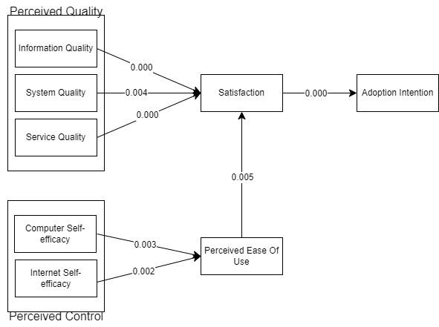

Figure 2. Final Result Model

H1 is accepted, indicating that Information Quality significantly influences Satisfaction.

H2 is accepted, signifying that System Quality significantly affects Satisfaction.

H3 is accepted, indicating that Service Quality significantly impacts Satisfaction.

H4 is accepted, suggesting that Computer Self-efficacy significantly influences Perceived Ease of Use.

H5 is accepted, demonstrating that Internet Self-efficacy significantly affects Perceived Ease of Use.

H6 is accepted, indicating that Perceived Ease of Use significantly influences Satisfaction.

H7 is accepted, signifying that Satisfaction significantly influences Adoption Intention.

**CONCLUSION**

In this study, both theories of TAM and D&M employed to investigate influence of perceived quality, perceived control, and perceived ease of use factors as determinants of the residents of West Papua Province's intention to utilize the LaporKitong application. Based on the results and discussions previously outlined, all the independents and mediation variabels are accepted. This means that they are all statistically significant in determination the intenion to adopt Laporkitong aplication. This implies that for the application to be adopted, all the latent variables need to be improved and managed accordingly.

**Perceived Quality (PQ)**

Within the PQ construct, Information Quality have significant influence on satisfaction. This indicates that the LaporKitong application provides accurate and clear information, leading to satisfaction among the users with the information available in the application. Consequently, the residents of West Papua demonstrate an intention to adopt the LaporKitong application.

System quality has a big impact on user happiness. This indicates that the LaporKitong application possesses a modern system quality and is not prone to errors during usage, thereby leading to user satisfaction and fostering an intention among the community to utilize the application.

Service Quality have significant influence on satisfaction. This indicates that the LaporKitong application provides fast services, leading to user satisfaction and fostering an intention among the community to utilize the application.

**Perceived Control (PC)**

Satisfaction is significantly influenced by computer self-efficacy. This is indicatesthat individuals have the belief in their ability to use or access the Laporkitong website application, resulting in user satisfaction and intention to utilize the application.

Internet Self-efficacy has significant influence on satisfaction. This indicates that individuals have the belief in their ability to utilize the internet to access the Laporkitong website application, resulting in user satisfaction and intention to utilize the application.

**Perceived Ease of Use (PEOU)**

Perceived ease of use influences satisfaction. This indicates that respondents can easily access and report spatial violations on the LaporKitong website application, resulting in users feeling satisfied and intending to utilize the application.

**Satisfaction (S)**

Satisfaction influences Adoption intention. This indicates that satisfaction in accessing the LaporKitong website application is a factor that influences the intention to adopt the LaporKitong website application.

**BIBLIOGRAPHY**

[1] P. W. Azizah and M. Sanglise, “Apa Yang Memotivasi Seseorang Mengakses Aplikasi Mobile Laporkitong? Perspektif Teori Uses And Gratification (U&G) Dengan PLS-SEM,” *J. Ris. Sist. Inf. Dan Tek. Inform. (JURASIK*, vol. 9, no. 1, pp. 383–390, 2024, [Online]. Available: https://tunasbangsa.ac.id/ejurnal/index.php/jurasikMotivasiseseorangmengaksesaplikasimobileLaporKitong

[2] N. P. Permatasari, A. W. Wijayanto, and W. Marsisno, “Analisis Cluster Kondisi Keterampilan , Akses dan Fasilitas Teknologi Informasi dan Komunikasi di Indonesia Cluster Analysis Conditions of Access , Facilities , and Information and Computer Technology Skills in Indonesia,” vol. 13, no. 148, 2024, doi: 10.34010/komputika.v13i1.10796.

[3] N. Wanma, D. I. Inan, L. Y. Baisa, and W. Papua, “Evaluasi User Experience Dan User Interface Aplikasi Laporkitong Dengan End User Computing Satisfaction something that is of great concern and determines the experience of using it for the people of”.

[4] R. Indriani, S. Tilaar, A. J. Tinangon, K. Arkuki, and K. F. Pante, “ISSN 2442-3262 ANALISIS TINGKAT KEKUMUHAN KAWASAN PERUMAHAN DAN MANOKWARI BARAT Abstrak Jurnal Perencanaan Wilayah dan Kota Jurnal Perencanaan Wilayah dan Kota,” vol. 7, no. 1, pp. 11–22, 2020.

[5] S. M. Rahakbauw, D. I. Inan, and R. Juita, “Analyzing Privacy Concern and Technology Anxiety as Determinants of Web-Based Laporkitong Adoption Level : UTAUT 2 Perspective,” pp. 1–10.

[6] C. H. Buzin, S. A. Dewhurst, and R. L. Seecof, “Temperature sensitivity of muscle and neuron differentiation in embryonic cell cultures from the Drosophila mutant, shibirets1,” *Dev. Biol.*, vol. 66, no. 2, pp. 442–456, 1978, doi: 10.1016/0012-1606(78)90250-6.

[7] B. Snoj, A. Pisnik Korda, and D. Mumel, “The relationships among perceived quality, perceived risk and perceived product value,” *J. Prod. Brand Manag.*, vol. 13, no. 3, pp. 156–167, 2004, doi: 10.1108/10610420410538050.

[8] J. C. Roca, C. M. Chiu, and F. J. Martínez, “Understanding e-learning continuance intention: An extension of the Technology Acceptance Model,” *Int. J. Hum. Comput. Stud.*, vol. 64, no. 8, pp. 683–696, 2006, doi: 10.1016/j.ijhcs.2006.01.003.

[9] Y. Y. Marwanta, “Perekayasaan Model Sistem Informasi E-Learning Menggunakan Modifikasi Technology Acceptance Model Untuk Pembelajaran Siswa Sekolah Menengah Kejuruan,” *Semin. Ris.* *Teknol. Inf. (SRITI).*, pp. 283–294, 2016, [Online]. Available: https://studylibid.com/doc/1148096/perekayasaan-model-sistem-informasi-e-learning

[10] H. Agustina, T. Lathif, M. Suryanto, and A. Pratama, “Analisis Penerimaan E-learning Madrasah Menggunakan Metode Technology Acceptance Model (TAM),” *Media Online)*, vol. 4, no. 1, pp. 173–181, 2023, doi: 10.30865/klik.v4i1.1097.

[11] A. Purwanto and Y. Sudargini, “Partial Least Squares Structural Squation Modeling (PLS-SEM) Analysis for Social and Management Research : A Literature Review,” *J. Ind. Eng. Manag. Res.*, vol. 2, no. 4, pp. 114–123, 2021.