Application of Webqual and End-User Computing Satisfaction (EUCS)
in Analyzing Information Content Measurement

Agus Suryadi¹, Eka Lia Febrianti^{2*}, Alex Sandri Sikumbang³
^{1,3} Informatics Engineering, Ibnu Sina University
² Software Engineering, Universal University
email: agussuryadi@uis.ac.id

Abstract: The essence of a website lies in the informational content provided by various entities such as institutions, organizations, or individuals, aiming to fulfill users' needs effectively. Evaluating the quality of a website becomes crucial to ensure its usefulness to the users, particularly for those websites that haven't undergone prior assessments. This research utilizes various data collection techniques, including observation, questionnaires, and literature review, relevant to website quality evaluation methods such as Webqual, along with the employment of the End-User Computing Satisfaction (EUCS) variable. The focal variables of the study encompass Usability, Information Quality, Service Interaction Quality, User Satisfaction, and Content. Through the application of the Webqual model and questionnaire administration, data gathered from respondents are analyzed to yield precise and relevant insights. Findings from this study indicate that both Service Interaction Quality and User Satisfaction exhibit low percentages, underscoring the necessity for improvements, particularly in Service Interaction Quality aspects, to enhance user satisfaction, notably in terms of security and meeting user needs.
Keywords: Webqual, End-User Computing Satisfaction (EUCS), Website Qualit

Abstrak: Hal yang esensial dari sebuah situs web adalah konten informasi yang disajikan oleh berbagai pihak, seperti instansi, organisasi, atau individu, sehingga dapat memenuhi kebutuhan pengguna dengan baik. Evaluasi kualitas situs web menjadi suatu hal yang penting untuk memastikan bahwa situs tersebut benar-benar bermanfaat bagi penggunanya. Terutama bagi situs web yang belum pernah dievaluasi sebelumnya, evaluasi kualitas menjadi krusial untuk mengetahui sejauh mana keunggulan dan kelemahan situs tersebut. Penelitian ini menggunakan berbagai teknik pengumpulan data, seperti observasi, kuesioner, dan studi literatur, yang relevan dengan metode evaluasi kualitas situs web, termasuk Webqual, serta variabel End-User Computing Satisfaction (EUCS). Variabel-variabel yang menjadi fokus penelitian meliputi Usability (Kualitas Kegunaan), Information Quality (Kualitas Informasi), Service Interaction Quality (Kualitas Interaksi Layanan), User Satisfaction (Kepuasan Pengguna), dan Content (Konten). Melalui penerapan model Webqual dan penggunaan kuesioner, data yang diperoleh dari responden kemudian dianalisis untuk menghasilkan informasi yang akurat dan relevan. Temuan dari penelitian ini menunjukkan bahwa Service Interaction Quality (Kualitas Interaksi Layanan) dan User Satisfaction (Kepuasan Pengguna) memiliki persentase yang rendah, menunjukkan perlunya perbaikan pada situs web, khususnya dalam aspek Kualitas Interaksi Layanan, untuk meningkatkan kepuasan pengguna, terutama dalam hal keamanan dan memenuhi kebutuhan pengguna.

Kata kunci: Webqual, End-User Computing Satisfaction (EUCS), Kualitas website

INTRODUCTION

PT Yudo Indonesia, a company operating in the machinery sector, opens up internship opportunities for students. The internship process begins with an introductory letter from the university and strict selection by the General Manager based on predetermined criteria. In this modern era, rapid technological developments bring great benefits to society, including easy access to information via the internet. Internet users can access various needs and knowledge easily, including information related to internships at PT Yudo Indonesia. The internet is not only used for work and education, but also to reach a global audience. One of the effective internet media is websites [1]. The website itself is a form of mass media that is published via the internet network and can be accessed anywhere and at any time [2]. Many companies, agencies and organizations use websites to build their identity and be accessed by internet users. This was also done by PT Yudo Indonesia. The PT Yudo Indonesia website provides various information, such as company profiles, job vacancies and internship programs. This website is useful for companies to promote themselves and recruit potential internship candidates, as well as for prospective interns to get the information they need before registering.
PT Yudo Indonesia, a well-known company in the field of buying and selling industrial machines and workshop services, has achieved resounding success thanks to the use of internet technology. Internet platforms, especially websites, have proven to be the main key in boosting company sales, with a contribution of almost 50%. The PT Yudo Indonesia website is designed with a wide reach, reaching all regions of Indonesia, making it easier for consumers everywhere to access information and carry out transactions.
PT Yudo Indonesia is one of the largest industrial machine sellers in Indonesia. To continue to boost sales, the company implements targeted promotional strategies and direct machine demos to potential customers. This strategy has proven effective in increasing consumer confidence and buying interest. PT Yudo Indonesia's success in utilizing internet technology should be an inspiration for other companies. With the right strategy and optimal use of technology, companies can increase their competitiveness and achieve brilliant success, so it would be a shame if the appearance of PT Yudo Indonesia's main website is not updated, both in terms of services and the appearance of the website, both in terms of design and layout.
WebQual 4.0 uses related to website design, for example appearance, ease of use, navigation and also the appearance presented on the website. [3]. The Webqual 4.0 tool presents an evaluation tool consisting of four main parameters, namely Usability, Information Quality, Service Interaction Quality, and Overall, to measure the quality of a website [4]. Pengukuran kualitas yang dihasilkan oleh Webqual 4.0 is expected to provide an accurate picture of satisfaction [5] users of the evaluated website [6]. Thus, it is hoped that the results of this measurement will provide valuable input for the development of further strategies aimed at improving the quality of the website. It is hoped that this website will be able to become an information medium for PT Yudo Indonesia customers to find out more about PT Yudo Indonesia in more complete and detailed terms. By analyzing and measuring the information content on the PT Yudo Indonesia website, it is hoped that it will make it easier for the company's customers to access more and complete information from the main information on the website.

METHOD

Overall, this research adopts a quantitative approach which aims to assess the level of user satisfaction with the PT Yudo In-donesia website using Webqual 4.0 and to identify the factors that influence it. [7]. Data was collected through a survey using a questionnaire, and statistical analysis was carried out using relevant software. To measure the quality of the PT Yudo In-donesia website, three Webqual 4.0 variables (Usa-bility quality, Information Quality, and Service Interaction quality) are used, along with one variable from EUCS (content) [8][9].

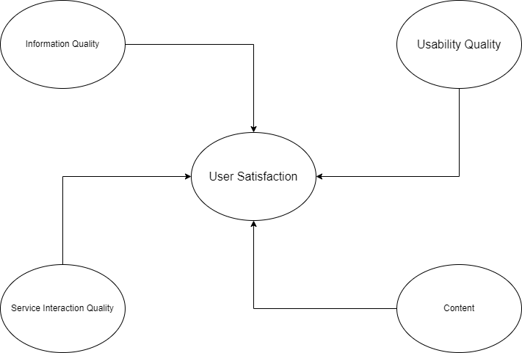

Figure 1. Information Content Testing Model Using the Webqual Method

Webqual 4.0 was prepared based on research on four dimensions, namely [10]:
- Quality of usability (Usability from human computer interaction). Usability is a quality related to the design of a website, such as appearance, ease of use, navigation, and the image that will be conveyed to users.
- Quality of information from information systems research (Information Quality). Information Quality is the quality of the content contained on the website, whether or not the information is suitable for user purposes, such as accuracy, format and relevance.
- Interaction quality and service quality from information system quality research (Service Interaction Quality). Service Interaction quality is the quality of service interactions experienced by users when they delve deeper into the website.
- Overall quality (Overall impression) Research the quality of all the three qualities above.
This research uses the Webqual 4.0 method, where the variables Usability, Information Quality, and Interaction Quality act as independent variables. Meanwhile, the Overall variable in this context is interpreted as an overall picture of User Satisfaction, and acts as a dependent variable [11].

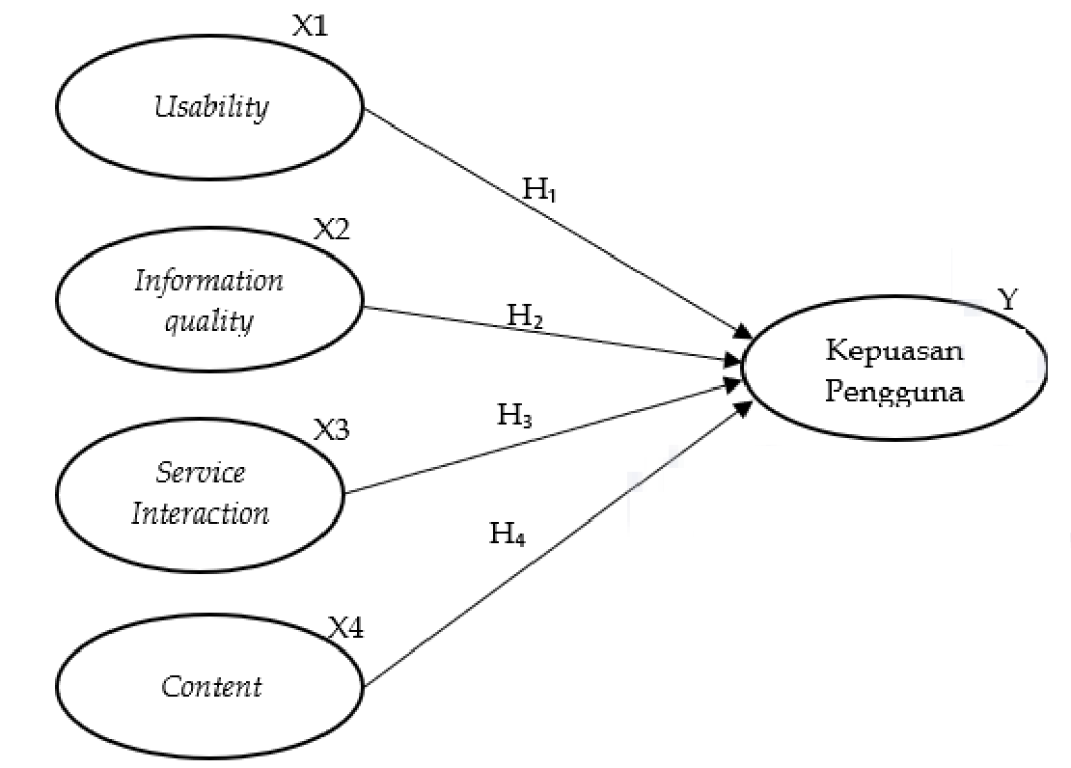
Gambar 2. Model WebQual 4.0

Information:
H1 : Usability has a significant influence on User Satisfaction or user satisfaction.
H2 : Information Quality has a significant influence on User Satisfaction or user satisfaction.
H3 : Interaction Quality of interaction has a significant influence on User Satisfaction/user satisfaction.

RESULT AND DISCUSSION
Process Analysis
- Analisis Deskriptif Variabel Usability (X1)
The Usability variable has an average rating of 5.36, which shows that respondents quite agree with the statements in the questionnaire related to Usability and Site Design. The average for each statement can be seen in Table 1.
Table 1. Description of Usability
Items | Scale (%) |  |  |  |  |  |  | Mean
Items | 1 | 2 | 3 | 4 | 5 | 6 | 7
The website is easy to learn | 2 | 0 | 2 | 6 | 22 | 60 | 8 | 5,58
Easy and clear interaction | 2 | 0 | 2 | 10 | 24 | 52 | 10 | 5,50
Website is easy to navigate | 2 | 0 | 2 | 6 | 30 | 48 | 12 | 5,54
Website is easy to use | 0 | 0 | 6 | 10 | 16 | 52 | 16 | 5,62
The appearance of the website is attractive | 2 | 2 | 14 | 24 | 24 | 34 | 0 | 4,68
Website appearance according to type | 0 | 2 | 0 | 20 | 26 | 42 | 10 | 5,36
Contains competence | 0 | 0 | 8 | 12 | 28 | 48 | 4 | 5,28
The website gives a positive impression | 0 | 2 | 2 | 12 | 30 | 50 | 4 | 5,36
Source: Primary data (processed)
Based on Table 1 above, the usability item which has the highest average of 5.58 is the ease of learning yudo.co.id. Meanwhile, the lowest average of 4.68 was the appearance of yudo.co.id. Therefore, to improve the quality of usability, website managers can improve the quality of the appearance or design of yudo.co.id to make users more interested.

- Descriptive Analysis of Information Quality Variables (X2)
The Information Quality variable has an average rating of 5.26, which indicates that respondents quite agree with the statements in the questionnaire related to information quality. The average for each statement can be seen in Table 2.
Table 2. Description of Information Quality
Items | Scale (%) |  |  |  |  |  |  | Mean
Items | 1 | 2 | 3 | 4 | 5 | 6 | 7
Accurate information | 0 | 0 | 6 | 20 | 34 | 28 | 2 | 5,10
Information can be trusted | 0 | 0 | 4 | 26 | 34 | 20 | 6 | 5,08
Up-to-date information | 0 | 0 | 2 | 28 | 26 | 42 | 2 | 5,14
Relevant information | 0 | 0 | 0 | 14 | 26 | 44 | 16 | 5,62
Information is easy to understand | 0 | 2 | 4 | 0 | 28 | 54 | 12 | 5,64
Complete information | 0 | 0 | 10 | 18 | 30 | 38 | 4 | 5,08
Information is neatly arranged | 0 | 2 | 8 | 14 | 30 | 38 | 8 | 5,18
Source: Primary data (processed)
Based on Table 2 above, the Information Quality item which has the highest average of 5.64 is the ease with which respondents understand the information provided by yudo.co.id. Meanwhile, the lowest average of 5.08 is regarding the completeness and correctness of information.

- Descriptive Analysis of Service Interaction Variables (X3)
The Service Interaction variable has an average rating of 5.15, which indicates that respondents quite agree with the statements in the questionnaire related to Trust and Empathy. The average for each statement can be seen in Table 3.

Table 3. Description of Service
Interaction
Items | Scale (%) |  |  |  |  |  |  | Mean
Items | 1 | 2 | 3 | 4 | 5 | 6 | 7
Good reputation | 0 | 0 | 2 | 24 | 24 | 48 | 2 | 5,24
Personalization | 0 | 0 | 4 | 8 | 36 | 48 | 4 | 5,40
Interaction between users | 6 | 2 | 12 | 14 | 26 | 30 | 10 | 4,82
Interaction with managers | 2 | 2 | 6 | 14 | 28 | 44 | 4 | 5,12
Source: Primary data (processed)

Based on Table 3 above, the Service Interaction item which has the highest average of 5.40 is the personalization provided by yudo.co.id. Respondents felt they could filter or select only the information they needed. Meanwhile, the lowest average of 4.82 is regarding interactions with fellow users. The yudo.co.id site provides interaction features between users such as providing a social media frame for Facebook, YouTube and Google Maps.

- Descriptive Analysis of Web User Satisfaction (Y) Variables
The Web User Satisfaction variable has an average rating of 5.74, which indicates that respondents agree with the statement in the questionnaire related to yudo.co.id user satisfaction. The average for each statement can be seen in Table 4.

Table 4. Description of Web
User Satisfaction
Items | Scale (%) |  |  |  |  |  |  | Mean
Items | 1 | 2 | 3 | 4 | 5 | 6 | 7
Download time | 0 | 0 | 2 | 6 | 26 | 32 | 32 | 5,80
Visit the website again | 0 | 0 | 0 | 12 | 18 | 48 | 22 | 5,80
Recommend website | 0 | 0 | 4 | 16 | 28 | 40 | 12 | 5,40
Accessible 24 hours | 0 | 0 | 0 | 12 | 14 | 40 | 34 | 5,96
Source: Primary data (processed)

Based on Table 4 above, the Web User Satisfaction item which has the highest average of 5.80 is the time needed by users when they first access yudo.co.id. Respondents felt they did not waste time when accessing the website because the time required when opening it for the first time was no more than 15 seconds. Apart from that, respondents were also willing to visit yudo.co.id again if they needed health service information. Meanwhile, the lowest average of 5.40 was respondents' willingness to recommend yudo.co.id to other people who need health service information.

Validity and Reliability Testing
- Usability Instrument Validity Test
There are eight items or instruments in the Usability variable. Each item is tested for validity. The results of the Usability instrument validity test can be seen in Table 5.
Table 5. Usability Instrument
Validity Test Results
Items | R Count | Status
Easy to learn | 0,688 | Valid
Interactions are understandable | 0,665 | Valid
Easy to navigate | 0,764 | Valid
Easy to use | 0,696 | Valid
Attractive appearance | 0,732 | Valid
Display according to type | 0,649 | Valid
Contains competence | 0,611 | Valid
Gives a positive impression | 0,564 | Valid
Source: Primary data (processed)

- Test the validity of the Information Quality instrument
There are seven items or instruments in the Information Quality variable. Each item is tested for validity. The results of the validity test of the Information Quality instrument can be seen in Table 6.

Table 6. Validity Test Results of the Information Quality Instrument
Items | R Count | Status
Accurate information | 0,795 | Valid
Information can be trusted | 0,571 | Valid
Up-to-date information | 0,772 | Valid
Relevant information | 0,686 | Valid
Information is easy to understand | 0,660 | Valid
Complete information | 0,858 | Valid
Information is neatly arranged | 0,711 | Valid
Source: Primary data (processed)
- Test the validity of the Service Inter-action Instrument
There are four items or instruments in the Service Interaction variable. Each item is tested for validity. The results of the validity test of the Service Interaction instrument can be seen in Table 7.
Table 7. Service Interaction Instrument Validity Test Results
Items | R Count | Status
Good reputation | 0,719 | Valid
Personalization | 0,632 | Valid
Interaction between users | 0,652 | Valid
Interaction with managers | 0,735 | Valid
Source: Primary data (processed)
- Test the validity of the Web User Satisfaction instrument
There are four items or instruments in the Web User Satisfaction variable. Each item is tested for validity. The results of the validity test of the Web User Satisfaction instrument can be seen in Table 8.
Table 8. Validity Test Results of the Web User Satisfaction Instrument
Items | R Count | Status
Download time | 0,781 | Valid
Visit the website again | 0,752 | Valid
Recommend website | 0,773 | Valid
Accessible 24 hours | 0,746 | Valid
Sumber: Data primer (diolah)

Reliability Testing
- Usability Instrument Reliability Test
There are eight items or instruments in the Usability variable. Each item is tested for reliability. The results of the reliability test of the Usability instrument can be seen in Table 9.
Table 9. Reliability Test Results
Usability Instrument
Cronbach's Alpha | N of Items
,827 | 8
- Reliability Test of the Information Quality Instrument
There are seven items or instruments in the Information Quality variable. Each item is tested for reliability. The results of the Information Quality instrument reliability test can be seen in Table 10.
Table 10. Reliability Test Results of the Information Quality Instrument
Cronbach's Alpha | N of Items
,846 | 7
- Reliability Test of the Service Interaction Instrument
There are four items or instruments in the Service Interaction variable. Each item is tested for reliability. The results of the reliability test of the Service Interaction instrument can be seen in Table 11.
Table 11. Service Interaction Instrument Reliability Test Results
Cronbach's Alpha | N of Items
,709 | 4
- Reliability Test of the Web User Satisfaction instrument
There are four items or instruments in the Web User Satisfaction variable. Each item is tested for reliability. The reliability test results of the Web User Satisfaction instrument can be seen in Table 12.
Table 12. Reliability Test Results of the Web User Satisfaction Instrument
Cronbach's Alpha | N of Items
,759 | 4

Regression Assumption Test Results
- Normality Test Results
Using a regression model for forecasting will produce errors or residues, namely the difference between actual data and forecast data. The remaining residues should have a normal distribution. To see whether the residual data is normally distributed, you can use the Normal Probability Plot (P-Plot) diagram as in Figure 3.

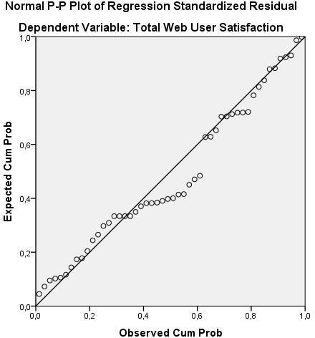
Figure 3. Normality Test Results
- Linearity Test Results
Linearity can be tested using a Scatter Plot diagram. This assumption states that the relationship between a dependent variable and an independent variable should be linear, either positive or negative. The linearity assumption is met if the relationship between the independent variable and the dependent variable in the Scatter Plot does not form a particular pattern, such as pa-rabola or exponential.

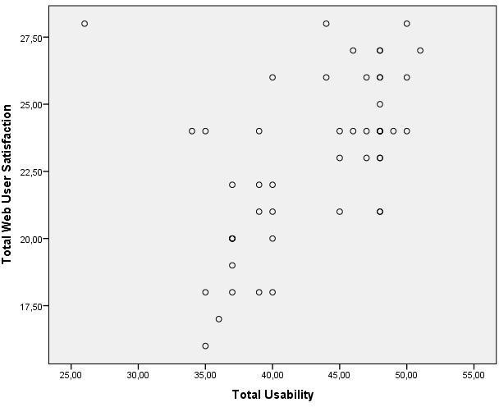
Figure 4. Linearity Test Results of the Relationship between Usability and Web User Satisfaction
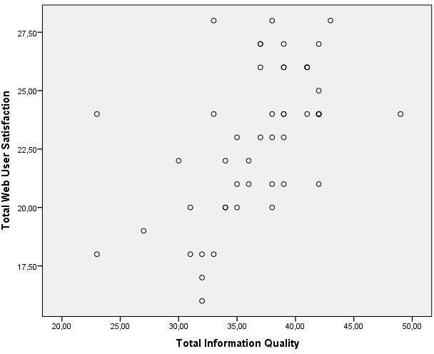
Figure 5. Linearity Test Results of the Relationship between Information Quality and Web User Satisfaction
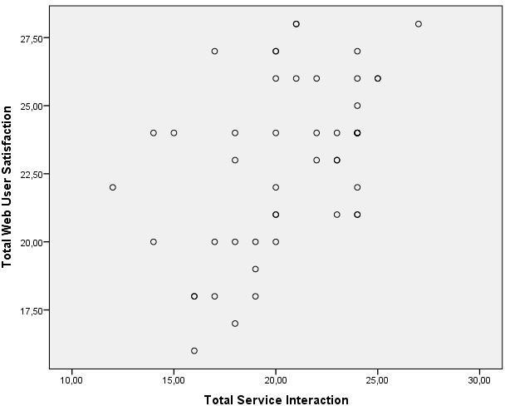
Figure 6. Linearity Test Results of the Relationship between Service Interaction and Web User Satisfaction

- Multicollinearity Test Results
The multicollinearity test is used to see whether the independent variables are related to each other. A good multiple regression model is if the independent variables are not related to each other. In this research, the variables Usability, Information Quality, and Service Interaction should not be related to each other.
Table 13. Multicollinearity Test Results
Model | Dimension | Eigenvalue | Condition Index | Variance Proportions
 |  |  |  | (Constant) | Total Usability | Total Information Quality | Total Service Interaction
 | 1 | 3,971 | 1,000 | ,00 | ,00 | ,00 | ,00
1 | 2 | ,014 | 17,143 | ,43 | ,01 | ,00 | ,63
1 | 3 | ,008 | 22,160 | ,00 | ,56 | ,74 | ,02
 | 4 | ,008 | 22,618 | ,57 | ,43 | ,26 | ,35

- Heteroscedacity Test Results
The multiple linear regression model is free from elements of heteroscedasticity if the data distribution in the scatter diagram does not show a certain pattern, such as increasing to the top right, decreasing to the bottom left, or other certain patterns.
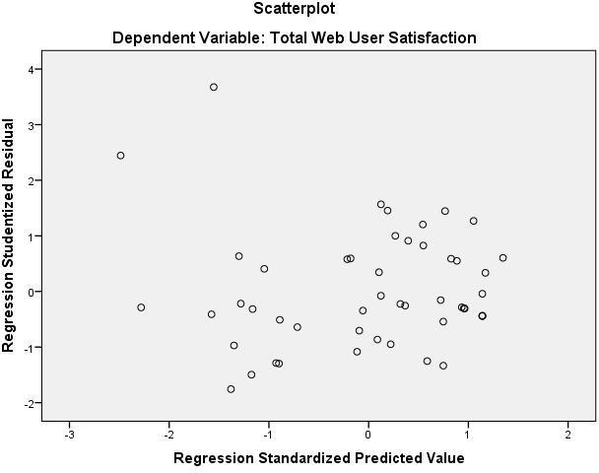
Figure 7. Heteroscedacity Test Results
Figure 7 shows that the data distribution does not form a particular pattern. Therefore, the multiple linear regression model used in this study is free from elements of heteroscedasticity.

CONCLUSION
Usability quality (Usability, X1) has a positive effect on user satisfaction, because all sub-variables X1 (X1.1, sub-variable X1) with the highest value in sub-variable X1.1 of 52.7%. For Information quality (Information Quality, X2) has a positive effect on user satisfaction, because all sub-variables X2 (X2.1, of the majority of respondents (the four sub-variables X2) with the highest value in sub-variable X2.1 at 49.2%. For Service Interaction Quality (X3) has a less positive effect on user satisfaction than other Webqual variables, because only the X3 sub-variable, namely 9% and 4. Content (Content, X4) has a positive influence on user satisfaction, because all sub-variables X4 (X4.1, X4.2, from the majority of respondents (all four sub-variables X4) with the highest equal value for sub-variables X4.1 and X4.4 at 50%.
BIBLIOGRAPHY
[1] N. Dalimunthe, A. Adawiyah, and T. Karina, “Analisa Kualitas Website Menggunakan Metode Webqual 4.0 (Studi Kasus: Badan Kepegawaian Daerah Provinsi Riau),” J. Ilm. Rekayasa dan Manaj. Sist. Inf., vol. 5, no. 2, p. 184, 2019.
[2] P. Palipi, E. Rajaguguk, M. Aritonang, M. Yohanna, and Y. Y. Rumapea, “Pengukuran Kualitas Layanan Website Dengan Metode Webqual (Studi Kasus: Sistem Informasi Akademik Universitas Methodist Indonesia),” Methosisfo J. Ilm. Sist. Inf., vol. 2, no. 2, pp. 60–70, 2022.
[3] A. Jefri, B. Purnama, and H. Mulyono, “Analisis Kualitas Layanan Website SMA Terhadap Kepuasan Siswa Menggunakan Metode Webqual 4.0,” TIN Terap. Inform. Nusant., vol. 4, no. 9, pp. 596–606, 2024.
[4] A. E. Prasetiyanto, “Analisis Penerimaan Sistem Informasi Penugasan Berbasis E-Learning Moodle Menggunakan Metode WebQual 4.0 Dan EUCS Di SMKN 1 Ngasem,” Semin. Nas. Inov. Teknol., vol. 5, pp. 047–052, 2021.
[5] A. Saputra and D. Kurniadi, “Analisis Kepuasan Pengguna Sistem Informasi E-Campus Di Iain Bukittinggi Menggunakan Metode Eucs,” Voteteknika (Vocational Tek. Elektron. dan Inform., vol. 7, no. 3, p. 58, 2019,
[6] T. Husain and A. Budiyantara, “Analisis End-User Computing Satisfaction (EUCS) Dan WebQual 4.0 Terhadap Kepuasan Pengguna,” JATISI (Jurnal Tek. Inform. dan Sist. Informasi), vol. 4, no. 2, pp. 164–176, 2018.
[7] L. Darwati, “Analisis Tingkat Kepuasan Pengguna Aplikasi WETV Menggunakan Metode End User Computing Satisfaction (EUCS),” J. Ilm. Komputasi, vol. 21, no. 4, pp. 34–42, 2022.
[8] rezki dwy putra, “analisis kepuasan pengguna aplikasi flip.id menggunakan metode TAM dan EUCS,” J. Emerg. Inf. Syst. Bus. Intell., vol. 2, no. 4, p. 4, 2021.
[9] F. Gusni, R. Gunawan, L. Setiyani, and Y. Rostiani, “Analisis kepuasan pengguna akhir PLN Mobile menggunakan Metode EUCS (End User Computing Satisfaction),” Pros. Semin. Nas. Inov. dan Adopsi Teknol., vol. 3, no. 1, pp. 60–71, 2023.
[10] A. G. Zakinah, A. E. Prasetiyanto, F. Khairani, A. Mahendra Wijaya, D. Ariatmanto, and T. Informatika, “Analisis Penerimaan Sistem Informasi Dapodik Menggunakan Metode Webqual dan EUCS,” Semin. Nas. Inov. Teknol., vol. 1, no. 1, pp. 1–6, 2021.
[11] G. Prasongko and S. R. Nurdin, “Analisis Kualitas Sistem Informasi MELISA Terhadap Kepuasan Pengguna Dengan Menggunakan Metode WebQual 4.0 dan EUCS ( End-User Computing Satisfaction ),” J. Emerg. Inf. Syst. Bus. Intell., vol. 04, no. 02, pp. 70–76, 2023.

