ANALYSIS AND DESIGN OF SCM METHODS IN TOKO 66 WEBSITE-BASED

Andrean Prasasti¹, Guntur Maha Putra^{2*}, Maulana Dwi Sena³
^{1,2,3}Information System, STMIK Royal Kisaran
email: igoenputra@gmail.com

Abstract: Clothing is a basic human need besides food and shelter. Human needs clothing to protect and cover them self. Toko 66 is a business that operates in the field of products and services. This business offers various types of products such as clothes, trousers and also shirts that are second hand, aka used. The absence of distribution transaction channels from upstream to downstream is one of the business problems at Toko 66. Therefore, a system such as Supply Chain Management is needed which can manage the flow of transactions from upstream to downstream and can also make it easier for owners to create sales reports. Based on the research results, it can be found that a system has been created that implements web-based Supply Chain Management to help owners, admins, suppliers and customers in carrying out transaction flows from upstream to downstream. The business process from upstream to downstream has also been running in accordance with the Supply Chain Management procedures that apply at the research object location so that it can provide information regarding the existence of sufficient product stock to ensure a good transaction flow from upstream to downstream.
Keywords: supply chain management; clothes; stock; transaction; distribution

Abstrak: Pakaian merupakan kebutuhan pokok manusia selain makanan dan tempat tinggal. Manusia membutuhkan pakaian untuk melindungi dan menutup dirinya. Toko 66 merupakan usaha yang bergerak dibidang produk dan jasa, usaha tersebut menawarkan berbagai jenis produk seperti baju, celana dan juga kemeja yang sudah second alias bekas pakai, Belum adanya jalur transaksi distribusi dari hulu ke hilir menjadi salah satu masalah bisnis yang ada di Toko 66 maka dari itu diperlukannya sebuah sistem seperti Supply Chain Management yang dapat mengatur alur transaksi dari hulu ke hilir dan juga dapat memudahkan pemilik untuk membuat laporan penjualan. Berdasarkan hasil penelitian maka dapat ditemukan hasil bahwa telah terciptanya sebuah sistem yang menginplementasikan Supply Chain Management berbasis web untuk membantu pemilik, admin, supplier dan juga pelanggan dalam melakukan alur transaksi dari hulu ke hilir. Proses bisnis dari hulu ke hilir juga telah berjalan sesuai dengan prosedur Supply Chain Management yang berlaku di tempat objek penelitian sehingga dapat memberikan informasi mengenai adanya stok produk yang cukup untuk terjalinnya alur transaksi yang baik dari hulu ke hilir.

Kata kunci: supply chain management; pakaian; stok; transaksi; distribusi

INTRODUCTION

Toko 66 is a business that operates in the field of products and services. This business offers various types of products such as shirts, trousers and also second hand tables, while in the service sector they send customer orders via bus transportation. Toko 66 started operating in 2010 with its address in Tanjung Balai City. Toko 66 has a workforce of 25 people, the number of foremen is 2 people and the workforce is 23 people. In developing its business, Toko 66 continues to strive to expand its target market to achieve its goals and tries to retain customers so they can be loyal to the company. The large number of customers means that toko 66 requires a good system to support a better buying and selling process for the progress and development of the business.
Based on the results of interviews with the company owner, several problems were found, including the company owner admitted that in managing Toko 66's sales report data, they still use ledgers so that it is not effective to carry out neatly arranged records and requires quite a long time and has not yet been implemented. there is a business distribution channel at toko 66 which regulates the flow of transactions from upstream to downstream.
From the analysis of the problems above, a system is needed that can help Toko 66 with the Supply Chain Management (SCM) method to assist the company in managing business distribution channels so that it can increase the company's productivity[1], simplify the buying and selling process with business distribution channels that are built from upstream to downstream in a sustainable manner[2][3].
Supply Chain Management (SCM) is a method for planning, controlling and running business production supplies[4]. This method includes the process of obtaining raw materials, production, and distribution to final resellers in the most economical and effective way [5][6]. SCM consists of three elements that are interconnected with each other, namely: supply chain network structure, member work network and relationships with other supply chain members[7]. SCM as a whole has the function of planning, implementing and controlling the recording of requests, receipts, expenditures, usage effectively and efficiently in seeing the condition of goods and material flows in real time[8].
Based on these problems, a web-based application was designed that can help Toko 66 in creating business distribution channels so that it can make it easier for customers to carry out transactions and of course save time because customers don't have to come to the store to look for items. stock availability of goods to be purchased.

METHOD

The research method used in this research is a qualitative research method. The qualitative research approach is research that is used to investigate, discover, describe and explain a condition or phenomenon by collecting data by making observations and by means of descriptions in the form of words and language, so that qualitative research is realistic[9][10]. Sources of qualitative data are observation notes and related documents in the form of writing or images.
To assist in preparing this research, it is necessary to have a clear framework in stages. This framework is the steps that will be taken in solving the problem that will be discussed. The framework for this research can be seen in the following picture:
Identification of problems

Study of literature
Implementasi Sistem
Implementasi Sistem
Implementasi Sistem
Implementasi Sistem
Implementasi Sistem
Implementasi Sistem
Data collection
Implementasi Sistem

Method Approach

System analysis

System Design and
System Testing

Image 1. Research Framework

The description of the framework in this research is as follows:
First, Identify the Problem. Problem identification is where the researcher must first determine what the problem will be researched. Here the researchers observed that there was no distribution route from upstream to downstream at Toko 66.
Second, Literature Study. The literature study carried out by the author was by searching various written sources, in the form of books, journals, the internet and other references that were relevant to the problem being studied. So that the information obtained from this literature study can be used as a reference to strengthen existing arguments.
Third, Data Collection. Data collection is a technique or method used by researchers to find out various problems that exist at Toko 66 and also create store distribution lines using the SCM method. This method is used to make it easier for customers to carry out buying and selling transactions.
Fourth, method approach. This method approach is carried out by managing the activity process using the SCM method to create a new system at Toko 66.
Fifth, Data Analysis. Data analysis is an activity of changing research results into information that can be used to make decisions in research. The way to draw conclusions can be done by estimating the results and analysis carried out on Toko 66 using the SCM method.
Sixth, System Design and System Testing. System Design is a form of planned organizational change. The author carried out the development of the Toko 66 system to design a distribution line system from upstream to downstream, using the PHP programming language and MySQL database. System testing is a process to assess whether what is planned is in accordance with what is expected. So that researchers can find out what shortcomings of the system need to be evaluated.
Seventh, System Implementation. System implementation is a procedure carried out to complete the design in the approved system design document and test and use the new system. After testing the system that has been built and the results are satisfactory or in line with expectations, the system can be used by company owners in running their business and increasing their income.
.
RESULTS AND DISCUSSION

Login Page Display
The login page is a page to confirm admin access rights to carry out processing on the system, grant access rights to business owners to view transaction reports in the system, and access rights for customers to carry out order transactions in the system. Here's what the log-in page looks like:
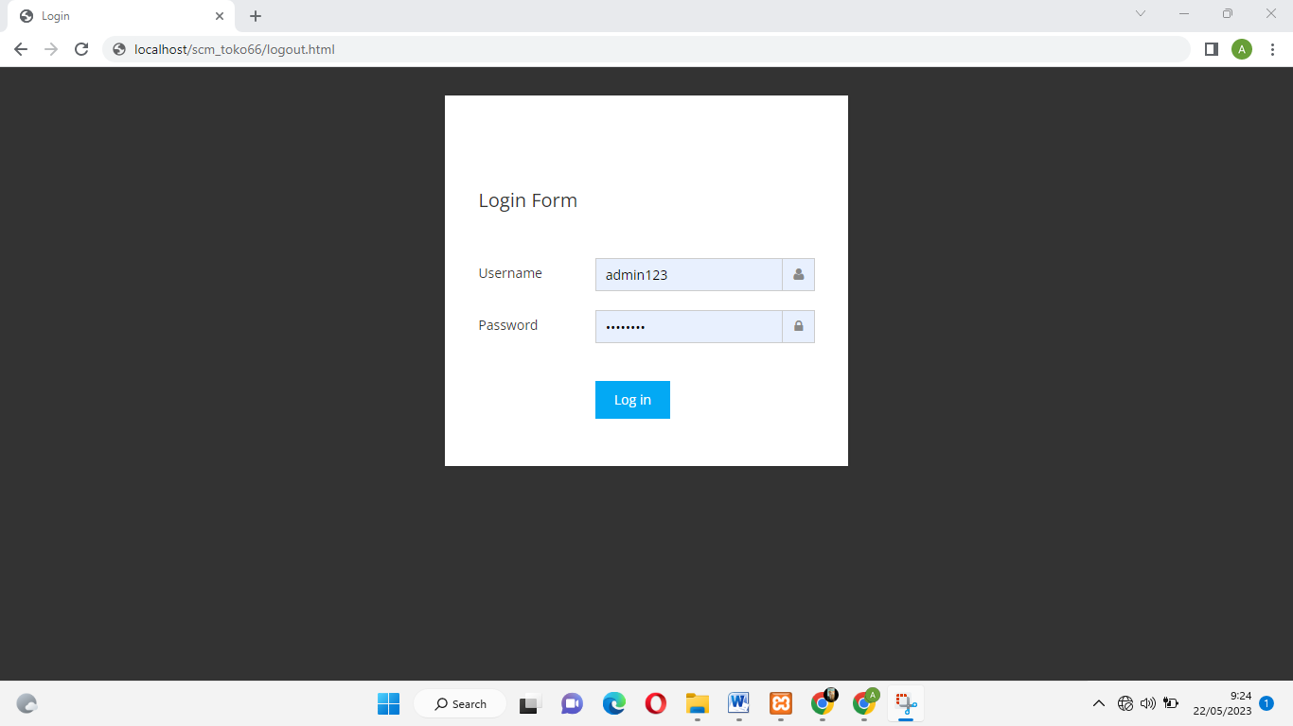

Image 2. Login page

Main Menu Page Display
The main menu is a menu that can be seen and selected specifically by admins and owners. The main menu in this system aims to simplify the process of viewing and searching for information.
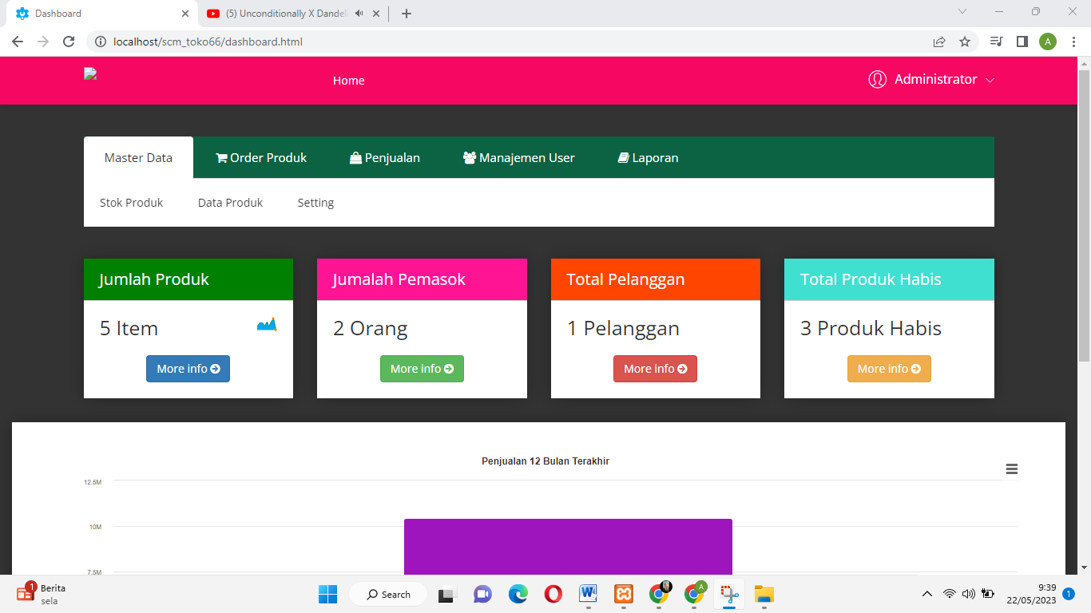

Image 3. Main Menu Page

Product List Page Display
The product list page aims to display product data as well as add, edit and delete product data.
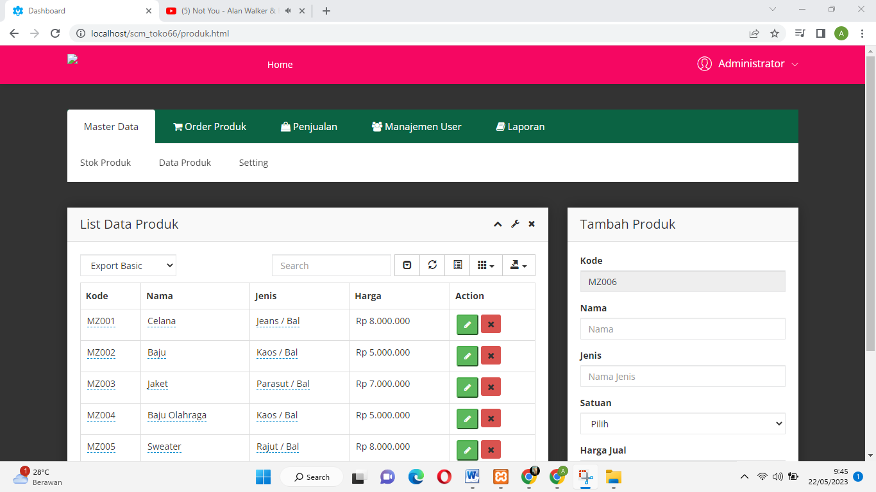

Image 4. Product List Page

Product Order List Page Display
The product order list page aims to display ordered product data as well as adding, editing and deleting product order data

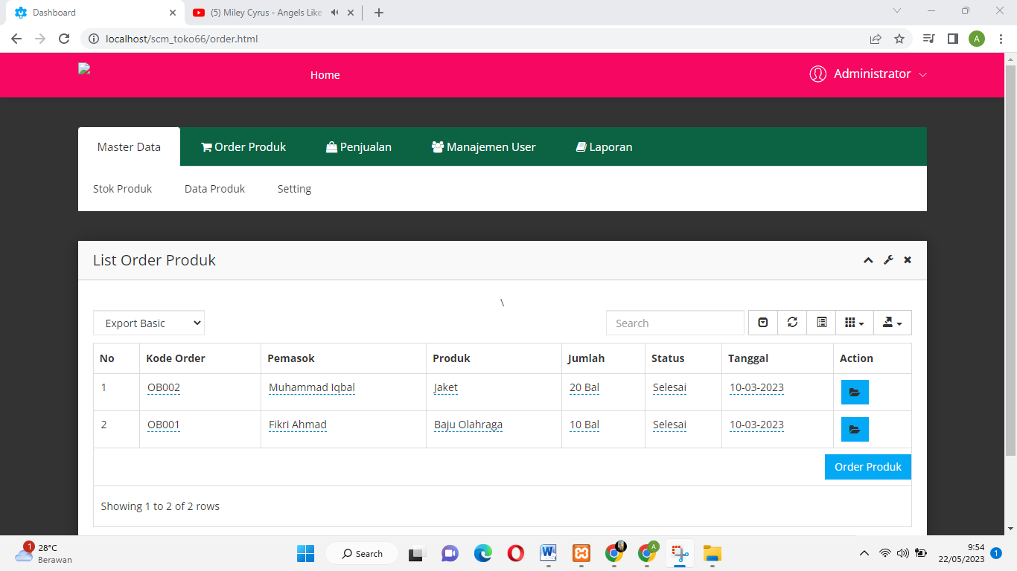

Image 5. Product Order List Page

Sales List Page Display
The product sales list page aims to display sales data as well as view sales details and delete sales data.
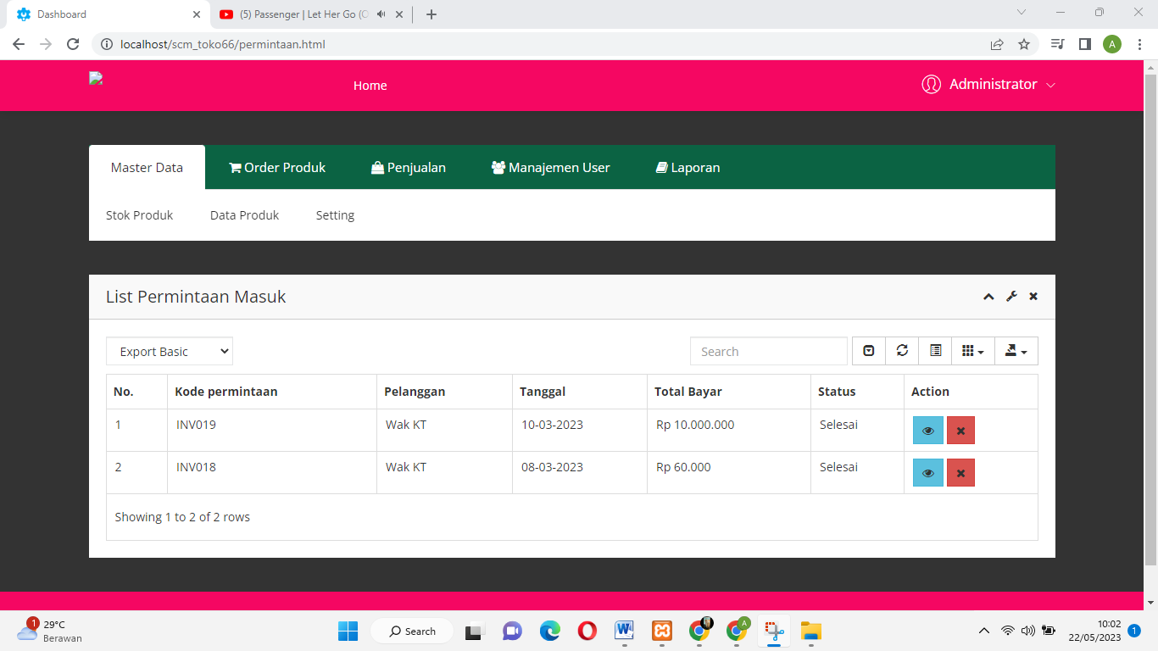

Image 6. Sales List Page

Notification Settings Page Display
The notification settings page aims to set the minimum available product stock.
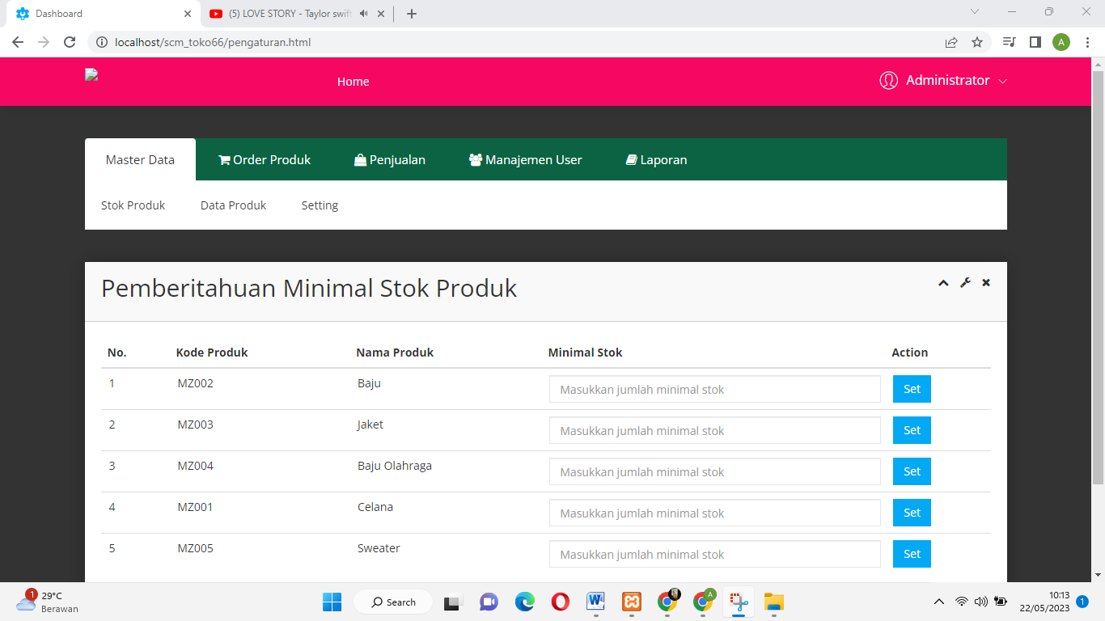

Image 7. Notification Settings Page

Main Menu Page Display (Supplier)
The main menu (Supplier) is a menu that can be seen specifically by suppliers. The main menu in this system aims to simplify the process of viewing and searching for information.
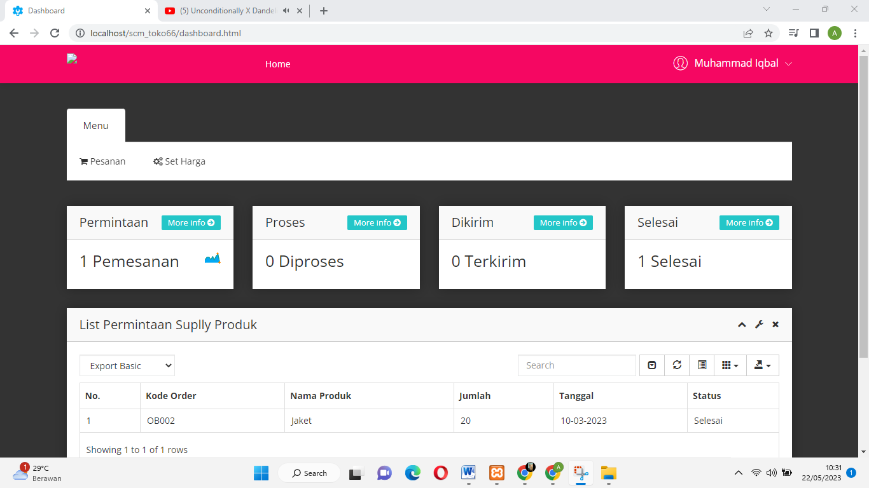

Image 8. Main Menu Page (Supplier)

Order Confirmation Page Display
The product order confirmation page is used by suppliers to confirm product orders made by the admin.
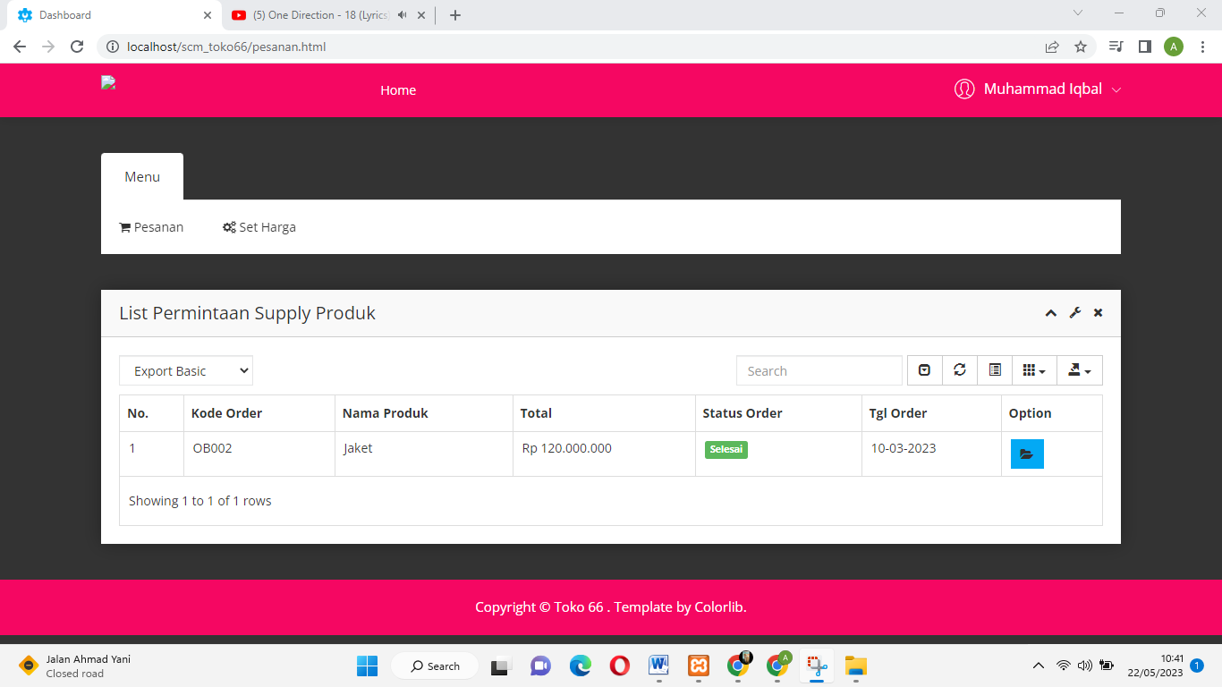

Image 9. Order Confirmation Page

Main Menu Page View (Customer)
The main menu (Customer) is a menu that can be seen specifically by Customers. The main menu in this system aims to simplify the process of viewing and searching for information.

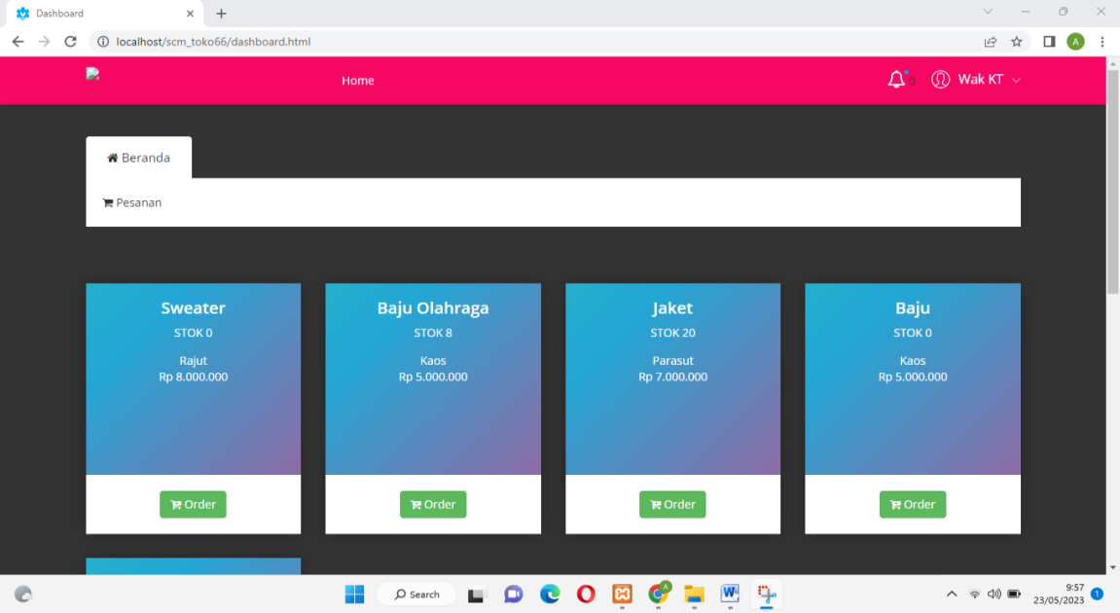

Image10. Main Menu Page (Customers)

Product Order Order Page Display
The product request ordering page is used by customers to process product requests at Toko 66.

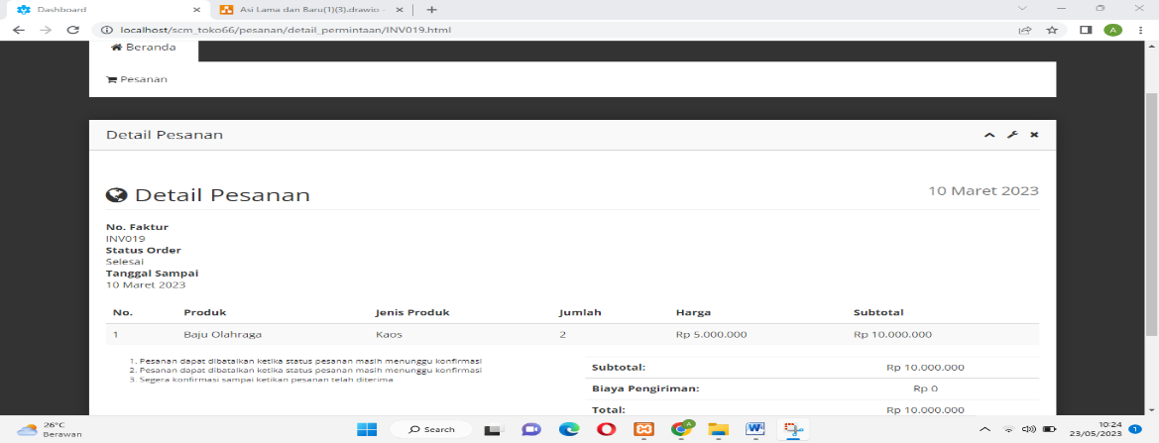

Image 11. Product Request Order Page

CONCLUSION

Based on the implementation and testing that has been carried out while creating this system, several conclusions can be drawn as follows: First. A system has been created that implements web-based Supply Chain Management to assist owners and admins in carrying out transaction flows from upstream to downstream. Second, a business process has been established from upstream to downstream which has been running in accordance with the SCM procedures that apply at the research object location and third, it provides information regarding the existence of sufficient product stock to ensure a good transaction flow from upstream to downstream.

DAFTAR PUSTAKA

[1] M. Pratiwi, U. Ilhami Arsyah, A. Pramana Gusman, and A. Muhammad, “Sistem Inventory Menggunakan Metode Supply Chain Management dalam Mengatur Jumlah Ketersediaan Obat pada Apotik,” Indones. J. Inform. Res. Softw. Eng., vol. 1, no. 2, pp. 139–145, 2021, doi: 10.57152/ijirse.v1i2.143.
[2] O. M. Al-Rawashdeh, O. Jawabreh, and B. J. A. Ali, “Supply Chain Management and Organizational Performance: The Moderating Effect of Supply Chain Complexity,” Inf. Sci. Lett., vol. 12, no. 3, pp. 1673–1684, 2023, doi: 10.18576/isl/120351.
[3] Myassignmenthelp.co.uk, “Supply Chain Management for product of Nestle,” Myassignmenthelp.co.uk, vol. X, no. 2, pp. 217–222, 2020, [Online]. Available: https://myassignmenthelp.co.uk/freesample/supply-chain-management-for-product-of-nestle
[4] Saiddinur and Mustaqiem, “Sistem Persediaan Dan Pengendalian Stok Obat Menggunakan Metode Scm-Lot Sizing Pada Apotek,” J. Penelit. Dosen Fikom, vol. 10, no. 1, pp. 41–50, 2019.
[5] S. W. Nasution, N. Manurung, and E. Rahayu, “Penerapan Supply Chain Management (SCM) Dalam Pemantauan Stok Barang Berbasis Web,” Build. Informatics, Technol. Sci., vol. 4, no. 2, pp. 361–368, 2022, doi: 10.47065/bits.v4i2.1781.
[6] F. A. Ramadheena, M. Zhafari, and Q. Aini, “Evaluation of Supply Chain Management Performance at MSMEs using the SCOR Method,” INTENSIF J. Ilm. Penelit. dan Penerapan Teknol. Sist. Inf., vol. 4, no. 2, pp. 159–172, 2020, doi: 10.29407/intensif.v4i2.13993.

[7] S. Padmantyo and A. Saputra, “Peranan manajemen rantai pasokan terhadap kualitas produk dan efisiensi distribusi,” Pros. dalam Semin. Peran Profesi Akunt. Dalam PenanggulangaKorupsi, no. eminar Nasional dan The 4th Call for Syariah Paper, pp. 191–197, 2017.
[8] M. Jamaludin, “Perencanaan Supply Chain Management (Scm) Pada Pt. Xyz Bandung Jawa Barat,” Kebijak. J. Ilmu Adm., vol. 13, no. Vol. 13 No. 2, Juni 2022, pp. 70–83, 2022, doi: 10.23969/kebijakan.v13i2.4552.
[9] S. A. Fakri Mursala, Grace Amalia Tondang, “Analisis Supply Chain Management Terhadap Kesediaan Bahan Pokok,” Pap. Knowl. . Towar. a Media Hist. Doc., vol. 2, no. Julil, pp. 490–496, 2022.
[10] W. Darmalaksana, “Metode Penelitian Kualitatif Studi Pustaka dan Studi Lapangan,” Pre-print Digit. Libr. UIN Sunan Gunung Djati Bandung, pp. 1–6, 2020.

