**DETERMINATION SUPERIOR USED MOTORCYCLES USING A COMBINATION OF COCOSO AND SAW ALGORITHM**

**Roni Dalimunthe 1 * , Rolly Yesputra 2 , Rohminatin 3**

1,2,3 Information Systems , STMIK Royal Kisaran

*Email* : ronidalimunthe729@gmail.com

# Abstract: Used motorbikes are motorized vehicles that are used by many people in various cicles. For someone who is a prospective buyer of a used motorbike, before coming to the place of puchase they have several choices based on several criteria that have been determined according to the used motorbike they want to buy. A problem that often occurs for prospective buyers is the difficulty in determination which used motorbike is superior from several choices based on predetermined criteria. This results in potential buyers feeling confused in making their choice. The difficulty in determining used motorbikes is the reason this research was conducted. In this case, the decision support system will be used as a tool in providing superior used motorbike choices for potential buyers. The method offered in this research is to use a combination of the CoCoSo and SAW algorithms. The criteria for determination a used motorbike consist of 8 criteria namely mileage, price, brand, accessories, tire condition, body condition, engine condition and completeness of documents. In the results of this decision support system research, ranking results using a combination of CoCoSo and SAW methods show that the red Suzuki F1 alternative (A39) is ranked with the highest score.

**Keywords:** Decision Support System; Combined Compromise Solution Method; Simple Additive Weighting Method

**Abstrak:** Sepeda motor bekas merupakan kendaraan bermotor yang digunakan oleh sebagian banyak masyarakat dalam berbagai kalangan. Bagi seseorang calon pembeli sepeda motor bekas, sebelum datang ke tempat pembelian mereka memiliki beberapa ketentuan pilihan yang berdasarkan pada beberapa kriteria yang telah ditentukan sesuai dengan sepeda motor bekas yang ingin dibeli. Permasalahan yang sering kali terjadi bagi calon pembeli ialah kesulitan dalam menentukan sepeda motor bekas mana yang unggul dari beberapa alternatif pilihan berdasarkan kriteria yang telah ditentukan sebelumnya. Hal ini mengakibatkan, calon pembeli merasa kebingungan dalam menentukan pilihannya. Kesulitan dalam penentuan sepeda motor bekas tersebut menjadi alasan penelitian ini dilakukan. Dalam hal ini sistem pendukung keputusan akan digunakan sebagai alat bantu dalam memberikan pilihan sepeda motor bekas yang unggul bagi calon pembeli. Metode yang ditawarkan dalam penelitian ini yaitu dengan menggunakan kombinasi algoritma CoCoSo dan SAW. Kriteria-kriteria dalam penentuan sepeda motor bekas terdiri dari 8 kriteria yaitu jarak tempuh, harga, merek, aksesoris, kondisi ban, kondisi *body*, kondisi mesin dan kelengkapan surat. Dalam hasil penelitian sistem pendukung keputusan ini, memberikan hasil perangkingan dengan kombinasi metode CoCoSo dan SAW menunjukkan bahwa alternatif Suzuki F1 merah (A39) adalah peringkat dengan nilai tertinggi.

**Kata kunci :** Sistem Pendukung Keputusan; Metode *Combined Compromise Solution*, Metode *Simple Additive Weighting*

**INTRODUCTION**

In the modern era, technology and development are becoming very rapid, making technology a very basic information need. With the help of current technology, it is possible for users to access the internet which is an information technology-based model. Technology also has an impact on the ease of finding information, especially in the motor vehicle sector.

A used motorbike is a motorized vehicle that uses an engine and has two wheels that have been used and owned by someone else before [1]. Several factors that cause motorbikes to become the most widely used vehicle are due to the ease and flexibility in using motorbikes, the lack of adequate public transportation infrastructure, motorbikes are an option used to meet family needs and are an existing culture and lifestyle in society.

Dealers Kembar Motor is a business that operates in the field of selling used motorbikes and cars which has been established since 2020. This dealer provides purchases of used motorbikes which have several types and variations. From the results of observations and questionnaires in December 2023, researchers obtained the results in the table below.

Table 1. Data Prospective Buyers and Purchasers

|  |  |
| --- | --- |
| Status | Total |
| Prospective Buyers | 24 |
| Purchasers | 8 |

From table 1 it can be seen that the total number of potential buyers is greater than their status as buyers. Based on the results of observations, prospective buyers experienced difficulty in deciding which used motorbike they wanted to choose and buy. This causes them not to buy used motorbikes provided in dealer Kembar Motor.

Apart from having an impact on prospective buyers, this problem also has an impact on dealer owners where Kembar Motor dealer owners and employees face difficulties because the service process to prospective motorbike buyers takes quite a long time, creating challenges in maintaining customer satisfaction and increasing operational productivity.

Based on the problems above, researchers want to create a system that will help prospective buyers and dealer owners in providing recommendations for the best used motorbike choices for both parties.

A decision support system is a system that can support expertise in solving a problem or it can be said to be an expertise in carrying out structured communication in providing support in resolving a problem in the condition that no one knows how the decision should be made [2].

The CoCoSo method or Combined Compromise Solution is a method in a decision support system that combines several other decision making techniques in multi-criteria to get a good solution or decision [3]. This method can also be used when making decisions during strategic planning or for resource allocation. And can be used to overcome decisions that have many criteria [4].

The SAW method or Simple Additive Weighting is a multi-criteria decision making technique used to select alternatives based on various criteria by giving weight to each criterion [5]. The SAW method is relatively simple and easy to understand, making it often used in decision-making contexts that involve many factors or criteria [6].

Research conducted by Nur Alam Arifin in 2020, with the title "Determination Used Motorcycles Using the AHP and SAW Methods". This research is motivated by the difficulties of prospective buyers in deciding which used motorbike they want to buy. Several criteria are needed when purchasing a used motorbike, in order to get a used motorbike that suits what the prospective buyer wants. The method used in this research is the AHP and SAW methods, which are expected to be implemented in fulfilling a very high sense of satisfaction for prospective buyers of used motorbikes at Sahabat Motor [7].

Due to these problems, research was carried out to determine which used motorbikes at the Kembar Motor dealer were superior for prospective buyers to purchase so that they would be satisfied with the choices provided.

**METHOD**

Data collection techniques in implementing the system for determining used motorbikes at twin motorbike dealers are carried out in several ways, consisting of:

**Observation**

Observe the system flow currently running at Kembar Motor dealer.

**Interview**

This is done by conducting questions and answers with the owner of the Kembar Motor dealer regarding determining the best used motorbike.

**Questionnaire**

Make a list of questions that will be asked to several respondents, namely potential buyers of used motorbikes.

**Studying Literature**

Look for literary sources that can be used as references in writing research, such as books, journals or other materials.

**System planning**

Carrying out system design starts from where the system will run and builds a user interface that suits the user's needs. So that the system can be implemented well.

**System Implementation**

At this stage, the system development process will be carried out based on the design that has been made previously. In this stage, the program code will be implemented into the system so that it can run according to design.

The decision support system for determining superior used motorbikes will use a combination of algorithms, namely the Combined Compromise Solution and Simple Additive Weighting methods. In the calculation and settlement, 8 criteria will be used consisting of mileage, price, brand, accessories, tire condition, body condition, engine condition and completeness of documents.

**Algorithm Combined Compromise Solution**

Calculations using the CoCoSo method are as follows [8]:

1. First, determine the criteria and assessment for each alternative.
2. Then, give a weight value to each criterion.
3. Create a normalized decision matrix from alternative assessments.

$r_{ij} \left(Benefit\right)= \frac{Xij-{Min X}_{ij}}{Max Xij- {Min X}_{ij}}$... 1

$r_{ij} \left(Cost\right)= \frac{Max Xij-X_{ij}}{Max Xij- {Min X}_{ij}}$... 2

1. Calculate the values of Si and Pi.

$S_{i}= \sum_{j=1}^{n}{(w_{j}* r_{ij})}$.... 3

$P_{i}= \sum_{j=1}^{n}{{(r_{ij})}^{w_{j}}}$.... 4

1. Then, calculate the Kia, Kib and Kic values.

$K_{ia}=\frac{P_{i}+S_{i}}{\sum_{i=1}^{m}{(}P_{i}+S_{i})}$.... 5

$K_{ib}=\frac{S_{i}}{{Min S}_{i}}+\frac{P_{i}}{{Min P}_{i}}$.... 6

$K_{ic}= \frac{0,5\left(S_{i}\right)+\left(1-0,5\right)*(P_{i})}{(0,5*{Max S}_{i}+\left(1-0,5\right)*{Max P}_{i})}$.... 7

1. Next, calculate the Ki value..

$K_{i}=({K_{ia}K_{ib}K_{ic})}^{\frac{1}{3}}+\frac{1}{3}(K_{ia}+K_{ib}+K_{ic})$.... 8

1. And finally calculate the Ki value.

**Algorithm Simple Additive Weighting**

The calculations and processes for the SAW method are as follows [9]:

1. First, determine the criteria and assessment for each alternative.
2. Then, assign a weight value to each criterion.
3. Normalize the decision matrix.

$Rij \left(Benefit\right)= \frac{Xij}{Max Xij}$.... 9

$Rij \left(Cost\right)= \frac{Min Xij}{Xij}$...10

1. Then, calculate the preference value for each alternative.
2. Lastly, do the ranking. Where the greatest value is the best alternative choice.

The method that will be used in this research is qualitative methods, so that the data that will be collected and processed will later be in the form of numbers.

**RESULT AND DISCUSSION**

The initial stage carried out in carrying out calculations using a combination of the CoCoSo and SAW methods is determining alternative data that will be calculated.

Table 2. Alternative Data

|  |  |
| --- | --- |
| No | Alternative |
| 1 | Yamaha Mio Red (2011) |
| 2 | Yamaha Mio Green (2009) |
| 3 | Yamaha Mio White (2011) |
| 4 | Yamaha Mio Red (2011) |
| 5 | Honda Beat Black (2012) |
| ... | ... |
| 63 | Kawasaki Ninja R 150 Green (2010) |

And next, determine the weight of each criterion. In this case, the criteria that will be used in this research are mileage, price, brand, accessories, tire condition, body condition, engine condition and completeness of documents. The criteria data can be seen in the table below.

Table 3. Weight Criteria

|  |  |  |  |
| --- | --- | --- | --- |
| No | Criteria | Type | Weight |
| 1 | Mileage | Cost | 0,1 |
| 2 | Price | Cost | 0,15 |
| 3 | Brand | Benefit | 0,11 |
| 4 | Accessories | Benefit | 0,01 |
| 5 | Tire Condition | Benefit | 0,15 |
| 6 | Body Condition | Benefit | 0,18 |
| 7 | Engine | Benefit | 0,16 |
| 8 | Documents | Benefit | 0,14 |

Then, carry out an assessment of each alternative, provided that the sub-criteria values are as follows.

Table 4. Sub Criteria

|  |  |  |  |
| --- | --- | --- | --- |
| No | Name | Sub Criteria | Weight |
| 1 | Mileage | < 50K Km | 1 |
| 50K – 100K Km | 2 |
| 100K – 150K Km | 3 |
| 150K – 200K Km | 4 |
| > 200K Km | 5 |
| 2 | Price | < 5 Million | 1 |
| 6 - 10 Million | 2 |
| 11 - 15 Million | 3 |
| 16 - 20 Million | 4 |
| > 20 Million | 5 |
| 3 | Brand | Yamaha | 1 |
| Suzuki | 2 |
| Kawasaki | 3 |
| Honda | 4 |
| 4 | Mod | Nothing | 1 |
| Available | 2 |
| 5 | Condition | Enough | 1 |
| Good | 2 |
| Very Good | 3 |
| 6 | Document | Nothing | 1 |
| 1 Document | 2 |
| 2 Documents | 3 |
| Complete | 4 |

Then, provide an assessment of each alternative.

Table 5. Alternative Assessment

|  |  |  |  |  |  |  |  |  |
| --- | --- | --- | --- | --- | --- | --- | --- | --- |
| A | C1 | C2 | C3 | C4 | C5 | C6 | C7 | C8 |
| A1 | 4 | 1 | 1 | 1 | 3 | 2 | 2 | 2 |
| A2 | 4 | 1 | 1 | 1 | 3 | 2 | 2 | 2 |
| A3 | 4 | 1 | 1 | 1 | 3 | 2 | 2 | 2 |
| A4 | 4 | 1 | 1 | 1 | 3 | 2 | 2 | 2 |
| A5 | 3 | 2 | 4 | 1 | 3 | 2 | 2 | 2 |
| ... | ... | ... | ... | ... | ... | ... | ... | ... |
| A63 | 3 | 4 | 3 | 1 | 3 | 2 | 2 | 1 |

***Combined Compromise Solution Calculation***

The stages carried out in solving using the CoCoSo method are the first to determine the normalized matrix, which is as follows.

Table 6. CoCoSo Normalized Matrix

|  |  |  |  |  |  |  |  |  |
| --- | --- | --- | --- | --- | --- | --- | --- | --- |
| A | C1 | C2 | C3 | C4 | C5 | C6 | C7 | C8 |
| A1 | 0,2 | 1 | 0 | 0 | 1 | 0,5 | 0,5 | 0,3 |
| A2 | 0,2 | 1 | 0 | 0 | 1 | 0,5 | 0,5 | 0,3 |
| A3 | 0,2 | 1 | 0 | 0 | 1 | 0,5 | 0,5 | 0,3 |
| A4 | 0,2 | 1 | 0 | 0 | 1 | 0,5 | 0,5 | 0,3 |
| A5 | 0,5 | 0,7 | 1 | 0 | 1 | 0,5 | 0,5 | 0,3 |
| ... | ... | ... | ... | ... | ... | ... | ... | ... |
| A63 | 0,5 | 0,2 | 0,6 | 0 | 1 | 0,5 | 0,5 | 0 |

Next is determining the Si and Pi values.

Table 7. Si and Pi Values

|  |  |  |
| --- | --- | --- |
| A | Si | Pi |
| A1 | 0,542 | 5,506 |
| A2 | 0,542 | 5,506 |
| A3 | 0,542 | 5,506 |
| A4 | 0,542 | 5,506 |
| A5 | 0,639 | 6,526 |
| ... | ... | ... |
| A63 | 0,481 | 5,479 |

The next process is determining the maximum and minimum Si values and the maximum and minimum Pi values.

Table 8. Determination of Max Min Si and Pi

|  |  |  |
| --- | --- | --- |
|  | Si | Pi |
| Max | 0,87917 | 8,58281 |
| Min | 0,28333 | 3,59932 |

The next stage is to calculate the Kia, Kib and Kic values.

Table 9. Calculation of Kia Kib and Kic

|  |  |  |  |
| --- | --- | --- | --- |
| A | Kia | Kib | Kic |
| A1 | 0,0155 | 3,4415 | 0,7133 |
| A2 | 0,0155 | 3,4415 | 0,7133 |
| A3 | 0,0155 | 3,4415 | 0,7133 |
| A4 | 0,0155 | 3,4415 | 0,7133 |
| A5 | 0,0184 | 4,0691 | 0,8451 |
| ... | ... | ... | ... |
| A63 | 0,0153 | 3,2195 | 0,7030 |

Then, do calculations on Ki to sort the rankings.

Table 10. Ki Calculation

|  |  |  |
| --- | --- | --- |
| A | Ki | Rank |
| A1 | 1,72673 | 38 |
| A2 | 1,72673 | 39 |
| A3 | 1,72673 | 40 |
| A4 | 1,72673 | 41 |
| A5 | 2,04277 | 17 |
| ... | ... | ... |
| A63 | 1,63865 | 46 |

***Simple Additive Weighting* Calculation**

The steps taken in solving using the SAW method are determining the normalized matrix first.

Table 11. SAW Normalized Matrix

|  |  |  |  |  |  |  |  |  |
| --- | --- | --- | --- | --- | --- | --- | --- | --- |
| A | C1 | C2 | C3 | C4 | C5 | C6 | C7 | C8 |
| A1 | 0,2 | 1 | 0,2 | 0,5 | 1 | 0,67 | 0,67 | 0,5 |
| A2 | 0,2 | 1 | 0,2 | 0,5 | 1 | 0,67 | 0,67 | 0,5 |
| A3 | 0,2 | 1 | 0,2 | 0,5 | 1 | 0,67 | 0,67 | 0,5 |
| A4 | 0,2 | 1 | 0,2 | 0,5 | 1 | 0,67 | 0,67 | 0,5 |
| A5 | 0,3 | 0,5 | 1 | 0,5 | 1 | 0,67 | 0,67 | 0,5 |
| ... | ... | ... | ... | ... | ... | ... | ... | ... |
| A63 | 0,3 | 0,2 | 0,7 | 0,5 | 1 | 0,67 | 0,67 | 0,2 |

Then, next calculate the preference value to get alternative ranking results.

Table 12. Preference Value

|  |  |  |
| --- | --- | --- |
| A | Vi | Rank |
| A1 | 0,65417 | 31 |
| A2 | 0,65417 | 32 |
| A3 | 0,65417 | 33 |
| A4 | 0,65417 | 34 |
| A5 | 0,67 | 26 |
| ... | ... | ... |
| A63 | 0,57 | 52 |

In order to make it easier for users to calculate used motorbikes using the CoCoSo and SAW methods, this research will also implement the system in application form. So, with this application system, it can be easier to determine used motorbikes.

When you want to access the decision support system in determining a used motorbike at the twin motorbike dealer, you will first be directed to the login menu to enter the username and password that have been provided..

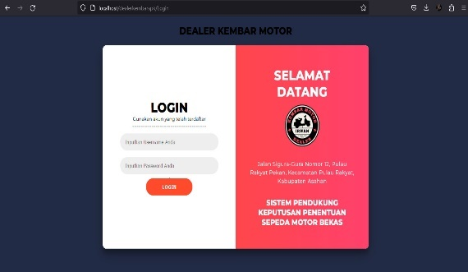

Image 1. Login Page

After logging into the system, the admin will enter the dashboard menu.

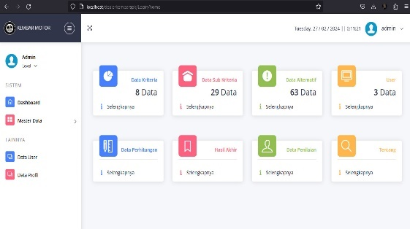

Image 2. Menu Dashboard Admin

And users or potential buyers will be able to access the dashboard page for users.

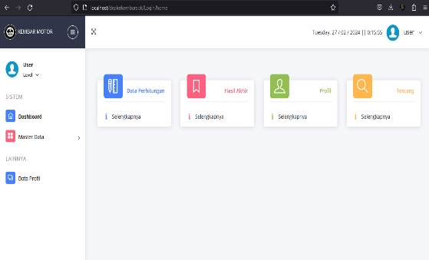

Image 3. Menu Dashboard User

When the admin has filled in alternative data, criteria, sub-criteria and carried out alternative assessments, the admin can carry out calculations according to the desired combination. For example, using the CoCoSo or SAW method.

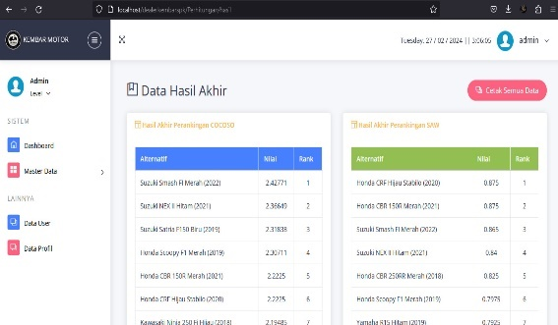

Image 4. Rank Result

**CONCLUSION**

After conducting research using a combination of the CoCoSo and SAW algorithms, it can be concluded that by using these two methods it is possible to compare the ranking results between the Combined Compromise Solution and Simple Additive Weighting methods. With this comparison, the choices received will be accepted more quickly by prospective buyers in determining which used motorbike they want to buy. So that the problems faced by prospective buyers at the Kembar Motor dealer can be made easier in determining the motorbike.

**BIBLIOGRAPHY**

[1] R. P. Sari and M. R. Darmawan, “Sistem Pendukung Keputusan Pemilihan Bahan Bakar Sepeda Motor Matic Mengunakan Metode Simple Additive Weighting (SAW),” *J. Sist. Komput. dan Inform.*, vol. 2, no. 3, p. 311, 2021, doi: 10.30865/json.v2i3.3028.

[2] I. G. I. Sudipa *et al.*, *Sistem Pendukung Keputusan*. Deli Serdang: PT. Mifandi Mandiri Digital, 2022.

[3] T. Nosilia, D. Marisa Midyanti, R. Hidayati, J. Rekayasa Sistem Komputer, and F. H. MIPA Universitas Tanjungpura Jalan Hadari Nawawi Pontianak, “PENERAPAN METODE COMBINED COMPROMISE SOLUTION (CoCoSo) DALAM PENENTUAN PENERIMA PINJAMAN KREDIT DI KOPERASI CU KELING KUMANG SINTANG BERBASIS WEB,” *J. Komput. dan Apl.*, vol. 9, no. 2, pp. 282–291, 2021.

[4] D. A. Rivaldi, “SISTEM PENDUKUNG KEPUTUSAN PEMBERIAN KREDIT MENGGUNAKAN COMBINED COMPROMISE SOLUTION,” Jakarta, Jul. 2023.

[5] F. Ghina, R. A. Anugrah, D. N. Febrianto, M. Munandar, and P. Rosyani, “Sistem Pendukung Keputusan Pemilihan Unit Kendaraan Bermotor Dengan Metode Simple Additve Weighting (SAW),” *OKTAL J. Ilmu Komput. dan Sains*, vol. 1, no. 12, pp. 2333–2345, 2022.

[6] J. V. B. Ginting, “Penerapan Sistem Pendukung Keputusan Dalam Menentukan e-Commerce Terbaik Dengan Menggunakan Metode SAW,” *J. MEDIA Inform. BUDIDARMA*, vol. 4, no. 1, p. 225, Jan. 2020, doi: 10.30865/mib.v4i1.1986.

[7] N. A. Arifin, “Sistem Pendukung Keputusan Pemilihan Sepeda Motor Bekas dengan Metode AHP dan SAW (Studi Kasus: Sahabat Motor),” *STRING (Satuan Tulisan Ris. dan Inov. Teknol.*, vol. 5, no. 2, p. 160, 2020, doi: 10.30998/string.v5i2.7739.

[8] M. Yazdani, Z. Wen, H. Liao, A. Banaitis, and Z. Turskis, “A grey combined compromise solution (CoCoSo-G) method for supplier selection in construction management,” *J. Civ. Eng. Manag.*, vol. 25, no. 8, pp. 858–874, 2019, doi: 10.3846/jcem.2019.11309.

[9] N. D. Apriani, N. Krisnawati, and Y. Fitrisari, “Implementasi Sistem Pendukung Keputusan Dengan Metode SAW Dalam Pemilihan Guru Terbaik,” *J. Autom. Comput. Inf. Syst.*, vol. 1, no. 1, pp. 37–45, 2021, doi: 10.47134/jacis.v1i1.5.