CANNY EDGE DETECTION AND IMAGE SEGMENTATION
FOR PRECISION FACE RECOGNITION SYSTEM

Retno Devita^{1*}, Sumijan²
^{1,2}Computer Science Faculty, Universitas Putra Indonesia YPTK, Padang, Indonesia
email: retno_devita@upiyptk.ac.id

Abstract: Facial recognition is widely used in areas such as video surveillance and database management. Facial images have been used as a preferred biometric trait in many identity recognition systems to obtain good image results in image segmentation. A good image must pay attention to several factors, namely high resolution, good contrast, image sharpness, consistent colors, lack of noise and appropriate lighting conditions. In this face recognition research, using 10 original images and paired with 10 other images using canny edge detection method. The original faces taken are male and female. Canny edge detection has a low error rate in image segmentation. Canny edge detection results can determine the edge of the image well and will display the results of image segmentation obtained. The results of the test data with data stored in the database is 1 face image produces 26.92% accuracy, 1 face image produces 67.69% accuracy and 8 face images produce 100% accuracy,. The average success rate of 10 image experiments using image segmentation is 89.461%. The conclusion that can be from this study is canny edge detection method can provide accurate results in the face recognition process.
Keywords: accuracy, image, canny edge detection, face recognition, segmentation

INTRODUCTION

Nowadays, facial recognition is widely used in computer vision. Facial recognition continues to improve day by day in areas such as video surveillance and database management as spatial feature analysis is critical[1]. Face recognition based on image sets is an important topic in Computer Vision[2].
As one of the most natural clues to identifying individuals, facial images have been used as the preferred biometric trait in many identity recognition systems[3]. Facial recognition that protects privacy involves at least two main parties: one party needs to recognize the image (Party 1), and the other party holds the image database (Party 2) to obtain the desired result[4].
Digital images can be obtained automatically from a digital image capture system that performs the process of capturing a three-dimensional object and forming a matrix in which the elements express the value of light intensity[5]. In facial recognition light factor is very influential once in the process of extraction, segmentation and pengalan other images[6].
Segmentation process the process of separating an image into independent objects according to the intensity of its pixels. It is applied in several areas such as medicine, agriculture and surveillance. One approach the most important and effective for image segmentation is thresholding[7].
In addition to thresholding, edge detection plays an important role in the world of image processing, and is a versatile tool in pattern recognition, image segmentation, contour detection, and feature extraction[8],[9],[10]. Traditional edge detection techniques include roberts, prewitt, sobel and canny. Improvements to traditional edge detection techniques are still being made today. In recent years, edge detection is used for the detection of overlapping objects such as circles [11],[12].
Canny edge detection can detect image edges from the original(initial) image with very few errors and is designed to output a very optimal and good image edge[13],[14].
There are several related research related to facial images from previous research, namely Face Detection and tracking using hybridmargin-based ROI techniques[15]. Real-time Face Detection architecture design for heterogeneous system-on-chip[16].
This study involves multiple thresholding and edge detection methods. First, the face image is taken as input and converted into binary image for processing, then the image is processed by canny method. To get a better calculation then the image segmentation. With image segmentation can get the level of similarity of the paired face image.
Some common criteria for performing edge detection in Canny methods[17] include:
- Edge detection with a low error rate, which means that the detection must accurately capture as many edges as possible displayed in the image[18].
- The detected edge point of the operator must be accurately localized in the center of the edge[19].
- Certain edges in the image should only be marked once, and if possible, image noise should not create false edges[20].
In this study, facial recognition process will be conducted using canny edge detection method.

METHOD

This study introduces a new approach to face pattern recognition by using canny edge detection and determining the accuracy of matching the original face pattern with the specified face pattern pair. Figure 1 below shows the research framework of this study:

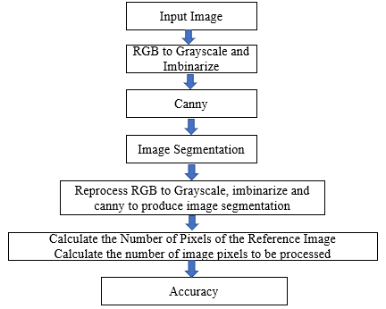

Figure 1. Research Framework

Image Input
The Input used in this study there are 20 facial images. This face Image will be the process of looking for facial similarities with a partner. the image, and perform morphological operations to improve the segmentation results. Display the image of segmentation results.

RGB to Grayscale and imbinarize
Converts the input face image to grayscale (rgb2gray) and performs binarization using the imbinarize function and displays the grayscale face image.

Canny
Apply edge detection using Canny method and display the edge detection image. Canny 3x3 kernels can be learned with the following values:
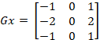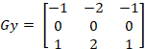

Image Segmentation
Fill in the holes in the image, clean the edges that are connected to the edges of the image, and perform morphological operations to improve the segmentation results. Display the image of segmentation results.

Reprocess RGB to Grayscale, imbinarize and canny to produce image segmentation
Read the next input image, perform RGB to grayscale, imbinarize and canny operations to display the segmented image.

Calculate the Number of pixels of the Reference Image and Calculate the number of image pixels to be processed
Calculates the number of pixels of the reference image and the image of the scanning results. The result is compared the number of pixels and calculated the degree of similarity.

Accuracy
Provides information about the degree of similarity between two images based on the number of corresponding pixels in the form of a percentage(%).

RESULT AND DISCUSSION
In this subsection, we describe the results obtained at each procedural stage and further engage in a comprehensive discourse on the previously described results. The results of the study, includes images generated through different phases of the original image of the face, the original image pair face, canny edge detection, segmentation of the image and the results of the image accuracy.

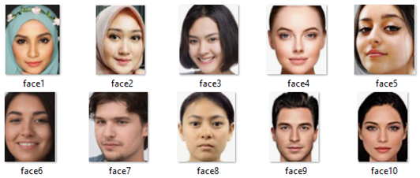
Figure 2. Original Image Of The Face

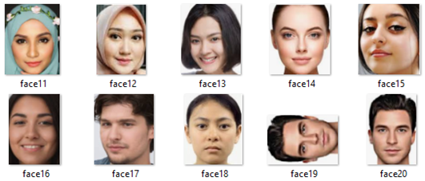

Figure 3. Couples Original Image Of The Face

From the original image of the face, there are two original images that are paired to get the image segmentation results. The original image pair can be seen in Table 1.

The results of image segmentation of the original image and the original image pair selected can be seen from Table 2.

Table 1. Canny Edge Detection
The results of the pair of test images (pixel) and database images (pixel) obtained the value of accuracy, error and identification results, the results can be seen in Table 3.

The results of the percentage of faces for the original face image experiment 10-fold and pairs of original face images can be seen in Table 4.

No | Citra Image | Deteksi Tepi Canny | No |  | Citra Image | Deteksi Tepi Canny
1 | face1 with face11 |  | 6 |  | face6 with face16 | 
2 | face2 with face12 |  | 7 |  | face7 with face17 | 
3 | face3 with face13 |  | 8 |  | face8 with face18 | 
4 | face4 with face14 |  | 9 |  | face9 with face19 | 
5 | face5 with face15 |  | 10 |  | face10 with face20 | 

Table 2. Segmentation image
No | Input Image | Database Image | No | Input Image | Database Image
1 |  |  |   6 |  | 
2 |  |  |   7 |  | 
3 |  | 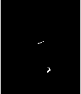 |   8 |  | 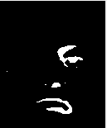
4 |  |  |   9 |  | 
5 |  | 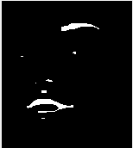 |   10 |  | 

Table 3. Identification Result
No | Test Image (Pixel) | Database Image (Pixel) | Accuracy (%) | Error (%) | Identification  Result
1 | 337 | 337 | 100 | 0 | Matching
2 | 55 | 55 | 100 | 0 | Matching
3 | 27 | 27 | 100 | 0 | Matching
4 | 159 | 159 | 100 | 0 | Matching
5 | 533 | 533 | 100 | 0 | Matching
6 | 132 | 132 | 100 | 0 | Matching
7 | 32 | 32 | 100 | 0 | Matching
8 | 634 | 634 | 100 | 0 | Matching
9 | 130 | 35 | 26,92 | 73,08 | Not Matching
10 | 130 | 88 | 67,69 | 32,31 | Not Matching

Table 4. Percentage Similarity
No | Jumlah Pixel Wajah di Database | Jumlah Pixel Wajah Hasil Scanning | Persentase Kemiripan
1 | 337 | 337 | 100%
2 | 55 | 55 | 100%
3 | 27 | 27 | 100%
4 | 159 | 159 | 100%
5 | 533 | 533 | 100%
6 | 132 | 132 | 100%
7 | 32 | 32 | 100%
8 | 634 | 634 | 100%
9 | 130 | 35 | 26,92%
10 | 130 | 88 | 67,69%
 |  | Rata-rata | 89,461%

CONCLUSION
The results found by using the canny edge detection method produces 8 original face images with original face pairs getting 100% accuracy and 2 other images produce different values. The average success rate of this study was 88.461%.

ACKNOWLEGMENTS
Thank you to Dr. Hj. Zerni Melmusi, SE, MM, Ak, CA, and Rector Prof. H. Sarjon Defit, S.Kom, M.Si and all those who have helped in the implementation of this research.

REFERENCE
[1] V. B. T. Shoba dan I. S. Sam, “A Hybrid Features Extraction on Face for Efficient Face Recognition,” Multimedia Tools and Applications, vol. 79, no. 31–32, hal. 22595–22616, 2020, doi: 10.1007/s11042-020-08997-1.
[2] L. Li, Z. Xia, X. Jiang, F. Roli, dan X. Feng, “CompactNet: learning a compact space for face presentation attack detection,” Neurocomputing, vol. 409, hal. 191–207, 2020, doi: 10.1016/j.neucom.2020.05.017.
[3] C. E. Widodo dan K. Adi, “Face geometry as a biometric-based identification system,” Journal of Physics: Conference Series, vol. 1524, no. 1, 2020, doi: 10.1088/1742-6596/1524/1/012008.
[4] M. A. P. Chamikara, P. Bertok, I. Khalil, D. Liu, dan S. Camtepe, “Privacy Preserving Face Recognition Utilizing Differential Privacy,” Computers and Security, vol. 97, hal. 101951, 2020, doi: 10.1016/j.cose.2020.101951.
[5] A. Hidayatno, R. R. Isnanto, dan K. Dhody, “Penentuan wilayah wajah manusia pada citra berwarna berdasarkan warna kulit dengan metode,” Teknologi Elektro, vol. 5, no. 2, hal. 1–8, 2006.
[6] H. Liang, J. Gao, dan N. Qiang, “A novel framework based on wavelet transform and principal component for face recognition under varying illumination,” Applied Intelligence, no. ii, 2020, doi: 10.1007/s10489-020-01924-9.
[7] A. Elngar dan H. Shaban, “Jou rna,” Expert Systems With Applications, hal. 114159, 2020, doi: 10.1016/j.eswa.2020.114159.
[8] A. Bozorgmehr, M. Khaleqi Qaleh Jooq, M. H. Moaiyeri, K. Navi, dan N. Bagherzadeh, “A novel digital fuzzy system for image edge detection based on wrap-gate carbon nanotube transistors,” Computers and Electrical Engineering, vol. 87, no. August, hal. 106811, 2020, doi: 10.1016/j.compeleceng.2020.106811.
[9] K. Wen, Z. Zhang, X. Jiang, J. He, dan J. Yang, “Results in Physics Image representation of structure color based on edge detection algorithm,” Results in Physics, vol. 19, hal. 103441, 2020, doi: 10.1016/j.rinp.2020.103441.
[10] G. Karimi dan M. Heidarian, “Facial expression recognition with polynomial Legendre and partial connection MLP,” Neurocomputing, vol. 434, hal. 33–44, 2021, doi: 10.1016/j.neucom.2020.12.070.
[11] S. T. H. Kieu, A. Bade, dan M. H. A. Hijazi, “Modified canny edge detection technique for identifying endpoints,” Journal of Physics: Conference Series, vol. 2314, no. 1, hal. 1–7, 2022, doi: 10.1088/1742-6596/2314/1/012023.
[12] U. A. Nnolim, “Heliyon Automated crack segmentation via saturation channel thresholding , area classi fi cation and fusion of modi fi ed level set segmentation with Canny edge detection,” Heliyon, vol. 6, no. July, hal. e05748, 2020, doi: 10.1016/j.heliyon.2020.e05748.
[13] J. Ulfah dan N. Nurdin, “Implementasi Metode Deteksi Tepi Canny Untuk Menghitung Jumlah Uang Koin Dalam Gambar Menggunakan Opencv,” Jurnal Informatika dan Teknik Elektro Terapan, vol. 11, no. 3, hal. 420–426, 2023, doi: 10.23960/jitet.v11i3.3147.
[14] A. Munandar, M. H. Santoso, dan S. Sulistiyasni, “Jurnal Media Pratama Jurnal Media Pratama,” vol. 15, no. 1, hal. 43–61, 2021.
[15] B. Rehman, W. Hong, O. Abby, C. Hong, T. Trung, dan D. Ngo, “Face detection and tracking using hybrid margin - based ROI techniques,” The Visual Computer, no. 0123456789, 2019, doi: 10.1007/s00371-019-01649-y.
[16] F. Spagnolo, S. Perri, dan P. Corsonello, “Design of a real-time face detection architecture for heterogeneous systems-on-chips,” Integration, vol. 74, no. October 2019, hal. 1–10, 2020, doi: 10.1016/j.vlsi.2020.04.008.
[17] T. R. Fujimoto, T. Kawasaki, dan K. Kitamura, “Canny-Edge-Detection/Rankine-Hugoniot-conditions unified shock sensor for inviscid and viscous flows,” Journal of Computational Physics, vol. 396, hal. 264–279, 2019, doi: 10.1016/j.jcp.2019.06.071.
[18] W. Iqbal, N. Khan, A. Mahmood, dan A. Erradi, “Canny edge detection and Hough transform for high resolution video streams using Hadoop and Spark Canny Edge Detection and Hough Transform for High Resolution Video Streams Using Hadoop and Spark,” no. March, 2020, doi: 10.1007/s10586-019-02929-x.
[19] A. B. Prasetyo dkk., “Comparative Analysis of Image on Several Edge Detection Techniques,” TEM Journal, vol. 12, no. 1, hal. 111–117, 2023, doi: 10.18421/TEM121-15.
[20] B. Kumar Shah, V. Kedia, R. Raut, S. Ansari, dan A. Shroff, “Evaluation and Comparative Study of Edge Detection Techniques Related papers Evaluation and Comparative Study of Edge Detection Techniques,” IOSR Journal of Computer Engineering (IOSR-JCE), vol. 22, no. 5, hal. 6–15, 2020, doi: 10.9790/0661-2205030615.

