CUSTOMER SATISFACTION ANALYSIS
REGARDING USING HALODOC APPLICATION
CUSTOMER SATISFACTION INDEX (CSI) METHOD

Dely Indah Sari, Widya Lestari Harahap, Faishal Ali
Perdagangan Internasional, Desain Komunikasi Visual Institut Teknologi Batam
deli@iteba.ac.id, Widiya@iteba.ac.id

Abstract: Halodoc is an information system technology that supports access to health service facilities, with various facilities such as consultations with doctors, purchasing medicines, making appointments with hospitals, as well as several other health support facilities. The occurrence of the COVID-19 pandemic has resulted in restrictions in various aspects. Taking into consideration the urgency that health applications are important during the COVID-19 pandemic to facilitate public access to health care, this motivated research to determine customer satisfaction with Halodoc application services using the Customer Satisfaction Index (CSI) method. The (CSI) method is a measurement scale that describes the level of consumer satisfaction with a product. It is hoped that the results of this research can be a reference for future researchers, especially those related to service quality, customer value for customer loyalty and become input for companies in increasing patient loyalty in using the halodoc application.

Keywords: CSI, halodoc, patient

Abstrak: Halodoc merupakan teknologi Sistem informasi yang mendukung akses fasilitas pelayanan kesehatan, dengan berbagai fasilitas yang dimiliki seperti konsultasi dengan dokter, pembelian obat, buat janji dengan rumah sakit, serta beberapa fasilitas pendukung kesehatan lainnya. Terjadinya pandemi COVID-19 mengakibatkan adanya pembatasan dalam berbagai aspek. Dengan pertimbangan urgensi bahwa aplikasi kesehatan merupakan hal yang penting dalam masa pandemi COVID-19 guna memudahkan akses masyarakat terhadap perawatan kesehatan, memotivasi terjadinya penelitian untuk mengetahui kepuasan pelanggan terhadap layanan aplikasi halodoc menggunakan metode Customer Satisfaction Index (CSI). Metode (CSI) merupakan suatu skala pengukuran yang menggambarkan tingkat kepuasan konsumen terhadap suatu produk. Hasil penelitian ini diharapkan dapat menjadi referensi untuk peneliti selanjutnya terutama yang berkaitan dengan kualitas pelayanan, nilai pelanggan terhadap loyalitas pelanggan serta menjadi masukan kepada perusahaan dalam meningkatkan loyalitas pasien dalam menggunakan aplikasi halodoc.

Kata kunci: CSI, halodoc, pasien

INTRODUCTION

Information technology in various operational aspects is used to increase access to the fields of education, health, and business. One of the uses in the health sector is to prevent the spread of Covid-19, one of which is Halodoc [1]. Halodoc health services aim to provide more efficient, accessible, and innovative solutions in health services, and this technology helps overcome geographical limitations in time and allows wider access to health services for the community. Halodoc is a health service that utilizes the internet to provide health services for its users [2].
Technological developments have given rise to various types of activities and services, one of which is facilitating access to health service facilities. Advances in supporting technology such as hardware and computer software have encouraged the development of various telemedicine systems for various types of applications [3]. The Ministry of Health of the Republic of Indonesia launched four health applications to accommodate and facilitate the public in obtaining accurate, credible, and trustworthy health services [4].
The increasing use of smartphones in Indonesia because of increasing internet use has given rise to various innovations that can facilitate various activities. According to research conducted by the Indonesian Internet Service Providers Association (APJII) between 2019 and 2020, there was a significant increase in the number of users of around 8.9% or reaching 73.7% or more than 196.7 million users in Indonesia [5].
With the help of the internet, smartphones have the benefit of searching for information. M-Health and halodoc are digital services in the health sector that have been downloaded by more than one million users with high ratings [6]. Continuous technological developments from year to year have resulted in several new innovations being discovered [7]. The amount of e-commerce in Indonesia is also increasing during this pandemic, one of which is health-focused applications such as halodoc, Alodokter, Go-Dok, and others which offer a few features that can make things easier for their users. to carry out consultations, buy medicine, even make appointments at their homes [8]. Thanks to the promotion of the Halodoc application through various media, including television, YouTube, and other online media, the Halodoc application is increasingly known among the public [9].
Digital health services have experienced a continuous and significant increase, in 2020 there was an increase in health service consultations via video by >6500 or reflecting a 2000% increase in health service consultations. This does not rule out the possibility of an increase after the pandemic [10].
Based on the background above, the problem identification that will be discussed in this research is: Does Service Quality Influence Customer Value of the Halodoc E-Health Application? Does Customer Value Influence Customer Loyalty of the Halodoc E-Health Application? Does Service Quality Influence Customer Loyalty of the Halo-doc E-Health Application? Does Service Quality Influence Customer Loyalty through E-Health Application customer value Hellodoc?
The following is the research objective of analyzing customer satisfaction with the halodoc application service using the Customer Satisfaction Index (CSI) method: Finding consumers who are influenced by technology readiness and their interest in using Halodoc, finding consumers who know the benefits of halodoc so they don't hesitate to use it, Finding consumers are not confused about using the Halodoc application, so many consumers try to use the Halodoc application.
Halodoc is a technology company originating from Indonesia. Halodoc serves in the health sector and was founded in 2016 in Jakarta by Jonathan Sudharta. The aim of the Halodoc application is to simplify healthcare or provide easy access to health for the Indonesian people. Halodoc is a secure platform that connects patients with licensed doctors, insurance, laboratories, and pharmacies into one mobile application.
People's limitations in accessing health services during the pandemic have shifted people's interest in considering long-distance access to health using telemedicine soon. The government is also developing telemedicine to increase access to quality health services amidst the Covid-19 pandemic. The Ministry of Health is developing the use of technological developments, to make it easier for people to seek treatment without having to meet a doctor face to face. Telemedicine services are health services provided by doctors using information and communication technology to diagnose, treat, prevent, and evaluate patients' health conditions. This service allows doctors to provide services without face-to-face contact
Until 2018, the total funding received was around US$13 million or around Rp. 170 billion; Some of its investors include Gojek, Blibli, Clermont, and NSI Ventures. Halodoc announced a collaboration with Gojek in May 2018. Through this collaboration, Gojek will connect the Gomed feature in the Gojek application with the Halodoc application. So Go-jek users will be directly directed to the Halodoc application to order medical needs such as medicine or vitamins.
According to the Halodoc.com website, Halodoc provides the most complete health solutions in Indonesia, such as chatting with doctors, buying medicine, making hospital appointments, lab checks, the latest information about health and others that can be accessed anywhere, anytime. Halodoc services are available in more than 100 cities throughout Indonesia for drug delivery, to more than 20,000 doctors with various specialties, and to 1,600 hospitals throughout Indonesia.
There are 4 types of business models available at halodoc including: First Consult in the consult business model, there are several services available to patients, including: Users can consult a general practitioner or specialist doctor. Users will be charged a consultation service fee with prices starting from Rp. 15,000, Users will be given a few minutes to consult via chat with several selected doctors. After sufficient consultation, the doctor will prepare a prescription for the user's medication needs. Next, the medication will be ordered through the Halodoc partnership pharmacy and will be sent directly to the home. Book. In the book business model, there are several services available to patients, including: Patients simply make an appointment with a doctor online at the hospital of their choice and arrive at the specified time.
To use it, patients only need to go to the 'Hospital' section on the official Halodoc website. Then, select the hospital you want to visit and determine the type of registration. Next, the patient just must choose the type of treatment based on the polyclinic, select a doctor, then determine the date and time of the consultation. After determining the schedule, the patient only needs to fill in the requested data. If approved, a confirmation SMS will be sent to the patient's cellphone number via SMS. Next, patients only need to come to the hospital 30 minutes before the scheduled consultation, then show the verification code to confirm attendance. Orders. In the order business model, there are several services available to patients, including: The Halodoc application is equipped with a Health Shop which allows us to buy online medicines, supplements, vitamins, and medicines with a doctor's prescription. Online orders are a Pharmacy Delivery service where orders are placed directly by the buyer or on the recommendation of the doctor who handles the patient/buyer based on previous online consultations carried out by the patient. Offline Orders is a service where the Pharmacy (user) and Patient Relations Officer make orders for patients/buyers based on a doctor's prescription. Orders made can be sent via the Go-Jek delivery service (Delivery Order) or patients can pick up the medicine directly at the Pharmacy (Pickup Order). Insurance. In the insurance business model, there are several services available to patients, including: FWD Insurance Indonesia (FWD Insurance) is improving the FWD Max application service through collaboration with Halodoc. Making it easier for the public to access health services, by providing features to ask a doctor, buy medicine, laboratory tests, and make appointments with doctors at hospitals via the application. Easy access to health services at halodoc can also be connected to your health insurance.
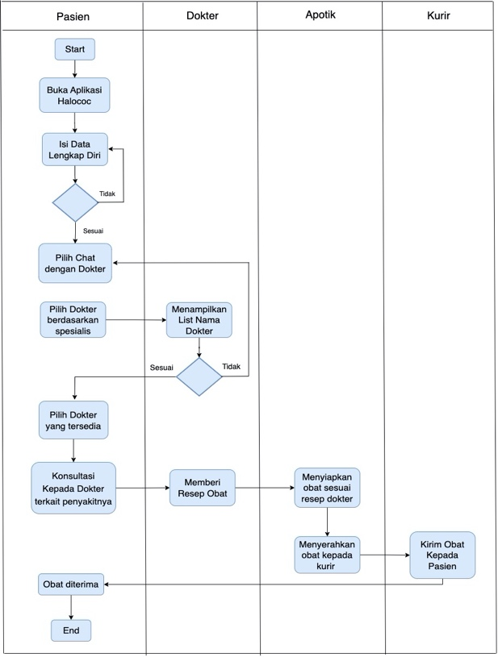
Picture 1 Business Process Flowchart Halodoc
According to Kasmir, service is the actions or deeds of a person or organization to provide satisfaction to customers, fellow employees, and leaders.
A service or service is an appearance performance, intangible and can be felt, disappears more quickly, and can be owned or imitated, and customers are more able to participate actively in the process of using or utilizing the service. Services are a form of service consisting of appearance, activities and benefits or satisfaction which are basically intangible and do not result in a transfer of ownership but can be felt.

METODE

The following is a research data collection technique for customer satisfaction analysis of Halodoc application services using the Customer Satisfaction Index (CSI) method [12].
Data collection in this research used observation and literature study methods. Observations are carried out to study problems in the fieldwhich is related to the object under study. Literature Study This method is carried out by looking for materials that support the definition of the problem through books, journals, and the internet. Questionnaire, a method used to collect user opinions and experiences regarding the digital health services provided.

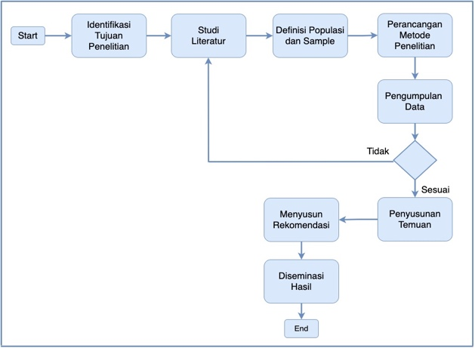
Picture 2 Research Diagram
The following is a research design for customer satisfaction analysis of the halo-doc application service using the Customer Sat-isfaction Index (CSI) method: Objective Identification
The research aims to determine the overall level of customer satisfaction using the approach and consideration of the product attributes being measured, so that the level of customer satisfaction is obtained to be evaluated periodically by making improvements that are lacking to improve health services. Study of literature. To understand the conceptual framework, previous research findings and current trends in related research, so that significant results will be obtained. Definition of population and sample. Determine the halodoc population and sample to reflect the diversity of users for more representative results.

Tabel 1
Customer Satisfaction Indeks (CSI)
Atribut | Interest  (I) | Satisfaction  (P) | Score  (S)
 | Scala 1-5 | Scala 1-5 | (S) =  (I) x (P)
……….
……….
Score Total | Total (I)=(Y) |  | Total (S)=(T)

Customer Satisfaction Index (CSI)
calculated by the formula:
CSI = $\frac{T}{5Y} x 100\%………………………$

Keterangan:
T = Total CSI Value
- = Maximum value on scale
measurement
Y = Total Value of the expected colum

Tabel 2 kriteria Tingkat Kepuasan
No | Nilai CSI (%) | Keterangan (CSI)
1 | 81% - 100% | Very satisfied
2 | 66% - 80.99% | Satisfied
3 | 51% - 65.99% | Quite satisfied
4 | 35% - 50.99% | Less Puas
5 | 0% - 34.99% | Not Puas

The maximum CSI value is 100%. A CSI value of 50% or lower indicates poor service performance. A CSI value of 80% or higher indicates that users are satisfied with service performance.

RESULT

Continuous technological developments from year to year have resulted in several new innovations being discovered. The amount of e-commerce in Indonesia has also increased during this pandemic, one of which is health-focused applications such as Halodoc, Alodokter, Go-Dok, and others which offer a number of features that can make things easier for their users. to carry out consultations, buy medicine, even make appointments at their homes. Thanks to the promotion of the Halodoc application through various media, including television, YouTube and other online media, the Halodoc application is becoming increasingly well known among the general public. The following are the results of demographic data on the distribution of respondents.
Respondent demographics base on age based on the data that has been collected, it can be concluded as in Figure 4.1, showing that most respondents who use the halodoc application are aged 19 to 25, numbering 14 or 70%, then those aged 26 to 35 are 6 people out of 20 respondents or 30%.

Picture 2 Respondent demographics base on age

Respondent demographics base on gender
Based on the data that has been collected, it can be concluded as in Figure 4.2, showing that the majority of Halodoc application users are women with a total of 11 people or 55% and male respondents totaling 9 people or 45% of the total sample of 20 data.

Picture 2 Respondent demographics base on gender
Respondent demographics base on occupantion Based on the data that has been collected, it can be concluded as in Figure 4.3, the diagram shows that most respondents are students with a total of 16 people or 80% of the 20 data, then employees etc. are 4 people or 20%.

Picture 2 Respondent demographics base on occupantion

The Customer Satisfaction Index (CSI) is an index to determine the overall level of customer satisfaction with an approach that considers the level of importance of product and service attributes. In implementing the CSI method, a questionnaire will be carried out which will be filled in by consumers and will produce data on the level of satisfaction that has been achieved. The following is the required questionnaire: Determining the Importance Level Scale as a guide for customers to assess the level of importance of service quality, using a Likert scale with a value of 1-4. Seen in table 3
Tabel 3
Likert Scale of Level of Importance
Bobot | Keterangan
1 | Very unimportant (VU)
2 | Not Important (NI)
3 | Important (I)
4 | Very Important (VI)

Determining the level of satisfaction/ performance scale (Performance). As a guide for customers to assess the level of service quality performance, using a Likert scale with 1-4. As in table 4
Table 4
Performance Level Likert Scale
Bobot | Keterangan
1 | Very dissatisfied (VD)
2 | Not satisfied (NS)
3 | Satisfied (P)
4 | Very Satisfied (VS)

Determining question indicators. In measuring service quality factors, the model (WEBQUAL) is used which consists of three indicators Usability, Information Quality, Interaction Quality as in table 5

Tabel 5
Question Indicator Table
No | Indikator | Kode
- | Usability | -
1 | Availability of consultation services with the right doctor on the Halodoc application | A1
2 | Halodoc application services make it easy for users to immediately get solutions to health problems | A2
 | Information Quality
3 | The Halodoc application is my main choice in increasing my knowledge about health | A3
4 | The Halodoc application provides accurate health information according to user needs. | A4
 | Interaction Quality
5 | Medical explanations in the Halodoc application provide accurate information according to the needs of application users | A5
6 | The availability of hospitals that collaborate with Halodoc makes it easier for users to schedule hospital visits as desired | A6

Based on the data that has been collected, it can be concluded, showing that most respondents who use the halodoc application are aged 19 to 25, numbering 14 or 70%, then those aged 26 to 35 are 6 people out of 20 respondents or 30%.
Based on the data that has been collected, it can be concluded, showing that the majority of Halodoc application users are women with a total of 11 people or 55% and male respondents totaling 9 people or 45% of the total sample of 20 data.
Based on the data that has been collected, it can be concluded, the diagram shows that most respondents are students with a total of 16 people or 80% of the 20 data, then employees etc. are 4 people or 20%.
The following is a manual calculation using only three respondents as follows:
Table 6
Table of Interests
Kode | R1 | R2 | R3 | Total | Average
A1 | 4 | 2 | 1 | 7 | 2.33
A2 | 3 | 4 | 3 | 10 | 3.33
A3 | 2 | 4 | 2 | 8 | 2.67
A4 | 5 | 4 | 2 | 11 | 3.67
A5 | 4 | 5 | 5 | 14 | 4.67
A6 | 3 | 1 | 2 | 6 | 2

Table 7
Satisfaction Table
Kode | R1 | R2 | R3 | Total | Average
A1 | 3 | 3 | 2 | 8 | 2.67
A2 | 1 | 3 | 2 | 6 | 2
A3 | 1 | 5 | 1 | 7 | 2.33
A4 | 5 | 3 | 3 | 11 | 3.67
A5 | 3 | 5 | 4 | 12 | 4
A6 | 4 | 2 | 3 | 9 | 3

Table 8
Table Customer Satisfaction Index (CSI)
Kode | Kepentingan (I) | Kepuasan (P) | Skor (S)  (I x P)
A1 | 2.33 | 2.67 | 6.22
A2 | 3.33 | 2 | 6.67
A3 | 2.67 | 2.33 | 6.22
A4 | 3.67 | 3.67 | 13.44
A5 | 4.67 | 4 | 18.67
A6 | 2 | 3 | 6
 | Total (I) = 18.67  Total (I) = (Y) |  | Total (S) = 57.22  Total (S) = (T)

CSI = T_ x 100%
5Y
= 57.22 x 100%
5 (18.67)
= 57.22 x 100%
93.35
= 61.29%

Tabel 9
Satisfaction Level Criteria
No | Nilai CSI (%) | CSI
1 | 81% - 100% | Very Satisfied
2 | 66% - 80.99% | Satisfied
3 | 51% - 65.99% | Quite Satisfied
4 | 35% - 50.99% | Less satisfied
5 | 0% - 34.99% | Not Satisfied

CONCLUSION

Based on the Customer Satisfaction Index (CSI) calculation, halodoc has 61.29% satisfaction criteria levels from the importance table, satisfaction table and CSI table, meaning that there is convenience in the halodoc application from fast health access so that patients can consult with doctors equipped with the convenience of consulting without needing come physical health facilities with online medicine ordering.

ACKNOWLEGMENTS

Thank for LPPM ITEBA with a letter of assignment for funding research customer satisfaction analysisregarding using halodoc application services customer satisfaction index (csi) method.

BIBLIOGRAPHY

[1] A. A. Pratama and A. B. Mutiara, “Software Quality Analysis for Halodoc Application using ISO 25010:2011,” Int. J. Adv. Comput. Sci. Appl., vol. 12, no. 8, pp. 383–392, 2021, doi: 10.14569/IJACSA.2021.0120844.
[2] Mochammad Aldi Kushendriawan, Harry Budi Santoso, Panca O. Hadi Putra, and Martin Schrepp, “Evaluating User Experience of a Mobile Health Application ‘Halodoc’ using User Experience Questionnaire and Usability Testing,” J. Sist. Inf., vol. 17, no. 1, pp. 58–71, Apr. 2021, doi: 10.21609/jsi.v17i1.1063.
[3] D. I. Sari, “Implementasi Manajemen Proyek CPM pada Pembangunan Infrastruktur IT Optical Distribution Point,” JURTEKSI (Jurnal Teknol. dan Sist. Informasi), vol. 7, no. 3, pp. 267–276, 2021.
[4] Kemkes.go.id, “Kemenkes Luncurkan 4 Aplikasi Bidang Kesehatan – Sehat Negeriku,” Kemkes.Go.Id, no. November, 2018.
[5] APJII, “Profil Internet Indonesia 2022,” 2022.
[6] A. Pratama, M. P. W, B. A. P, and R. A. F, “PENGUKURAN USABILITY SYSTEM APLIKASI HALODOC SEBAGAI LAYANAN M-HEALTH MENGGUNAKAN USE QUESTIONNAIRE,” Pros. Semin. Nas. Inform. Bela Negara, vol. 2, 2021, doi: 10.33005/santika.v2i0.120.
[7] D. I. Sari and M. Jufri, “INTEGRATED NETWORK SYSTEM SECURITY TO DETERMINE GIS (GEOGRAPHIC INFORMATION SYSTEM) BASED CYBER CRIME PATTERNS,” JURTEKSI (Jurnal Teknol. dan Sist. Informasi), vol. 9, no. 1, 2022, doi: 10.33330/jurteksi.v9i1.1890.
[8] “QUALITY CONTROL OF OPTICAL FIBER DISRUPTION WITH BIG DATA USING THE SIX SIGMA METHOD,” STMIK R., vol. Vol 8, No, 2022.
[9] D. A. Saputra and R. K. Dewi, “Hubungan Kualitas Pelayanan Terhadap Kepuasan Pengguna Platform Telemedicine Halodoc Tahun 2022,” JURMIK (Jurnal Rekam Medis dan Manaj. Inf. Kesehatan), vol. 2, no. 2, pp. 1–16, 2022.
[10] B. M. Demaerschalk, R. N. Blegen, and S. R. Ommen, “Scalability of Telemedicine Services in a Large Integrated Multispecialty Health Care System during COVID-19,” Telemed. e-Health, vol. 27, no. 1, pp. 96–98, Jan. 2021, doi: 10.1089/tmj.2020.0290.
[11] D. I. Sari, W. L. Harahap, and Y. T. Yoss, “TRANSFORMATION DIGITAL IN LOGISTIC COMPANY STRATEGY MANAGEMENT AFTER PANDEMIC COVID 19,” JURTEKSI (Jurnal Teknol. dan Sist. Informasi), vol. 9, no. 3, 2023, doi: 10.33330/jurteksi.v9i3.2427.
[12] S. M. Widodo and J. Sutopo, “Metode Customer Satisfaction Index (CSI) Untuk Mengetahui Pola Kepuasan Pelanggan Pada E-Commerce Model Business to Customer,” J. Inform. Upgris, vol. 4, no. 1, 2018.

