**ANALYSIS OF PUBLIC OPINION ON INDONESIAN TELEVISION SHOWS ON TWITTER SOCIAL MEDIA USING SUPPORT VECTOR MACHINE**

**Fidya Farasalsabila1*, Ema Utami 2, Hanafi3**

1,2,3Master of Informatics Engineering, Universitas Amikom Yogyakarta

*email*: fidya@students.amikom.ac.id

**Abstract:** Lots of researchers are now studying sentiment analysis using supervised and machine learning methods. The analysis made can be based on movie reviews, Twitter reviews, online product reviews, blogs, discussion forums or other social networks. However, as technology advances, it is becoming easier for people to use social media to find information and exchange information or opinions with the public without being limited by space or time. Twitter is one of the social media platforms that is used as a container for opinions. Various methods are used to get the best and practically accurate pressure recognition. The results of the analysis and discussion conclude that the Support Vector Machine (SVM) was successfully implemented for this study using public opinion data regarding television program reviews in Indonesia. The Twitter data set is analyzed using different parameters using the SVM classifier. By collecting up to 320 reviews from 4 television shows for training data and 80 reviews for testing, the preprocessing process for filtering and classifying data using SVM with a total of 400 data was successfully completed to carry out this study with a comparison of 200 positive and 200 negative data points. According to this experiment, the SVM method with Term Frequency–inverse Document Frequency (TF-IDF) was used to obtain the highest accuracy test results with an accuracy of 80% on the test and an accuracy of 100% on the training data.

**Keywords:** Sentiment Analysis, Television Shows Review, TF-IDF, Support Vector Machine.

**Abstrak:** Banyak peneliti sekarang mempelajari analisis sentimen menggunakan metode yang diawasi dan machine learning. Analisis yang dilakukan dapat berdasarkan review film, review Twitter, review produk online, blog, forum diskusi atau jejaring sosial lainnya. Namun seiring kemajuan teknologi, masyarakat semakin mudah menggunakan media sosial untuk mencari informasi dan bertukar informasi atau pendapat dengan masyarakat tanpa dibatasi oleh ruang dan waktu. Twitter merupakan salah satu platform media sosial yang digunakan sebagai wadah penyampaian opini. Berbagai metode digunakan untuk mendapatkan pengenalan tekanan yang terbaik dan praktis akurat. Hasil analisis dan pembahasan menyimpulkan bahwa Support Vector Machine (SVM) berhasil diimplementasikan untuk penelitian ini dengan menggunakan data opini masyarakat mengenai review program televisi di Indonesia. Kumpulan data Twitter dianalisis menggunakan parameter berbeda menggunakan pengklasifikasi SVM. Dengan mengumpulkan sebanyak 320 review dari 4 acara televisi untuk data pelatihan dan 80 review untuk pengujian, maka proses preprocessing untuk menyaring dan mengklasifikasikan data menggunakan SVM dengan total 400 data berhasil diselesaikan untuk melaksanakan penelitian ini dengan perbandingan 200 positif dan 200 titik data negatif. Berdasarkan percobaan ini, metode SVM dengan Term Frekuensi – inverse Document Frekuensi (TF-IDF) digunakan untuk memperoleh hasil pengujian akurasi tertinggi dengan akurasi 80% pada pengujian dan akurasi 100% pada data pelatihan.

**Kata kunci:** Analisis Sentimen, Review Tayangan Televisi, TF-IDF, Support Vector Machine.

**INTRODUCTION**

Television is a type of electronic media that provides entertainment as well as information to viewers of television shows. Ratings for television shows can be seen by looking at which pro-grams are most popular with the general public. Viewers of television shows frequently share their thoughts or comments about their favorite shows on social media platforms such as Twitter. The opinion is in the form of a tweet, which will later become news on the Twitter timeline. Twitter public opinion toward television shows is important be-cause it can be used to perform sentiment analysis in predicting people's evaluation of a television program, whether positive or negative.

Many text mining methods, including Lexicon Based, Support Vector Machine, K-Nearest Neighbor, and Nave Bayes classifier, can be used to perform sentiment analysis. The Support Vector Machine method was chosen from among the many text mining methods because it has a relatively high accuracy value when compared to other methods, such as in [1] research which compared the Performance of the K-Nearest Neighbor, Nave Bayes Algorithm Classi-fier, and Support Vector Machine. The highest accuracy value obtained from the Support Vector Machine method of 81.58%, while the K-Nearest Neighbor and Naive Bayes methods are 81.32%.

Then, in subsequent research [2], obtain accuracy results of 98.33% using the SVM method, and [3] obtain the highest accuracy score by SVM of 89.70%. Based on the three studies dis-cussed above, the SVM method has the highest accuracy value.

Research on Public Sentiment Analysis On Social Media Twitter Against Implementation of Simultaneous PILKADA Using the Support Algorithm Vector Machine [4]. The classification process produces two types of category tweets: positive and negative. Labeling 3000 Indonesian language tweet datasets is done using clustering method, by di-viding 3000 data into 2700 training data and 300 testing data. Classification yields the highest accuracy of 91%, while clustering l-means yields only 82%.

Twitter Implementation Sentiment Analysis For Review Movies [5] research Vector Engines Benefit from the Use of Algorithms. With the classification process using Algorithm Support Vector Machine, it is easy to see positive, negative, or neutral opinion. Accu-racy evaluation yields a high level of accuracy stable up to 76% of the time during the training process, which is higher than the Nave Bayes algorithm only until 75% is the classifier stable.

According to [6], the Naive Bayes procedure was used to analyze sentiment on Twitter against the performance of the Eradication Commission Corruption (KPK) in Indonesia. With the intention of addressing issues with KPK performance based on Twitter data. Ac-cording to the findings of this study, 50.96% of Twitter accounts have positive sentiment and 49.03% have negative sentiment. While the test data analysis shows an accuracy rate of 65.51%, a precision level of 51.35%, and a recall rate of 90.47%.

Based on the findings of the pre-ceding studies, the SVM method has the highest accuracy value. Furthermore, study found that using term weights with a more efficient training process and classification functions can improve accuracy [7]. The goal of weighting words (terms) is to give equal weight to each word (term) contained in the to-be-processed text document [8]. The TF-IDF method was then used to improve accuracy. The goal of this study is to use SVM to determine the pattern of public opinion regarding television broadcasts in Indonesia, and to use TF-IDF to determine the results of increasing accuracy.

**METHOD**

The model proposed in this study is Support Vector Machine. There are several steps that need to be done before implementing this model into research. The review text is then prepared for the trained model. The technique used for this research project will be applied to the discussion in this section.

**Proposed Model**

The model proposed in this study is Support Vector Machine. There are several steps that need to be done before implementing this model into research.

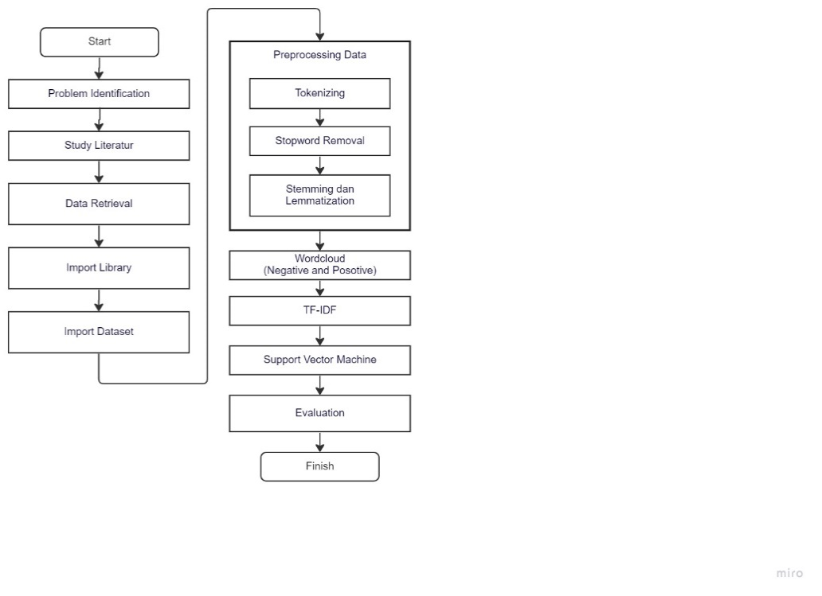

Image 1. Research Flow

**Sentiment Analysis**

Sentiment analysis, also known as opinion mining, is a field of study that investigates how people express their feelings about a particular thing or quality in written text. The entity in question could be goods, services, businesses, people, events, problems, or subjects. Sentiment analysis, subjectivity analysis, affect analysis, emotion analysis, and review mining are all terms that re-fer to the same concept but slightly different tasks. All of these terms are grouped together under the umbrella term "sentiment analysis" [9]

Sentiment analysis has been one of the most active areas of research in natural language processing since the early 2000s. The goal of sentiment analysis is to define an automated tool that can extract sentiments and other subjective information from texts and natural language, resulting in organized and useful knowledge that can be used by decision support systems or decision making. Due to some uncertainty about the distinction between sentiment and opinion, researchers disagree on whether the discipline should be called sentiment analysis or opinion mining. In contrast to opinion, which is defined as a mental view, judgment, or judgment on a specific issue, Merriam-Webster defines sentiment as an attitude, thinking, or judgment motivated by feelings. The distinctions are minor, and both share several characteristics. The definition shows that, while sentiment is a feeling, opinion is a person's concrete perception of something [10].

**Television Shows**

Television shows can reach a large audience. Experiments with television broadcast began in the late 1920s and early 1930s. Television can also be interpreted as a tool or object for broad-casting broadcasts that bring sound and images at the same time, and the audience can hear and see the images presented, which combine elements of radio and film, through these television broad-casts. Television is a visual broadcasting medium. Television is derived from the words tele and vision, which mean far (tele) and visible (vision), respectively, so television refers to viewing from a distance. Television is compared to the invention of the wheel in that it has the potential to change world civilization [11].

**Preprocessing**

Tokenization, Stop Word Removal, Stemming, and Lemmatization are ex-amples of fundamental text processing procedures [12].

**Tokenization**

Tokenization is the process of recognizing words in a character input sequence, primarily through the separation of punctuation marks, but also through recognition, abbreviations, and other means. If the content was taken from a web page, the tokenization process may also include normalization procedures such as removing HTML tags, truecasing, or lowercase lettering.

**Stop Word Removal**

Stop words, also known as function words or closed-class words, are high-frequency words such as subjects, affixes, pronouns, determinants, prepositions, and conjunctions. Throughout this process, words that are not essential to the text document will be removed.

**Stemming**

Despite the fact that many words in natural language have similar meanings, their various forms render recognition useless. Simply put, stemming is the process of removing suffixes and prefixes from an input word to obtain the term's parent (root), which will be shared by all associated words. Computation, computations, and computations, for example, will all derive from the same root. When a system rather than a human being is the "consumer" of a root word, stemming frequently produces root words that are invalid or irrelevant.

**Lemmatization**

As an alternative to stemming, lemmatization reduces a word's inflectional form to its root form. Lemmatization, as opposed to stemming, produces legitimate word forms, which are the earliest forms of words found in dictionaries. Lemmatization has the advantage of making the output more human read-able, but it requires a more computationally demanding procedure because it requires a list of grammatical forms to handle regular inflection as well as a long list of irregular words.

**Term Frequency-Inverse Document Frequency (TF-IDF)**

The term frequency (TF) and the inverse document frequency (IDF) are combined in TF-IDF [13]. (IDF). The TF representation is one of the simplest TWSs because it uses the document's original term frequency values. The assumption behind TF is that terms with higher term frequency values are more important than terms with lower term frequency values. It is determined by the number of times certain terms appear in the local document. As a result of its ignorance of collection frequency, TF's ability to distinguish all relevant documents from other irrelevant documents is very poor. To address this issue, in-verse document frequency (IDF) in terms of coverage frequency [14] has been proposed, which improves term distinguishability for text classification. IDF goes beyond document frequency (DF) to the number of documents containing the term. This is based on the assumption that terms that appear in fewer documents are considered more important than terms that appear in more documents [15]. The IDF value of a specific term can be calculated as follows.

$IDF (t,d,D)=log\frac{|D|}{DF(t,D)}$ (1)

$IDF (t,d,D)=log\frac{\left|D\right|+1}{DF\left(t,D\right)+1}$ (2)

$TF-IDF \left(t,d,D\right)=TF\left(t,d\right)*IDF(t,d,D)$ (3)

**Support Vector Machine**

The SVM algorithm [16] is a binary classification model. A straight line is the best-fit segmentation between two data classes in two-dimensional space, and it must establish an optimal decision plan as the segmentation reference in high-dimensional data sets. When solving a classification problem, the basic principle of SVM requires that the distance between the nearest sample point and the decision surface be maximum, i.e. the minimum distance between two classes of sample points to separate the samples [17].

It is represented by the classification function f(x) = wTx + b. It is equal to the distance between the two dotted lines ̃r, that is, the interval of two dotted lines to 2̃r, and the support vector on the dotted line. ̃r is defined as the geometric distance, and the formula is:

$r=yr\frac{ ̂r}{w}$ (4)

Where ̂r = y(wTx + b) = yf(x), ̂r is a function interval.

**Evaluation Matrix**

The Confusion Matrix is a matrix that shows how well a model predicts a given situation. The confusion matrix is one method for evaluating the performance of a classification model. In its most basic form, the confusion matrix contains a 2x2 table for categorizing models with data as A or B (4).

Table 1. Confusion Matrix Table

|  |  |  |
| --- | --- | --- |
| **Actual Class** | **Predict Class** | |
|  | **Positive** | **Negative** |
| Positive | True Positive | False Negative |
| Negative | False Positive | True Negative |

A variety of evaluation methodologies are used to assess the classification's effectiveness on previously unseen test data. The most commonly used metrics for text classification are precision, recall, F-measure, and accuracy. A common goal is to maximize all metrics with values between 0 and 1. As a result, higher values indicate better categorization performance [18].

Precision and recall are two statistics in text categorization that are frequently combined to assess the effectiveness of information retrieval. More specifically, recall counts the number of relevant documents that were successfully retrieved, whereas accuracy counts the number of relevant documents that were actually retrieved. The formula, which can be found in equations (5), can be used to calculate both of these metrics (6).

Precision = TP/(TP + FP) (5)

Recall = TP/(TP + FN) (6)

Precision and recall are rarely considered separately. These two measurements are frequently combined in the F-measure, which provides a single weighted statistic for assessing overall performance. The F-measure can be calculated using the formula in the equation (7).

$F1-measure=2×\frac{Precision ×Recall}{Precision ×Recall}$ (7)

Another metric used to assess categorization performance is accuracy. The number of correctly identified samples is used to calculate accuracy. Accuracy is used when the classification consistently predicts one class, which can be determined using a formula such as equation (8).

Accuracy $=2×\frac{TP+TN}{TP+TN+FP+FN}×100\%$ (8)

**RESULT AND DISCUSSION**

In this study the authors carried out several implementations with several parameters to get maximum results. The parameters tested were Wordcloud before and after preprocessing and then proceed to the feature extraction stage, namely TF-IDF. For the first, the parameter being tested is Wordcloud. In Figure 2 these are the words contained in the worldcloud for negative word.

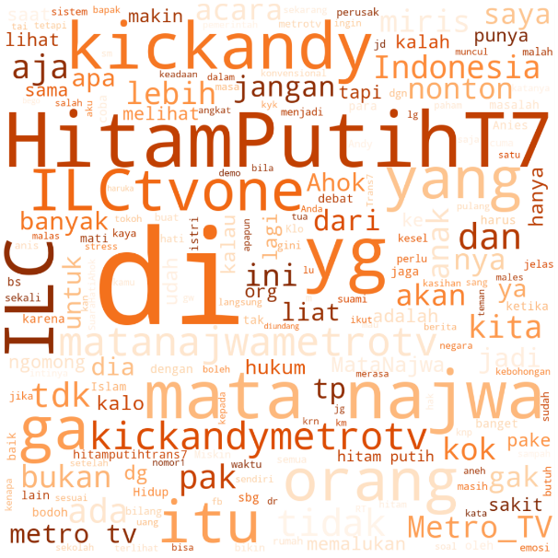

Image 2. Wordcloud Negative

Furthermore, for the second parameter tested is worldcloud positive word. In the Figure 4 these are the words from Wordcloud positive word. After that, it is continued to the feature extraction process and evaluation matrix.

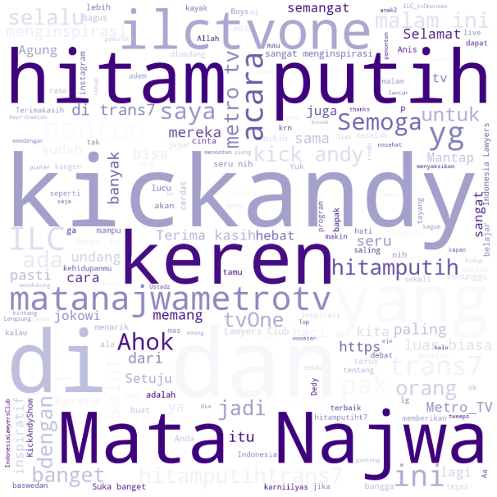

Image 3. Wordcloud Positive

**Evaluation Model**

It may be concluded from the analysis and discussion conducted that SVM has been successfully implemented using the Television Show Review data for this study (Support Vector Machine). In order to perform this study, the preprocessing process for filtering and classifying data using SVM was successfully completed with 400 data, aggregating up to 320 for training data and 80 reviews for test data. The opinion is divided into 50% positive data and 50% negative data. The test results in this study are presented in Table 2.

Table 2. Result of Confusion Matrix

|  |  |  |
| --- | --- | --- |
| **Actual Class** | **Predict Class** | |
|  | **Positive** | **Negative** |
| Positive | 40 (TP) | 0 (FN) |
| Negative | 16 (FP) | 24 (TN) |

From the evaluation results that can be seen in table 2, it describes that the model detects TP as many as 40 data, FN 0 data, FP 16 data and TN 24 data. The test results in this study of the training data is 100% while for the test data is 80% as can be seen in figure 4.

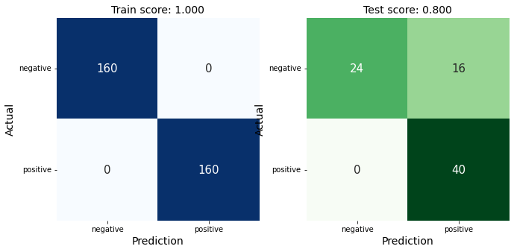

Image 4. Result

**CONCLUSION**

Based on the results of the analysis and discussion that has been carried out, it can be interpreted that the data for this study succeeded in implementing the Support Vector Machines (SVM) algorithm for . It can be said from the analysis and discussion carried out that SVM has been successfully implemented on television broadcast data. To carry out this research, the preprocessing process to filter and classify data using SVM was successfully completed with a total of 400 data, with a calculation of 200 positive labeled data and 200 negative labeled data with a calculation of 80% training data and 20% test data. data. Opinion from the data is divided into negative data 0.50 and positive data 0.50. 80% of the highest quality test results are achieved using SVM (Support Vector Machine).

Complete word dictionaries (known as "library stop words" in Indonesian) and specialist linguistics are expected to be used in future research to improve the accuracy of the results. For further research, case studies with various social media platforms and comparisons with other models and algorithms are suggested. In a further study, additional analyzes included not only Twitter but also other social media needs. Fourth, most of the younger generation use Twitter, the results of this study may not reflect the characteristics of the elderly who do not use Twitter. Twitter's accuracy in predicting negative or positive expressions is also low due to the nature of everyday language. Further research is needed to determine whether the algorithm can overcome the limitations of unbalanced data in embedding calculations and weight selection to improve the performance of NLP models that analyze everyday conversations. [19], [20]

**BIBLIOGRAPHY**

[1] I. Saputra And D. Rosiyadi, “Perbandingan Kinerja Algoritma K-Nearest Neighbor, Naïve Bayes Classifier Dan Support Vector Machine Dalam Klasifikasi Tingkah Laku Bully Pada Aplikasi Whatsapp,” *Faktor Exacta*, Vol. 12, No. 2, P. 101, Jul. 2019, Doi: 10.30998/Faktorexacta.V12i2.4181.

[2] A. Setiyono And H. F. Pardede, “Klasifikasi Sms Spam Menggunakan Support Vector Machine,” *Jurnal Pilar Nusa Mandiri*, Vol. 15, No. 2, Pp. 275–280, Sep. 2019, Doi: 10.33480/Pilar.V15i2.693.

[3] M. Rangga, A. Nasution, And M. Hayaty, “Perbandingan Akurasi Dan Waktu Proses Algoritma K-Nn Dan Svm Dalam Analisis Sentimen Twitter,” *Jurnal Informatika*, Vol. 6, No. 2, Pp. 212–218, 2019, [Online]. Available: Http://Ejournal.Bsi.Ac.Id/Ejurnal/Index.Php/Ji

[4] A. Rahmawati, A. Marjuni, J. Zeniarja, J. Informatika, U. Dian, And N. Semarang, “Analisis Sentimen Publik Pada Media Sosial Twitter Terhadap Pelaksanaan Pilkada Serentak Menggunakan Algoritma Support Vector Machine Public Sentiment Analysis On Twitter Social Media To Pilkada Serentak Event Using Support Vector Machine Algorithm,” 2017.

[5] F. Rahutomo, P. Y. Saputra, And M. A. Fidyawan, “Implementasi Twitter Sentiment Analysis untuk Review film Menggunakan Algoritma Support Vector Machine,” *Jurnal Informatika Polinema* , Vol. 4, 2018.

[6] R. Taufiq, A. E. Wardoyo, And R. Pratama, “Analisis Sentimen Pada Twitter Terhadap Kinerja Komisi Pemberantasan Korupsi (Kpk) Di Indonesia Dengan Metode Naive Bayes.”

[7] S. Al Faraby, “Analisis Dan Implementasi Support Vector Machine Dengan String Kernel Dalam Melakukan Klasifikasi Berita Berbahasa Indonesia Analysis And Implementation Support Vector Machine With String Kernel For Classification Indonesian News,” 2018.

[8] R. S. Perdana And M. A. Fauzi, “Analisis Sentimen Terhadap Tayangan Televisi Berdasarkan Opini Masyarakat Pada Media Sosial Twitter Menggunakan Metode K-Nearest Neighbor Dan Pembobotan Jumlah Retweet,” 2017. [Online]. Available: Http://J-Ptiik.Ub.Ac.Id

[9] S. Bhatia, M. Sharma, And K. K. Bhatia, “Sentiment Analysis And Mining Of Opinions,” In *Studies In Big Data*, Vol. 30, Springer Science And Business Media Deutschland Gmbh, 2018, Pp. 503–523. Doi: 10.1007/978-3-319-60435-0_20.

[10] F. A. Pozzi, E. Fersini, E. Messina, And B. Liu, *Sentiment Analysis In Social Networks*. 2017.

[11] A. Halik, S. Sos, And M. Si, “Buku Daras Uin Alauddin Komunikasi Massa Universitas Islam Negeri (Uin) Alauddin Makassar,” 2013.

[12] G. Ignatow And R. Mihalcea, “An Introduction To Text Mining,” 2018.

[13] Z. Jiang, B. Gao, Y. He, Y. Han, P. Doyle, And Q. Zhu, “Text Classification Using Novel Term Weighting Scheme-Based Improved Tf-Idf For Internet Media Reports,” *Math Probl Eng*, Vol. 2021, 2021, Doi: 10.1155/2021/6619088.

[14] M. Lan, C. L. Tan, J. Su, And Y. Lu, “Supervised And Traditional Term Weighting Methods For Automatic Text Categorization,” *Ieee Trans Pattern Anal Mach Intell*, Vol. 31, No. 4, Pp. 721–735, 2009, Doi: 10.1109/Tpami.2008.110.

[15] T. Sabbah *Et Al.*, “Modified Frequency-Based Term Weighting Schemes For Text Classification,” *Appl Soft Comput*, Vol. 58, Pp. 193–206, Sep. 2017, Doi: 10.1016/J.Asoc.2017.04.069.

[16] W. S. Noble, “What Is A Support Vector Machine?,” 2006. [Online]. Available: Http://Www.Nature.Com/Naturebiotechnology

[17] R. M. Freund, F. Girosi, E. Osuna, R. Freund, And C. B. C. L. O. R. Center, “An Improved Training Algorithm For Support Vector Machines An Improved Training Algorithm For Support Vector Machines (To Appear In The,” 1997. [Online]. Available: Https://Www.Researchgate.Net/Publication/2808303

[18] E. Beauxis-Aussalet, “Simplifying The Visualization Of Confusion Matrix,” 2014. [Online]. Available: Https://Www.Researchgate.Net/Publication/302412429

[19] D. D. Nur Cahyo *Et Al.*, “Sentiment Analysis For Imdb Movie Review Using Support Vector Machine (Svm) Method,” *Inform : Jurnal Ilmiah Bidang Teknologi Informasi Dan Komunikasi*, Vol. 8, No. 2, Pp. 90–95, Mar. 2023, Doi: 10.25139/Inform.V8i2.5700.

[20] N. Ritha *Et Al.*, “Sentiment Analysis Of Health Protocol Policy Using K-Nearest Neighbor And Cosine Similarity,” European Alliance For Innovation N.O., Jan. 2023. Doi: 10.4108/Eai.11-10-2022.2326274.