FORECASTING UNEMPLOYMENT IN INDONESIA
USING WEIGHTED MOVING AVERAGE METHOD

Havid Syafwan¹, Pristiyanilicia Putri², Mahdhivan Syafwan³
¹Department of Informatics Management, ²Department of Information Systems
Sekolah Tinggi Manajemen Informatika dan Komputer Royal Kisaran, Indonesia
³Department of Mathematics, Faculty of Mathematics and Natural Sciences,
Andalas University, Indonesia
¹e-mail: havid_syafwan@yahoo.com

Abstract: Unemployment is one of the economic problems that directly affect the standard of living of people in developed and developing countries, especially in Indonesia, which, if ignored, will severely impact society's social dynamics. To overcome these problems, it is necessary to make a forecast so that later the government can adopt policies to control and suppress the unemployment growth rate. This study aims to predict the number of unemployed in Indonesia in 2023 using the Weighted Moving Average method. Unemployment data is obtained from the Central Statistics Agency (BPS) from 2000 to 2022 (for 23 years). The accuracy method used in this study uses the Mean Absolute Deviation (MAD) to calculate the number of errors, Mean Squared Error (MSE) to evaluate forecasting methods, and Mean Absolute Percentage Error (MAPE) to calculate the percentage of errors. The results of this study are forecasting the number of unemployed in Indonesia in 2023, namely 8874942 people at a weight value of 3 with a MAD value of 745786.1833, an MSE value of 948402050986.3 and a MAPE value of 8.28%.
Keywords: Forecasting; Unemployment; Weigth Moving Average Method; Indonesia

Abstrak: Pengangguran merupakan salah satu masalah ekonomi yang berpengaruh langsung bagi standar kehidupan masyarakat di negara-negara maju dan berkembang khususnya di negara Indonesia, yang jika diabaikan akan berdampak serius terhadap dinamika sosial masyarakat. Untuk mengatasi permasalahan tersebut perlu dibuat sebuah peramalan agar nantinya pihak pemerinta dapat mengambil kebijakan dalam mengendalikan dan menekan angka pertumbuhan pengangguran tersebut. Adapun tujuan dari penelitian ini adalah untuk meramalkan jumlah pengangguran di Indonesia pada tahun 2023 menggunakan metode Weighted Moving Average. Data pengangguran diperoleh dari Badan Pusat Satatistik (BPS) dimana data aktualnya diambil dari tahun 2000 sampai dengan tahun 2022 (selama 23 tahun). Metode akurasi yang digunakan pada penelitian ini menggunakan Mean Absolute Deviation (MAD) untuk menghitung jumlah error, Mean Squared Error (MSE) untuk mengevaluasi metode peramalan, dan Mean Absolute Persentage Error (MAPE) untuk menghitung persentase error. Hasil dari penelitian ini berupa peramalan jumlah pengangguran di Indonesia pada tahun 2023 yaitu sebesar 8874942 orang pada nilai bobot 3 dengan nilai MAD sebesar 745786,1833, nilai MSE sebesar 948402050986,3 serta nilai MAPE sebesar 8,28 %

Kata kunci: Peramalan; Pengangguran; Metode Weigth Moving Average; Indonesia

INTRODUCTION
Indonesia has the fourth largest population in the world, where the population in 2023 will be 273.52 million people. With the large population in Indonesia, of course, it will have an impact on economic growth. The occurrence of inconsistencies in the current economic growth in Indonesia will undoubtedly impact various sectors of life, one of which is the employment sector, where the number of unemployed people is increasing. Unemployment is the working-age population who do not work or do not yet have a job [1]
The addition of unemployment will impact the community's social life, including increasing the number of poverty, many beggars, homeless people, and buskers. It can also affect the level of crime because of the difficulty in finding work. As a result, many people will commit crimes such as stealing, robbing, and so on to fulfill their lives. Thus it will impact difficulties in meeting subsistence needs so that with the increase in the number of unemployed people, it can trigger high crime cases, which are part of social dynamics [2] .
Therefore, it is necessary to predict unemployment in the future which the government can use in making a policy to control and suppress the growth of unemployment [3]. So that later can reduce poverty and crime cases. We examined problems related to unemployment before in predicting forecasting in Asahan District using the same method, namely the Weighted Moving Average, where the results were obtained in the form of unemployment predictions in the following period [4].
The Weight Moving Average (WMA) method is a method that is widely used to determine the trend of a time series which is part of one of the Time Series methods. This method provides future predictions by utilizing previous data and assigning different weights to each data used [5].
The Weight Moving Average method is an improved form of the previous process, namely the Simple Moving Average (SMA), which gives greater weight to newer data than older ones. The weight factor is calculated from the time used in the time series data or the number of digits [6]. This method is widely used in predicting various fields, including the area of employment where one of the problems is unemployment.
From this description, the authors are very interested in developing research on forecasting the number of unemployed in Indonesia in 2023 using the Weight Moving Average method, where data is obtained from the Central Statistics Agency (BPS) from 2000 to 2022. As for measuring the level of forecasting error in this study using Mean Absolute Deviation (MAD) to calculate the number of errors, Mean Squared Error (MSE) to evaluate forecasting methods, and Mean Absolute Percentage Error (MAPE) to calculate the percentage error [7].

METHOD
The Weighted Moving Average method is a method that is widely used to determine the trend of a time series. This method is used for data whose changes are slow. The moving average model uses several actual demand data to generate forecast values ​​for future demand. The Weight Moving Average (WMA) method is a method that is suitable for use on time-series data, namely data that changes from time to time [6].
In the Weighted Moving Average method, in addition to simple calculations, the Weighted Moving Average technique is given a different weight for each available past historical data, with the assumption that the most recent or recent historical data will have greater importance than old historical data because the most recent or newest data is the most relevant data for forecasting. Another advantage of this method is that the weight value can be adjusted, but determining the optimal weight is difficult [8].
The mathematical equation of the Weighted Moving Average method is:
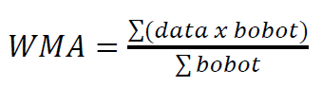 (1)
Where:
Data = Actual data in period t
Bobot = Assessment according to the length of the period

Mean Absolute Deviation
The Mean Absolute Deviation (MAD) method evaluates forecasts using the sum of absolute errors to measure forecast accuracy by averaging the estimated errors (the absolute value of each error). MAD is useful when measuring forecast error in the same units as the original series. The formula for calculating MAD is seen in Equation 2 below

MAD = (2)

Mean Squared Error
Mean Squared Error (MSE) is another method for evaluating forecasting methods. Each error or remainder is squared. Then summed up and added to the number of observations. This approach allows for significant forecasting errors because the errors are squared. The method yields moderate errors, which may be better for minor mistakes, but sometimes makes a big difference. Mean Squared Error is the average of forecast errors squared, or if written in equation 3
MSE = (3)

Mean Absolute Percentage Error
Mean Absolute Percentage Error (MAPE) is the average absolute percentage error calculated by finding the absolute error value in each period, then divided by the actual observed value and the absolute percentage error. The MAPE value can be calculated using the following equation 4

MAPE = (4)

Where eq (2), (3), and (4) is
x_{t} = Data actual in period t
F_{t} = Value of forecasting in period t
n = Data numbering
t = Periode of forecasting

Forecasting ability is excellent if it has a MAPE value of less than 10% and has good forecasting ability if the MAPE value is less than 20%. The following table shows the quality level of accuracy in MAPE:

Table 1. MAPE value for forecasting evaluation
MAPE Value | Accuracy
MAPE ≤ 10% | High
10% < MAPE ≤ 20% | Good
20% < MAPE ≤ 50% | Reasonable
MAPE 50% | Low

Forecasting accuracy will be higher (better) if the MAD, MSE, and MAPE values ​​are smaller. The need to compare calculations that have the smallest MAPE value because the smaller the MAPE value, the smaller the difference between the forecasting results and the actual value [3].

RESULT AND DISCUSSION
The data used for forecasting the number of unemployed in Indonesia in 2023 is using unemployment data from 2000 to 2022 (for 23 years) in Indonesia. The following table is a recap of historical data on the number of unemployed in Indonesia from the Central Bureau of Statistics (BPS)

Table 2. Unemployment Data in Indonesia for 2000-2022
Periode | Year | Number of Unemployment | Periode | Year | Number of Unemployment
1 | 2000 | 5813231 | 13 | 2012 | 7344866
2 | 2001 | 8005031 | 14 | 2013 | 7410931
3 | 2002 | 9132104 | 15 | 2014 | 7244905
4 | 2003 | 9939301 | 16 | 2015 | 7560822
5 | 2004 | 10251351 | 17 | 2016 | 7031775
6 | 2005 | 11011142 | 18 | 2017 | 7005262
7 | 2006 | 10932000 | 19 | 2018 | 7073385
8 | 2007 | 10011142 | 20 | 2019 | 7104424
9 | 2008 | 9394515 | 21 | 2020 | 9767754
10 | 2009 | 8962617 | 22 | 2021 | 9102052
11 | 2010 | 8319779 | 23 | 2022 | 8425931
12 | 2011 | 8681392

From Table 2, unemployment data in Indonesia from 2000 to 2022 can be visualized in the following graphical form:

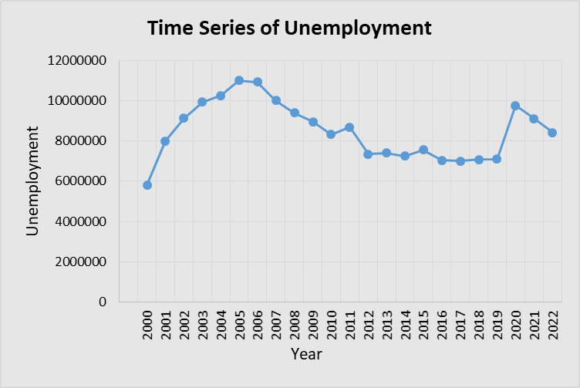
Image 1. Graph of Total Unemployment in Indonesia from 2000 - 2022

In the calculation process using the Weighted Moving Average method, this study limits the weight values​​, namely 3, 4, 5, and 6. The following is the manual calculation process for forecasting unemployment in Indonesia using a weight value = 3

WMA₄ = ((9132104 * 3) + (8005031 * 2) + (5813231 * 1)) / (3+2+1)
= 8203267,5

WMA₅ = ((9939301 * 3) + (9132104 * 2) + (8005031 * 1)) / (3+2+1)
= 9347857

WMA₆ = ((10251351 * 3) + (9939301 * 2) + (9132104 * 1)) / (3+2+1)
= 9960793,167
WMA₇ = ((11011142 * 3) + (10251351 * 2) + (9939301 * 1)) / (3+2+1)
= 10579238,167
…..
…..

WMA₂₄ = ((8425931 * 3) + (9102052 * 2) + (9767754 * 1)) / (3+2+1)
= 8874941,833

The calculation process using the Weighted Moving Average method is carried out repeatedly for weight values ​​of 4, 5, and 6, which are carried out on unemployment data in Indonesia.
The results of the recapitulation of unemployment forecasting with a weight value = 3 can be seen in Table 3 below::

Table 3. Actual and Forecasted Unemployment Data in Indonesia for 2000-2023
Periode | Year | Number of Unemployment | Forecasting | Periode | Year | Number of Unemployment | Forecasting
1 | 2000 | 5813231 | - | 13 | 2012 | 7344866 | 8607725.167
2 | 2001 | 8005031 | - | 14 | 2013 | 7410931 | 7952860.167
3 | 2002 | 9132104 | - | 15 | 2014 | 7244905 | 7600652.833
4 | 2003 | 9939301 | 8203267.5 | 16 | 2015 | 7560822 | 7316907.167
5 | 2004 | 10251351 | 9347857 | 17 | 2016 | 7031775 | 7430534.5
6 | 2005 | 11011142 | 9960793.167 | 18 | 2017 | 7005262 | 7243645.667
7 | 2006 | 10932000 | 10579238.17 | 19 | 2018 | 7073385 | 7106693
8 | 2007 | 10011142 | 10844939.17 | 20 | 2019 | 7104424 | 7043742.333
9 | 2008 | 9394515 | 10484761.33 | 21 | 2020 | 9767754 | 7077550.667
10 | 2009 | 8962617 | 9856304.833 | 22 | 2021 | 9102052 | 8430915.833
11 | 2010 | 8319779 | 9281337.167 | 23 | 2022 | 8425931 | 8991014.667
12 | 2011 | 8681392 | 8713181 | 24 | 2023 |  | 8874941,833

From Table 3, actual unemployment data in Indonesia from 2000 to 2022 and data from forecasting calculations can be visualized in the following graphical form:
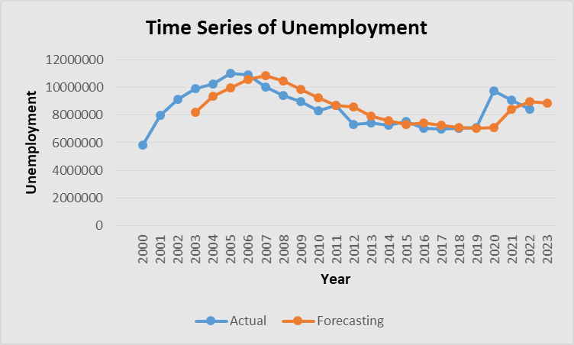

Image 2. Graph Comparison of Actual and Forecasted Data on Unemployment in Indonesia

After all forecasting results for each weight are obtained, then the calculation evaluation process is carried out using three accuracy methods, namely Mean Absolute Deviation (MAD) to calculate the number of errors, Mean Squared Error (MSE) to evaluate forecasting methods, and Mean Absolute Percentage Error (MAPE) to calculate the percentage error. This evaluation is done for each weight value 3, 4, 5, and 6. So that from the calculation results of the three accuracy methods, the error values ​​are obtained in Table 4 below:

Table 4. MAD,MSE, and MAPE Value
Weight  Value | MAD | MSE | MAPE
3 | 745786,1833 | 948402050986,3 | 8,28 %
4 | 779477,7684 | 1013207741987,62 | 8,71 %
5 | 818729,1889 | 1128966470880,22 | 9,27 %
6 | 847724,2717 | 1159498397091,03 | 9,91 %

In Table 4, it can be seen that the best forecasting results for unemployment data are at a weight value of 3 which has a MAD value of 745786.1833, an MSE value of 948402050986.3, and a MAPE value of 8.28%, where the forecasting result for the number of unemployed in Indonesia in 2023 is 8874941.833 ~ 8874942 people.

CONCLUSION
Based on the results and discussion of the research that has been conducted on unemployment forecasting in Indonesia, it can be concluded that this unemployment forecast uses the Weight Moving Average method with forecasting accuracy methods, namely Mean Absolute Deviation (MAD), as a method for calculating the number of errors, Mean Squared Error (MSE) for evaluating forecasting methods, and Mean Absolute Percentage Error (MAPE) as a method for calculating the percentage of errors. The results of this study are forecasting the number of unemployed in Indonesia in 2023, namely 8874942 people at a weight value of 3 with a MAD value of 745786.1833, an MSE value of 948402050986.3 and a MAPE value of 8.28%. Forecasting ability is very high because the MAPE value is less than 10%.
BIBLIOGRAPHY
[1] K. N. Irma Fitria, Nur Hanifa, Annisa Rahmita Soemarsono, “Konstruksi Model Pengaruh Pertumbuhan Pengangguran terhadap Dinamika Angka Kriminalitas melalui Pemberian Kontrol Optimal,” SPECTA J. Technol., vol. 5, no. 1, pp. 58–67, 2021.
[2] R. Franita and A. Fuady, “Analisa Pengangguran Di Indonesia,” J. Ilmu Pengetah. Sos., vol. 1, no. 3, pp. 88–93, 2019.
[3] H. Syafwan, M. Syafwan, E. Syafwan, A. F. Hadi, and P. Putri, “Forecasting Unemployment in North Sumatra Using Double Exponential Smoothing Method,” J. Phys. Conf. Ser., vol. 1783, no. 1, 2021, doi: 10.1088/1742-6596/1783/1/012008.
[4] H. Syafwan, F. Siagian, P. Putri, M. Handayani, S. H. Tinggi Manajemen Informatika dan Komputer Royal Jln M Yamin No, and S. Utara, “Forecasting Jumlah Pengangguran Di Kabupaten Asahan Menggunakan Metode Weighted Moving Average,” J. Tek. Inform. Kaputama, vol. 5, no. 2, pp. 224–229, 2021.
[5] A. Nasution, “Forecasting Produksi Karet Menggunakan,” vol. 9986, no. September, 2018.
[6] R. Riyanto, F. R. Giarti, and S. E. Permana, “Sistem Prediksi Menggunakan Metode Weight Moving Average Untuk Penentuan Jumlah Order Barang,” J. ICT Inf. Commun. Technol., vol. 16, no. 2, pp. 37–42, 2017, doi: 10.36054/jict-ikmi.v16i2.20.
[7] N. D. Maharani, I. G. A. Gunadi, and K. Setemen, “Prediksi Jumlah Penumpang Bus Trans Metro Dewata di PT . Satria Trans Jaya Menggunakan Double Exponential Smoothing dan Weighted Moving Average,” vol. VIII, no. 2, pp. 5246–5255, 2023.
[8] R. D. Syahputra, Supriono, and Suharyono, “PERAMALAN PENJUALAN JASA FREIGHT FORWARDING DENGAN METODE SINGLE MOVING AVERAGES, EXPONENTIAL SMOOTHING DAN WEIGHTED MOVING AVERAGES (Studi kasus pada PT Anugerah Tangkas Transportindo, Jakarta) Reza,” Adm. Bisnis, vol. 55, no. 2, pp. 113–121, 2018.

