ENTERPRISE ARCHITECTURE DESIGN ON IMPROVING DISKOMINFO SERVICES IN CENTRAL LOMBOK REGENCY USING TOGAF 9.2

Baiq Vidisasca Suhita^{1*}, Asti Amalia Nur Fajrillah ², Widyatasya Agustika Nurtrisha³
¹Prodi Sistem Informasi, Telkom University
²Prodi Sistem Informasi, Telkom University
³Prodi Sistem Informasi, Telkom University
¹email: baiqvidisascasuhita@student.telkomuniversity ac.id
²email: astiamalia@telkomuniversity.ac.id
³email: widyatasya@telkomuniversity.ac.id

Abstract: Currently, there is an increasing demand from the public for efficient, effective, transparent, and accountable public services. Various applications are designed to achieve a transparent and accountable working system, as well as to improve the speed, accuracy, and precision of work processes. Therefore, the local government is currently actively developing e-Government, also known as Electronic-Based Government System (SPBE) in Indonesia. In implementing SPBE, the Central Lombok Regency Government, particularly the Department of Communication and Informatics, is involved in developing SPBE, particularly in the field of Information Technology Applications with the Program of Information Technology Application Management. This research aims to support the management of SPBE-based information technology applications for the existing government agencies in Central Lombok Regency and the public. The design of SPBE adopts the TOGAF 9.2 approach and is also aligned with the Presidential Regulation on Electronic-Based Government System in designing the enterprise architecture. This research focuses on the Program of Information Technology Application Management within the domains of business process architecture, service architecture, data and information architecture, application architecture, and technology architecture (infrastructure). The result of this research is a blueprint that will serve as a solution or support for the implementation of SPBE in the Program of Information Technology Application Management within the domains of business process architecture, service architecture, data and information architecture, application architecture, and technology architecture (infrastructure).
Keywords: Electronic-Based Government System, Department of Communication and Informatics, Information Technology Applications, Program of Information Technology Application Management, enterprise architecture, TOGAF 9.2

Abstrak: Saat ini, meningkatnya kebutuhan masyarakat untuk mendapatkan pelayanan publik yang efisien, efektif, transparan dan akuntabel publik. Berbagai aplikasi di rancang agar dapat mewujudkan sistem kerja yang transparan dana akuntabel serta adanya peningkatan proses kerja yang cepat, tepat, dan akurat. Maka dari itu, Pemerintah daerah kini sedang gencar-gencarnya mengembangkan e-Government atau di pemerintahan Indonesia dikenal sebagai Sistem Pemerintahan Berbasis Elektronik (SPBE). Dalam menjalankan SPBE Pemerintah Kabupaten Lombok Tengah khususnya Dinas Komunikasi dan Informatika ikut serta mengembangkan SPBE salah satunya pada Bidang Aplikasi Informatika yang memiliki Program Pengelolaan Aplikasi Informatika. Dalam penelitian ini memiliki tujuan untuk menunjang layanan pengelolaan aplikasi informatika berbasis SPBE bagi OPD yang ada di Kab. Lombok Tengah dan juga publik. Perancangan SPBE ini mengadopsi pendekatan TOGAF 9.2, dan juga di sesuaikan dengan Peraturan Presiden tentang Sistem Pemerintahan Berbasis Elektronik dalam melakukan perancangan enterprise architecture. Penelitian ini berfokus pada Program Pengelolaan Aplikasi Informatika dengan domain arsitektur proses bisnis, domain arsitektur layanan, domain arsitektur data dan informasi, domain arsitektur aplikasi, dan domain arsitektur teknologi (infrastruktur). Hasil dari penelitian ini yaitu suatu blueprint yang nantinya akan dijadikan solusi ataupun penunjang berjalannya SPBE dalam Program Pengelolaan Aplikasi Informatika dengan domain arsitektur proses bisnis, domain arsitektur layanan, domain arsitektur data dan informasi, domain arsitektur aplikasi, dan domain arsitektur teknologi (infrastruktur).

Kata kunci: Dinas Komunikasi dan Informatika, Bidang Aplikasi Informatika, Program Pengelolaan Aplikasi Informatika, Enterprise Architecture, TOGAF 9.2

INTRODUCTION
In the context of increasing public demand for efficient, effective, transparent and accountable public services. Various applications are designed in order to realize a transparent work system of accountable funds and an increase in work processes that are fast, precise, and accurate[1]. In general, the utilization of ICT in supporting public services in local governments has been supported by the central government through national policies and strategies for e-Government development[2].Evaluation of e-Government in Indonesia is carried out periodically by the Directorate of e-Government of the Ministry of Communication and Information through the e-Government Indonesia (PeGI) ranking at the provincial level, not followed by all provincial governments. Based on the evaluation assessment through measuring the level of maturity using e-Government which refers to five domains, namely describing the business process domain, data and information domain, infrastructure domain, application domain, and integrated service domain. Local governments are now aggressively developing e-Government or in the Indonesian government known as Electronic Based Government System (SPBE).[3]
In the context of implementing the Electronic-Based Government System (SPBE) as mandated in Presidential Regulation No. 95/2018[4] and implementing the direction of the transformation policy in the field of institutions and governance which is a national development priority in Presidential Regulation No. 18/2020 concerning the 2020-2024[5] National Medium-Term Development Plan and Circular Letter of the Minister of PANRB No.18 of 2022 concerning the Integration of National Digital Services Through the Implementation of SPBE Architecture and SPBE Plan Map, it is necessary for central and regional government agencies to prepare their respective SPBE Architecture.[5]
SPBE implementation is one of the efforts to develop a government system. At this time the Communication and Informatics Office and SKPD in Central Lombok Regency still lack Human Resources who have technical expertise in the field of communication and information. As stated in the Central Lombok Regent Regulation Number 81 of 2016,[6] the Communication and Informatics Office (DISKOMINFO) of Central Lombok Regency is positioned as a supporting element of the Regent's duties led by a Head of Service under and responsible to the Regent through the Regional Secretary with the main task of assisting the Regent in carrying out Communication, Informatics, coding and statistics affairs which are the regional authority and assistance tasks assigned to the Regency. Based on the Achievement Target of the RPJMD for the Development of Electronic-Based Government Systems (SPBE) at the Communication and Informatics Service of Central Lombok Regency[7]. The development of communication and informatics facilities and infrastructure is included in the policies and strategies for developing a network system for regional facilities and infrastructure in Central Lombok Regency. When viewed from the two indicators of the Informatics Application Management Program, there are indicators that have been met, namely the percentage of Regional Apparatus (PD) using statistical data in compiling regional development planning. However, there are also indicators that have not been met, namely the percentage of OPDs that run online public services. Therefore, in implementing the Informatics Application Management Program at the Communication and Informatics Service (DISKOMINFO) Central Lombok Regency faces obstacles, namely the unoptimal use of Information Communication Technology (ICT) to support the implementation of SPBE.[6]
Based on the exposure of these problems, it can be seen that there is a need for improvement in the SPBE Governance Domain contained in the Information and Communication Technology Aspect, and also the need for special attention to indicators of increasing the Maturity of SPBE Application Development in accordance with these problems. Solutions that can be taken in overcoming the problems of implementing the Electronic-Based Government System (SPBE), namely in the form of an enterprise architecture design for the SPBE Governance Domain contained in the Information and Communication Technology Aspect, precisely on the indicator of increasing the Maturity of SPBE Application Development. So, this research will focus on designing Enterprise Architecture (business process domain, data and information domain, infrastructure domain, application domain, and service domain) using the TOGAF framework at the Communication and Informatics Service (DISKOMINFO) of Central Lombok Regency, according to the 3rd Mission, namely "Easy, Fast and Clean Government General Services" on the Central Lombok Regency Government's target "Realizing Electronic-Based Government in supporting a good Bureaucratic System and satisfying Public Services". "[8]

METHOD
TOGAF is a very detailed method of building, managing and implementing enterprise architecture in an information system.[9] TOGAF can be used freely by any organization or company. TOGAF is a method that is easily accepted and developed in an organization or company because the method is very practical and precise[10]. The following is an overview of the TOGAF phases
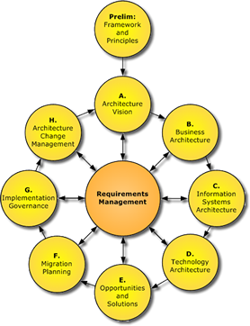
Figure 1 Togaf Phases

RESULT AND DISCUSSION
- Preminary Phase
The Preminary Phase is the initial phase in EA where in this phase decisions are made to later determine the principles used in the architecture domain to be developed. Furthermore, mapping is carried out to determine solutions such as the applications used and the technology that supports the running of these applications. [11]After that, mapping the stakeholders involved in it and determining the value that exists in the Communication and Informatics Office of Central Lombok Regency.
Table 1 Principles
Domain | Prinsip
Business Process | Primacy of Principles
Data and Information | Data is an Aset
Application | Technology Independence
Services | Sederhana
Infrastructure (Technology) | Responsive Change Management
- Architecture Vision
The TOGAF 9.2 Architecture Vision phase begins with an initial stage that explains the importance of agreement on enterprise architecture planning. Architecture Vision is used to define the roles and interests of stakeholders, business objectives, triggers for the organization's business strategy, as well as an overview of the desired architectural vision in the organization[12]. This stage produces the output of Value Chain Diagram.
Table 2 Value Chain
Value Chain
Secondary Activities
Infrastructure | - Government regulations of the Communication and Informatics Office of Central Lombok Regency  - Local government regulations of Central Lombok Regency  - Legislation
Human Resources | Digital Human Resources
Technology Development | - Digitalization of the economy  - Digitalization of government
Procurement | - ICT infrastructure procurement  - Internal infrastructure procurement
Primary Activities
Informatics Application Management Program |  | - Information systems analyst  - System and network management
Public Information and Communication Program |  | - Use of e-government in Regional Apparatus Organizations  - Maturity level management in the service domain
Sectoral Statistics and Information Security Program |  | - Statistical data management for Regional Apparatus Organizations  - Management of government information security levels
- Business Process Architecture
The next stage is Phase B: Business Architecture, where this phase describes how the company's operations are carried out to achieve its business objectives. This phase includes an analysis of the company's needs in carrying out its business functions, including how business objectives and interactions between parts of the company can be achieved[13]. In the preparation of the Business Process Architecture stage, it is carried out based on PermenPAN RB No. 19 of 2018 concerning the Preparation of Government Agency Business Process Maps.[14]
Level 0 business process map is a depiction consisting of main business processes and supporting business processes. Level 1 is a more detailed stage in the depiction of level 0 business process maps. At this level, each process carried out by each process at level 0 is drawn in detail. [15]In business process map modeling, there are two types of business processes, namely existing and targeting. Pre-existing business processes refer to business processes that already exist and are running in the organization[16], while targeted business processes are new or proposed business processes that include improvements and development of existing processes at DISKOMINFO Central Lombok Regency.
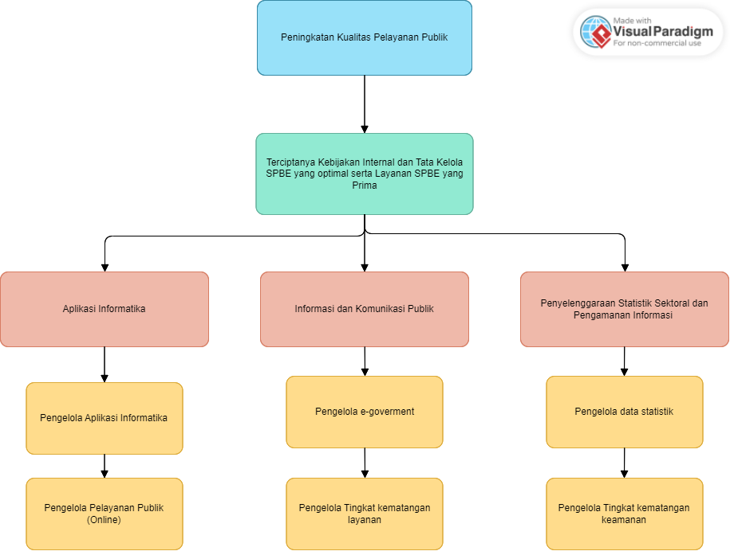
Figure 2 Proses Bisnis

- Services Architecture
Service architecture is the output of one or more business processes presented to users by describing the characteristics of a particular service, and integrated with various strategic initiatives, national programs, and laws and regulations related to government services. In accordance with what is stated in the PANRB Ministerial Regulation No.18 of 2022 that by identifying government services, it will be possible to accelerate the achievement of the development agenda through the transformation of public services towards integrated government digital services.[15] The following is a service/business process matrix
Table 3 Service/business process matrix
Business Process (Y) / Work Unit (X | Informatics Application Management | Information Systems Analyst | System and Network Manager
DKA 01.01.01 Application submission | App Creation Service | N/A | N/A
DKA 01.02.01 Submission of Objection to Rejection of Information Request | Information and Documentation Management Services | N/A | N/A
DKA 01.02. 01 Application Development Submission | Application Development Service | N/A | N/A
DKA 01.02.02 Central Lombok District Licensing Online System | Online Licensing System Service | N/A | N/A
DKA 01.02.03 Monitoring of app usage in Central Lombok District | Application usage monitoring service | N/A | N/A
- Data And Information Architecture
Data and Information Architecture is the third phase in TOGAF 9.2. This phase has the aim of maximizing the previous phases.[17] In this phase, identification of existing data and information needs at DISKOMINFO Central Lombok Regency is carried out. The following is a table of application portfolio catalogs that exist at DISKOMINFO Kab. Central Lombok. The following is the Dissemination data at DISKOMINFO Central Lombok Regency

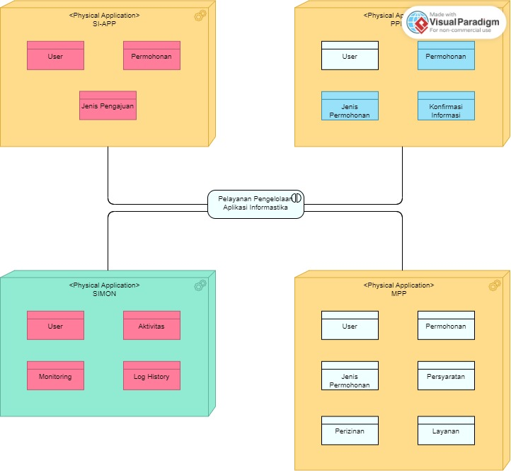
Figure 3 Dissemination Data
- Application Architecture
Application Architecture is a method to describe the way applications or software used by a company or organization interact and process data with each other with the aim of meeting business needs in the company or organization. Overall, Application Architecture involves the process of defining interactions between applications or software with middleware, databases, and other applications that support the business functions of the company or organization.[18] The following is a catalog of applications in the Informatics Application Division, DISKOMINFO Kab. Central Lombok
Table 4 Application Division
Application Name | Application Description | Application Provider | Related Work Units
SI-APP | The SI-APP application is an application that is used to support if there is a request for the creation or development of applications from other OPDs at DISKOMINFO Kab. Lombok Tengah | Communication and Informatics Office (DISKOMINFO) Central Lombok District | Informatics Application Division DISKOMINFO Kab. Central Lombok
SI-PPID (Pejabat Pengelola Informasi dan Dokumentasi) | The SI-PPID application is an application that contains Public Information in the Central Lombok Regency Government. This application also provides a form where the public can request the information needed which will later be provided through easy answers in the application. | Central Bureau of Statistics | Informatics Application Division DISKOMINFO Kab. Central Lombok
MPP (Mal Pelayanan Publik) | MPP (Public Service Mall) is a place where the activities of public service providers of both goods and services are carried out in one place in order to provide fast, easy, and accountable services. | Investment and Integrated Service Office  One Stop (DPMPTSP) | Informatics Application Division DISKOMINFO Kab. Central Lombok
SIMON | The SIMON application is an application specifically for the Regent of Central Lombok Regency and employees of the Central Lombok Communication and Information Agency to monitor all applications used in Central Lombok. | Informatics Application Division DISKOMINFO Kab. Central Lombok | Informatics Application Division DISKOMINFO Kab. Central Lombok
- Technology Architecture
Technology Architecture is one of the stages contained in Phase D of TOGAF 9.2. This stage focuses on developing the technology infrastructure needed to meet Data Architecture Standards and support Application Architecture.[19] The following is the Environment and Location Diagram at DISKOMINFO Kab. Central Lombok
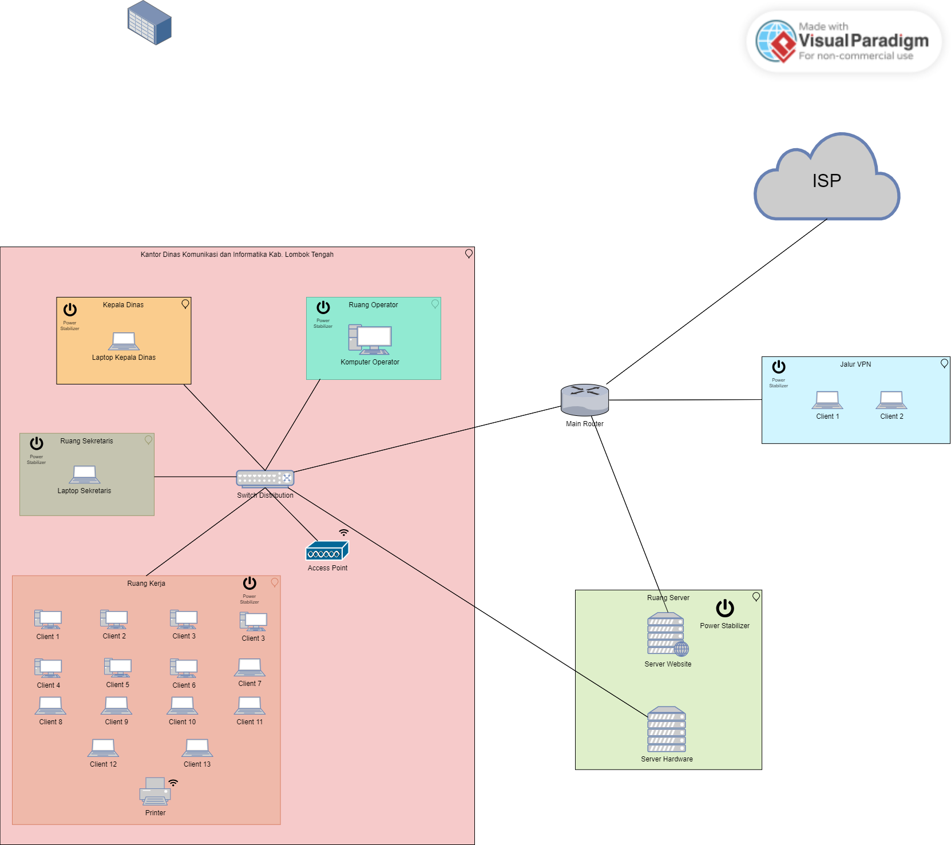
Figure 4 Location Diagram

- Blueprint Enterprise Architecture
The Enterprise Architecture Blueprint in this study aims to plan the transformation of the Komu-nication and Informatics Office of Central Lombok Regency. The business and technological change plans carried out aim to achieve the organization's long-term strategic plan[20]. The following is the blueprint Enterprise Architecture mapping that has been done at DISKOMINFO Kab. Central Lombok
Table 5 Blueprint EA
Blueprint Enterprise Architecture Of Communication And Information Agency Of Central Lombok District
Scope :  Informatics Application Field | Organizational Strategy Direction :  Vision : “Mewujudkan Masyarakat Lombok Tengah Yang Beriman, Sejahtera, Bermutu, Maju dan Berbudaya (Bersatu Jaya)”  Mission :  “Pelayanan Umum Pemerintahan Yang Mudah, Cepat dan Bersih.”
Basic Directive Document :  - Presidential Instruction No. 3 Year 2003  - PermenPan RB Number 19 Ta-hun 2018  - PermenPan RB Number 18 Year 2022  - Central Lombok Regency Strategy Plan 2021-2026  - RPJMD of Central Lombok Regency 2021-2026 | Business Architecture Domain :  - Relationship Map Update  - Design of Level 0, 1, and 2 Business Process Maps  - Redesign of business process level 2
Service Architecture Domain :  Service design in the field of Informatics Application Management | Data and Information Architecture Domain  - Mapping Data Entities with Business Processes and Applications  - Data Conceptual Model Design  - Design of Data Dissemination Model
Application Architecture Domain  - Identify application functions related to the organization's business processes and data entities  - Improving existing applications  - Addition of new applications according to the needs of the organization | Infrastructure Architecture Domain (Technology)  - Identify the standard technology used at the Central Lombok District Communication and Information Office.  - Identify technology related to the application used.  - Environment and Location Diagram Design  - Designing Platform Decomposition Diagram

Blueprint Solution Concept Diagram
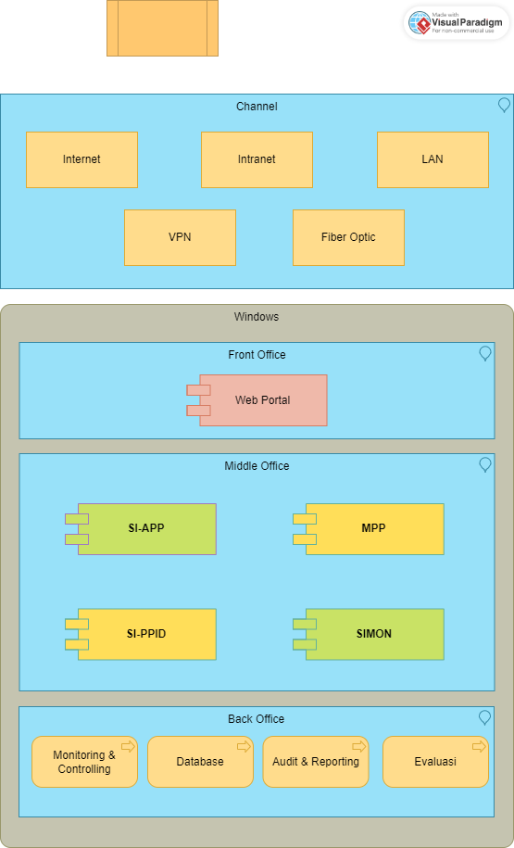

CONCLUSION

The results of analyzing the design of Enterprise Architecture (EA) which focuses on the development of an Electronic-Based Government System (SPBE) at the Communication and Informatics Office (DISKOMINFO) of Lombok Ten-gah Regency. This SPBE development focuses on the Informatics Application Management Program with the TOGAF 9.2 approach which is adjusted to PermenPan RB No.19 of 2018 and PermenPan RB No.18 of 2022. This design goes through the prelimi-nary phase, the architecture vision phase, business architecture, service architecture, data and information architecture, application architecture, and technology architecture. Therefore, the results of this research can support the SPBE level of the Informatics Application Management Program, Informatics Application Division, DISKOMINFO Kab. Central Lombok.
In this research, there is data validation carried out with the Central Lombok District Communication and Informatics Office (DISKOMINFO), especially in the Informatics Application Division with the aim of relevance and alignment of the data used and needed to develop the right SPBE architecture. This research finally produces a blueprint that can later be used according to its function, namely developing SPBE architecture at the Communication and Informatics Office for the Informatics Application Management Program.

BIBLIOGRAPHY

[1] E. B. Setiawan, “PEMILIHAN EA FRAMEWORK,” Semin. Nas. Apl. Teknol. Inf., pp. 114–119, Jun. 2009.
[2] P. R. Indonesia, “INSTRUKSI PRESIDEN REPUBLIK INDONESIA NOMOR 3 TAHUN 2003 TENTANG KEBIJAKAN DAN STRATEGI NASIONAL PENGEMBANGAN E-GOVERNMENT,” vol. 2004, pp. 1–61, 2004.
[3] W. Wardiana, “Perkembangan Teknologi Informasi di Indonesia,” Bandung, Jul. 2002.
[4] Kementerian Sekretariat Negara, “Peraturan Presiden Nomor 95 Tahun 2018 tentang Sistem Pemerintahan Berbasis Elektronik,” Menteri Huk. Dan Hak Asasi Mns. Republik Indones., p. 110, 2018.
[5] Presiden Republik Indonesia and Perpres No. 18 Tahun 2020, “Peraturan Presiden Republik Indonesia Nomor 18 Tahun 2020 Tentang Rencana Pembangunan Jangka Menengah Nasional 2020-2024,” Sekr. Pres. Republik Indones., pp. 1–7, 2020.
[6] P. K. L. Tengah, “Peraturan Bupati Lombok Tengah No.81 Tahun 2016,” pp. 1–38, 2019.
[7] BAPPEDA, “Rencana Pembangunan Jangka Menengah Daerah,” Pemerintah Kabupaten Lomb. Teng., p. 1, 2013, [Online]. Available: http://www.dof.gov.my/en/c/document_library/get_file?uuid=e25cce1e-4767-4acd-afdf-67cb926cf3c5&groupId=558715
[8] H. M. Zarkasi, “RENSTRA Dinas Komunikasi dan Informatika Kabupaten Lombok Tengah,” Lombok Tengah, Aug. 2021.
[9] O. Group, “Open Group TOGAF,” https://pubs.opengroup.org/togaf-standard/adm-techniques/chap02.html.
[10] R. S. Wahono, “Panduan Pengembangan Enterprise Architecture Berbasis Framework IdEA,” 2022.
[11] R. Fahmi Awaludin, S. Bahri, and M. Muslih, “Penerapan Zachman Framework Dalam Perancangan Sistem Informasi Manajemen Keuangan Sekolah,” Tekno Kompak, vol. 15, no. 1, pp. 55–66.
[12] L. Sofyana and A. R. Putera, “Business architecture planning with TOGAF framework,” in Journal of Physics: Conference Series, Institute of Physics Publishing, Nov. 2019, pp. 1–11. doi: 10.1088/1742-6596/1375/1/012056.
[13] S. Labolatory, “[IND] MODUL 1 BUSINESS ARCHITECTURE,” pp. 1–23, 2022.
[14] M. R. Indonesia, “Permenpan No 19 Tahun 2018”.
[15] P. R. Indonesia, “Surat Edaran Menteri PANRB No.18 Tahun 2022”.
[16] W. F. M. Haryono, R. Mulyana, and N. Ambarsari, “Perancangan Information System Architecture Menggunakan Togaf Adm Pada Fungsi Promosi (Studi Kasus: Dinas Pariwisata dan Kebudayaan Pemerintah Kabupaten Bandung Barat),” Fountain Informatics J., vol. 5, no. 1, pp. 1–8, Dec. 2019, doi: 10.21111/fij.v5i1.3312.
[17] S. Labolatory, [IND] MODUL 2 INFORMATION SYSTEM ARCHITECTURE. 2022.
[18] R. Fitriana and M. Bakri, “PERANCANGAN ARSITEKTUR SISTEM INFORMASI AKADEMIK MENGGUNAKAN THE OPEN GROUP ARSITEKTURE FRAMEWORK (TOGAF),” Bandar Lampung, 2019.
[19] S. Labolatory, “Modul 3 EA Techonology,” 2022.
[20] B. Gunawan Sudarsono and P. Lestari, “KAJIAN LITERATUR MODEL KONSEPTUAL KEBERHASILAN E-GOVERNMENT,” KOMIK (KonferensiNasionalTeknologiInformasidanKomputer), vol. 2, no. 1, pp. 491–498, Oct. 2018, [Online]. Available: http://ejurnal.stmik-budidarma.ac.id/index.php/komik

