**IMPLEMENTATION OF ANGULAR JS FRAMEWORK IN DESIGN**

**WEB-BASED ADMISSION SYSTEM APPLICATION**

**Eka Lia Febrianti 1 * , Ilwan Syafrinal 2 , Agus Suryadi 3**

1.2 Software Engineering , Universal University

3 Informatics Engineering , Ibnu Sina University

*email* : ekalia88@gmail.com

**Abstract:** Technology is able to digitize human work that was originally manual to become automatic and of course takes less time and better accuracy compared to results done by humans. But there are still many companies that have not implemented this technology. This research will design and build a WEB-based application using the AngluarJS framework to digitize the admissions system. This system can assist companies in increasing productivity, business performance, facilitating the dissemination of information digitally and facilitating data collection.

**Keyword s:** WEB, admissions, AngularJS

**INTRODUCTION**

The current technological developments are so rapid that the digital revolution occurs where changes from analog mechanical and electronic technology to digital technology. The impact of the digital revolution can be seen in the easy and fast dissemination of information, increasing business productivity and performance, changing the way individuals and companies interact, and creating a revolutionary business world[1].

The creation of a revolutionary business world because it is easy, cheap, practical, dynamic in communicating and obtaining information, and the large number of internet users. Based on the results of a survey from the Association of Indonesian Internet Service Providers (APJII) there were 171,176,716.8 internet users in 2018 where the growth of internet users increased by 27,916,716 which can be seen in Figure 1.

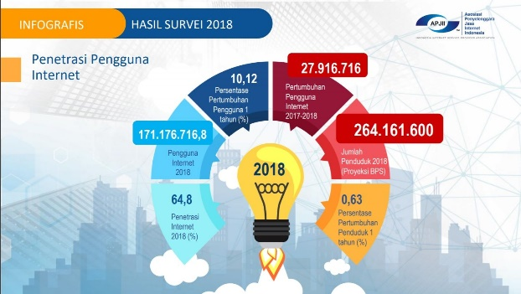

Figure 1. Survey results from the Association of Indonesian Internet Service Providers (APJII)

Increased internet users make dissemination of information faster and easier. Business people see that as an opportunity because they can advertise their company quickly. In addition to fast advertising, technology is also able to digitize human work that was originally manual to be automated and of course takes less time and better accuracy compared to results done by humans.

So in order to improve business performance and company productivity, the Wings company cooperates with PT. Intek Karya to build web-based applications used for Wings company management.

The usability of a web is the main factor that determines whether a web is successful or fails to be made [2]. Usability here is defined as the extent to which a product can be used by certain users to achieve specific goals with effectiveness, efficiency and satisfaction in the context of certain uses [3]. To meet the requirements for the success of web-based applications, we created them using the Angular JS framework.

The main reason we use AngularJS is because it makes web applications easy to maintain and standardized so that models can use the same component [4]. In addition, AngularJS can also synchronize data with HTML in real time or what is known as data binding, namely synchronization between models and views [5]. And most importantly, AngularJS can improve the User Interface, interactivity, usability, and user experience [6].

**METHOD**

The method for developing application designs with Angular JS uses agile, seen from <https://www.replicon.com/polaris-psa/what-is-agile-project-management/>where the system design process will be carried out in several stages. The design stages of the admissions application for the application of the Agile method are shown in Figure 2 [8].

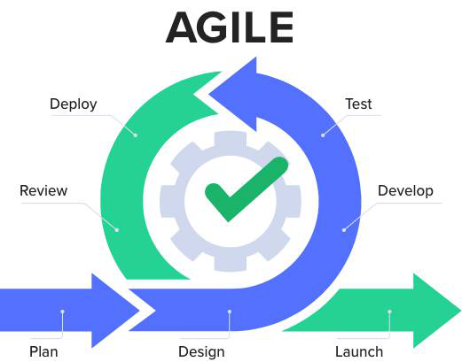

Figure 2. Agile Stages

From Figure 2 above the first step is [9]:

1. Planning (Plan) :

Identification of needs: Identification and in-depth understanding of the needs of users and stakeholders regarding the admissions application .

Product backlog creation: Create a list of features and functionalities required in the application, based on identified needs. Arrange the product backlog in order of priority.

1. Design and Prototyping:

Create intuitive and responsive user interface (UI/UX) designs.

Create interactive prototypes to validate designs and get feedback from users.

1. Development

At this Development stage or also called the software development stage is a series process of developing software. Software development requires the precautionary principle both at the design stage, as well as the execution stage according to the objectives to be achieved . The development process is not just writing program code, but it certainly includes the stages of preparing software requirements, the software design stage, and the software testing stage.

1. testing

At this testing stage is the process of executing all parts of the software with the intention of finding errors. This stage is a critical element in the software development series, because from this testing the features and tasks have been developed and are as expected.

1. Deployments

At this stage, it is the stage where activities occur that aim to deploy applications that have been worked on by the developer. Deployment can be done in various ways depending on the type of application.

1. Reviews

The complete process of examining software products, this process will produce a good product, this stage will also determine the positive and negative aspects of the program.

**RESULTS AND DISCUSSION**

System design uses system modeling, such as Data Flow Diagrams and Entity Relationship Diagrams. The description of the designed system modeling is as follows:

**Data Flow Diagrams**

Data Flow Diagram (DFD) describes the flow of data that occurs in the system, so that by making this data flow diagram you can see the flow of data flowing in the system. DFD starts from level 0 to the lowest level of the required process [10].

The data flow diagram illustrates the processes that take place on the system. In addition, you can also see external entities related to the system by providing input to the system and then the system will also provide output to these entities. There is also a data store that is used by the system to store and read data for input and output requirements for running processes.

**A. Data Flow Diagram level 0**

DFD level 0 consists of 2 processes, namely the member registration process and program registration. In the member registration process, prospective members will enter their personal data which will later be processed by the system and finally entered into the database.

In the second process, namely the program registration process, members will enter data on any program they want to register. After that the system will process the data which will later be stored in the system. For more details can be seen in Figure 3.

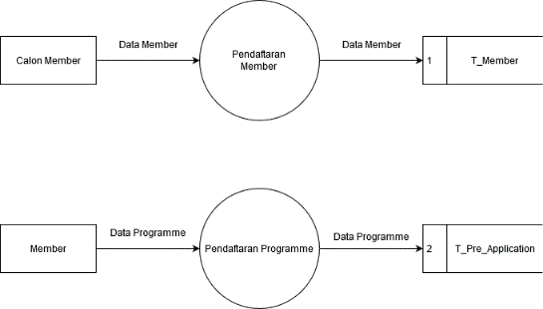

Figure 2. DFD Level 0

**B. Data Flow Diagrams Level 1**

DFD level 1 is the details of the program registration process, the program registration process is divided into 4 processes, namely the process of entering registration data, checking available seats, creating receipts, paying & updating available seats.

The registration data input process is the process by which members enter the program they want to register. After that the system will store the data in the T_Pre_Application table. After that the system continues the process to the 2nd stage, which is to check the available benches.

Checking available seats is done automatically by the system to ensure that the program can still accept participants. Because each program has a limited number of seats. After that the system will notify the members of the results. Next, the member needs to confirm.

If the member has confirmed the registration, then the 3rd process will run. The system will create a payment receipt and then give it to the member so that the member can make payments.

After the member makes a payment, the system will update the bench data available on the program registered by the member and create invoices which will later be given to the member as proof of payment. The whole process can be seen in Figure 4.

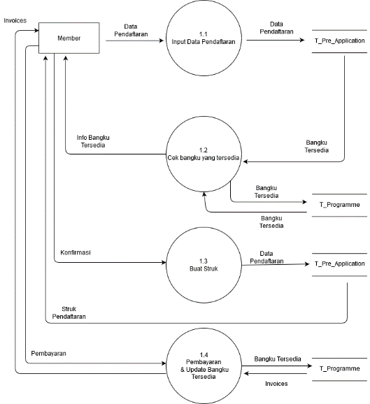

Figure 3. DFD Level 1

**Entity relationship diagrams**

Entity Relationship Diagram (ERD) shows the relationship of the set entities stored in the database. Entities in this context are data components. In other words, Entity Relational Diagrams describe the logical structure of the database [11].

The ERD on this system can be seen in Figure 5. The member table has a one to many relationship in the program table, while the program table has a many to one relationship in the shopping cart table. The shopping cart table has a one to one relationship in the pre application table. And the pre application table has a one to one relationship on the in voice table. The invoice table has a many to one relationship in the member table.

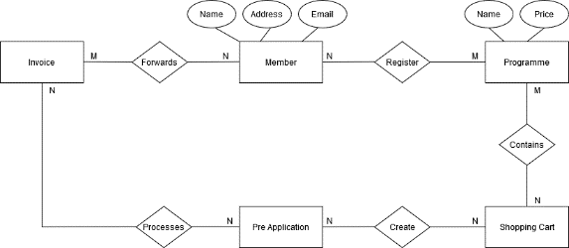

Figure 4. Entity Relationship Diagram

**Home view**

The Home display does not contain much information, on the home page there are only pictures of activities carried out by the Wings company. For more details, it can be seen in Figure 5.

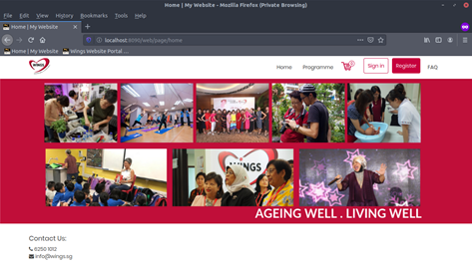

Figure 5. Home view

**Login view**

The login screen contains an input box so that the user can enter a username and password. After that the system will check the correctness of the username and password. You can see the login display in Figure 6



Figure 6. Login Display

**Registration View**

In this view the user is asked to enter their personal data. In this view, users can choose whether they want to use their email or cellphone number as their username. And also users can create their own passwords or generated by the system. Can be seen in figure 7.

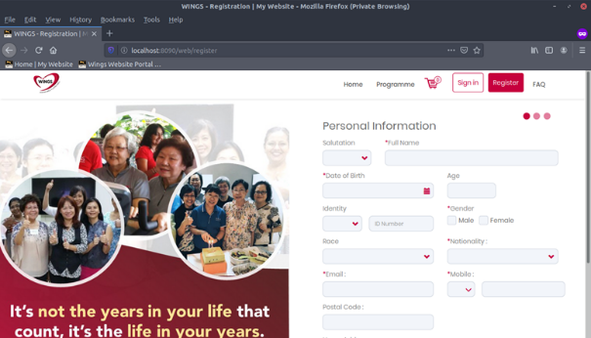

Figure 7. Registration Display

**User Profile View**

Users can view their information on this page and they can also change that information. Here users can also change their username. This display can be seen in Figure 8.

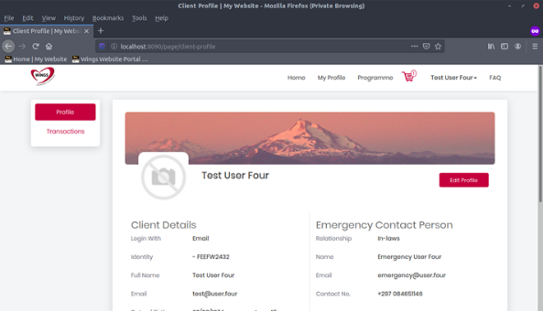

Figure 8. Display User Profile

**Change Password display**

In this view, users can change their password by entering it in the input provided. Can be seen in figure 9.

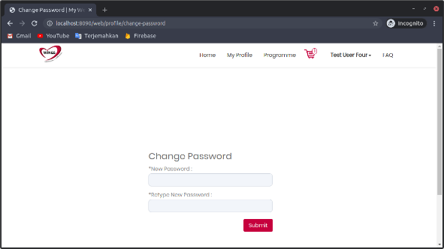

Figure 9. Display Change Password

**Transaction view**

This view contains transaction information that has been carried out by the user. The information is displayed in tabular form and details can be seen. This display can be seen in Figure 10.

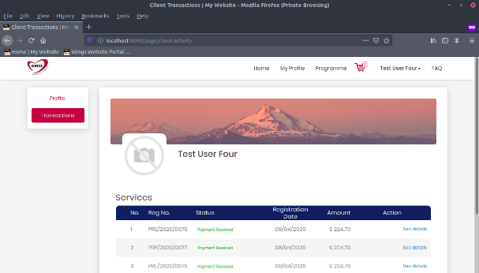

Figure 10. Display Transactions

**Display Transactions Details**

This page details the selected transaction. These details are in the form of programs that have been registered along with prices and time. The results can be seen in Figure 11.

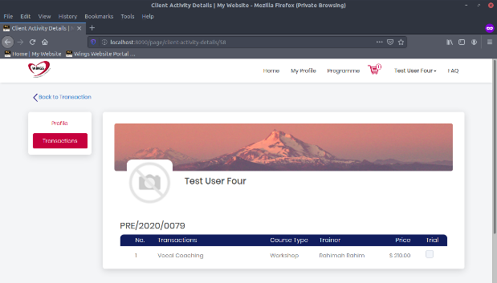

Figure 11. Display Transactions Details.

**Program View**

The program display is a display that contains the programs in Wings. Starting from those that have not started to those that have been completed. The information displayed includes the start time of the program, registration time, the name of the trainne, and the registration price. Can be seen in figure 12

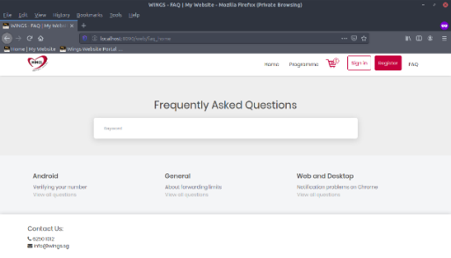

Figure 12. Display Program

**Program Details View**

This display contains more detailed program information. Starting from the description, to the sessions available in the program. Can be seen in figure 13.

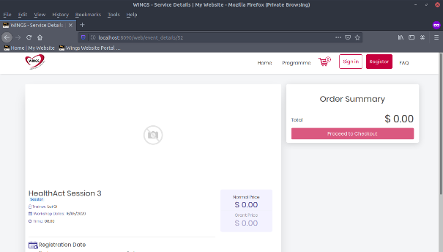

Figure 13. Program detail display

**Frequently Asked Question (FAQ) display**

This is a display that contains information that can help the user if they have difficulty using this application. Can be seen in figure 14.

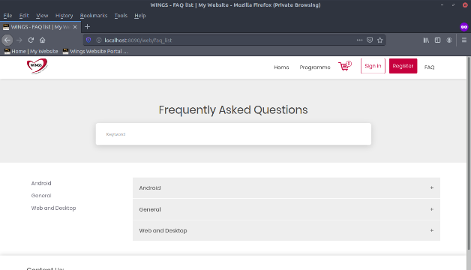

Figure 14. Frequently Asked Question (FAQ) dis-play

**FAQ list view**

In this view, information is displayed per category and is more complete. so users can more easily find the information they need. The appearance of this page can be seen in Figure 15.

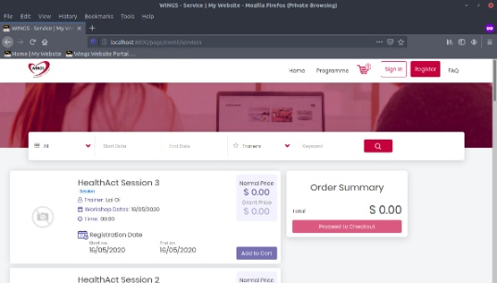

Figure 15. FAQ list display

**FAQ Detail View**

This view contains complete information about the topic selected by the user. Here is explained in detail how to solve the problem or the steps for use. The appearance of this page can be seen in Figure 17.

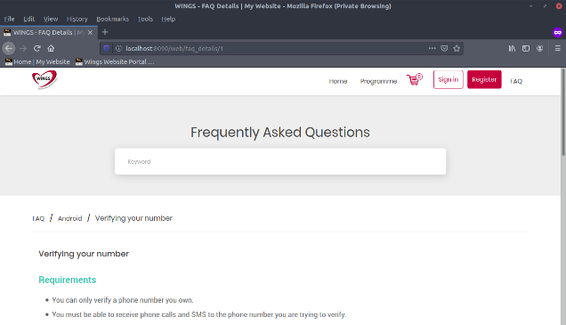

Figure 17. FAQ Detail Display

**BIBLIOGRAPHY**

[1] Sulistianingrum, EW, Rusdianto, DS, & Wihandika, RC (2021). Development of an Order Management System and Delivery of Goods for a Web-based Trading Company (Case Study: PT Arista Semesta Alam). *Journal of Development of Information Technology and Computer Science e-ISSN* , 2548, 964X.

[2] SE Rosenbaum, “Passage of drugs through membranes,” in *Basic Pharmacokinetics and Pharmacodynamics: An Integrated Textbook and Computer Simulations* , John Wiley & Sons, 2016.

[3] EL Febrianti and T. Christi, "Implementation of Forward Chaining for Diagnosing Malaria and Web-Based Prevention," *Jurteksi* , vol. 4, no. 1, pp. 93–100, 2017.

[4] SE Rosenbaum, *Basic pharmacokinetics and pharmacodynamics: An integrated textbook and computer simulations* . John Wiley & Sons, 2016.

[5] N. Nurwati, "Noise Level Detector and Rating in Arduino-Based Libraries," in *Royal National Seminar (SENAR)* , 2018, pp. 295–298.

[ 6] J. Hutahaean, *Concept of Information Systems* . Yogyakarta: Deepublish, 2015.

[7] D. Sutrisno, SN Gill, and S. Suseno, "The development of spatial decision support system tools for marine spatial planning," *Int. J. Digits. Earth* , vol. 11, no. 9, pp. 863–879, 2018.

[8] Km. Syarif Haryana, " Application of Agile Development Methods With the Scrum Framework in the Design of Qr-Code Based General Meeting Attendance Software "Journal of Computech & Bisnis, Vol. 13, No. 2, December 2019, 70-79

[9] Burhan, MI, Nawir, F., & Salam, KN (2022). Development of a Tracer Study System Using Agile Development Methods on Ibk Nitro. *JURSIMA (Journal of Information and Management Systems)* , *10* (3), 160-170.

[10] Muliadi, M., Andriani, M., & Irawan, H. (2020). Website-Based (Web) Hotel Room Booking Information System Design Using Data Flow Diagrams (Dfd). *JISI: Journal of Industrial System Integration* , *7* (2), 111-122.

[11] Latukolan, MLA, Arwan, A., & Ananta, MT (2019). Development of Entity Relationship Diagram Automatic Mapping System Into Database. *Journal of Information Technology Development and*

*Computer Science e-ISSN* , *2548* , 964X.