**Motor Spare Parts Sales Application**

**New Sei Kamah Rudi Spare Parts Shop**

**Suparmadi1** , **Parini2**, **Mhd. Ihsan3**

Informatics Management, College of Computer Informatics Management

Email; [Suparmadi43@gmail.com](mailto:Suparmadi43@gmail.com)

Information Systems, Royal College of Informatics and Computing Management

Email; [mhdihsan1207@gmail.com](mailto:mhdihsan1207@gmail.com)

Information Systems, Royal College of Informatics and Computing Management

Email : parini.royal@gmail.com

***Abstract****: Technology plays an important role in the management of a trading business. The sales application is a system that carries out data processing and financial transactions that are equipped with integrated management such as sales transaction processes like cash registers and inventory calculations or stock items. the role of this goods sales application can simplify the operational forms they need and be able to increase their work effectiveness. As the main goal of procurement software is to replace manual operations with technology, which is able for a business to survive in the midst of business competition and be able to develop as expected. Rudi Sparepart Store is a motorcycle spare parts shop located in Sei Kamah Baru, Sei Dadap District which is engaged in sales, especially motorcycle spare parts and all motorcycle accessories. By implementing a sales application at the Rudi Sparepart Store, it can help the shop admin in carrying out the transaction process for selling motorbike spare parts and recording reports can be generated quickly.*

***Keywords****: Sales, spare parts, shop Rudi*

***Abstract:*** *Technology plays an important role in the management of a trading business. The sales application is a system that carries out data processing and also financial transactions that are equipped with integrated management such as sales transaction processes like cash registers and inventory calculations or stock items. the role of this goods sales application can simplify the operational forms they need and be able to increase their work effectiveness. As the main goal of procurement software is to replace manual operations with technology, which is able for a business to survive in the midst of business competition and be able to develop as expected. Rudi Sparepart Store is a motorcycle spare parts selling shop located in Sei Kamah Baru, Sei Dadap District which is engaged in sales, especially motorcycle spare parts and all motorcycle accessories. By implementing a sales application at the Rudi Sparepart Store, it can help the shop admin in carrying out the transaction process for selling motorbike spare parts and recording reports can be generated quickly.*

***Keywords: Sale, Sparepart, Rudi Shop***

**INTRODUCTION**

The rapid development of science and technology has helped humans produce more accurate and precise information. Humans are capable of producing very sophisticated technology, namely computers. Computers are very useful for dealing with complex tasks and large amounts of data. Performed under computer control, from calculating, storing, generating data, generating reports, and generating accurate information for individuals and businesses.

The company takes advantage of the development of internet technology and information systems that are currently developing rapidly. Technology plays an important role in the management of a trading business. The sales application is a system that carries out data processing as well as financial transactions that are equipped with integrated management such as sales transaction processes like cash registers and calculations.*inventory/stock* goods[1].

*Point Of Sale* (POS) which is a sales-oriented activity and a system that helps process transactions. Each POS consists of hardware in the form of (Terminal/PC,*Receipt Printer*, *Cash Drawer*, *Terminal* payment,*Barcode Scanner*) and*software* form (*Inventory Management*, Reporting,*Purchasing*, *Customer Management*, Transaction Security Standards,*Return Processing*) where both components are used for each transaction process.*Point Of Sales* (POS) can be a*checkout counters* in a store or place of business where sales transactions occur [2].

Due to the large number of people who want to open a business, the role of this goods sales application can simplify the operational form they need and be able to increase their work effectiveness. As the main purpose of*software procurement* is to replace manual operations with technology, which is able for a business to survive in the midst of business competition and be able to develop as expected.

One solution to overcome these obstacles is to use a website-based motorcycle spare parts sales information system that can provide information and sales quickly so that customers can find out product availability and make product purchases anytime and anywhere [3]. Rudy's shop*spare parts*is a shop seller*spare parts*motorcycle is located in Sei Kamah Baru, Sei Dadap District which is engaged in the sale, especially of motorcycle spare parts and all motorcycle accessories. Rudy's shop*spare parts*established in 2018 which is owned by Rudi is here to answer the needs of society or consumers who keep up with the times, whose technology is growing, especially in the need for electronic devices that can help ease the work that is better known as computers.

Based on the explanation above, the writer wishes to conduct research with the title**"Application for Selling Motor Spare Parts at the Sei Kamah Baru Rudi Spare Parts Store"**. The aim is to help Toko Rudi users or business owners process sales data properly and avoid errors in the data reporting process caused by forgetting or recording errors. Furthermore, this information management system software is expected to produce the required information effectively and efficiently.

**RESEARCH METHODOLOGY**

The research results are more of a tentative description of interpretation in the context of a particular time and situation. The truth of research results is more widely supported through trust (trustworthiness) based on confirmation of results by the parties studied [4].

**Research Framework**

The research framework is the steps that will be carried out by researchers in solving research problems. The form of the research framework can be seen in the image below.

Identifikasi

Masalah

Analisis

Data

Perancangan

Implementasi Sistem

Uji Coba Sistem

Pengumpulan

Data

**Picture 1. Research Framework**

The description of each research framework in a study is as follows:

**Identification of problems**

Research and formulation of problems is one of the most important aspects of conducting research in any field. Research problems are problems that allow empirical investigations to be carried out. The significance of the problem is the rationale of something being studied. The significance of the problem explains to the reader why the study is important, and shows the reader why the researcher chose the problem. Because research requires knowledge, expertise, time planning, and costs, the problem under study must be really important [5]. Problem identification is the first step in this research. The problems found in Rudi's shop *spare parts* Sei Kamah Baru is the process of processing sales data that has not been integrated precisely and accurately in each section, causing errors that can cause losses, the process of making sales data reports takes quite a long time and errors often occur in making sales reports because records in the general ledger are often torn because in back and forth.

**Data collection**

At this data collection stage, the researcher conducted an interview and observation at the research site to collect the required data and information. Here the researcher conducted interviews and collected data related to the research title, namely sales applications*spare parts*motorcycle at Rudi's shop *spare parts* Sei Kamah Baru.

**Data analysis**

At this stage an analysis of the data that has been obtained from survey results and interviews at Rudi's shop is carried out*spare parts*Sei Kamah Baru.

**System Planning**

At the system design stage, researchers carry out a process of designing the contents of an information system starting from designing the system interface display and data to be processed in the information system. The process of designing an information system uses design tools, namely the information system flow (*flowchart*), *context diagram* (cd), *data flow diagram* (dfd) and*entity relationship diagram* (erd), system interface display and*database* system.

**System Implementation**

At the system implementation stage, the researcher implements a good system at the research site with several processes such as installing the application programming used. After the application installation process is successful, then the process of inputting sales data at Rudi's Store*spare parts*Sei Kamah Baru.

**System Test**

At this testing stage it is explained about how the results of the stages of the process determine the design of a sales information system*spare parts*motorbikes at the Sei Kamah Baru Rudi Sparepart shop can be done by digitizing. System testing is carried out to see the deficiencies of the system that has been designed for the future to develop a better system in the future.

**Research methods**

Qualitative approach as a process of research and understanding based on a methodology that investigates a social phenomenon and human problems. In this approach, the researcher makes a complex picture, examines words, reports in detail from the views of respondents, and conducts studies in natural situations [6]. In this study, the authors used a qualitative descriptive method. A qualitative descriptive research method is to analyze, describe and summarize various conditions or situations from the data collected in the form of interviews or observations regarding the problems studied that occur in the field.

The steps in conducting research using a qualitative descriptive method are as follows:

1.    Determine the problem to be studied.

2. Limiting and formulating the problem clearly.

3. Determine the purpose and benefits of research.

4. Conduct literature studies related to the problem.

5. Determine the framework, and research questions or research hypotheses.

6. Designing the research method to be used includes determining instruments, collecting data, and analyzing data using relevant statistical techniques.

7. Make a research report.

**RESULTS AND DISCUSSION**

The research results are presented in the form of graphs and tables which are a summary of the research results. The graphs and tables are displayed according to the type of sub-discussion so that it is expected to make it easier for readers to understand the results of this study [7].

Rudy's shop*spare parts*have various sales data or sales reports such as sales receipts, stock*spare parts*and sales reports must be stored and maintained in accordance with applicable regulations. A good system in a company will be able to make the company more advanced and develop, because with a good system all service, sales and purchasing activities that take place in the company can be controlled very well, therefore every company feels the need for system adjustments. 8]. To provide fast and accurate information, data processing must be done computerized in a system commonly called an information system. Collecting and displaying sales data is one of the most important things a Rudi Shop must have*spare parts*, especially in terms of sales*spare parts*motorcycle. Management of Rudi Store sales data*spare parts*still manual, namely recording sales data in the general ledger. This can lead to many problems, such as when searching for sales data is time consuming, sometimes the job is not completed on time. Here are some data*spare parts*What's in Rudi's Store:

**Table 1. Data*spare parts***

|  |  |  |
| --- | --- | --- |
| **No** | **Name of goods** | **Price of goods** |
| 1 | Inner Tire*Swallow* | Rp. 35,000 |
| 2 | Pertamina Mesran oil | Rp. 29,000 |
| 3 | Oli MPX 2 | Rp. 45,000 |
| 4 | Helm Bogo | Rp. 200,000 |
| 5 | Oli Gerdang | Rp. 10,000 |
| 6 | Kanebo | Rp. 20,000 |
| 7 | Kit Body Motor | Rp. 40,000 |
| 8 | Car Cover Support | Rp. 25,000 |
| 9 | Ring Piston Vario 150 | Rp. 50,000 |
| 10 | Velak Lingkar 17 Supra | Rp. 150,000 |
| 11 | Capital*Gold* | Rp. 35,000 |

The amount of sales data processed by Toko Rudi*spare parts*causing a buildup of paper containing reports. This can cause corruption or loss of data in reports, so there must be a solution to the problem. Management is often interpreted as knowledge, tips and profession. Said to be a science by Luther Gulick because management is seen as a field of knowledge that systematically seeks to understand why and how people work together to achieve goals and make this system of cooperation more beneficial to humanity[9]. The existence of a computerized sales application system allows the human resources involved to be coordinated without personal meetings, so that the owner knows how sales transactions are carried out and who is responsible for each sales transaction Database programming language.

**System Implementation**

Implementation is an action or plan that has been designed and prepared in detail. At this stage the focus is on implementing the system that has been designed and built with the appropriate programming language so that results can be obtained that can be manipulated and used according to user needs. According to Sudianto Aris, in his research which raised the benefits of the website as a promotional medium, he stated that using the website as a medium for cultural tourism promotion could reduce the promotion costs used in promoting cultural tourism objects, especially in East Lombok district. Websites can not only be used for promotion or sales, but websites can also be used as information system media for data collection, as one example is tracerstudy data collection [10]. The purpose of implementing this system is to test and record procedures from system design documents that have been designed to ensure that users can operate the system and train users to consider that the system meets user requirements i.e. through system-wide testing.

**Interface Implementation (*Interface*)**

Interface implementation is applying a design or plan that has been made previously to the design and coding process so that the system can be realized. Here is the implementation:

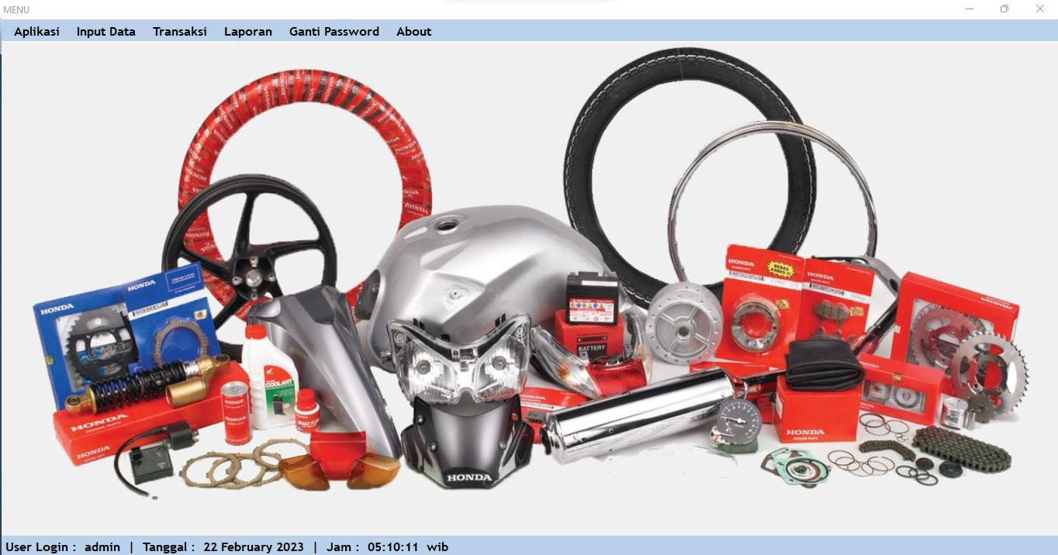Application Main Page

**Picture 2. Admin Main Menu Implementation**

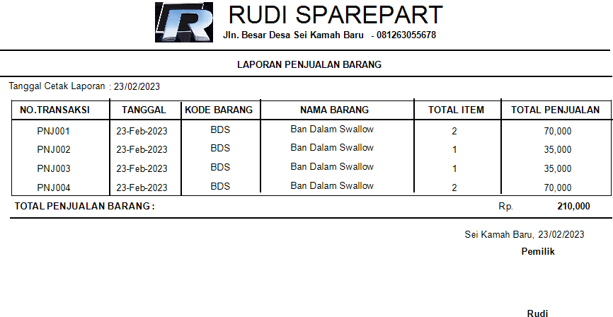Sales report

**Picture 3. Goods Sales Report**

Stock Report

        The following is the stock report data that has been realized at the Rudi Spare Parts shop on the 23rd of February 2023 with a total of 11 types of goods with listed prices and each of the available stocks at Rudi Sparepart's workshop.

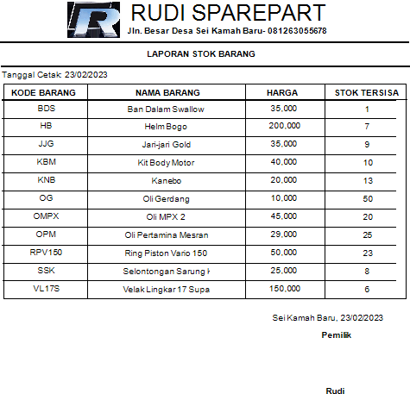

**Picture 4. Goods Stock Report**

**Conclusion**

In the research that has been done at Toko Rudi*spare parts*, then the authors draw conclusions as follows:

1.        The sales application that is made can help Rudi's Shopspare partsto record the purchase and sale of goods.

2.      The sales application can find out the amount of stock remaining in the warehouse automatically realtime without having to count the goods left in the warehouse.

3.        The sales application can generate reports quickly making it easier for Toko Rudispare *parts*to record data.

**THANK YOU**

Praise and gratitude the author conveys to the presence of Allah S.W.T, God Almighty, because of His grace and guidance, the author can complete this research entitled **“**Motor spare parts sales application at Rudi Sei Kamah Baru spare parts shop**”** right under current conditions. The writing of this research is structured as one of the Tri Darma of Higher Education which is the task of the lecturer function between teaching, research and community service tasks.

During the implementation of the preparation of this report, the author received a lot of input and information from fellow lecturers. Therefore the authors would like to thank those who have supported this research. Do not forget the author would like to thank profusely to:

1.    Mr. Rudi as the owner of the Rudi Spare Parts workshop.

2.  Brother Indriani as Admin/finance and Brother Sujaliadi as operator/mechanic at Rudi Sparepart's workshop.

3. Chairperson of STMIK Royal Kisaran and its staff and functionaries.

4.   Mr. Chairman of LPPM AMIK Royal Kisaran and his administrative staff.

  The author realizes that there are still many deficiencies that need to be corrected from the presentation of the form and content of this research writing. Therefore, the author is happy to expect constructive criticism and suggestions from all readers for the perfection of writing this research. Hopefully this research is useful and beneficial for readers.

**BIBLIOGRAPHY**

[1]  D. Maryani, N. Suarna, S. Tinggi, M. Informatika, and S. Ikmi, "Web-Based Inventory Management Information System at Perumda BPR Bank Cirebon," vol. 1, no. 3, 2023.

[2]  T. Bin Tahir, M. Rais, and M. Apriyadi HS, "Point OF Sales Application Using the Laravel Framework,"*JIKO (Informal and Computer Journal)*2, no. 2, pp. 55–59, 2019, doi: 10.33387/jiko.v2i2.1313.

[3]  Novasanda Kartika Putra Al-amin and Novita Mariana, "Information System for Motor Spare Parts Sales on Website-Based NOPNOPPART,"*Elkom J. Elektron. dan Comput.*, vol. 15, no. 1, pp. 180–188, 2022, doi: 10.51903/elkom.v15i1.796.

[4]  H. Widyastono, "Scientific and Natural Research Methods,"*Journal of Education and Culture*, no. 068. pp. 757–775, 2007.

[5]  A. R. S. Nasution, "Identification of Research Problems,"*ALACRITY  J. Educ.*, vol. 1, no. 2, pp. 13–19, 2021, doi: 10.52121/alacrity.v1i2.21.

[6]  E. Murdiyanto,*Qualitative Research Methods (Systematics Qualitative Research)*. 2020. [Online]. Available: http://www.academia.edu/download/35360663/METODE_PENELITIAN_KUALITAIF.docx

[7]  FEB UI, “digital_126768-RB13C33a-subject analysis-Analysis,”*Article*, 2008.

[8]  I. Ashadi, I. Himawan, J. Timur, and R. Analysis, "Motorcycle spare parts sales information system," vol. VIII, no. 2, pp. 275–280, 2022.

[9]  N. Syafrina, “HUMAN RESOURCES MANAGEMENT Eri Susan 1,”*J. Manaj. Educator.*, flight. 9, no. 2, pp. 952–962, 2019.

[10] A. Sudianto, H. Ahmadi, and A. Alimuddin, "Design of a Motor Spare Parts Sales Information System at a Web-Based Motorbike Workshop to Increase Sales and Product Promotion,"*Infotek J. Inform. and Technol.*, vol. 3, no. 2, pp. 115–122, 2020, doi: 10.29408/jit.v3i2.2289.