**Transformation Digital in Logistic Company Strategy Management**

**After Pandemic Covid 19**

**Dely Indah Sari, Widya Lestari Harahap**

Perdagangan Internasional, Desain Komunikasi Visual Institut Teknologi Batam

*deli@iteba.ac.id,* *Widiya@iteba.ac.id*

**Abstract:** Currently in Indonesia freight forwarding services or expeditions are increasingly being used in business. Companies that provide freight forwarding services are also increasingly popping up, besides that the range of shipping services is much wider, starting from big cities to small villages, now they are starting to become targets in the business process of freight forwarding services. There are also various kinds of goods that can be sent, ranging from small items, large items such as vehicles, or items that are private in nature such as documents. It is also undeniable that currently goods delivery services have become a mainstay of the community since the pandemic hit. However, in a number of cases with the onset of COVID-19 this can reduce income in goods delivery services due to the emergence of lock down policies in various regions according to the risk map zone for the spread of COVID-19 so that public transportation restrictions must be carried out, therefore it is necessary to carry out and also transformation in technology. One of the companies in the delivery service sector, namely a logistics company, must create a management strategy so that it can survive under the effects of the post-pandemic digital transformation in the logistics sector. In this study, the authors will discuss the business strategies carried out by logistics companies in dealing with the post-COVID-19 pandemic.

**Keywords:** *logistics, strategy management, transformation digital*

**Abstrak:** Saat ini di Indonesia jasa pengiriman barang atau ekspedisi semakin marak digunakan dalam proses bisnis. Perusahaan penyedia jasa layanan pengiriman barang pun semakin banyak bermunculan, selain itu jangkauan pengiriman barang pun jauh lebih luas mulai dari kota-kota besar sampai ke desa-desa kecil sekarang sudah mulai menjadi target dalam proses bisnis jasa layanan pengiriman barang. Barang yang dapat dikirim pun ada berbagai macam mulai dari barang yang kecil, barang yang besar seperti kendaraan, ataupun barang yang bersifat privasi seperti dokumen. Tidak dapat dipungkiri juga bahwa saat ini jasa pengiriman barang menjadi andalan masyarakat semenjak melandanya pandemi. Namun, pada beberapa kasus dengan melandanya COVID-19 ini bisa menurunkan penghasilan pada jasa layanan pengiriman barang dikarenakan munculnya kebijakan lock down di berbagai daerah sesuai dengan zona peta resiko penyebaran COVID-19 sehingga harus dilakukan pembatasan transportasi umum. Salah satu perusahaan di bidang jasa pengiriman yaitu perusahaan Logistik harus membuat manajemen strategi yang lebih baik agar mampu bertahan di bawah pengaruh pandemic terhadap perusahaan logistic dalam teknologi informasi dalam transformasi digital ERP logistik. Pada penelitian ini penulis akan membahas mengenai strategi-strategi yang dilakukan oleh perusahaan logistic untuk menangani masalah tersebut.

**Kata kunci:** *logistik, manajemen strategi,transformasi digital*

**INTRODUCTION**

In 2021 is a year of global economic recovery which continues to show significant developments even though it is not evenly distributed and still faces uncertainty, including Indonesia which continues to experience recovery in the economic and transportation sectors. There are challenges after the COVID-19 pandemic that logistics companies must go through, namely the survival of the logistics company to survive in economic disruption and market excitement, so it is necessary to implement strategic steps by integrating technology.

Picture 1 logistics transport 2017-2021

Based on the data above, it shows that logistics companies have experienced a decrease in the volume of freight transport in 2021 when compared to the previous year. In 2017 there were 76.693 volumes of logistics transportation, in 2018 there were 176.9310 volumes of logistics transportation, in 2019 there were 171.8940 volumes of logistics transportation, in 2020 there were 1354.995 volumes of logistics transportation and in 2021 there were 1.209.705 volumes of logistics transportation.

During the pandemic, public transportation was restricted. On the other hand, logistics companies were used as a means to support the continuity of logistics distribution throughout Indonesia, namely Java, Bali and Sumatra. The volume of logistics management or goods transportation decreased by around 12 percent in the April period, which was around 1.28 million tons compared to March's volume of around 1.46 million tons. This decline from March to April 2020 was heavily influenced by the Covid-19 pandemic which not only paralyzed Indonesia but also almost the entire world,"[1]

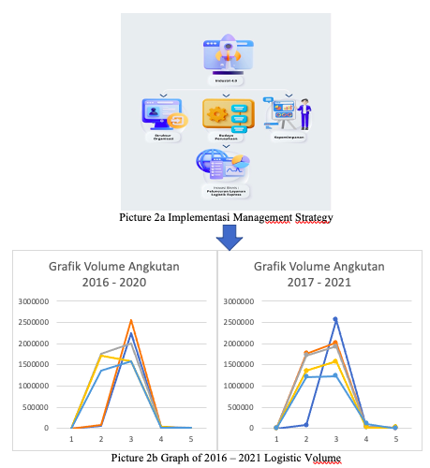

Digital transformation is becoming important at this time in logistics companies by covering business performance where there is supervision of the distribution of goods by checking from delivery to the destination, there are solutions to customer complaints by monitoring through the customer satisfaction index.

In the midst of the changes that occurred after the Covid-19 pandemic, logistics companies were able to manage the company by being able to increase growth amidst the dynamics of uncertain economic conditions, there were factors that could reduce the income of logistics companies, a logistics company management strategy was carried out by developing products offered in the form of digital transformation through customer delivery services. with services aimed at the shipping segment weighing 10 kg and below, facilitating the need for delivery of goods with a minimum weight and premium line, that is, customers do not need to pick up the package from a logistics company, but the package will be delivered to the destination address.

The problem is Post-pandemic recovery of logistics companies where logistics companies are used as a means to support logistics distribution throughout Indonesia, second how is strategic management carried out by logistics companies in order to overcome problems in surviving after the COVID-19 pandemic by adopting information technology in the form of digital transformation, the thrid create a management strategy solution to increase company revenue with digital transformation of logistics delivery services to customers. For all to find out how much influence the productivity of strategic management has on the effectiveness of a logistics company's business processes in the form of shipping goods using digital transformation

Strategy management is the activity of formulating, implementing and evaluating strategies by a company. The company will analyze internal and external factors in order to identify the company's strengths and weaknesses to capture opportunities and avoid threats.

In implementing strategic management, companies can apply several alternative strategies [2].

Digital transformation strategic planning as a basis for implementing technology that can be used as the main key for companies to be able to compete in order to gain profit [3], digital transformation strategic planning is one of the factors for an organization to be able to compete with companies engaged in the same field [4], digital transformation strategic planning has stages through which the main stages are input, output and application. ) so that it is necessary to secure a digital transformation because there are appropriate management decision makers for the sustainability of a logistics company [5], digital transformation will be important so that system development can be carried out by integrating existing applications to make it easier for customers to access logistics company services [6]. The development of digital transformation includes scope, cost and time for managing data that is done digitally [7].

Logistics companies must carry out the right strategy to maximize the potential possessed by logistics companies by overcoming various threats that will come in the future. The strategy carried out involves all components of the logistics company to the internal and external factors of the company to provide suggestions and formulate the right competitive strategy for the company to win the competition in the logistics industry [8]. The need for transportation always moves dynamically as a form of reaction to various changes in the structure of the national economy [9]. SWOT analysis is a strategic analysis design method used to monitor and evaluate both the internal and external environment of logistics companies [10]

Picture 3 Logistic Stage

**METODE**

The metode use is :

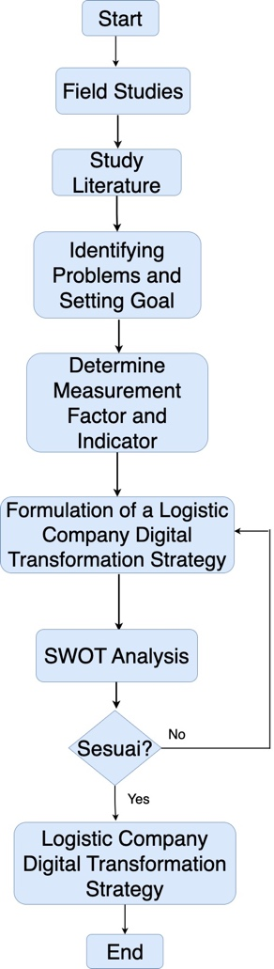

Picture 4 Methodology

Giving a value to the question table to determine factors and indicators based on information on scale 4: If these factors have a very strong effect on logistic (Strongly Agree), scale 3: If these factors have an effect on logistic (Agree), scale 2: If these factors it has little effect on logistic (Disagree), scale 1: If this factor has very little effect on logistic (Disagree).

$$bobot=\frac{total}{ internal(strength+weakness)}…(1)$$

$$rating=\frac{total}{responden}……………………………(2)$$

$$internal analysis coordinator= \frac{total strength score }{2}……………………..(3)$$

**RESULT**

Data collection techniques were obtained from questionnaire observation research data. To make the initial steps of SWOT analysis and make decisions, this data collection technique uses a questionnaire data collection of 40 samples, which form each of the SWOT variables. The table below is the indicators given to the respondents that form the SWOT variable.

Tabel 1 Internal Factor

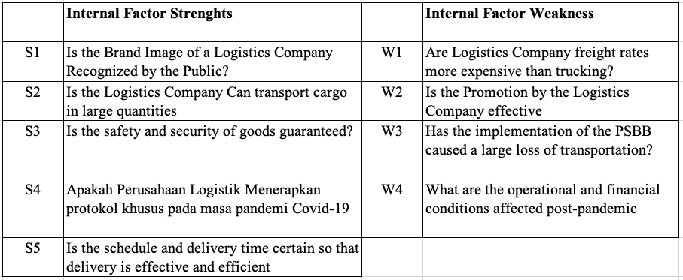

Tabel 2 Faktor Eksternal

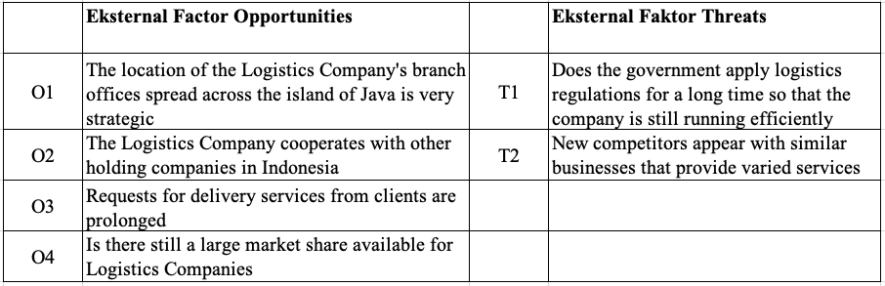

The calculation below is data on the number of respondents who filled out the value scale for each statement. Statement no. 1 Logistics brand image is known by the public with the number of respondents who filled out a scale of 1 was 0 respondents, a scale of 2 was 1 respondent, a scale of 3 was 28 respondents and a scale of 4 was 11 respondents who filled out.

Tabel 3 Responden- Strength



Tabel 4 Skala Faktor Internal – Strength

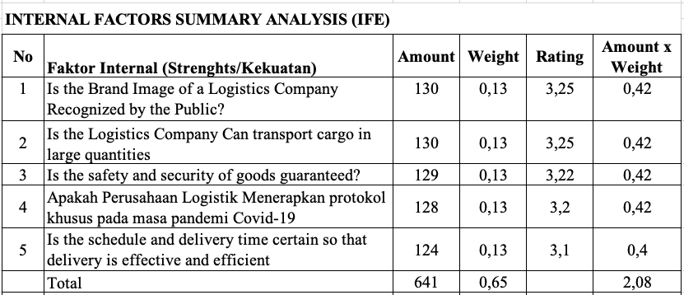

Tabel 4 Responden- Weakness



Tabel 5 Skala Faktor Internal - Weakness

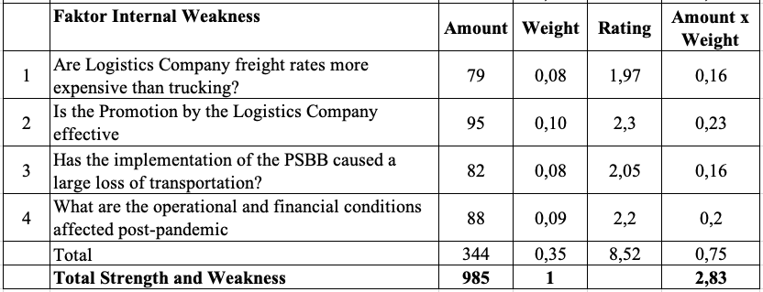



Tabel 6 Skala Faktor Eksternal –

Opportunities

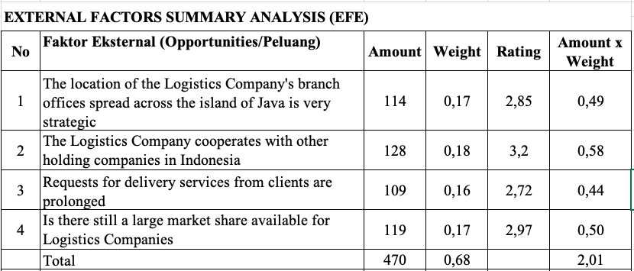



Tabel 7 Skala Faktor Eksternal - Threats

The calculation of the IFAS matrix is ​​a calculation to determine weights, ratings and scores where the total weights do not exceed 1.00. And calculating the rating value of each factor by giving a scale of 1 (below average/not important) to 4 strongly agree. The following is a table of the results of the IFAS matrix calculation.

The calculation of the weight for the strength factor is obtained from the total answers of 40 respondents divided by the total calculation of the IFAS questionnaire data seen in table 4.5 with the result that the weight = $\frac{130}{985}$ = **0,13**.

In calculating the total weight of the quotient, it may be rounded up with the provision that if the result is less than 0.5, it is rounded down and if the result is more than 0.5, it may be rounded up.

The rating calculation for the strength opportunity factor is obtained from the total number of answers of 40 respondents divided by the number of respondents. Calculation as follows : Rating = $\frac{130}{40}$ = **3,25**. Calculation of the score for the strength factor is obtained by multiplying the weight and rating. The calculation is: Weight x Rating = 0.13 x 3.25 = 0.42.

The calculation of the weight for the strength factor is obtained from the total answers of 40 respondents divided by the total calculation of the EFAS questionnaire data seen in the table with the results of the weight = $\frac{114}{695}$ = **0,17** In calculating the total weight of the quotient, it may be rounded up with the provision that if the result is less than 0.5, it is rounded down and if the result is more than 0.5, it may be rounded up.

The rating calculation for the strength opportunity factor is obtained from the total number of answers of 40 respondents divided by the number of respondents. Calculation as follows: = $\frac{114}{40}$ = **2,85** Calculation of the score for the opportunity factor is obtained by multiplying the weight and rating. The calculation is: Weight x Rating = 0.17 x 2.85 = 0.49.

Then the total results of calculating the IFAS and EFAS matrix scores are as follows:

Total strength score (Strengths) = 2.08

Total score of strength (Weakness) = 0.75

Total strength score(Opportunities) = 2.01

Total strength score (Threats) = 0.9

Coordinate internal analysis; external analysis coordinates

= $\frac{S-W}{2}$; $\frac{O-T}{2}$

= $\frac{2,08-0,75}{2}$; $\frac{2,01-0,9}{2}$

= 0,67; 1,56

the coordinates are located at (0.67; 1.56)

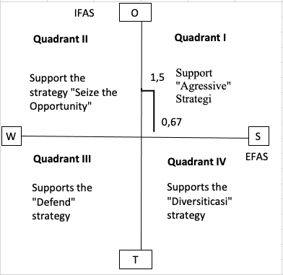

Picture 5 Cartecius Diagram

Tabel Matriks SWOT

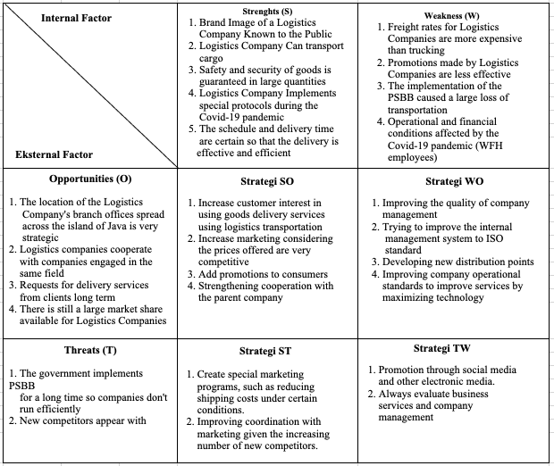

**CONCLUSION**

Based on the analysis that has been carried out using the SWOT analysis, the implementation of logistics technology is very important because it is in quadrant I of the Cartesian diagram which requires using digital technology.

**ACKNOWLEGMENTS**

Thank for LPPM ITEBA with a letter of assignment 004/ST/LPPM-ITEBA /VI / 2023 for funding research Transformation Digital in Logistic Company Strategy Management After Pandemic Covid 19

**BIBLIOGRAPHY**

[1] E. N. Hayati, “Supply Chain Management (SCM) Dan Logistic Management,” *J. Din. Tek.*, vol. 8, no. 1, 2014.

[2] “QUALITY CONTROL OF OPTICAL FIBER DISRUPTION WITH BIG DATA USING THE SIX SIGMA METHOD,” *STMIK R.*, vol. Vol 8, No, 2022.

[3] R. Hidayat, “Rancang Bangun Sistem Informasi Logistik,” *J. Optimasi Sist. Ind.*, vol. 13, no. 2, 2016, doi: 10.25077/josi.v13.n2.p707-724.2014.

[4] N. Siswanto, S. E. Wiratno, and A. I. Arianty, “ANALISIS STRATEGI LOGISTIK PERUSAHAAN DENGAN MENGGUNAKAN ANALYTICAL NETWORK PROCESS (ANP),” *J. Teknobisnis*, vol. 1, no. 2, 2017, doi: 10.12962/j24609463.v1i2.2810.

[5] W. H. K. Atmaja, “Penyusunan Metodologi Perencanaan Strategis Sistem Informasi Berbasis Value Bisnis (Be Vissta Planning) untuk Meningkatkan Peran Strategis Sistem Informasi pada Suatu Organisasi (Bagian I),” *The Winners*, vol. 3, no. 1, p. 32, 2002, doi: 10.21512/tw.v3i1.3831.

[6] Y. Utami, A. Nugroho, and A. F. Wijaya, “Perencanaan Strategis Sistem Informasi dan Teknologi Informasi pada Dinas Perindustrian dan Tenaga Kerja Kota Salatiga,” *J. Teknol. Inf. dan Ilmu Komput.*, vol. 5, no. 3, p. 253, 2018, doi: 10.25126/jtiik.201853655.

[7] P. Diskin, *Strategic Planning for Information systems*, vol. 26, no. 4. 1979.

[8] D. I. Sari, “Implementasi Manajemen Proyek CPM pada Pembangunan Infrastruktur IT Optical Distribution Point,” *JURTEKSI (Jurnal Teknol. dan Sist. Informasi)*, vol. 7, no. 3, pp. 267–276, 2021.

[9] N. Imaniyati, “SISTEM INFORMASI LOGISTIK DALAM PENGAMBILAN KEPUTUSAN EKSPOR IMPOR PADA REKANAN PT TWINS LOGISTIK,” *J. MANAJERIAL*, vol. 9, no. 1, 2015, doi: 10.17509/manajerial.v9i1.1221.

[10] Rinaldi Mohammad and Pradana, “Kinerja Logistik Kalog Terimbas COVID-19,” *economi.bisnis.com*, 2020. https://ekonomi.bisnis.com/read/20200618/98/1254445/kinerja-logistik-kalog-terimbas-covid-19

[11] W. H. K. Atmaja, “Penyusunan Metodologi Perencanaan Strategis Sistem Informasi Berbasis Value Bisnis (Be Vissta Planning) untuk Meningkatkan Peran Strategis Sistem Informasi pada Suatu Organisasi (Bagian I),” *The Winners*, vol. 3, no. 1, p. 32, 2002, doi: 10.21512/tw.v3i1.3831.

[12] F. N. D. Fatimah, *Teknik Analisis SWOT - Google Books*, Anak Hebat. 2016. [Online]. Available: https://www.google.co.id/books/edition/Teknik_Analisis_SWOT/CRL2DwAAQBAJ?hl=id&gbpv=1&dq=SWOT&printsec=frontcover