**IMPLEMENTATION OF GATEWAY SMS FOR CAR SPAREPART INVENTORY AT CV. MUL JAYA**

**Laila Purnama1*, Fauriatun Helmia2, Ari Dermawan3**

1Prodi Sistem Informasi, STMIK Royal

2Prodi Sistem Informasi, STMIK Royal

3Prodi Manajemen Informatika, STMIK Royal

email: *[lailapurnama35@gmail.com](mailto:lailapurnama35@gmail.com), [fauriatunh@gmail.com](mailto:fauriatunh@gmail.com), [aridermawan451@gmail.com](mailto:aridermawan451@gmail.com)

**Abstrak:** CV. MOL JAYA merupakan salah satu CV yang bergerak dibidang penyediaan barang *sperepart* mobil. Dalam hal pengolahan persedian *sparepart* di CV. Mol Jaya masih mengalami kesulitan, seperti tidak dapat mengetahui jumlah stok *sparepart* dan laporan penjualan kurang maksimal, sehingga menyebabkan pekerjaan tertunda karena harus menunggu pemesanan *sparepart* dari supplier. Teknologi Mobile web saat ini sangat berkembang pesat, misalnya seperti ponsel. Maka dari itu pemilik CV melakukan Investasi TI dalam mengembangkan aplikasi yang dapat memantau persediaan secara real time sehingga ketika persediaan menipis dapat diprediksi dengan cepat menggunakan konsep yang menggabungkan aplikasi online dan teknologi *message recall* pada CV. Mol Jaya. Aplikasi ini bertujuan untuk memudahkan dan mempercepat pekerjaan karyawan dalam mengatasi permasalahan penyimpanan barang yang berada di Gudang, dengan menerapkan konsep rantai pasok.

**Kata kunci:**Inventori**;***Supply Chain Management****;*** SMS *Gateway*

**Abstract:** CV. MOL JAYA is one of the CVs engaged in the supply of car spare parts. In terms of spare parts inventory processing in CV. Mol Jaya is still experiencing difficulties, such as not being able to find out the amount of spare parts stock and sales reports that are not optimal, causing work to be delayed because they have to wait for spare parts orders from suppliers. One of the highly developed technologies to date is the development of mobile web technology, such as cell phones. Therefore CV owners invest in IT to develop applications that are able to monitor inventory of goods in real-time, so that when inventory is running low it can be anticipated quickly through a concept that combines web applications and message reminder technology at CV MOL JAYA. Making this application aims to build a Web-based application that makes it easier for employees to solve problems with storing goods in the Warehouse, by applying the supply chain concept.

**Keywords**: Inventory; Supply Chain Management; SMS Gateways

**INTRODUCTION**

Various types of businesses that are currently developing, especially in Indonesia, such as in the culinary, fashion and so on. One of the current business developments is in the field of supply of goods [1] which provides various kinds of spare parts or auto parts, such as engine oil, oil filters, air filters, spark plugs, batteries, brake linings and so on. However, many business actors still collect stock data or inventory using stationery and reports in the form of sheets of paper. A technological development that is so fast at this time makes several aspects of life more efficient[2]*.* Technological developments in the field of warehousing are very important. Where the warehouse is a place for temporarily storing goods that are neatly arranged so that the owner can easily find out the location or amount of an item. For the best storage of goods, supporting technology is needed. Coupled with the increasing purchasing power of consumers at this time. So that technology can be utilized to facilitate a job[3].

CV. Mol Jaya is a company engaged in the supply of car spare parts located in the village of Pulau Maria Dusun II, Teluk Dalam sub-district, Asahan Regency, North Sumatra. CV. MOL JAYA was founded in 2008. There are many car repair shops around it, so CV. Mol Jaya has many customers, and this is very profitable for the company. Therefore from time to time CV.Mol Jaya develops and advances, and is required to provide complete car spare parts to attract customers or consumers. Management of spare parts inventory at CV. Mol Jaya is still not optimal, there are still frequent shortages of supplies due to the small supply of spare parts available, which results in work being delayed and having to wait for spare parts orders from suppliers again. Recording of items that still use paper causes the reporting of the number of items on the CV. Mol Jaya is hampered and also the negligence of an employee in checking the inventory of an item in the warehouse so that sometimes the inventory of goods is completely used up without anyone knowing. With that CV. Mol Jaya must be able to condition the inventory of goods in its warehouse, so that the demand for goods can be controlled properly and efficiently.

Inventory or often called inventory is a temporary place for raw goods, materials or finished goods that are stored for use for certain purposes or within a certain period of time[4]. Companies need to implement good inventory management, to anticipate demand or market changes Where the policies are taken based on data processing of goods in warehouses and affect the survival of CV. Mol Jaya. Therefore, a computerized inventory data management system is needed that can view real-time inventory of goods[5]*.* So that when the inventory of goods is running low, anticipation can be carried out quickly[6].

System requirements include analysis of user needs, admin needs, and analysis of system requirements for implementing SMS Gateway for stock inventory at CV. Mol Jaya using the supply chain management method[7]. The system will display information to the user by processing the data that has been stored in the database and for notifications of stocks that have been depleted through SMS gateways sent to suppliers without the need to check one by one the inventory of goods that have reached the minimum limit.

The SMS Gateway functions as a system for sending and receiving text messages and is frequently used, among others, in commercial applications and for broadcast advertisements, user information services, and product/ service content distribution.[8]. The SMS gateway will later become the gateway for communication via text messages. We can send messages to several numbers automatically and quickly, without having to type hundreds of numbers and messages to cellphones, because all numbers have been automatically searched from the database.[9]. In this case, precise and accurate information is needed for the smooth running of the service process at CV. Mol Jaya. Information related to data on the supply of spare parts must be stored in the form of a database server so that when data is needed it can be easily searched and viewed to ensure the number of orders that must be ordered so that supplies do not run out or are empty.

**METHOD**

Identifikasi Masalah

Pengumpulan Data

Analisa Data

Perancangan Sistem

Uji Coba Sistem

Implementasi Sistem

Mempelajari Literatur

In this study using qualitative methods, research that is descriptive and tends to use analysis. This method collects data that can be obtained directly through direct interviews with informants, conducting field observations and also obtained from the results of discussions. The goal is to determine the object under study, namely to simplify CV. Mol Jaya in obtaining inventory information of an item via sms by implementing Supply Chain Management [7]*,*[10]*.* The preparation of this research was designed with several stages, which will be explained in the research framework as shown in Figure 1.



**Figure 1. Research Framework**

**Identification of problems**

This stage will explain what problems are found and how these problems are measured and related to research procedures. The identification of the existing problem is the recording of goods that are still using paper so that the reporting of the number of goods is hampered and also the negligence of an employee in checking the inventory of an item in the warehouse so that sometimes the inventory of goods is completely exhausted without anyone knowing.

**Data collection**

At this stage, data and information were collected through direct interviews and direct observation of the CV. Mol Jaya. Furthermore, the results of the data and information obtained will later be used as a reference in processing the system that will be designed.

**Study of literature**

To strengthen and deepen this research, literature studies were carried out, in the form of books, journals, and articles related to the problems and research objectives.

**System planning**

The design of the system will later become an overview that is made to overcome the problems faced by related agencies or companies after conducting an analysis first. The system is designed using the PHP and MYSQL programming languages. The design of this application uses Visual Studio Code (VS Code) and Visual Paradigm to create an overview of the system to be designed

**System Testing**

After completing the system design, the system can be tested to what extent the system can be relied upon by the company. Will the system built later be able to run well in accordance with the desired.

**System Implementation**

After system testing is done, the next step is the implementation of the design results that have been made. Whether the system can be implemented in accordance with the analysis and design that has been done before.

**RESULTS AND DISCUSSION**

**System Usage**

To clarify user rights or users in logging in to enter the system, there are four users or users who log in including: Owner, admin, Supplier, and cashier. The following is the login display in the application of the SMS gateway for this stock inventory, which can be seen in Figure 2.

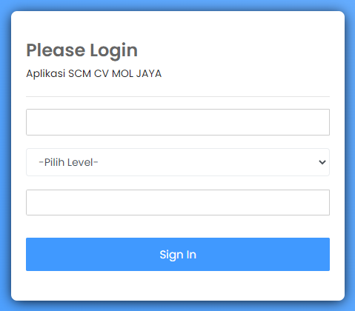

**Figure 2. Login Menu**

**Admin Main Menu Display**

On the main page display, the admin can manage request data, approve offers, manage spare part data, manage supplier data and manage user data, can be seen in figure 3.

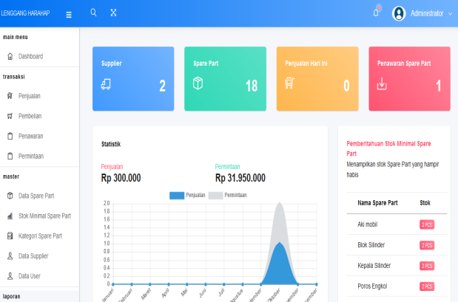

**Figure 3. Display of the Admin Main Menu**

**Admin View Manage Request Data**

In this view, the admin can manage request data. The following display of managing request data can be seen in Figure 4.

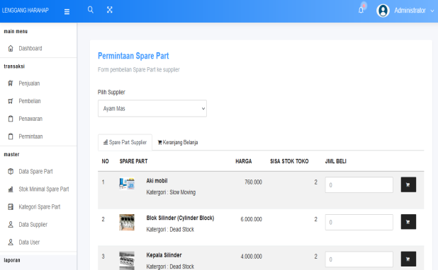

**Figure 4. Display of Admin Managing Request Data**

**Admin View Manage Supplier Data**

In this view, the admin can manage supplier data. The following shows how the admin manages supplier data, which can be seen in Figure 5.

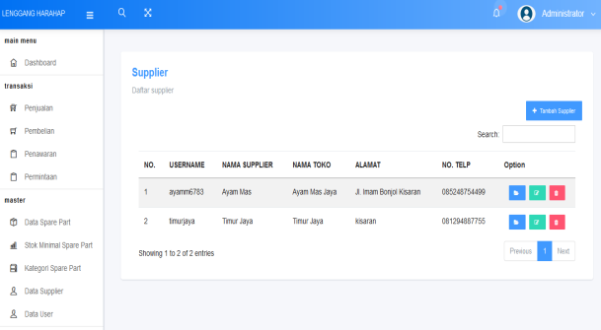

**Figure 5. Admin Manages Supplier Data**

**Supplier main page display**

On this main page display, suppliers can manage demand and supply data, manage spare parts data, and change passwords, as shown in Figure 6.

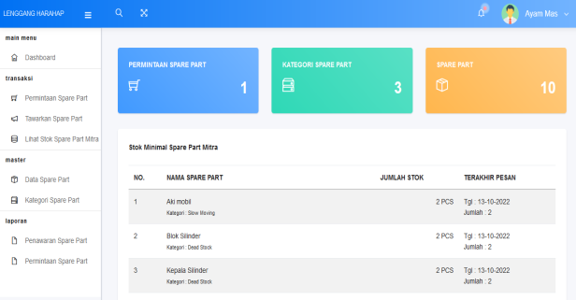

**Figure 6. Supplier main page**

**Supplier Page Display Manages Demand Data**

On this page view, suppliers can manage request data such as viewing requests, sending requests, canceling orders, and printing invoices, as shown in Figure 7.

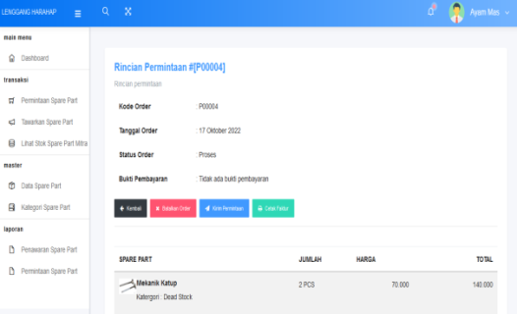

**Gambar 7. Supplier Mengelola Data Permintaan**

**Supplier Page Display Offers Spare Parts**

On the display of this page, the supplier offers the spare parts they have. Supplier displays offering spare parts can be seen in Figure 8.

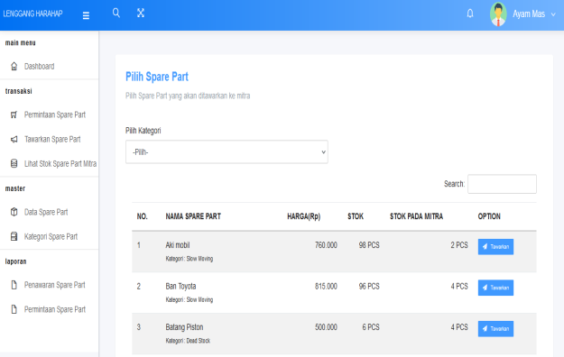

**Figure 8. Display of the Supplier Offering Spare Parts Page**

**Supplier Page Display Manage Spare Part Data**

In this main page display, Supplier manages the spare part data they have. Supplier display managing spare part data can be seen in Figure 9.

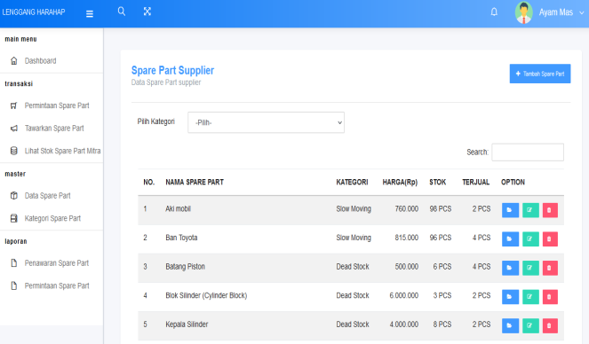

**Figure 9. Display of the Supplier Page Managing Spare Parts Data**

**Display Main Page Cashier**

On this main page view, the cashier can manage sales data, print sales invoices and sales reports, and change passwords. The following is the display of the cashier's main page, which can be seen in Figure 10.

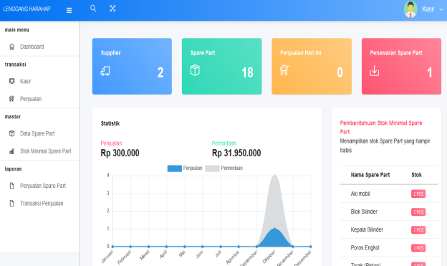

**Figure 10. Display of the Cashier Main Page**

**Sales Admin Page Display Processing Sales Data**

The display of this page is the appearance of the cashier in carrying out the sales process, starting from inputting product data sold, and calculating transactions. The following is the display of the cashier page managing sales data, which can be seen in Figure 11.

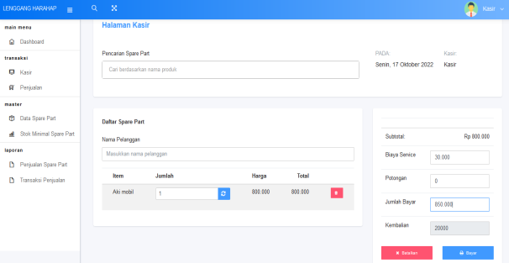

**Figure 11. Display of the Cashier Manage Sales Page**

**Sales Report Display**

The sales report display is a report to view sales data for each period which is then printed and submitted to the owner. The following display of the sales report can be seen in Figure 12.

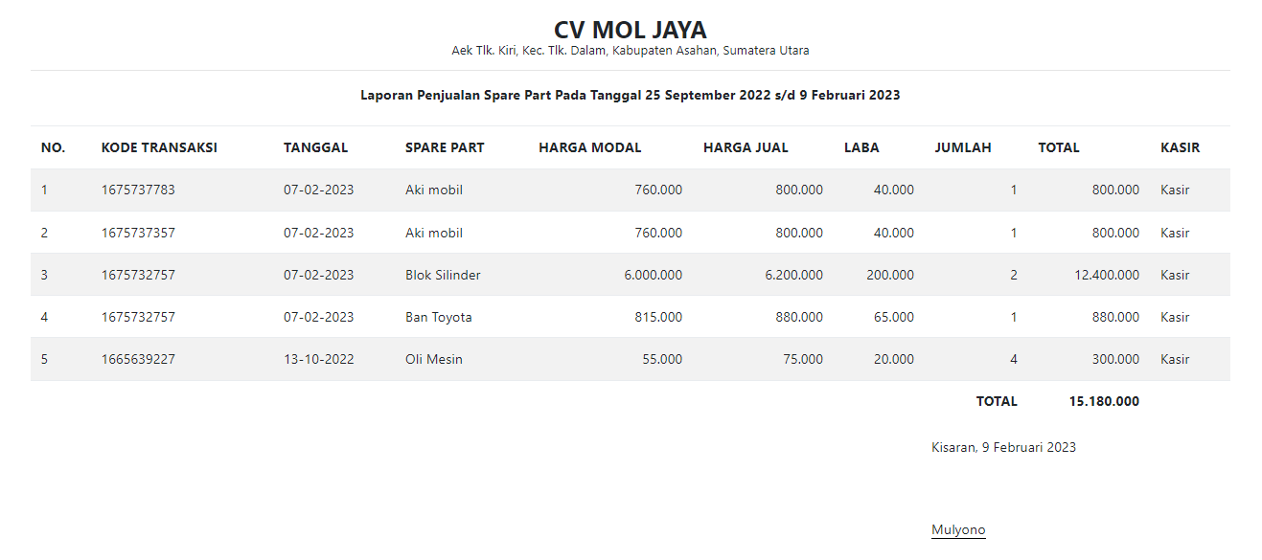 **Figure 12. Display of Sales Reports**

**CONCLUSION**

The spare part inventory management application system that was built functions so that there is no shortage of inventory at CV. Mol Jaya. The application of the sms gateway for web-based goods inventory has been successfully built and running well, as an information system that can assist in inventory management, spare part stock quantities and sales reports. The application of web-based Supply Chain Management is very effective for coordinating the relationship between suppliers and CV. Mol Jaya.

**BIBLIOGRAPHY**

[1] R. Wahyudi, “Analisis Pengendalian Persediaan Barang Berdasarkan Metode EOQ Di Toko Era Baru Samarinda,” *Ejournal Ilmu Admistrasi Bisnis*, vol. 2, no. 1, pp. 162–173, 2015.

[2] A. N. Warisman, U. Salamah, and Y. Jumaryadi, “Sistem Pengingat Pada Gudang Pt. Alfa Beauty Cosmetica Menggunakan Sms Gateway,” *J. Tek. Inform.*, vol. 13, no. 1, pp. 1–10, 2020, doi: 10.15408/jti.v13i1.11520.

[3] Y. Jumaryadi, “Customer Complaint Information Systems At National Standardization,” *Int. J. Inf. Syst. Comput. Sci.*, vol. 3, no. 2, pp. 43–49, 2019.

[4] M. Hasanudin, “Rancang Dan Bangun Sistem Informasi Inventori Barang Berbasis Web (studi kasus pt. nusantara sejahtera raya),” *J. IKRA-ITH Inform.*, vol. 2, no. 3, pp. 24–37, 2018, doi: 10.29207/resti.v4i4.2218.

[5] M. Siddik and A. Nasution, “Perancangan Aplikasi Push Notification Berbasis Android,” *Jurteksi*, vol. 4, no. 2, pp. 149–154, 2018, doi: 10.33330/jurteksi.v4i2.56.

[6] A. Nasution *et al.*, “MONITORING STOK BARANG MENGGUNAKAN TEKNOLOGI PUSH NOTIFIKASI ANDROID CORE View metadata, citation and similar papers at core.ac.uk provided by Aisyah Journal Of Informatics and Electrical Engineering,” pp. 39–44.

[7] H. Sucahyowati, “Manajemen Rantai Pasokan (Supply Chain Management),” *Maj. Ilm. Gema Marit.*, vol. 13, no. 1, pp. 20–28, 2011, doi: 10.37612/gema-maritim.v13i1.19.

[8] M. R. Meta, I. E. Putra, and A. Urfa, “Aplikasi Penerimaan Mahasiswa Baru Online Dengan Sms Gateway di STMIK Indonesia Padang,” *J. RESTI (Rekayasa Sist. dan Teknol. Informasi)*, vol. 2, no. 3, pp. 716–721, 2018, doi: 10.29207/resti.v2i3.582.

[9] A. Tanthowi, “Implementasi Sistem Informasi Pembayaran Berbasis SMS Gateway,” *J. Inform. dan Rekayasa Perangkat Lunak*, vol. 2, no. 2, pp. 188–195, 2021.

[10] P. Kindangen, I. Debbie Palandeng, F. Ekonomi dan Bisnis, and J. Manajemen Universitas Sam Ratulangi Manado, “Analisis Manajemen Rantai Pasokan Spring Bed Pada Pt. Massindo Sinar Pratama Kota Manado (Analysis Supply Chain Management (Scm) Spring Bed At Pt. Massindo Sinar Pratama Kota Manado),” *Anal. SCM ……. 901 J. EMBA*, vol. 5, no. 2, pp. 893–900, 2017.