EXPERT SYSTEM FOR DETECTING DISEASES OF PALM OIL WITH FORWARD CHAINING METHOD ANDROID BASED

Basmallah Ramadhani Aisha Putri * ¹ Ainul Rhozy Ichwanto ² Imelda ³
^{1,2,3}Master of Science Computer , Faculty Technology Information , Budi Luhur University
e-mail : * ¹ basmallahramadhani08@gmail.com , ² rhozy12@gmail.com , ³ imelda@budiluhur.ac.id ,

Abstrak
Perkebunan kelapa sawit memiliki peranan yang sangat strategis dalam pembangunan ekonomi Indonesia. Kelapa sawit ini banyak diolah menjadi minyak masak dan bahan bakar. Untuk menghasilkan produk turunan yang berkualitas dari kelapa sawit ini maka membutuhkan penanganan yang tepat dalam pemeliharaannya. Pada perkebunan kelapa sawit banyak ditemukan kasus kelapa sawit yang terserang penyakit, sehingga hal ini akan menghambat produktivitas perkebunan. Penanganan yang tidak tepat terhadap kelapa sawit yang terserang penyakit dapat mengakibatkan kerugian yang tidak sedikit. Untuk mengatasi masalah tersebut dibuatlah sistem pakar yang berbasis android. Sistem pakar dapat mendiagnosis penyakit dengan mendeteksi gejala-gejala yang ditunjukan kelapa sawit saat terserang penyakit, sehingga pengambilan keputusan untuk penanganan selanjutnya akan lebih akurat yang akan berdampak pada hasil panen yang maksimal.
Kata Kunci : Android, Kelapa Sawit, Penyakit, Sistem Pakar.
Abstract
Oil palm plantations have a very strategic role in Indonesia's economic development. Palm oil is widely processed into cooking oil and fuel. To produce quality derivative products from palm oil, requires proper handling in its maintenance. In oil palm plantations, there are many cases of oil palm being attacked by diseases, so this will hinder the productivity of the plantation. Improper handling of palm oil infested by the disease can result in a lot of losses. To solve this problem, an expert system based on Android was created. Expert systems can diagnose diseases by detecting the symptoms shown by palm oil when attacked by the disease, so that decision-making for subsequent treatment will be more accurate which will have an impact on maximum yields
Keywords : Android, Expert System, Oil Palm, Sickness.

INTRODUCTION
In Indonesia when This coconut palm is one commodity owned plantation role strategic in development economy . Coconut palm is one commodity the biggest it can be grow fertile in Indonesia. Plant This have role important in producer oil Cook as well as material burn . Indonesia is one producer coconut palm the largest in Asia spread across various island such as Sumatra and Kalimantan.
However , p the Certain There is problems that hinder the growth process and diseases that can attack plant the . So that can resulted decrease productivity results harvest from coconut palm . The amount losses that occur consequence exists disease late plant handler and already reach very severe stage Can resulted happening fail harvest . Actually disease That Can prevented when plant the show persistent symptoms be on stage light or little .
A number of reference study system plant expert coconut palm among them system expert diagnosis disease plant coconut palm use bayes theorem [1]. Research results system expert diagnosis disease plant coconut palm with method bayes theorem gives solution , where has done testing to users, 84% of respondents state information on the system complete in overcome problem disease plant coconut attacking palm . on research system expert diagnosis disease plant coconut palm based on Android [5]. Application This use forward chaining method for know disease plant coconut palm with method This CF values are in the range of 0 to with 1, if CF output is approaching one , then certainty approach right . Next on research System Expert For Diagnose Disease Plant Coconut Palm Oil At PT. Farmers Prima Makmur [3]. Application This can make it easy for the user to know disease plant coconut palm with the identification process type disease form systematic consultancy like ask answer with expert
System expert is one method that can diagnose disease that already android based . System This designed For answer question and solve A problem happened so that can finish and take right decision
METHOD
2.1 System Expert
System expert is system based computer that uses knowledge , facts and techniques reasoning in solve problem [6]. System expert is branch from intelligence made and fields emerging knowledge along development knowledge computers [8]. System expert designed aim For imitate skill a expert in answer question and solve something problem . System expert capable Work with information that is not complete or No sure . User can respond with “ no know ” or “ no sure ” on one or more questions and systems expert still will give the answer is [2].
2.2 Forward Chaining
Study This use Forward Chaining method . The Forward Chaining method is something method application future that makes facts as representation knowledge For get conclusion [1].
However with use Forward Chaining method for support system expert so the accuracy of the data obtained would be very good , as well with do a live survey spaciousness will can make system expert who will made can with easy understood by one farmer .
On research This use forward chaining method with steps deep data collection study This described below this :
- At stage review studies librarian , researcher look for various related journals with system experts , types and symptoms disease plant coconut palm as well as control nor other related material with study as material appropriate reference with topic research .
- At stage data analysis , performed collection supporting facts planning system with stage consultation to a expert or a expert in the field .
- Studies Literature On Stage This writer gather various type information and learn material as well as related data sources with system expert . Type disease plant coconut palm , symptoms plant coconut palm as well as control nor other related material with material research .
- Analysis At stage This done collection supporting facts planning system with stage consultation to a expert or a expert in the field .
- Implementation System On stage This done the designed system is implemented to in program coding form
- Testing At stage This done testing is system Already walk
RESULTS AND TESTING
Implementation system created in the system expert This is stage final in the development process system . System expert For detect disease plant palm This based on android mobile. Activity detection disease can done right on the field or in the garden coconut palm .
3.1. Main Menu page
Main menu page consists from There are three main menus in the application system expert the that is including a menu list of diseases , consultation plants and about the application.
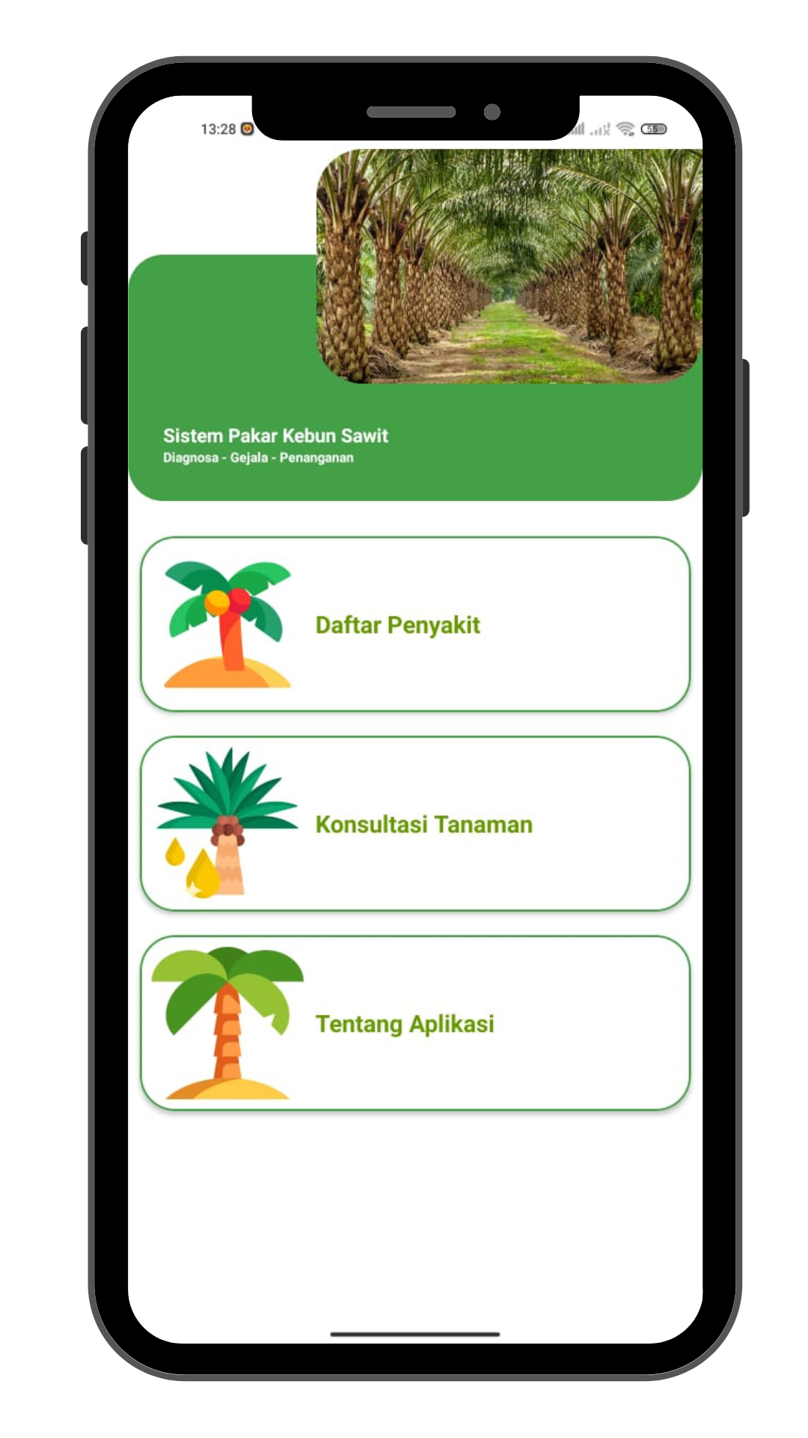
Figure 3.1 Main Menu page
3.2 Disease List Page
Diseases page containing a number of list of possible diseases Can happens in plants coconut palm . The list of diseases in the application as following : :
- Pedicab Leaf
- Rotten Base Stem (Ganoderma)
- Disease header
- Leaf Rust
- Disease Rotten Disappeared
- Anthracnose
- Rotten Fruit ( Marasmius Palmivorus )

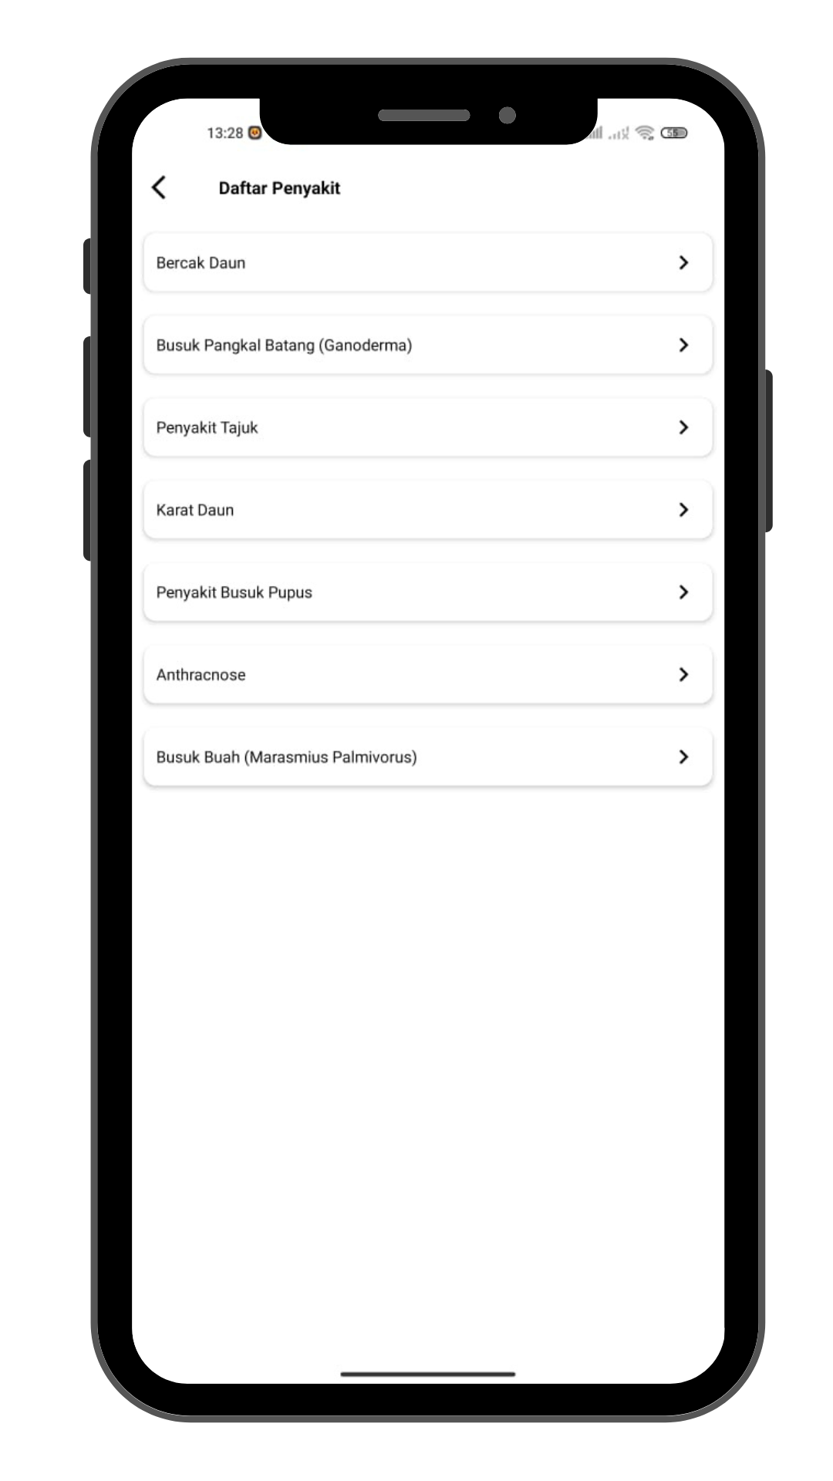
Figure 3.2 Disease List Page

3.3 Disease Detail Page
Disease details page is a detail of a number of disease from disease list page On the disease details page This containing about explanation disease plant coconut palm and way treatment for each disease the .

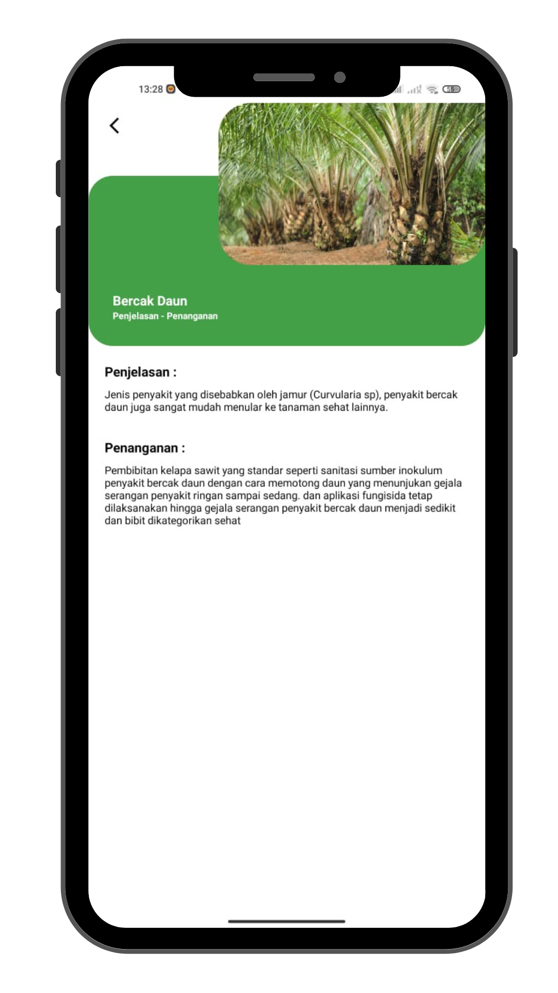
Figure 3.3 Disease List Page

3.4 Consultancy Page Plant
Consultancy page plant containing containing various type frequent symptoms arise in plants coconut palm . internal diagnosis consultancy plant This can chosen a maximum of 3 symptoms that occur in plants . a number of type system diagnostics application This is as following :
- Symptom beginning form spotting colored brown
- Symptom carry on form spotting colored chocolate old with edge colored yellow
- Symptom early on in plants yellow it almost whole midrib leaf
- Network sick resulted death plant
- A number of sheet leaf spear rotting and yellowing
- Colony algae merges cover surface sheet leaf
- etc
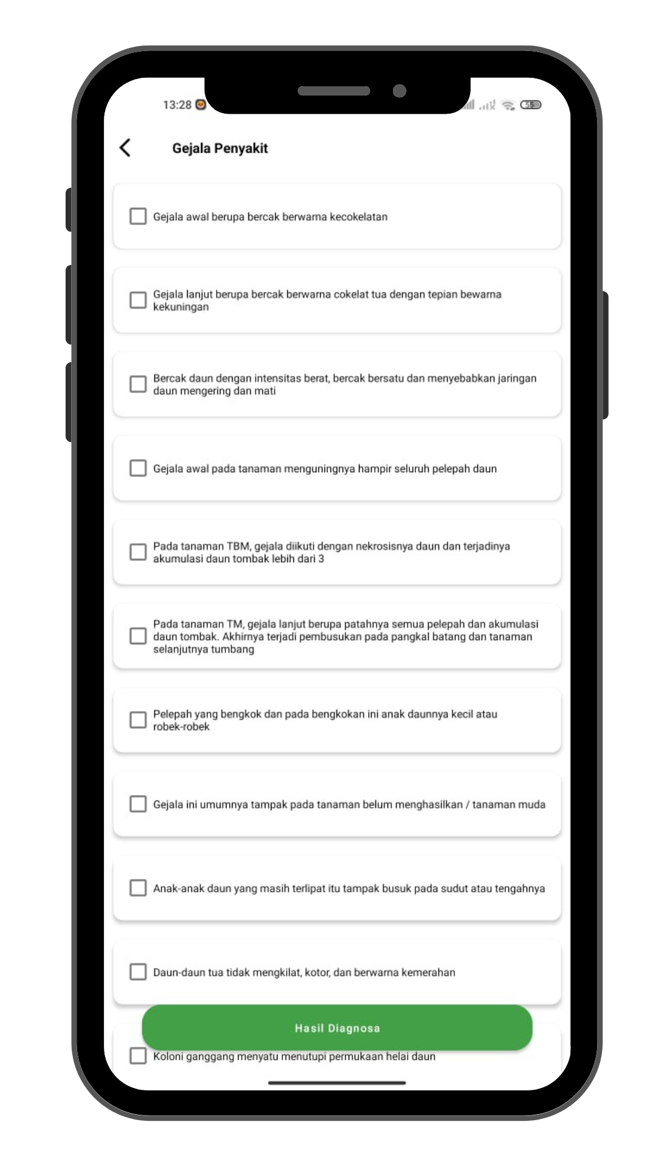
Figure 3.4 Consultation Page Plant

3.5 Diagnostic Results Page Plant
this page is results from diagnosis on the consulting menu page . On results diagnosis can is known diseases that occur in plants palm . On the page This containing about explanation diseases that arise in plants , as well can make diagnosis repeat and do see How many percentage plant the infected disease .
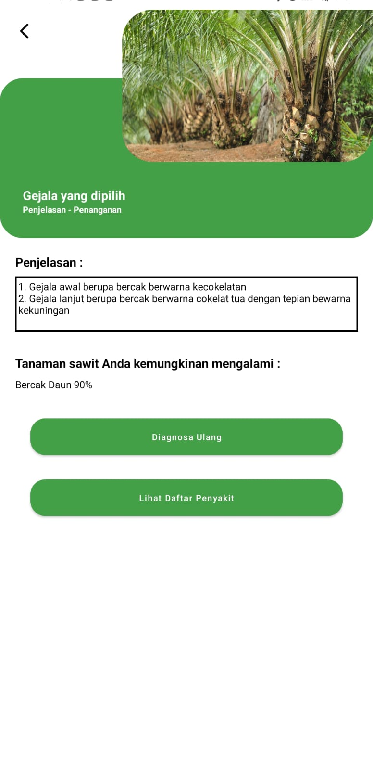
Figure 3.5 Diagnostic Results Page
CONCLUSION
Based on results analysis system expert For detect disease in plants coconut palm can taken conclusion from existing application made as following
- Can facilitate the user in prevent emergence common illness happens in plants coconut palm .
- System application based on mobile android and is offline so the user can with easy use right on the field although No There is even the internet .
- Application system expert This need developed Again with added data upload mode , period coordinates in each user commits diagnostics on the plant and datagrid backend For know results the diagnosis has created by users.

BIBLIOGRAPHY
[1 ] Ahmad , N. and Iskandar, I., 2020. Forward Chaining Method for Detection Diseases In Plants Potatoes . JINTECH: Journal Of Information Technology, 1 (2), pp.7-20.
[2 ] Darsin , DAK and Sesunan , MF, 2022. System Expert For Diagnose Disease Teeth and Mouth Use Method Forward Chaining ( Study at Menggala Hospital ). Journal System Information and Technology Science , 4 (2).
[3 ] Octaviani , E., Suliman, S. and Susanto, A., 2022. System Expert For Diagnose Disease Plant Coconut Palm Oil At PT. Farmers Prima Makmur. Journal System Information and Systems Computers , 7 (2), pp.74-81.
[4 ] Satria , D., Poningsih , P. and Saputra , W., 2019. System Expert detect Disease Plant Coconut palm Use Forward Chaining Method . In Proceedings of the National Seminar on Information Science Research (SENARIS) (Vol. 1, pp. 444-451).
[5 ] Sidauruk , A. and Pujianto , A., 2017. System Expert Diagnosis Disease Plant Coconut palm Use Bayes' theorem . Data Management and Technology Information (TIE), 18 (1), pp.51-56.
[6 ] Silmi , M., Sarwoko , EA and Kushartantya , K., 2014. System Expert Web Based And Mobile Web For Diagnose Blood Diseases in Humans With Use Method Inference Forward Chaining. Journal of Informatics and Technology, 2 (3), pp.42-49.
[7 ] Surianti , S. and Banyal , NA, 2021. System Expert Diagnosis Disease Plant Coconut palm Android based . Journal Scientific Matrix , 23 (1), pp.28-33.
[8 ] Triawan , M., 2018. Application Deep Forward Chaining Method System Expert Diagnosis computer . Journal Informatics , 7 (1), pp.38-47.
[9 ] Wahyuni , L. and Darma , S., 2017, October. System Expert Diagnose Disease plant Coconut palm With Certainty Factor Method . In National Seminar on Informatics ( SNIf ) (Vol. 1, No. 1, pp. 122-127).

