**APPLICATION OF SAW TECHNIQUE FOR RESEARCHING POTENTIAL NEW PARTNERS OF THE CENTRAL STATISTICS AGENCY OF ASAHAN REGENCY APPLICATION OF APPLICATION**

**Novi Silvana Kawila1*, Fauriahtun Helmiah2, Elly Rahayu3**

12Information Systems Study Program, STMIK ROYAL KISARAN

*Email*: [novisilvana92@gmail.com](mailto:novisilvana92@gmail.com)

**Abstract:** The Central Bureau of Statistics is a government agency that serves the public in providing accurate statistical data. The Asahan Regency Central Bureau of Statistics office is located on Jl. Tusam No. 2, Range, Mekar Baru, District. West City Range, Asahan Regency, North Sumatra 21216. Central Statistics Agency Every year the Central Statistics Agency accepts new partners. Partners who do data processing that has been done on data in the field. In this case, the acceptance of new partner candidates is quite often held to carry out survey and population census activities. The partner acceptance process is less effective because it still uses the manual method, namely the approach between existing partners. So we need a decision support system that can help election performance to be more effective. Therefore the problem can be solved with the saw model. The results of the research conducted produced the best alternative decision, namely Ruslan Efendi with a score of 0.975 and Yenni Yulistina with a score of 0.95. based on these results can assist the Central Bureau of Statistics in determining the assessment of potential new partners so that they can provide a reference in decision making.

Keywords: Decision Support Support System, Simple Addictive Weighting, Prospective Partners, Information Systems

**Abstract:** The Central Bureau of Statistics is one of the government agencies that serves the public in providing accurate statistical data. The office of the Central Statistics Agency of Asahan Regency is located on Jl. Tusam No. 2, Kisaran, Mekar Baru, District. West Range City, Asahan Regency, North Sumatra 21216. Central Bureau of Statistics Every year the Central Bureau of Statistics receives new partners. Partners who carry out data processing that has been carried out on data in the field. . In this case, the admission of potential new partners is held quite often in order to carry out survey and census activities of the population. This partner onboarding process is less effective because it still uses manual methods, namely and approaches between pre-existing partners. So a decision support system is needed that can help the performance of elections to be more effective. Therefore, the problem can be solved with a saw model. The results of the research conducted resulted in the best alternative decision, namely Ruslan efendi with a value of 0.975 and Yenni Yulistina with avalue of 0.95. based on these results, it can help the Central Statistics Agency in determining assessment of potential new partners so that they can provide a reference in decision making.

**Keywords :** Decision Support System, Simple Addictiv Weighting, Potential Partner, Information System

**INTRODUCTION**

The age of information technology is now growing rapidly so that it has a myriad of benefits for its users, according to the needs and procedures that use it. In an agency today, some work activities are supported by information technology. The information technology is applied to help and accelerate work activities within the agency. And the use of information technology is also one of the things that affects the performance of an agency. Information Technology is a technology used to process data, including processing, obtaining, compiling, storing, manipulating data in various ways to produce quality information, namely relevant, accurate and timely information, which is used for personal, business, and government purposes[1]. Including the Central Statistics Agency which has used information technology[2].

The Central Statistics Agency (BPS) is one of the government agencies that serves the public in providing accurate statistical data. Previously, BPS was the Central Bureau of Statistics, which was formed based on Law Number 6 of 1960 concerning Census and Law Number 7 of 1960 concerning Statistics. As a substitute for the two laws, Law Number 16 of 1997 concerning Statistics was established. [3].

The office of the Central Statistics Agency of Asahan Regency is located on Jl. Tusam No. 2, Kisaran, Mekar Baru, District. West Kisaran City, Asahan Regency, North Sumatra 21216, is a Non-Departmental Government Institution in Indonesia that has the main function as a provider of basic statistical data, both for the government and for the general public, nationally and regionally[4].

The Central Statistics Agency in Asahan Regency not only conducts surveys or censuses from one variable, but the Central Statistics Agency of Asahan Regency conducts various surveys, the Asahan Regency Central Statistics Agency has many partners who assist in conducting the census. Every year the Central Bureau of Statistics receives a new partner[5].

However, the problem that exists in the agency, the Central Statistics Agency of Asahan Regency does not have a record of partner data and assessments from each partner. Whether the partner followed the pre-census training well or not. In addition, the Central Bureau of Statistics has difficulties when determining the selection of the best potential partners to deserve a job after attending training. Previously, the system used by the Central Statistics Agency of Asahan Regency to recruit partners or open registration for partners using selection methods and interviews, but in the current covid19 era, conducting face-to-face interview tests is very ineffective because they must be orderly in order to maintain distance in accordance with state regulations and also have little difficulty seeing or checking which partners are active or not in carrying out their duties[6] .

Because in this agency previously there was no system to register for partners and there was also no system to see whether previous partners were active or not in carrying out their duties, to help and facilitate the staff at the Asahan Regency Statistics Agency, an application design was made which aimed to make it easier for employees to find partners and then select which partners are good at collecting data in the field or processing census data and also helps employees to see which partners are active or not in carrying out their duties

The selection of partners for each census and survey activity has several criteria, namely, age, recent education, communication skills, punctuality, responsibility, and discipline. In each activity, special criteria can be added so that the results of the selection process can be more accurate in accordance with and the existence of a decision support system. In the application of the Simple Addictive Weigthing method, the calculation of the value of each of the criteria tested will have a different weight priority scale[7].

Decision Support System or often called *Decision Support System* (DSS) is a model-based system that consists of procedures in data processing and its consideration to assist managers in making decisions[8]. Basically, DSS is designed to support all stages of decision making from identifying problems, selecting relevant data, determining the approach used in the decision-making process to evaluating alternative options. In the decision-making process to produce an alternative requires a method[9]. This method was chosen because the assessment criteria used are very dynamic and can be determined according to the needs of the company or agency[10].

**METHOD**

*Simple Additive Weighting* (SAW) method, often also known as the weighted summation method. The basic concept of the *Simple Additive Weight* (SAW) method is to look for weighted summation of the performance rating on each alternative on all attributes. A larger value indicates that an alternative is more elected. According to the *Simple Additive Weighting* (SAW) Method it is recommended to solve the selection problem in a multi-process decision-making system[9]. *The Simple Additive Weight*ing (SAW) method is a method that is widely used in decision making that has many attributes.

There are several steps in solving the *Simple Additive Weighting* (SAW) method are as follows[11]:

1.Determine the criteria used as a reference in supporting the decision, namely Ci.

2. Determine the match rating of each alternative on each criterion.

3.Create a decision matrix based on criteria (Ci).

4.Then normalize the matrix based on the equation adjusted to the type of attribute (profit attribute and cost attribute) so that the normalized matrix R is obtained.

5.The final result is obtained from the ranking process, namely the summation of the normalized matrix multiplication R with the weight vector so that the largest value is obtained which is chosen as the best alternative (Ai) as a solution.

The SAW method is often also known as the weighted summation method. The basic concept of the SAW method is to find the weighted summation of the performance rating on each alternative on all attributes[12]. The calculation formula of the Simple Additive Weighting Method is shown in the following formula.

$$r_{ij=}\sum_{\frac{Min Xij}{Xij} }^{\begin{aligned}\frac{Xij}{Max Xij} \\ \end{aligned}}{\begin{matrix}if j is a benefit attribute (benefit) \\ if j is a cost attribute (cost)\end{matrix}}$$

Information:

RIJ : Rated Value Nominated

xij : the value of the attributes possessed of each keriteria

Max xij : the largest value of each criterion i

Min xij : the smallest value of each criterion i

Prefence value for each alternative (Vi)

$$V_{i}=\sum_{j=1}^{n}{\begin{matrix}W_{j} & r_{ij}\end{matrix}}$$

Information:

Vi : ranking for each alternative

Wj : the weight value of each criterion

RIJ : Nationalized Performance Rating Value

A larger Vi value indicates that the Ai alternative is more elected.

In accordance with the flow of the *Simple Addictive Weigthing* method process on the Decision Support System, the assessment of new potential partners will be designed starting with the need for criteria data inputted in the system consisting of:

**Table 4.1 Criteria**

|  |  |  |  |  |
| --- | --- | --- | --- | --- |
| **Code** | **Criterion** | **Weight** | **Normalized Weights** | **Information** |
| C1 | Age | 10 | 10 / 100 = 0.10 | Cost |
| C2 | Final Education | 20 | 20 / 100 = 0.20 | Benefits |
| C3 | Communication Skills | 25 | 25/ 100 = 0.25 | Benefits |
| C4 | Timeliness | 15 | 15 / 100 = 0.15 | Benefits |
| C5 | Responsibility | 10 | 10 / 100 = 0.10 | Benefits |
| C6 | Discipline | 20 | 20 / 100 = 0.20 | Benefits |
| **Total** | | **100** | **1** |  |

The data will be processed into a form that can be received by the computer which will later be stored in the *database*. After the data is inputted and processed, an *outpu*t of the ranking results is obtained as a reference for the administrative part in the assessment of potential new partners.

Regarding the flow of the calculation process of the *Simple Addictive Weighting (SAW)* method by first describing the subcriteria along with the values from the assessment criteria for prospective new partners at the Central Statistics Agency.

**Table 4.2 Subcriteria along with criteria values**

**Age**

|  |  |
| --- | --- |
| **Value** | **Information** |
| 5 | 18 – 25 |
| 4 | 26 – 33 |
| 3 | 34 – 41 |
| 2 | 42 – 49 |
| 1 | 50 |

**Table 4.3 Subcriteria along with criteria values**

**Final Education**

|  |  |
| --- | --- |
| **Value** | **Information** |
| 5 | S1 |
| 4 | D3 |
| 3 | D1 |
| 2 | SMA |

**Table 4.4 Subcriteria along with criteria values**

**Communication Skills**

|  |  |
| --- | --- |
| **Value** | **Information** |
| 5 | Excellent |
| 4 | Good |
| 3 | Enough |
| 2 | Not Good Enough |
| 1 | Very Less |

**Table 4.5 Subcriteria along with criteria values**

**Timeliness**

|  |  |
| --- | --- |
| **Value** | **Information** |
| 5 | Very Precise |
| 4 | True |
| 3 | Quite Precise |
| 2 | Not Quite Right |
| 1 | Very Incorrect |

**Table 4.6 Subcriteria along with criteria values**

**Responsibility**

|  |  |
| --- | --- |
| **Value** | **Information** |
| 5 | Excellent |
| 4 | Good |
| 3 | Enough |
| 2 | Less |
| 1 | Very less |

**Table 4.7 Subcriteria along with criteria values**

**Discipline**

|  |  |
| --- | --- |
| **Value** | **Information** |
| 5 | Excellent |
| 4 | Good |
| 3 | Enough |
| 2 | Less |
| 1 | Very less |

1. The first step is to make a decision table by compiling criteria and alternatives into matrix form. In this calculation, the researcher used 15 (fifteen) alternatives to carry out the calculation process.

**Table 4.8 Table of Decisions**

|  |  |  |  |  |  |  |  |
| --- | --- | --- | --- | --- | --- | --- | --- |
| **Alternative** | **Criterion** | | | | | | |
| **C1** | **C2** | **C3** | **C4** | **C5** | **C6** | |
| Sri Indarin | 20 | S1 | Excellent | True | Very Less | Good | |
| Onita Prianti | 23 | D3 | Good | True | Good | Enough | |
| Yenni Yulistina | 29 | S1 | Good | Very Precise | Good | Good | |
| Inako Cartine | 40 | D1 | Good | True | Good | Good | |
| Ruslan Efendi | 19 | D3 | Good | True | Good | Good | |
| Anastasya Arliza | 34 | D3 | Good | True | Excellent | Less | |
| Ahmad Shafi'i | 50 | D1 | Very Less | True | Less | Very Less | |
| Sri Puji Astuti | 45 | D1 | Good | Enough | Good | Good | |
| Rudi | 39 | SMA | Good | True | Enough | Good | |
| Sutriana | 48 | SMA | Enough | True | Good | Good | |
| Dian Aprillia | 38 | SMA | Good | Enough | Good | Enough | |
| Muchlis Ashari | 28 | D3 | Good | True | Good | Good |
| Rina | 24 | S1 | Excellent | Very Precise | Enough | Good | |
| Novi Silavana Kawila | 21 | SMA | Good | Very Precise | Excellent | Good | |
| Ita Purmala Sari | 30 | S1 | Enough | Very Precise | Excellent | Less | |

2. Next determine the weighting based on the initial data**.** The weighted value of the assessment of potential new partners is converted by looking at the table of criteria.

**Note** :

- Alternative : Name of Prospective Partner who registered

-Criteria: criteria of the selected activity

**Table 4.9 Weight Value Data Conversion Table**

|  |  |  |  |  |  |  |  |
| --- | --- | --- | --- | --- | --- | --- | --- |
| **No** | **Alternative** | **Criterion** | | | | |  |
| **C1** | **C2** | **C3** | **C4** | **C5** | **C6** |
| 1 | Sri Indarin | 4 | 2 | 5 | 4 | 1 | 4 |
| 2 | Onita Prianti | 4 | 3 | 4 | 3 | 4 | 3 |
| 3 | Yenni Yulistina | 3 | 3 | 3 | 5 | 5 | 4 |
| 4 | Inako Cartine | 4 | 5 | 4 | 4 | 3 | 4 |
| 5 | Ruslan Efendi | 4 | 4 | 3 | 3 | 4 | 4 |
| 6 | Anastasya Arliza | 5 | 3 | 4 | 4 | 3 | 2 |
| 7 | Ahmad Shafi'i | 4 | 2 | 3 | 3 | 2 | 1 |
| 8 | SriPuji Astuti | 4 | 2 | 4 | 3 | 3 | 4 |
| 9 | Rudi | 3 | 4 | 4 | 4 | 3 | 4 |
| 10 | Sutriana | 3 | 3 | 4 | 4 | 4 | 4 |
| 11 | Dian Aprillia | 5 | 4 | 3 | 3 | 4 | 3 |
| 12 | Muchlis Ashari | 4 | 2 | 4 | 4 | 4 | 4 |
| 13 | Rina | 5 | 4 | 3 | 4 | 3 | 4 |
| 14 | Novi Silavana | 5 | 2 | 5 | 5 | 5 | 4 |
| 15 | Ita Purmala Sari | 4 | 4 | 3 | 3 | 3 | 2 |

3. Determining criteria C1, C2, C3, C4, C5, C6 is a favorable criterion**.** Decision making gives weight based on the level of importance of each of the required criteria is as follows:

**W = (3,4,5,5,5,4,)**

The next step is to normalize the matrix X calculating the value of each criterion.

a. Normalization

The function of normalization is to calculate the normalized performance rating from the alternatives above using the formula:

$$r_{ij=}\sum_{\frac{Min Xij}{Xij} }^{\begin{aligned}\frac{Xij}{Max Xij} \\ \end{aligned}}{\begin{matrix}if j is a benefit attribute (benefit) \\ if j is a cost attribute (cost)\end{matrix}}$$

Then, it will be able to value as follows:

**For criterion C1:**

$$r_{1.1}=\frac{3}{\min\left(4,4,3,4,4,5,4,4,3,3,5,4,5,5,4\right) }= \frac{3}{4}=0.75$$

$$r_{2.1}=\frac{3}{\min\left(4,4,3,4,4,5,4,4,3,3,5,4,5,5,4\right) }= \frac{3}{4}=0.75$$

$$r_{3.1}=\frac{3}{\min\left(4,4,3,4,4,5,4,4,3,3,5,4,5,5,4\right) }= \frac{3}{3}=1.00$$

$$r_{4.1}=\frac{3}{\min\left(4,4,3,4,4,5,4,4,3,3,5,4,5,5,4\right) }= \frac{3}{4}=0.75$$

$$r_{5.1}=\frac{3}{\min\left(4,4,3,4,4,5,4,4,3,3,5,4,5,5,4\right) }= \frac{3}{4}=0.75$$

$$r_{6.1}=\frac{3}{\min\left(4,4,3,4,4,5,4,4,3,3,5,4,5,5,4\right) }= \frac{3}{5}=0.60$$

$$r_{7.1}=\frac{3}{\min\left(4,4,3,4,4,5,4,4,3,3,5,4,5,5,4\right) }= \frac{3}{4}=0.75$$

$$r_{8.1}=\frac{3}{\min\left(4,4,3,4,4,5,4,4,3,3,5,4,5,5,4\right) }= \frac{3}{4}=0.75$$

$$r_{9.1}=\frac{3}{\min\left(4,4,3,4,4,5,4,4,3,3,5,4,5,5,4\right) }= \frac{3}{3}=1.00$$

$$r_{10.1}=\frac{3}{\min\left(4,4,3,4,4,5,4,4,3,3,5,4,5,5,4\right) }= \frac{3}{3}=1.00$$

$$r_{11.1}=\frac{3}{\min\left(4,4,3,4,4,5,4,4,3,3,5,4,5,5,4\right) }= \frac{3}{5}=0.60$$

$$r_{12.1}=\frac{3}{\min\left(4,4,3,4,4,5,4,4,3,3,5,4,5,5,4\right) }= \frac{3}{4}=0.75$$

$$r_{13.1}=\frac{3}{\min\left(4,4,3,4,4,5,4,4,3,3,5,4,5,5,4\right) }= \frac{3}{5}=0.60$$

$$r_{14.1}=\frac{3}{\min\left(4,4,3,4,4,5,4,4,3,3,5,4,5,5,4\right) }= \frac{3}{5}=0.60$$

$$r_{15.1}=\frac{3}{\min\left(4,4,3,4,4,5,4,4,3,3,5,4,5,5,4\right) }= \frac{3}{4}=0.75$$

**For criterion C2 :**

$$r_{1.1}=\frac{5}{\max\left(2,3,3,5,4,3,2,2,4,3,4,2,4,2,4\right) }= \frac{5}{2}=0.40$$

$$r_{2.1}=\frac{5}{\max\left(2,3,3,5,4,3,2,2,4,3,4,2,4,2,4\right) }= \frac{5}{3}=0.60$$

$$r_{3.1}=\frac{5}{\max\left(2,3,3,5,4,3,2,2,4,3,4,2,4,2,4\right) }= \frac{5}{3}=0.60$$

$$r_{4.1}=\frac{5}{\max\left(2,3,3,5,4,3,2,2,4,3,4,2,4,2,4\right) }= \frac{5}{5}=1.00$$

$$r_{5.1}=\frac{5}{\max\left(2,3,3,5,4,3,2,2,4,3,4,2,4,2,4\right) }= \frac{5}{4}=0.80$$

$$r_{6.1}=\frac{5}{\max\left(2,3,3,5,4,3,2,2,4,3,4,2,4,2,4\right) }= \frac{5}{3}=0.60$$

$$r_{7.1}=\frac{5}{\max\left(2,3,3,5,4,3,2,2,4,3,4,2,4,2,4\right) }= \frac{5}{2}=0.40$$

$$r_{8.1}=\frac{5}{\max\left(2,3,3,5,4,3,2,2,4,3,4,2,4,2,4\right) }= \frac{5}{2}=0.40$$

$$r_{9.1}=\frac{5}{\max\left(2,3,3,5,4,3,2,2,4,3,4,2,4,2,4\right) }= \frac{5}{4}=0.80$$

$$r_{10.1}=\frac{5}{\max\left(2,3,3,5,4,3,2,2,4,3,4,2,4,2,4\right) }=\frac{5}{3}=0.60$$

$$r_{11.1}=\frac{5}{\max\left(2,3,3,5,4,3,2,2,4,3,4,2,4,2,4\right) }= \frac{5}{4}=0.80$$

$$r_{12.1}=\frac{5}{\max\left(2,3,3,5,4,3,2,2,4,3,4,2,4,2,4\right) }= \frac{5}{2}=0.40$$

$$r_{13.1}=\frac{5}{\max\left(2,3,3,5,4,3,2,2,4,3,4,2,4,2,4\right) }= \frac{5}{4}=0.80$$

$$r_{14.1}=\frac{5}{\max\left(2,3,3,5,4,3,2,2,4,3,4,2,4,2,4\right) }= \frac{5}{2}=0.40$$

$$r_{15.1}=\frac{5}{\max\left(2,3,3,5,4,3,2,2,4,3,4,2,4,2,4\right) }= \frac{5}{4}=0.80$$

**For C3 criteria:**

$$r_{1.1}=\frac{5}{\max\left(5,4,3,4,3,4,3,4,4,4,3,4,3,5,5\right) }= \frac{5}{5}=1.00$$

$$r_{2.1}=\frac{5}{\max\left(5,4,3,4,3,4,3,4,4,4,3,4,3,5,5\right) }= \frac{5}{4}=0.80$$

$$r_{3.1}=\frac{5}{\max\left(5,4,3,4,3,4,3,4,4,4,3,4,3,5,5\right) }= \frac{5}{3}=0.60$$

$$r_{4.1}=\frac{5}{\max\left(45,4,3,4,3,4,3,4,4,4,3,4,3,5,5\right) }= \frac{5}{4}=0.80$$

$$r_{5.1}=\frac{5}{\max\left(5,4,3,4,3,4,3,4,4,4,3,4,3,5,5\right) }=\frac{5}{3}=0.60$$

$$r_{6.1}=\frac{5}{\max\left(5,4,3,4,3,4,3,4,4,4,3,4,3,5,5\right) }= \frac{5}{4}=0.80$$

$$r_{7.1}=\frac{5}{\max\left(5,4,3,4,3,4,3,4,4,4,3,4,3,5,54\right) }= \frac{5}{3}=0.60$$

$$r_{8.1}=\frac{5}{\max\left(5,4,3,4,3,4,3,4,4,4,3,4,3,5,5\right) }= \frac{5}{4}=0.80$$

$$r_{9.1}=\frac{5}{\max\left(5,4,3,4,3,4,3,4,4,4,3,4,3,5,54\right) }= \frac{5}{4}=0.80$$

$$r_{10.1}=\frac{5}{\max\left(5,4,3,4,3,4,3,4,4,4,3,4,3,5,5\right) }=\frac{5}{4}=0.80$$

$$r_{11.1}=\frac{5}{\max\left(5,4,3,4,3,4,3,4,4,4,3,4,3,5,5\right) }=\frac{5}{3}=0.60$$

$$r_{12.1}=\frac{5}{\max\left(5,4,3,4,3,4,3,4,4,4,3,4,3,5,5\right) }= \frac{5}{4}=0.80$$

$$r_{13.1}=\frac{5}{\max\left(45,4,3,4,3,4,3,4,4,4,3,4,3,5,5\right) }= \frac{5}{3}=0.60$$

$$r_{14.1}=\frac{5}{\max\left(5,4,3,4,3,4,3,4,4,4,3,4,3,5,5\right) }= \frac{5}{5}=1.00$$

$$r_{15.5}=\frac{5}{\max\left(5,4,3,4,3,4,3,4,4,4,3,4,3,5,3\right) }= \frac{5}{3}=0.60$$

**For criterion C4:**

$$r_{1.1}=\frac{5}{\max\left(4,3,5,4,3,4,3,3,4,4,3,4,4,5,3\right) }= \frac{5}{4}=0.80$$

$$r_{2.1}=\frac{5}{\max\left(4,3,5,4,3,4,3,3,4,4,3,4,4,5,3\right) }= \frac{5}{3}=0.60$$

$$r_{3.1}=\frac{5}{\max\left(4,3,5,4,3,4,3,3,4,4,3,4,4,5,3\right) }= \frac{5}{5}=1.00$$

$$r_{4.1}=\frac{5}{\max\left(4,3,5,4,3,4,3,3,4,4,3,4,4,5,3\right) }= \frac{5}{4}=0.80$$

$$r_{5.1}=\frac{5}{\max\left(4,3,5,4,3,4,3,3,4,4,3,4,4,5,32\right) }=\frac{5}{3}=0.60$$

$$r_{6.1}=\frac{5}{\max\left(4,3,5,4,3,4,3,3,4,4,3,4,4,5,3\right) }= \frac{5}{4}=0.80$$

$$r_{7.1}=\frac{5}{\max\left(4,3,5,4,3,4,3,3,4,4,3,4,4,5,3\right) }= \frac{5}{3}=0.60$$

$$r_{8.1}=\frac{5}{\max\left(4,3,5,4,3,4,3,3,4,4,3,4,4,5,3\right) }= \frac{5}{3}=0.60$$

$$r_{9.1}=\frac{5}{\max\left(4,3,5,4,3,4,3,3,4,4,3,4,4,5,3\right) }= \frac{5}{4}=0.80$$

$$r_{10.1}=\frac{5}{\max\left(4,3,5,4,3,4,3,3,4,4,3,4,4,5,3\right) }=\frac{5}{4}=0.80$$

$$r_{11.1}=\frac{5}{\max\left(4,3,5,4,3,4,3,3,4,4,3,4,4,5,32\right) }=\frac{5}{3}=0.60$$

$$r_{12.1}=\frac{5}{\max\left(4,3,5,4,3,4,3,3,4,4,3,4,4,5,3\right) }= \frac{5}{4}=0.80$$

$$r_{13.1}=\frac{5}{\max\left(4,3,5,4,3,4,3,3,4,4,3,4,4,5,3\right) }= \frac{5}{4}=0.80$$

$$r_{14.1}=\frac{5}{\max\left(4,3,5,4,3,4,3,3,4,4,3,4,4,5,3\right) }= \frac{5}{5}=1.00$$

$$r_{15.1}=\frac{5}{\max\left(4,3,5,4,3,4,3,3,4,4,3,4,4,5,3\right) }= \frac{5}{3}=0.60$$

**For criterion C5:**

$$r_{1.1}=\frac{5}{\max\left(1,4,5,3,4.3,2,3,3,4,4,4,3,5,3\right) }= \frac{5}{1}=0.20$$

$$r_{2.1}=\frac{5}{\max\left(1,4,5,3,4.3,2,3,3,4,4,4,3,5,3\right) }= \frac{5}{4}=0.80$$

$$r_{3.1}=\frac{5}{\max\left(1,4,5,3,4.3,2,3,3,4,4,4,3,5,3\right) }= \frac{5}{5}=1.00$$

$$r_{4.1}=\frac{5}{\max\left(1,4,5,3,4.3,2,3,3,4,4,4,3,5,3\right) }= \frac{5}{3}=0.60$$

$$r_{5.1}=\frac{5}{\max\left(1,4,5,3,4.3,2,3,3,4,4,4,3,5,3\right) }=\frac{5}{4}=0.80$$

$$r_{6.1}=\frac{5}{\max\left(1,4,5,3,4.3,2,3,3,4,4,4,3,5,3\right) }= \frac{5}{3}=0.60$$

$$r_{7.1}=\frac{5}{\max\left(1,4,5,3,4.3,2,3,3,4,4,4,3,5,3\right) }= \frac{5}{2}=0.40$$

$$r_{8.1}=\frac{5}{\max\left(1,4,5,3,4.3,2,3,3,4,4,4,3,5,3\right) }= \frac{5}{3}=0.60$$

$$r_{9.1}=\frac{5}{\max\left(1,4,5,3,4.3,2,3,3,4,4,4,3,5,3\right) }= \frac{5}{3}=0.60$$

$$r_{10.1}=\frac{5}{\max\left(1,4,5,3,4.3,2,3,3,4,4,4,3,5,3\right) }=\frac{5}{4}=0.80$$

$$r_{11.1}=\frac{5}{\max\left(1,4,5,3,4.3,2,3,3,4,4,4,3,5,3\right) }=\frac{5}{4}=0.80$$

$$r_{12.1}=\frac{5}{\max\left(1,4,5,3,4.3,2,3,3,4,4,4,3,5,3\right) }= \frac{5}{4}=0.80$$

$$r_{13.1}=\frac{5}{\max\left(1,4,5,3,4.3,2,3,3,4,4,4,3,5,3\right) }= \frac{5}{3}=0.60$$

$$r_{14.1}=\frac{5}{\max\left(1,4,5,3,4.3,2,3,3,4,4,4,3,5,3\right) }= \frac{5}{5}=1.00$$

$$r_{15.1}=\frac{5}{\max\left(1,4,5,3,4.3,2,3,3,4,4,4,3,5,3\right) }= \frac{5}{3}=0.60$$

**For criterion C6:**

$$r_{1.1}=\frac{4}{\max\left(4,3,4,4,4,2,1,4,4,4,3,4,4,4,2\right) }= \frac{4}{4}=1.00$$

$$r_{2.1}=\frac{4}{\max\left(4,3,4,4,4,2,1,4,4,4,3,4,4,4,2\right) }= \frac{4}{3}=0.75$$

$$r_{3.1}=\frac{4}{\max\left(4,3,4,4,4,2,1,4,4,4,3,4,4,4,2\right) }= \frac{4}{4}=1.00$$

$$r_{4.1}=\frac{4}{\max\left(4,3,4,4,4,2,1,4,4,4,3,4,4,4,2\right) }= \frac{4}{4}=1.00$$

$$r_{5.1}=\frac{4}{\max\left(4,3,4,4,4,2,1,4,4,4,3,4,4,4,2\right) }= \frac{4}{4}=1.00$$

$$r_{6.1}=\frac{4}{\max\left(4,3,4,4,4,2,1,4,4,4,3,4,4,4,2\right) }= \frac{4}{2}=0.50$$

$$r_{7.1}=\frac{4}{\max\left(4,3,4,4,4,2,1,4,4,4,3,4,4,4,2\right) }= \frac{4}{1}=0.25$$

$$r_{8.1}=\frac{4}{\max\left(4,3,4,4,4,2,1,4,4,4,3,4,4,4,2\right) }= \frac{4}{4}=1.00$$

$$r_{9.1}=\frac{4}{\max\left(4,3,4,4,4,2,1,4,4,4,3,4,4,4,2\right) }= \frac{4}{4}=1.00$$

$$r_{10.1}=\frac{4}{\max\left(4,3,4,4,4,2,1,4,4,4,3,4,4,4,2\right) }= \frac{4}{4}=1.00$$

$$r_{11.1}=\frac{4}{\max\left(4,3,4,4,4,2,1,4,4,4,3,4,4,4,2\right) }= \frac{4}{3}=0.75$$

$$r_{12.1}=\frac{4}{\max\left(4,3,4,4,4,2,1,4,4,4,3,4,4,4,2\right) }= \frac{5}{5}=1.00$$

$$r_{13.1}=\frac{4}{\max\left(4,3,4,4,4,2,1,4,4,4,3,4,4,4,2\right) }= \frac{4}{4}=1.00$$

$$r_{14.1}=\frac{4}{\max\left(4,3,4,4,4,2,1,4,4,4,3,4,4,4,2\right) }= \frac{4}{4}=1.00$$

$$r_{15.1}=\frac{4}{\max\left(4,3,4,4,4,2,1,4,4,4,3,4,4,4,2\right) }= \frac{4}{2}=0.50$$

After getting the results, you will be able to see the normalization value (R) in the table below:

**Table 4.10 Normalization of each alternative on each criterion**

|  |  |  |  |  |  |  |
| --- | --- | --- | --- | --- | --- | --- |
| **Alternative** | **Criterion** | | | | | |
| **C1** | **C2** | **C3** | **C4** | **C5** | **C6** |
| A1 | 0,75 | 0,50 | 1,00 | 0,80 | 0,20 | 1,00 |
| A2 | 0,75 | 0,75 | 1,00 | 1,00 | 0,80 | 0,75 |
| A3 | 1,00 | 0,75 | 1,00 | 1,00 | 1,00 | 1,00 |
| A4 | 0,75 | 1,00 | 0,80 | 0,80 | 1,00 | 1,00 |
| A5 | 0,75 | 1,00 | 1,00 | 1,00 | 1,00 | 1,00 |
| A6 | 0,60 | 0,75 | 0,80 | 1,00 | 1,00 | 0,50 |
| A7 | 0,75 | 0,50 | 0,60 | 0,60 | 0,40 | 0,25 |
| A8 | 0,75 | 0,50 | 0,80 | 1,00 | 1,00 | 1,00 |
| A9 | 1,00 | 1,00 | 0,80 | 1,00 | 0,60 | 1,00 |
| A10 | 1,00 | 0,75 | 1,00 | 1,00 | 0,80 | 1,00 |
| A11 | 0,60 | 1,00 | 1,00 | 1,00 | 0,80 | 0,75 |
| A12 | 0,75 | 0,50 | 0,80 | 0,80 | 0,80 | 1,00 |
| A13 | 0,60 | 1,00 | 1,00 | 1,00 | 0,60 | 1,00 |
| A14 | 0,60 | 0,50 | 0,80 | 1,00 | 1,00 | 1,00 |
| A15 | 0,75 | 1,00 | 0,60 | 1,00 | 1,00 | 0,50 |

b. Preference (Vi)

The function of the preference is to search for the highest value. Next, multiplication is made between the W*R matrices by using the formula :

$$\sum_{j=1}^{n}{\begin{matrix}W_{j} & r_{ij}\end{matrix}}$$

**Table 4.11 Weight Values**

|  |  |  |  |  |  |  |  |
| --- | --- | --- | --- | --- | --- | --- | --- |
| Weight | 10 | 20 | 25 | 15 | 10 | 20 | 100 |
|  | 0,10 | 0,20 | 0,25 | 0,15 | 0,10 | 0,20 | 1 |
|  |  |  |  |  |  |  |  |

The highest value of the multiplication is to obtain alternatives to new potential partners by using the largest value ranking. Then the following results are obtained.

V1={(0.10*0.75)+(0.20*0.40)+(0.25*1)+(0.15*0.80)+(0.10*0.20)+(0.20*1)}

= 0.765

V2={(0.10*0.75)+(0.20*0.60)+(0.25*0.80)+(0.15*0.60)+(0.10*1)+(0.20*0.75)}

=0.855

V3={(0.10*1)+(0.20*0.60)+(0.25*0.60)+(0.15*1)+(0.10*0.80)+(0.20*1)}

= 0.95

V4={(0.10*0.75)+(0.20*1)+(0.25*)+(0.15*0.80)+(0.10*0.60)+(0.20*1)}

= 0.895

V5={(0.10*0.75)+(0.20*0.80)+(0.25*0.60)+(0.15*0.60)+(0.10*0.80)+(0.20*1)}

= 0.975

V6={(0.10*0.60)+(0.20*0.60)+(0.25*0.80)+(0.15*0.80)+(0.10*0.60)+(0.20*1)}

= 0.76

V7={(0.10*0.75)+(0.20*0.40)+(0.25*0.60)+(0.15*0.60)+(0.10*0.40)+(0.20*0.25)}

=0.505

V8={(0.10*0.75)+(0.20*0.40)+(0.25*0.80)+(0.15*0.60)+(0.10*0.60)+(0.20*1)}

= 0.825

V9={(0.10*1)+(0.20*0.80)+(0.25*0.80)+(0.15*0.80)+(0.10*0.60)+(0.20*1)}

=0.91

V10={(0.10*1)+(0.20*0.60)+(0.25*0.80)+(0.15*0.80)+(0.10*0.80)+(0.20*1)}

=0.93

V11={(0.10*0.60)+(0.20*0.80)+(0.25*0.60)+(0.15*0.60)+(0.10*0.80)+(0.20*0.75)}

= 0.89

V12={(0.10*0.75)+(0.20*0.40)+(0.25*0.80)+(0.15*0.80)+(0.10*0.80)+(0.20*1)}

= 0.825

V13={(0.10*0.60)+(0.20*0.80)+(0.25*0.60)+(0.15*0.60)+(0.10*0.60)+(0.20*1)}

= 0.92

V14={(0.10*0.60)+(0.20*0.40)+(0.25*1)+(0.15*1)+(0.10*1)+(0.20*1)}

= 0.81

V15={(0.10*0.75)+(0.20*0.80)+(0.25*0.60)+(0.15*0.60)+(0.10*0.60)+(0.20*0.50)}

= 0.775

**Table 4.11 Alternative Assessment Results of Potential New Partners**

|  |  |  |  |
| --- | --- | --- | --- |
| Alternative Code | Alternative | Result | Ranking |
| A1 | Sri Indarin | 0,765 | 13 |
| A2 | Onita Prianti | 0,855 | 8 |
| A3 | Yenni Yulistina | 0,95 | 2 |
| A4 | Inako Cartine | 0,895 | 6 |
| A5 | Ruslan Efendi | 0,975 | 1 |
| A6 | Anastasya Arliz | 0,76 | 14 |
| A7 | Ahmad Shafi'i | 0,505 | 15 |
| A8 | Sri Puji Astuti | 0,825 | 9 |
| A9 | Rudi | 0,91 | 5 |
| A10 | Sutriana | 0,93 | 3 |
| A11 | Dian Aprillia | 0,89 | 7 |
| A12 | Muchlis Ashari | 0,775 | 12 |
| A13 | Rina | 0,92 | 4 |
| A14 | Novi Silavana Kawila | 0,81 | 10 |
| A15 | Ita Purmala Sari | 0,775 | 11 |

Based on the results of the ranking in the table above, the best alternative decisions can be taken, namely **Ruslan efendi** with a value of **0.975** and **Yenni Yulistina with a** value of **0.95** if the value of V there is a similarity of values, the decision is returned to the decision maker, namely the Central Statistics Agency.

**RESULTS AND DISCUSSION**

System implementation is a procedure that must be carried out to complete the existing system design in the approved system design document, as well as test installing, and starting the use of the new system. In general, the purpose of this implementation is to carry out trials of the concept of system development that has

been prepared. Implementation as a support analysis system requires several devices as follows.

***Login Page View***

The *login* page is a page that contains a *Username* and *Password*, namely the admin or owner must *log* in first to get access rights from the system. Here's what the *login* page looks like

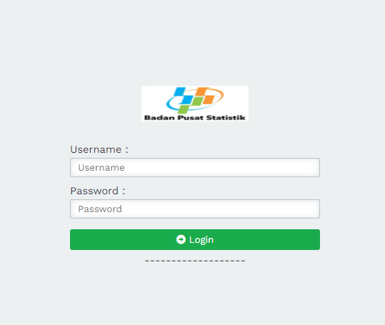

**Figure 5.1 *Login Page View***

**Main Page View**

The main page is a page that will be given specifically for admins. The main page contains the *Dashboard* menu, assessment types, alternative data, criteria, weights, assessments, results, and *logouts.* Here is what the main menu page looks like.

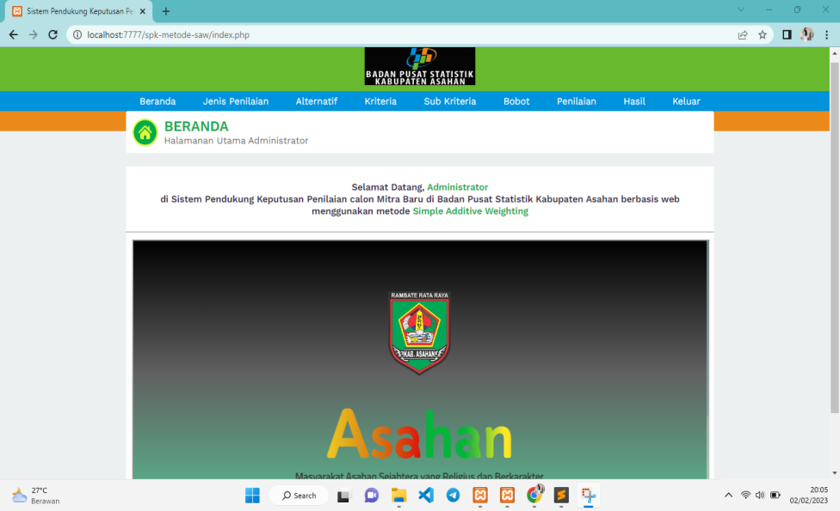

**Figure 5.2 Main Page View**

**Assessment Type Data Page View**

The assessment type data display page is a page that displays data data of the assessment type selected to be inputted by the admin in the page displaying data this type of assessment is available features to save assessment type data, change assessment type data, delete assessment type data and one table that aims to display assessment type data in the system. Here is what the assessment type data page looks like:

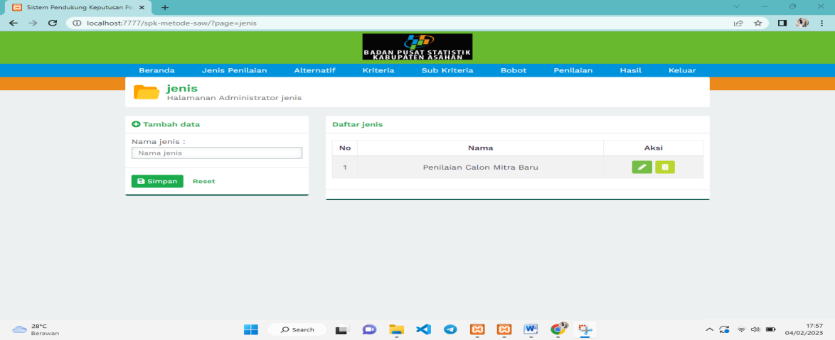

**Figure 5.3 Assessment Type Data Page View**

**Alternate Data Page View**

The alternative data display page is a page that displays alternative data entered by the admin in the alternative data display page, there are features to add alternative data, change alternative data, delete alternative data and one table that aims to display alternative data on the system. Here is what the alternative data page looks like:

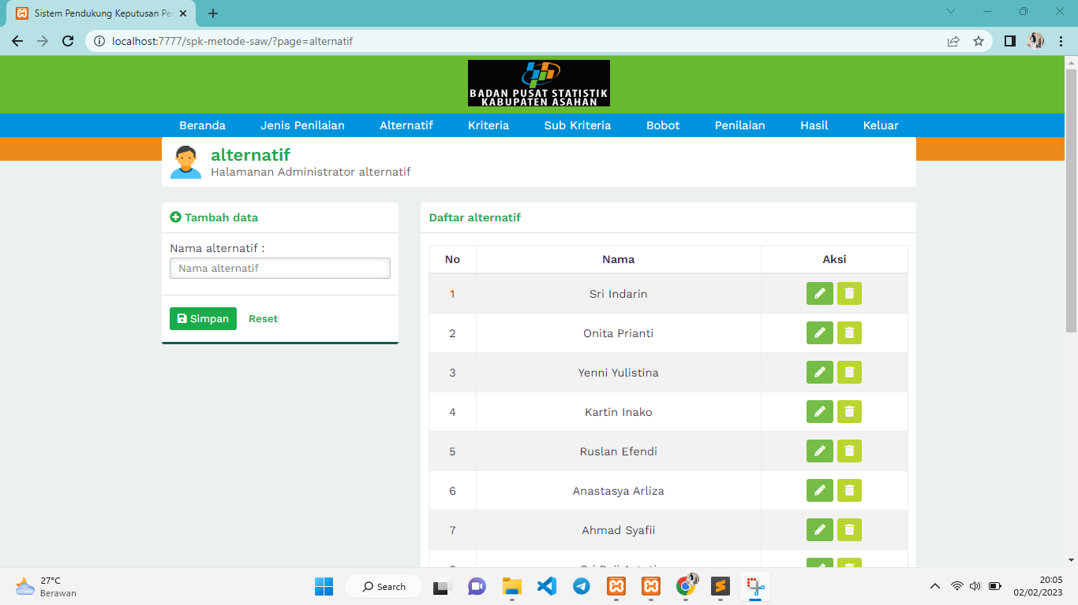

**Figure 5.4 Alternate Data Page View**

**Criteria Value Page View**

The page displaying criteria values is a page that displays sub data data from criteria inputted by the admin in the page displaying the value of these criteria available features to add value data, change value data, delete criteria value data and one table that aims to display the data of criteria values in the system. Here's what the criteria values page looks like:

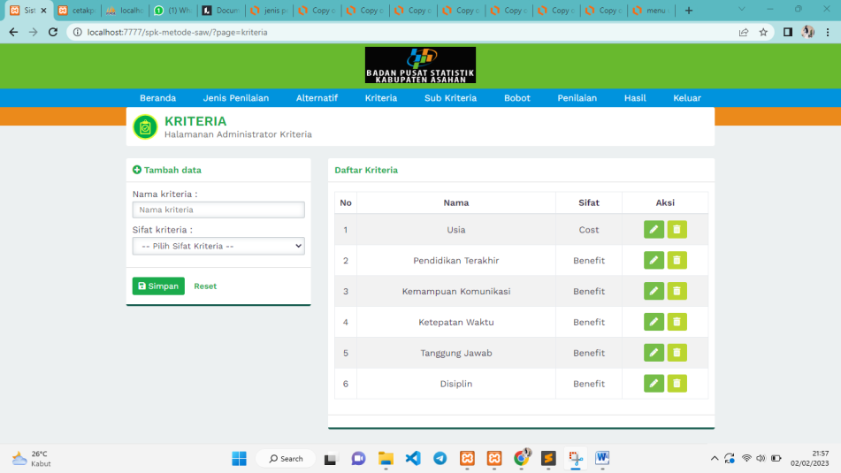

**Figure 5.5 Criteria Value Page View**

**Sub Criteria Values page view**

The page displaying sub-criteria values is a page that displays data data from sub-criteria inputted by the admin in the page displaying sub-criteria values this is available features to add value data, change value data, delete sub-criteria value data and one table that aims to display sub-criteria value data in the system. Here's what the sub-criteria values page looks like:

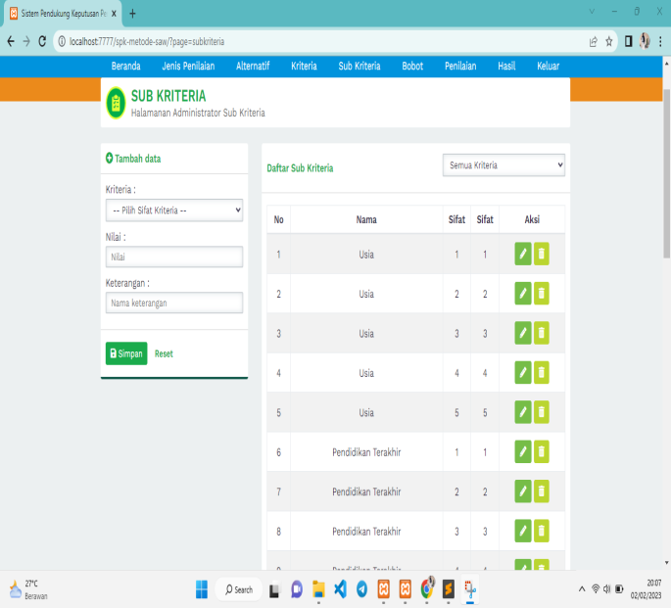

**Figure 5.6 Sub Criteria Values Page View**

**Weight Value pageview**

The page displaying weight values is a page that displays data data from weight values inputted by admins in the page displaying weight values this is available features to add weight data, change weight data, delete weight data and one table that aims to display weight value data in the system. Here's what the weight value page looks like:

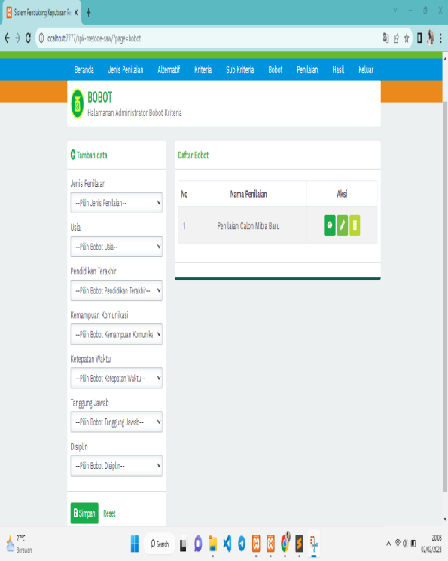

**Figure 5.7** **Weight Value Page View**

**Assessment Page View**

The assessment display page is a page that displays data from the assessor entered by the admin in the assessment display page this feature is available features to add assessment data, change assessment data, delete assessment data and one table that aims to display assessment value data in the system. Here's what the scoring values page looks like:

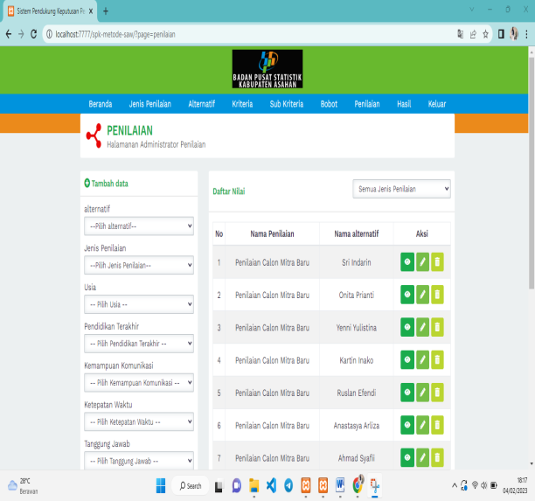

**Figure 5.8 Grading Page View**

**Calculation Process Page View**

The ga n perhitun process display page is a page that displays all data from criteria data, alternative data and criteria value data whose purpose is to be calculated using the *Simple Addictive Weighting (SAW)* method so that it will get the results of these calculations which will be used as a reference in decision making by the Central Statistics Agency. Here's what the calculation process page looks like:

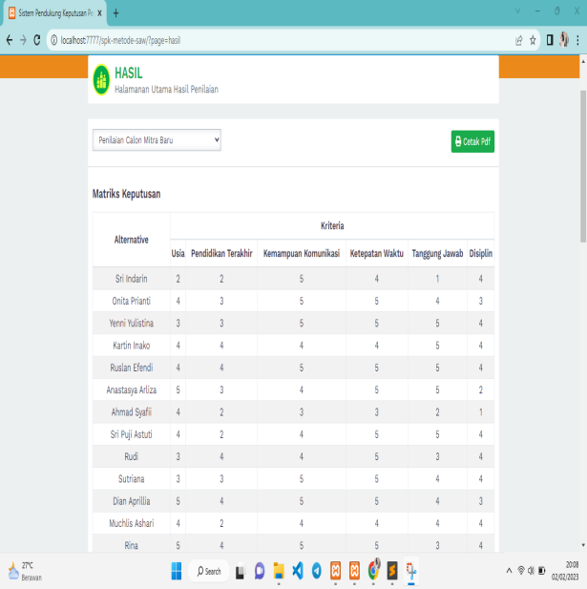

**Figure 5.9 Calculation Process Page View**

**Report Print Page View**

A report print page is a page that displays data on the results of the report in *pdf format* which aims to be able to print the results or*download* the results of these calculations. Here's what the report prints look like:

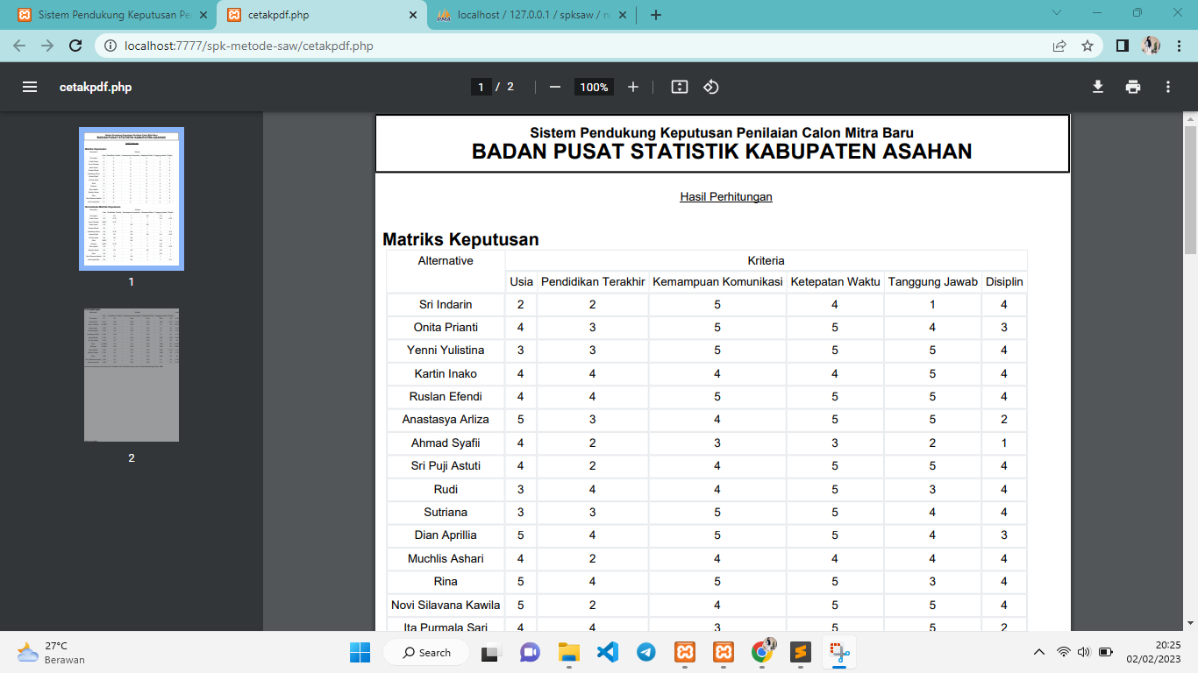

**Figure 5.10 Print Page View of the Report**

**CONCLUSION**

The system is built with a PHP programming language that can analyze alternative data and criteria so that it is processed by the system and produces automatic rankings that are useful as a reference for the Central Statistics Agency in making decisions on the assessment of new potential partners.

With the criteria and alternative data obtained, it can be analyzed using the *Simple Addictive Weigthing (SAW)* method so that it can be a reference to the Central Statistics Agency in the assessment of potential new partners of the Asahan Regency Statistics Agency.

The results of the analysis on the system obtained a decision of 1-10 the best alternative rankings are Ruslan efendi with a value of 0.975 and Yenni Yulistina with a value of 0.951 based on these results can help the Central Statistics Agency in determining the assessment of potential new partners so that it can provide a reference in decision making.

**BIBLIOGRAPHY**

[1] B. Bondy, U. Klages, F. Müller-Spahn, and C. Hock, "Cytosolic free [Ca2+] in mononuclear blood cells from demented patients and healthy controls," Eur. Arch. *Psychiatry Clin. Neurosci*., vol. 243, no. 5, pp. 224–228, 1994, doi: 10.1007/BF02191578.

[2] M. Mulyadi, F. Hesriva, and A. Amirullah, "Application of the Topsis and SAW Model in the Acceptance of New Partners in BPS Lhokseumawe City," *Sisfo J. Ilm. Sist. Inf*., vol. 6, no. 1, pp. 1–11, 2022, doi: 10.29103/sisfo.v6i1.7950.

[3] Desriani, "Chapter I ْ ُ با حض خ ِ ي," *Galang Tanjung*, no. 2504, pp. 1–9, 2021.

[4] K. Erwansyah, "Decision Support System Determines New Data Entry Partners at the Central Statistics Agency of Medan City Using the MOORA (Multi Objective Optimization On The Basis Of Ratio Analysis) Method," *J. SAINTIKOM (Journal of Ancient Sciences. Inform. and Computers)*, vol. 18, no. 1, p. 35, 2019, doi: 10.53513/jis.v18i1.101.

[5] Suparyanto and Rosad (2015, "済無No Title No Title No Title," *Suparyanto and Rosad (2015*, vol. 5, no. 3, pp. 248–253, 2020.

[6] S. Melindah, F. Taufik, U. Fatimah, and S. Sitorus, "Decision Support System for Determining Nusantara Tourism Partners at the Central Statistics Agency of Deli Serdang Regency Using the Additive Ratio Assessment Method," 2020.

[7] Putu Adi Wiryawan, I Gede Suardika, and I. K. P. Suniantara, "Application of the Simple Additive Weighting Method to the Decision Support System for Accepting Debtors of Cooperative Members," *SATIN - Science and Technology. Inf*., vol. 6, no. 2, pp. 12–23, 2020, doi: 10.33372/stn.v6i2.655.

[8] A. Wicaksana, "済無No Title No Title No Title," *Https://Medium.Com/*, pp. 6–19, 2016, [Online]. Available: https://medium.com/@arifwicaksanaa/pengertian-use-case-a7e576e1b6bf

[9] M. A. Manullang and H. Fahmi, "Decision Support System for Granting Motorcycle Loans to PT Adira Finance Medan Using the SAW Method," vol. 4, no. 2, pp. 143–148, 2021.

[10] M. B. Sholeh and D. R. R. Prehanto, “Penilaian Kinerja Karyawan Badan Pusat Statistik Menggunakan Metode Simple Additive Weighting (SAW),” *J. Emerg. Inf. …*, vol. 02, no. 01, pp. 1–7, 2021, [Online]. Available: https://ejournal.unesa.ac.id/index.php/JEISBI/article/view/37651%0Ahttps://ejournal.unesa.ac.id/index.php/JEISBI/article/download/37651/33334

[11] H. D. Prasetyo *et al.*, “Sistem Pemilihan Keputusan memilih Handphone Dengan Menggunakan Metode Simple Addictive Weighting Berbasis Web,” *J. Infra Petra*, pp. 1–5, 2018.

[12] P. H. Ikhtiarini, B. Nurlitasari, and H. A. Hanifa, “Sistem Pendukung Keputusan Penilaian Kinerja Dan Pemilihan Mitra Badan Pusat Statistik (BPS) Kabupaten Gunungkidul …,” *Semin. Nas. Teknol. Inf. dan Multimed.*, pp. 127–132, 2017, [Online]. Available: https://www.ojs.amikom.ac.id/index.php/semnasteknomedia/article/view/1676

[https://ssl.microsofttranslator.com/static/27828690/img/tooltip_logo.gif](http://www.bing.com/translator)https://ssl.microsofttranslator.com/static/27828690/img/tooltip_close.gif

**Original**

PENERAPAN TEKNIK SAW UNTUK PENILIAN CALON MITRA BARU BADAN PUSAT STATISTIK KABUPATEN ASAHAN PENERAPAN PENERAPAN