COMPARISON OF SGD, ADADELTA, ADAM OPTIMIZATION IN GENDER CLASSIFICATION USING CNN

Sartika Mandasari^{1*}, Desi Irfan¹, Wanayumini², Rika Rosnelly³
^{1,2,3}Faculty of Engineering and Computer Science, Computer Science Study Program, Main Potential University, Medan, Indonesia
email: *sartikamandasari12@gmail.com

Abstract: Gender classification is one of the most important video analysis tasks. It would be advantageous if a computer system or machine could correctly classify a person's gender. For example, a mall's CCTV camera system can be useful for knowing the gender of a customer to make the right strategy, or a sales robot can use a precise and intelligent approach to communicate with customers based on their gender. In this paper, a machine learning-based approach is presented to identify male and female facial images with a data set of 2000 images taken from kaggle. The Gradient Descent optimization method is often used for training Artificial Neural Networks (ANN). This method plays a role in finding the weight value that gives the best output value. The working principle of the Gradient Descent method is to reduce the Loss value by changing the parameter values step by step. The better the performance of the optimization method, the better the accuracy and processing time provided by the Artificial Neural Network. Three optimization methods have been implemented, namely Stochastic Gradient Descent (SGD), ADADELTA, and Adam on the Neural Network system for classifying arrhythmia data. This study uses the most appropriate learning rate from each optimization method as training termination criteria. The results showed that the Artificial Neural Network with Adam optimization produced the highest accuracy compared to the SGD and ADADELTA optimization methods. The Deep Learning technique which is extensively applied to image recognition uses the Adam optimizer method. The model we trained using the Adam optimization function achieved 91% accuracy on our tests, demonstrating the feasibility of our approach.
Keywords: Artificial Neural Networks; Gender; SGM; Adadelta; Adam

Abstrak: Klasifikasi gender adalah salah satu tugas analisis video yang paling penting. Akan menguntungkan jika sistem komputer atau mesin dapat mengklasifikasikan jenis kelamin seseorang dengan benar. Misalnya, sistem kamera CCTV mal dapat bermanfaat untuk mengetahui jenis kelamin pelanggan untuk membuat strategi yang tepat, atau robot penjual dapat menggunakan pendekatan yang tepat dan cerdas untuk berkomunikasi dengan pelanggan berdasarkan jenis kelamin mereka. Dalam makalah ini, pendekatan berbasis machine learning disajikan untuk mengidentifikasi gambar wajah male dan female dengan kumpulan data sebanyak 2000 gambar yang diambil dari kaggle. Metode optimasi Gradient Descent sering digunakan untuk pelatihan Jaringan Syaraf Tiruan (JST). Metode ini berperan dalam menemukan nilai bobot yang memberikan nilai keluaran terbaik. Prinsip kerja metode Gradient Descent adalah memperkecil nilai Loss dengan mengubah nilai parameter selangkah demi selangkah. Semakin baik kinerja metode optimasi maka akurasi dan waktu proses yang diberikan oleh Jaringan Syaraf Tiruan akan semakin baik pula. Telah diimplementasikan tiga buah metode optimasi yaitu Stochastic Gradient Descent (SGD), ADADELTA, dan Adam pada sistem Jaringan Saraf Tiruan untuk klasifikasi data aritmia. Penelitian ini menggunakan learning rate yang paling sesuai dari masing-masing metode optimasi sebagai kriteria pemberhentian pelatihan. Hasil penelitian menunjukkan Jaringan Saraf Tiruan dengan optimasi Adam menghasilkan akurasi tertinggi dibandingkan dengan dengan metode optimasi SGD dan ADADELTA. Teknik Deep Learning yang diterapkan secara ekstensif pada pengenalan gambar yang digunakan memanfaatkan metode optimizer Adam. Model yang dilatih menggunakan fungsi optimisasi Adam mencapai akurasi 91 % pada tes yang lakukan, menunjukkan kelayakan pada pendekatan yang dilakukan.

Kata kunci: Jaringan Syaraf Tiruan; Gender; SGM; Adadelta; Adam

INTRODUCTION
The Live streaming application has attracted many users, which makes it possible to share videos of daily life with others. This act of sharing constantly generates a large number of real-world videos and most of these videos take precedence over capturing human faces, so facial analysis in videos is becoming increasingly important in real-life applications for video content inspection and recommendation [1]. Classifying facial images in terms of biometric traits, such as gender, age, or ethnicity, has received a lot of attention in the Computer vision literature recently, especially in the context of video surveillance. Gender classification is one of the most important tasks of video analysis. It would be advantageous if a computer system or machine could correctly classify a person's gender [2]. For example, a mall buyer's surveillance camera system can be useful for knowing the customer's gender to create the right strategy, or a seller robot can use the right and intelligent approach to communicate with customers based on their gender.
Much of the work on gender classification is based on facial features and has proposed several valuable models, in which neural networks, supporting vector machines, and methods of increasing advertising are the most representative [3]. Moghaddam and Yang compared different gender classification methods on the FERET face database and showed that vector engine support has better recognition performance than other classifiers (such as nearest neighbor classifier, linear classifier) [4]. Deep Convolutional Neural Network (CNNs Trained on imagenet dataset) transfer learning works well in identifying male and female gender images and this is also inseparable from the optimization function. In computer vison, CNN has been known as a powerful visual model as well as producing an accurate hierarchy of segmentation features. The model has also been known to make predictions relatively faster than other algorithms while maintaining competitive performance at the same time [5].
The Gradient Descent optimization method is often used for Artificial Neural Network (JST) training. This method plays a role in finding the weight value that gives the best output value. The working principle of the Gradient Descent method is to reduce the Loss value by changing the parameter value step by step. Three optimization methods have been implemented, namely Stochastic Gradient Descent (SGD), ADADELTA, and Adam in the Artificial Neural Network system for the classification of arrhythmia data [6].

METHOD
2.1 Stages of Research
At this stage of the study, a classification system for male and female sex in the wild was designed to determine accuracy using digital image processing methods [7]. As figure 1 shows the block diagram of the system designed in this study.

Pengumpulan
Data
Preprosesing
Training
Testing

Image 1. System Diagram Blocks in General
In general, the system diagram block systematics shown in Figure 1 is:
1. Collection of Face imagery
2. The facial image is preprocessed with stages of resizing and data augmentation.
3. Training is a cit-ra learning process with the CNN method to obtain a training image model that will be stored in the database.
4. The test was performed with mod-el classified test imagery data from the trainer image using the CNN method to obtain the results and accuracy of the system.
2.2 Deep Learning
Deep Learning or often referred to as Deep Learning or often known as Deep Structured Learning or Hierarchical Learning is one of the branches of machine learning that consists of high-level abstraction modeling algorithms on data using a set of non-linear transformation functions that are arranged in layers in depth [8]. Learning is divided into supervised, semi-supervised or unsupervised. The model in Deep Learning is basically built on artificial neural networks, whose research has been going on since the 80s but has recently risen again with the existence of faster computers, especially coupled with the ability of modern graphics cards that are able to perform matrix-based calculations simultaneously [9]. Based on recent research, deep learning is able to recognize graphics, handwritten patterns and several other patterns more accurately compared to other machine learning algorithms. Deep learning is a learning method carried out by machines by imitating how the basic systems of the human brain work [10]. The basic system of the human brain working these is called neural networks To be able to achieve that ability, deep learning uses layered algorithmic structures. That is why deep learning is called using artificial neural networks (ANN) which in other words uses 'artificial neural networks'. Deep learning is a technology used in image recognition and computer vision [11].
2.3 CNN
In Deep Learning, convolutional neural networks (CNN or ConvNet) are a class of deep neural networks, generally applied to analyzing visual images[12]. CNN uses a multilayer perceptron variation designed for minimal pre-processing [13]. The model is also known as space invariant artificial neural networks (SIANN), based on the shared weight architecture and translational invariant characteristics.
2.4 Optimizer Functions
Function opitmalization is an algorithm that modifies neural network attributes, such as learning weight and speed. Thus the automation function can help reduce overall loss and improve accuracy [14].

2.5 Learning Transfer
The learning transfer section is a research problem in machine learning that focuses on storing the knowledge gained to solve one problem and applying it to different problems but still has a problem, for example, the knowledge gained while learning to recognize a car can be applied when trying to recognize a truck. This field of research has some historical relationship of the psychology literature on the transfer of learning, although the formal bond between the two fields is limited [15].
2.6 Kaggle
Kaggle is a site for sharing ideas, getting inspired, competing with other data scientists, learning new information and coding tricks, as well as seeing examples of real-world data science applications. There are many data sets that can be used for anything as simple as video game sales, to something more complex and important like air pollution data. This data is real and referenced, so you can train and test your model on projects that can ultimately help others. There are many other useful features of Kaggle such as data, code, community, inspiration, competitions, and courses [16].
RESULTS AND DISCUSSION
In this section we describe the proposed solution as a selected Convolutional Network (ConvNet) Architecture and discuss related design options, evaluation methods and implementation aspects.
3.1 Data Set
The data set provided by Kaggle has 5000 train data and 1500 test data. All images vary in size by 96 dpi. However, this study used a modification in the number and size because it avoided the process of running data that was too long to become 800 data trains and 400 test data with a size of 64 x 64 pixels. A sample of male images can be seen in Figure 2 and a female sample can be seen in figure 3, as well as the distribution of data in figure 4 [17].


Image 2. Sample Images of males



Image 2. Sample Female Image
Image 3. Data Spread
3.2 Evaluation
Competition is a binary classification problem with the area under the ROC curve between the predicted probability and the observed target as an evaluation matrix, because we want the output to be as close as possible to the actual probability, so we use data augmentation i.e. transform before the image is processed. In addition, researchers used the NLL function (loss with Logsoftmax) as the last layer activation function.
3.3 Validation Methods
To evaluate the model, researchers must optimize the dataset for the right optimizer between the adadelta, SGD, Nadam optimizer methods and Adam's method. In this experiment, researchers used one of the optimization functions, namely Nadam. The researcher observed a fairly good accuracy of 89.5% with a loss of 0.21 shown in figure 4, and the researcher concluded that the optimization method using Nadam was not suitable for this dataset, and we decided to use Adam's optimization method as a substitute.
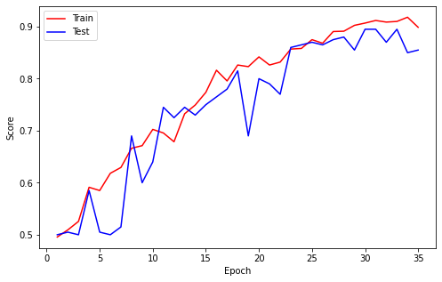

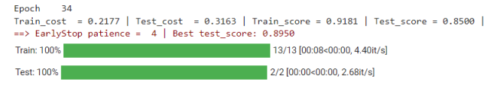

Image 4. Plot and Accuracy Results Using Nadam Optimizer
3.4 Preliminary Observations
To have a basis that can be used as a comparison of how well the expected model is doing reasonably, the researchers used pre-trained VGG-19 with the following table 1:

Table 1. Pre-Trained VGG19
No | Layer | Output Shape
1 | Batch Size | 128
2 | Crop size | 64
3 | Input Layer | 3 x 64 x 64
4 | nn.model | 64 x 4 x 4
5 | Global Average pooling 2d layer | 3, 8, 3, 1, 1
6 | Dropout | 10 %

In all the experiments that the researchers have done, the only changes made are to change the model layer and modify the image size on the input.
3.5 Learning Transfer
Because the dataset is relatively small, researchers had to use learning transfer with a set of models using an experiment-focused CNN model using multiple optimized functions [17]. There are some general steps to take, the first step is to make a size modification to the image before it is used as input, this is necessary to avoid too long a process. In this case, the researcher uses the following sequence:
- Global Average Pooling2D layer with sigmoid at convolution.
- Dropout layer.
- And the last layer is a Fully Connected Layer with an output size of 1 (for binary classification) and an activation function (softmax).
3.6 Data Augmentation
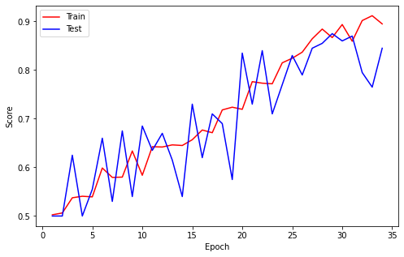
To maximize some training examples and improve model accuracy, researchers augmented the data through a number of random transformations that the data augmentation technique chose was: random rotation (150), resize crop scale = (80%) random horizontal flip. Furthermore it is expected that data augmentation should also avoid overfitting, as well as the ability to improve in model generalizations [18]. Researchers have experimented with several optimizer models from python libraries, namely Adam, Adadelta, Nadam and SGD on CNN models with reported results. In all the experiments that researchers have conducted, several different accuracy results have been obtained.
a. Adam
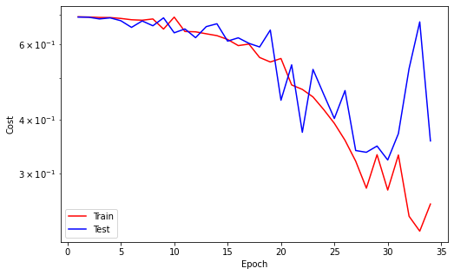
Adam Is a replacement optimization algorithm for stochastic gradient descent for training deep learning models. Adam combines the best properties of the AdaGrad and RMSProp algorithms to provide an optimization algorithm that can handle sparse gradients on noisy problems. In this optimization model, researchers get an accuracy mode of 91.5% with a loss of up to 0.1% with the best learning rate of 1.0 according to figure 5.
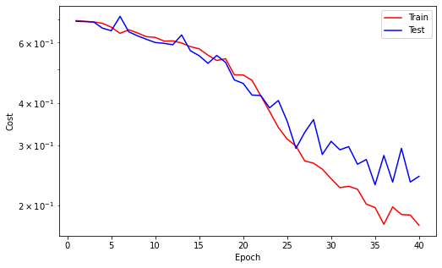
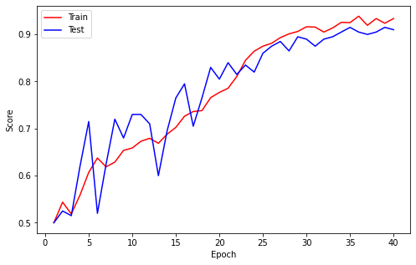
Image 5. Adam's Plot Cost and Score Results

b. Adadelta
Adadelta Is a stochastic gradient lowering method that is based on adaptive learning rates per dimension to overcome. In the second model we get an accuracy of 0.90%, as seen in the following figure 6.
Image 6. Adadelta Plot Cost and Score Results
- Stochastic Gradient Descent (SGD)
Stochastic Gradient Descent (SGD) Is the solution to solve the issue of GD. SGD will update the weight without waiting for 1 epoch to finish. SGD uses a concept similar to batching by dividing the train data into batches [19]. The weight will be updated in each completed batch. In this optimizer method, we get an accuracy of 63% with a still high loss of 0.6 with the best learning rate of 0.01. This is no better than the two previous optimizer models, corresponding in figure 7.
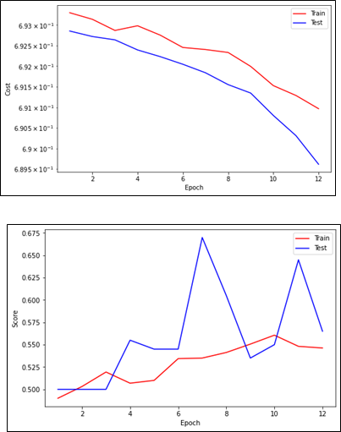
Image 7. Adadelta Plot Cost and Score Results
- Data Visualization
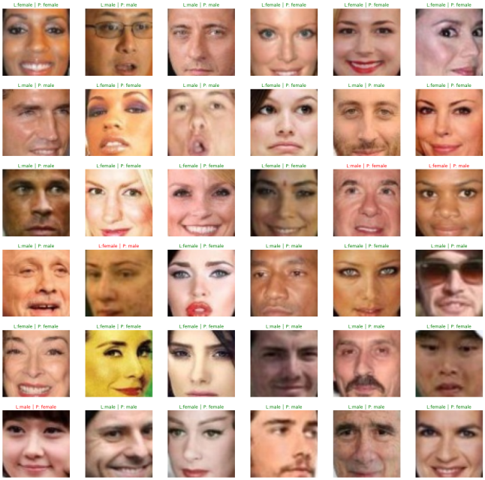
To see how the model works and what exactly is learned, we chose to visualize intermediate activations consisting of the results of map features ejected by various convolution and unification layers in the network, given a specific optimizer input (the output of a layer is often called activation, the output of the activation function). Output the original image prediction data with predictions as shown in Figure 8, the model learned how to identify male and female genders using Adam's optimizer, especially on the face [20].
Image 8. Image Prediction
From figure 8 there are 36 predicted data and produced 32 correct predictions (green writing) and 4 wrong predictions (red writing). From the data, you can find the MSE with a confusion matrix, especially precision manually with the formula:
Precision = TP/(TP+FP) = 36/(36+4) = 36/40 = 0,9 setara 90%.
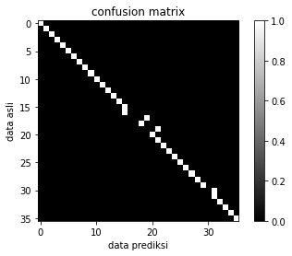
The 36 predicted data can also be visualized as shown in figure 9 below:
Image 8. Matrix Confusion Visualization
Table 2 shows the results of experiments that have been carried out using adam, adadelta, and SGD models in classifying gender.
Table 2. Experimental Results Adam
Model | Tes
Adam  Epoch 31  Train_cost = 0.1945 | Test_cost = 0.2569 | Train_score = 0.9269 | Test_score = 0.9100 |  ==> EarlyStop patience = 5 | Best test_score: 0.9100  ==> Execute Early Stopping at epoch: 31 | | Best test_score: 0.9100

Table 2. Experimental Results Adadelta, SGM
Model | Tes
Adadelta  Epoch 42  Train_cost = 0.1908 | Test_cost = 0.4294 | Train_score = 0.9219 | Test_score = 0.7900 |  ==> EarlyStop patience = 5 | Best test_score: 0.9050  ==> Execute Early Stopping at epoch: 42 | | Best test_score: 0.9050
SGD  Epoch 17  Train_cost = 0.6926 | Test_cost = 0.6925 | Train_score = 0.5425 | Test_score = 0.5950 |  ==> EarlyStop patience = 5 | Best test_score: 0.6350  ==> Execute Early Stopping at epoch:17 | Best test_score: 0.6350

CONCLUSION
Based on the application of the method that has been carried out, to better identify gender accurately, with an accuracy of 91.5% for the best model, namely Adam Optimization. There were 36 predicted data and produced 32 correct predictions and 4 false predictions. The application of this method can provide solutions in helping gender classification quickly, and more reliably [21]. In the future, researchers suggest comparing Adam's method with the latest optimization function to see the reliability of the optimization method above.
DAFTAR PUSTAKA

[1] J. Ho et al., “Imagen Video: High Definition Video Generation with Diffusion Models,” pp. 1–18, 2022, [Online]. Available: http://arxiv.org/abs/2210.02303
[2] F. D. Adinata and J. Arifin, “Klasifikasi Jenis Kelamin Wajah Bermasker Menggunakan Algoritma Supervised Learning,” J. Media Inform. Budidarma, vol. 6, no. 1, p. 229, 2022, doi: 10.30865/mib.v6i1.3377.
[3] A. M. Rizki, G. E. Yuliastuti, E. Y. Puspaningrum, and A. Lina, “KLASIFIKASI JENIS KELAMIN BERDASARKAN CIRI FISIK,” vol. XVII, pp. 1–5, 2022.
[4] C. Neural, N. Cnn, R. Firdaus, and J. Satria, “Jurnal Computer Science and Information Technology ( CoSciTech ) Klasifikasi Jenis Kelamin Berdasarkan Gambar Mata Dengan Menggunakan Algoritma,” vol. 3, no. 3, pp. 267–273, 2022.
[5] Y. Dong, Q. Liu, B. Du, and L. Zhang, “Weighted Feature Fusion of Convolutional Neural Network and Graph Attention Network for Hyperspectral Image Classification,” IEEE Trans. Image Process., vol. 31, no. January, pp. 1559–1572, 2022, doi: 10.1109/TIP.2022.3144017.
[6] D. Irfan, R. Rosnelly, M. Wahyuni, J. T. Samudra, and A. Rangga, “Perbandingan Optimasi Sgd, Adadelta, Dan Adam Dalam Klasifikasi Hydrangea Menggunakan Cnn,” J. Sci. Soc. Res., vol. 5, no. 2, p. 244, 2022, doi: 10.54314/jssr.v5i2.789.
[7] D. Frenza and R. Mukhaiyar, “Aplikasi Pengenalan Wajah Menggunakan Metode Adaptive Resonance Theory ( ART ),” Multidicsiplinary Res. Dev., vol. 3, no. 1, pp. 35–42, 2021, [Online]. Available: https://doi.org/10.31933/rrj.v3i3.392
[8] M. Ula, A. Faridhatul Ulva, M. Abdullah Ali, Y. Rilasmi Said, and S. Informasi, “Application of Machine Learning in Determining the Classification of Children’S Nutrition With Decision Tree,” J. Tek. Inform., vol. 3, no. 5, pp. 1457–1465, 2022, [Online]. Available: https://doi.org/10.20884/1.jutif.2022.3.5.599
[9] S. W. P. Listio, “Performance of Deep Learning Inception Model and MobileNet Model on Gender Prediction Through Eye Image,” Sinkron, vol. 7, no. 4, pp. 2593–2601, 2022, doi: 10.33395/sinkron.v7i4.11887.
[10] B. Hardiansyah and A. Primasetya, “Sistem Deteksi Penggunaan masker ( Face Mask Detection ) Menggunakan Algoritma Deep Learning YOLOv4,” vol. 2, pp. 313–318, 2023.
[11] S. H. Abdullah, R. Magdalena, and R. Y. N. Fu’adah, “Klasifikasi Diabetic Retinopathy Berbasis Pengolahan Citra Fundus Dan Deep Learning,” J. Electr. Syst. Control Eng., vol. 5, no. 2, pp. 84–90, 2022, doi: 10.31289/jesce.v5i2.5659.
[12] Bimrew Sendekie Belay, “No Titleהכי קשה לראות את מה שבאמת לנגד העינים,” הארץ, vol. 7, no. 8.5.2017, pp. 2003–2005, 2022.
[13] HAMDANI MUBAROK, “Menggunakan Algoritma Convolutional Neural Network (CNN),” Skripsi, vol. 4, no. 2, pp. 89–96, 2019.
[14] D. Hardiyanto and D. Anggun Sartika, “Optimalisasi Metode Deteksi Wajah berbasis Pengolahan Citra untuk Aplikasi Identifikasi Wajah pada Presensi Digital,” Setrum Sist. Kendali-Tenaga-elektronika-telekomunikasi-komputer, vol. 7, no. 1, p. 107, 2018, doi: 10.36055/setrum.v7i1.3367.
[15] F. Mignacco and P. Urbani, “The effective noise of stochastic gradient descent,” J. Stat. Mech. Theory Exp., vol. 2022, no. 8, pp. 1–15, 2022, doi: 10.1088/1742-5468/ac841d.
[16] Y. Kong, X. Ma, and C. Wen, “A New Method of Deep Convolutional Neural Network Image Classification Based on Knowledge Transfer in Small Label Sample Environment,” Sensors, vol. 22, no. 3, 2022, doi: 10.3390/s22030898.
[17] R. Rosnelly, L. Wahyuni, and E. Aditya, “Pelatihan Pengenalan Teknik Pengolahan Citra Digital Pada Bidang Medis Training Introduction to Digital Image Processing Techniques In The Medical Field,” JUDIMAS J. Inov. Pengabdi. Kpd. Masy., vol. 3, no. 1, pp. 11–19, 2022, [Online]. Available: https://stmikpontianak.ac.id/ojs/index.php/judimas/article/view/1282
[18] K. C. Leowis, J. Raharjo, N. Ibrahim, U. Telkom, F. Detecion, and P. C. Analysis, “Rancang Bangun Sistem Pengenalan Wajah Diarea Publik Berbasis Video Menggunakan Metode Principal Component Analysis ( Pca ) Dan Viola Jones Design of the Public Face Recognition System Based on Video Using Principal Component Analysis ( Pca ) and Viola Jo,” vol. 8, no. 5, pp. 5448–5464, 2021.
[19] F. Tangguh and Y. Islami, “Analisis performa algoritma Stochastic Gradient Descent ( SGD ) dalam mengklasifikasi tahu berformalin,” Indones. J. Data Sci., vol. 3, no. 1, pp. 1–8, 2022.
[20] M. Milano, G. Agapito, and M. Cannataro, “Application of CCTV Methodology to Analyze COVID-19 Evolution in Italy,” BioTech, vol. 11, no. 3, pp. 1–22, 2022, doi: 10.3390/biotech11030033.
[21] Z. Lou, W. Zhu, and W. B. Wu, “Beyond Sub-Gaussian Noises: Sharp Concentration Analysis for Stochastic Gradient Descent,” J. Mach. Learn. Res., vol. 23, pp. 1–22, 2022.

