OPERATIONAL RISK ANALYSIS FOR MAN POWER (DRIVER) ON POSTAL NETWORK

Maniah^{1*}, Erna², Dini Hamidin³
¹Prodi D3 Manajemen Informatika, Politeknik Pos Indonesia, Bandung, Indonesia 40151
²Prodi D4 Logistik Bisnis, Politeknik Pos Indonesia, Bandung, Indonesia 40151
³Prodi D3 Teknik Informatika, Politeknik Pos Indonesia, Bandung, Indonesia 40151
email: maniah@ulbi.ac.id¹, ernamulyati@ulbi.ac.id²,dinihamidin@ulbi.ac.id³

Abstract: PT. Pos Logistik Indonesia has cooperation in the field of Postal Networks, namely cooperation in sending goods or shipments at a certain time, a certain amount from one point to another in accordance with an order from the partner. The components of the Postal network include: Man Power, Vehicles, Postal Operational Control, and Operational Costs. This study aims to examine the problems and root causes that cause potential risk events in 4 (four) Postal Network components and find out how high the risk impact is. The research method used in this study is a qualitative method by conducting case studies. Data was collected by means of interviews/FGDs, and distributing questionnaires. The results show that the Man Power (Driver) component has the highest risk value compared to other Postal network components (Vehicles, Postal Operational Control, or Operational Costs). Identified 11 (eleven) potential risks in the Postal network of PT. Pos Logistik Indonesia, namely Man Power (driver) - RA1 (8%), RA2 (11%), Vehicle - RB1 (7%), RB2 (7%), Postal Operational Control - RC1 (11%), RC2 (11 %), RC3 (9%), RC4 (7%), and Operating Costs - RD1 (9%), RD2 (11%), RD3 (9%). The results of the study will provide recommendations for the Postal Network component that has the highest risk potential (Man Power – Driver) in the form of risk mitigation and can be used by the company in managing its operational risk.
Keywords: Postal Network; ManPower (Drivers); Operational risk; Potential risk.

Abstrak: PT. Pos Logistik Indonesia memiliki kerjasama dalam bidang Jaringan Postal, yaitu kerjasama dalam mengirimkan barang atau kiriman pada waktu tertentu, jumlah tertentu dari satu titik ke titik lain sesuai dengan surat perintah dari mitra. Komponen pada jaringan Postal meliputi: Man Power, Kendaraan, Pengendalian Operasional Postal, dan Biaya Operasional. Penelitian ini bertujuan untuk mengkaji permasalahan dan akar masalah yang menimbulkan potensi kejadian risiko pada 4(empat) komponen Jaringan Postal dan mengetahui seberapa tinggi dampak risikonya. Metode penelitian yang digunakan dalam penelitian ini adalah metode kualitatif dengan melakukan studi kasus. Pengumpulan data dilakukan dengan cara wawancara/FGD, dan penyebaran kuesioner. Hasil penelitian meunjukan bahwa komponen Man Power (Driver) memiliki nilai risiko tertinggi dibandingkan dengan komponen jaringan Postal lainya (Kendaraan, Pengendalian Operasional Postal, atau Biaya Operasional). Teridentifikasi 11(sebelas) potensi risiko pada jaringan Postal PT. Pos Logistik Indonesia, yaitu Man Power (driver) - R_{A1} (8%), R_{A2} (11%), Kendaran - R_{B1} (7%), R_{B2} (7%), Pengendalian Operasional Postal - R_{C1} (11%), R_{C2} (11%), R_{C3} (9%), R_{C4} (7%), dan Biaya Operasional - R_{D1} (9%), R_{D2} (11%), R_{D3} (9%). Hasil penelitian akan memberikan rekomendasi terhadap komponen Jaringan Postal yang memiliki potensi risiko tertinggi (Man Power – Driver) berupa mitigasi risiko dan dapat digunakan perusahaan dalam pengelolaan risiko operasionalnya.

Kata kunci: Jaringan Postal; Man Power (Driver); Risiko operasional; Potensi risiko.

INTRODUCTION

The era of the very fast industrial revolution 4.0 with its digital technology breakthroughs has forced almost every industry to be able to adapt to make changes in business processes, including the logistics business. Several logistics operational activities have undergone a transformation with the presence of the 4.0 industrial revolution, such as changes to the production system, transportation, delivery of goods to the payment system. One of them is the development of the transportation system owned by PT. Pos Logistik Indonesia is to develop a Postal system by conducting Postal cooperation, namely cooperation in sending goods or shipments at a certain time, a certain amount from one point to another in accordance with an order from a partner. PT. Pos Logistik Indonesia implements its logistics distribution system using the Postal Network system which consists of a primary network (transport/vehicle movement between provinces), a secondary network (transportation/vehicle movement between cities/districts within one province/region), and a tertiary network (transport movement/ vehicles between sub-districts in one district). In running this Postal network business, PT. Pos Logistik Indonesia must meet the requirements of industry 4.0 in a sustainable manner in terms of utilizing the right technology and increasing vertical and horizontal integration among supply chain partners [1]. In an effort to adapt to changes in the 4.0 industrial revolution era, of course the industrial world will experience challenges, opportunities, impacts, and risks. This is because risk is an integral part of a business activity [2]. Risk monitoring can be used as a tool for continuous monitoring that involves identifying, analyzing, planning and tracking new risks, monitoring trigger conditions for contingency plans, and monitoring residual risks, as well as reviewing the implementation of risk responses while evaluating their effectiveness. [3]. Risk is an integral part of all business activities, and can be a possibility of unwanted incidents and their consequences on certain assets, while the level of risk is the possible level or value of the risk that arises [4].
PT. Pos Logistik Indonesia manages the Postal network business by implementing 4 (four) main components, including: Man Power, Vehicles, Postal Operational Control, and Operational Costs. The man power component focuses on managing drivers with limitations: drivers are outsourced, the recruitment system is carried out by the Branch Office. The current condition is that drivers do not have a clear job desk, driver skills are not standardized, there is no recruitment standard, so this can result in drivers not having loyalty and integrity. This will certainly have an impact on the operational risk of the Postal network business owned by PT. Logistics Post, including drivers who lack discipline, drivers are less responsible, drivers commit fraud or theft, driver abilities are not standardized, there is a possibility of nepotism in recruitment, drivers become apathetic and have no enthusiasm to make improvements in improving their performance. Based on the above problems, PT. Pos Logistik Indonesia considers it necessary to implement risk management and carry out risk analysis on the Postal network business, especially operational risk analysis on the Man Power component (driver) by taking into account the root causes and causes and observing several potential risks and causes of risk. So it is hoped that the results of this study will provide recommendations to the company's management in the form of recommendations that are interpreted as risk mitigation efforts for PT. Pos Logistik Indonesia.

RELATED LITERATURE

Market instability, potential losses suffered by the company and the emergence of crime in the transportation sector, all of these can pose a large potential risk for the logistics industry, so that the impact of this risk can be minimized, the company must implement risk management in the logistics sector [5]. Risk management can be interpreted as the steps taken starting from identifying, analyzing, assessing, controlling, avoiding, minimizing, or even eliminating risks that are likely to arise. [6]. There are 4 components in the risk management process, namely: Risk Framing, Risk Assessment, Risk Response, Risk Monitoring [7]. In detail the risk management process can be shown in Image 1.

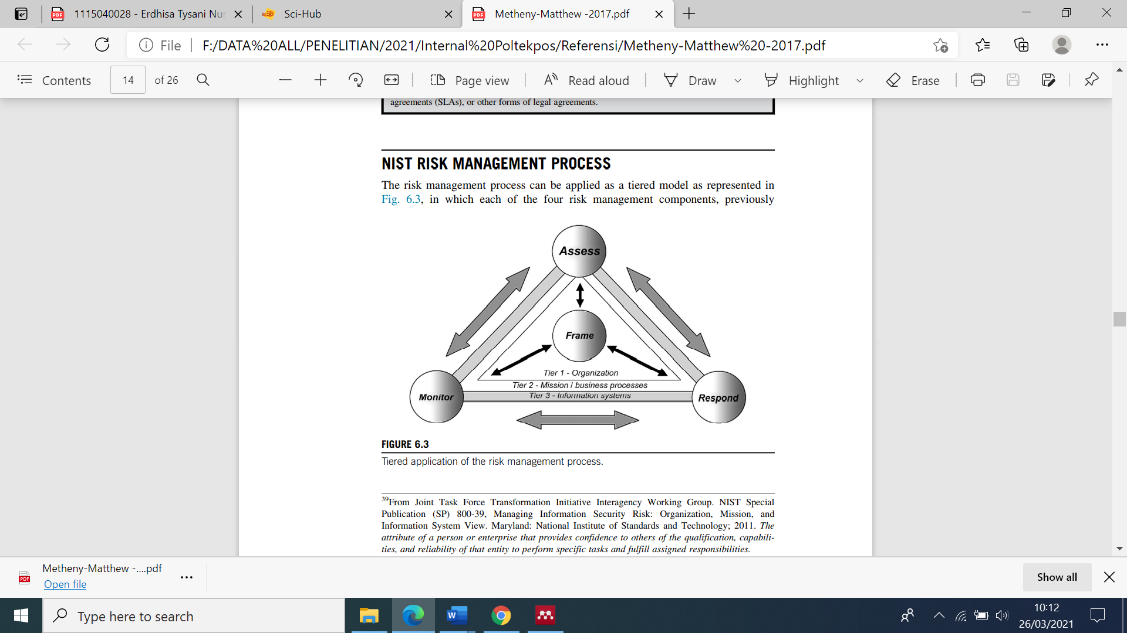
Image 1. Risk Management Process [7]

Risk framing establishes a general strategy that produces guidelines or guidelines on how the organization manages risk. In the Risk Assessment there are 2 (two) main activities that must be carried out, namely: identifying threats and vulnerabilities and preventing risks. The risk response stage includes several activities, namely: identifying actions, evaluating alternative courses of action, and selecting and implementing actions. Risk monitoring provides a means to verify compliance, determine the ongoing effectiveness of risk response actions and identify risks that impact changes to the organization and operating environment driven by the monitoring strategy.

Tabel 1. Risk Monitoring [7]
Activity | Input | Output
- Risk monitoring strategy  - Risk monitoring | - Risk framing  - Risk assessment  - Risk response | - Verify risk response implementation actions;  - Determine the effectiveness of ongoing response actions;  - Identify changes in information systems and the environment.

Risk is an integral part of all business activities. Risk is the possibility of an unwanted incident and its consequences for certain assets, while the level of risk is the possible level or value of the risk that arises [4] and is an integral part of a business activity [2].
Measures to reduce risk can be grouped into 2 (two) major steps, namely [8]:
- Prevention, this step shows the impacts that are likely to occur so that threats arise, so that by knowing the impacts that will occur we can reduce the risk.
- Minimize the level of loss, in this step first identify the potential loss due to the occurrence of risk, so that as early as possible the potential loss due to risk can be reduced.
Risk analysis is a method to reduce the possibility of risk arising, while information technology (IT) risk analysis is more focused on handling technological attacks or threats that aim to control and maintain an acceptable level of risk [8]. Risk assessment or risk assessment is a step that includes: (1) risk identification, including: identifying assets, threats, existing controls, vulnerabilities, and consequences; (2) risk analysis or risk estimation, including: assessment of consequences, assessment of the likelihood of incidents, and the level of risk determination; (3) risk evaluation [9].
Operational risk is the risk caused by failures in the company's internal systems, failures in the systems or technology used, failures in human resource management or failures caused by external factors of the company [10], [11]. The potential risk due to failures in the company's internal systems can be in the form of inconsistencies in the processes managed internally by the company, for example, inconsistent documentation or incomplete internal reports. The potential risk due to failures in the system or technology used can be in the form of inaccuracies in choosing and applying technology as a tool to support the company's business processes, for example, choosing the wrong computer technology to support the company's business. The potential for risk due to failure in human resource management can be shown from the absence of standards in the implementation of the personnel system. Failures caused by external factors of the company can be seen from the potential risk in the form of events that arise due to threats from outside the company, can be in the form of physical or non-physical threats, or can also be due to natural causes, such as natural disasters, wars or the actions of people. outside the company that is not responsible. This operational risk is very influential in almost all areas of the company's business, this is because it is closely related to the company's business operations. Even this operational risk can pose a significant danger that can result in failure of the company's structural and business process mechanisms [12]. When the business process is running, sometimes humans as actors to run the business process are not fully aware that the running business process series is experiencing problems, even existing problems can pose a big risk or are classified as extreme risks. In risk grouping, there are 3 (three) levels of risk, namely low, medium, and high [13]. The risk value can be obtained from the possibility of the risk arising and the impact of the risk. In order for the risk value to be determined, the probability level value and the risk impact value must be determined first. The probability values and impact values are shown in Table 1, which was used in the previous study by [14].
Several studies that have been carried out previously are research that describes risk management models which include: risk identification, risk analysis/assessment, remedial, risk response planning, educate, monitor, and respond. [6]; further research that aims to integrate risk management through a multitier risk management structure by examining every step of the risk management process at all levels of the organization [7]; The next research is a monitoring program for food safety hazards that is organized based on risk by developing a decision tree to rank chemical substances that may occur in food products [15]; and risk management research related to freight forwarding services, including HR management of business competition in freight forwarding services, delivery errors, damage to goods sent, theft or warehouse fire [16]. In addition, research related to operational risk assessment has been carried out on the offshore transportation system, by using the Hazard Identification (HAZID) technique this research can measure and assess the level of risk during offshore operations using a fuzzy logic model [11]. Research on ship systems is carried out to measure ship operational risks in ship safety, in this study an alternative dataset is used (actual failure scenarios from ships) [17]. Furthermore, there is research on operational risk analysis that concentrates on operational risk for business process management using the COSO framework which aims to assess operational risk by measuring risk factors in each activity, and for the whole process [12]. In submitting risk management reports, there are many methods that were previously available, such as the Risk IT Framework [18], OCTAVE Allegro [19].

METHOD

The research method approach used in this study is a mixture of qualitative and semi-quantitative approaches. Qualitative/descriptive approach, namely a research approach that uses investigative strategies such as narrative, phenomenology, ethnography, grounded theory studies, or case studies [20]. The qualitative approach is exploratory, it can be in the form of a concept or phenomenon that needs to be explored further because only a few studies have been conducted on the concept. While in the semi-quantitative research method, the researcher calculates the value which is then included in the qualitative research variable, but the value obtained is a value that is not absolute. The steps used in this study refer to the steps in qualitative research methods, namely:
- Select and formulate the problem
- Gather relevant materials
- Determine the setting and research subject
- Define strategy and develop instruments
- Collecting data
- Data analysis
To get optimal results and have a valid and generally accepted basis, we present this solution based on references from previous research. While the model in this study uses the Postal Network model [21] that have been applied to the object of this research, as shown in Images 2 and 3 below:
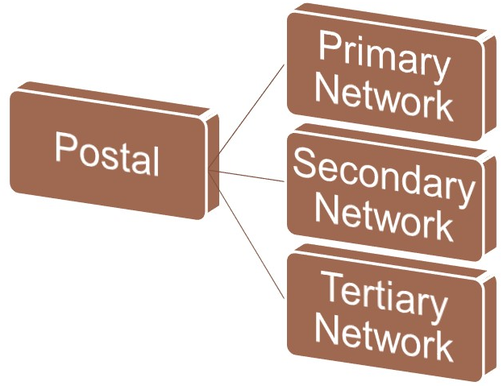
Image 2. Postal Network [21]

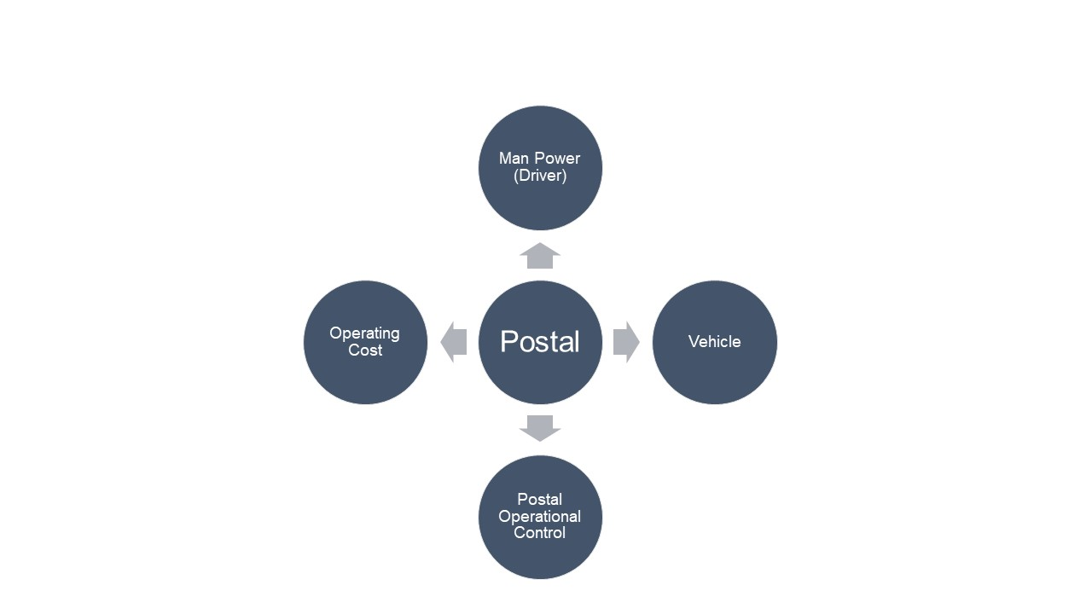

Image 3 Postal Component [21]

Based on Image 2, the Postal network can be divided into 3 (three), namely: Primary Network (Transport/vehicle movement between provinces), Secondary Network (Transportation/vehicle movement between Cities/Regencies within one Province/Regional), and Tertiary Network (Transport movement between sub-districts within one district). Image 3 shows the components of Postal consisting of: Man Power (Driver), Vehicle, Postal Operational Control, and Operational Costs.

RESULT AND DISCUSSION

Based on the results of the analysis on the Postal network that in the Postal network there are 4 (four) Postal components as shown in Figure 2 above which can be identified as follows:
  - Man Power (Driver)
There are several weaknesses of the system applied to the current Man Power (driver), namely:
- Drivers with outsourcing;
- Recruitment is carried out by the Branch Office;
- No recruitment standards yet.
The impact of the weakness in the Man Power system (driver) above, then the problems that arise in the driver are:
- Drivers lack discipline;
- Drivers do not have job descriptions yet;
- The capabilities of the drivers are not standardized;
- Loyalty and integrity of drivers still need to be improved.

- Vehicle
In the vehicle system there are 3 (three) possibilities that can be used, namely:
- Investment, with limitations that include the cost of purchasing KBM, depreciation costs, periodic service fees, vehicle tax costs, driver salaries, and direct operational costs.
- Vehicle rent, through vehicle rental, the costs that are likely to arise are the cost of renting a vehicle, the cost of driver salaries, and direct operational costs.
- Rent all in, the cost that will appear is the rental fee by ritase.

- Postal Operational Control
In Postal operational control there are several provisions that must be applied, namely:
  - Meet the arrival and departure schedule of ssd transportation determined by the company;
  - Provide Drivers;
  - Provide vehicles suitable for use;
  - Provide a replacement vehicle if there is a problem/strike.

- Operational Cost
Costs that can appear on vehicle operations are fuel costs, toll fees, and daily cash costs.

Based on the 4 (four) main components in the Postal network, it can then be analyzed that the risk value on the Postal network needs to use the risk register. Based on the results of the risk register that is carried out regularly, we can monitor improvements to existing processes so that we can reduce the occurrence of risks in the process [22]. Table 2 shows the results of the analysis of the risk value of the Postal network components that have the potential risk.

Table 2. Potentially Risky Postal Components
NO | POTENTIAL RISK EVENTS | CAUSES OF RISK | PROBABILITY POSSIBLE RISK | IMPACT RISK
A | Man Power (Driver)
1 | Driver recruitment is done by Branch Office | There is no standardized policy for the driver recruitment process | Often occur | Very high
2 | Drivers lack discipline, do not have a job desk, skills are not standardized, lack of loyalty and integrity | There is no standardization regarding drivers | Almost Definitely Happening | Very high
B | Vehicle
1 | Increase in vehicle costs, including: motor vehicle purchase costs, depreciation costs, periodic service fees, vehicle tax costs, driver salaries, direct operating costs | The company is still using the investment method for the vehicles used | Often occur | Tinggi
2 |  | Companies sometimes still use the rental method for the vehicles used | Often occur | Tinggi
C | Postal Operational Control
1 | Postal Operational Control, in the form of vehicles suitable for use, providing replacement vehicles if there are problems/strikes. | Drivers do not have the ability to overcome vehicle obstacles | Almost Definitely Happening | Very high
2 |  | Job desk driver has not been specifically stated in the contract document | Almost Definitely Happening | Very high
3 |  | There is no call center that can monitor the vehicle while it is operating | Often occur | Very high
4 | Drivers carry out operational activities only to the extent of their abilities and according to Poslog orders | There is no clear mechanism / SOP for driver operational activities | Often occur | Tinggi
D | Operational Cost
1 | The costs incurred for vehicle operations include: fuel costs, toll fees, daily cash costs. | There is no control and monitoring of operating expenses | Often occur | Very high
2 | There are limitations in the procurement of driver vendors (agents) and vehicle vendors | The authority to procure driver vendors and vehicle vendors is at the center | Almost Definitely Happening | Very high
3 | There is no reward system for drivers that applies to all branch offices | The mechanism for the reward system has not yet been determined | Often occur | Very high

Based on Table 1 above, it can then be calculated the risk score of each component of the Postal network with the known probability of risk occurrence, so that the risk score is obtained as followst:

Table 3 Risk Level of Postal Network Components [23]
No | Potential Risk | Probability |  | Impact |  | Score
1 | R_{A1} | Often occur | 4 | Very high | 5 | 20
2 | R_{A2} | Almost Definitely Happening | 5 | Very high | 5 | 25
3 | R_{B1} | Often occur | 4 | High | 4 | 16
4 | R_{B2} | Often occur | 4 | High | 4 | 16
5 | R_{C1} | Almost Definitely Happening | 5 | Very high | 5 | 25
6 | R_{C2} | Almost Definitely Happening | 5 | Very high | 5 | 25
7 | R_{C3} | Often occur | 4 | Very high | 5 | 20
8 | R_{C4} | Often occur | 4 | High | 4 | 16
9 | R_{D1} | Often occur | 4 | Very high | 5 | 20
10 | R_{D2} | Almost Definitely Happening | 5 | Very high | 5 | 25
11 | R_{D3} | Often occur | 4 | Very high | 5 | 20

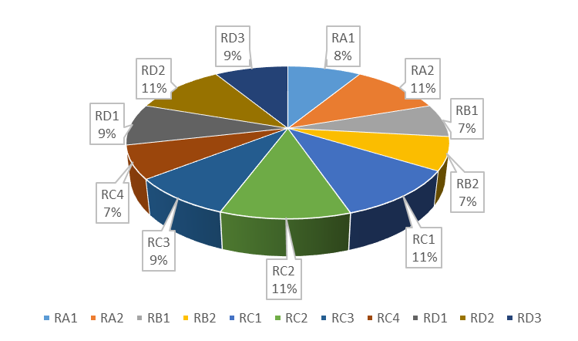
Image 4. Composition of Risk Value on Postal Network

Based on Image 4 above, it can be seen that the highest risk values are in RA2, RC1, RC2, and RD2 which can be summarized as follows:

Table 4 Highest Potential Risk on Postal Network
Risk | Potential Risk
R_{A2} | There is no standardization regarding drivers
R_{C1} | Drivers do not have the ability to overcome vehicle obstacles
R_{C2} | Job desk driver has not been specifically stated in the contract document
R_{D2} | The authority to procure driver vendors and vehicle vendors is at the center

Based on the calculation of the risk value on the Postal network, it was found that the Man Power (Driver) component has the highest risk value compared to the Vehicle component, Postal Operational Control and Operational Costs. Therefore, the company will then conduct a special risk analysis on the Man Power component (Driver) to determine the potential for more specific risk events from the root causes that arise in the Man Power component (driver) which aims to explore the extent of the loyalty and integrity problems of Man Power. (drivers) [24] can lead to potential risks. There are 3 (three) factors that affect loyalty, namely compensation, career development, and work environment that can be used as the root cause of the problem. Man Power (driver) does not have loyalty and integrity.
Table 5 below can be shown in detail the relationship of the problems that exist in Man Power (driver), the root of the problem and its causes, as well as potential risk events, causes of risk occurrence, due to risk events, so that the probability of the occurrence of risks and the impact of risks can be identified. is in the Man Power component (driver).

Table 5 Risk Impact on Man Power (Driver)
No. | The cause | Potential Risk Events | Causes of Risk | Consequences of Risk Events | Probability Possibility of Risk | Risk Impact
Problem: The theft of valuables on the Primary Postal transportation route which resulted in billions of rupiah in losses for the company
Root of the Problem: Driver lacks Loyalty and integrity
1 | Compensation not as expected | Driver's employment status as a casual daily employee or a vendor contract providing labor services so that the salary is not up to standard | Drivers lack discipline | The departure time of the vehicle is not on time, so postal shipments become late | Often occur | High
 |  |  |  | The arrival time of the vehicle is not on time, so postal shipments become late | Often occur | High
 |  |  | Drivers are not responsible | Goods received are not in accordance with the manifest (delivery list), the goods are received in damaged condition | Rarely happening | Rarely happening
 |  |  |  | Goods received in less / more condition | Often occur | High
 |  |  |  | Item received in damaged condition | Often occur | High
 |  |  | Driver commits fraud or theft | The company gets a claim for compensation for the loss of partner's property | Often occur | High
 |  |  |  | Company image is bad in the eyes of partners | Often occur | High
 |  |  |  | The company must deal with the law that results in material and immaterial losses | Often occur | High
2 | Work environment | Driver recruitment is carried out by each branch office so there is no standard SOP. | Driver capabilities are not standardized | Drivers do not obey traffic signs | Possible | Currently
 |  |  |  | Reckless drivers on the highway | Possible | Currently
 |  |  |  | The car broke down on the road because it was not checked regularly by the driver | Possible | Currently
 |  |  |  | The car is dirty and not maintained because the driver doesn't want to clean it | Almost Definitely Happening | Very High
 |  |  |  | Driver has an accident on the road | Possible | Low
 |  |  | Possible nepotism in recruitment | Low driver quality | Often occur | High
 |  |  |  | Drivers are always the cause of the problem | Possible | Currently
 |  |  |  | Drivers are hard to stop | Possible | Currently
3 | Career development | No career development for Drivers | Drivers become apathetic and have no enthusiasm to make improvements to improve their performance | Drivers are not excited at work | Often occur | High
 |  |  |  | Drivers become lazy so the quality of work is low | Often occur | High
 |  |  |  | Driver apathetic when there are changes for improvement | Often occur | High

As an effort to reduce operational risk on Man Power (Driver), this study provides several risk mitigation measures. There are 3 (three) forms of risk mitigation strategies that refer to the mitigation approach from OCTAVE Allegro, as shown in Table 6 below:

Table 6 Risk Mitigation [19]
Mitigation Approach | Description
Mitigate | Companies must make strategies to overcome possible threats or minimize the impact of threats
Deffer | Companies must analyze existing risks in more detail and collect additional information to monitor and re-evaluate decisions on assets that have high risk.
Accept | The company does not have to take any action to address the risk

From the causes of the risk in Table 7 above, each risk can be mitigated, as follows:

Table 7. Risk Mitigation on Man Power (Driver)
Causes of Risk | Mitigation Approach | Risk Mitigation
Drivers lack discipline | Deffer | Created Jobdesk, SOPs and clear work contracts with drivers, made a control book for vehicle departure hours, carried out a pick-up test for vehicle departure delays, made a coordination group with partners to monitor vehicle departures, enforced disciplinary penalties and rewards drivers who were always on time.
Drivers are not responsible | Mitigate | Created Jobdesk, SOPs and clear work contracts with drivers, enforced disciplinary penalties and awards for drivers who always obeyed SOPs, carried out periodic employee performance assessments involving internal and external parties of the company.
Driver commits fraud or theft | Mitigate | Standardize the recruitment system, work contracts with drivers include a guarantee (diploma), a statement letter if you commit theft it will be legally processed
Driver capabilities are not standardized | Deffer | Standardize the recruitment system, have written tests and practice driver selection, recruitment is carried out openly, jobdesk is opened, SOPs and work contracts with drivers include a guarantee (diploma), a statement letter if you commit theft it will be legally processed, socialize about Jodesk and SOP, enforce rules, rights and obligations made in writing
Possible nepotism in recruitment | Deffer | Open recruitment system, training and briefing before drivers work
Drivers become apathetic and have no enthusiasm to make improvements to improve their performance | Accept | Create a clear career path based on performance

CONCLUSION

The results of this study conclude:
- There are 11 (eleven) potential risks in the Postal network of PT. Pos Logistik Indonesia, namely Man Power (driver) - RA1, RA2; Vehicles - RB1, RB2, Postal Operational Control - RC1, RC2, RC3, RC4 and Operating Costs - RD1, RD2, RD3. And there are 4 (four) of the 11 (eleven) potential risks that have the highest risk value, namely RA2 (There is no standardization related to drivers), RC1 (Drivers do not have the ability to overcome vehicle problems), RC2 (Job desk drivers have not been listed in detail). specified in the contract document), RD2 The authority to procure driver vendors and vehicle vendors is at the center);

- Based on the results of this study, researchers can submit recommendations to the company as an effort to realize the risk mitigation that has been determined, namely:
  - Making driver recruitment standards;
  - Created a jobdesk driver;
  - Making SOPs;
  - The existence of a very clear employment contract regarding the rights and obligations of drivers;
  - The existence of work rules that include clear rewards and punishments;
  - Create driver work evaluation forms by internal and external parties;
Conduct regular driver training and socialization on work safety and QHSSE.

ACKNOWLEGMENTS

We would like to thank the University of Logistics and International Business (ULBI) campus institution for funding this research.
Especially to the Rector of ULBI, D3 Informatics Management Study Program, D4 Business Logistics, and D3 Informatics Engineering.

BIBLIOGRAPHY

[1] Y. Kayikci, “Sustainability impact of digitization in logistics,” Procedia Manuf., vol. 21, pp. 782–789, 2018, doi: 10.1016/j.promfg.2018.02.184.
[2] M. Nada, B. Youssef, B. Brahim, and R. Boubker, “Survey: Risk assessment models for cloud computing: evaluation criteria,” 2017, vol. 1, pp. 3–7.
[3] D. Gonzales, J. M. Kaplan, E. Saltzman, Z. Winkelman, and D. Woods, “Cloud-Trust-a Security Assessment Model for Infrastructure as a Service (IaaS) Clouds,” IEEE Trans. Cloud Comput., vol. 5, no. 3, pp. 523–536, 2017, doi: 10.1109/TCC.2015.2415794.
[4] K. Djemame, D. Armstrong, J. Guitart, and M. Macias, “A Risk Assessment Framework for Cloud Computing,” IEEE Trans. Cloud Comput., vol. 4, no. 3, pp. 265–278, 2016, doi: 10.1109/TCC.2014.2344653.
[5] A. N. Jonar, “Manajemen Risiko Pada Industri Logistik,” 2019.
[6] D. Gonzalez, “Risk Management Digital Style,” Manag. Online Risk, pp. 1–24, 2015, doi: 10.1016/b978-0-12-420055-5.00001-3.
[7] M. Metheny, “Risk management [6],” Br. Dent. J., no. 6, pp. 185–210, 2017, doi: https://doi.org/10.1016/B978-0-12-809710-6.00006-8.
[8] A. Rot, “Selected Issues of IT Risk Management in the Cloud Computing Model . Theory and Practice,” in Proceedings of The 8th International Multi-Conference on Complexity, Informatics and Cybernetics (IMCIC 2017), 2017, no. Imcic, pp. 89–94, [Online]. Available: http://www.iiis.org/CDs2017/CD2017Spring/AuthorsZ1.htm#/.
[9] S. H. Albakri, B. Shanmugam, G. N. Samy, N. B. Idris, and A. Ahmed, “Security risk assessment framework for cloud computing environments,” Malaysia, 2014. doi: 10.1002/sec.923.
[10] M. F. A. Nazir and M. N. H. Ryandono, “Manajemen Risiko Operasional pada Lembaga Amil Zakat Nasional,” Ekon. Syariah Teor. dan Terap., vol. 6, no. 11, pp. 2236–2251, 2019, [Online]. Available: https://www.neliti.com/publications/315066/manajemen-risiko-operasional-pada-lembaga-amil-zakat-nasional.
[11] N. Abdussamie, A. Zaghwan, M. Daboos, I. Elferjani, and A. Mehanna, “Operational risk assessment of offshore transport barges,” Ocean Eng., vol. 156, no. March, pp. 333–346, 2018, doi: 10.1016/j.oceaneng.2018.03.006.
[12] A. K. Jallow, B. Majeed, K. Vergidis, A. Tiwari, and R. Roy, “Operational risk analysis in business processes,” BT Technol. J., vol. 25, no. 1, pp. 168–177, 2007, doi: 10.1007/s10550-007-0018-4.
[13] S. Islam, S. Fenz, E. Weippl, and H. Mouratidis, “A Risk Management Framework for Cloud Migration Decision Support,” J. Risk Financ. Manag., vol. 10, no. 2, pp. 1–24, 2017, doi: 10.3390/jrfm10020010.
[14] S. Chandel, T. Ni, and G. Yang, “Enterprise Cloud : its Growth & Security Challenges in,” 2018 5th IEEE Int. Conf. Cyber Secur. Cloud Comput. (CSCloud)/2018 4th IEEE Int. Conf. Edge Comput. Scalable Cloud, pp. 144–152, 2018, doi: 10.1109/CSCloud/EdgeCom.2018.00034.
[15] E. D. van Asselt, M. Y. Noordam, M. G. Pikkemaat, and F. O. Dorgelo, “Risk-based monitoring of chemical substances in food: Prioritization by decision trees,” Food Control, vol. 93, no. March, pp. 112–120, 2018, doi: 10.1016/j.foodcont.2018.06.001.
[16] R. Vikaliana, “Faktor-Faktor Risiko Risiko Dalam Perusahaan Jasa Pengiriman,” J. Logistik Indones., vol. 1, no. 1, pp. 68–76, 2017, doi: 10.31334/jli.v1i1.128.
[17] A. Aziz, S. Ahmed, F. Khan, C. Stack, and A. Lind, “Operational risk assessment model for marine vessels,” Reliab. Eng. Syst. Saf., vol. 185, no. January, pp. 348–361, 2019, doi: 10.1016/j.ress.2019.01.002.
[18] U. Fischer et al., The Risk IT Framework Principle-Process Details-Management Guidelines-Maturity Models, 2009 ISACA. USA: CGEIT is a trademark/service mark of ISACA, 2009.
[19] R. A. Caralli, J. F. Stevens, L. R. Young, and W. R. Wilson, “Introducing OCTAVE Allegro : Improving the Information Security Risk Assessment Process,” Qatar, 2007. [Online]. Available: https://resources.sei.cmu.edu/asset_files/TechnicalReport/2007_005_001_14885.pdf.
[20] J. W. Creswell, Research design - Qualitative, Quantitative. and Mixed Methods Approaches - Second Edition. 2014.
[21] Aisah, “Jaringan Postal,” Bandung, 2022.
[22] Maniah, B. Soewito, F. L. Gaol, and E. Abdurachman, “Risk Assessment on Cloud Computing for the Learning System in the Education Environment,” 2019, doi: 10.1109/TALE48000.2019.9225941.
[23] E. Cayirci, A. Garaga, A. S. De Oliveira, and Y. Roudier, “A risk assessment model for selecting cloud service providers,” J. Cloud Comput. Adv. Syst. Appl., pp. 1–12, 2016, doi: 10.1186/s13677-016-0064-x.
[24] U. Qasanah, “Pengaruh Gaya Kepemimpinan Transaksional Dan Loyalitas Kerja Terhadap Kinerja Karyawan,” J. Ilmu dan Ris. …, vol. 8, no. 1, pp. 127–133, 2020, [Online]. Available: e-journals.unmul.ac.id/index.php/psikoneo/article/download/4867/pdf.

