SKIN DISEASE DETECTION EXPERT SYSTEM USING NAIVE BAYES CLASSIFIER METHOD

Cici Santika Putri¹, Muhammad Ardiansyah Sembiring, S.Si, M.Kom²,
Hommy Dorthy Ellyany Sinaga ST.,M.M³
Sistem Informasi, STMIK Royal Kisaran
email: cicisentika500@gmail.com

Abstract: With artificial intelligence, computers can do things that were previously only able to be done by humans, and humans can make computers as decision makers based on how the human brain works in making decisions. One method that can be used is the Naive Bayes Classifier Method. Skin diseases can be caused by fungi, viruses, germs, animal parasites, bacterial infections and others. Identifying skin diseases usually we have to go to a doctor, but we still have problems in handling disease identifiers, it is sometimes influenced by the community, sometimes they feel ashamed to consult their skin diseases to a doctor because signs of skin diseases have started to appear, consultation fees and drugs are quite expensive, Doctor's practice location is far away.
Keywords: Naïve Bayes , Skin Disease, Doctor

Abstrak: Dengan kecerdasan buatan komputer dapat melakukan hal-hal yang sebelumnya hanya dapat dilakukan oleh manusia, dan Manusia dapat menjadikan komputer sebagai pengambil keputusan berdasarkan cara kerja otak manusia dalam mengambil keputusan. Salah satu metode yang dapat digunakan adalah Metode Naive Bayes Classfifier. Penyakit kulit dapat disebabkan oleh jamur, virus, kuman, parasit hewani, infeksi bakteri dan lain-lain. Mengidentifikasi penyakit kulit biasanya kita harus ke dokter, namun masih mengalami kendala dalam menangani pengidentifikasi penyakit hal itu terkadang dipengarui oleh masyarakat terkadang merasa malu untuk mengkonsultasikan penyakit kulitnya ke dokter karena tanda-tanda penyakit kulit sudah mulai tampak, biaya konsultasi dan obat yang tergolong mahal, lokasi praktek dokter jauh.

Kata kunci: Naïve Bayes , Penyakit Kulit, Dokter

Preliminary

Expert systems are software or computer programs that are intended as providers of advice and aids in solving problems in certain areas of knowledge [1]
Along with the development of computer technology today is not used as a substitute for typewriters or ordinary calculation tools
From the above background, the researchers raised the title "Expert System for Detecting Skin Diseases Using the Naive Bayes Classifier Method". It is hoped that the application that is built can help the community in identifying skin diseases online that can be accessed by the public anywhere at any time and can provide the right solution.
Research purposes
The aim of this research is :
1. Build an expert system that can diagnose skin diseases in humans and provide solutions for detected skin diseases.
2. Applying the Naive Bayes Classifier method on the expert system website to diagnose skin diseases.
3. Build a skin disease detection system with the aim of making it easier for patients to detect skin diseases suffered by patients and their solutions.

Method

Naive Bayes Classfifier is a simple classification algorithm in which each attribute is independent and allows to contribute to the final decision. Although the attributes are assumed to be independent, Naive Bayes has proven to be effective and efficient.
After the correctness of the classification results can be measured, a combination of values ​​is calculated to be used as a measurement value (F1-score). F1-score can be calculated by the following formula:
Formula F1-Score
F1-Score = 2X Precision Recall
Precision+ Recall
F1-
Precision+ Recall

Table 1. Naïve Bayes

No | Types Of Diseses | Year | Amount
1 | Impetigo Krustosa (Cacar Madu) | 2017 | 37
2 | Staphylococcal Scalded (Toksin Kulit) | 2017 | 23
3 | Abses Multipel (Kelenjar Keringat) | 2017 | 19
4 | Impetigo Krustosa (Cacar Madu) | 2018 | 25
5 | Staphylococcal Scalded (Toksin Kulit) | 2018 | 28
6 | Pionikia (Pembengkaan Kuku) | 2018 | 54
7 | Hidraadenitis supurativa.(Benjolan Kacang) | 2019 | 56
8 | Staphylococcal Scalded (Toksin Kulit) | 2019 | 35
9 | Pionikia (Pembengkaan Kuku) | 2020 | 34
10 | Impetigo Krustosa (Cacar Madu) | 2021 | 19
11 | Staphylococcal Scalded (Toksin Kulit) | 2021 | 37
12 | Hidraadenitis supurativa.(Benjolan Kacang) | 2022 | 13

System Analysis
System analysis is an activity to identify and evaluate the problems that arise, so as to provide solutions that can be implemented better on the new system as needed. The purpose of the ongoing system analysis is to get an overview of the weaknesses of the system so that improvements can be proposed in developing a better system.

Results and Discussion
This section no longer contains the research design, but focuses on the results of the research that has been carried out.
Build an expert system that can diagnose skin diseases in humans and provide solutions for detected skin diseases.
Applying the Naive Bayes Classifier method on the expert system website t diagnose skin diseases.

Table 2 List Of Skin Diseases
Diseases Id | Name Diseases
P1 | Cacar Madu
P2 | Toksin Kulit
P3 | Kelenjar Keringat
P4 | Cacar Madu
P5 | Pembengkaan Kuku
P6 | Benjolan Pada Kulit
P7 | Pytiriasis Versikolor
P8 | Scabies
Tabel 3 List Of Symptoms Skin Deseases
Diseases Id | Name Symptoms
G1 | Kulit komedo
G2 | Kulit benjolan kecil
G3 | Kulit benjolan kecil bernanah
G4 | Kulit bintik – bintik merah
G5 | Kulit gatal
G6 | Kulit sakit atau nyeri
G7 | Kulit merah
G8 | Kulit bersisik
G9 | Kulit terasa terbakar
G10 | Kulit kering
G11 | Kulit alergi
G12 | Kulit menebal
G13 | Hiperpigmentasi
G14 | Kulit berminyak
G15 | Kulit terkelupas
G16 | Kulit berwarna putih kekuningan
G17 | Kulit bersisik putih keperakan
G18 | Kulit luka
G19 | Kulit terdapat semacam terowongan berwarna putih
G20 | Kulit terdapat tungau
G21 | Kulit bercak lingkaran merah
G22 | Kuku tampak pucat
G23 | Kulit melepuh
G24 | Hipopigmentasi
G25 | Kulit pecah - pecah

Tabel 4 Naïve Bayes Calculayion
Disease (P) | Amount Date |  |  |  | Result
Disease (P) | P | P&G5 | P&G7 | P&G2 | Result
Cacar Madu | 20 | 0 | 20 | 0 | 0
Toksin Kulit | 122 | 115 | 122 | 122 | 0.0913
Kelenjar Keringat | 180 | 65 | 180 | 180 | 0.0516
Cacar Madu | 85 | 0 | 62 | 0 | 0
Pembengkaan Kuku | 94 | 7 | 94 | 0 | 0
Benjolan Pada Kulit | 116 | 116 | 116 | 40 | 0.0318
Pytiriasis Versikolor | 257 | 0 | 257 | 148 | 0
Scabies | 51 | 39 | 51 | 23 | 0.014
Tinea pedis | 92 | 64 | 92 | 0 | 0
Tinea korporis | 196 | 0 | 196 | 0 | 0

Menu Home
This home menu consists of the initial menu of this application system consisting of the home menu of the skin disease diagnosis system
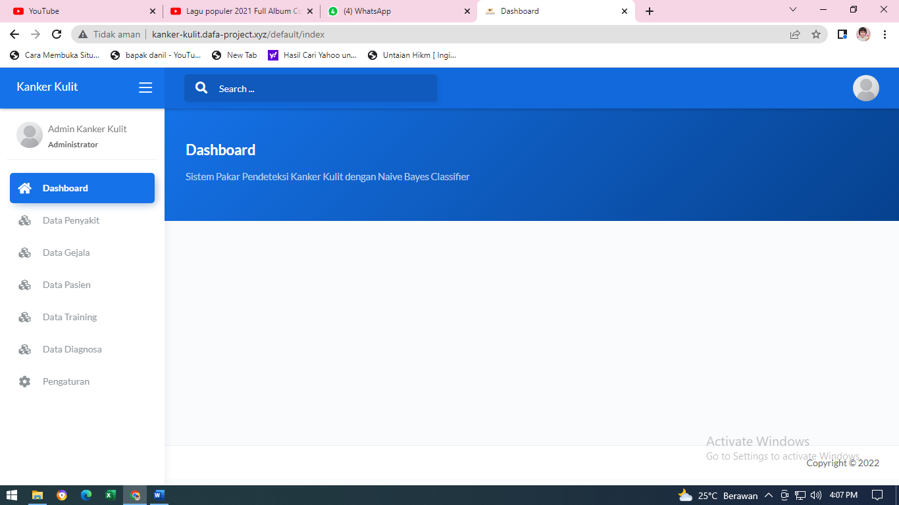
Menu Home

Disease System
The picture below describes the appearance of the skin disease criteria menu in the system that was built

Patient Display
The picture below describes the display of the patient data menu that will be diagnosed with skin diseases using this application later.
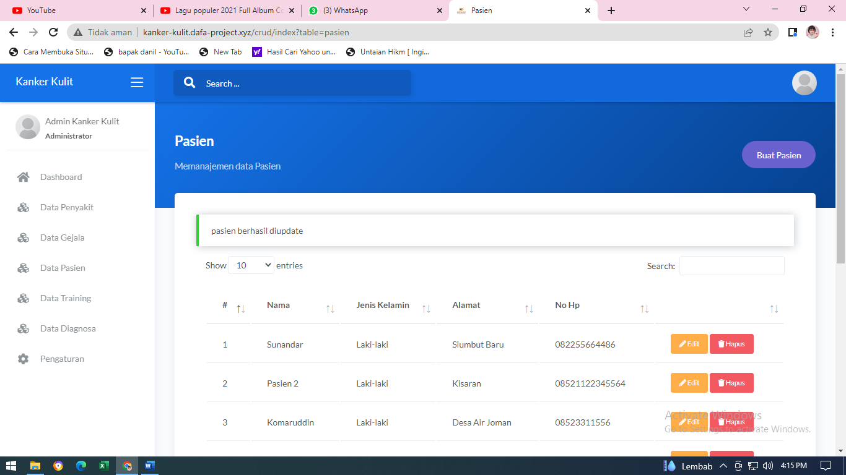

Patient Data Display

Skin Cancer Diagnosis
The picture below describes the appearance of the results of the diagnosis of skin diseases
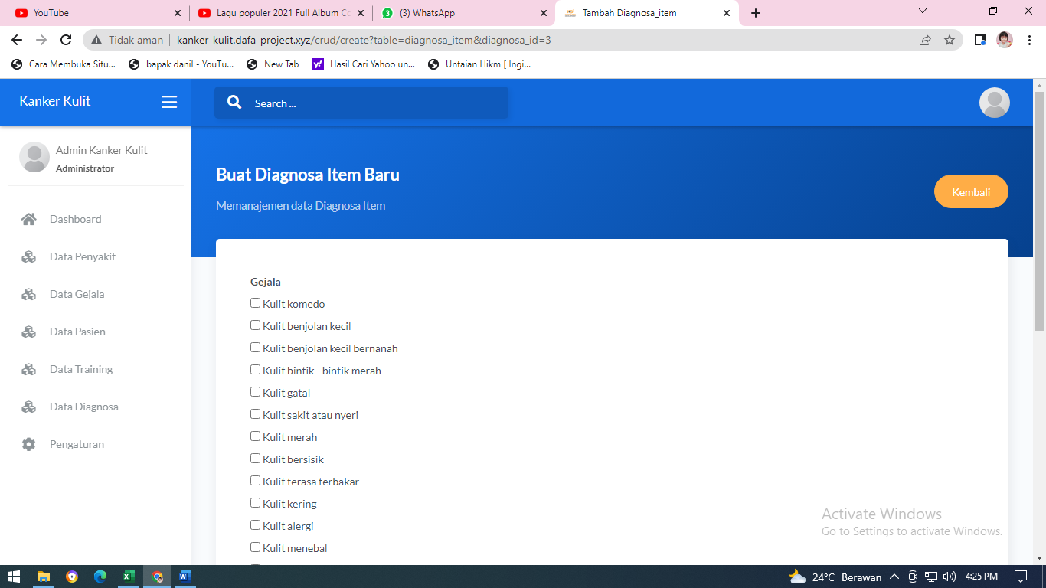

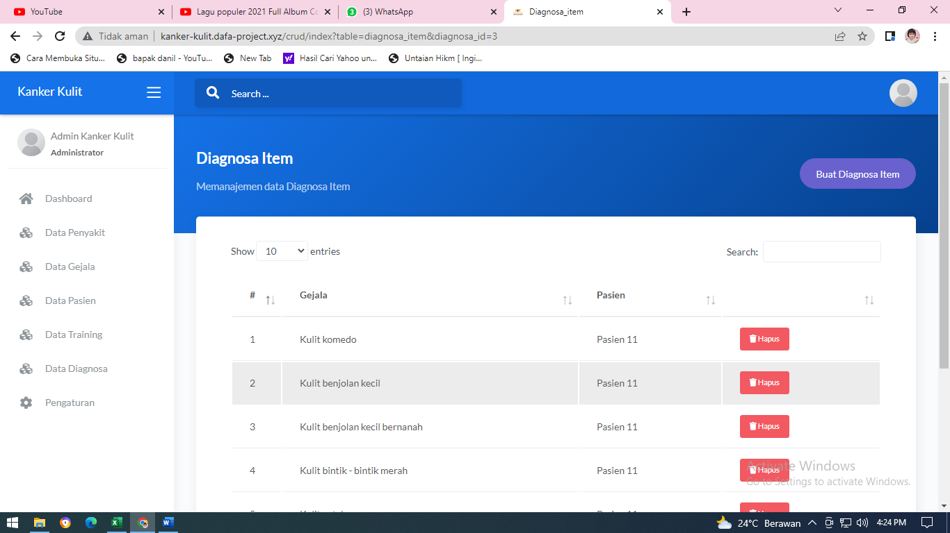
Diagnostic Results Display

Conclusion

This skin cancer diagnosis system can decide the results of the disease diagnosis decisions in detail
The alternative given by the application in displaying decisions in the form of value results and decisions on diagnosing the disease
This system will make it easier for officers to diagnose skin cancer
.

DAFTAR PUSTAKA

[1] R. Y. Hayuningtyas, “Implementasi Metode Triple Exponential Smoothing Untuk Prediksi Penjualan Alat Kesehatan,” vol. 8, no. 1, pp. 29–35, 2020.
[2] I. Simamora, “Metode Trend Non Linear Untuk Forecasting Komposisi Penduduk Kabupaten Tapanuli Tengah Menurut Jenis Kelamin Tahun 2006-2019,” J. Chem. Inf. Model., vol. 2, no. 02, pp. 175–183, 2018.
[3] L. Umsb, “Vol. XII Jilid I No.79 Januari 2018 MENARA Ilmu,” vol. XII, no. 79, pp. 54–60, 2018.
[4] A. Amrullah, E. Affandi, W. Riansyah, and S. Sobirin, “Peramalan Penjualan Bulanan menggunakan metode Trend Moment pada Toko Suamzu Boutique,” J. SAINTIKOM (Jurnal Sains Manaj. Inform. dan Komputer), vol. 19, no. 2, p. 46, 2020, doi: 10.53513/jis.v19i2.2423.
[5] Y. K. Hadi, M. J. Syaputra, and D. Setiawan, “Peramalan Penjualan Obat Generik Melalui Time Series Forecasting Model Pada Perusahaan Farmasi di Tangerang : Studi Kasus,” vol. 1, no. 2, pp. 35–49, 2020.
[6] A. Irmayana and A. Akhriana, “Sistem Prediksi Alat Promosi Pada Unit Consumer Care and Marketing PT . Telkom Regional VII KTI Menggunakan Pendekatan Trend Linear,” pp. 275–280, 2018.

