APPLICATION OF CAI (COMPUTER ASSISTED INSTRUCTION) METHOD
IN TAJWID SCIENCE LEARNING MEDIA APPLICATIONS
MULTIMEDIA BASED

Parini
¹ Sistem Informasi, STMIK Royal Kisaran
Email: parini.royal@gmail.com

Abstract: One component urgent in the learning process is the medium. The position of learning media right now is not only just a tool to help to teach but also is a method for motivating and communicating with students more effectively. The science of tajwid is one part of the branch of Qur’an science that is very important for every Muslim to learn. A teacher tries to develop and advance education, especially at MIS Al-Mahdy. Efficient and students are less active due to the provision of material that is still watching causes students be passive. Therefore, the teaching and learning process applies the CAI method to avoid this. CAI ( Computer Assisted Instruction ) is a learning media through a computer system built as a complement and support learning techniques that can be packaged in an attractive and interactive multimedia form to increase student interest in learning. Therefore, the learning media with the CAI method can be a learning resource that can help achieve the goals of learning Islamic religious education and can also increase students' learning motivation in the teaching and learning process of Islamic religious education, especially the science of tajwid.

Keywords: CAI ( Computer Assisted Instruction ); Application; Instructional Media; Tajwid

Abstract: Salah satu komponen penting dalam proses belajar adalah media. Kedudukan media pembelajaran saat ini tidak hanya sekedar alat bantu untuk mengajar, tetapi juga merupakan cara untuk memotivasi dan berkomunikasi dengan pelajar agar lebih efektif.
Ilmu tajwid merupakan salah satu bagian dari cabang ilmu alquran yang amat penting untuk dipelajari setiap muslim, untuk itu seorang guru berusaha mengembangkan dan memajukan pendidikan khususnya di MIS Al-mahdy permasalahan yang dihadapi khususnya dalam pengajaran quran hadist menganai ilmu tajwid seorang guru tersebut dalam melaksanakan pengajaran kurang efisien dan siswa kurang aktif disebabkan pemberian materi yang masih menonton menyebabkan siswa/i pasif maka dari itu untuk menghindari hal tersebut proses belajar mengajar menerapkan metode CAI. CAI (Computer Assisted Instruction) merupakan media pembelajaran melalui sistem komputer yang dibangun sebagai pelengkap dan pendukung dalam metode pembelajaran yang dapat dikemas dalam bentuk multimedia yang menarik dan interaktif sehingga dapat meningkatkan minat siswa untuk belajar. Oleh karena itu media pembelajaran dengan metode CAI dapat dikatakan sebagai sumber belajar yang dapat membantu mencapai tujuan dari pembelajaran pendidikan agama islam dan juga dapat meningkatkan motivasi belajar siswa dalam proses belajar mengajar pendidikan agama islam khususnya ilmu tajwid.

Keywords: CAI (Computer Assisted Instruction); Aplikasi; Media Pembelajaran; Ilmu Tajwid

INTRODUCTION

Development Technology Information and Communication (ICT) has made a significant contribution _ to field education [1]. Role technology information and communication in learning, apart from helping students in study also have enough role _ take effect, especially for teachers in utilization facility for interest enrich ability teach him [2].
Media learning is a tool, method, and technique used as intermediary communication Between a teacher and student in skeleton more streamline communication and interaction between teacher and student in the educational process of teaching in schools [3].
With very good learning media help students and teachers in the learning process teach so the student is not easily bored in following the learning process teaching. Students more easily understand the material, and the learning process becomes more effective and efficient [4].
Besides could replace part teacher's job as a presenter Theory ( distributor message ) media to have utility for an overcome obstacles in communication, limitations physical in class, attitude passive students as well as unite observation. Because it's a learning medium, could say as a source learn what you can help reach the destination from learning Islamic religious education and could also increase motivation students in the learning process teach Islamic religious education wrong the only one in knowledge tajwid.
Knowledge tajwid is a branch of knowledge to learn how to read the Koran properly and correctly to perfect its meaning [5].
For that, a teacher is trying to develop and advance education. in reality, daily problems faced on institution MIS Al Mahdy education in teaching specifically eye lesson Qur’an HadiS about science t ajwid such a teacher in doing teaching not efficient enough, thing this caused students who are still not active enough in following the learning process teach or method monotonous teacher teaching so that causing passive student.
Because that to avoid student the passive one, the teacher should be more careful in choosing and using media, specifical computer for repeat problem passive student the Becomes active student. Therefore the authors apply using the CAI ( Computer Assisted Instruction ) method.
CAI One method application learning based on frequent computer used, where is development than technology integrated that is communication ( interactive ), audio, video, performance packaged image _ with designation multimedia technology [6].

METH ODE

This research uses the method:

Computer Assisted Instructions (CAI)
Computer Assisted Instructions (CAI) Teaching Help Computer or abbreviated with CAI (Computer Assisted Instruction), is something system teaching and learning using _ equipment computer as a tool help him together _ _ with a knowledge base ( basic knowledge )- her. CAI is the development of information-integrated communication ( interactive ), audio, video, performance packaged image _ with designation multimedia technology [7].
The use of the Computer Assisted Instruction (CAI) method gives Theory in the form of a text course, and the process provides Theory-shaped sound. Interaction Between computer with educator occur individually and _ in the group [8].
Communication Among students with a computer in Computer Assisted Instruction (CAI) includes stages as follows: (1) Computer serve Theory lesson, (2) Students learn Theory, (3) Computer submit questions, (4) Students give a response, (5) Computer check response that, if rated right, computer serve Theory next, but if rated wrong, computer give correct answer _ along with the explanation [9].
The Computer Assisted Instruction (CAI) method is as follows ( Heinich et al., 1993): (a) Explanation (Tutorial), (b) Train and Practice (Drill and Practice), (c) Simulation, (d) Game (Game) and (e) Solving Problem (Problem-Solving).

Design process
Stage planning is made specification by detail about program architecture so that on Step next, no critical decision new, will but no close possibility existence addition, change or omitted. _ After the view is designed _ in the script format, and the Next Step is creating a display on the computer screen and designing a flow chart for knowing the program/relationship between the view developed [3].
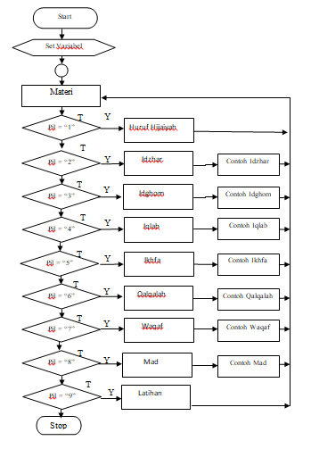
Figure 1. Design process

Implementation
Implementation is procedures that must be conducted to complete the design of existing interface _ in document design interface who have approved, as well test, install, and _ start use from learning media knowledge recitation.
In producing application learning media, this tajweed shared Becomes two processes, namely the process of collecting material/object and process editing using some software.
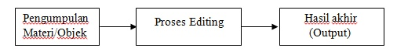
Figure 2. Production Process Application
Material/Object Collection
Material/object main in making application this is Arabic letters. Besides that, making an application also need Images supporter to beautify the app layout. There is also a recording of voice pronunciation letters Arabic and back sound.

Editing Process
In application editing, the manufacturing process necessary elements _ not only conducted in a device soft but conducted with some device soft. For more explanation, the process occurs by merging elements that could be seen in the picture.

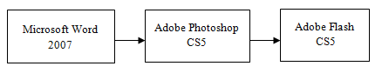
Figure 3. Editing Process

RESULTS AND DISCUSSION

This outlines the method to use or media implementation learning Tajwid multimedia-based to make learning media easy.
Following this appearance, operate application those :

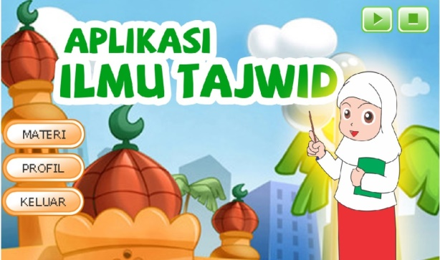
Picture 3. Main Menu
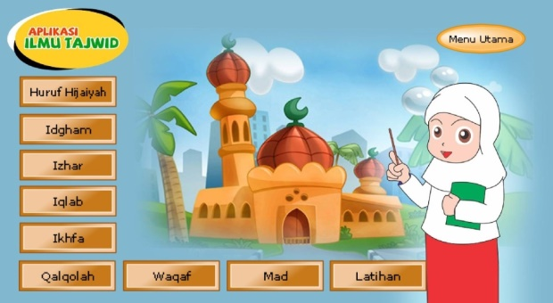
Picture 4. Material Menu
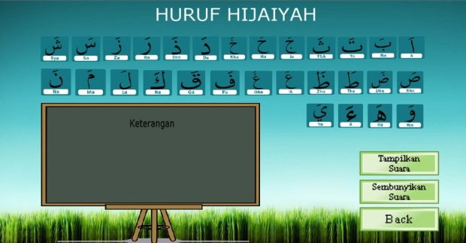
Picture 5. Menu Hijaiyah Letters

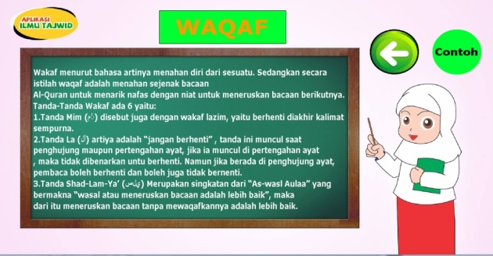
Picture 6. Letters of Waqaf
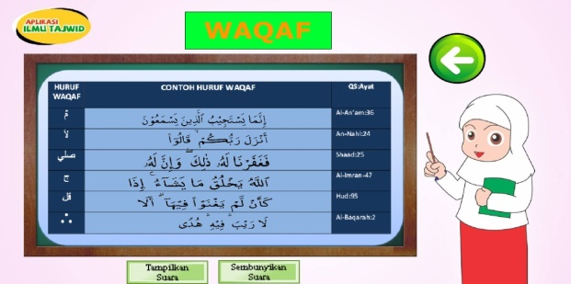
Picture 7. Examples of Waqf Letters

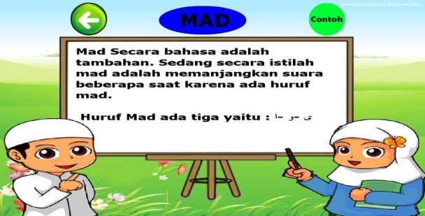
Picture 8. Letter Mad

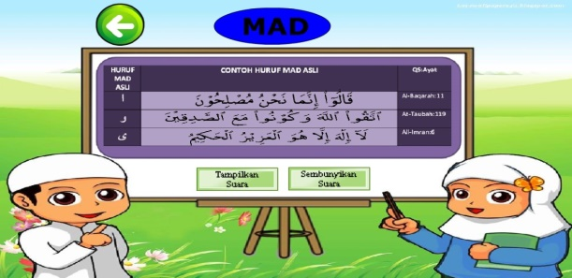
Picture 9. Examples of Mad Letters

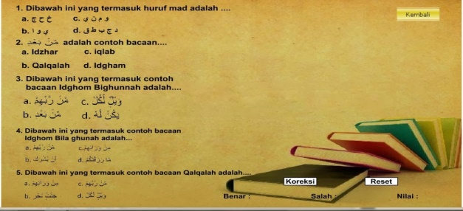
Picture 10. Exercise

CONCLUSION

From the result study and planning learning media Tajweed multimedia -based using Adobe Flash, then Writer could conclude as follows: (1) Design multimedia applications using this flash capable make children interested in study Tajwid compared to using the previous media, (2) With use learning media application this expected could help students can study with good and fast as well as could abbreviate long learning process this be delivered manually _ with a guide book, and (3) With the existence of learning media based on this multimedia then process study teach so more interesting and fun.

BIBLIOGRAPHY
[1] D. Solehat, "Journal of Physics Education, University of Muhammadiyah Makassar Use of Computer Assisted Instruction (CAI) Learning Model Assisted with Physics Learning Research Group (PLRG) Simulator to Improve Concept Mastery of High School Students," vol. 6, no. 30, pp. 279–286.
[2] H. Budiman, "The Influence of the Science-Technology-Society Learning Model in Improving Science and Technology Literacy in Students' Cognitive Style," Al-Tadzkiyyah J. Educator. Islam, vol. 8, pp. 75–83, 2017, [Online]. Available: https://media.neliti.com/media/publications/177430-ID-peran-technology-information-dan-komunikasi.pdf
[3] FL & B. Ramli., "Multimedia Applications for Learning Based on Animated Games Using the Computer Assisted Instruction Method for Physics Subjects," vol. 17, pp. 55–59, 2021.
[4] J. Junaidi, "The Role of Learning Media in the Teaching and Learning Process," Rev. J. Manaj. Educator. and Coach. , vol. 3, no. 1, pp. 45–56, 2019, doi:10.35446/diklatreview.v3i1.349.
[5] V. Mutiawani, "Interactive web-based tajwid learning application,” IJAI, vol. 2, no. 2.
[6] AK Tarigan, SD Nasution, and A. Karim, “Image Learning Applications Using Computer Assisted Instruction (Cai) Methods,” vol. 3, no. 4, pp. 1–4, 2016.
[7] A. Harjanto, D. Suprihanto, and K. Kunci, “Computer Assisted Instruction (Cai) for High School Physics Learning,” J. Inform. Mulawarman, vol. 7, no. 3, pp. 88–93, 2
multimedia-based Computer Assisted Instruction (CAI) Method," Maj. science. Inf. and Technol. science. , vol. XI, no. 1, pp. 78–81, 2016.
[9] A. Harjanto, T. Prahasto, and S. Suhartono, "The Design of Computer Assisted Instruction (CAI) as a Learning Media in High School Physics Subjects," J. Sist. Inf. Business, vol. 1, no. 3, pp. 1–43, 2014, doi:10.21456/vol1iss3pp177-122.

