DESIGNING TAX ME SERVICE APPLICATIONS IN TAX CONSULTING

Joosten^{1*}, Fandi Halim², Jennifer Arianto³, Cindy Yulinda⁴
^{1,2,3,4}Program Studi Sistem Informasi, Universitas Mikroskil
email: joosten.ng@mikroskil.ac.id

Abstract: "Tax Me" is an application that specializes in providing tax consultation services operating through a mobile platform. The problems often faced by the public, especially taxpayers, are the difficulty in choosing a reliable and trustworthy tax consultant because many tax consultants embezzle money and slow down the tax reporting process, as well as the taxpayer's lack of knowledge regarding all tax regulations, the complex and constantly changing taxation system. People's negative perceptions about taxes such as corruption regarding taxes that have been paid by taxpayers. The startup business plan “Tax Me” is here as a forum for tax consulting services in collaboration with the Directorate General of Taxes (DJP) which is able to provide transparent and reliable tax consulting services. “Tax Me” is expected to be able to provide education to taxpayers, overcome taxpayers' concerns regarding the tax calculation and reporting process as well as in choosing a tax consultant they can trust. Apart from that, several features of the “Tax Me” application including NPWP, Tax Calculation, Tax Consultation, Report & Check Annual SPT, E-Billing & Pay Tax, Tax Reminders and Tax Articles.
Keywords: Directorate General of Taxes (DJP); Tax; Tax Me; Taxpayer

Abstrak: “Tax Me” adalah aplikasi yang bergerak pada bidang pelayanan konsultasi pajak yang dijalankan melalui platform mobile. Masalah yang sering dihadapi oleh masyarakat khususnya Wajib Pajak adalah kesulitan dalam memilih konsultan pajak yang dapat diandalkan dan dipercaya karena banyak konsultan pajak yang menggelapkan uang dan memperlambat proses pelaporan pajak, serta kurangnya pengetahuan Wajib Pajak mengenai segala peraturan perpajakan, sistem perpajakan yang rumit dan sering berubah, dan juga masih ada anggapan negatif masyarakat tentang pajak seperti korupsi atas pajak yang telah dibayarkan oleh Wajib Pajak. Perencanaan bisnis startup “Tax Me” hadir sebagai wadah layanan konsultasi perpajakan yang bekerja sama dengan lembaga Direktorat Jenderal Pajak (DJP) yang mampu memberikan layanan konsultasi perpajakan yang transparan dan terpercaya. “Tax Me” diharapkan mampu memberikan edukasi kepada Wajib Pajak, mengatasi kekhawatiran Wajib Pajak terhadap proses perhitungan dan pelaporan pajak juga dalam memilih konsultan pajak yang dapat di percaya. Disamping itu, beberapa fitur dari aplikasi “Tax Me” seperti: NPWP, Hitung Pajak, Konsultasi Pajak, Lapor & Periksa SPT Tahunan, E-Billing & Bayar Pajak, Pengingat Pajak dan Artikel Pajak.

Kata kunci: Direktorat Jenderal Pajak (DJP); Pajak; Tax Me; Wajib Pajak

INTRODUCTION

Taxes are government payments made by individuals and communities that are mandatory, do not receive direct compensation, and are used by the government for the welfare of the people [1]. Taxes are very important to the government because they constitute a large part of government revenue [2].
In 1983, the Directorate General of Taxes (DJP) implemented several tax reforms aimed at improving tax regulations. One of the results of this tax reform is to make it easier for taxpayers to pay and report their taxes online[3], [4]. In 2014, the government launched the official DJP Online website along with the e-Filling service [5]. In 2019 the Director General of Taxes issued a new regulation Number PER-02/PJ/2019 concerning Procedures for Submitting, Receiving and Processing Tax Returns (SPT). Submission of SPT by Taxpayers is now done online via e-filling. This latest regulation is an implementation of the Minister of Finance Regulation (PMK) Number 9/PMK.03/2018 [6]. The Directorate General of Taxes, Ministry of Finance (Kemenkeu) noted that the realization of reporting the 2020 Annual Tax Return (SPT) has increased. The number of Annual Income Tax Returns (SPT) received in 2020 was 14.76 million. This figure is 78% of the number of WP (Taxpayers) who are required to submit SPT, an increase from the previous year which was 73% [7].
However, in reality there are still problems related to tax reporting via e-filling, one of which is the inaccuracy of reporting time via the online system and taxpayers' insufficient knowledge of how to calculate tax. Since tax reform occurred in 1983 in Indonesia, the self-assessment tax collection system began to be implemented. This system is a tax collection system that gives authority, trust and responsibility to taxpayers to calculate, pay and report the amount of tax that must be paid themselves [5]. In fact, what often happens is the taxpayer's lack of knowledge regarding all tax regulations, the tax system is complicated and there are still negative public perceptions about taxes such as corruption regarding taxes that have been paid by taxpayers. Therefore, people are still reluctant to pay taxes because they are afraid that the taxes paid will be misused by unauthorized officials. Taxation knowledge must be possessed by every taxpayer in order to increase taxpayer compliance. Taxpayers also find it difficult to choose a tax consultant who is reliable and trustworthy because many tax consultants actually slow down the tax reporting process by manipulating taxpayer data to gain undue advantage, especially in terms of expenses that are not actually needed or diverting funds to inappropriate purposes. in accordance with tax provisions. This of course makes taxpayers confused about choosing and using reliable tax consultant services. Most taxpayers only know information about tax consultants from their acquaintances, who can sometimes be trusted or not.
Tax consultants are one of the parties who better understand and understand the procedures for implementing tax obligations. Commitment and professionalism of tax consultants is needed to produce service products that can help taxpayers meet their needs effectively and efficiently. However, the problem that tax consultants often face is when collecting the data needed for tax reporting. There are still many taxpayers who do not have complete and accurate financial documentation. This causes tax reporting problems to become complicated due to the lack of awareness and understanding of taxpayers [8]. Many tax consultants are experienced and skilled in solving various tax problems. However, because they are not well known by the public, these consultants have difficulty finding clients. So we need a medium to bridge between taxpayers who need a trusted consultant and a tax consultant with great abilities in solving various tax problems.
Therefore, this research focuses on designing the "Tax Me" application as an innovative solution to meet the tax consultation and education needs of Taxpayers.

METHOD

The method used in this research adopts the Waterfall software development method [9], [10]. The Waterfall model is often referred to as a waterfall model with stages as in Figure 1 [11], [12].
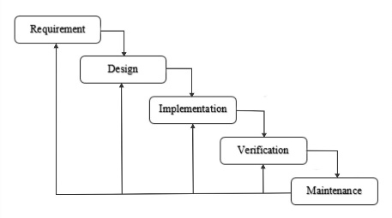
Figure 1 Waterfall Method
The explanation for the stages in Figure 1 is:
- Analysis
Before implementing software, developers need to know and understand the information needs of software users. This data collection method can be used through several methods, including discussions, observations, surveys, interviews and others.
- Design
Technical design interests such as programming languages, data layers, services and others. Typically, a design specification is created that describes how the business logic contained in the analysis will be technically implemented. The stages of the waterfall method are a design and development process based on user needs information. The design is of course carried out to make the work process easier and to get a detailed picture regarding the appearance of a system. Apart from that, the design stage in this method also functions to identify the hardware and system requirements needed for the entire development process.
- Coding
The system development process will go through stages in the form of small modules which in the next stage of the waterfall method will be combined. Apart from that, checking each module that has been created is also checked in this phase. The aim is to ensure that the module fulfills the specified function and complies with standards.
- Testing
After all items or modules developed and tested in the implementation stage are then integrated into the overall system. Once the integration process is complete, the system as a whole is checked and tested to identify possible bugs and system errors.
- Maintenance
After a series of systematic steps above, maintenance of the system that has been created is the final stage of this method. The system has been distributed and used by users. What still needs to be done is maintenance and ensuring that the system continues to run well according to its function. This process usually includes improving the implementation of the system unit, fixing remaining or newly detected errors, and improving system performance tailored to user needs. The method contains the stages or research procedures and algorithms used in the research, the formula for the problem studied in more detail, as well as the system design if needed.
In this research, the stages referred to are the design or mobile application design stages.

RESULTS AND DISCUSSION

The results of the research consist of DFD depictions, use case diagrams and mobile designs. The results of the DFD depiction of the tax consulting service system. The modeling results from the DFD context diagram image can be seen in Figure 2.
Figure 2 Tax Me Context Diagram
Next, so that the process can be seen more clearly, the context diagram in Figure 2 is then modeled further into DFD level 0 shown in Figure 3.
Figure 3 DFD Level 0 Tax Me
So that the functionality of the system as a whole is easier to understand, the system functionality is modeled using a use case diagram as can be seen in Figure 4
Figure 4 Use Case Tax Me
Based on the modeling results above, the activity then continues with designing the interface which is made using a mobile-based display form.
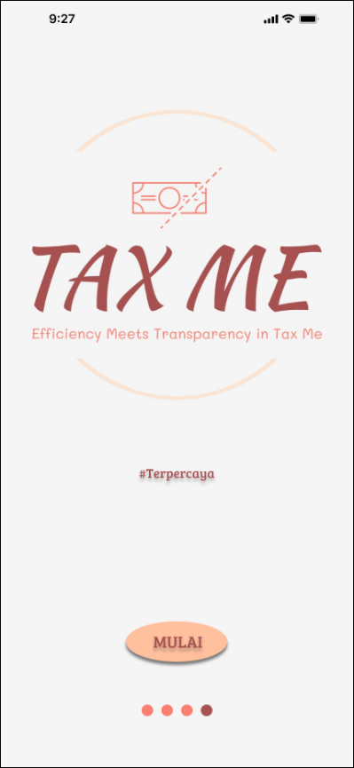
Figure 5 Initial View of Tax Me
Figure 5 is the initial display of the Tax Me application. When the user presses the start button, the user will be taken to the user list display shown in Figure 6.
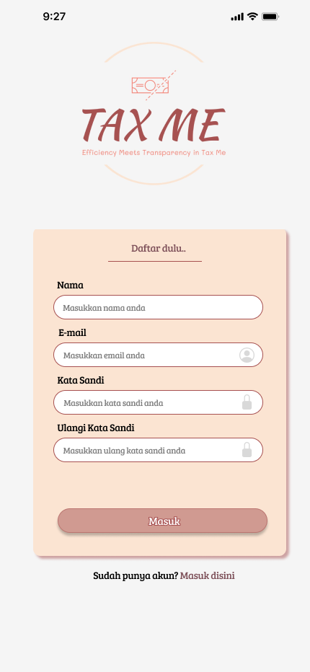
Figure 6 Registration View
After logging in, the user displays a home menu as in Figure 7.
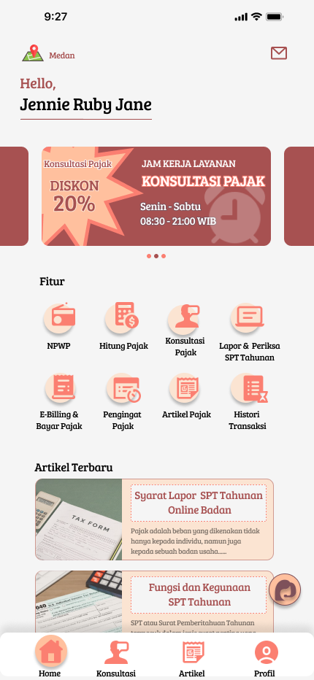
Figure 7 Tax Me Home View
On the home screen there are several features such as calculating taxes, tax consultations, reporting/checking annual tax returns, e-billing/paying taxes, and tax articles.
The tax calculation display is shown in Figure 8.
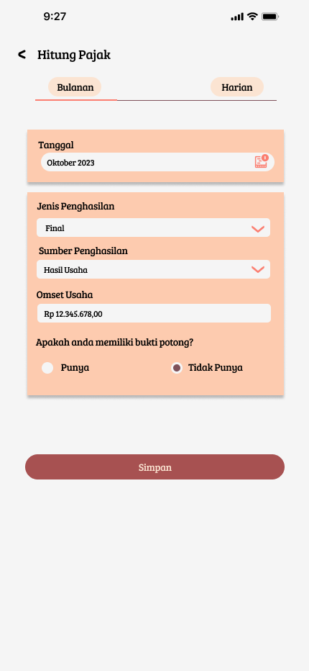
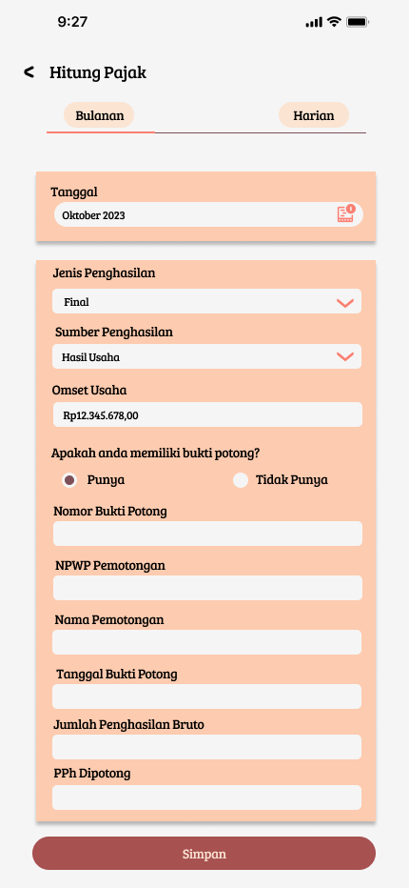
Figure 8 Tax Calculation Display
In Figure 8, users can carry out tax calculations by filling in the date, type of income, source of income and business turnover. If the user does not have proof of deduction, then immediately click the save button, then he will be directed to the transaction details which contain the calculation of the nominal tax that must be paid. If the User has proof of withholding, then the User needs to fill in the proof of withholding number, NPWP withholding, name of withholding, date of proof of withholding, amount of gross income and Pph withheld. After the user has filled in the data, click the save button and he will be directed to the transaction details which contain the calculation of the nominal tax that must be paid.
Then users can consult with a tax consultant regarding tax payments or other matters. The tax consultation display is shown in Figure 9.
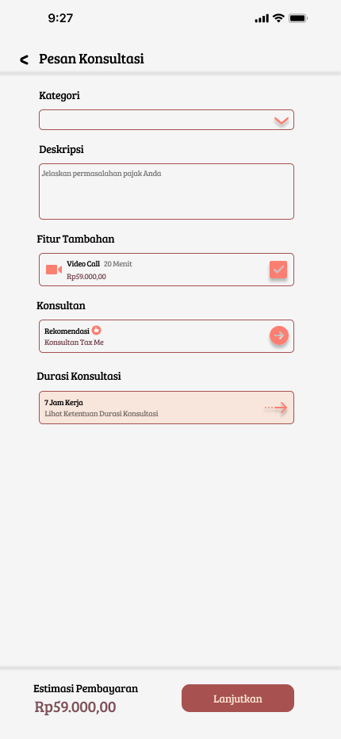
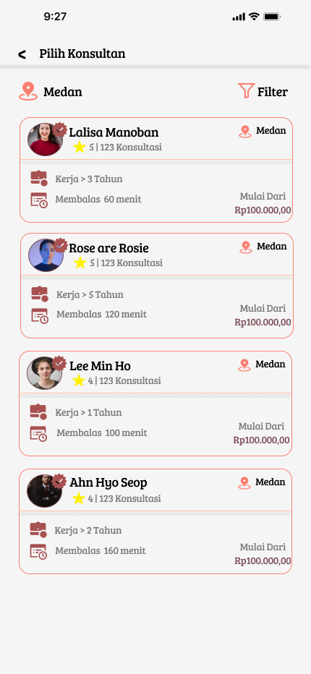
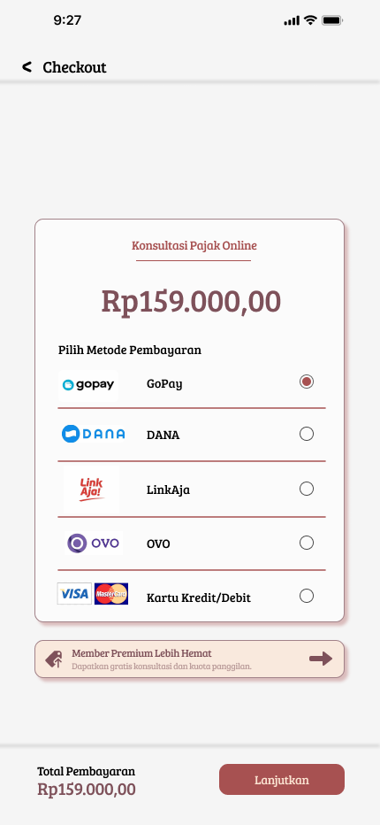
Figure 9 Consultation Feature Display
In Figure 9, users can carry out tax consultations by selecting a category (General Central Tax, Finance, Tax Compliance, Tax Review, Tax Planning, SPT), then writing a description of the tax problem. Then there are additional features (video calls) where users can choose to add additional features or not. Then users can select consultants based on ratings with filter mode. After the User has selected a category, written a description, added additional features (optional), and selected a tax consultant, the User can continue payment where there is a subscription package that the User can choose. The subscription package consists of a premium package (tax consultation package with call quota & unlimited e-billing) and a premium lite package (tax consultation package without call quota & unlimited e-billing). After the User has selected a subscription package, the User can make a payment and then be directed to the consultation menu.
Taxpayers can report and check their annual SPT as shown in Figure 10.
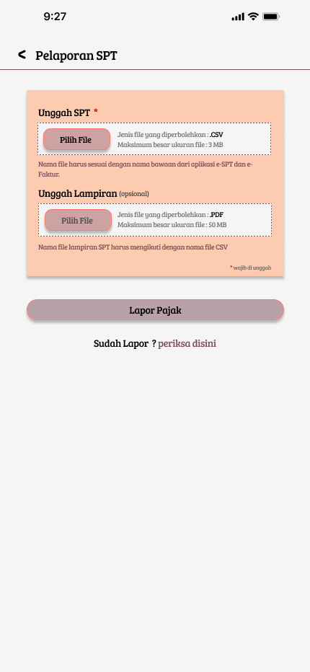
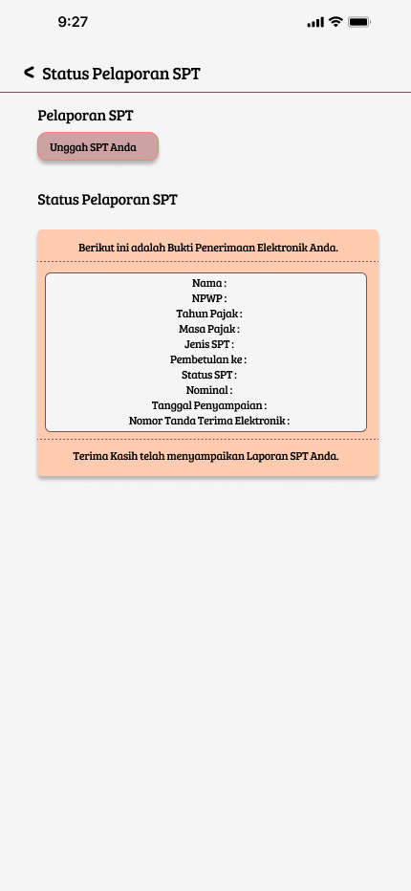
Figure 10 SPT Report Feature Display
In Figure 10, Users can report SPT by uploading the User's (Taxpayer's) SPT. If the User has reported their Annual SPT, then they can check the SPT reporting status whether they have paid tax or not.
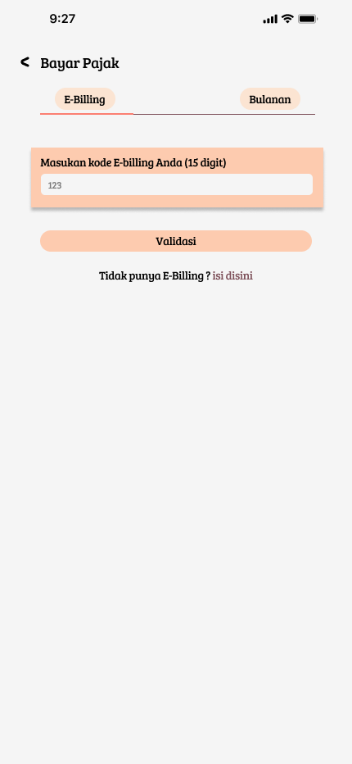
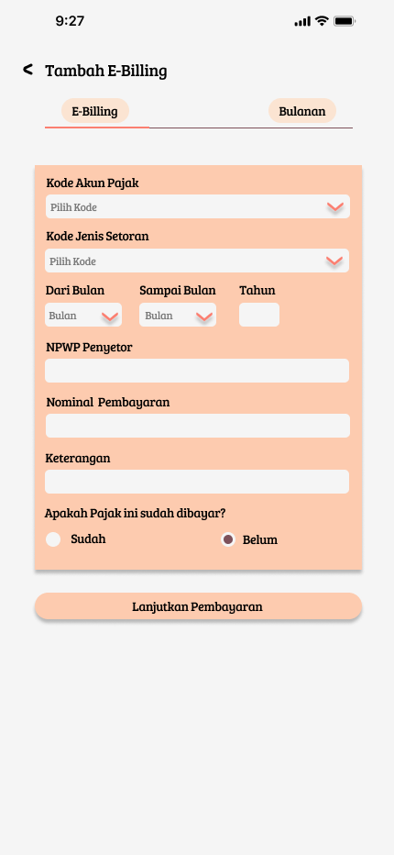
Figure 11 Display Pay Tax and Add e-billing
In Figure 11, users can pay taxes by entering a 15-digit e-billing code. If the User does not have an e-billing code, the User can create an e-billing code by filling in the tax account code, deposit type code, depositor's NPWP, payment amount and information.

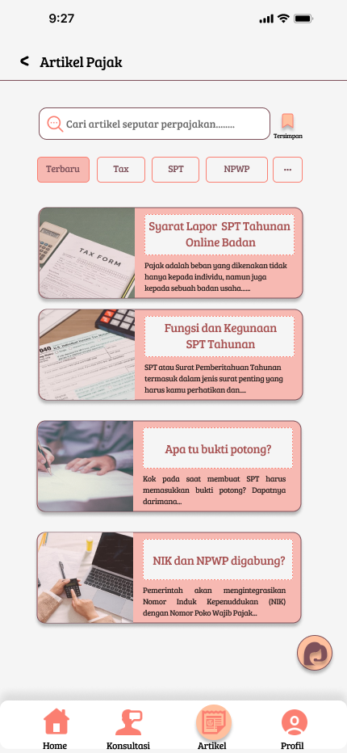
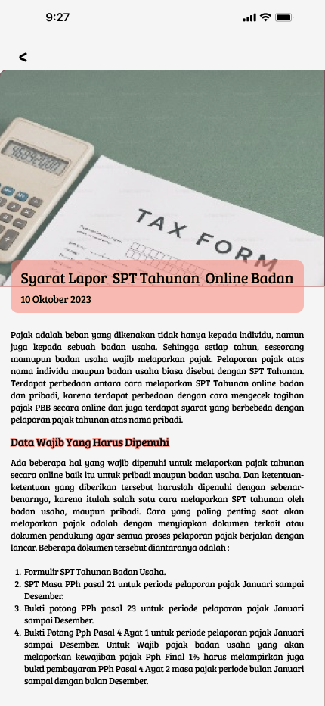
Figure 12 Tax Article View
In Figure 12, users can see interesting articles about taxes. Various latest news and important facts about taxes are available in this feature. Users can select and read various tax news and facts they want. The available articles are taken from trusted sources so that the information obtained by users will be more accurate.

CONCLUSION
The conclusion of this study is that the design of the Tax Me application will help taxpayers pay taxes and can consult with trusted consultants. Tax Me can also help many parties if it is developed into an official application.

BIBLIOGRAPHY
[1] N. Azzahra and D. Sofianty, “Pengaruh Kesadaran Wajib Pajak dan Pengetahuan Pajak terhadap Kepatuhan Wajib Pajak Orang Pribadi,” Bandung Conference Series: Accountancy, vol. 3, no. 1, pp. 126–134, Jan. 2023, doi: 10.29313/bcsa.v3i1.5853.
[2] C. D. Anggriantari and A. H. Purwantini, “Pengaruh Profitabilitas, Capital Intensity, Inventory Intensity, dan Leverage Pada Penghindaran Pajak,” in 3rd Prosiding Business and Economics Conference In Utilizing of Modern Technology 2020, F. Anisa, U. Rachmawati, B. Maharani, N. Hidayah, D. F. Yusuf, and A. L. T. Sari, Eds., Magelang: FEB UNIMMA, Aug. 2020, pp. 137–153.
[3] N. Wahyuni, “Analysis of Compliance and Effectiveness of Land and Building Tax Collection in Increasing Original Regional Income in Pangkep Regency,” Jurnal Online Manajemen ELPEI, vol. 4, no. 1, pp. 834–841, Feb. 2024, doi: https://doi.org/10.58191/jomel.v4i1.231.
[4] A. D. S. Pratiwi and K. E. C. Sinaga, “Pengaruh Motivasi, Pengetahuan Perpajakan, Dan Sanksi Pajak Terhadap Kepatuhan Pajak (Studi Kasus Pada Wajib Pajak Orang Pribadi Wilayah Kantor Pelayanan Pajak Pratama Yogyakarta),” Ultimaccounting Jurnal Ilmu Akuntansi, vol. 15, no. 1, pp. 95–110, Jun. 2023, doi: 10.31937/akuntansi.v15i1.3162.
[5] T. Nur and F. Valentinus, “Kelemahan Penggunaan E-Filling Pada Pengisian Surat Pemberitahuan Tahunan Pajak Penghasilan Orang Pribadi Dengan Periode Penghasilan Kurang Dari 12 Bulan,” Jurnal Administrasi Bisnis Terapan (JABT), vol. 2, no. 2, 2020, doi: 10.7454/jabt.v2i2.1067.
[6] Utomo, G. Setyo, Titisari, K. Hendra, Wijayanti, and Anita, “Pengaruh Kualitas E-Government Terhadap Kepuasan Pengguna E-Filing: Studi Kasus Wajib Pajak Di Surakarta,” Jurnal Program Studi Akuntansi, vol. 6, no. 1, pp. 13–21, May 2020, doi: 10.31289/jab.v6i1.2752.
[7] Y. Mulyati and J. Ismanto, “Pengaruh Penerapan E-Filing, Pengetahuan Pajak dan Sanksi Pajak terhadap Kepatuhan Wajib Pajak pada Pegawai Kemendikbud,” Jurnal Akuntansi Berkelanjutan Indonesia, vol. 4, 2021, doi: jabi.v4i2.y2021.p139-155.
[8] A. Nurhidayat and A. Ariesanti, “Analisis Faktor-Faktor Yang Dipertimbangkan Wajib Pajak Badan Dalam Memilih Menggunakan Jasa Konsultan Pajak,” Journal of Management & Business, vol. 6, no. 2, pp. 327–333, 2023, doi: 10.37531/sejaman.v6i2.5227.
[9] Hermansyah, R. F. Wijaya, and R. B. Utomo, “Metode Waterfall Dalam Rancang Bangun Sistem Informasi Manajemen Kegiatan Masjid Berbasis Web,” KLIK: Kajian Ilmiah Informatika dan Komputer, vol. 3, no. 5, pp. 563–571, Apr. 2023, doi: https://doi.org/10.30865/klik.v3i5.756.
[10] M. A. Rosid and A. Ardiansyah, “Sistem Informasi Penjualan Dan Stock Bahan Baku Berbasis Web (Studi Kasus Pabrik Krupuk Berkah Jaya),” Journal of Technology and System Information, vol. 1, no. 1, pp. 43–54, Jan. 2024, doi: 10.47134/jtsi.v1i1.2145.
[11] I. Pratiwi, S. Anardani, and A. R. Putera, “Rancang Bangun Sistem Informasi Penjadwalan Mata Pelajaran dengan Metode Waterfall,” JDMIS: Journal of Data Mining and Information System, vol. 1, no. 1, pp. 20–28, Feb. 2023, doi: 10.54259/jdmis.v1i1.1513.
[12] E. Mardiani and F. A. Ramadhan, “Rancang Bangun Perangkat Lunak Penjualan Dengan Menggunakan Metode Waterfall,” Digital Transformation Technology, vol. 3, no. 2, pp. 662–668, Nov. 2023, doi: 10.47709/digitech.v3i2.3224.

