COUNSELING AND TRAINING TO IMPROVE THE LEVEL OF
DENTAL AND ORAL HEALTH IN JUNIOR HIGH SCHOOL
TAMAN SISWA BELAWAN MEDAN

Cek Dara Manja¹*, Rini Octavia Nasution², Dewi Kartika³, Maria NH Sitanggang⁴
^{1,3,4}Department of Dentomaxillofacial Radiology, Faculty of Dentistry, Universitas Sumatera Utara
²Department of Periodontics, Faculty of Dentistry, Universitas Sumatera Utara
email: cek@usu.ac.id

Abstract: SMP Taman Siswa Belawan Medan in North Sumatra has problems regarding dental and oral health in school residents, especially students, so many suffer from cavities and problems with periodontal tissue. In addition, anxiety about seeing a dentist and doing dental radiography as a supporting examination is also a problem that must be solved immediately. Counseling and training are carried out through community service programs, which aim to improve health through training on how to brush teeth, counseling on the causes of periodontal disease, and dental intra-oral radiography examinations. The implementation is carried out twice, where the first visit provides counseling and training and the second visit is an evaluation. The results showed a significant increase. The level of student knowledge in the pretest was good at 28%, sufficient at 56.67%, and poor at 15.33%, and in the post-test, it was good at 60%, sufficient at 30.67%, and poor at 9.33%. The level of teacher knowledge in the pre-test was good at 52.94%, sufficient at 47.06%, and poor at 0%, and in the post-test, it was good at 100% based on the questionnaire distributed. In conclusion, counseling and training in dental and oral hygiene are effective in increasing knowledge in students and teachers so that they can reduce the prevalence of cavities and periodontal disease, increase awareness of checking teeth with a dentist, and improve the level of dental and oral health.
Keywords: counseling, training, dental and oral health

Abstrak: SMP Taman Siswa Belawan Medan di Sumatera Utara memiliki masalah mengenai kesehatan gigi dan mulut pada warga sekolah terutama siswa, sehingga banyak yang menderita gigi berlubang dan masalah pada jaringan periodontal gigi. Selain itu, kecemasan untuk berobat ke dokter gigi dan melakukan radiografi kedokteran gigi sebagai pemeriksaan penunjang juga menjadi masalah yang harus segera mendapatkan solusi. Penyuluhan dan pelatihan dilakukan melalui program pengabdian kepada masyarakat, dimana tujuannya adalah untuk meningkatkan derajat kesehatan melalui pelatihan cara menyikat gigi, penyuluhan penyebab terjadinya penyakit jaringan periodontal dan pemeriksaan radiografi intra oral kedokteran gigi. Pelaksanaan dilakukan dua kali, dimana kunjungan pertama melakukan penyuluhan dan pelatihan dan kunjungan kedua sebagai evaluasi. Hasil menunjukkan peningkatan signifikan. Tingkat pengetahuan siswa pada pretest adalah baik 28%, cukup 56,67% dan buruk 15,33%, dan pada post-test adalah baik 60%, cukup 30,67% dan buruk 9,33%. Tingkat pengetahuan guru pada pre-test adalah baik 52,94%, cukup 47,06% dan buruk 0%, dan pada post-test adalah baik 100% berdasarkan kuesioner yang dibagikan. Kesimpulannya, penyuluhan dan pelatihan kebersihan gigi dan mulut efektif meningkatkan pengetahuan pada siswa dan guru sehingga dapat menurunkan prevalensi gigi berlubang dan penyakit periodontal, meningkatkan kesadaran untuk memeriksakan gigi ke dokter gigi serta meningkatkan derajat kesehatan gigi dan mulut.

Kata kunci: Penyuluhan, Pelatihan, Kesehatan Gigi dan Mulut

INTRODUCTION

Everyone's health can be impacted by healthy behavior. Since dental and oral health are a component of overall health, they should constantly be taken into consideration. The WHO states that oral and dental health has a significant impact on overall health and well-being (Boel T et al., 2021). Thus, it is crucial to keep teeth and oral cavities healthy by keeping them clean at all times. People feel more comfortable speaking, eating, and interacting with others when their teeth and oral cavities are clean and free of pain, discomfort, or shame (Septiani et al., 2021).
Because unhealthy teeth and gums can lead to discomfort, trouble biting, and other health issues, oral and dental health is crucial. Although they can be avoided, many cavities, gingivitis, and periodontitis need to be treated right away. Brushing teeth is the primary preventive measure, and it is one of the indicators of community dental care behavior in preserving oral and dental health (Agung & Dewi, 2019). The most effective method of removing plaque and preventing problems like cavities and periodontitis is to brush your teeth regularly (Aspinall et al., 2021).
Brushing your teeth twice a day, namely in the morning after breakfast and before bed, is a beneficial habit to maintain dental and oral health (Anggraeni et al., 2022). Brushing your teeth twice a day is essential because failing to do so after eating, and particularly before bed, can cause harm to your teeth due to the millions of bacteria that reside in your mouth. Your teeth will have fewer debris and cavities the longer you brush them regularly (Saputri et al., 2022).
Continuous education about the necessity of maintaining oral and dental health will yield positive outcomes. To avoid dental issues, dental and oral health promotion and prevention must begin as soon as possible (Kurniawati et al., 2023). Because the information they get can be further reinforced in school, habits and lifestyles established early on will endure longer (Bramantoro T et al., 2021).
According to Law No. 36 of 2009 concerning health, dental and oral health services are provided in order to preserve and enhance the community's health. These services include promoting dental health, preventing dental diseases, treating dental diseases, and restoring dental health. These services are provided in an integrated, ongoing manner and are carried out through individual, community, and school dental health initiatives. Dental radiography is one of the supporting examination methods used in dentistry. intraoral radiography examination in which the bitewing, occlusal, and periapical regions of the mouth are exposed to the film or sensor (Putri & Yunus, 2021).
Because of its widespread effects and the need for prompt treatment before it's too late, oral and dental health is one of the public health issues that needs to be handled thoroughly. Data on how long people spend brushing their teeth reveals that Indonesians have very poor oral health self-care habits. Even though 91.1% of Indonesians wash their teeth, data indicates that just 7.3% do so. 6.7% of Indonesians acknowledge having dental and oral hygiene issues, per the findings of a basic health study (Riskesdas 2018). This figure is substantially below the World Health Organization's (WHO) goal that 50% of kids between the ages of 10 and 14 understand dental and oral hygiene (Riskesdas, 2018).
People in North Sumatra Province do not yet realize how important it is to preserve dental and oral health, as evidenced by the 19.4% incidence of dental and oral disorders in the province. When a person's teeth start to erupt at the age of one year, the proportion of those who suffer from oral and dental issues rises. With corresponding prevalences of 26% and 25.9%, dental and oral disorders can arise in both urban and rural settings. There is no discernible change. Because there are more dentists in cities than in rural areas, dental treatment is better in cities than in rural ones. Therefore, early prophylaxis is crucial to avoiding oral and dental problems (Riskesdas, 2018).
This community service project aims to raise awareness of periodontal tissue disease and tooth brushing techniques, boost confidence in intraoral radiography dental exams, and give sinks as a way to promote better health.
METHOD

The task of enhancing oral and dental health by education and counseling was completed twice. At SMP Taman Siswa Belawan in Medan, North Sumatra, 150 students and 17 teachers participated in the counseling and training activities on July 23, 2024, and the evaluation activities on August 7, 2024. SMP Taman Siswa Belawan and the Community Service Institute of Universitas Sumatera Utara collaborated on this project. Three phases make up the execution of this community service project: planning, training and counseling, and evaluation. Analyzing the site and activity area, forming partnerships, securing the service's location permit, and constructing a sink at SMP Taman Siswa Belawan's restroom and yard are all part of the preparation phase.
A questionnaire was given out as a pre-test during the counseling and training phase to gauge teachers' and students' understanding of periodontal tissue, intraoral dental radiography kinds, and dental cleanliness. Following that, a phantom head and direct practice utilizing a sink constructed by the community service team were used in conjunction with discussion, lecture, and practice approaches to provide the counseling contents. In the evaluation stage, activities were carried out in the schoolyard, starting with repeating the material using posters, followed by a question-and-answer activity with prizes. The distribution of questionnaires was carried out as a post-test to evaluate students' and teachers' understanding of the material presented. The evaluation activity ended with the provision of plaques, posters, refreshments, and goodie bags.

DISCUSSION

The schoolyard and classrooms of SMP Taman Siswa Belawan became the place for implementing community service. The program began with a counseling and training stage on the first visit and ended with an evaluation stage on the second visit. Lecturers from the Faculty of Dentistry, Universitas Sumatera Utara, carried out counseling using audiovisual media in the form of videos and PowerPoint.
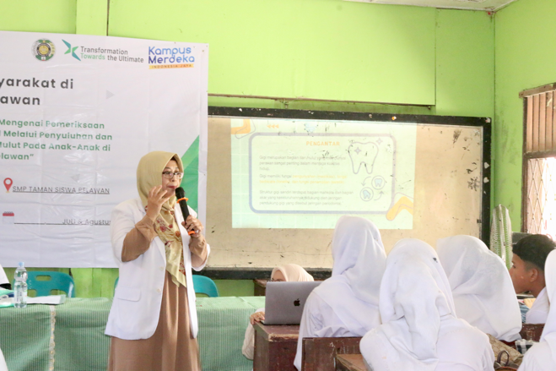
The first material provided is related to the importance of maintaining dental health and the negative impacts that occur if teeth are not treated. Sick teeth will affect the health of the body as a whole. Food and drink residue that sticks to the surface of the teeth can cause plaque to form. Plaque is a local and primary cause of other dental and oral diseases such as caries, calculus, and periodontal disease. The second material includes counseling on periodontal tissue diseases, namely gingivitis and periodontitis. Gingivitis is an inflammation of the gums with symptoms of bright red or dark red gums, swelling, easy bleeding when brushing teeth, and bad breath. Treatment can be done by scaling (cleaning tartar) and filling or replacing damaged teeth. Periodontitis is an inflammation of the supporting tissue of the teeth and a continuation of gingivitis that is not treated. Symptoms are pain when chewing, reddish or purplish gums, receding gums, and loose or loose teeth.
The final piece of content discusses the various forms of intraoral radiography used in dentistry. specifically, bitewing, occlusal, and periapical radiographs, which can aid in the diagnosis, planning, and assessment of oral and dental conditions (Figure 1). To enable dentists to see the state of the teeth's interior from the crown, roots, and supporting tissues that are invisible to the naked eye, radiographic examination is a necessary tool. The fourth piece of content discusses everyday dental health maintenance strategies, like limiting sugary foods, drinking fewer colored beverages, and maintaining a balanced diet. Preventive strategies include brushing and flossing your teeth regularly, visiting the dentist every six months, and using a toothbrush and toothpaste.

Figure 1. Counseling Activities

Next, training was conducted on how to brush teeth using a tooth phantom, and students were instructed to demonstrate it again (Figure 2). During a fifteen-minute break, each student received a goodie bag containing snacks, toothpaste, and a toothbrush from the community service team. After consuming snacks, students applied a disclosing solution to the students' tongues and were instructed to spread it evenly over the entire surface of their teeth to show students that there was food residue stuck. The students immediately practiced the correct tooth-brushing technique using a sink that had been made by the community service team. Each student began brushing their teeth using the toothbrush and toothpaste that had been provided. The correct way to brush your teeth is to use the Bass Method. This method is done by holding the toothbrush until the tip of the bristles forms a 45° angle to the axis of the teeth, then the bristles are pressed towards the gums so that they enter the gap between the gums and teeth, then moved horizontally, back and forth (Figure 3). It is recommended to students that brushing their teeth should be done twice a day, namely in the morning after breakfast and at night before sleeping (Wati et al., 2020).
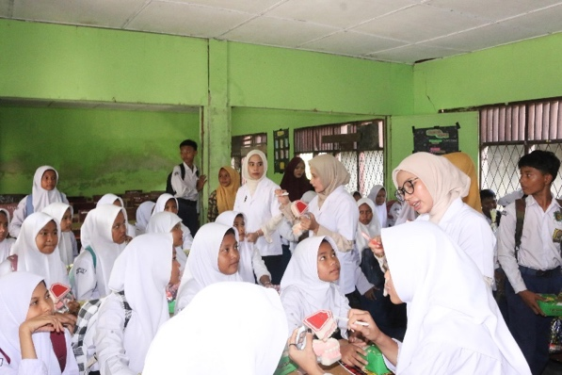
Figure 2. Training on how to brush teeth using tooth phantom

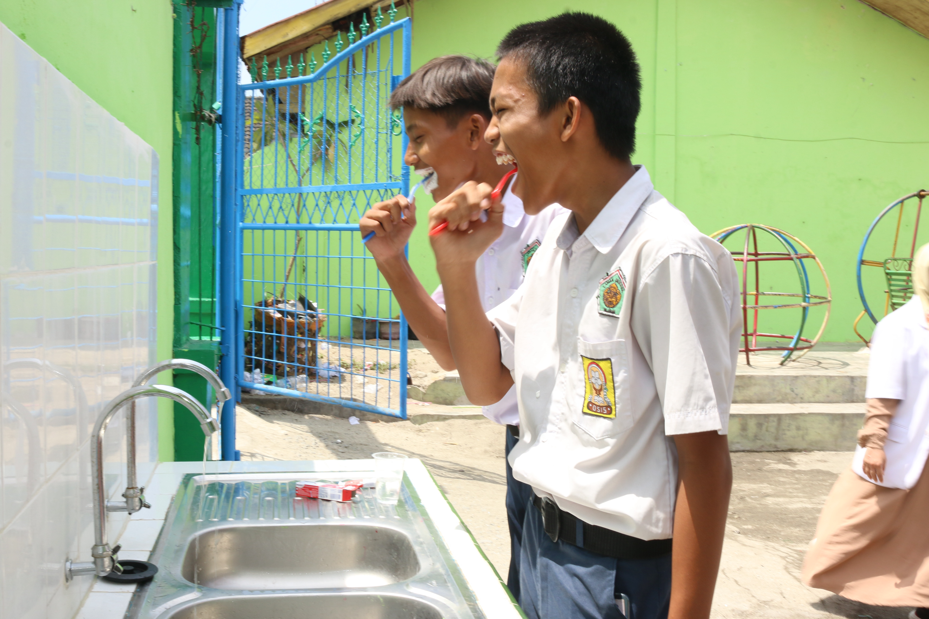
Figure 3. Direct practice of brushing teeth together

The community service team held an assessment exercise in the schoolyard two weeks after the initial visit. Using posters titled How to Brush Your Teeth Properly, Types of Intraoral Radiography in Dentistry, and Periodontal Disease, the exercise started by repeating the content. In addition, a test with questions about the counseling content was administered. Correct answers would earn students practical rewards. The community service team then administered a post-test questionnaire with identical items to the pre-test to teachers and pupils. A plaque, posters, snacks, and gift bags were given out when the evaluation session came to a close (Figure 4).
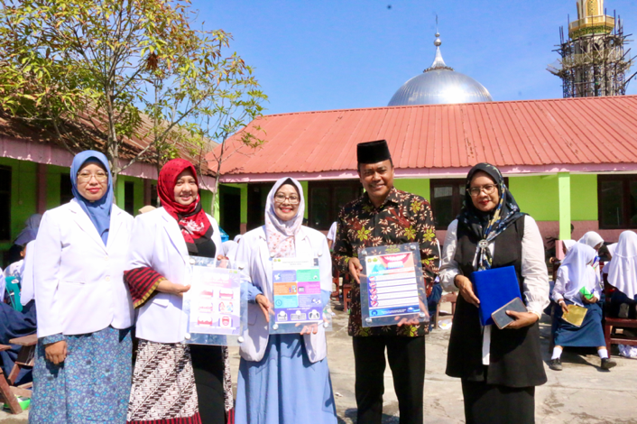
Figure 4. Poster handover to partners

The results of the pre-test and post-test, which included questions regarding periodontal tissue, intraoral radiography types in dentistry, and dental and oral health care, will be compared to assess the degree of success. Based on the right answers, the knowledge level is separated into three groups: good (10–12), sufficient (7-9), and bad (0–6). In the post-test, a higher proportion of teachers and students were able to properly answer every question than in the pre-test. Table 1 displays the full distribution of general knowledge among SMP Taman Siswa Belawan students and teachers.

Table 1. General description of knowledge of students and teachers of SMP Taman Siswa Belawan
Overview of knowledge of students and teachers
No. | Questions | Pre-Test |  |  |  | Post-Test
 |  | Right |  | Wrong |  | Right |  | Wrong
 |  | n | % | n | % | n | % | n | %
 | How many times do you brush your teeth in a day? | 157 | 94,01 | 10 | 5,99 | 159 | 95,21 | 8 | 4,79
 | When do you brush your teeth in a day? | 125 | 74,85 | 42 | 25,15 | 141 | 84,43 | 26 | 15,57
 | What type of tooth brush to use? | 146 | 87,43 | 21 | 12,57 | 146 | 87,43 | 21 | 12,57
 | Do you use toothpaste when brushing your teeth? | 167 | 100,00 | - | - | 167 | 100,00 | - | -
 | How do you brush your teeth properly? | 95 | 56,89 | 72 | 43,11 | 133 | 79,64 | 34 | 20,36
 | What are the types of dental radiography? | 123 | 73,65 | 44 | 26,35 | 125 | 74,85 | 42 | 25,15
 | How many types of intraoral radiographic examinations? | 59 | 35,33 | 108 | 64,67 | 119 | 71,26 | 48 | 28,74
 | What are the risks that can occur if you don't clean your teeth and mouth? | 147 | 88,02 | 20 | 11,98 | 152 | 91,02 | 15 | 8,98
 | What are the symptoms of gum inflammation (gingivitis)? | 100 | 59,88 | 67 | 40,12 | 117 | 70,06 | 50 | 29,94
 | What can cause bleeding gums? | 140 | 83,83 | 27 | 16,17 | 144 | 86,23 | 23 | 13,77
 | What can you do if you have gum disease (gingivitis)? | 75 | 44,91 | 92 | 55,09 | 128 | 76,65 | 39 | 23,35
 | If gum disease is not treated, what will happen? | 47 | 28,14 | 120 | 71,86 | 119 | 71,26 | 48 | 28,74

According to the study's findings, the majority of students (54.00%) fell into the sufficient category on the pre-test, demonstrating that they understood and knew enough about periodontal tissue, intraoral radiography types in dentistry, and dental and oral health care. Furthermore, a minor percentage of students (18.00%) fell into the poor category, whereas 28.00% of students were in the good category. Additionally, the teachers were separated into several categories; 47.06% fell into the sufficient category, while 52.94% fell into the good category. Additionally, the community service team used the same questionnaire as a post-test during the evaluation phase to gauge how much the teachers and students knew about periodontal tissue, intraoral radiography types in dentistry, and proper tooth brushing techniques.
According to the post-test results, 100.00% of teachers fell into the good category, meaning that all of them understood periodontal tissue, intraoral radiography kinds in dentistry, and proper tooth brushing techniques. The majority of pupils (60.00%) had a good comprehension, 33.33% had a decent understanding, and 6.67% were in the low group, according to the evaluation results. Table 2 displays the full distribution of the evaluation results.

Table 2. Knowledge level of students and teachers at SMP Taman Siswa Belawan
Pre-Test and Post-Test Knowledge Level
Category |  | Students |  | Teachers
 |  | Frequency | % | Frequency | %
Good | Pre-Test | 42 | 28,00 | 9 | 52,94
 | Post-Test | 90 | 60,00 | 17 | 100,00
Moderate | Pre-Test | 81 | 54,00 | 8 | 47,06
 | Post-Test | 50 | 33,33 | - | -
Poor | Pre-Test | 27 | 18,00 | - | -
 | Post-Test | 10 | 6,67 | - | -

Figure 5. Comparison of the level of knowledge of students and teachers
at SMP Taman Siswa Belawan

Figure 5 shows that, according to the findings of the pre-test and post-test, the knowledge of Taman Siswa Belawan Middle School's teachers and pupils has grown. According to the pre-test results, the majority of instructors and students (89 total) fell into the sufficient category, and the majority of teachers and students (107 total) fell into the good category. This indicates how the lecture-style counseling and training, which used audio-visual materials like PowerPoint, videos, and tooth phantom demonstrations, was highly successful in raising the level of understanding among Taman Siswa Belawan Middle School teachers and students about maintaining dental and oral hygiene, the various forms of intraoral radiography in dentistry, and periodontal tissue.
Increasing the knowledge of students and teachers at Taman Siswa Belawan Middle School will have an impact on efforts to achieve the priority targets of Sustainable Development Goals (SDGs) 3, namely Good Health and Welfare, ensuring healthy living and improving the welfare of all ages.

CONCLUSION

The Community Service Program conducted at SMP Taman Siswa Belawan Medan for two visits through training and counseling has succeeded in achieving its goal of improving the level of dental and oral health. The evaluation results showed an increase in the percentage of knowledge levels in students and teachers, especially related to maintaining dental and oral health. periodontal tissue, types of intraoral radiography, and counseling on proper tooth brushing. The positive results of this training and counseling can be an effective solution to improve the level of dental and oral health in other schools.

ACKNOWLEDGMENT

In addition to the head of the Taman Siswa Belawan Middle School Foundation and the teaching staff who supported and assisted the community service team during the implementation of this community service activity, gratitude is also expressed to the Community Service Institute of Universitas Sumatera Utara in 2024, which has provided funding for community service activities.

BIBLIOGRAPHY

Agung AAG, & Dewi NKEP. (2019). Hubungan perilaku menyikat gigi dan karies gigi molar pertama permanen pada siswa kelas V di SDN 4 Pendem tahun 2018. Jurnal Kesehatan Gigi (Dental Health Journal), 6(2), 5–8.
Anggraeni ANDF, Prasetyowati S, & Mahirawatie IC. (2022). Tingkat Pengetahuan Menyikat Gigi Anak Sekolah Dasar Kelas 1-3 Di SDN 2 Sumberejo Kabupaten Trenggalek. Indonesian Journal of Health and Medical, 2(4), 523–533.
Aspinall SR, Parker JK, & Khutoryanskiy VV. (2021). Oral care product formulations, properties and challenges. Colloids and Surfaces B: Biointerfaces, 200(111567).
Boel T, Zulkarnain M, Nasution RO, Nainggolan LI, & Kartika D. (2021). Improving oral and dental health through counseling, video and phantom demonstration during the Covid-19 pandemic to the Medan Belawan community. ABDIMAS TALENTA: Jurnal Pengabdian Kepada Masyarakat, 6(1), 74.
Bramantoro T, Santoso CMA, Hariyani N, Setyowati D, Zulfiana AA, Nor NAM, & Irmalia WR. (2021). Effectiveness of the school-based oral health promotion programmes from preschool to high school: A systematic review. PloS One, 16(8), e0256007.
Departemen Kesehatan Republik Indonesia. (2018). Data laporan nasional riset kesehatan dasar.
Kurniawati D, Ningsih JR, Kirom FF, & Haya AHA. (2023). Impact of School Dental Health Education Programme on Elementary School Students in Kartasura, Indonesia. Journal of International Dental and Medical Research, 16(3), 1203.
Putri NPSS, & Yunus B. (2021). Penggunaan teknik radiografi konvensional dan digital pada perawatan endodontik (Tinjauan Pustaka). Cakradonya Dental Journal, 13(2), 97–105.
Saputri DY, Hadi S, & Marjianto A. (2022). Hubungan cara menyikat gigi dengan karies gigi pada siswa kelas xi sma widya darma surabaya. Indonesian Journal of Health and Medical, 2(3), 134.
Septiani D, Sughesti D, Susanti D, Sihombing MTP, & Novitasari S. (2021). Pentingnya menjaga kesehatan gigi dan mulut di era pandemi Covid’19, demi kelangsungan aktivitas usaha. Dedikasi Pkm, 3(1), 56.
Wati, R., Fahmi SH, & Sari E. (2020). Perbedaan menyikat gigi metode fone’s dan metode bass terhadap skor debris pada murid kelas iii dan iv sekolah dasar negeri gambut 11. Jurnal Terapis Gigi Dan Mulut, 1(2), 40–46.

