IMPLEMENTATION OF SOLAR-POWERED WATER PUMP AND MONITORING SYSTEM FOR HYDROPONIC URBAN FARMING

Adi Mahmud Jaya Marindra¹*, Dwi Surya Santaki², Deny Kurniawan³, Ferdian Ilham Maulana⁴, Raihan Adji Widjaksana⁵, Muhammad Irham Amzari⁶, Pandu Jati Bayu Saputra⁷, Chenny Azalia Eka Putri Minggus⁸, Rafi Fauzan⁹
^{1,2,3,4,5} Program Studi Teknik Elektro, Institut Teknologi Kalimantan
^{6,7} Program Studi Teknik Mesin, Institut Teknologi Kalimantan
^{8,9} Program Studi Teknik Industri, Institut Teknologi Kalimantan
email: adi.marindra@lecturer.itk.ac.id

Abstract: Hydroponic farming is gaining popularity in urban areas due to its efficient resource usage and high, clean yields. However, systems like the Nutrient Film Technique (NFT) rely on electric pumps for continuous nutrient circulation, making them vulnerable to extended power outages that can disrupt plant nutrition and lead to crop failure. This community service project addresses that issue by implementing a solar-powered water pump and a water quality monitoring system in the hydroponic gardens of the Women Farmers Group (KWT) in Sepinggan Raya, Balikpapan. The program consisted of an initial survey, system development and installation, and training sessions on system operation and maintenance. Results indicate that the implementation of the solar pump and monitoring system improves hydroponic productivity while reducing operational costs previously dependent on the national electricity grid. Additionally, the project empowered the local women's group with renewable energy knowledge and modern farming technologies, promoting sustainable urban agriculture practices.
Keywords: Hydroponic; renewable energy; application of technologies; urban farming; water quality monitoring

Abstrak: Pertanian hidroponik semakin populer di area perkotaan yang memiliki keterbatasan ruang karena efisiensi sumber daya dan hasil panen yang tinggi. Namun, sistem hidroponik seperti Nutrient Film Technique (NFT) sangat bergantung pada pompa listrik untuk sirkulasi air nutrisi secara berkelanjutan. Pemadaman listrik yang berkepanjangan dapat mengganggu suplai nutrisi dan berpotensi menyebabkan kegagalan panen. Proyek pengabdian kepada masyarakat ini bertujuan mengatasi kerentanan tersebut dengan mengimplementasikan pompa air tenaga surya dan sistem pemantauan kualitas air berbasis sensor di kebun hidroponik Kelompok Wanita Tani (KWT) Seraya, Sepinggan Raya, Balikpapan. Kegiatan meliputi survei awal, pengembangan dan instalasi sistem, serta pelatihan pengoperasian dan pemeliharaan teknologi bagi para petani. Hasil menunjukkan bahwa sistem ini meningkatkan produktivitas kebun hidroponik dan mengurangi ketergantungan terhadap jaringan listrik nasional (PLN). Selain itu, proyek ini memberdayakan kelompok tani dengan pengetahuan tentang energi terbarukan dan teknologi pertanian modern, mendorong praktik pertanian yang berkelanjutan di lingkungan urban.

Kata kunci: Energi baru terbarukan; hidroponik; monitoring kualitas air; penerapan teknologi; urban farming

INTRODUCTION
Hydroponic urban farming, an innovative and sustainable approach to agriculture, dates back to the 17th century when Francis Bacon first documented the concept in 1627 (Caputo, 2022). In Indonesia, hydroponics was popularized in the 1980s through Bob Sadino’s initiatives (Setyo et al., 2023). Originally adopted as a hobby by plant enthusiasts eager to experiment with soil-less cultivation, hydroponics has since evolved into a significant commercial agricultural practice, especially in urban areas where limited space restricts traditional farming (Monisha et al., 2023; Serio et al., 2022). This transformation demonstrates hydroponics’ adaptability and efficiency in densely populated environments (Debangshi, 2021). Furthermore, the COVID-19 pandemic accelerated hydroponic entrepreneurship, emphasizing sustainable income with economic, social, and environmental considerations (Pardede & Pardede, 2022).
In Balikpapan City, the KWT Seraya RT 28 exemplifies urban farming’s potential in East Kalimantan (Anggraini, 2022). Their farming system integrates hydroponic methods, especially the Nutrient Film Technique (NFT), and traditional soil-based cultivation. Lettuce is the primary hydroponic crop due to its market demand and economic value (Agrawal et al., 2020). Additional crops include spinach, celery, bok choy, chili, eggplant, and fruit trees such as Sunkist oranges and Crystal guava (Putri & Matarru, 2023). Despite being in its early stages, the hydroponic initiative has carved a niche market.
Like humans, plants need a rest period of 7–8 hours daily; during this time, maintaining moisture is crucial to prevent root drying and wilting. For NFT-type hydroponics, the continual operation of the nutrient pumps during the night is essential to sustain these moisture levels and provide necessary nutrients (Maestre-Valero et al., 2018). Unfortunately, in Sepinggan Raya, the farming community faces significant challenges due to power outages. frequent power outages in Sepinggan Raya interrupt the electric pumps essential for nutrient delivery, risking plant wilting and loss. Furthermore, water quality checks, such as pH measurement using well water, are manually performed, consuming time and reducing precision. This situation highlights the interplay between the physical needs of hydroponic farming and the socio-economic environment (Ragaveena et al., 2021).
Recent advances in renewable energy, electronics, and IoT-based sensor technologies offer solutions to these issues (Majeed et al., 2023; Ng & Mahkeswaran, 2021). Solar energy addresses power disruptions by ensuring consistent pump operation (Gorjian et al., 2021), while automated sensors can optimize nutrient levels, pH, and moisture, reducing the risks of manual monitoring (Prakash et al., 2023). Without a stable power supply, these systems can automate and optimize nutrient delivery, pH balance, and moisture levels (Saad et al., 2021). The ability to closely monitor and adjust these parameters can mitigate the risks associated with manual checks and the uncertainties of power-reliant systems.
Community service plays a crucial role in introducing these technologies to farming practices. Training in hydroponics improves yields and empowers local farmers with modern skills (Rozak et al., 2022). Exemplifying community service through renewable solar energy and installing solar-powered public lighting in community areas enhances safety and accessibility while promoting environmental sustainability (Mahmud et al., 2022). Furthermore, plant monitoring technology, including sensors and data analytics tools, allows for precise control over environmental conditions, leading to optimized plant growth and reduced waste (Nasution et al., 2021). Integrating these technologies into urban agriculture aligns with global trends toward sustainability and technological innovation in farming (Ekaputri et al., 2021).
This project aims to implement two innovations in the KWT Seraya community. First, we introduce a solar-powered water pump system to maintain consistent irrigation during power outages. This ensures that the hydroponically grown lettuce and other crops do not suffer from interrupted water supply. Second, we deploy a water quality monitoring system focusing on pH level management, which automates the monitoring process, reduces manual intervention, and maintains optimal nutrient conditions for plant growth. These initiatives address immediate challenges in Sepinggan Raya and contribute to the broader goal of sustainable urban farming. We anticipate improved productivity, greater resilience, and reduced operational costs by integrating renewable energy and smart monitoring technologies. These advancements also empower the local farming community with modern agricultural practices, supporting the transition toward sustainable, technology-driven urban agriculture.
Figure 1. Method of community service

METHOD
Figure 1 illustrates the method of our community service project in Sepinggan Raya. The community service project in Sepinggan Raya was conducted through five main stages to address specific challenges in hydroponic farming. The first stage was an initial survey to identify key problems, particularly power outages that affected irrigation continuity and the manual water quality monitoring process. Based on the findings, the second stage involved the development of a solar-powered water pump, and a water quality monitoring system tailored to local needs. In the third stage, both systems were installed on-site to provide a reliable irrigation source and automate pH and nutrient level monitoring. The fourth stage focused on training and capacity building for the Women Farmers Group (KWT Seraya), ensuring they could operate and maintain the new technologies independently. Finally, an evaluation and feedback phase were implemented, involving direct observation and farmer input to assess the effectiveness of the systems and make necessary adjustments. This structured approach ensured that the technologies introduced were appropriate, functional, and sustainable for long-term use in the local hydroponic farming context.
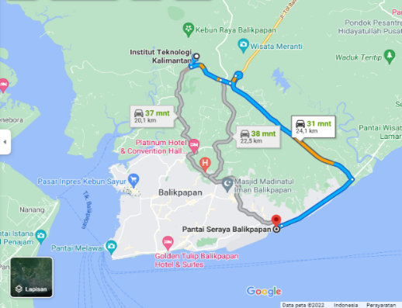  (a) | 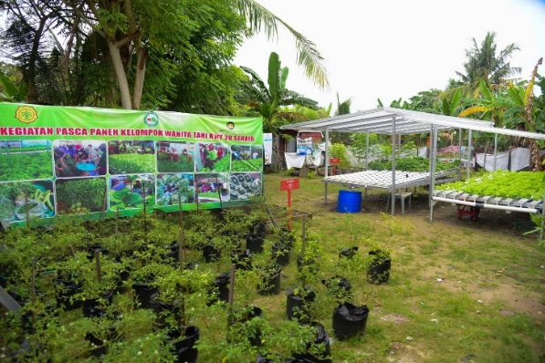  (b)
Figure 2. Location of community service (a) Seraya Beach Balikpapan seen from the Kalimantan Institute of Technology (b) The hydroponic and soil-based farms owned by Women Farmers Group at Sepinggan Raya (Seraya)
The community service project was located at the hydroponic facility in Pantai Seraya, Sepinggan, in the district of South Balikpapan, City of Balikpapan, East Kalimantan. As depicted in Figure 2a, this location showcases the Seraya Beach Balikpapan, as seen by the Kalimantan Institute of Technology (ITK). The location's significance is amplified by its distance from the ITK campus, approximately 24.1 kilometers away, roughly a 31-minute drive via the Balikpapan-Samarinda toll road. This proximity facilitated ease of access for the project team and stakeholders, allowing for efficient coordination and implementation of the community service activities. Figure 2b further illustrates the dual farming systems adopted by the Women Farmers Group at Sepinggan Raya (Seraya), providing a visual context to our project's agricultural setting. The project's strategic location not only offered logistical advantages but also provided a meaningful connection to the local agricultural community, ensuring that the interventions and solutions developed were well-aligned with the needs and practices of the Women Farmers Group in Seraya Beach, Balikpapan.
Figure 3 presents a diagram of the solar-powered water pump and pH-nutrient monitoring systems implemented at the hydroponic farm. The pump system harnesses solar energy via photovoltaic panels, with energy stored in batteries and regulated by a solar charge controller. An inverter converts direct current (DC) to alternating current (AC) to operate the water pump, while an Automatic Transfer Switch (ATS) enables a seamless transition between solar and grid electricity, ensuring uninterrupted irrigation. The pH and nutrient monitoring system, essential for maintaining optimal plant nutrition, is centered on an Arduino UNO microcontroller that receives continuous data from pH and nutrient probes. This data is displayed in real-time, enabling precise adjustments. A submersible pump circulates the nutrient solution using solar power, demonstrating the farm’s commitment to sustainability and technological advancement. This integrated system addresses challenges in power reliability and water quality control, setting a model for autonomous, renewable energy-based hydroponic farming.
The success and impact of the community service project at RT 28, Sepinggan Raya, which focused on implementing a solar-powered water pump and a hydroponic nutrient and pH monitoring system, were evaluated through a structured survey. The survey collected feedback from the farmers on several key aspects: the usefulness of the developed systems; the effectiveness of the solar-powered pump during PLN outages; the ease of hydroponic water management using the monitoring system; the contribution of the technologies to enhancing the appeal of the hydroponic site at Seraya Beach; the perceived improvement in vegetable quality and production; and the performance of the community service team in executing planned activities and achieving project objectives.
Figure 3. Diagram of the implemented solar-powered and pH and nutrient monitoring system at the hydroponic farm
DISCUSSION
Hydroponic farming depends on consistent irrigation to circulate nutrient-rich water vital for plant growth. At KWT Seraya in Sepinggan Raya, dependence on the PLN electricity grid posed a significant risk, as frequent outages interrupted pump operation, causing plant wilting and crop failure. Manual monitoring of pH and nutrient levels also added labor-intensive routines to the farmers’ workflow. To overcome these issues, two solutions were developed: an automated real-time nutrient and pH monitoring system and a photovoltaic solar power system (PLTS) that ensured continuous pump operation. The PLTS adopted an on-grid configuration, which allowed it to function autonomously during PLN outages, maintaining 24-hour irrigation.
The project began with a field study (Figure 4) to understand local conditions and farming practices. Surveys and observations of hydroponic and soil-based systems (Figure 4a–4b) were conducted, along with discussions involving the neighborhood unit leader and local farmers (Figure 4c). This initial assessment identified key problems such as irrigation failure due to outages and the inefficiency of manual water quality checks.
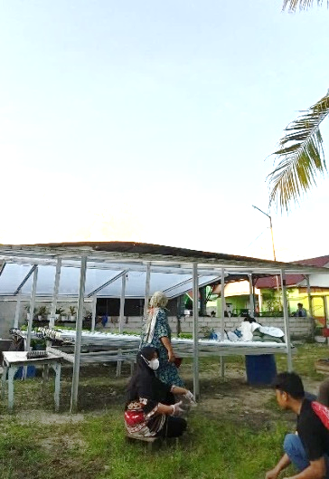  (a) | 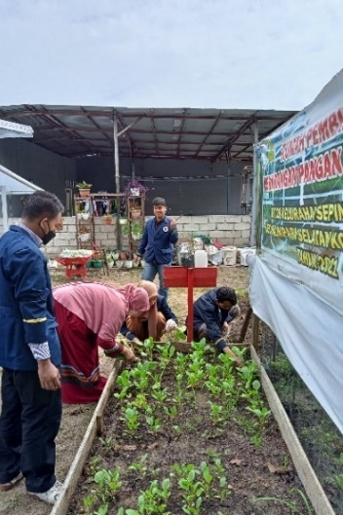  (b) | 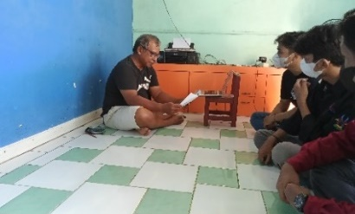  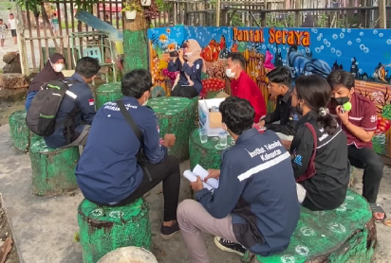  (c)
Figure 4. Initial survey: (a) the hydroponic house, (b) Soil-based farming as an alternative, (c) Discussions with the head of the neighborhood unit and a local farmer at Sepinggan Raya
The realization of these innovations began with a survey to determine the type of pump being used, which then informed the specifications for the photovoltaic (PV) modules to be used. Following this, the procurement and assembly of the necessary equipment were undertaken. The assembly included components like the Automatic Transfer Switch (ATS), a 1000-Watt PSW Inverter, a Solar Charge Controller (SCC), terminal blocks, MCB rails, indicator lights, and the hydroponic monitoring system including an LCD and various supporting components. Installation involved placing 170 Wp solar panels and relevant sensors at the farm.
Figure 5a illustrates the assembly and development process, showing key equipment testing and integration. Upon completion, the system was installed at the KWT Seraya 28 site. The solar panel was mounted on the rooftop beside the hydroponic area, while the control and monitoring panel was installed at the farm. A two-week testing period confirmed that the PLTS could power the water pump and nutrient-pH monitoring system for over two hours beyond expected durations, indicating the success of the implemented technologies. Figure 5c illustrates the training and capacity-building phase essential to ensure sustainability and effective system use. A hands-on session was conducted for them to operate the solar-powered pump and the monitoring system independently. This training equipped farmers with practical skills and strengthened their ability to adopt technologies in hydroponics farming.
During the training sessions, participants were thoroughly guided through the standard operating procedures of the solar-powered system. They were instructed on monitoring battery voltage via the Solar Charge Controller (SCC), emphasizing maintaining a minimum of 10 volts for system operation. Procedures for activating the inverter, handling the Miniature Circuit Breaker (MCB), and manually switching from battery to grid power were explained, including the SCC's automatic disconnection and reset functions.
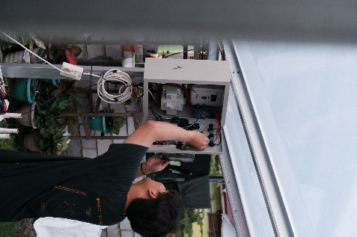  (a) | 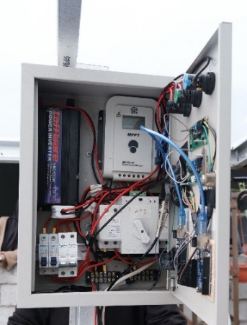  (b) | 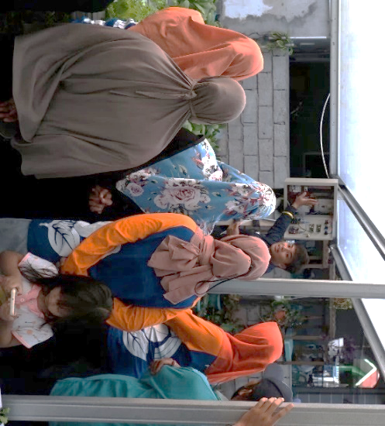  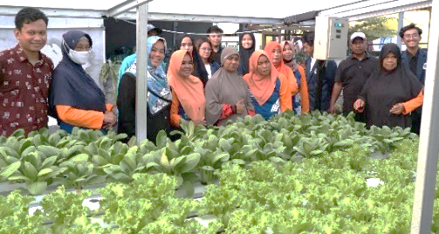 (c)
Figure 5. System installation and training: (a) Developing the system onsite (c) Inside view of the installed control and monitoring panel (c) Training on using the solar-powered water pump and monitoring systems
A survey involving 22 hydroponic farmers was conducted to evaluate the project's impact, with results presented in Figure 6. The average score was 3.79 out of 4, indicating that implementing the solar-powered pump and the monitoring system was highly successful and beneficial. Respondents reported improvements in irrigation reliability during PLN outages, ease of water quality management, and overall system efficiency. The survey also highlighted the increased attractiveness of the hydroponic site, better crop quality and yield. These outcomes validate the project's effectiveness in addressing local challenges and empowering KWT Seraya with sustainable, technology-driven agricultural solutions for future urban farming.

CONCLUSION
Implementing a solar-powered water pump and monitoring system in Sepinggan Raya’s hydroponic urban farming has significantly improved agricultural productivity and sustainability. The solar pump addressed irrigation disruptions caused by electricity outages, while the monitoring system enabled automated control of pH and nutrient levels, maintaining optimal growing conditions. The high survey score reflects the project's success, indicating strong community approval. Training and capacity-building activities strengthened KWT Seraya’s ability to adopt and maintain the technology. Overall, this initiative resolved immediate challenges and established a foundation for future advancements in sustainable urban farming.
Figure 6. Evaluation results of the community service project

ACKNOWLEDGMENT
The authors thank the Institute for Research and Community Service (LPPM) at the Kalimantan Institute of Technology (ITK) for supporting this community service project financially. We would also like to thank Mrs. Tatu Neni Suryani and the Women Farmers Group of RT. 28 Sepinggan Raya, Balikpapan, for supporting the community service team.

BIBLIOGRAPHY
Agrawal, R., Gandhi Krishi Vishwavidyalaya, I., Tripathi, M., Verma, A., & Khalkho, D. (2020). Hydroponic systems for cultivation of horticultural crops: A review. Journal of Pharmacognosy and Phytochemistry, 9(6), 2083–2086.
Anggraini, M. A. (2022, February 17). Bantu Kelompok Wanita Tani, Kancab Bandara SAMS Sepinggan Balikpapan Serahkan 1 Ton Pupuk Kompos - Tribunkaltim.co. https://kaltim.tribunnews.com/2022/02/17/bantu-kelompok-wanita-tani-kancab-bandara-sams-sepinggan-balikpapan-serahkan-1-ton-pupuk-kompos
Caputo, S. (2022). History, Techniques and Technologies of Soil-Less Cultivation. 45–86. https://doi.org/10.1007/978-3-030-99962-9_4
Debangshi, U. (2021). Hydroponics – An Overview. Chronicle of Bioresource Management, 5(Sep, 3), 110–114.
Ekaputri, R. Z., Jumiarni, D., Usman, B., Karyadi, B., & Putra, E. P. (2021). The Potential of Hydroponics as a Solution for Food Security and Economics Resilience: Issues and Challenges of Smart-Agriculture. Engagement: Jurnal Pengabdian Kepada Masyarakat, 5(2), 493–505. https://doi.org/10.52166/ENGAGEMENT.V5I2.457
Gorjian, S., Calise, F., Kant, K., Ahamed, M. S., Copertaro, B., Najafi, G., Zhang, X., Aghaei, M., & Shamshiri, R. R. (2021). A review on opportunities for implementation of solar energy technologies in agricultural greenhouses. Journal of Cleaner Production, 285, 124807. https://doi.org/10.1016/J.JCLEPRO.2020.124807
Maestre-Valero, J. F., Martin-Gorriz, B., Soto-García, M., Martinez-Mate, M. A., & Martinez-Alvarez, V. (2018). Producing lettuce in soil-based or in soilless outdoor systems. Which is more economically profitable? Agricultural Water Management, 206, 48–55. https://doi.org/10.1016/J.AGWAT.2018.04.022
Majeed, Y., Khan, M. U., Waseem, M., Zahid, U., Mahmood, F., Majeed, F., Sultan, M., & Raza, A. (2023). Renewable energy as an alternative source for energy management in agriculture. Energy Reports, 10, 344–359. https://doi.org/10.1016/J.EGYR.2023.06.032
Mahmud, A., Marindra, J., Filiana, F., Yuslah, N. N., Elektro, T., & Kalimantan, T. (2022). PERBAIKAN DAN INSTALASI PENERANGAN JALAN UMUM TENAGA SURYA (PJUTS) DI LINGKUNGAN JALAN GIRI MULYO RT. 25 KM. 14 BALIKPAPAN. Kumawula: Jurnal Pengabdian Kepada Masyarakat, 5(2), 345–351. https://doi.org/10.24198/KUMAWULA.V5I2.37260
Monisha, K., Kalai Selvi, H., Sivanandhini, P., Sona Nachammai, A., Anuradha, C. T., Rama Devi, S., Kavitha Sri, A., Neya, N. R., Vaitheeswari, M., & Hikku, G. S. (2023). Hydroponics agriculture as a modern agriculture technique. Journal of Achievements in Materials and Manufacturing Engineering, Vol. 116(nr 1), 25–35. https://doi.org/10.5604/01.3001.0016.3395
Nasution, N., Lestari, S. U., & Hasan, M. A. (2021). Penerapan Teknologi Otomatisasi dalam Pertanian Agrotech Farm System. Dinamisia : Jurnal Pengabdian Kepada Masyarakat, 5(6), 1361–1373. https://doi.org/10.31849/DINAMISIA.V5I6.7752
Ng, A. K., & Mahkeswaran, R. (2021). Emerging and Disruptive Technologies for Urban Farming: A Review and Assessment. Journal of Physics: Conference Series, 2003(1), 012008. https://doi.org/10.1088/1742-6596/2003/1/012008
Pardede, G., & Pardede, G. (2022). A SWOT Analysis of the Hydroponics Entrepreneurship as Sustainable Income in Covid-19 Pandemic Adaptation. Teknotan: Jurnal Industri Teknologi Pertanian, 16(2), 93–102. https://doi.org/10.24198/jt.vol16n2.5
Prakash, C., Singh, L. P., Gupta, A., & Lohan, S. K. (2023). Advancements in smart farming: A comprehensive review of IoT, wireless communication, sensors, and hardware for agricultural automation. Sensors and Actuators A: Physical, 362, 114605. https://doi.org/10.1016/J.SNA.2023.114605
Putri, N. A., & Matarru, A. A. (2023). PEMANFAATAN LIMBAH DAUN KETAPANG MENJADI PUPUK ORGANIK CAIR UNTUK APLIKASI TANAMAN BAYAM. JMM (Jurnal Masyarakat Mandiri), 7(4), 3690–3700. https://doi.org/10.31764/JMM.V7I4.16203
Ragaveena, S., Shirly Edward, A., & Surendran, U. (2021). Smart controlled environment agriculture methods: a holistic review. Reviews in Environmental Science and Biotechnology, 20(4), 887–913. https://doi.org/10.1007/S11157-021-09591-Z/METRICS
Rozak, M., Hidayatul Arifah, A., Fitriani, R., Umardiyah, F., Muhibuddin, A., & Wahab Hasbulloh, K. A. (2022). Pelatihan Bertani Hidroponik dengan Memanfaatkan Lahan Pekarangan untuk Meningkatkan Kreativitas dan Ekonomi. Jumat Pertanian: Jurnal Pengabdian Masyarakat, 3(2), 54–58. https://doi.org/10.32764/ABDIMASPER.V3I2.2159
Saad, M. H. M., Hamdan, N. M., & Sarker, M. R. (2021). State of the Art of Urban Smart Vertical Farming Automation System: Advanced Topologies, Issues and Recommendations. Electronics 2021, Vol. 10, Page 1422, 10(12), 1422. https://doi.org/10.3390/ELECTRONICS10121422
Serio, F., Manuel, R., Machado, A., Fussy, A., & Papenbrock, J. (2022). An Overview of Soil and Soilless Cultivation Techniques—Chances, Challenges and the Neglected Question of Sustainability. Plants 2022, Vol. 11, Page 1153, 11(9), 1153. https://doi.org/10.3390/PLANTS11091153
Setyo, G., Witjaksono, B., & Si, M. (2023). Penggunaan Teknologi Tepat Guna Sistem Hidroponik dengan Memanfaatkan Lahan Kosong Di Kelurahan Rembang. Jurnal Sosiologi Pertanian Dan Agribisnis, 5(2), 43–57. https://doi.org/10.55542/JUSPA.V5I2.647

