**THE EFFECT OF USING E-LEARNING TO STUDENTS’ INTEREST IN LEARNING STATISTIC SUBJECT**

**Hommy Dorthy Ellyany Sinaga**

Study Program of Informatic System, STMIK Royal Kisaran, Indonesia

**ABSTRACT**

***Corresponding author*:**

omisinaga@gmail.com

***Keywords:***

e-learning

learn from home

students’ interest

statistic subject

As a prevention effort to limit the spread of pandemic COVID-19, learn from home is a learning activity through the online system. It makes lecturers and students have to use one or more learning media which replace the conventional class teaching. As the subject of statistic is given in theory and practical concepts, then the online learning seems to give an effect to students’ interest in studying statistic. Then this research is aimed to know the effect of using e-learning to students’ interes by collecting information from 7 groups of regular classes of Informatics system of STMIK Royal. The 156 random sample students asnwered the questionaire and the result of hypothetical testing analysis shows that using e-learning is giving positif effect to the students’ interest of studying statistic subject.

**INTRODUCTION**

The pandemic COVID-19 has made Indonesia Government made decision to shut down the public education to stop the transmission of the virus [1]. The online learning is the best alternative and highly beneficial to keep the students out of healthy risk. President of Indonesia, Joko Widodo said:”The schools have been encouraged to be creative in adopting technology in the teaching and learning process” [2].

The STMIK Royal as one of education institution, also obey the government rule, and close the learning activities in campus temporarily and change to online distance learning system.

E-learning is utilizing electronic technologies to get access educational curriculum, and refers to a course that is completed through online [3]. In technology, e-learning is a powerful tool, which provides direct access to get information and knowledge by themselves. E-learning leading to independent learning [4].

Statistic as one of learning subject in Informatic System Study Program, has a theory and computer practical concepts for students in 4th semester. The statistic lecturer has to choose the appropriate learning media such as google classroom, whatsapp application, zoom application, youtube, and other media to ensure the subject is completely transferred and the students have a good comprehensive via online learning as good as learning in class.

Using e-learning, makes students will be able to receive instruction from the statistic lecturer, they will have flexible learning time, easily download the statistic materials each course from home [5]. On contrary, some students reported the home learning program to be even more stressful having lots of assignments than regular classroom [1].

Hilgard in Slameto [6] defined that interest is persisting tendency to pay attention to and enjoy some activity or content. An interest is not a heritage but it is an acceptance of something an will give a postitif affect to someones’s habit. Learning interest gives a big impact to the learning activities. Student who has interest in statistis will learn hard and will be able to solve problems in most cases.

According to other results from prior researchers, Moghadam [7], found in their study that using educational methods such as e-learning can increase students' interest and enthusiasm and willingness for learning. The result is consistent with findings of Roca and Ganiyeh (2013) [8], these researchers' findings indicate that the basic psychological needs and intrinsic motivation are useful in predicting desire and interest expression to continuous using of e-learning researches.

**METHOD**

This research is conducted to know the effect of using e-learning to students’interest in learning statistic subject. The population is consist 205 students in 7 clasess of regular class in majoring Informatic system. The minimum sampling size is defined by Yamane formula as below where n is sample size, N is population size and d is margin error:

$n= \frac{N}{Nd^{2}+1}$ (1)

From the number of population and margin of error 10% then from the formula can be calculated the minimum sample size is 68 persons. The researcher took 156 random students who filled the questionaire, so the analysis will give more representative result.

The data collection method used was a survey using questionnaire instrument that distributed using google form application and it can be filled online by respondents. Data measurement is using ordinal scale that is Likert scale [9] with answer choices as in table 1:

Table 1. Measurement scale

|  |  |
| --- | --- |
| Answer choices | Score |
| Strongly disagree | 1 |
| Disagree | 2 |
| Netral | 3 |
| Agree | 4 |
| Strongly Agree | 5 |

The validity is tested by using Bivariate Pearson correlation and for reliability test is using Cronbach alpha’s method.

The statistical model to explain the relationship between using e-learning and students’ interest in learning statistic subject is shown in picture 1.

Students’ interest of learning statistic subject

Using e-learning

Picture 1

Relationship between Using e-learning and studensts’ interest in learning subject

The hypothetical testing is using linear regression analysis.

H0: There is no effect of using e-learning to students’ interest in learning statistic subject.

H1: There is significant effect of using e-learning to students’ interest in learning statistic subject.

The data is processed by using Statistical Program for Social Science (SPSS) version 25.

**RESULT AND DISCUSSION**

Bivariate Pearson correlation is using to test the validity of the instrument. The coefficient correlation of each item to total score is at 5% level of significance at two tailed test gives result that the rtable is 0.1572. As the result shown in table 2, both of variables has coefficient correlation which more than rtable value and it is stated as valid.

Table 2. The testing result of instruments validity

|  |  |  |  |  |
| --- | --- | --- | --- | --- |
| Item | Using e-learning | | Students’ interest | |
|  | Coefficient Correlation | rtable | Coefficient Correlation | rtable |
| 1 | 0.578 | 0.1572 | 0.815 | 0.1572 |
| 2 | 0.618 | 0.1572 | 0.820 | 0.1572 |
| 3 | 0.681 | 0.1572 | 0.777 | 0.1572 |
| 4 | 0.390 | 0.1572 | 0.294 | 0.1572 |
| 5 | 0.447 | 0.1572 | 0.556 | 0.1572 |
| 6 | 0.599 | 0.1572 | 0.724 | 0.1572 |
| 7 | 0.722 | 0.1572 | 0.700 | 0.1572 |
| 8 | 0.675 | 0.1572 | 0.561 | 0.1572 |
| 9 | 0.721 | 0.1572 | 0.450 | 0.1572 |
| 10 | 0.661 | 0.1572 | 0.786 | 0.1572 |
| 11 | 0.756 | 0.1572 | 0.829 | 0.1572 |
| 12 | 0.777 | 0.1572 | 0.671 | 0.1572 |
| 13 | 0.733 | 0.1572 | 0.687 | 0.1572 |
| 14 | 0.701 | 0.1572 | 0.492 | 0.1572 |
| 15 | 0.753 | 0.1572 | 0.711 | 0.1572 |

The Cronbach’s alpha’s method is using to test the reliability of the instrument. The acceptable coefficient Cronbach’s alpha’s value is in range 0.7 to 0.8 [10]. The result shows the Cronbach’s alpha coefficient for using e-learning instrument is 0.907 and Cronbach’s alpha coefficent for students’ interest in learning statistic subject is 0.905. both of the instruments are reliable.

Normal distribution data of the variables is one condition based on this assumption so we can use the parametric statistic testing. The normality test is used to get the information of the sample data has been drawn from normally distributed population. The Kolmogorov-Smirnov test has been conducted to get he probability value. This value is then compare to the 0.05 level of significance. The data is called normally distributed if the probability value is over than the significance level. From the SPSS output, it shows that the value of two-tailed significance is 0.2, then the data is normally distributed.

The cumulative probability plots of residuals (P-P plot) is used to judge whether the distribution of variables is consistent with a specified distribution. When the standardized residuals are normally distributed then the scatters should fall on or tightly close to the normal distribution line, and it is indicating a normal distribution of residual. As it show in picture 2, the scatters of residuals spread closely to the normal distribution line, then we can say it is a normal distribution, thus we can continue to the parametric statistic testing.

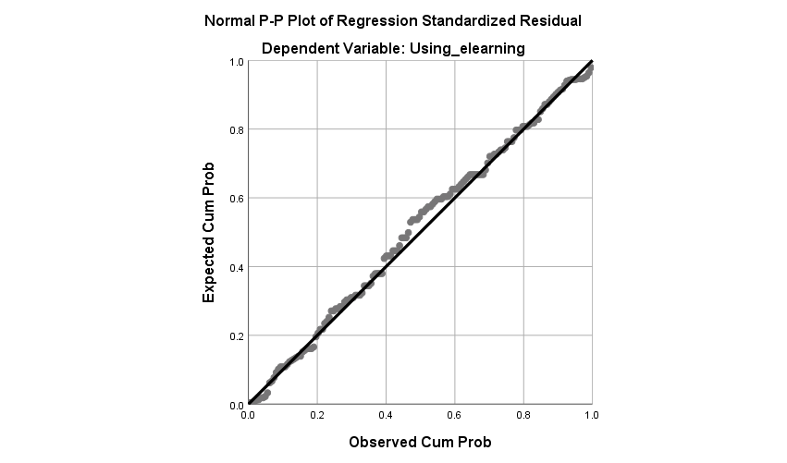

Picture 2. Normal P-P Plot

To determine the effect between dependent variable and independent variable, a simple regression analysis is used in this study.The using of e-learning is stated as independent variable, and the students’ interest in learning statistic subject is used stated as dependent variable. The correlation coefficient, R2 will tell how strong a linear relationship between the two variables. The coefficient of determination, R2 is used to analyze the percentage variation in dependent variable explained by independent variable.The value of R and R2 are shown in table 3.

Table 3. R and R2 result

|  |  |  |  |  |
| --- | --- | --- | --- | --- |
| Model | R | R Square | Adjusted R Square | Std. Error of the Estimate |
| 1 | .907a | .823 | .822 | 4.057 |
| a. Predictors: (Constant), Xtot | | | | |
| b. Dependent Variable: Ytot | | | | |

The value of R = 0.907 indicates that the using of e-learning is having a strong relationship to students’ interest in learning statistic. The value of R2 = 0.823 explains that the students’ interest in learning statistic subject is effected by 82.3% by using e-learning, while rest (17.7%) is explained by other causes.

Table 4. Unstandardized Coefficient

|  |  |  |  |  |  |  |
| --- | --- | --- | --- | --- | --- | --- |
| Model | | Unstandardized Coefficients | | Standardized Coefficients | t | Sig. |
| B | Std. Error | Beta |
| 1 | (Constant) | 2.863 | 1.908 |  | 1.500 | .136 |
| StudentsInterest | .923 | .035 | .907 | 26.746 | .000 |
| a. Dependent Variable: Using_elearning | | | | | | |

Table 4 provides some information to predict the students’ interest in learning statistic subject (Y) from using e-learning (X), as well as determine whether using e-learning contributes statistically to the linear regression model presented as [11]:

Y = 2.863 + 0.923 X (2)

The hypothesis statement that formulated as “there is a positive and significance effect of using e-learning to students’ interest in learning statistic subject” can be tested by using the t-test with 0.05 level of significance. From the result, the value of statistical significance of the regression is 0.0 which means less than 0.05, so we have to reject the null hypothesis and accept the alternative hypothesis, and it means there is a significant effect of using e-learning to students’interest of elearning statistic.

Oktarika [12] also found in her research that the using of e-learning has a significant effect to students’ interest of e-learning subject.

**CONCLUSION**

This study is taken to determine the effect of using e-learning to students’ interest in learning statistic subject of college students majoring Informatic System at STMIK Royal Kisaran. Using e-learning has significant effect to students’ interest in learning statistic subject, and the effect is explained about 82.3%. It can say that e-learning gives more interesting way and method as an online learning media.

**BIBLIOGRAPHY**

[1] R. P. Angdhiri, “Challenges of home learning during a pandemic through the eyes of a student,” *Jakarta POst*, Jakarta, 11-Apr-2020.

[2] Office of Assistant to Deputy Cabinet Secretary for State Documents & Translation, “COVID-19 Pandemic Brings Fresh Ideas in Learning Methods: President Jokowi,” *2nd May*, 2020. [Online]. Available: https://setkab.go.id/en/covid-19-pandemic-brings-fresh-ideas-in-learning-methods-president-jokowi/.

[3] L. Salamat, “EFFECTS OF E–LEARNING ON STUDENTS’ ACADEMIC LEARNING AT UNIVERSITY LEVEL,” 2018.

[4] H. A. Alismail and P. McGuire, “21 st century standards and curriculum: current research and practice,” *J. Educ. Pract.*, 2015.

[5] Jakarta Globe, “Cities Turn to Online Learning to Prevent Covid-19 Spreading Among Students,” Jakarta, 15-Mar-2020.

[6] Slameto, *Belajar dan Faktor-Faktor Yang Mempengaruhinya*. Jakarta: Rineka Cipta, 2010.

[7] M. Shokouhi Moghadam, “The effect of electronic education on interest of learning Students of Payame Noor University,” *Int. J. Med. Res. Heal. Sci.*, vol. 5, no. 11, pp. 625–629, 2016.

[8] J. C. Roca and M. Gagné, “Understanding e-learning continuance intention in the workplace: A self-determination theory perspective,” *Comput. Human Behav.*, 2008, doi: 10.1016/j.chb.2007.06.001.

[9] S. Arikunto, *Manajemen Penelitian*, Revisi. Jakarta: Rineka Cipta, 2005.

[10] Sugiyono, *Metode Penelitian Pendidikan Pendekatan Kuantitatif, Kualitatif, dan R&D*. Bandung: Alfabeta, 2014.

[11] G. Sudarmanto, *Analisis Regresi Linier dengan SPSS*. Yogyakarta: Graha Ilmu, 2005.

[12] D. Oktarika, “Pengaruh Pembelajaran Menggunakan Media E-Learning Terhadap Minat Belajar,” *Pengaruh Pembelajaran Menggunakan Media E-Learning Terhadap Minat Belajar*, 2015.