ELECTRONIC WORD OF MOUTH IN SOCIAL MEDIA INSTAGRAM
¹ Jeperson Hutahaean, ² Wily Julitawaty
¹ Information System, STMIK Royal Kisaran, Indonesia
² Accounting, STIE Professional Manajemen College Indonesia, Indonesia

ABSTRACT
Corresponding author:
jepersonhutahaean@yahoo.com
wilyjulitawaty@yahoo.com

Keywords:
eWOM, Purchase Decision

The purpose of this study was to analyze the extent of the influence of platform assistance, concern for others, expressing positive feelings, economic incentives, and helping the company on consumer purchase decisions in Ayam Geprek Mak Judes Medan.
There are 98 respondents with a sampling technique that is probability sampling with an accidental sampling approach. Quantitative research methods with multiple linear regression analysis using SPSS analysis tool version 20.0.
The results of this study indicate that platform assistance, expressing positive feelings, economic incentives, and helping the company have a positive and significant effect on consumer purchase decisions at Ayam Geprek Mak Judes Medan. While concern for others has a positive but not significant effect on consumer purchase decisions at Ayam Geprek Mak Judes Medan.

INTRODUCTION
Currently, the development of the culinary business in Indonesia has been so rapid. The proliferation of culinary businesses is encouraging entrepreneurs to be able to survive, earn profits, and grow. This can certainly be achieved by using strategies that are able to compete with other companies. One of the right strategies in the current millennial era is the use of internet media as promotional media which is considered very effective in reaching all consumers.
From the development of the internet in Indonesia, Indonesian people who use the internet also utilize social media to interact. Social media is one of the media used to interact with other users. In the era of technology that continues to grow rapidly at this time making social media as an alternative to delivering messages as well as business media. Marketing through social media can help companies in expanding markets to get customers. In addition, marketing costs through social media are relatively cheaper compared to conventional media which are considered too expensive. Users on social media in Indonesia can be seen from Figure 1 below:
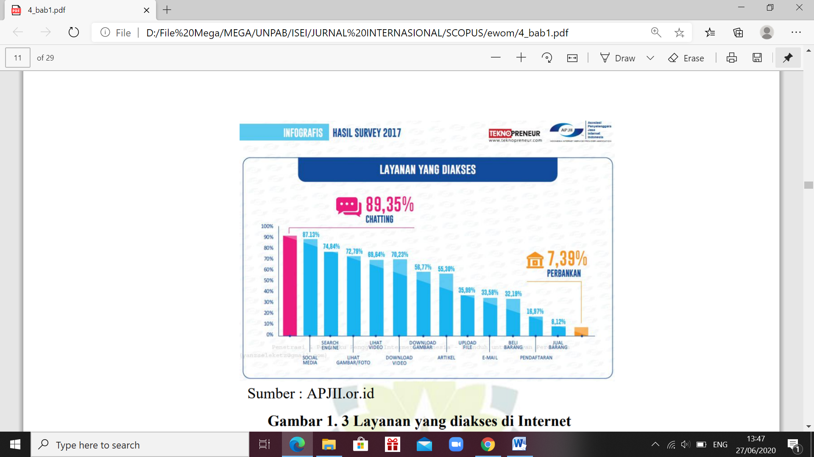
Figure 1. Services Accessed by Internet Users in Indonesia
Source: APJII.or.id, 2017

According to the 2017 Indonesian Internet Service Providers Association (APJII) survey, around 87.13% of 143.26 million internet users in Indonesia access social media. Ismud Park Medan uses social media as its main marketing strategy. The social media used by Ismud Park Medan are Instagram and Facebook. According to the 2016 APJII survey, Instagram social media users are fewer than Facebook social media users.
Around 40% of the top brands have adopted Instagram as part of their marketing. Instagram helps give businesses a personal touch through interesting and varied visuals. Through Instagram, companies can maintain the level of business growth and can build interaction with consumers through hashtags, along with photos of the company’s brand in order to create feedback from consumers (Akram & Wibowo, 2016). Where all these interactions are part of the electronic word of mouth.
According to Cheung and Lee (2012: 219) explain that electronic word of mouth (eWOM) is a communication and exchange of information between old consumers and new consumers, by using technological developments such as online discussion forums, electronic bulletin boards, newsgroups, blogs, review sites, and social media networking site that facilitates the exchange of information between communicators. Ekawati et al., (2014: 2) say word of mouth has undergone a paradigm shift. In the past, word of mouth communication was done face-to-face with people who were already known, but now word of mouth can be done in cyberspace with a wider scope, that is, in seconds what we share can be read by others. The paradigm shift is word of mouth through internet media called the electronic word of mouth.
Although it looks the same, traditional WOM has some differences with e-WOM. First, electronic word-of-mouth has a unique message distribution speed and scalability. Second, contrary to traditional WOM, e-WOM communication is more stable and the availability of information is always there. Third, electronic word-of-mouth communication can be measured more than traditional WOM.
This vast information is archived in an internet database so that customers can access the information for an unlimited period of time. If WOM is a communication between two people who face each other face to face, then e-WOM is the opposite of that, where the source and recipient of information usually do not know each other (Lopez, 2014).
In eWOM marketing provides several advantages, according to Hadi and Herawati (2013:6) the advantages of eWOM are cost-effective and because of its dynamics, the communication content can be changed as often and as quickly as the marketer’s needs. In addition, another great advantage of eWOM is its multiple object diversity, where eWOM is able to bring awareness-raising and direct purchase functions at the same time.
Ewom is defined as “positive or negative statements made by potential, actual or former customers about a product or company, which are made available to many people and institutions through the Internet”, (Hennig-Thurau, 2004). Positive statements delivered by consumers become a means to build customer trust in the company, but positive statements are not always true, especially for the case of credibility. Positive e-WOM that lasts for a long time will damage the credibility of the WEB site (Doh, M.S, & Hwang, 2009).
Consumer confidence in current purchasing decisions is greatly influenced by the delivery of positive news to others (word of mouth) (Darma, 2018), which is now an electronic word of mouth (eWOM). Ewom plays an important role in purchasing decisions because basically, individuals will make purchases based on the results of positive reviews about a product or service (Dewi and Darma, 2019). Furthermore, Almana and Mirza (2013), the decision to make a purchase was greatly influenced by eWOM. Then Lopez and Sicilia (2014) state that a person’s experience in using the internet simultaneously influences attitude in criticizing information. Jeonga and Jang (2011) customers are motivated to spread positive eWOM because they have good experience with the food served, service, and atmosphere and are driven by the customer’s desire to help the company. The activity of delivering information by word of mouth has long been a factor influencing the purchase decision of Hennig-Thurau, (2004). Positive e-WOM practices in modern business today are very important to attract and retain customers of Sa’ait, Kanyan, & Nazrin, (2016).
Ayam Geprek Mak Judes Medan located in Cemara Asri Boulevard Raya, GK Megapark Captains Muslim, and JCity Medan Johor is one of the booming chicken business in Medan today by using Instagram as one of its promotional media. Where in the menu Ayam Geprek Mak Judes Medan provides a slightly different menu from other chicken, by adding fried Indomie, omelet, and village crackers. Coupled with the spicy sauce according to the tastes of Medan people.
Therefore it is considered important for Ayam Geprek Mak Judes Medan to maintain the conduciveness of social media owned by minimizing public misunderstanding with the content presented in conducting promotions. Paying attention to influencers or people who have the potential to spread positive WOM is important for the company’s marketing strategy because it can increase the effectiveness and efficiency in penetrating the market.

METHOD
Hennig-Thurau (2004) defines e-WOM in 5 dimensions, namely:
- Platform Assintance: (1) the frequency of customer visits to the opinion platform and (2) the number of comments written on the opinion platform.
- Concern for Other Consumer, title to others is closely related to the concept of altruism.
- Extraversion/positive self-enhancement. Positive restaurant customer experiences contribute to psychological tension in customers because they have a strong desire to share the joy of the experiences of others. This tension can be revealed by conveying the experience of eating on the online site with positive comments
- Social Benefits Affiliate with a virtual community can represent a social benefit of consumers for reasons of identification and social integration, thus consumers can be suspected of engaging in e-WOM communication to participate and belong to the online community.
- Helping The Company is the result of customer satisfaction with the product and the subsequent desire to help the company.
Where in this study eWOM consisting of 5 dimensions became the independent variable in this study, with X1 Platform Assintance (5 indicators), X2 Concern for Other Consumer (4 indicators), X3 Extraversion/Positive self-Enhancement (3 indicators), X4 Affiliate Social Benefits (3 indicators), X5 Helping The Company (3 indicators). And the dependent variable in this study is Y purchasing decisions with 5 indicators.
The following is a picture of the framework in this research:

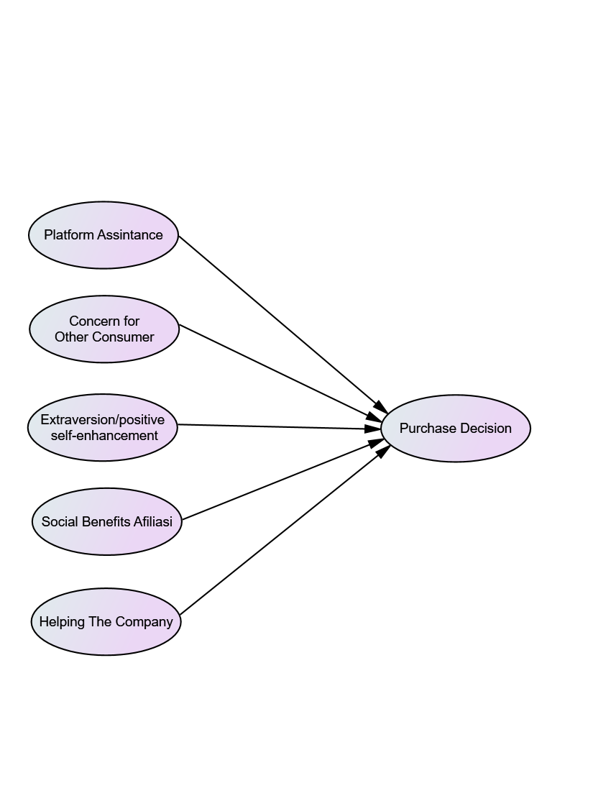
Figure 2. Conceptual Framework
The object of this research is all consumers of Medan Geprek Mak Judes Medan located in Cemara Asri Boulevard Raya, GK Megapark Kapten Muslim, and JCity Medan Johor. With an estimated one day consumers who buy at Ayam Geprek Mak Judes Medan through Instagram and online drivers around 200 people per day. So that it is estimated a month consumers reach 6000 people. By using the Slovin formula with a preposition rate of 10%, the number of samples is 98 people. Probability sampling with an accidental sampling approach is used as a sampling technique. Quantitative research methods with multiple linear regression analysis using SPSS analysis tool version 20.0.
The multiple linear regression equation in this study can be formulated as follows:
Y= a + b₁X₁ + b₂X₂ + b₃X₃ + b₄X₄ + b₅X₅ + e ………………………….. 1)
Where:
Y = Purchase Decision
a = Constant
X₁ = Platform Assistance
X₂ = Concern for Others
X₃ = Expressing Positive Feeling
X₄ = Economic Incentive
X₅ = Helping the Company
b_{1,} b₂, b₃, b₄, b₅ = Regression coefficient
e = Error term

Testing data used by using validity test, reliability test, classic assumption test, multiple linear regression analysis, coefficient of multiple determination (R2), equipped with partial hypothesis testing t-test, and simultaneous F-test.

RESULT AND DISCUSSION
- Research result
- Reliability Test
The reliability test results can be seen in the following table:

Table 1. Reliability Test Results

No. | Research variable | Cronbach’s Alpha | N of Items | Conclusion
1 | Platform Assistance | 0.866 | 5 | Reliabel
2 | Concern for Others | 0.837 | 4 | Reliabel
3 | Expressing Positive Feeling | 0.835 | 3 | Reliabel
4 | Economic Incentive | 0.785 | 3 | Reliabel
5 | Helping the Company | 0.810 | 3 | Reliabel
6 | Purchase Decision | 0.870 | 5 | Reliabel

The instrument has a high level of reliability if the coefficient value obtained is> 0.60 (Ghozali, 2011). So it can be concluded that all the variables in this study can be declared reliable because of the Cronbach alpha value of all variables above 0.60. This implies that if all the variables in the study if measurements were taken again on the same respondent, they would be able to give relatively the same results.
- Validity Test
The validity test results can be seen in the following table:

Table 2. Validity Test Results

Item-Total Statistics
Indicator | Scale Mean if Item Deleted | Scale Variance if Item Deleted | Corrected Item-Total Correlation | Cronbach's Alpha if Item Deleted
X1.1 | 14.12 | 6.366 | .682 | .840
X1.2 | 14.11 | 6.131 | .720 | .830
X1.3 | 14.03 | 6.301 | .714 | .832
X1.4 | 14.16 | 6.512 | .673 | .842
X1.5 | 14.17 | 6.661 | .651 | .847
X2.1 | 10.52 | 4.251 | .635 | .807
X2.2 | 10.50 | 4.108 | .668 | .793
X2.3 | 10.53 | 3.891 | .681 | .788
X2.4 | 10.54 | 3.963 | .688 | .784
X3.1 | 7.06 | 2.040 | .729 | .738
X3.2 | 6.99 | 2.259 | .691 | .778
X3.3 | 7.10 | 2.163 | .671 | .796
X4.1 | 7.04 | 1.617 | .677 | .649
X4.2 | 7.05 | 1.717 | .637 | .694
X4.3 | 7.01 | 1.899 | .562 | .773
X5.1 | 6.99 | 1.784 | .647 | .758
X5.2 | 7.20 | 1.859 | .706 | .691
X5.3 | 7.03 | 2.086 | .634 | .767
Y1 | 14.06 | 6.910 | .675 | .848
Y2 | 14.02 | 6.640 | .719 | .837
Y3 | 14.04 | 7.099 | .678 | .847
Y4 | 14.04 | 6.559 | .720 | .837
Y5 | 14.01 | 6.799 | .685 | .845

The calculated value is obtained from the corrected item value - the total correlation of each item of auditor competency statement items. From the results of the analysis, it can be seen that for the item statement of auditor competency variables the calculated value is greater than r-table. Because the correlation coefficient on the statement item is greater than 0.339, it can be concluded that the entire instrument is valid.

- Classical Assumption Test
- Normality test
The normality test aims to test whether in a regression, confounding or residual variables are normally distributed or not. Regression models are either normal or near-normal data distribution.
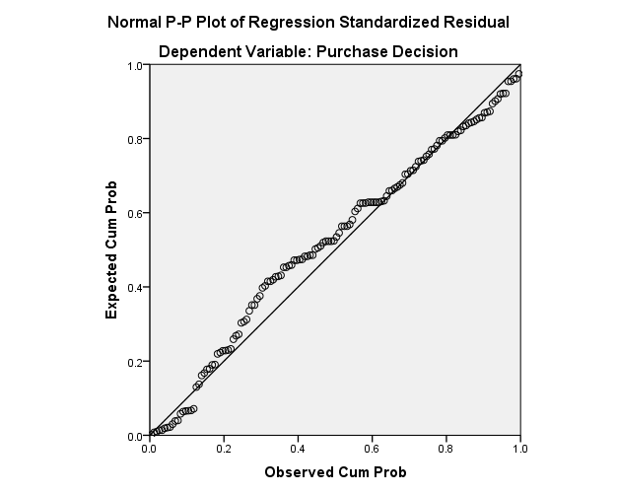
Figure 2. P-Plot Graph

Based on Figure 2 above, then for the results of testing data normality using P-Plot images, visible data points that are spread around the diagonal line so that the data has been normally distributed.

- Heteroscedasticity Test
Heteroskedacity test aims to test whether in the regression model there is an inequality of variance from the residuals of one observation to another. A good regression model is one that does not occur heteroskedacity.

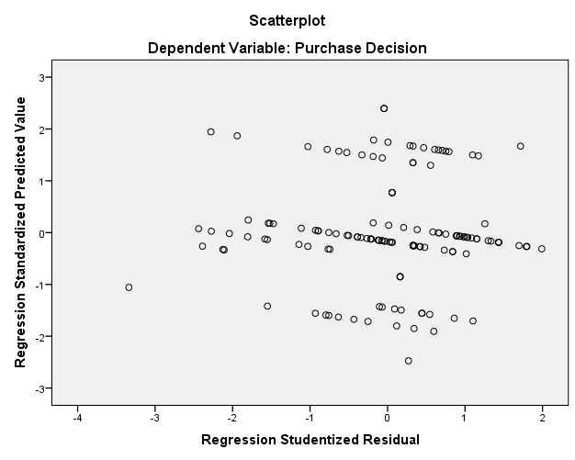
Figure 3. Scatterplot graph

Based on Figure 3 above, there is no clear pattern, and the points spread above and below the number 0 on the Y axis, then there is no heteroscedasticity.

- Multicollinearity Test
Multicollinearity test aims to test whether the regression model found a correlation between independent variables (independent). This test is done by looking at the value of tolerance and variance inflation factor (VIF) from the results of the analysis using SPSS. If the tolerance value> 0.10 or VIF <10, it can be concluded that multicollinearity does not occur.

Table 3. Multicollinearity Test Results

Model |  | Collinearity Statistics
 |  | Tolerance | VIF
1 | (Constant)
1 | Platform Assintance | .100 | 8.047
1 | Concern for Other Consumer | .071 | 6.117
1 | Extraversion/Positive self-Enhancement | .142 | 7.028
1 | Social Benefits Afiliasi | .210 | 4.754
1 | Helping The Company | .137 | 7.313

Based on Table 3 above, it is known that the tolerance value> 0.10 or VIF <10, it is concluded that there is no multicollinearity.

- Determination Coefficient Test
The results of the coefficient of determination test can be seen in the following table:

Table 4. Determination Test Results

Model Summary^{b}
Model | R | R Square | Adjusted R Square | Std. Error of the Estimate
1 | .974ª | .949 | .947 | .14737
a. Predictors: (Constant), Helping The Company, Social Benefits Afiliasi, Extraversion/Positive self-Enhancement, Platform Assintance, Concern for Other Consumer
b. Dependent Variable: Purchase Decision

Table 4 above explains the results of the model summary analysis obtained by the R Square figure of 0.949. This shows that there is an ability to explain Platform Assintance, Concern for Other Consumer variables, Extraversion/Positive self-Enhancement, Affiliated Social Benefits, Helping The Company to the Purchase Decision variable that is equal to 0.949 or 94.9%.

- F-Test
F-test results (simultaneous/simultaneous test) can be seen in the following table:

Table 5. F-Test Results
ANOVAª
Model |  | Sum of Squares | df | Mean Square | F | Sig.
1 | Regression | 54.319 | 5 | 10.864 | 500.225 | .000^{b}
1 | Residual | 2.910 | 134 | .022
1 | Total | 57.230 | 139
a. Dependent Variable: Purchase Decision
b. Predictors: (Constant), Helping The Company, Social Benefits Afiliasi, Extraversion/Positive self-Enhancement, Platform Assintance, Concern for Other Consumer

Based on the table above, it can be explained that the calculated F value is 500.225> F table 2.1925 with a significance level of 0.000 which is smaller than 5%, so it can be concluded that the Platform Assintance, Concern for Other Consumers, Extraversion / Positive self-Enhancement, Social Benefits Affiliate, Helping The Company has a positive and significant effect on Purchasing Decisions.

- t-Test

t-test results (partial/individual) can be seen in the following table:

Table 6. t-Test Result

Coefficientsª
Model |  | Unstandardized Coefficients |  | Standardized Coefficients | t | Sig.
 |  | B | Std. Error | Beta | t | Sig.
1 | (Constant) | -.069 | .075 |  | -.916 | .361
1 | Platform Assintance | .293 | .064 | .284 | 4.594 | .000
1 | Concern for Other Consumer | .105 | .072 | .107 | 1.466 | .145
1 | Extraversion/Positive self-Enhancement | .197 | .047 | .217 | 4.192 | .000
1 | Social Benefits Afiliasi | .239 | .043 | .234 | 5.514 | .000
1 | Helping The Company | .181 | .051 | .186 | 3.526 | .001
a. Dependent Variable: Purchase Decision

Based on the results of statistical tests that have been carried out, the parameters for the equation that have been formulated are as follows:
Y= -0.069 + 0.293X₁ + 0.105X₂ + 0.197X₃ + 0.239X₄ + 0.181X₅ …………… 2)

Based on Table 6 above it can be explained that:
The influence of Platform Assintance on purchasing decisions is 0.293 (29.3%), t value 4.594> t table 1.985, with a significance value of 0.000. This proves that the Platform Assintance is positive and significant for consumer purchasing decisions at Ayam Geprek Mak Judes Medan.
The effect of Concern for Other Consumer on purchasing decisions of 0.105 (10.5%), t value 1.466<t table 1.985, with a significance value of 0.145. This proves that Concern for Other Consumer has a positive and not significant effect on consumer purchasing decisions at Ayam Geprek Mak Judes Medan.
The effect of Extraversion/Positive self-Enhancement on purchasing decisions of 0.197 (19.7%), t value 4.192>t table 1.985, with a significance value of 0,000. This proves that Extraversion/Positive self-Enhancement has a positive and significant effect on consumer purchasing decisions at Ayam Geprek Mak Judes Medan.
The effect of Affiliate Social Benefits on purchasing decisions of 0.239 (23.9%), t value 5.514> t table 1.985, with a significance value of 0.000. This proves that Affiliate Social Benefits has a positive and significant influence on consumer purchasing decisions at Ayam Geprek Mak Judes Medan.
The influence of Helping The Company on purchasing decisions was 0.181 (18.1%), t value 3.526> t table 1.985, with a significance value of 0.001. This proves that Helping The Company has a positive and significant effect on consumer purchasing decisions at Ayam Geprek Mak Judes Medan.

CONCLUSION
The conclusions of this study can be described as follows:
- Platform Assintance is positive and significant for consumer purchasing decisions at Ayam Geprek Mak Judes Medan.
- Concern for Other Consumer has a positive and not significant effect on consumer purchasing decisions in Ayam Geprek Mak Judes Medan.
- Extraversion / Positive self-Enhancement has a positive and significant influence on consumer purchasing decisions in Ayam Geprek Mak Judes Medan.
- Social Benefits Affiliation has a positive and significant effect on consumer purchasing decisions at Ayam Geprek Mak Judes Medan.
- Helping The Company has a positive and significant effect on consumer purchasing decisions in Ayam Geprek Mak Judes Medan.

Reference

Akram, Muhammad & Wibowo, Sampurno. (2016). Influence Of Electronic Word Of Mouth through Social Media Instagram to purchase decision of Vespa Piaggio case study in Bandung City. ISSN: 2442-5826 e-Proceeding of Applied Science: Vol. 2, No. 3 December 2016.
Almana, A. M. (2013). The Impact of Electronic Word of Mouth on Consumers ' Purchasing Decisions.
Cheung, C. M. K., & Lee, M. K. O. (2012). What drives consumers to spread electronic word of mouth in online consumer-opinion platforms. Decision Support Systems Vol. 53 (1).
Darma, G.S. (2018). A string of messages, answering times. Indonesia: Larasan Press Library.
Dewi, C.R., and Darma, G.S. (2014). Website Usability, Satisfaction, Loyalty, Security Perception, Trust, and Word of Mouth in E-Commerce Business, Business & Management Journal, 11 (2): 1-30.
Doh, S.-J., M. S, & Hwang, J.-S. (2009). Rapid Communication. How Consumers Evaluate eWOM (Electronic Word-of-Mouth) Messages.
Ekawati, M., Kumadji, S., Kusumawati, A. (2014). The influence of Electronic Word of Mouth on consumer knowledge as well as its impact on purchasing decisions. Journal of Business Administrator, 14 (2).
Hadi, Susilo and F. Herawati, Anita. (2013). Influence of brand associations to the level of willingness to do E-Word Of Mouth (an expreslanative study of influence level associations brand products FashionBonvieux against the level of willingness to do E-Word Of Mouth). Yogyakarta UAJY.
hened-Thurau, T. (2004). Electronic Word-Of-Mouth Via Consumer-Opinion Platforms: What Motivates Consumer To Articulate Themselves On The Internet?
Jeong, E., & Jang, S. S. (2011). Restaurant experiences triggering positive electronic word-of-mouth (eWOM).
Lopez, M. (2014). Determinants of E-WOM Influence: The Role of Consumers ' Internet Experience.

