IMPACT OF USING MOBILE LEARNING APPLICATIONS
IN THE LEARNING PROCESS

Akmal Nasution^{1*}, Mohd. Siddik ²
^{1,2}Sistem Informasi, STMIK Royal

ABSTRACT
Corresponding author:
nst.akmal@gmail.com

Keywords:
Mobile Learning
Android
Learning Process

Development of the world education and the learning process triggers a teaching trend that places teachers and students in an equally active position through the use of technology and media in the learning process. The use of technology in learning such as mobile technology application can be used as one of the factors driving the development of the learning process in formal and non-formal educational institutions. For that, we need a mobile technology facility that can be accessed by anyone anywhere and anytime. Of course, the role of mobile devices such as mobile phones or Android smartphones is the best solution for learning. So in this study, it will be seen the impact of applying Mobile Learning applications in the learning process. The object of mobile learning research in this study is the English course. Will measure the extent of the development of students in learning English with m-learning compared to conventional learning.

INTRODUCTION

The development of technology, especially Android mobile technology has become excellent among smartphone users lately [1], thus causing the development of people's lifestyles, including in the shopping process [2]. This influence has also penetrated the business world and businesses such as companies and even the teaching process in the world of education.
During this time, the assumption that learning only occurs in the classroom with trained teachers has become a habit that has become entrenched. However, educators and scholars in the 20th century, have developed theories that advocate transferring learning experiences from a far location, little emphasis is placed on aspects of learning mobility [3]. Conventional teaching trends where placing teachers as active communicators can be changed now using information and communication technology. Teachers and students can be placed in positions that are equally active, namely by using technology and media in the learning process. One method that is currently well established is to use Mobile Learning (m-learning). This technology has been used in every method of learning for almost 20 years [4].
The possibility of independent learning wherever they are supported by speed and time efficiency is the most important feature of M-Learning [5]. So far, based on the literature review that has been done that M-Learning will only succeed when students can adapt and accept this technology. In addition, it should also be noted that the behavior of the recipients of this technology is certainly not the same in its application in different cultures [6]. This is because mobile learning activities experienced by users via smartphones are unique because knowledge information is processed and received wherever students are. The context is more individual and completely different from conventional learning [7].
At present, there is a big tendency in educational institutions to adopt new learning methods along with conventional methods. The education sector has been demanded to enter a new era along with the rapid information and communication technology revolution. Conventional classroom learning will be equipped with electronic learning and mobile learning which makes the learning process more effective through mobile applications, such as Android. It is clear that industry demands and requirements have not been met so far with conventional learning methods. This old method also tends to stagnate educational growth. Therefore, it has become a necessity to improve techniques in the learning process in accordance with industry needs [8].
The object of study used as a sample in implementing m-learning in this study is English language learning. Actually previous researchers have examined the impact of m-learning on ESL Listening Comprehension [9], but there is no literature specifically that discusses how the use of m-learning applications on the learning process. Therefore, the purpose of this study is to look at the impact of using m-learning applications in the learning process. The Impact will be measured by comparing conventional learning with m-learning, the value of which will be taken from a questionnaire filled out by a group of students (n = 100). The evaluation points in the questionnaire were divided into three criteria, namely material, time, and cost criteria.

METHOD

This study uses a qualitative research paradigm where previously it was also used by previous researchers who used the case study method to test the improvement of cellular technology for PST learning with PLN [10]. In the case of this study, the focus is on gaining a deeper understanding of the learning process conventional and using the mobile learning application so that it will conclude the impact of using this m-learning application by exploring the research questions and answers of participants about the material, time, and cost (see table 1).

Table 1. Sample Assessed Activity
Learning process activity |  | Assessment of the learning process
 |  | M-Learning | Conventional
material | understanding of learning material | Skor 1-5  (bad – good) | Skor 1-5  (bad – good)
material | delivery of material | Skor 1-5  (bad – good) | Skor 1-5  (bad – good)
material | access to learning material | Skor 1-5  (bad – good) | Skor 1-5  (bad – good)
time | learning time | Skor 1-5  (long - short) | Skor 1-5  (long - short)
time | time to access the subject material | Skor 1-5  (long - short) | Skor 1-5  (long - short)
cost | costs in the learning process | Skor 1-5  (expensive - cheap) | Skor 1-5  (expensive - cheap)
cost | fees for accessing study material | Skor 1-5  (expensive - cheap) | Skor 1-5  (expensive - cheap)
cost | costs for learning support equipment | Skor 1-5  (expensive - cheap) | Skor 1-5  (expensive - cheap)

Overall 100 students participated in the questionnaire filling. In semester 2, they took an English course. They are all students majoring in information systems with different backgrounds and cultures, some have worked and some have not.
Participating students were given the opportunity for 3 days to fill out an online questionnaire. Where they are free to give an assessment of 1 to 5 in accordance with the assessment criteria in the learning process using m-learning applications and conventionally. The results of the assessment of each learning process will be compared to obtain differences. From these differences, it will be concluded the impact arising from the use of m-learning applications on conventional learning.
Before submitting the questionnaire, the mobile learning application was first designed and developed. The mobile learning application contains material about English in the form of video and text. The subject in the mobile learning application includes 7 complete learning modules outline namely Pronouns, Verbs and Conjunctions, Direct and Indirect Speeches, Comparative Degrees, Similarities and Differences, Passive Sounds, and the last Conditional Sentences. Besides material, training assignments and points are also provided through this mobile learning application.

RESULT AND DISCUSSION

Before discussing the results of the research, it is first discussed the results of the development of m-learning applications that are intended as a tool in this study. The Android-based m-learning application developed (figure 1) is adapted to an easy-to-use interface, so it is not reliable in its use. There are seven main material English lessons that can be accessed without logging in first via the menu pinned in the upper right corner. In addition to general material content, tips and tricks are also provided in learning English and are available in video or text format.
To facilitate students in doing their assignments, they are also equipped with menus to access assignments given by lecturers or instructors. In addition, it also supports the collection of tasks and task history directly through the application (see figure 2).
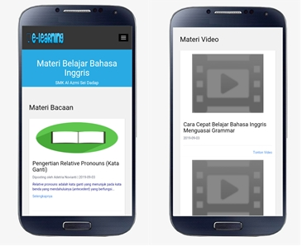
Figure 1. M-Learning applications

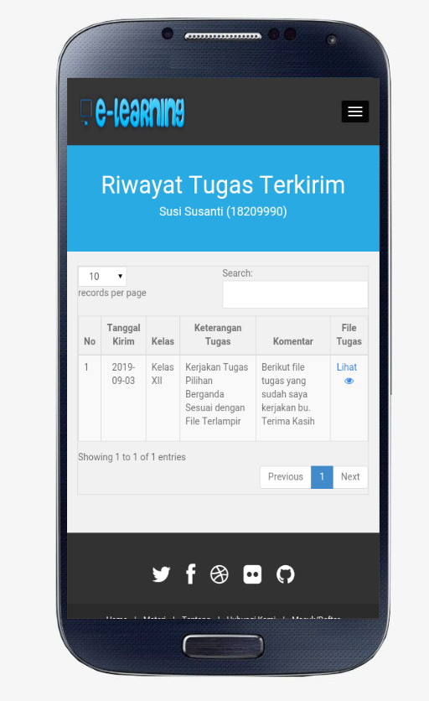
Figure 2. Task function in the application

Retrieval and measurement of the English learning process are carried out for 1 semester. Students who are participants are given the freedom to use mobile learning applications along with conventional learning in a class conducted in semester 2. The results revealed that the value of the learning process using mobile learning applications is higher than conventional. The biggest weakness of students in the learning process with mobile learning applications is in the cost section. Costs incurred to support online learning are quite expensive, where at a minimum they must have an Android smartphone and data package to access the internet.
The results of the two learning processes are illustrated in figure 2 below. This shows that the value for the learning process with mobile learning applications achieves higher results or we can conclude that it is more effective for participants than conventional learning. Participants rated the mobile learning application an average of 28.5. While the average value for conventional learning is 25.4.
Figure 3. Participant assessment results
Based on the results of the questionnaire test revealed that the use of mobile learning applications in the learning process has a positive impact, which is 7.75% more effective than conventional learning.
This study provides results that mobile learning through Android applications, especially learning English, is more effective in the learning process of students. Previous statistical analysis proved that students who participated in the assessment of the use of mobile learning applications in their learning process were more effective at 7.75% compared to conventional face-to-face learning in class. Similar results were also found in other research studies on the impact of mobile learning on student achievement outcomes [4]. In the study, can conclude it students who used mobile learning applications got higher test scores of up to 43.9 points compared to other groups who only scored an average of 31.8.

CONCLUSION

The results of research on the impact of the use of mobile learning applications as explained earlier are the birth of an android mobile application based on student needs and can continue to be facilitated by lecturers or instructors.
This application is proven effective in improving the learning process and has a positive impact. In addition, the results also confirm that mobile learning can also function as an appropriate complementary method when combined with conventional learning. However, it should be noted that students must also be encouraged and guided to use this application because some students sometimes forget to open this learning application.
Then it is necessary for future application development to be given a reminder in the form of a notification that will appear when students within a few days do not open the application. In addition, it is also necessary to consider the user's ability to procure supporting devices for the use of this application, such as the procurement of smartphones and internet data packages. For future development, this application also needs to be developed for other mobile operating systems besides Android, so that application users can get even more.

ACKNOWLEDGMENTS

This research was supported by STMIK Royal Kisaran, which was carried out in the Information Systems Department. The author thanks LPPM, lecturers, and staff who have helped.

BIBLIOGRAPHY

[1] A. Nasution, “Metode Weighted Moving Average dalam M-Forecasting,” JURTEKSI, vol. V, no. 2, pp. 119–124, 2019.
[2] A. Nasution, “Implementasi Konsep Distribution Portal Business To Business dengan Teknologi M-Commerce,” JURTEKSI, vol. 3, no. 2, pp. 66–138, 2017.
[3] F. Alkhezzi, “The Impact of Mobile Learning on ESP Learners’ Performance,” J. Educ. Online, vol. 13, no. 2, pp. 73–101, 2016.
[4] K. Blanka, “Impact of Mobile Learning on Students’ Achievement Results,” vol. 9, no. 2, 2019.
[5] M. Alrasheedi and L. F. Capretz, “Determination of critical success factors affecting mobile learning : a meta-analysis approach,” vol. 14, no. 2, pp. 41–51, 2015.
[6] M. Alshurideh, A. S. Salloum, B. Al Kurdi, A. A. Monem, and K. Shaalan, “Understanding the Quality Determinants that Influence the Intention to Use the Mobile Learning Platforms : A Practical Study,” vol. 13, no. 11, pp. 157–183.
[7] S. A. Shonola and M. S. Joy, “The Impact of Mobile Devices for Learning in Higher Education Institutions : Nigerian Universities Case Study,” no. August, pp. 43–50, 2016.
[8] R. K. Mallya and B. Srinivasan, “Impact of Mobile Learning in the Cloud on Learning Competencies of Engineering Students,” vol. 15, no. 09, pp. 80–87.
[9] Y. Zhang, “The Impact of Mobile Learning on ESL Listening Comprehension,” no. 5, 2016.
[10] M. Kearney and D. Maher, “Mobile learning in pre-service teacher education : Examining the use of professional learning networks,” vol. 35, no. 1, pp. 135–148, 2019.

